Test1

SophieZ

2024-05-14

# Default

## R Markdown

This is an R Markdown document. Markdown is a simple formatting syntax for authoring HTML, PDF, and MS Word documents. For more details on using R Markdown see <http://rmarkdown.rstudio.com>.

When you click the **Knit** button a document will be generated that includes both content as well as the output of any embedded R code chunks within the document. You can embed an R code chunk like this:

summary(cars)

speed dist   
 Min. : 4.0 Min. : 2.00   
 1st Qu.:12.0 1st Qu.: 26.00   
 Median :15.0 Median : 36.00   
 Mean :15.4 Mean : 42.98   
 3rd Qu.:19.0 3rd Qu.: 56.00   
 Max. :25.0 Max. :120.00

## Including Plots

You can also embed plots, for example:

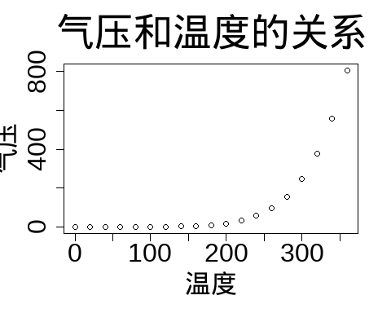

Note that the echo = FALSE parameter was added to the code chunk to prevent printing of the R code that generated the plot.

# Learning materials

[How to use Rmarkdown](https://blog.csdn.net/weixin_43843918/article/details/128060062)

## Test: Implement python in Rmd

[Use of Library “reticulate”](https://blog.csdn.net/weixin_38008864/article/details/108191385)  
[Yihui-rmarkdown](https://bookdown.org/yihui/rmarkdown/language-engines.html)

You can also change the engine interpreters globally for multiple engines, e.g.,

knitr::opts_chunk$set(engine.path = list(  
 python = '~/anaconda/bin/python',  
 ruby = '/usr/local/bin/ruby'  
))

### install package:

# install.packages("reticulate")

### introduce library:

library(reticulate)  
# use_python('C:\\Users\\sustech\\.conda\\envs\\gdalcartopy\\python.exe')

### run python code:

import numpy as np   
import matplotlib.pyplot as plt   
# 计算正弦曲线上点的 x 和 y 坐标  
x = np.arange(0, 3 * np.pi, 0.1)   
y = np.sin(x)  
plt.title("sine wave form")   
# 使用 matplotlib 来绘制点  
plt.plot(x, y)   
plt.show()

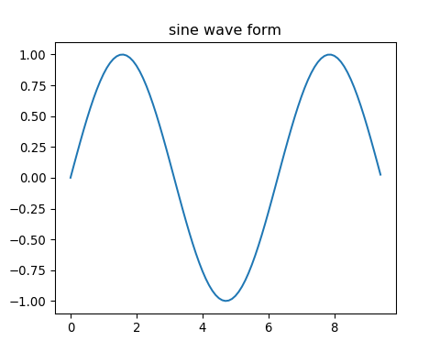

### call python variable in R code:

py$y

[1] 0.00000000 0.09983342 0.19866933 0.29552021 0.38941834 0.47942554 0.56464247 0.64421769  
 [9] 0.71735609 0.78332691 0.84147098 0.89120736 0.93203909 0.96355819 0.98544973 0.99749499  
[17] 0.99957360 0.99166481 0.97384763 0.94630009 0.90929743 0.86320937 0.80849640 0.74570521  
[25] 0.67546318 0.59847214 0.51550137 0.42737988 0.33498815 0.23924933 0.14112001 0.04158066  
[33] -0.05837414 -0.15774569 -0.25554110 -0.35078323 -0.44252044 -0.52983614 -0.61185789 -0.68776616  
[41] -0.75680250 -0.81827711 -0.87157577 -0.91616594 -0.95160207 -0.97753012 -0.99369100 -0.99992326  
[49] -0.99616461 -0.98245261 -0.95892427 -0.92581468 -0.88345466 -0.83226744 -0.77276449 -0.70554033  
[57] -0.63126664 -0.55068554 -0.46460218 -0.37387666 -0.27941550 -0.18216250 -0.08308940 0.01681390  
[65] 0.11654920 0.21511999 0.31154136 0.40484992 0.49411335 0.57843976 0.65698660 0.72896904  
[73] 0.79366786 0.85043662 0.89870810 0.93799998 0.96791967 0.98816823 0.99854335 0.99894134  
[81] 0.98935825 0.96988981 0.94073056 0.90217183 0.85459891 0.79848711 0.73439710 0.66296923  
[89] 0.58491719 0.50102086 0.41211849 0.31909836 0.22288991 0.12445442 0.02477543

### import python packages in R code:

library(reticulate)  
#导入库  
os <- import("os")  
#os库的listdir函数  
os$listdir()

[1] ".git" ".Rhistory" "docs" "helloworld.py" "index.Rmd" "README.md"   
 [7] "test1.pdf" "test1.Rmd" "test1_files" "test2.Rmd" "_site.yml"

PS: 在R代码块中执行Python代码时，默认会将Python对象转为R对象。

### introduce python variable from .py file in R code:

library(reticulate)  
source_python("helloworld.py")  
print(A)  
[1] "Hello"  
print(B)  
[1] "world"  
paste0(A, B)  
[1] "Helloworld"

### run .py file in R code:

library(reticulate)  
py_run_file("helloworld.py")

## In-line code

we can run code between text like this: date: 2024-05-14 date: 最近更新日期为14 五月, 2024

## Journal article templates for R markdown

[rticles-github](https://github.com/rstudio/rticles)

## Chinese not showed in PDF

Solution [here](https://blog.csdn.net/xlf5323/article/details/136418610#:~:text=%E5%9C%A8%E4%BD%BF%E7%94%A8%20R%20Markdown%20%E7%BC%96%E5%86%99%E6%96%87%E6%A1%A3%E5%B9%B6%E5%AF%BC%E5%87%BA%E4%B8%BA%20PDF%20%E6%A0%BC%E5%BC%8F%E6%97%B6%EF%BC%8C%E7%BB%8F%E5%B8%B8%E4%BC%9A%E9%81%87%E5%88%B0%E4%B8%80%E4%B8%AA%E6%99%AE%E9%81%8D%E7%9A%84%E9%97%AE%E9%A2%98%EF%BC%9A%E4%B8%AD%E6%96%87%E5%A4%B1%E6%95%88%E3%80%82%20%E6%88%96%E8%80%85%E5%AF%BC%E5%87%BA%E7%9A%84%E6%96%87%E6%A1%A3%E4%B8%AD%E6%96%87%E5%AD%97%E7%AC%A6%E6%AE%8B%E7%BC%BA%20%E8%A7%A3%E5%86%B3%E6%96%B9%E6%B3%95,title%3A%20%22%E4%B8%AD%E6%96%87%E6%96%87%E6%A1%A3%22%20documentclass%3A%20ctexart%20output%3A%20pdf_document%3A%20latex_engine%3A%20xelatex)

### in the words

Change output: latex_engine and documentclass like this:

title: "中文文档"  
documentclass: ctexart  
output:  
 pdf_document:  
 latex_engine: xelatex

### in the output plot

在Rmd正文最开始写上

{r setup, include=FALSE}  
library(showtext)  
showtext_auto()

如果不喜欢showtext默认的字体，可以自行添加字体

{r setup, include=FALSE}  
library(showtext)  
font_add("simsun", regular = "simsun.ttc")  
showtext_auto()