FINAL PORTFOLIO DOCUMENTATION
STUDENT: Safiyyah Mohammed
INSTITUTION: Miva Open University
COURSE: MIT 8103 – Advanced Database Systems
CASE STUDY: Kudi Trust Bank Database Management System

PROJECT SUMMARY
This portfolio shows how advanced database concepts apply in practice, using Kudi Trust Bank as an example. The project looked at designing, implementing, managing, and analysing both relational and non-relational database systems in a banking setting.
The project started by designing a relational database system to handle customers, accounts, and transactions. We used normalization methods to build the database structure and set it up in MySQL. Later, the portfolio covered SQL query processing, transaction management, NoSQL databases, and distributed and cloud database technologies.
During the project, we carried out practical demonstrations with MySQL and MongoDB. We created and documented SQL queries, transaction processing, CRUD operations, aggregation functions, and distributed database setups. Our main goal was to see how modern database technologies help make banking operations secure, reliable, and scalable.
This portfolio combines theory with hands-on work and shows how database systems support business operations and decision-making.

SELECTED ORGANISATION

KUDI TRUST BANK
Kudi Trust Bank is a simulated financial institution and the main case study for this portfolio. It offers a realistic setting to explore how modern database technologies are used in banking.
The bank offers services such as customer registration, account management, deposits, withdrawals, fund transfers, transaction monitoring, and customer activity management. These services generate a lot of data that must be stored, processed, secured, and analysed efficiently.
I chose the banking environment because it requires strong data integrity, security, consistency, and availability. This makes it a good example for showing advanced database concepts like transaction management, replication, distributed databases, and cloud computing.

PORTFOLIO OVERVIEW
Portfolio | Topic | Key Outcome
Portfolio 1 | Database Design | Designed and normalized a relational database for Kudi Trust Bank
Portfolio 2 | SQL Query Processing | Implemented SQL queries, joins, views, aggregate functions, and indexing
Portfolio 3 | Transaction Management | Demonstrated ACID properties, COMMIT, ROLLBACK, transaction logging, and concurrency control
Portfolio 4 | NoSQL Databases | Implemented MongoDB collections, CRUD operations, and aggregation functions
Portfolio 5 | Distributed and Cloud Databases | Designed a distributed cloud database architecture with replication and disaster recovery mechanisms

EVIDENCE OF PRACTICAL IMPLEMENTATION
PORTFOLIO 1
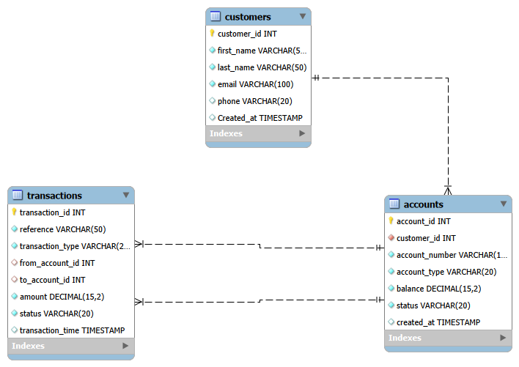
PORTFOLIO 2
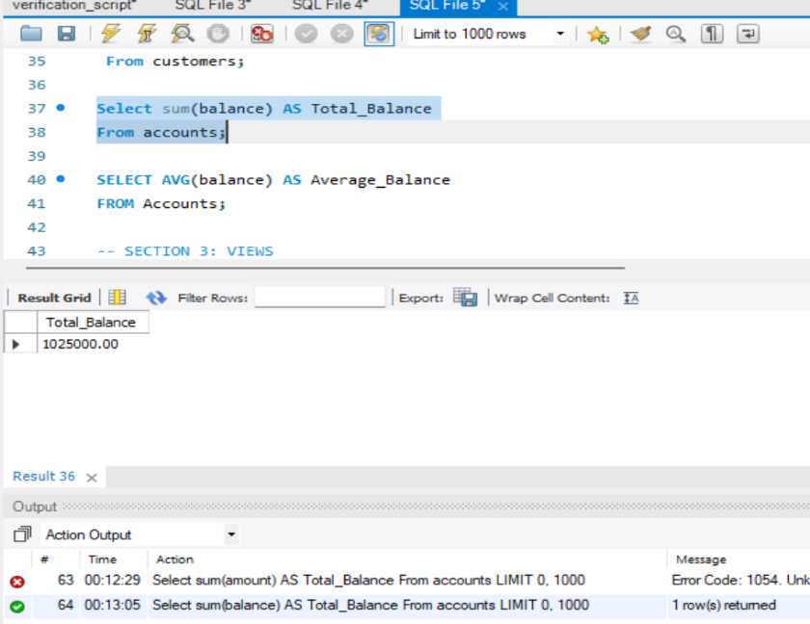
PORTFOLIO 3
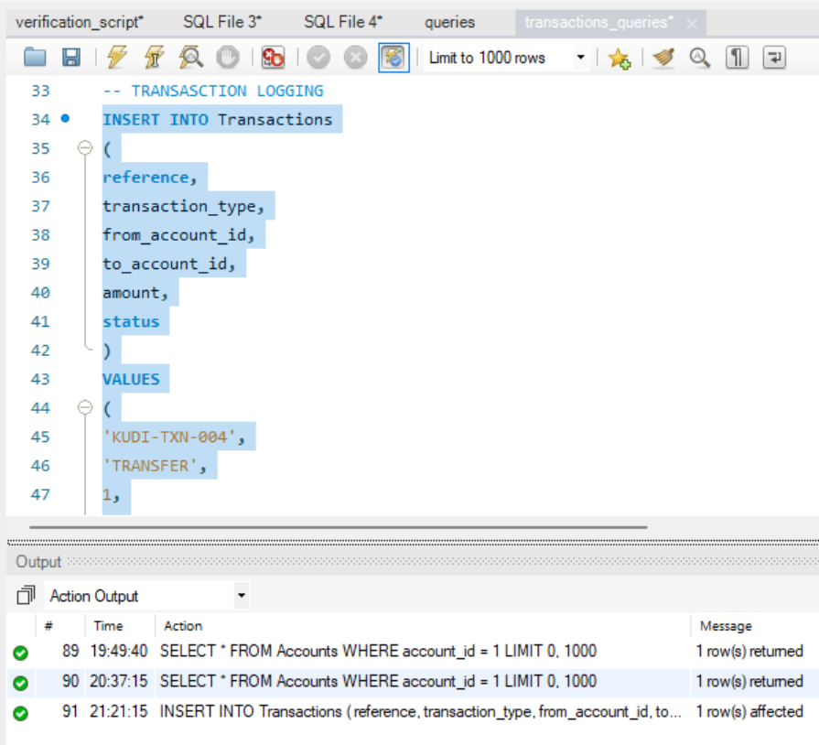
PORTFOLIO 4
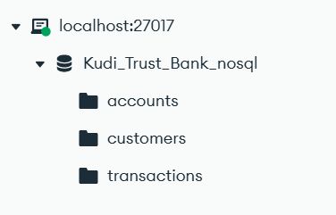

GITHUB REPOSITORY
The complete portfolio has been maintained within a GitHub repository throughout the project lifecycle.
GitHub Repository Link:
https://github.com/SophieeM/advanced-database-portfolio
The repository contains:
- Portfolio reports
- SQL scripts
- MongoDB scripts
- Database screenshots
- Architecture diagrams
- Supporting documentation
GitHub was used to maintain version control and provide a centralized location for storing project deliverables and evidence of implementation.

INDIVIDUAL REFLECTION
This project helped me better understand database systems and how organizations use them today. By completing various portfolio activities, I gained practical experience designing relational databases, writing SQL queries, managing transactions, using NoSQL databases, and working with distributed cloud architectures.
A key part of the project was learning how relational and non-relational databases differ. Using both MySQL and MongoDB showed me each type's strengths and weaknesses and how they can solve different business problems. I like NoSQL because it seems simpler and more straightforward, or maybe because I'm just starting and my data is large, and the operations I did were simple.
The transaction management part of the project showed me why ACID properties are important for keeping data accurate in financial systems. The NoSQL section helped me understand how document-oriented databases work well for managing large amounts of semi-structured data.
Working on distributed and cloud databases helped me learn more about scalability, replication, disaster recovery, and business continuity planning. These ideas are very important in today’s banking systems, where reliability and availability matter a lot.
Overall, this portfolio improved my understanding of database theory and my practical database administration skills. It also helped me apply advanced database concepts in real situations.

AI USE DECLARATION
I used artificial intelligence tools during this project to support learning, research, concept clarification, proofreading, document organization, and understanding database topics.
I personally reviewed, carried out, checked, and documented all practical work, including database setups, SQL queries, MongoDB tasks, screenshots, designs, testing, portfolio changes, and final submissions.
I used AI only as a learning aid, not as a replacement for doing the practical work or critical thinking myself

REFERENCES
- Oracle. (2025). What is a distributed database?. Oracle Corporation. Retrieved from https://www.oracle.com/database/distributed-database/what-is-distributed-database/ [oracle.com]
- Winks, E. (2023). Database replication: Techniques, benefits, and security. Atlan. Retrieved from https://atlan.com/what-is/database-replication/ [atlan.com]
- Kelly, G. (2026). Database replication: Types, methods, and how it works. Fivetran. Retrieved from https://www.fivetran.com/learn/database-replication [fivetran.com]
- Lopez, P. (2025). What is database replication: Tools, types, and uses. Airbyte. Retrieved from https://airbyte.com/data-engineering-resources/database-replication [airbyte.com]
- OPSWAT. (2024). What is database replication and how it works. OPSWAT. Retrieved from https://www.opswat.com/blog/database-replication [opswat.com]
- Mitchell, T. (2023). What is data replication in cloud computing? A guide. Couchbase. Retrieved from https://www.couchbase.com/blog/cloud-data-replication/ [couchbase.com]
- Hulsebos, M., Demiralp, Ç., & Groth, P. (2021). GitTables: A Large-Scale Corpus of Relational Tables.
- Bhosale, P. (2022). NoSQL Databases Explored: A Comprehensive Study of Columnar, Graph, and Document-Based Approaches.

