PORTFOLIO 1: DATABASE DESIGN

KUDI BANK DATABASE

Introduction
Kudi Bank is a simulated financial institution used as the case study for this database design project. The bank provides basic banking services, including customer registration, account management, deposits, withdrawals, and fund transfers.
The purpose of this project is to design and implement a relational database that supports the storage, retrieval, and management of customer information, bank accounts, and financial transactions.
The database is designed to support banking operations by maintaining accurate customer records, linking customers to their accounts, and tracking transactions between accounts. It also applies relational database principles, including primary keys, foreign keys, integrity constraints, and normalization, to ensure data consistency and reduce unnecessary duplication.
The proposed database provides a foundation for reliable record management and can be extended to support additional banking services in the future.

Database Tables
The database consists of three main tables:
- Customer Table
Stores information about customers registered with Kudi Bank.
- Primary Key (PK): customer_id
- Purpose: customer unique identifier

- Accounts Table
Stores customers’ bank account information.
- Primary Key (PK): account_id
- Foreign Key (FK): customer_id
- Reference: Customers (customer_id)
- Purpose: links each account to its owner

- Transactions Table
Stores information about transactions carried out by customers between bank accounts.
- Primary Key (PK): transaction_id
- Foreign Key 1 (FK): from_account_id
- Foreign Key 2 (FK): to_account_id
- Reference: Accounts (account_id)
- Purpose: records the source and destination accounts involved in each transaction.

2.1 Relational Schema
The relational schema defines the structure of the Kudi Bank database, including the attributes, data types, primary keys, and foreign keys of each table.

A. CUSTOMERS
Attribute | Data type | Key / Constraint
customer_id | INT | Primary Key, Auto Increment
first_name | VARCHAR(50) | NOT NULL
last_name | VARCHAR(50) | NOT NULL
email | VARCHAR(100) | NOT NULL, UNIQUE
phone | VARCHAR(20) | NULL
created_at | TIMESTAMP | Default CURRENT_TIMESTAMP

B. ACCOUNTS
Attribute | Data type | Key / Constraint
account_id | INT | Primary Key, Auto Increment
customer_id | INT | Foreign Key
account_number | VARCHAR(10) | NOT NULL, UNIQUE
account_type | VARCHAR(20) | NOT NULL
balance | DECIMAL(15,2) | NOT NULL, Default 0.00
status | VARCHAR(20) | NOT NULL, Default ACTIVE
created_at | TIMESTAMP | Default CURRENT_TIMESTAMP

C. TRANSACTIONS
Attribute | Data type | Key / Constraint
transaction_id | INT | Primary Key, Auto Increment
reference | VARCHAR(50) | NOT NULL, UNIQUE
transaction_type | VARCHAR(20) | NOT NULL
from_account_id | INT | Foreign Key, NULL allowed
to_account_id | INT | Foreign Key, NULL allowed
amount | DECIMAL(15,2) | NOT NULL
status | VARCHAR(20) | NOT NULL, Default PENDING
transaction_time | TIMESTAMP | Default CURRENT_TIMESTAMP

The foreign key relationships connect accounts to customers and transactions to their respective source and destination accounts.

2.2 Database Constraints
The Kudi Bank database uses several constraints to maintain data accuracy, consistency, and integrity.
- Primary Key Constraints: Each table has a primary key that uniquely identifies every record. These are customer_id, account_id, and transaction_id.
- Foreign Key Constraints: Foreign keys establish relationships between tables and prevent records from referencing non-existent records. The customer_id in the Accounts table references the Customers table, while from_account_id and to_account_id in the Transactions table reference the Accounts table.
- Unique Constraints: The email address in the Customers table and the account number in the Accounts table must be unique. Transaction references must also be unique to prevent duplicate identification.
- NOT NULL Constraints: Essential fields such as customer names, account numbers, account types, transaction references, transaction types, and transaction amounts cannot be left empty.
- CHECK Constraints: The database enforces rules to prevent invalid values. Account balances must be zero or greater, transaction amounts must be greater than zero, and account types, account statuses, and transaction statuses must contain only permitted values.
- DEFAULT Constraints: Default values are provided for certain fields. New accounts receive a default balance of 0.00 and an ACTIVE status, while new transactions receive a PENDING status. Timestamp fields are automatically populated with the current date and time.
These constraints help maintain reliable records and support the integrity of Kudi Bank's banking operations.

Database Relationships
The database contains three main relationships:
- Customers to Accounts (One-to-Many)
One customer can own multiple accounts, but each account belongs to one customer.

- Accounts to Transactions – Source Account (One-to-many)
One account can perform multiple transactions. The from_account_id FK identifies the account from which money is being transferred (Source).

- Accounts to Transactions -Destination Account (One-to-Many)
One account can receive multiple transactions. The to_account_id FK identifies the account receiving the money (Destination).

Primary Keys and Foreign Keys
A primary key is a unique identifier; it identifies records in each table, while a foreign key establishes relationships between tables.
The use of foreign keys helps maintain referential integrity by ensuring that related records reference existing records in the parent tables.

Entity Relationship Diagram (ERD)
The ERD illustrates the structure of the Kudi Bank database, showing the three tables, their primary keys, foreign keys, and relationships.

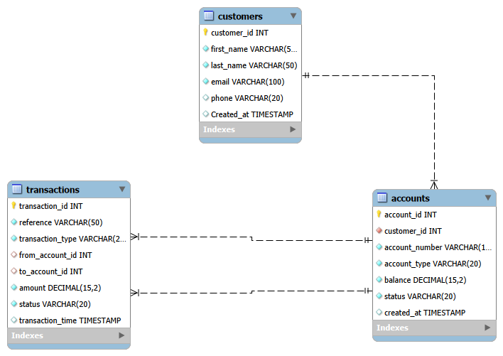

Database Normalization
Database normalization is the process of organizing data in a database to reduce unnecessary data duplication, improve consistency, and make maintenance easier.
For Kudi Bank’s database:
1NF is satisfied because each table cell contains a single atomic value, with no repeating groups.
2NF is satisfied because each table has a single primary key, so there are no partial dependencies.
3NF is satisfied because customer information is stored in Customers, account information in Accounts, and transaction information in Transactions, preventing unnecessary duplication and maintaining data integrity.
In conclusion, Kudi Bank database design follows the principles of 1NF, 2NF, and 3NF.

Conclusion
The database design provides a structured foundation for managing customer records, bank accounts, and financial transactions. The relationships between the tables help maintain data consistency and reduce unnecessary data duplication.

