PORTFOLIO 2: SQL QUERY PROCESSING

1. Introduction

1.1 Overview
Kudi Trust Bank utilizes database queries to retrieve, analyse, and manage customer, account, and transaction information. Structured Query Language (SQL) provides a standardized way to interact with the database and generate business intelligence. SQL query processing facilitates the efficient retrieval of customer records, account balances, transaction histories, and financial summaries.
This portfolio demonstrates SQL queries, joins, aggregate functions, views, indexing, and query optimization techniques within the Kudi Trust Bank database.

2. Database Query Operations

2.1 Retrieving Customer Information
This query retrieves all customer information maintained by Kudi Trust Bank. It enables bank personnel to access customer details, including names, email addresses, phone numbers, and registration dates.
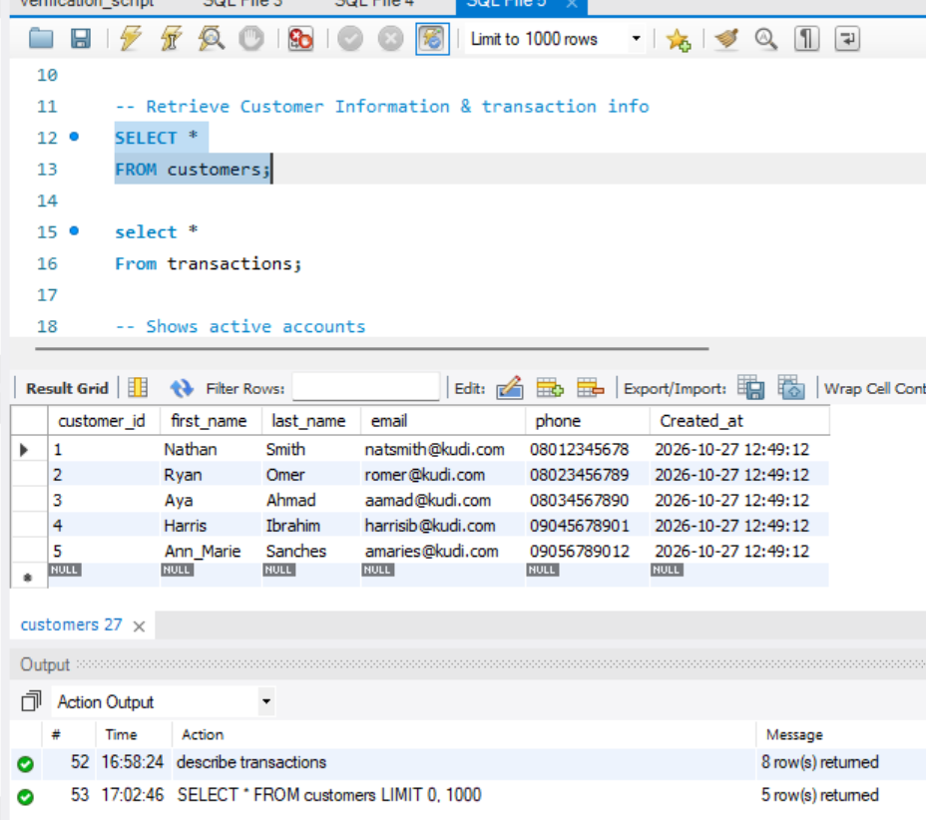

2.2 Retrieving Active Accounts
The WHERE clause filters records to return only accounts with an ACTIVE status. This approach lets the bank focus on valid operational accounts and exclude inactive or closed accounts.
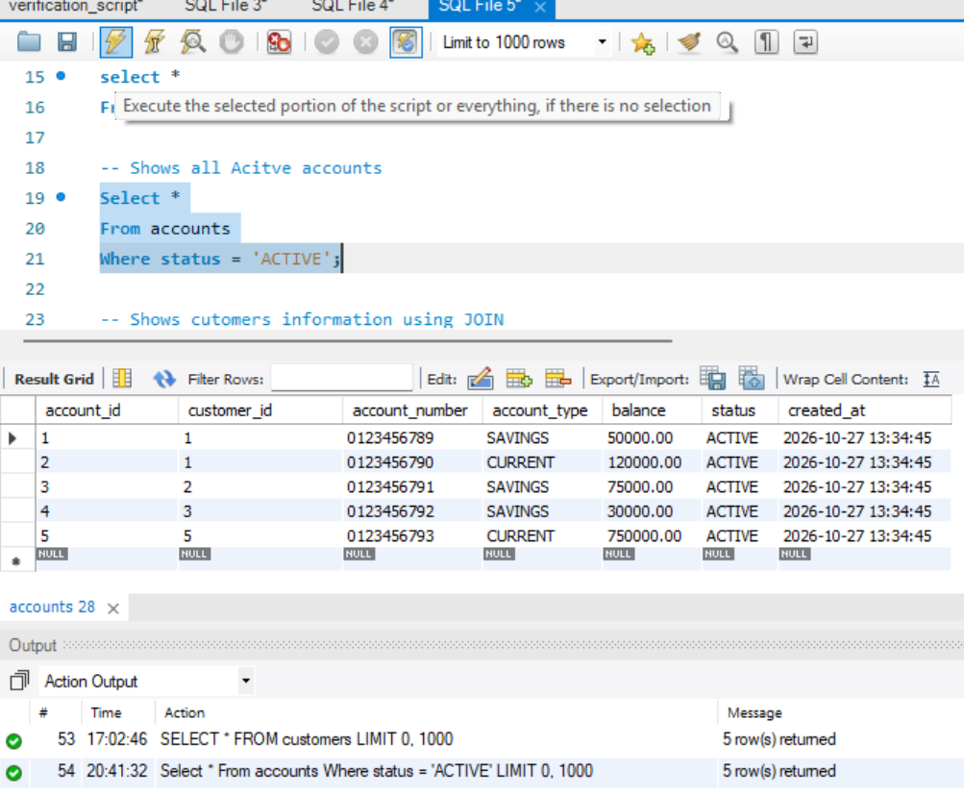

3. SQL Join Operations

3.1 Customer and Account Information
An INNER JOIN combines records from the Customers and Accounts tables based on the customer_id field. This operation enables simultaneous viewing of customer details and account information within a single result set.
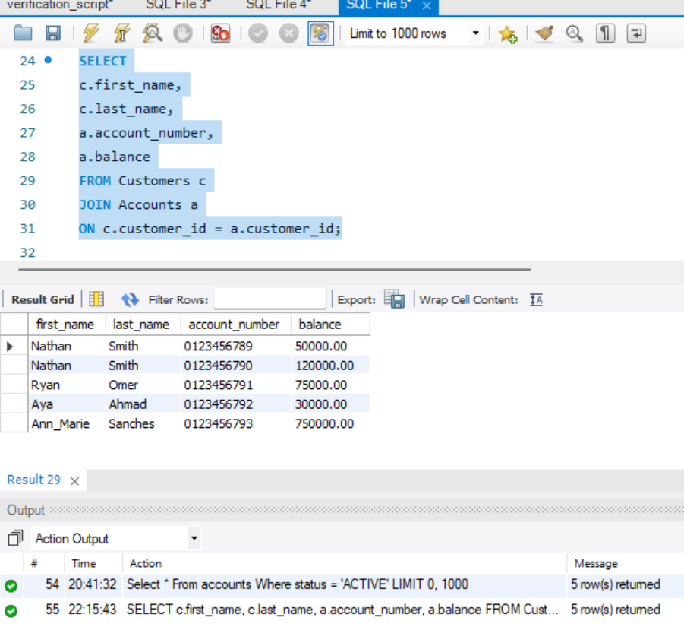

4. Aggregate Functions

4.1 Counting Customers
The COUNT() function calculates the total number of registered customers stored within the database.
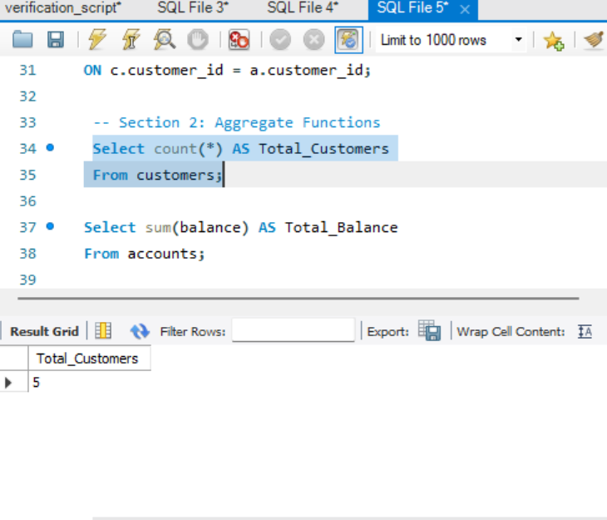

4.2 Calculating Total Account Balances
The SUM() function is used to calculate the aggregate funds held across all customer accounts. Kudi Trust Bank holds total customer funds amounting to ₦1,025,000.
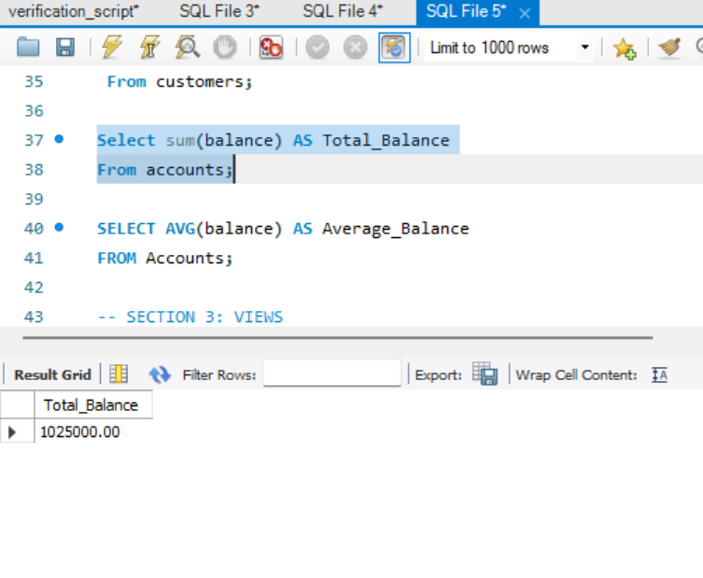

4.3 Calculating Average Balance
The AVG() function calculates the average account balance across all customer accounts.
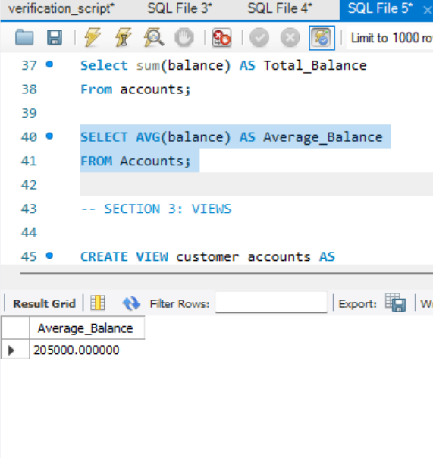

5. Database Views

5.1 Creating a View
A database view provides streamlined access to frequently used information by encapsulating a predefined query. Views improve usability and limit direct access to the underlying base tables.
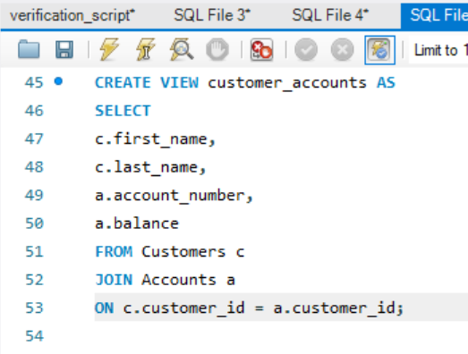
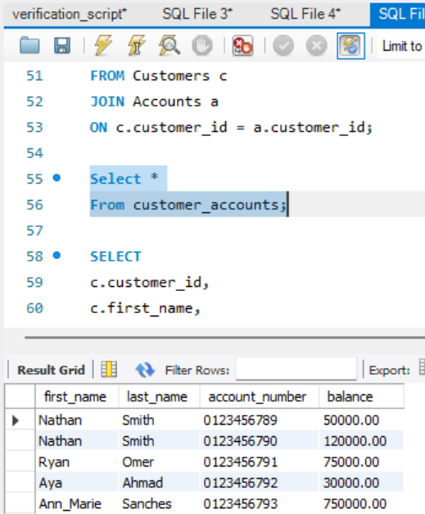

6. Indexing and Query Optimization

6.1 Creating an Index
Indexes improve database performance by helping MySQL locate records more efficiently. Rather than scanning each row in the table, the database uses the index to quickly identify the required account record.
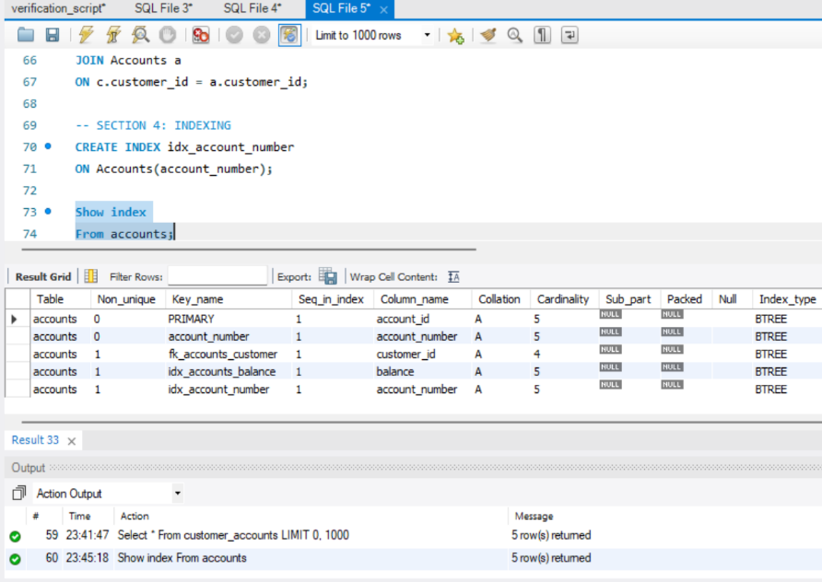

6.2 Query Optimization
Query optimisation refers to the process of enabling a SQL query to produce the correct result while minimizing execution time and resource consumption. This process is essential because SQL specifies the desired outcome rather than the retrieval method, so the database management system must determine an efficient execution strategy.
Several techniques can enhance the performance of SQL queries:
- Implementing indexes on columns that are frequently searched.
- Applying the WHERE clause to filter records.
- Selecting only the necessary columns rather than using SELECT *.
- Utilizing appropriate join operations to minimize unnecessary processing.
These techniques improve response time and support more efficient banking operations.

7. Conclusion
This portfolio demonstrated SQL query processing techniques within the Kudi Trust Bank database. SQL queries retrieved customer records, account information, and transaction data. Aggregate functions provided meaningful business summaries, while views simplified data access. Indexing and query optimization techniques also improved database performance. These concepts are essential to database administration and support efficient banking operations.

