Team Information
- Section: ___________________________
- Date: ___________________________

Team Members (write full names):

- ____________________________________________

- ____________________________________________

- ____________________________________________

- ____________________________________________

(Optional) Team Name: ___________________________________________

Instructions
This in-class activity guides you through programming buzzer on the MSP430-Grove board pack and
Includes five (5) deliverables..
- Insert diagrams, pseudocode, and code directly into this Word file.
- Conduct your calculations in Excel, record the results in this Word file.
- Submit ONLY your Word file through the designated Brightspace In-Class Activity Drop Box.
File naming convention:
- Word file → ENGR131_ICA_YourName.docx

Relevant Course Resources:
Pre-Class Videos | - None
Course Resources | - Getting Started with Energia and the TI Kits  - Sketchbook in Activity

Submission Instructions:
- Re-name your answer sheet as:
  - Word file → ENGR131_ICA_TeamNumber.docx
- Submit your work through the designated Brightspace In-Class Activity Drop Box at https://purdue.brightspace.com/.

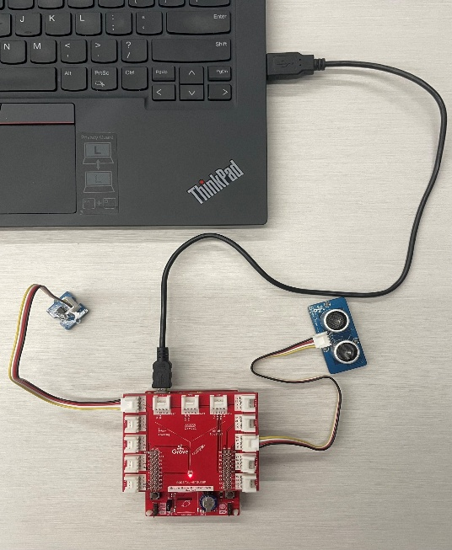
Guide:
- Connect the Grove Starter Kit Ultrasonic Range Sensor. The code indicates that the signal (sig) pin of the Range Sensor connects to pin 38. This means that the Range Sensor must connect to J15 of the Grove Board using the four-prong connector cable.

- Connect the Grove Starter Kit Light Sensor. The code indicates that the signal (sig) pin of the Light Sensor connects to pin 23. This means that the Range Sensor must connect to J5 of the Grove Board using the four-prong connector cable.

- Connect the Grove Board to MSP 430. Remember to align the pin numbers.

- Connect MSP 430 to your laptop.

Task 1: Pseudocode/Flowchart
Draft a pseudocode/ draw a flow chart that represents to show how to turn on the LED when BOTH of the following conditions are met:
- When the environment gets dark
- When an object is within a certain distance of the ultrasonic sensor

Task 2.1: Code Synthesis – Picture Result
Insert a picture showing the LED lit up when you cover the light sensor (to simulate darkness) and hold an object close to the ultrasonic sensor.

Task 2.2: Code Synthesis – Code
Insert your code in the box below.

Task 3.1: Logic Structure: Record your results for the following conditions.
((brightness < darkThreshold) && (distance < distThreshold))
Dark Environment | Close Object | LED (ON/OFF)
False | False
False | True
True | False
True | True

((brightness < darkThreshold) || (distance < distThreshold))
Dark Environment | Close Object | LED (ON/OFF)
False | False
False | True
True | False
True | True

!(distance < distThreshold)
Dark Environment | Close Object | LED (ON/OFF)
False | False
False | True
True | False
True | True

((brightness < darkThreshold) && !(distance < distThreshold))
Dark Environment | Close Object | LED (ON/OFF)
False | False
False | True
True | False
True | True

Task 3.2: Logic Structure: Briefly comment on the results.

