Team Information
- Section: ___________________________
- Date: ___________________________

Team Members (write full names):

- ____________________________________________

- ____________________________________________

- ____________________________________________

- ____________________________________________

(Optional) Team Name: ___________________________________________

Instructions
- Use Data Streamer in Excel to visualize data in real time.

- Program your system to send three values to Excel via the Serial Monitor:
- Time – Timestamp of each reading
- CH1 – Displays “ALERT: Water level critical!” when distance < 5 cm
- CH2 – Shows the measured distance (cm) simulating water level
- The buzzer must turn on when the water level is too high (distance < 5 cm).

- Insert all required screenshots, diagrams, and explanations directly into this Word file.
- Submit only your Word file to the designated Brightspace In-Class Activity drop box.

File naming convention:
- Word file → ENGR131_ICA_YourName.docx

Relevant Course Resources:
Pre-Class Videos | - None
Course Resources | - Getting Started with Energia and the TI Kits  - Excel Data Streamer Setup

Submission Instructions:
- Re-name your answer sheet as:
  - Word file → ENGR131_ICA_TeamNumber.docx
- Submit your work through the designated Brightspace In-Class Activity Drop Box at https://purdue.brightspace.com/.

Guide:
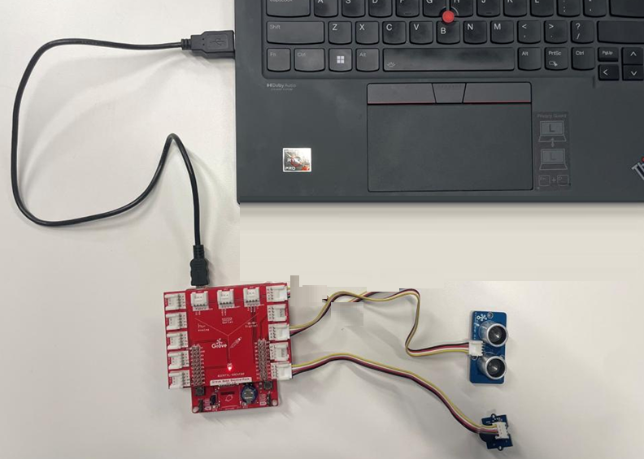
- Connect the Grove Ultrasonic Sensor to the Grove Board using a four-pin cable.

- Connect the Grove Buzzer to the Grove Board using another four-pin cable.
→ You will decide which signal (SIG) pins to use for each component. Make sure to tell the AI which pins you selected so it can generate the correct code.

- Connect the Grove Board to the MSP430, ensuring the pin numbers are properly aligned.

- Connect the MSP430 to your laptop.

Task 1: Data Streamer Screenshots
- Capture a screenshot showing the three columns: Time, CH1, and CH2.
- Include at least one screenshot where the alert message appears in CH1 (“ALERT: Water level critical!”) and CH2 shows –1 (indicating a critical water level).
Insert your Screenshot in the box below.

Task 2: Create a Chart in Excel
- Use the data collected from Data Streamer to create a chart.
- Set the X-axis to Time (s) and the Y-axis to Distance (cm) (CH2).
- Add a clear and descriptive title that reflects your experiment (for example, Water Level vs. Time).

Insert your chart in the box below.

Task 2.2: Code
Insert your code in the box below.

