**Team Information**

* **Section:** ___________________________
* **Date:** ___________________________

**Team Members (write full names):**

1. ____________________________________________
2. ____________________________________________
3. ____________________________________________
4. ____________________________________________

(Optional) **Team Name:** ___________________________________________

|  |
| --- |
| **Instructions** |
| This in-class activity guides you through programming two built-in LEDs on the MSP430FR5994 and includes six **(6) deliverables**.   * Use the **Excel template** provided for recording data and generating statistics. * Insert diagrams, pseudocode, code, and figures directly into this Word file. * Submit both your **Word file** and **Excel file** through the designated Brightspace In-Class Activity Drop Box.   **File naming convention:**   * Word file → ENGR131_ICA_Blink_LastNames.docx * Excel file → ENGR131_ICA_Blink_LastNames.xlsx |

**Relevant Course Resources**:

|  |  |
| --- | --- |
| Pre-Class Videos | * None |
| Course Resources | * Getting Started with Energia and the TI Kits |
|  | |

|  |
| --- |
| **Submission Instructions:**   1. Re-name your answer sheet as:    * Word file → ENGR131_ICA_Blink_LastNames.docx    * Excel file → ENGR131_ICA_Blink_LastNAmes.xlsx 2. Submit your work through the designated **Brightspace In-Class Activity Drop Box at** [https://purdue.brightspace.com/](https://purdue.brightspace.com/?utm_source=chatgpt.com). |

## Task 1: Block Diagram

## Draw (by hand or via a computer) a block diagram of the microcontroller set up shown in the picture.

## Block Diagram

|  |
| --- |
|  |

## Task 2: Pseudocode

A) Write pseudocode that describes the steps needed to make the red and green LEDs blink according to your program (ON, OFF, change speed, alternate pattern, etc.).

## Pseudocode

|  |
| --- |
|  |

## Task 3: Upload your code to the TI Board

A) Open the Sketchbook/ENGR 131/Activity 1 – Introduction/Task1a_blink file in Energia. If you don’t see the ENGR 131 folder in your sketchbook options, please see the [Getting Started page](https://sophiezhaowen.github.io/ti-kit-guide/) for download and instructions

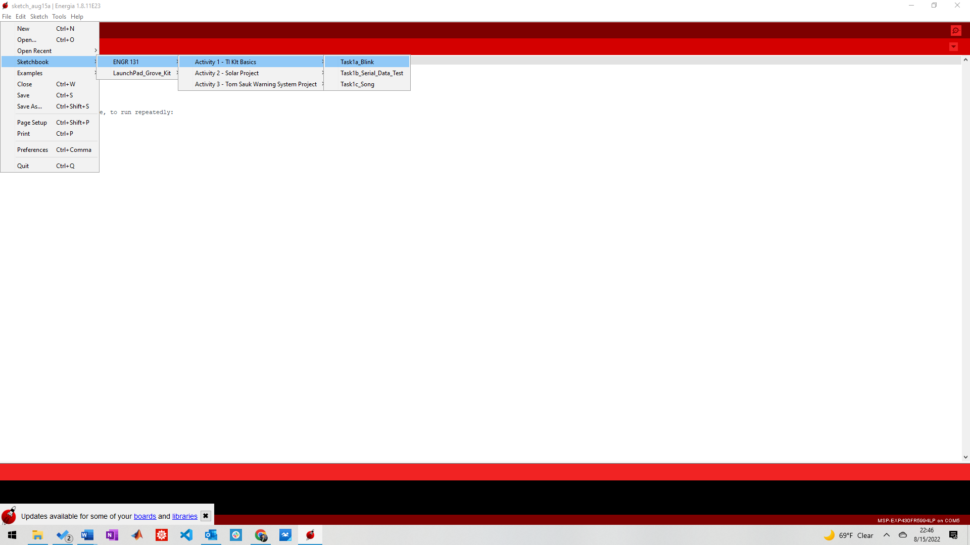

Figure 1: TI Kit Basics File path Example through Sketchbook

B) Compile and upload the Blink sketch to your TI Kit. **HINT:** If this works, two lights should be illuminated on your TI Kit.

C) Take a picture of your TI Kit with the blinking red light lit up and insert it into the activity sheet below.

|  |
| --- |
|  |

## Task 4: Upload your code to the TI Board

A) Change the blinking speed of one LED (make it faster or slower).

## In the box below, describe the changes you made to your code:

|  |
| --- |
|  |

B) Make both the red and green LEDs blink in an alternating pattern.

## In the box below, describe the changes you made to your code:

|  |
| --- |
|  |

C) Program the LEDs to blink with a 1-second interval (delay(1000)).

## In the box below, describe the changes you made to your code:

|  |
| --- |
|  |

## Task 5: Data Collection with Stopwatch

A) Run your code with the programmed interval (delay(2000)).  
B) Using a stopwatch, measure the ON and OFF times of the LEDs for **8 cycles**.  
C) Record your data in the Excel template provided.

Reminder: Use one column for *Cycle*, one for *ON Time (s)*, and one for *OFF Time (s)*.

**Solution: Paste your raw data table from Excel here.**

|  |
| --- |
|  |

## Task 6: Data Analysis in Excel

A) In your Excel file, calculate the following descriptive statistics for both ON and OFF times:

* Mean
* Standard Deviation
* Minimum
* Maximum

B) Create at least one chart (line, bar, or histogram) to visualize your measured times compared to the expected **2.0 seconds**.

Reminder: Make sure your table and chart are clearly labeled (title, axis labels, units).

**Paste your summary table and chart here.**

|  |
| --- |
|  |

|  |
| --- |
| **Reference CODE:**  The Blink code should be already in the sketchbook.  If you can’t download the sketchbook, copy and paste the code below into a blank sketch. |
| /* Blink  The basic Energia example. Turns on an LED on for one second, then off for one second, repeatedly.  Change the LED define to blink other LEDs.  Hardware Required:  * LaunchPad with an LED  This example code is in the public domain. */  #define RLED RED_LED // the MSP430 and MSP432 launchpads have a red LED  //#define GLED GREEN_LED // the MSP430 and MSP432 launchpads have a green LED  //#define BLED BLUE_LED // only the MSP432 launchpads have a blue LED  // See <https://www.youtube.com/watch?v=AF8d72mA41M> for why blue is less common  // See pins_energia.h for more LED definitions    void setup() { // the setup routine runs once when you press reset:  pinMode(RLED, OUTPUT); // initialize the digital pin as an output.  }  void loop() { // the loop routine runs over and over again forever:  digitalWrite(RLED, HIGH); // turn the LED on (HIGH is the voltage level)  delay(1000); // wait for a second before doing the next operation  digitalWrite(RLED, LOW); // turn the LED off by making the voltage LOW  delay(1000); // wait for a second before doing the next operation  } |

|  |
| --- |
| **Communication Errors between the TI Kits and Your Computer:**   1. Make sure that your TI Kit is plugged in correctly using the provided Micro USB to USB A cable. There should be a green power LED lit up when this occurs. 2. The COM port selected in Energia is not the correct port. While it is generally the highest port number available. This is not always the case. All COM Ports should be tried if there are communication issues. 3. Ensure all drivers have been installed. For instructions on how to install, please see Step 2 in [Getting Started](https://sophiezhaowen.github.io/ti-kit-guide/). 4. Restart Energia IDE. 5. Restart your computer (Should not be required, but can help depending on your computer’s settings). |