Company & Issue
The company we chose is NTUC FairPrice because they have to allocate resources and manpower to train staff. As a result, we are proposing a software solution to aid in the training of staff to reduce the amount of resources and manpower needed to train personnel, which also allows NTUC to allocate those resources and manpower to other areas. Hence, enhancing the business by giving the company staff who are prepared.

Business needs
- NTUC FairPrice requires convenient and low-maintenance software that aids in the training of employees to reduce the burden of training new employees.

- Employees can use this anywhere, removing travel costs, and also, a Brandon-Hall study states that learning through e-learning typically requires 40% to 60% less employee time (Gutierrez, n.d.), learning the staff things compared to, for example, training in a classroom

- The Research Institute of America found that eLearning increases retention rates by 25% to 60%, while retention rates for face-to-face training are much lower: 8% to 10% (Gutierrez, n.d.), as the employees who are using this have much more control over how they learn, while having the ability to revisit this software again and again.

- IBM found that participants learned more than 4 times more material while not increasing the time spent in training (Gutierrez, n.d.). This allows companies to reduce the money allocated to training staff to other areas, as a result of e-learning being more efficient compared to traditional training/on-the-job training.

Introduction (Wei Lun)
Having an introduction section, consisting of both start and instructions buttons is useful as employees can easily locate the start button, which will direct them to the next part of the introduction. They can also click on the instructions button to learn about the rules of the game. This way, the company will not receive any complaints from the employees on the poor user interface of the game.

Wireframe:
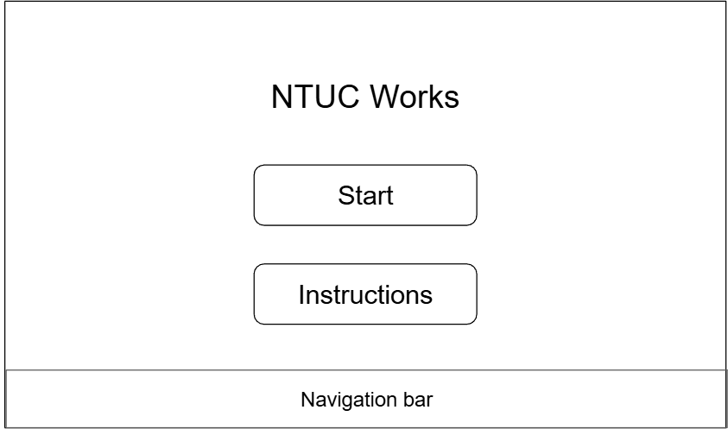
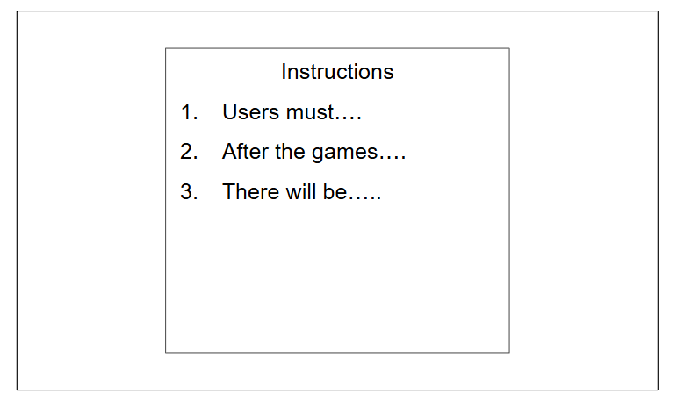

Game(jun long)
Making a game would benefit this company as it is entertaining and would help staff remember how to do their job better as they can learn through interactive gameplay. It would also cut long-term costs as the game is replayable, which saves money for trainers, and onboarding sessions.

There is also no risk of making a mistake as it is only a simulation and therefore staff can practice real-life scenarios safely in game. This game will also motivate the staff through rewards, for instance being rewarded for achieving top 1 highscore out of the whole staff in the month. This is also very accessible to staff as they do not have to play the games at work and they can play at any time and any place.

Since NTUC has many branches at different locations, there is a standardized game for all staff, which leads to them receiving the same quality of training. This reduces variation of service quality in different stores and also feedback from customers is easier to interpret.

Through this, managers can also identify who needs extra time for training and who are the ones ready for work.

The game consists of Cashier, Restock, Cleaning that the staff will be simulated in.

Wireframe:

Starting Page
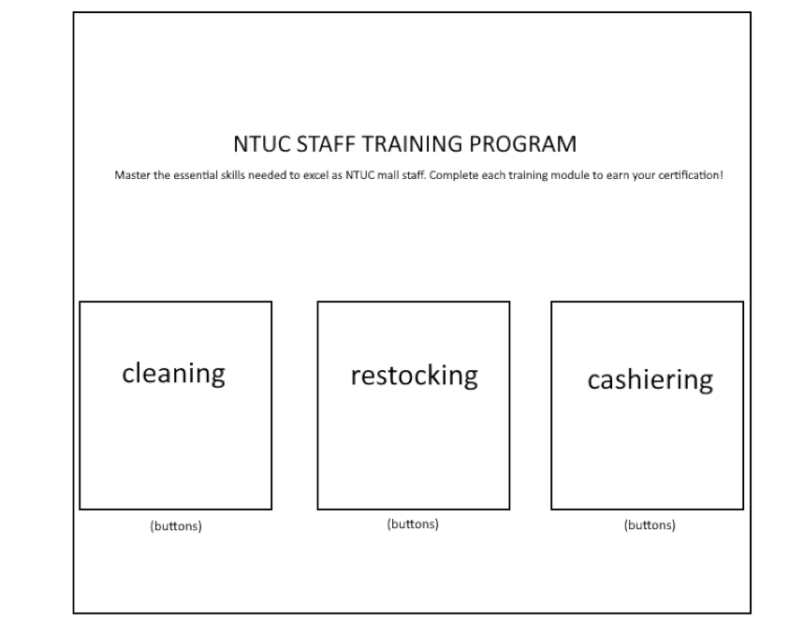

Cleaning
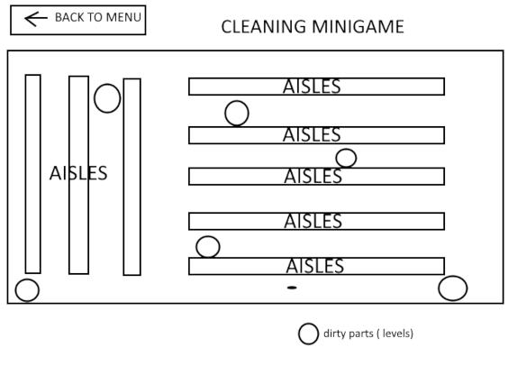

Restocking
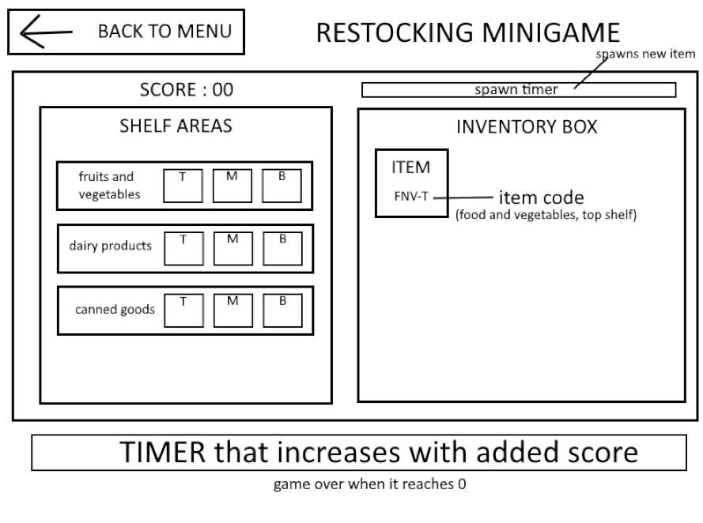

Cashiering
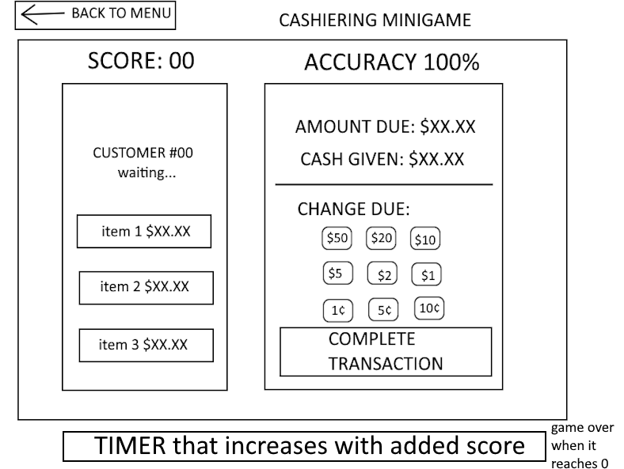

E-learning (nigel)
Having an e-learning section benefits the company as it allows the staff who are being trained to read up on the different roles that they might take up in the store, hence giving them a better idea of what they would be doing, supplying the company with staff who are more ready on their first day, as compared to staff who didn’t use this.
Wireframe: Consists of a description of the page at the top, a flip card that provides the user with tips and a navigation bar so the user can navigate around the software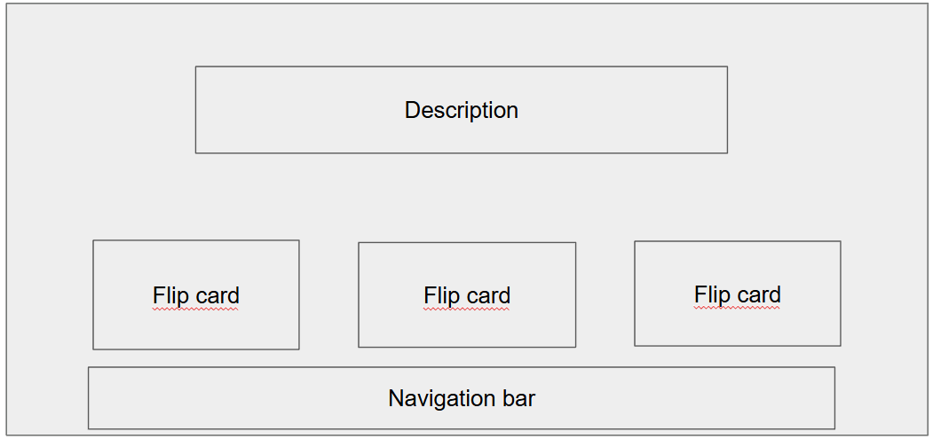

Quiz (caleb)
Creating a quiz at the end of the game would be beneficial for us as we are able to authenticate whether the main learning points of the game have been efficiently taught to the new hires and if they do not pass the test. The Quiz will specifically point out which section is lacking and propose a new quiz that specifically caters to the weak points of the new hires.

Wireframe:

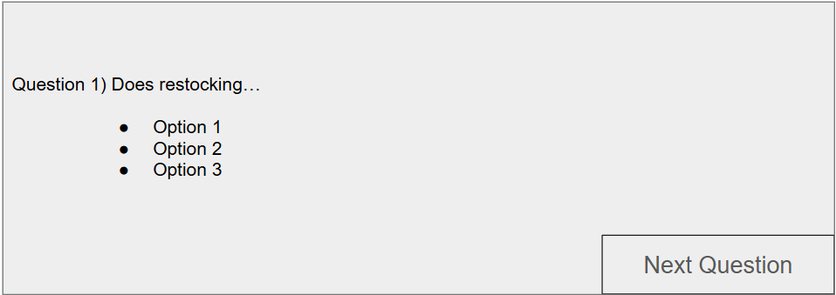

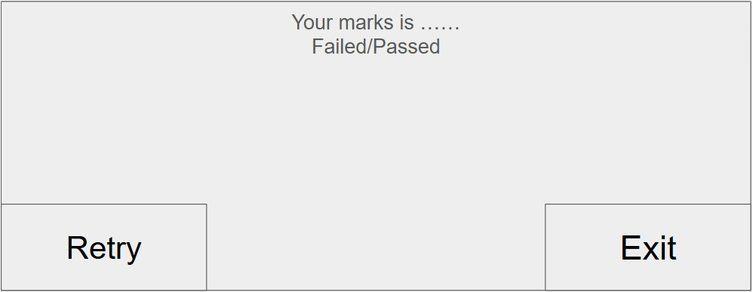

References
Gutierrez, K. (n.d.). Facts and Stats That Reveal The Power Of eLearning [Infographic]. SH!FT.
https://www.shiftelearning.com/blog/bid/301248/15-facts-and-stats-that-
reveal-the-power-of-elearning

