

|  |
| --- |
| **High-Performance Computing** |

Jiarui XIE

Semester: 2018/2019

Superviser: David Hill

# Introduction

Beware of floating point arithmetics by doing this lab.

# Float and double

The standard way to show the double is %.18f. If we use for example %.15 instead of %.18 we will get the result with lost precision.

If we are using C++ to display double, we would better use setprecision(18) to set precision ahead.

# Kahan sum

We used the following code to realize the KANHAN SUM and test with the code following. The result like Figure1, obviously it is better than the normal method. Why we use float is because it is easy to test the lost precision.

|  |
| --- |
| double KahanSum(float *input, int size)  {  double sum = 0.0;  double c = 0.0;  for (int i = 0; i < size; i++)  {  double y = input[i] - c;  double t = sum + y;  c = (t - sum) - y;  sum = t;  }  return sum;  }  int main()  {  float a = 123456;  float b = 2.123456;  float aaaa[] = {123456,2.123456};  printf("the sum is %.18f\n", KahanSum(aaaa, 2));  printf("%.18f\n", a+b);  return 0;  } |

C:\Users\QM\Desktop\HPC\Lab3\01.png

Figure1. Contraction with Kahan method

# Pthread with pi

During the simulation only one time I get the difference between Kahan method and normal Method the result like Figure2.

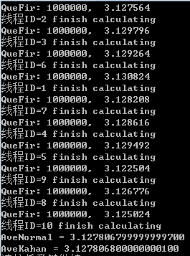

Figure2. Calculate pi with thread