

The University of Manila
546 Delos Santos St., 403, Manila, 1008 Metro Manila
College of Computer Science

UNDERSTANDING USER EXPERIENCE IN E-GOVERNMENT SERVICES THROUGH PUBLIC SURVEYS

A Thesis Proposal
In Partial Fulfilment of the Requirements
In THS 103
For the Degree of Bachelor in Science in Computer Science

A Thesis Presented to
Mr. Joselito Borces
Faculty of Computer Science

Presented by:
Balosa, John Ray V.
Cabalda, Recca Ann S.
Samaniego, Matthew V.
ABSTRACT
E-government services play a crucial role in providing accessible and efficient public services to citizens. This study evaluates the current user experience of e-government platforms in the Philippines, identifies key challenges faced by users, and proposes recommendations for improvement. Using a mixed-methods approach, we collected data through an online survey distributed to diverse participants across different regions, capturing insights on trust, accessibility, usability, and satisfaction. Quantitative data were analyzed using statistical tools to identify trends, while qualitative responses provided deeper context through thematic analysis. Findings reveal common issues such as digital accessibility barriers, trust concerns, and usability challenges, which impact user adoption and engagement. Based on these insights, the study highlights the need for improved digital infrastructure, user-friendly design, and stronger security measures to enhance the overall experience. The results contribute to the ongoing development of more inclusive and efficient e-government services, ensuring better accessibility, trust, and user satisfaction.
TABLE OF CONTENTS
Front
Title Page ………………………………………………………………………………... 1
Abstract ……………………………………………………………………...…………... 2
Table of Contents ………………………………………………………………………... 3
List of Figures and Tables ………………………………………………………..……... 4
List of Abbreviations & Acronyms ……………………………………………………... 5
List of Symbols ……………………………………………………………...…………... 6
Acknowledgement …………………………………………………………..…………... 7
Dedication …….…………………………………………………………….…………... 8
Preface …………………………………………………………………………………... 9

Body
Introduction …………………………………………………………………………….. 10
Literature Review …………………………………………………………..…………... 12
Methodology ……………………………………………………………….…………... 15
Results …………………………………………………………………………………. 18
Discussions ……………………………………………………………………………...26
Conclusion ……………………………………………………………….……………...27

End
References ……………………………………………………………………………... 28
Appendices ……………………………………………………………………………...29
Vita ……………………………………………………………………………………...30

LIST OF FIGURES AND TABLES
Figure 1. Age groups of the respondents ……………………………………………………….18
Figure 2. Highest educational attainment of respondents ……………………………………...18
Figure 3. The frequency of usage of e-government services ……………………………………19
Figure 4. Most used e-government services ………………………………………………….…19
Figure 5. User perception about e-Gov simplicity and usability ……………………………….20
Figure 6. User experience towards technical issues in e-Gov platforms ……………………….20
Figure 7. Common issues encountered in e-Gov platforms …………………………………….21
Figure 8. Trust rating of users towards e-Gov platforms’ security …………………………….21
Figure 9. User perception towards e-Gov platforms’ accessibility …………………………….22
Figure 10. User perception about e-Gov platforms’ reliability and transparency ……………..22
Figure 11. User perception about e-Gov platforms’ inclusivity ………………………………..23
Figure 12. E-Gov features that need improvement …………………………………………….23
Figure 13. Users’ overall satisfaction towards e-Gov services ………………………………..24
Figure 14. Desired support in e-Gov services …………………………………………………24
Figure 15. User motivation in using e-Gov platforms …………………………………………25
Figure 16. Likelihood of user recommendation ………………………………………………..25

LIST OF ABBREVIATIONS AND ACRONYMS
EGOV – Electronic Government
SEM - Structural Equation Model
SLR - Systematic Literature Review
TAM - Technology Acceptance Model
TPB - Theory of Planned Behavior
UX – User Experience

LIST OF SYMBOLS
& - ampersand, term used to refer to the symbol &, which stems from the ligature of the Latin word et, meaning “and.”
% - The percent sign is the symbol used to indicate a percentage, a number or ratio as a fraction of 100.
ACKNOWLEDGEMENT
First and foremost, we would like to express my deepest gratitude to God Almighty for granting us the strength, wisdom, and guidance to complete this work.
We extend our heartfelt thanks to our professor, Mr. Joselito Borces, and the panel members for their invaluable insights, constructive feedback, and continuous support throughout this journey. Their guidance has been instrumental in shaping this project.
To the participants of the survey, we are sincerely grateful for your time, cooperation, and willingness to share your thoughts and experiences, which have been essential to the success of this study.
We are profoundly thankful to our families for their unwavering love, support and encouragement. Which kept us motivated every step of the way. To our friends and classmates, thank you for your camaraderie, understanding, and assistance during this challenging yet rewarding process.
This accomplishment would not be possible without each of you. Thank you all for being a part of this journey.

DEDICATION
This thesis is dedicated to the participants of this research who generously shared their time, insights, and experiences. Your invaluable contributions have provided the foundation for understanding user experiences in e-government services through public services.
Your willingness to engage in this study has not only enriched this work but also contributed the broader goal of improving public service delivery for all. This dedication is a testament to your voices, which serve as a guiding light for innovation and progress in e-government.
Thank you for making this research possible.
PREFACE
The rapid growth of digital technology has transformed the way governments around the world deliver public services. In the Philippines, the government has been actively pursuing the implementation of e-government services to provide more accessible, efficient, and transparent public service delivery. Despite these advancements, the effectiveness of these services ultimately depends on how well they address the needs expectations of the citizens.
This thesis aims to explore how Filipinos perceive and engage with e-government platforms. It seeks to identify challenges faced by users, assess the usability and accessibility of these services, and provide insights that could help policymakers and service providers enhance the overall user experience.
The context of this research is deeply rooted in the Philippine setting, where digital transformation is confronted with unique challenges, including digital divide issues, varying levels of technological literacy, and infrastructure limitations. By gathering data directly from public surveys, this study sheds light on the actual experiences and feedback of Filipino citizens, ensuring that the findings are grounded in the realities of the country’s diverse population.
Through this research, we hope to contribute to the continuous improvement of e-government services in the Philippines, ensuring they are not only technologically advanced but also inclusive and user-centric. It is our aspiration that the insights gained will serve as a valuable resource for policymakers, government agencies, and developers striving to create a more effective and citizen-friendly e-government system.
INTRODUCTION
The increasing digitization of public services through e-government platforms has reshaped how governments interact with their citizens. In the Philippines, these platforms are designed to enhance efficiency, accessibility, and transparency by offering digital alternatives for services such as, license applications, and accessing government records and services. While the potential benefits are promising, challenges such as usability issues, limited accessibility, and a lack of trust among citizens often hinder the full adoption of these systems. Many Filipinos face difficulties navigating e-government platforms due to technical challenges, digital illiteracy, or ineffective design, further worsening the digital divide in the country. These challenges emphasize the critical need to understand user experiences and perceptions to ensure -e-government platforms effectively address the needs of the population.
This study is significant as it highlights the importance of user-centered design in e-government systems to promote digital inclusion and enhance trust in public institutions. By examining user experiences, governments can uncover specific barriers that prevent widespread adoption and address the design and functionality issues that hinder access. Improving the user experiences of e-government services is particularly vital in the Philippine context, where socioeconomic disparities, varying levels of technological literacy, and infrastructure limitations impact citizens’ ability to access digital services. Insights from this research will guide policymakers and developers in creating platforms that cater to the diverse needs of Filipino citizens, ensuring convenience, inclusivity, and efficiency.
The primary objectives of this study are to evaluate the current user experience of e-government services in the Philippines, identify the key challenges faced by users, and provide actionable recommendations to these platforms. To achieve these goals, this research seeks to answer the following questions: (1) What are the common challenges Filipino citizens encounter when using e-government services? (2) How do trust and accessibility perceptions influence the adoption of these platforms? (3) What improvements can enhance the overall user experience and encourage greater utilization of e-government services?
By addressing these questions, this study aims to contribute to the development of more effective, user-friendly, and inclusive e-government platforms in the Philippines, fostering broader adoption and satisfaction among citizens.

LITERATURE REVIEW
Local Literature
According to Bajar, J.T. in E-government in the Philippines: An Assessment (2020), the study benchmarks the e-government practices of 21 websites in the Philippine government’s executive branch. It reveals that while E-government platforms have streamlined governance, they are susceptible to misuse due to the autonomy government offices have in managing their websites, potentially allowing for political manipulation. The research also highlights concerns over the proper allocation of public funds for maintaining these platforms, emphasizing that e-government systems should serve the public interest rather than political agendas.
According to Jou et al. (2024), the study investigates various factors influencing the accessibility of the eGov PH mobile application, which was introduced to Filipino citizens in December 2022. Using an integrated approach of the extended Technology Acceptance Model (TAM) and the Theory of Planned Behavior (TPB), the research aimed to assess user adaptation to the app. An online questionnaire was distributed to 320 residents in Occidental Mindoro, Philippines. The results highlighted significant correlations between social influence, service awareness, and users' perceptions, with technology readiness directly influencing perceived ease of use. Additionally, internet quality, subjective norms, and system quality were found to be crucial in shaping users' intention to use the app. The study emphasizes the importance of addressing challenges like poor internet access and limited digital knowledge to improve the adoption of e-government services in emerging economies. The findings provide valuable insights and contribute to enhancing the accessibility and efficiency of digital government platforms, with the structural equation model (SEM) offering a useful framework for future assessments (Jou et al., 2024).
According to Palma et al. (2023), their study critically reviews the features of e-government systems and frameworks essential for their success. The authors emphasize the importance of understanding the characteristics and capabilities of e-government platforms to ensure effective service delivery, citizen engagement, and governance efficiency. They highlight various challenges, including infrastructure limitations and user adoption barriers, that need to be addressed for the successful implementation of e-government systems. The research also discusses the frameworks that have been shown to improve e-government services and the need for a well-defined approach to ensuring their long-term sustainability and effectiveness. Their findings provide valuable insights into the complexities of e-governance, underscoring the importance of strategic planning, robust system design, and stakeholder collaboration for successful implementation (Palma et al., 2023).
Foreign Literature
According to Chan, Frank K. Y. and Thong, et al., in Service Design and Citizen Satisfaction with E-Government Services: A Multidimensional Perspective (2021), citizens’ perceptions of E-government service design experience. By applying Gronhoos’s (2000) multidimensional view of service, the study identified 10 service design characteristics linked to three key service perceptions. The findings showed that these characteristics impacted citizens' perceptions, which, in turn, affected the perceived quality and overall satisfaction with e-government services. The research emphasizes the importance of considering the complementarity of service perceptions and the complexity of services when governments implement specific design features to enhance citizen satisfaction and service quality.
According to Prakoso and Subriadi (2018), the SIMPATIKA Service Application, part of Indonesia's e-government online services, provides a positive user experience for government employees, although the novelty aspect scored lower compared to other service aspects. This suggests that government employees may not prioritize novelty when evaluating their user experience, particularly since the use of the SIMPATIKA Service application is mandatory. The findings offer valuable insights for the developers of SIMPATIKA, indicating that the application is functioning well but could benefit from further design improvements. However, the study has limitations, such as focusing only on one type of e-government service and not accounting for factors like age, gender, and education, which could influence the user experience. Future research could address these limitations by including a wider range of e-government services and diverse user groups to provide a more comprehensive analysis of user experience (Prakoso & Subriadi, 2018).
According to Aldrees and Gračanin (2023), enhancing user experience (UX) in e-government services remains a critical focus, as a systematic literature review (SLR) highlights essential factors impacting user interaction with digital government platforms. The study identifies key UX elements, such as the usability and trustworthiness of e-government services, which are fundamental to citizen adoption and satisfaction. By analyzing various studies, the authors emphasize that the design of these platforms should prioritize user-friendliness, transparency, and accessibility to improve overall user engagement. The SLR findings offer valuable insights for policymakers and developers aiming to create more effective, user-centered e-government systems that better meet citizens' needs and expectations. (Aldrees & Gračanin, 2023).
METHODOLOGY
The purpose of this chapter is to outline the methodological approach adopted in this study to achieve its objectives of assessing the current experience of e-government services, identifying key challenges faced by citizens, and proposing actionable recommendations for improving these platforms. The research aims to answer the following questions:
1. What are the common issues citizens face while using e-government services?
2. How do user perceptions of trust and accessibility influence their adoption of these platforms?
3. What improvements can be made to enhance the overall user experience of e-government systems?
To address these questions effectively, this study employs a mixed-methods research design that integrates both quantitative and qualitative approaches. This design enables a comprehensive examination of the factors influencing user experience, providing measurable data to uncover trends and correlations, while also capturing nuanced insights through qualitative feedback.
By employing a structured yet flexible methodology, this study ensures a holistic evaluation of e-government platforms, enabling the generation of meaningful insights that contribute to the development of more inclusive, efficient and user-friendly digital public services.
Research Design
This study uses a mixed-methods research design, combining quantitative surveys and qualitative open-ended questions to assess user experience in e-government services. The survey includes Likert-scale questions to measure trust, accessibility, usability, and satisfaction, with responses analyzed for patterns and trends. Open-ended questions provide deeper insights into user challenges and suggestions for improvement. A random sampling strategy ensures diverse representation across demographics. Quantitative data is analyzed statistically, while qualitative responses undergo thematic analysis. This approach offers a comprehensive understanding of user interactions, helping to improve the accessibility, efficiency, and inclusivity of e-government platforms.
Research Setting
This study was conducted online, focusing on e-government users in the Philippines. It examines citizen interactions with digital government services like tax filing, license applications, and social service registrations. The research covers urban, suburban, and rural areas to account for differences in digital access and infrastructure. To ensure diverse perspectives, participants of various ages, occupations, education levels, and digital literacy were included. Data was collected through online surveys, making the process convenient and aligned with the study’s digital focus. Efforts were made to ensure accessibility, such as mobile-friendly forms and clear language. This approach helps identify key challenges and improvements for enhancing e-government accessibility, trust, and usability.
Participants of the Study
The participants of this study consist of 40 online users from Metropolitan Manila who have experience using e-government services. To ensure a diverse and representative sample, the study targeted individuals from different age groups, educational backgrounds, and levels of digital literacy. This approach allows for a comprehensive understanding of user experiences, challenges, and perceptions regarding accessibility, trust, and satisfaction with digital government platforms. The selection of participants was designed to capture insights from a broad spectrum of users, reflecting the varying degrees of internet connectivity and technological adoption across urban and rural areas in the country.
Data Collection Method
This study utilized an online survey as the primary data collection method, administered through Google Forms. The survey was designed to gather insights from participants across different regions in the Philippines regarding their experiences with e-government services. The questionnaire included both closed-ended and open-ended questions to capture quantitative and qualitative data. To maximize reach and participation, the survey link was distributed through various online channels, including social media platforms and email. This method ensured accessibility, convenience, and efficiency in collecting responses while allowing participants to complete the survey at their own pace.
Data Analysis
The collected survey data was analyzed using graphical representation to identify patterns and trends in user experiences with e-government services in the Philippines. Responses were compiled and visualized through charts, graphs, and tables to present a clear and structured interpretation of the findings. By using these visual tools, key insights such as common challenges, trust levels, accessibility concerns, and user adoption rates were effectively highlighted. This approach provided a straightforward method to compare different user perspectives and ensure a comprehensive understanding of the data, aiding in the formulation of actionable recommendations for improving e-government services.
Limitation of the Study
While this study provides valuable insights into the user experience of e-government services in the Philippines, specifically in Metro Manila, several limitations should be acknowledged. First, the data was collected exclusively through an online survey, which may exclude individuals with limited internet access or those who are less technologically inclined. This could result in a sampling bias, as the study primarily represents users who are already engaged with digital platforms. Second, the study relies on self-reported data, which may be influenced by personal perceptions and potential response biases. Additionally, the study does not account for in-depth qualitative feedback, which could provide a more nuanced understanding of user challenges and expectations. Lastly, since the study focuses solely on Filipino users, the findings may not be directly applicable to e-government systems in other countries with different technological infrastructures and socio-economic conditions. Despite these limitations, the study offers important contributions to understanding and improving e-government services in the local context.
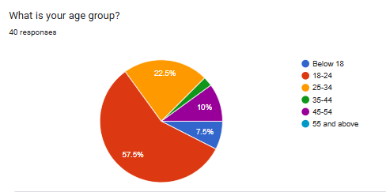
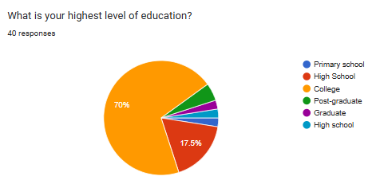
RESULTS

Figure 1. Age groups of the respondents
Based on the data gathered, 57.5% of the participants belong to the age group 18-24, followed by age group 25-34 at 22.5%. Age groups 45-54 and below 18 have 10% and 7.5% respectively, while the age group 35-44 had the least member of participants at 2.5%.

Figure 2. Highest educational attainment of respondents
According to the data, majority of the participants says they are at least a college-level at 70%. Meanwhile, 17.5% of the participants responded that they have reached high school-level.

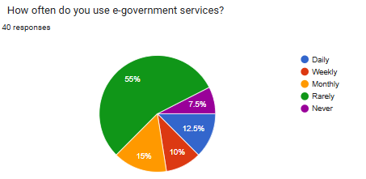

Figure 3. The frequency of usage of e-government services
Based on the data collected, 55% of the participants says that they rarely uses e-government services. Subsequently followed by monthly at 15%, daily at 12.5%, weekly at 10%, and never at 7.5%.
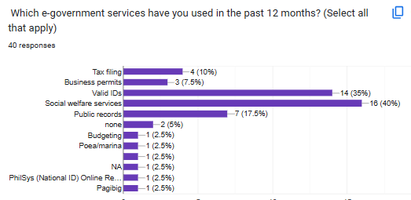

Figure 4. Most used e-government services
According to the data presented, 40% of the respondents they used e-government services for social welfare, while 35% says they access e-Gov services for acquiring valid IDs. Meanwhile, a minority of 17.5% claims that they use it for other public records.

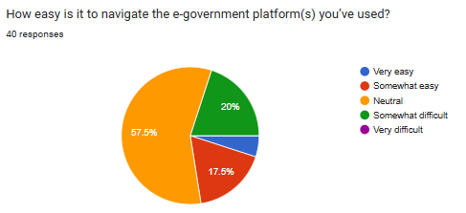
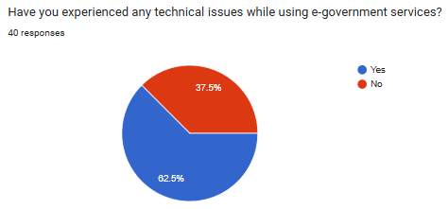

Figure 5. User perception about e-Gov simplicity and usability
Based on the data collected, 57.5% of the respondents feel neutral about how easy to use e-Gov platforms. On the other hand, 20% of participants claim that these platforms are somewhat difficult to navigate, while a measly 17.5% found e-Gov platforms somewhat easy to use.

Figure 6. User experience towards technical issues in e-Gov platforms
According to the data gathered, 62.5% of the population claimed that they have encountered technical issues while using e-Gov platforms, while 37.5% says that they have yet to experience any difficulties using said platforms.

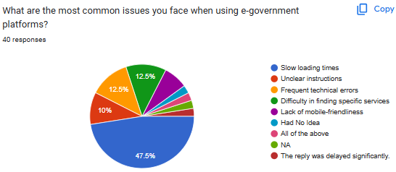

Figure 7. Common issues encountered in e-Gov platforms
According to the data collected, 47.5% of the respondents agreed that they have experienced slow loading times, followed by 12.5% who claims finding certain services are difficult and another 12.5% for participants who have seen frequent technical errors.
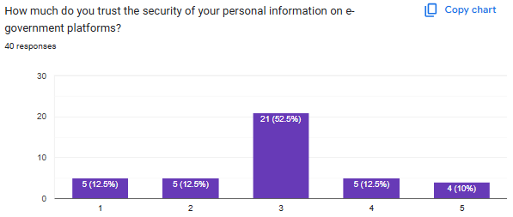

Figure 8. Trust rating of users towards e-Gov platforms’ security
Based on the gathered data, 52.5% says they are neutral towards the security of e-Gov platforms, while 12.5% agreed that e-Gov’s safeguarding personal data are slighty trustworthy, and another 12.5% who slighty disagrees about these platforms’ security.

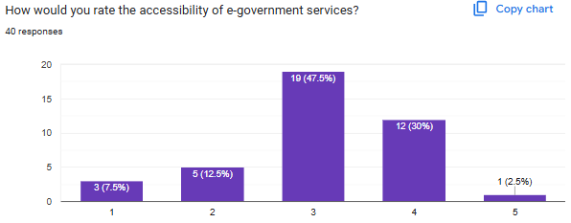
Figure 9. User perception towards e-Gov platforms’ accessibility
According to the data collected, 47.5% of the respondents feel neutral about e-Gov platforms’ accessibility, though by 12% believes that these platforms are quite accessible.
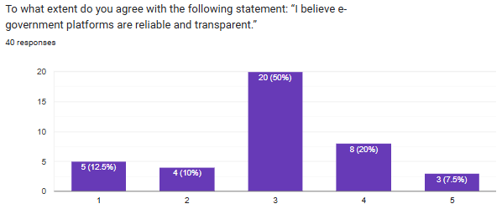

Figure 10. User perception about e-Gov platforms’ reliability and transparency
Based on the data gathered, 50% of the participant claim that they are neither agree nor disagree that e-Gov platforms’ exhibits reliability and transparency, while 20% slightly agrees that these platforms are indeed reliable and transparent.

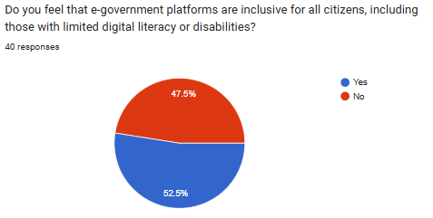

Figure 11. User perception about e-Gov platforms’ inclusivity
Based on the data collected, 52.5% of the participant believed that e-Gov platforms cater to all citizens, while 47.5% says these platforms do not favor certain kind of people.
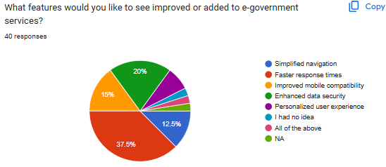

Figure 12. E-Gov features that need improvement
According to the data gathered, 37.5% of the respondents emphasized that faster response times should be a priority, while 20% and 15% of the population are more concerned about enhancing data security and improved mobile compatibility, respectively.

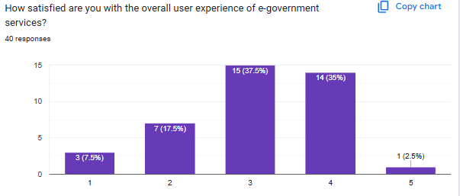

Figure 13. Users’ overall satisfaction towards e-Gov services
According to the data collected, 37.5% of the respondents feel neutral about their experience in e-Gov services, while 35% acknowledges that e-Gov platforms gives them slight satisfaction.
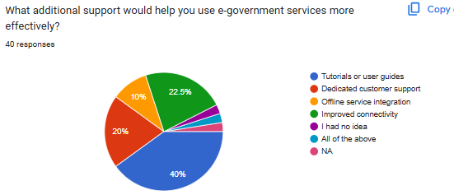

Figure 14. Desired support in e-Gov services
According to the data gathered, 40% of the participant says that tutorials and user guides are necessary in helping e-Gov platforms to be more effective. Meanwhile, 22.5% of the respondents claim that these platforms should have better connectivity to be productive.

The respondents were asked about their own opinion towards the most urgent improvement needed in e-government platforms. Many of them believed that quicker loading time and better data security are the aspects that should be prioritized.
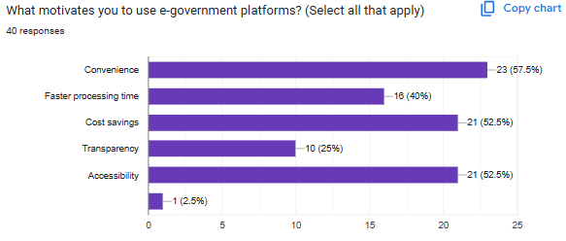

Figure 15. User motivation in using e-Gov platforms
According to the data gathered, 57.5% of the participant says they use e-Gov platforms for convenience. Subsequently, 52.5% of the respondents claim these platforms helps them in saving costs and because e-Gov platforms are accessible.
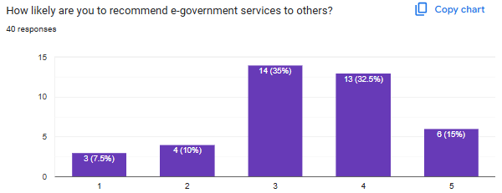

Figure 16. Likelihood of user recommendation
Based on the data gathered, 35% of the respondents feel neutral about recommending e-Gov services to other people, followed by 32.5% of the population claiming they are quite likely to convince others to give e-Gov platforms a try.

DISCUSSION
Demographics of Respondents
The majority of respondents are young adults, particularly those aged 18-24, with a significant portion having at least a college-level education. This suggests that younger, more educated individuals are more likely to engage with digital services.
Usage Patterns of E-Government Services
Most respondents use e-Gov services infrequently, primarily for social welfare and acquiring valid IDs. This indicates that while these platforms serve essential needs, they may not yet be integrated into daily digital interactions.
Perceptions of Usability and Accessibility
Many respondents feel neutral about the usability and accessibility of e-Gov platforms, while a notable portion finds them somewhat difficult to navigate. This suggests a need for improved user experience and design.
Technical Issues and Reliability Concerns
Technical difficulties, particularly slow loading times, are a common challenge. Security concerns also persist, with many users unsure about the safety of their personal data. Addressing these issues could improve trust and engagement.
Areas for Improvement
Faster response times, enhanced data security, and better mobile compatibility are key areas for improvement. Additionally, providing tutorials and improving connectivity could make these platforms more effective for users.
Overall Satisfaction and Recommendations
User satisfaction remains mixed, with many respondents feeling neutral about their experience and likelihood of recommending e-Gov services. Convenience and cost savings are major motivators for usage, highlighting the potential for increased adoption if key issues are addressed.
CONCLUSION
E-Government services play a crucial role in providing digital access to essential public services, yet the findings indicate that various challenges hinder their full potential. Issues related to usability, accessibility, security, and technical performance must be addressed to foster greater trust and engagement among users. By enhancing platform responsiveness, ensuring data protection, and improving the overall user experience, governments can make these digital services more effective and widely adopted.
Moving forward, a user-centered approach should be prioritized in the development and improvement of e-Gov platforms. Investing in better technical infrastructure, offering user support through tutorials, and optimizing mobile compatibility can significantly enhance the convenience and accessibility of these services. With strategic improvements, e-Government platforms can become a more integral and reliable part of digital interactions, benefiting both users and administrative efficiency.
REFERENCES
Aldrees, A., & Gračanin, D. (2023). UX in E-government Services for Citizens: A Systematic
Literature Review. Journal of User Experience, 18(3).
Bajar, J. T. (2020). E-Government in the Philippines: An assessment. Ciencia: Humanities, Education, Arts, Languages, and Social Sciences (HEALS), 1(1), 26-50. https://ssrn.com/abstract=3762071
Chan, Frank K. Y. and Thong, James Y.L. & Brown, Sue A. & Venkatesh, Viswanath, Service Design and Citizen Satisfaction with E-Government Services: A Multidimensional Perspective (2021).
Jou, Y.-T., Mariñas, K. A., Saflor, C. S., Baleña, A., Gutierrez, C. J., Dela Fuente, G., Manzano, H. M., Tanglao, M. S., Verde, N. A., Alvarado, P., & Young, M. N. (2024). Investigating Various Factors Influencing the Accessibility of Digital Government with eGov PH Mobile Application. Sustainability, 16(3), 992. https://doi.org/10.3390/su16030992
Palma, J. P. B., Avila, L., Mag-iba, M. A., Buman-eg, L., Nacpil, E., Dayrit, D. J., & Rodelas, N. (2023). e-Governance: A critical review of e-government systems features and frameworks for success. International Journal of Computing Sciences Research, 7, 2004-2017. https://doi.org/10.25147/ijcsr.2017.001.1.138
Prakoso, B. S., & Subriadi, A. P. (2018). User Experience on E-Government Online Services: A Case Study on The SIMPATIKA Service Application at The Ministry of Religious Affairs of Indonesia. Journal of Information Technology and Computer Science, 3(1), 67–76. https://doi.org/10.25126/jitecs.20183152

APPENDICES
Appendix 1: Survey Questions ………………………………………………………………30

APPENDIX 1: SURVEY QUESTIONS
- What is your age group?
  - Below 18
  - 18-24
  - 25-34
  - 35-44
  - 45-54
  - 55 and above
- What is your highest level of education?
- Primary school
- High school
- College
- Post-graduate
- Other
- How often do you use e-government services?
  - Daily
  - Weekly
  - Monthly
  - Rarely
  - Never
- Which e-government services have you used in the past 12 months? (Select all that apply)
- Tax filing
- Business permits
- Valid IDs
- Social welfare services
- Other
- How easy is it to navigate the e-government platform(s) you’ve used?
- Very easy
- Somewhat easy
- Neutral
- Somewhat difficult
- Very difficult
- Have you experienced any technical issues while using e-government services?
- Yes
- No
- What are the most common issues you face when using e-government platforms?
- Slow loading times
- Unclear instructions
- Frequent technical errors
- Difficulty in finding specific services
- Lack of mobile-friendliness
- Other
- How much do you trust the security of your personal information on e-government platforms?
Legend: Completely distrust = 1 to Completely trust = 5
- 1
- 2
- 3
- 4
- 5
- How would you rate the accessibility of e-government services?
Legend: Very poor = 1 to Excellent = 5
- 1
- 2
- 3
- 4
- 5
- To what extent do you agree with the following statement: “I believe e-government platforms are reliable and transparent.”
Legend: Strongly disagree = 1 to Strongly agree = 5
- 1
- 2
- 3
- 4
- 5
- Do you feel that e-government platforms are inclusive for all citizens, including those with limited digital literacy or disabilities?
- Yes
- No
- What features would you like to see improved or added to e-government services?
- Simplified navigation
- Faster response times
- Improved mobile compatibility
- Enhanced data security
- Personalized user experience
- Other
- How satisfied are you with the overall user experience of e-government services?
Legend: Strongly disagree = 1 to Strongly agree = 5
- 1
- 2
- 3
- 4
- 5
- What additional support would help you use e-government services more effectively? *
- Tutorials or user guides
- Dedicated customer support
- Offline service integration
- Improved connectivity
- Other
- In your opinion, what is the most urgent improvement needed for e-government platforms? (Open-ended)
- What motivates you to use e-government platforms? (Select all that apply)
- Convenience
- Faster processing time
- Cost savings
- Transparency
- Accessibility
- Other
- How likely are you to recommend e-government services to others?
Legend: Very unlikely = 1 to Very likely = 5
- 1
- 2
- 3
- 4
- 5

CURRICULUM VITAE

Name: BALOSA, JOHN RAY V.
Address: 11 Lagusan St. Kaingin Bukid,
Apolonio Samson, Quezon City
Contact No.: 09664451005
Email: rayjohnbalosa@gmail.com

EDUCATIONAL BACKGROUND
2019-Present: Bachelor of Science in Computer Science at The University of Manila (Sampaloc, Manila)
2016-2018: Humanities and Social Sciences at Apolonio Samson National High School (Apolonio Samson, QC)
2012-2016: Masambong High School (Masambong, QC)
2006-2012: San Francisco Elementary School (San Francisco Del Monte, QC)

CURRICULUM VITAE

Name: CABALDA, RECCA ANN S.
Address: 7-C Quirino St. Tondo Manila
Contact No.: 09956423074
Email: cabaldareccaann@gmail.com

EDUCATIONAL BACKGROUND
2021-Present: Bachelor of Science in Computer Science at The University of Manila (Sampaloc, Manila)
2018-2020: General Academic Strand at Ondoy National High School (Ondoy Ibajay, Aklan)
2014-2018: Ondoy National High School (Ondoy, Ibajay Aklan)
2008-2014: Ondoy Elementary School (Ondoy, Ibajay Aklan)

CURRICULUM VITAE

Name: SAMANIEGO, MATTHEW V.
Address: 105 Bayani St. Caloocan City
Contact No.: 09512315668
Email: mtthwsmng@gmail.com

EDUCATIONAL BACKGROUND
2019-Present: Bachelor of Science in Computer Science at The University of Manila (Sampaloc, Manila)
2016-2018: Science Technology Engineering Mathematics at The University of Manila (Sampaloc, Manila)
2012-2016: Florentino Torres High School (Tondo, Manila)
2006-2012: Bo. Obrero Elementary School (Tondo, Manila)

