- System Overview
The proposed system is a backend relational database for a simple e-commerce platform. It handles product inventory, customer accounts, staff management, saved payment methods, and purchase transactions.

- User Roles and Use Cases
- Customers:
  - Can view available products
  - Can securely save multiple credit cards to their profile
  - Can make purchases of products using a saved credit card
- Staff:
  - Can view current inventory
  - Can insert new products into the database
  - Can update inventory levels
- Data Requirements (Entities)
- Customer:
  - Needs to store personal information like Name and Email
- Staff:
  - Needs to store employee details and role
- Product:
  - Needs to store item details, pricing, and current stock
- CreditCard:
  - Needs to store card details linked to a specific Customer
- Purchase:
  - Needs to log transaction details, linking the customer, the producting, and the quantity bought

- Entity-Relationship (ER) Diagram

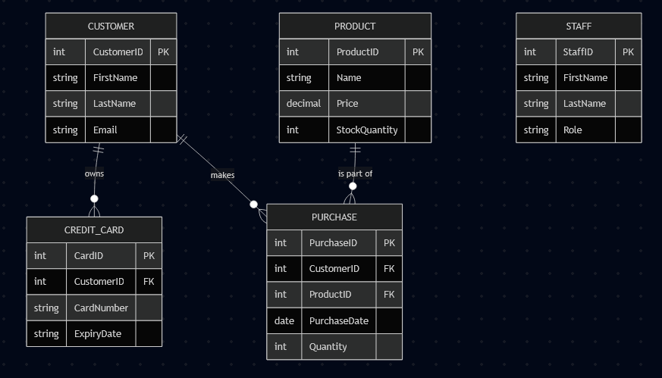

- Relational Schema Design
- Customer
  - (CustomerID, FirstName, LastName, Email)
- Staff
  - (StaffID, FirstName, LastName, Role)
- Product
  - (ProductID, Name, Price, StockQuantity)
- CreditCard
  - (CardID, CustomerID, CardNumber, ExpiryDate)
    - Foreign Key: CustomerID references Customer(CustomerID)
- Purchase
  - (PurchaseID, CustomerID, ProductID, PurchaseDate, Quantity)
    - Foreign Key: CustomerID references Customer(CustomerID)
    - Foreign Key: ProductID references Product(ProductID)

