**SPI**

About:

* Communicates in full duplex (can communicate in both directions simultaneously)
* Uses master-slave architecture
* Master generates the clock that both sides sync up to
* Multiple slaves by using slave or chip select (SS or CS)
* 4 logic signals:
  + SCLK: Serial Clock (output from master)
  + MOSI: Master Out Slave In (data output from master)
  + MISO: Master In Slave Out (data output from slave)
  + SS/CS: Slave/Chip Select (chooses which slave should wake up and send/receive data)
* Most slaves have 3 states: high, low and high impedance (electrically disconncected)

How it works:

* Master configures clock using a frequency supported by the slave device (usually up to a few MHz)
* CS is normally held high (active low) to disconnect it from the SPI bus
* Just before data is sent out SS is brought low to communicate with it
* During each SPI clock cycle a full-duplex transmission occurs:
  + Master sends a bit on the MOSI line and the slave reads it
  + Slave sends a bit on the MISO line and the master reads it
  + Both happen simultaneously
* On clock edge both master/slave shift out a bit and output it on to the transmission line
* On next clock edge each receiver samples the transmitted bit and sets it as the new LSB on the shift register
* The CS is then made high again to deactivate it
* Process is then repeated
* Transmissions usually 8 bits long

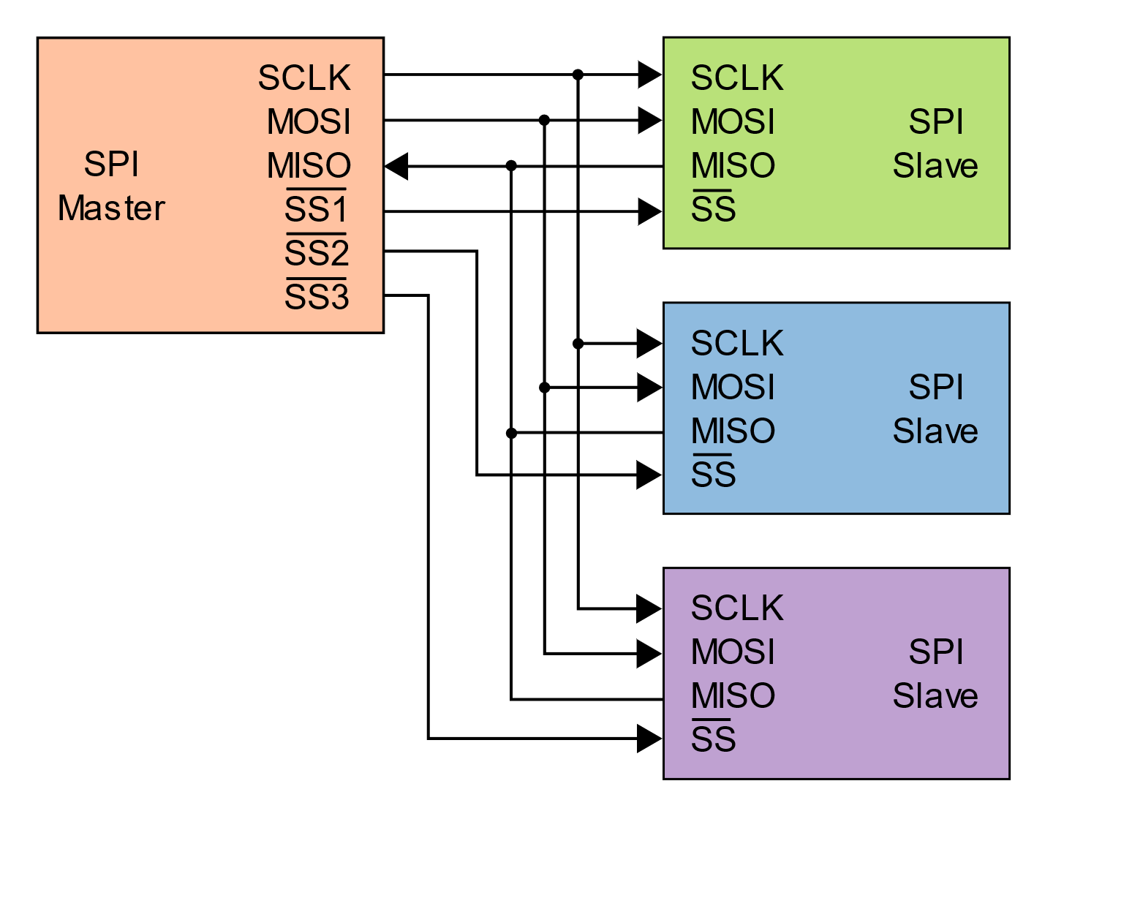

*Independent Slave Config Daisy Chain Config*

Arduino Pins:

* MOSI -> Pin 11 (ICSP-4)
* MISO -> Pin 12 (ICSP-1)
* SCK -> Pin 13 (ICSP-3)
* SS (slave) -> Pin 10 **ALWAYS SET AS OUTPUT SINCE WE ARE USING THE ARDUINO AS A MASTER AND WE CAN’T USE THE LIBRARY IF THIS ISN’T SETUP PROPERLY AS AN OUTPUT**