= CTF Try Out =
Critical Flight
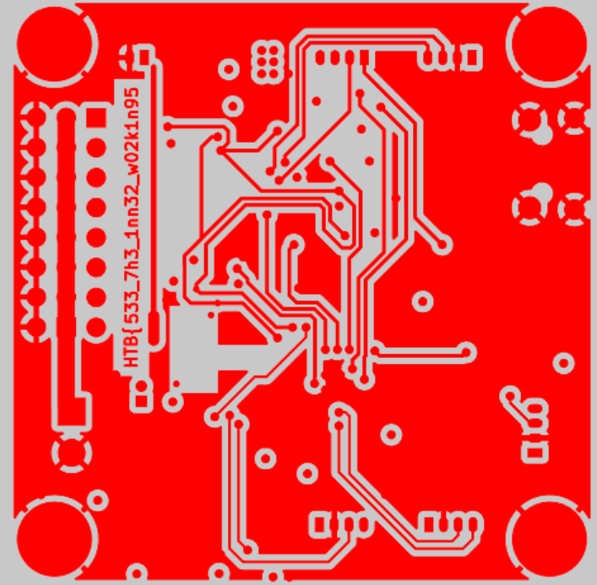
Your team has assigned you to a mission to investigate the production files of Printed Circuit Boards for irregularities. This is in response to the deployment of nonfunctional DIY drones that keep falling out of the sky. The team had used a slightly modified version of an open-source flight controller in order to save time, but it appears that someone had sabotaged the design before production. Can you help identify any suspicious alterations made to the boards?
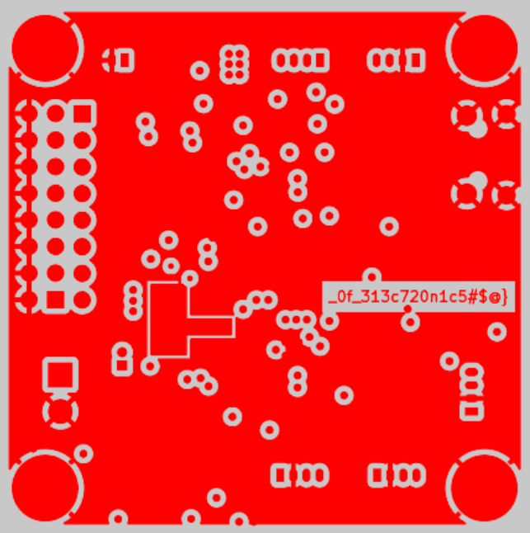
MacOS-generated metadata folder contains ghost files starting with ._ — they're not real Gerber files, which are the standard format for PCB fabrication.
So I uploaded the .gbr files from /home/sorana/Downloads/hw_critical_flight/flight_control_board/ to Online PCB Viewer to Visualize and Share Electronics Design Projects | Altium 365 Viewer and got the flag.

