= CTF Try Out =
Debug
Your team has recovered a satellite dish that was used for transmitting the location of the relic, but it seems to be malfunctioning. There seems to be some interference affecting its connection to the satellite system, but there are no indications of what it could be. Perhaps the debugging interface could provide some insight, but they are unable to decode the serial signal captured during the device's booting sequence. Can you help to decode the signal and find the source of the interference?

Solution:
Using Logic 2 (Recommended)
Step-by-Step to Decode UART in Logic 2:
- Open Logic 2 and load your .sal file (you’ve already done this).
- Enable the UART Analyzer:
  - On the right panel, click the "Analyzer" (chip icon).
  - Click "+", then select "Async Serial" (UART) from the list.
  - Set the following parameters:
    - Input Channel: D1 (RX)
    - Bit rate: Try 115200 (common default). If decoding looks like garbage, try 9600, 19200, 38400, etc.
    - Bits per frame: 8
    - Parity: None
    - Stop bits: 1
    - LSB First: Checked (this is the usual setting)
- Apply and Inspect:
  - Click "Save" to apply the analyzer.
  - You should now see decoded UART data as ASCII bytes right above the waveform.
  - If it's still unreadable, try a different baud rate in the settings.
- Export the Decoded Data (Optional):
  - Click the three-dot menu ⋮ on the analyzer result.
  - Choose "Export as CSV" if you want to analyze the data in a text editor or Excel.

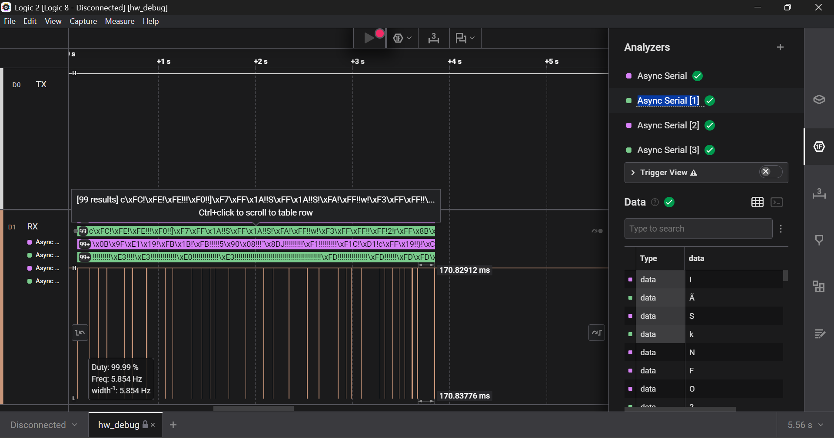
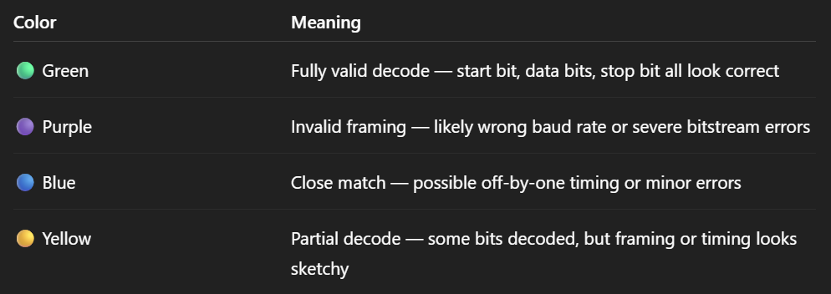
I tried more bit rates. For the default bit rate 115200, by inspecting the terminal of the Async serial, I got the flag :
