REQUIREMENTS ANALYSIS DOCUMENT (RAD)

**Introduction 2**

Purpose of the system 2

Scope of the system 2

Objectives & success criteria of the project 2

Objectives 2

Success criterias 2

**Proposed system 3**

Overview 3

Functional requirements 3

Nonfunctional requirements 3

System models 4

Use case model 4

Object model 4

Dynamic models 4

User interface 4

**Glossary 6**

# 

# Introduction

## Purpose of the system

The purpose of the system is to help everyday people plan their holidays.

## Scope of the system

The application is a travel platform that lets users access a list of essential destinations and create multiple bucket lists containing both public and private destinations they want to visit.

## Objectives & success criteria of the project

### Objectives

* Develop an application that meets the needs of both users and administrators
* Ensure the application is scalable and can handle increased user traffic as the user base grows
* Ensure the application is scalable and can handle increased user traffic as the user base grows

### Success criterias

* The application is delivered by July 31, 2023
* Increase Romania’s revenue from tourism by 5%
* Achieve a customer satisfaction rating of 4.5 out of 5 stars
* Achieve 50 000 registered users by December 31, 2024
* Have a 1 000 daily logins for 30 days by December 31, 2024

# Proposed system

## Overview

The system is a simple account-based platform, which allows its users to access a list which holds the most important destinations in the world and choose from it the ones they want to visit. The user is also able to choose from a separate, private, list of destinations, managed by themselves.

The user will be able to create and manage multiple bucket lists. A bucket list is a list containing both public and private destinations which the user supposedly wants to visit.

## Functional requirements

* The user must be able to register an account
* The user must be able to login into an already existing account
* The user should be able to delete or cancel their account
* The user can update their account’s details
* The user can create a new bucket list
* The user can delete a private bucket list
* The user can view the destinations list
* The user can view their private bucket lists
* The user can create a new private destination
* The user can update a private destination
* The user can delete a private destination
* The user can add (public or private)destinations to the **PRIVATE** bucket list
* The user can remove (public or private) destinations from the **PRIVATE** bucket list
* The admin must be able to add destinations to the public list
* The admin can remove destinations from the public list
* The admin can update destinations
* The admin can delete user accounts

## Nonfunctional requirements

* The language of the interface must be English
* Friendly display

## 

## System models

## 

### 

### Use case model

https://drive.google.com/drive/folders/1ETxdaDHc-zxcQz3NUzuRmRK_pnZoRjFj

### Object model

[Entity-Objects](https://docs.google.com/document/d/1eFgS2iKlCC6-CLQYHd9VNnF6qxW7kaJmHRFUm9WY-hs/edit)

[Boundary-Objects](https://docs.google.com/document/d/1dnvO30kC_j0XE2ABC58uikqpiJN_c7anbLhbYaq9SlM/edit)

[Control-Objects](https://docs.google.com/document/d/1fGZuwvEkKJdL5q-4lxRiAlaj1S6KdLzIdidRD3PUVKM/edit)

### Dynamic models

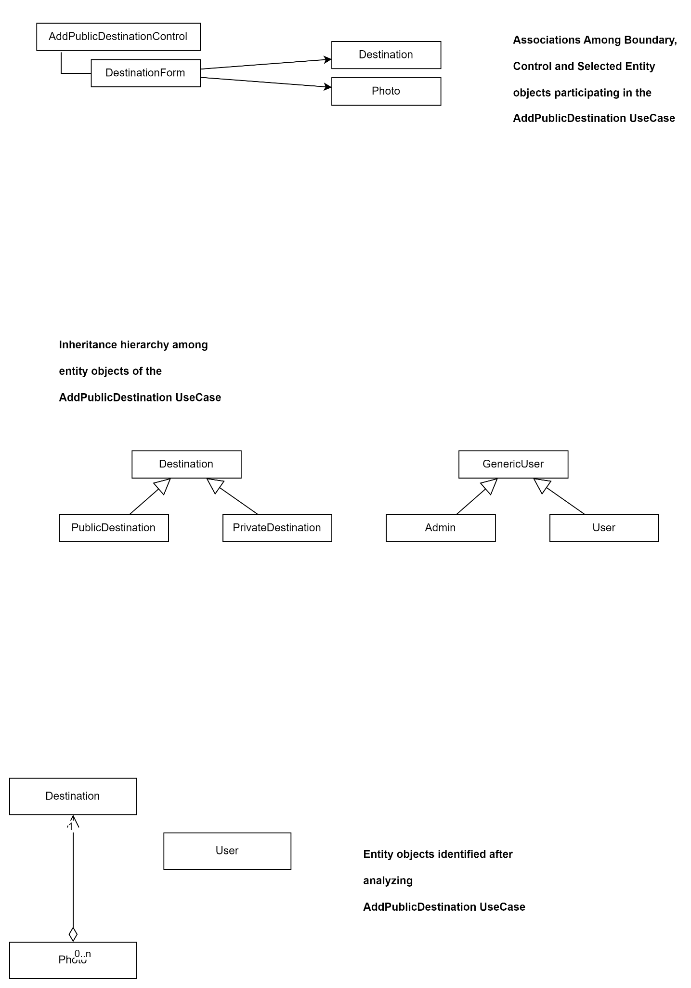

### User interface

# 

# Glossary

**User**: Any individual who interacts with the application to perform specific tasks or actions.

**Admin**: A user with special permissions or privileges within the application, responsible for managing the system, such as adding / removing / updating public destinations and performing other administrative tasks.

**Dashboard**: A summary page or screen that provides an overview of the application's main features.

**(Public) Destination List** - a public list, managed by an admin with the representative tourist attractions in Romania.

**Private Destination List** - an user-specific list, managed by themselves which holds the destinations added by the user.

**Bucket List** - a user-specific list, managed by themselves, which contains one or multiple destinations.