Sprint 2 Plan Slug’s Bus Schedule

Version 0.1.0. Exodus, T.E.A.M.

# Goal

Improve team productivity, task completion rate, collaboration and support in order to more effectively utilize the ASP.NET CORE framework, Microsoft’s Azure Cloud Platform, and SQL database to allow users to retrieve available UCSC bus schedule information in a simple and easy to use format.

# Task Listing and roles (by user story)

* I am a user, and I want to see what routes I can take from my bus stop, so that I can choose which bus to take. **Story Points: 8**
  + Task 1: Connect SQL Database to Azure Resource Group (½ hour)
  + Task 2: Store all available UCSC bus line data we have from Google Maps into excel spreadsheet (2 hours)
  + Task 3: Use Entity Framework to map Bus Line Data Object (SQL database entities) to the table and columns of our relational database (1.5 hours)
  + Task 4: Create home controller to process SQL database entities (1 hour)
  + Task 5: Through the entities, pass data from the SQL database through the controller and map to their corresponding ViewModel properties (.5 hours)
  + Task 6: Using Razor, display the VIewModel data for each property (1 hour)
  + Task 7: Style the user interface with the Bootstrap Framework in order to make the web application responsive (2.5 hours)

**Total Hours: 9**

* I am a developer, and I want to know the user's location via GPS, so that I can find out the nearest bus stop. **Story Point: 3**
  + Task 1: Figure out the concept of acquiring user’s GPS information (5 hours)
  + Task 2: Get the user’s GPS information.(3 hours)

**Total Hours: 8**

# Team roles

Riwen: PO

Josh: Scrum Master

Cyrus: Team member

Calvin: Team member

# Initial task assignment

Calvin: User Story 1, initial task: task 1

Riwen: User Story 1, initial task: task 3

Josh: User Story 1, initial task: task 6

Cyrus: User Story 2, initial task: task 1

# Initial burnup chart

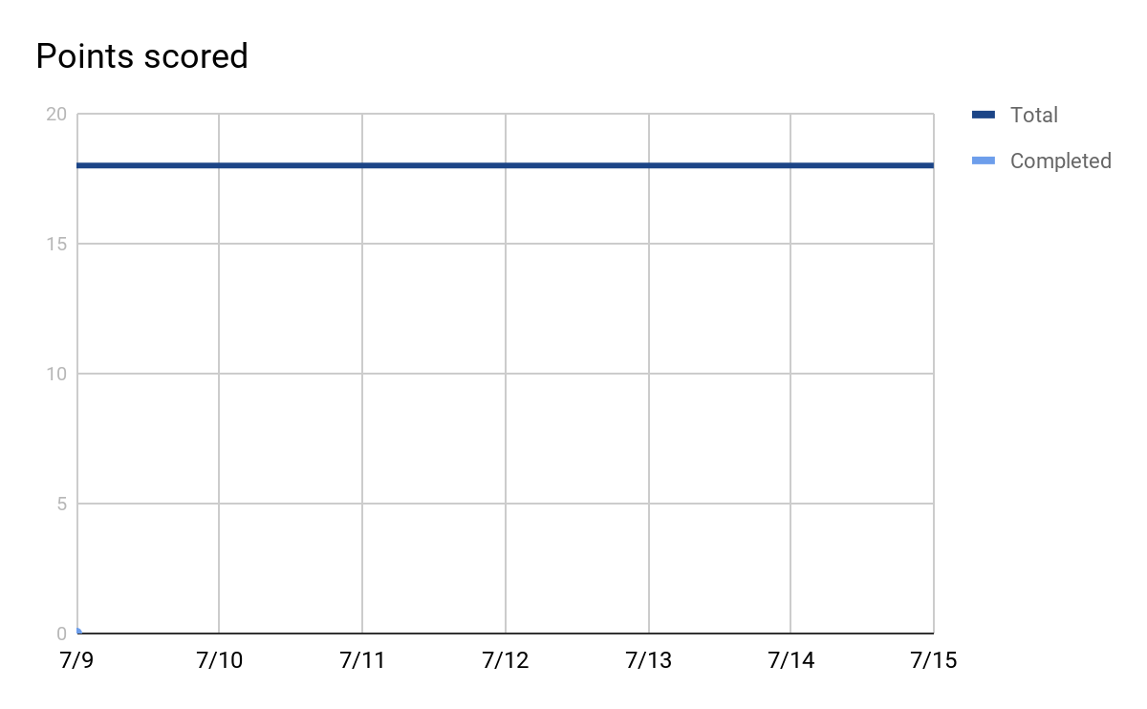

# 

# 

# Initial scrum board

|  |  |  |  |
| --- | --- | --- | --- |
| User Stories | Tasks not started | Tasks in progress | Tasks Done |
| Routes | Connect SQL Database to Azure Resource Group |  |  |
|  | Store all available UCSC bus line data we have from Google Maps into excel spreadsheet |  |  |
|  | Use Entity Framework to map Bus Line Data Object (SQL database entities) to the table and columns of our relational database |  |  |
|  | Create home controller to process SQL database entities |  |  |
|  | Through the entities, pass data from the SQL database through the controller and map to their corresponding ViewModel properties |  |  |
|  | Using Razor, display the VIewModel data for each property |  |  |
|  | Style the user interface with the Bootstrap Framework in order to make the web application responsive |  |  |
|  |  |  |  |
| Location GPS | Figure out the concept of acquiring user’s GPS information |  |  |
|  | Get the user’s GPS information. |  |  |
|  |  |  |  |
|  |  |  |  |
|  |  |  |  |

# Scrum times

1. Monday (5:30 to 6:00) with TA
2. Tuesday (12:30 to 1:00)
3. Thursday (5:30 to 6:15) with TA