

Trance
USB-DMX
User Manual

Author | Samuel Hafen

First Setup
Connect the the device with a compatible DMX over USB device.

Configuration
If you turned on the device for the first time, or it does not find the configured WiFi the Trance will open up a Configuration Hotspot. On a WiFi capable device, search for the wifi named
“trance-config” it should not be password protected. Connect to this WiFi. On most devices this will automatically open a configuration page.
If it does not automatically open a configuration page, just open any web browser and type this into the addressbar: http://192.168.4.1
Type the WiFi Login data into the Configuration page and save the settings with the save button under the settings. After submitting the hotspot will close, and the device will connect to the specified WiFi network.

Legend
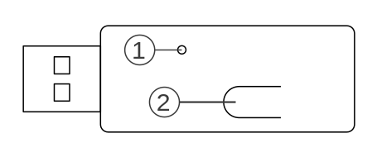
Nr. | Function
1 | Indicator LED
2 | Reset Button

Indicator LED
Currently This LED does not have a Function, but in the Future it will be indicate the state of the Device and Allow for remote Locating Indication.

Reset Button
Press and Hold the Reset Button for 10s to clear all Settings and Configurations.

Controller Configuration
To Correctly control this Device your ArtNet-Controller does have to be ArtNet 4 Compliant. If it ArtNet 4 is correctly implemented, your controller should automatically recognize all Trance devices in the same network.
It is important that the controller does send the Data to the Trance device by unicasting. Multicasting is not supported, because most WiFi Accesspoints ratelimit multicasting over WiFi, and that can lead to visual glitches, lags and latency.

Troubleshooting
If you read the user manual carefully, and followed it. The device should work. If it does, or for guides on updating and installing Firmware pleas refer to our Website. You can also try contacting me via E-Mail for support.
https://hafen-innovation.ch
info@hafen-innovation.ch

