CS008

Brody Childs and Treuvor Holowinsky

Assignment: CS008 Final Project Website

Clean Burning Black Rocks Inc. Website

Version <1.0>

Table Of Contents

Time Log 3

Introduction 4

Purpose 4

Definitions, acronyms, and abbreviations 4

Overall Description 4

Story Board 5

Specific requirements 6

|  |  |  |  |
| --- | --- | --- | --- |
| Time Log | | | |
| Estimated time to complete assignment => | | | 100 Hours |
| Date | Time Spent  (in hours) | Description | Author |
| 10/10 | 1.5 | First Version of Software Requirements | Brody Childs, Treuvor Holowinsky |
|  |  |  |  |
|  |  |  |  |
|  |  |  |  |
|  |  |  |  |
|  |  |  |  |
|  |  |  |  |
|  |  |  |  |
|  |  |  |  |
|  |  |  |  |
|  |  |  |  |
|  |  |  |  |
|  |  |  |  |
|  |  |  |  |
|  |  |  |  |
|  |  |  |  |
|  |  |  |  |
|  |  |  |  |
|  |  |  |  |
|  |  |  |  |
|  |  |  |  |
|  | Mark me wrong if not updated | <=Total Time Spent |  |
|  |  |  |  |

# Introduction

### Purpose

The purpose of this document is to describe the requirement specification for the web site “Clean Burning Black Rocks Inc”.

The intended audience for this document is the customers of Clean Burning Black Rocks Inc in an effort to show them the product.

*First it is the contract between you and the client. Second it is for the developer of the site. Two primary goals are:*

1. *Client gets a very good understanding of what you will be delivering.*
2. *Developer has a very good understanding of what they are going to create.*

### Definitions, acronyms, and abbreviations

ER Diagram – a diagram to represent the data you want to save with your system

W3 Validation – refers to both Html and CSS validation tool provided by the W3c.org. the html validator is located at:

<http://validator.w3.org/>

with the CSS validator located at:

<http://jigsaw.w3.org/css-validator/>

CBBR – a shortened form of clean burning black rock

# Overall Description

The site’s purpose is to show the potential clients of Clean Burning Black Rocks Inc the companies main product: a form clean burning black rock. The website needs to be easy to use and guide the user to whatever page they may be searching for quickly and easily without much fuss. Ideally the website will have a modern tone and represent the highly advanced nature of Clean Burning Black Rocks Inc.

# Story Board

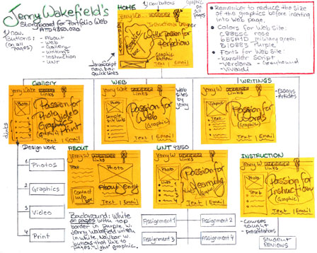

# Specific requirements

1. *You fill out* – This is where you would put the exact detail of what you want for the project. For example:
2. *Title for main page*: *What is the title, shows up as a link in a search result.*
3. *Meta Description*: *what is the description for the above link.*
4. *Meta Character set*: UTF - 8
5. *Logo*: *pick a logo to be used on the site.*
6. *Main page photo*: *pick a photo of you.*
7. *Content can be found here*:
8. I hope you get the idea. The goal would be the developer would be able to make the entire site based on this document and the client would see you have included everything.