Sorcha Platform

Construction Permit Walkthrough
15 Construction Projects Executed on Live Platform
User Experience Walkthrough with Screenshots
Date: 21 March 2026
Platform Version: v1.0.0
Environment: Docker (API Gateway on port 80)

Contents
1. Executive Summary
2. Platform Overview
3. User Story: Sign In
4. User Story: Dashboard
5. User Story: Browse Available Services
6. User Story: Submit a Planning Application
7. User Story: Pending Actions
8. User Story: View Registers
9. User Story: Inspect Transaction Ledger
10. User Story: Docket Chain Integrity
11. User Story: Manage Wallets
12. User Story: Manage Blueprints
13. Bulk Execution: 15 Construction Projects
14. Appendix: Project Summary Table

1. Executive Summary
This document records the end-to-end user experience walkthrough of the Sorcha Construction Permit Approval workflow. The walkthrough was conducted against a live Docker instance of the Sorcha platform, accessed entirely through the API Gateway (port 80) and the Blazor WebAssembly UI at /app/.
15 construction projects of varying types, sizes, and risk profiles were executed programmatically via the API, followed by a manual UI walkthrough of a 16th project (Waterfront Library & Community Centre) to capture the complete user experience with screenshots.
Key Results:
- 16 construction permit applications processed (15 API + 1 UI)
- 88 transactions recorded on the Construction Permit Register
- All 15 API projects approved with permits RBC-2026-00100 through RBC-2026-00114
- 5 low-risk projects (5 actions, skip environmental review)
- 10 high-risk projects (6 actions, include environmental assessment)
- Building Permit Verifiable Credentials issued for all approved projects
- Full docket chain integrity verified (87 dockets, all Valid)

2. Platform Overview
The Construction Permit Approval blueprint models a realistic multi-organisation planning permission workflow involving:
Organisation | Participant | Role
Meridian Construction | Contractor (Site Manager) | Submits building application
Apex Structural Engineers | Lead Engineer | Structural assessment, risk scoring
Riverside Borough Council | Planning Officer | Zoning review, conditional routing, final approval
Green Valley Environmental | Environmental Consultant | Environmental impact (high-risk only)
Riverside Borough Council | Building Control Inspector | Technical compliance, fee calculation

Workflow Actions
The blueprint defines 6 sequential actions with conditional routing based on a calculated risk score:
# | Action | Sender | Key Feature
1 | Submit Application | Contractor | Building plans and project details
2 | Structural Assessment | Engineer | Calculates riskScore via JSON Logic
3 | Planning Review | Planning Officer | Routes: high-risk (>=7) or low-risk (<7)
4 | Environmental Assessment | Environmental | Conditional: only for high-risk projects
5 | Building Control Inspection | Building Control | Calculates permitFee
6 | Final Approval | Planning Officer | Issues BuildingPermitCredential VC

3. User Story: Sign In
As a platform user, I want to sign in securely so that I can access my workflows, wallets, and registers.
The Sorcha sign-in page provides multiple authentication methods: email/password, passkey (WebAuthn), and social login (Google, Microsoft, GitHub, Apple). The platform uses JWT Bearer tokens for session management.
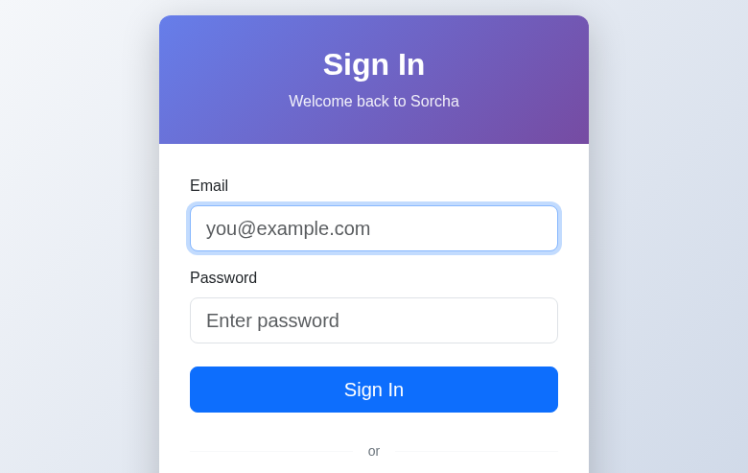
Figure 1: Sorcha Sign In page with multiple authentication options

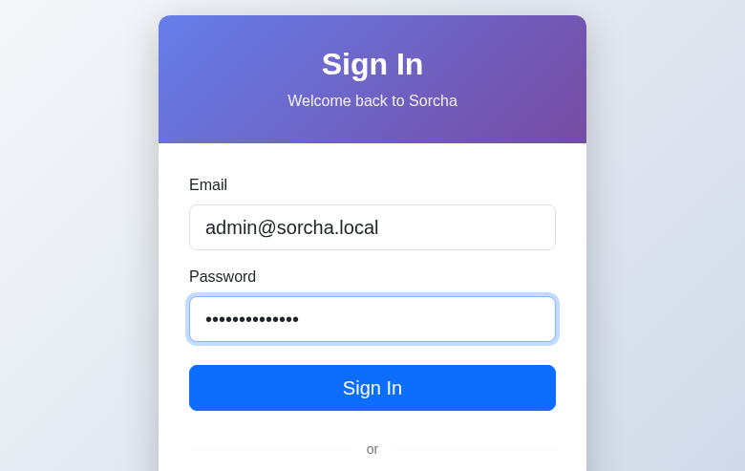
Figure 2: Credentials entered — admin@sorcha.local

4. User Story: Dashboard
As a signed-in user, I want to see an overview of my platform activity so that I can quickly assess the state of my blueprints, wallets, and registers.
After successful authentication, the dashboard displays real-time statistics: 1 Blueprint, 7 Wallets, 91 Transactions, 2 Registers, and 1 Organisation. The green 'Connected' indicator confirms the SignalR WebSocket connection is active for real-time notifications. Quick Action buttons provide one-click navigation to common tasks.
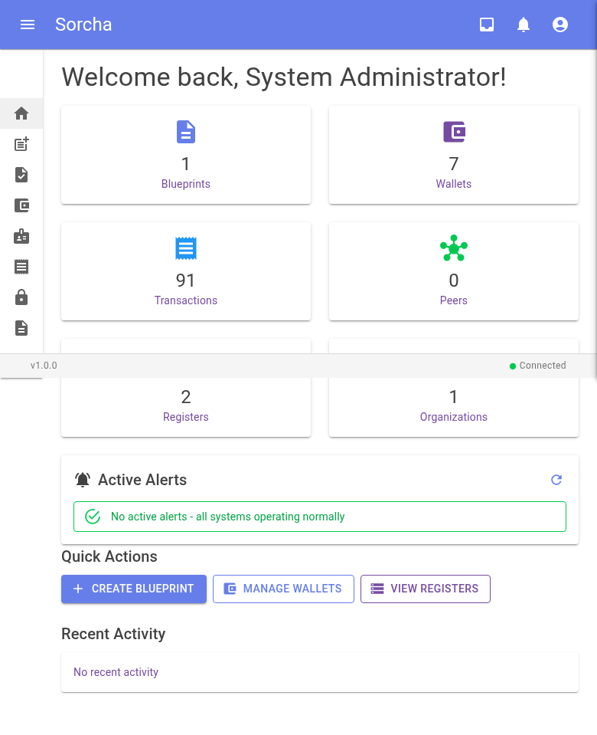
Figure 3: Dashboard showing platform statistics, alerts, and quick actions

5. User Story: Browse Available Services
As a member of the public or contractor, I want to browse available services by register so that I can find and start a new planning application.
The 'New Submission' page groups available blueprints by register. Each register shows its published blueprints with descriptions, version numbers, and the starting action name. The user can click 'Start' to begin a new workflow instance.
In this walkthrough, the Construction Permit Approval blueprint is available on both the Sorcha System Register and the Construction Permit Register. The user selects the Construction Permit Register to submit their application against the dedicated planning ledger.
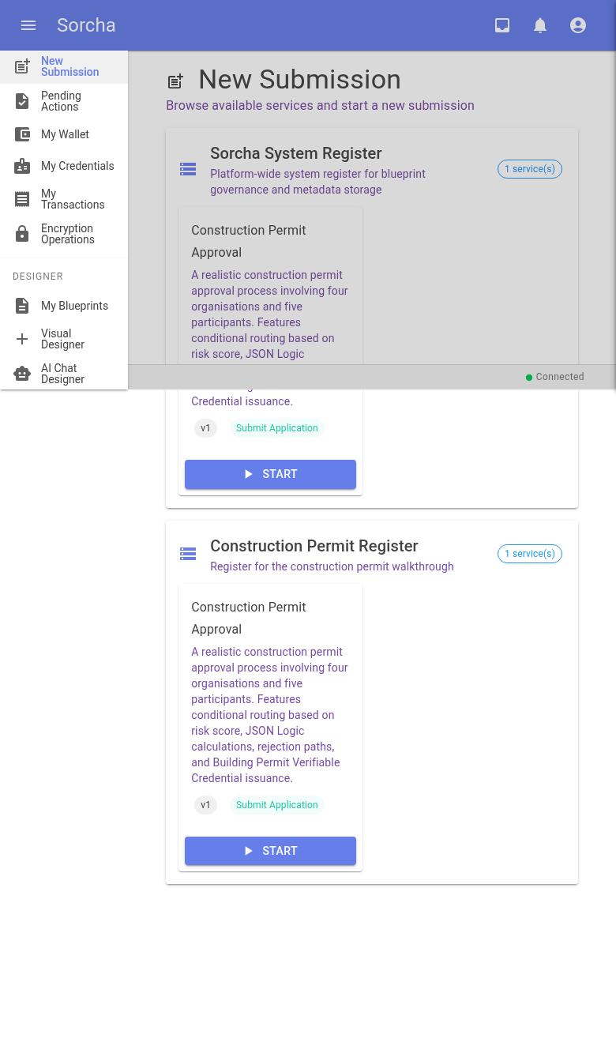
Figure 4: New Submission page — blueprints grouped by register with Start buttons

6. User Story: Submit a Planning Application
As a contractor, I want to fill in and submit a building application form so that I can initiate the construction permit approval process.
Clicking 'Start' opens the New Submission dialog. The form is dynamically rendered from the blueprint's JSON Schema and form definition. Key elements include:
- Signing Wallet selector — the user chooses which HD wallet to sign the transaction with
- Project Details section — project name, site address, building type (dropdown)
- Building Specifications section — estimated value, gross floor area, storeys (numeric inputs)
- Existing structure toggle — boolean checkbox
- Schema validation — required fields enforced before submission
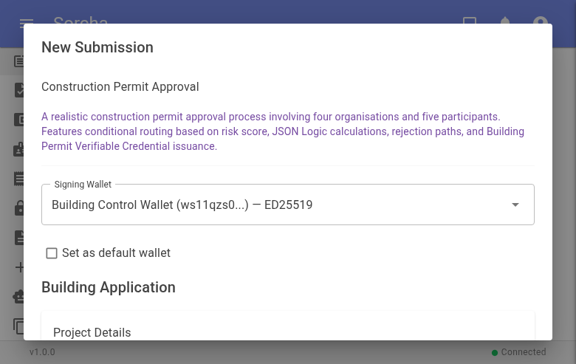
Figure 5: New Submission dialog — wallet selector and form header

The form was completed for a 'Waterfront Library & Community Centre' — a 3-storey commercial building at 25 Harbour Road, Inverness, with an estimated value of GBP 4,200,000 and 2,400m² gross floor area.
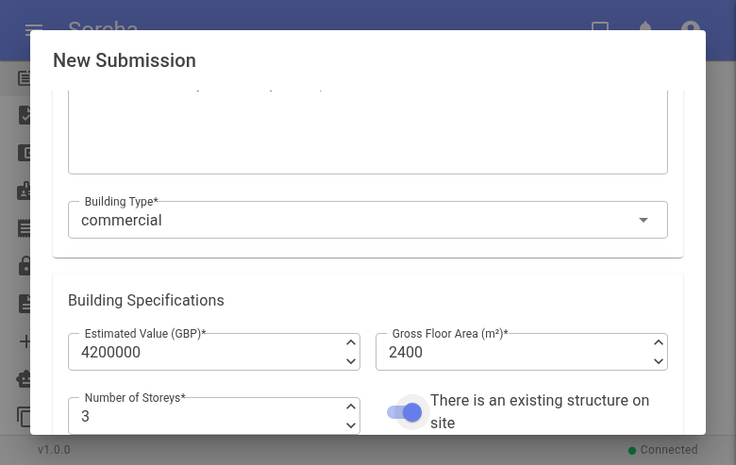
Figure 6: Completed form — commercial, GBP 4.2M, 2,400m², 3 storeys

On clicking Submit, the platform creates a new workflow instance, signs the transaction with the selected wallet, and records it on the Construction Permit Register. A success toast confirms the submission with the instance ID.
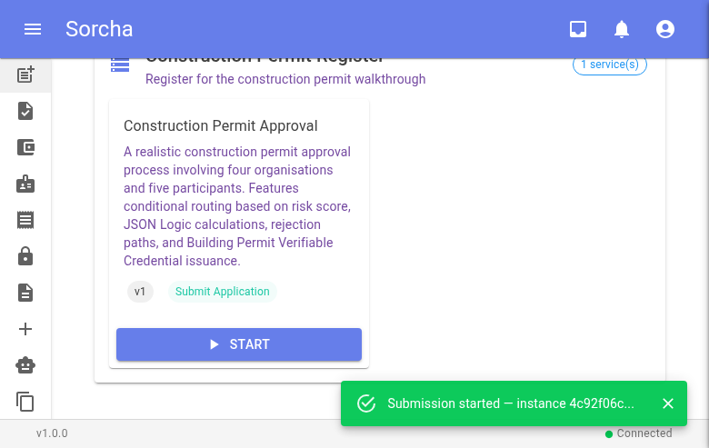
Figure 7: Submission confirmed — 'Submission started — instance 4c92f06c...'

7. User Story: Pending Actions
As a workflow participant, I want to see actions that require my attention so that I can respond to pending workflow steps assigned to my wallet.
The 'My Pending Actions' page shows a real-time feed of actions waiting for the current user's wallet. After submitting the planning application (Action 1), the next step — Structural Assessment (Action 2) — is assigned to the structural engineer's wallet, not the contractor's.
The page correctly shows 'All Caught Up!' for the contractor, demonstrating that Sorcha's disclosure and routing model ensures each participant only sees their own pending work. The green 'Connected' badge confirms real-time updates are active — new actions will appear automatically via SignalR when they become available.
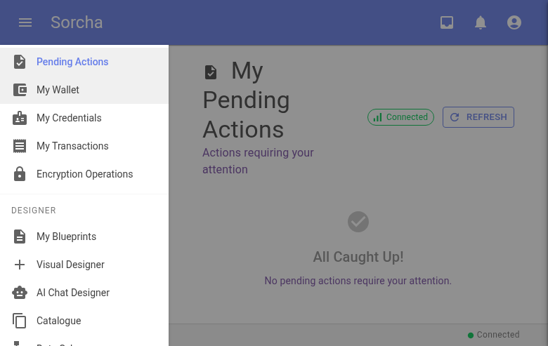
Figure 8: My Pending Actions — 'All Caught Up!' (next action is another participant's)

8. User Story: View Registers
As an auditor or administrator, I want to view all distributed ledger registers so that I can monitor their health and inspect recorded transactions.
The Registers page lists all registers with their status (Online/Offline), visibility (Public/Private), and unique identifiers. Filter buttons allow filtering by status. Both the Sorcha System Register and the Construction Permit Register show as Online.
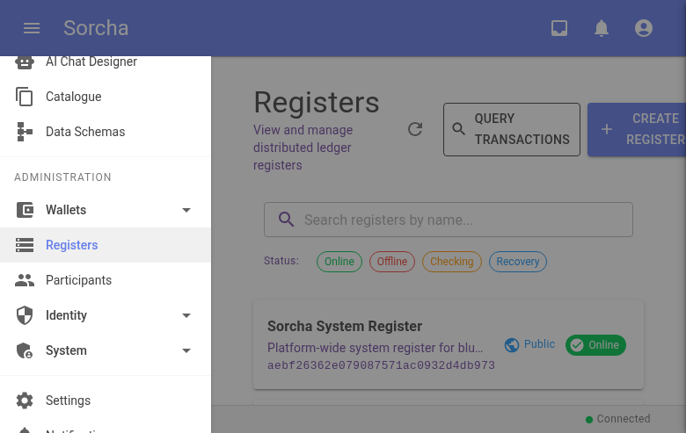
Figure 9: Registers page — System Register and Construction Permit Register, both Online

9. User Story: Inspect Transaction Ledger
As an auditor, I want to inspect individual transactions on the register so that I can verify the integrity of recorded actions and their signatures.
Clicking on the Construction Permit Register opens the register detail view. The summary bar shows Height: 88, Transactions: 88, Last Updated: 1 minute ago, and Visibility: Public.
The Transactions tab displays a paginated list of all transactions with their truncated TX ID, timestamp, sender wallet (truncated with tooltip for full address), transaction type (Action), and the docket number they were included in. Each transaction can be clicked to reveal full details including the complete TX ID, cryptographic signature, action ID, and blueprint reference.
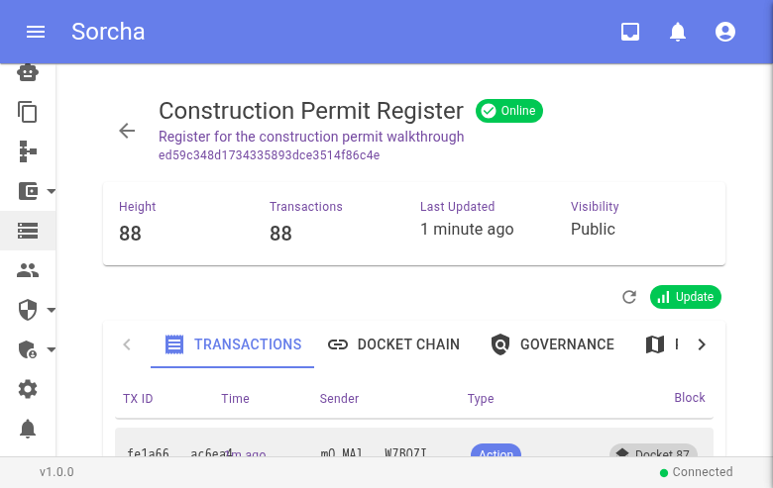
Figure 10: Register detail — 88 transactions across 87 dockets

10. User Story: Docket Chain Integrity
As an auditor or compliance officer, I want to verify the docket chain integrity so that I can confirm that no transactions have been tampered with or removed.
The Docket Chain tab shows the blockchain-like structure of the register. Each docket contains one or more transactions, has a cryptographic hash, and references the previous docket's hash — forming an immutable chain. The green 'Valid' badge on each docket confirms the hash chain is intact.
Docket #87 (the most recent) contains 2 transactions and shows its hash and previous hash, allowing anyone to independently verify the chain's integrity.
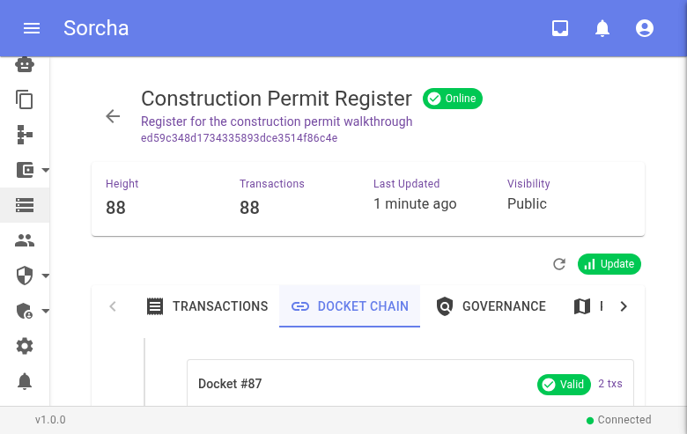
Figure 11: Docket Chain — Docket #87 Valid, hash chain verified

11. User Story: Manage Wallets
As a platform user, I want to manage my HD wallets so that I can sign transactions and verify my identity across workflows.
The My Wallets page displays all wallets associated with the user's account. Each wallet shows its name, truncated address, algorithm (ED25519), creation date, and status (Active). Users can create new wallets, recover wallets from mnemonics, view QR codes, share addresses, and set favourites.
For this walkthrough, 7 wallets were created — one per participant role — all using the ED25519 signing algorithm with BIP32/39/44 HD derivation.
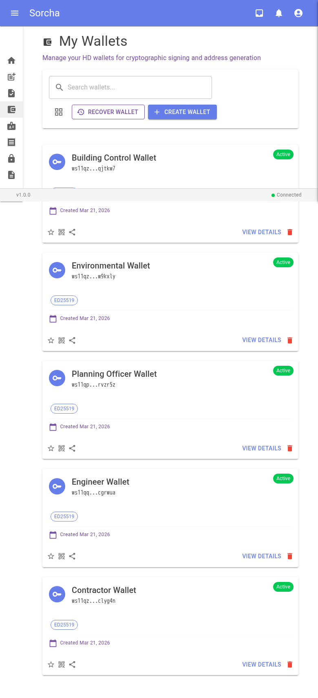
Figure 12: My Wallets — 5 active ED25519 wallets for all participant roles

12. User Story: Manage Blueprints
As a workflow designer, I want to view and manage my blueprint definitions so that I can publish workflows to registers for participants to use.
The My Blueprints page shows all blueprint definitions with their status, version, and available actions (View, Visual Editor, AI Chat, Publish, Delete). The Construction Permit Approval blueprint is shown with its full description and v1 version tag.
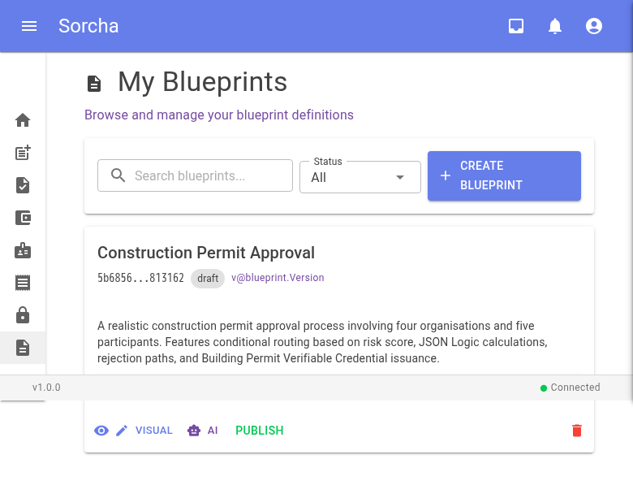
Figure 13: My Blueprints — Construction Permit Approval with Visual/AI/Publish options

13. Bulk Execution: 15 Construction Projects
To demonstrate the platform's throughput and data variety, 15 construction projects were executed programmatically via the API Gateway. The projects span residential, commercial, and industrial building types with floor areas from 65m² to 8,000m² and estimated values from GBP 120,000 to GBP 15,000,000.
Each project followed the full 5 or 6 action workflow depending on its calculated risk score. Projects with a risk score >= 7 were routed through the environmental assessment (6 actions); low-risk projects skipped it (5 actions). All 15 projects were approved and issued building permit credentials.

Risk Score Calculation
The risk score is calculated by the Structural Assessment action using JSON Logic:
riskScore = (storeys x 1.5 + floorArea / 500) x typeMultiplier
Where typeMultiplier: residential=1.0, commercial=1.2, industrial=1.5

Permit Fee Calculation
The permit fee is calculated by the Building Control action:
permitFee = max(250, estimatedValue x 0.002 + floorArea x 1.50)

14. Appendix: Project Summary Table
# | Project | Type | Storeys | Area (m²) | Value (GBP) | Actions | Permit
1 | Riverside Heights | residential | 3 | 800 | 500,000 | 5 | RBC-2026-00100
2 | Central Business Tower | commercial | 8 | 3,500 | 5,000,000 | 6 | RBC-2026-00101
3 | Harbour View Apartments | residential | 5 | 2,000 | 2,200,000 | 6 | RBC-2026-00102
4 | Greenfield Primary School | commercial | 2 | 2,800 | 3,500,000 | 6 | RBC-2026-00103
5 | Eastside Retail Park | commercial | 1 | 5,000 | 8,000,000 | 6 | RBC-2026-00104
6 | Mill Conversion Lofts | residential | 4 | 1,500 | 1,800,000 | 6 | RBC-2026-00105
7 | Northgate Industrial Unit | industrial | 2 | 4,000 | 4,500,000 | 6 | RBC-2026-00106
8 | Willow Court Care Home | commercial | 3 | 3,200 | 6,000,000 | 6 | RBC-2026-00107
9 | The Paddock Bungalow | residential | 1 | 95 | 180,000 | 5 | RBC-2026-00108
10 | Station Quarter Hotel | commercial | 6 | 6,000 | 12,000,000 | 6 | RBC-2026-00109
11 | Oakwood Family Home | residential | 2 | 180 | 350,000 | 5 | RBC-2026-00110
12 | Southbank Warehouse | industrial | 1 | 3,000 | 2,500,000 | 6 | RBC-2026-00111
13 | Crofters Cottage | residential | 1 | 65 | 120,000 | 5 | RBC-2026-00112
14 | Lakeside Office Campus | commercial | 4 | 8,000 | 15,000,000 | 6 | RBC-2026-00113
15 | Heritage Terrace Row | residential | 3 | 600 | 900,000 | 5 | RBC-2026-00114
16 | Waterfront Library | commercial | 3 | 2,400 | 4,200,000 | - | UI Submitted

Total Transactions on Register: 88
Register Height: 88 dockets
Chain Integrity: All dockets Valid

Document generated from Sorcha Platform walkthrough, 21 March 2026.

