Demographics of First 5 Ventura

Gwendolyn Reynolds

1/30/2018

|  |  |  |
| --- | --- | --- |
| school_year | count | perc |
| 2005 | 1 | 0.0337724 |
| 2006 | 7 | 0.2364066 |
| 2007 | 5 | 0.1688619 |
| 2008 | 7 | 0.2364066 |
| 2009 | 18 | 0.6079027 |
| 2010 | 39 | 1.3171226 |
| 2011 | 67 | 2.2627491 |
| 2012 | 90 | 3.0395137 |
| 2013 | 227 | 7.6663289 |
| 2014 | 866 | 29.2468761 |
| 2015 | 738 | 24.9240122 |
| 2016 | 530 | 17.8993583 |
| 2017 | 355 | 11.9891928 |
| NA | 11 | 0.3714961 |

## Warning: Removed 1 rows containing missing values (position_stack).

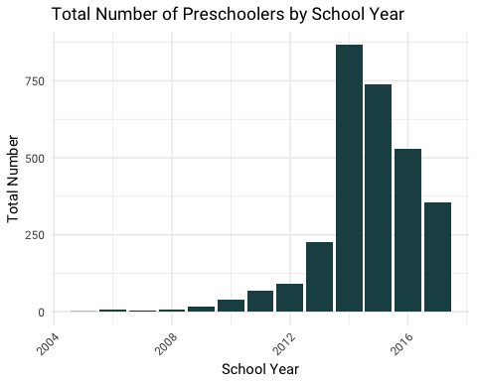

|  |  |  |
| --- | --- | --- |
| Ethnicity | count | perc |
| 04. Hispanic / Latino | 1770 | 71.19871 |
| 07. White | 390 | 15.68785 |
| Other | 326 | 13.11344 |

|  |  |  |  |
| --- | --- | --- | --- |
| school_year | Ethnicity | count | perc |
| 2014 | 04. Hispanic / Latino | 655 | 75.635104 |
| 2014 | 07. White | 110 | 12.702079 |
| 2014 | Other | 101 | 11.662818 |
| 2015 | 04. Hispanic / Latino | 567 | 76.829268 |
| 2015 | 07. White | 98 | 13.279133 |
| 2015 | Other | 73 | 9.891599 |
| 2016 | 04. Hispanic / Latino | 324 | 61.247637 |
| 2016 | 07. White | 115 | 21.739130 |
| 2016 | Other | 90 | 17.013233 |
| 2017 | 04. Hispanic / Latino | 224 | 63.456091 |
| 2017 | 07. White | 67 | 18.980170 |
| 2017 | Other | 62 | 17.563739 |

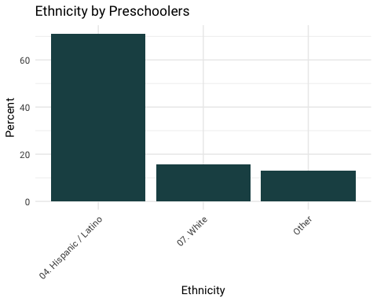

|  |  |  |
| --- | --- | --- |
| Language | count | perc |
| 01. English | 1349 | 54.395161 |
| 02. Spanish | 1015 | 40.927419 |
| Other | 116 | 4.677419 |

|  |  |  |  |
| --- | --- | --- | --- |
| school_year | Language | count | perc |
| 2014 | 01. English | 410 | 47.344111 |
| 2014 | 02. Spanish | 403 | 46.535797 |
| 2014 | Other | 53 | 6.120092 |
| 2015 | 01. English | 386 | 52.374491 |
| 2015 | 02. Spanish | 327 | 44.369064 |
| 2015 | Other | 24 | 3.256445 |
| 2016 | 01. English | 342 | 64.772727 |
| 2016 | 02. Spanish | 167 | 31.628788 |
| 2016 | Other | 19 | 3.598485 |
| 2017 | 01. English | 211 | 60.458453 |
| 2017 | 02. Spanish | 118 | 33.810888 |
| 2017 | Other | 20 | 5.730659 |

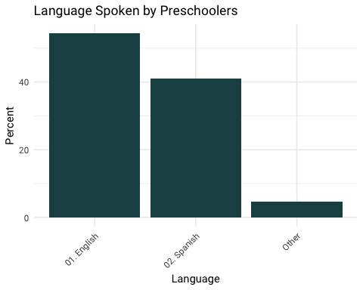

|  |  |  |
| --- | --- | --- |
| income | count | perc |
| $10,000 less than $20,000 | 201 | 13.645621 |
| $20,000 less than $30,000 | 222 | 15.071283 |
| $30,000 less than $40,000 | 155 | 10.522743 |
| $40,000 less than $50,000 | 149 | 10.115411 |
| $50,000 less than $75,000 | 194 | 13.170400 |
| $75,000 less than $100,000 | 119 | 8.078751 |
| Less than $10,000 | 169 | 11.473184 |
| More than $100,000 | 86 | 5.838425 |
| No answer/prefer not to say | 178 | 12.084182 |

|  |  |  |  |
| --- | --- | --- | --- |
| school_year | income | count | perc |
| 2014 | $10,000 less than $20,000 | 65 | 19.287834 |
| 2014 | $20,000 less than $30,000 | 58 | 17.210683 |
| 2014 | $30,000 less than $40,000 | 38 | 11.275964 |
| 2014 | $40,000 less than $50,000 | 33 | 9.792285 |
| 2014 | $50,000 less than $75,000 | 30 | 8.902077 |
| 2014 | $75,000 less than $100,000 | 17 | 5.044510 |
| 2014 | Less than $10,000 | 55 | 16.320475 |
| 2014 | More than $100,000 | 7 | 2.077151 |
| 2014 | No answer/prefer not to say | 34 | 10.089021 |
| 2015 | $10,000 less than $20,000 | 52 | 14.525140 |
| 2015 | $20,000 less than $30,000 | 55 | 15.363129 |
| 2015 | $30,000 less than $40,000 | 31 | 8.659218 |
| 2015 | $40,000 less than $50,000 | 30 | 8.379888 |
| 2015 | $50,000 less than $75,000 | 43 | 12.011173 |
| 2015 | $75,000 less than $100,000 | 28 | 7.821229 |
| 2015 | Less than $10,000 | 48 | 13.407821 |
| 2015 | More than $100,000 | 10 | 2.793296 |
| 2015 | No answer/prefer not to say | 61 | 17.039106 |
| 2016 | $10,000 less than $20,000 | 52 | 11.479029 |
| 2016 | $20,000 less than $30,000 | 61 | 13.465784 |
| 2016 | $30,000 less than $40,000 | 49 | 10.816777 |
| 2016 | $40,000 less than $50,000 | 59 | 13.024283 |
| 2016 | $50,000 less than $75,000 | 68 | 15.011038 |
| 2016 | $75,000 less than $100,000 | 40 | 8.830022 |
| 2016 | Less than $10,000 | 41 | 9.050773 |
| 2016 | More than $100,000 | 36 | 7.947020 |
| 2016 | No answer/prefer not to say | 47 | 10.375276 |
| 2017 | $10,000 less than $20,000 | 32 | 9.846154 |
| 2017 | $20,000 less than $30,000 | 48 | 14.769231 |
| 2017 | $30,000 less than $40,000 | 37 | 11.384615 |
| 2017 | $40,000 less than $50,000 | 27 | 8.307692 |
| 2017 | $50,000 less than $75,000 | 53 | 16.307692 |
| 2017 | $75,000 less than $100,000 | 34 | 10.461538 |
| 2017 | Less than $10,000 | 25 | 7.692308 |
| 2017 | More than $100,000 | 33 | 10.153846 |
| 2017 | No answer/prefer not to say | 36 | 11.076923 |

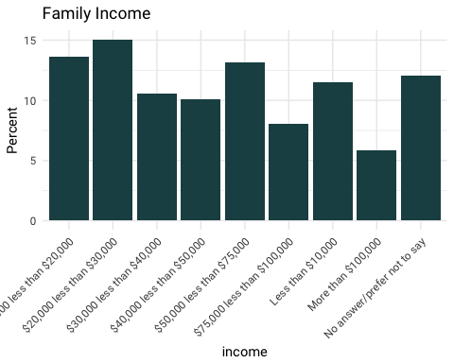

|  |
| --- |
| meanHouseholdMembers |
| 4.57367 |

|  |  |
| --- | --- |
| school_year | meanHouseholdMembers |
| 2014 | 5.047904 |
| 2015 | 4.473239 |
| 2016 | 4.504425 |
| 2017 | 4.292308 |

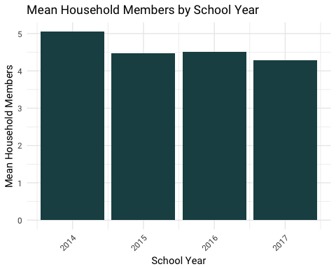

|  |  |  |
| --- | --- | --- |
| Gender | count | perc |
| F | 1241 | 49.85938 |
| M | 1248 | 50.14062 |

|  |  |  |  |
| --- | --- | --- | --- |
| school_year | Gender | count | perc |
| 2014 | F | 435 | 50.23095 |
| 2014 | M | 431 | 49.76905 |
| 2015 | F | 362 | 49.05149 |
| 2015 | M | 376 | 50.94851 |
| 2016 | F | 260 | 49.05660 |
| 2016 | M | 270 | 50.94340 |
| 2017 | F | 184 | 51.83099 |
| 2017 | M | 171 | 48.16901 |

