Demographics of First 5 Ventura

Gwendolyn Reynolds

2/14/2018

### Zip Code Analysis

Below we construct a Federal Poverty Line ratio for each preschooler in our dataset and examine the distribution by Zip Code.

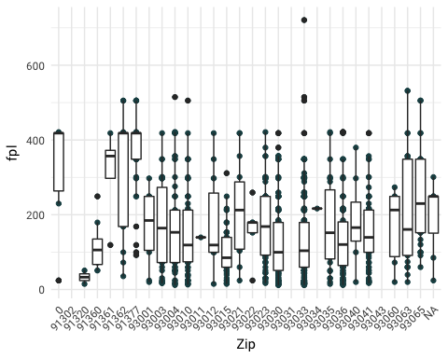

|  |  |  |  |
| --- | --- | --- | --- |
| Zip | meanfpl | medianfpl | count |
| 91320 | 32.90246 | 32.90246 | 23 |
| 93015 | 101.60039 | 84.97621 | 213 |
| 91360 | 116.77364 | 105.71900 | 69 |
| 93030 | 130.67818 | 99.60159 | 232 |
| 93033 | 131.99989 | 103.73444 | 581 |
| 93036 | 138.03204 | 120.30799 | 183 |
| 93011 | 139.44223 | 139.44223 | 1 |
| 93010 | 151.20458 | 118.96669 | 84 |
| 93041 | 152.79033 | 139.44223 | 210 |
| 93022 | 158.76936 | 179.28287 | 12 |
| 93001 | 167.76321 | 184.65599 | 11 |
| 93060 | 168.55346 | 212.63670 | 9 |
| 93012 | 170.38153 | 118.96669 | 14 |
| 93003 | 171.45329 | 164.21440 | 76 |
| 93004 | 172.44610 | 152.95717 | 103 |
| 93023 | 173.08931 | 168.43118 | 91 |
| 93035 | 176.77638 | 151.82831 | 46 |
| 93040 | 184.96200 | 165.58311 | 33 |
| NA | 196.19630 | 249.00398 | 295 |
| 93063 | 210.69132 | 160.69418 | 39 |
| 93021 | 214.86391 | 212.44052 | 24 |
| 93034 | 216.55438 | 216.55438 | 1 |
| 93065 | 248.48399 | 229.90016 | 40 |
| 91362 | 308.14729 | 418.32669 | 53 |
| 91361 | 312.77338 | 356.90007 | 10 |
| 0 | 318.77074 | 418.32669 | 21 |
| 91377 | 371.74739 | 418.32669 | 87 |
| 91302 | NaN | NA | 1 |
| 93031 | NaN | NA | 2 |
| 93043 | NaN | NA | 2 |

Table 1. Total Preschoolers Served by First5 Ventura by Year

|  |  |  |
| --- | --- | --- |
| school_year | count | perc |
| 2014 | 867 | 33.7879969 |
| 2015 | 737 | 28.7217459 |
| 2016 | 541 | 21.0833983 |
| 2017 | 416 | 16.2120031 |
| 2018 | 5 | 0.1948558 |

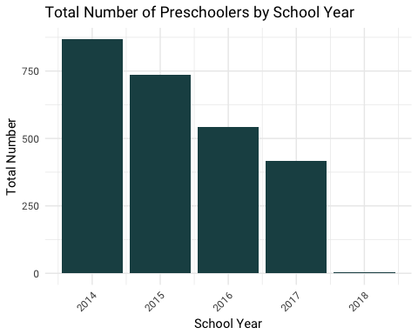

Table 2. Total Ethnicity of Preschoolers

|  |  |  |
| --- | --- | --- |
| Ethnicity | count | perc |
| 04. Hispanic / Latino | 1807 | 70.47582 |
| 07. White | 421 | 16.41966 |
| Other | 336 | 13.10452 |

Table 3. Ethnicity by Year

|  |  |  |  |
| --- | --- | --- | --- |
| school_year | Ethnicity | count | perc |
| 2014 | 04. Hispanic / Latino | 657 | 75.778547 |
| 2014 | 07. White | 109 | 12.572088 |
| 2014 | Other | 101 | 11.649366 |
| 2015 | 04. Hispanic / Latino | 567 | 76.933514 |
| 2015 | 07. White | 100 | 13.568521 |
| 2015 | Other | 70 | 9.497965 |
| 2016 | 04. Hispanic / Latino | 329 | 60.813309 |
| 2016 | 07. White | 120 | 22.181146 |
| 2016 | Other | 92 | 17.005545 |
| 2017 | 04. Hispanic / Latino | 252 | 60.869565 |
| 2017 | 07. White | 91 | 21.980676 |
| 2017 | Other | 71 | 17.149759 |
| 2018 | 04. Hispanic / Latino | 2 | 40.000000 |
| 2018 | 07. White | 1 | 20.000000 |
| 2018 | Other | 2 | 40.000000 |

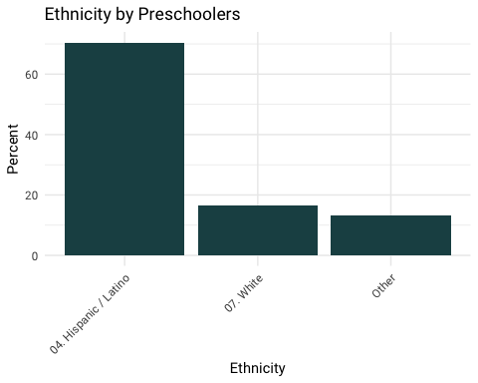

Table 4. Total Language Spoken by First5 Ventura Preschoolers

|  |  |  |
| --- | --- | --- |
| Language | count | perc |
| 01. English | 1406 | 54.92188 |
| 02. Spanish | 1034 | 40.39062 |
| Other | 120 | 4.68750 |

Table 5. Language Spoken by Year

|  |  |  |  |
| --- | --- | --- | --- |
| school_year | Language | count | perc |
| 2014 | 01. English | 411 | 47.404844 |
| 2014 | 02. Spanish | 403 | 46.482122 |
| 2014 | Other | 53 | 6.113033 |
| 2015 | 01. English | 385 | 52.309783 |
| 2015 | 02. Spanish | 327 | 44.429348 |
| 2015 | Other | 24 | 3.260870 |
| 2016 | 01. English | 349 | 64.510166 |
| 2016 | 02. Spanish | 172 | 31.792976 |
| 2016 | Other | 20 | 3.696858 |
| 2017 | 01. English | 257 | 62.530414 |
| 2017 | 02. Spanish | 131 | 31.873479 |
| 2017 | Other | 23 | 5.596107 |
| 2018 | 01. English | 4 | 80.000000 |
| 2018 | 02. Spanish | 1 | 20.000000 |

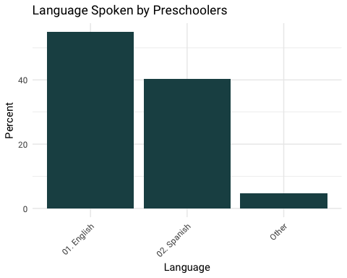

Table 6. Income for First 5 Ventura Preschoolers

|  |  |  |
| --- | --- | --- |
| income | count | perc |
| $10,000 less than $20,000 | 192 | 13.025780 |
| $20,000 less than $30,000 | 223 | 15.128901 |
| $30,000 less than $40,000 | 158 | 10.719132 |
| $40,000 less than $50,000 | 150 | 10.176391 |
| $50,000 less than $75,000 | 201 | 13.636364 |
| $75,000 less than $100,000 | 120 | 8.141113 |
| Less than $10,000 | 167 | 11.329715 |
| More than $100,000 | 84 | 5.698779 |
| No answer/prefer not to say | 179 | 12.143826 |

Table 7. Income by Year

|  |  |  |  |
| --- | --- | --- | --- |
| school_year | income | count | perc |
| 2014 | $10,000 less than $20,000 | 65 | 19.174041 |
| 2014 | $20,000 less than $30,000 | 59 | 17.404130 |
| 2014 | $30,000 less than $40,000 | 38 | 11.209440 |
| 2014 | $40,000 less than $50,000 | 34 | 10.029499 |
| 2014 | $50,000 less than $75,000 | 30 | 8.849557 |
| 2014 | $75,000 less than $100,000 | 17 | 5.014749 |
| 2014 | Less than $10,000 | 55 | 16.224189 |
| 2014 | More than $100,000 | 7 | 2.064897 |
| 2014 | No answer/prefer not to say | 34 | 10.029499 |
| 2015 | $10,000 less than $20,000 | 52 | 14.444444 |
| 2015 | $20,000 less than $30,000 | 55 | 15.277778 |
| 2015 | $30,000 less than $40,000 | 31 | 8.611111 |
| 2015 | $40,000 less than $50,000 | 30 | 8.333333 |
| 2015 | $50,000 less than $75,000 | 45 | 12.500000 |
| 2015 | $75,000 less than $100,000 | 28 | 7.777778 |
| 2015 | Less than $10,000 | 48 | 13.333333 |
| 2015 | More than $100,000 | 10 | 2.777778 |
| 2015 | No answer/prefer not to say | 61 | 16.944444 |
| 2016 | $10,000 less than $20,000 | 46 | 10.823529 |
| 2016 | $20,000 less than $30,000 | 58 | 13.647059 |
| 2016 | $30,000 less than $40,000 | 47 | 11.058824 |
| 2016 | $40,000 less than $50,000 | 54 | 12.705882 |
| 2016 | $50,000 less than $75,000 | 66 | 15.529412 |
| 2016 | $75,000 less than $100,000 | 36 | 8.470588 |
| 2016 | Less than $10,000 | 39 | 9.176471 |
| 2016 | More than $100,000 | 34 | 8.000000 |
| 2016 | No answer/prefer not to say | 45 | 10.588235 |
| 2017 | $10,000 less than $20,000 | 29 | 8.381503 |
| 2017 | $20,000 less than $30,000 | 50 | 14.450867 |
| 2017 | $30,000 less than $40,000 | 42 | 12.138728 |
| 2017 | $40,000 less than $50,000 | 32 | 9.248555 |
| 2017 | $50,000 less than $75,000 | 59 | 17.052023 |
| 2017 | $75,000 less than $100,000 | 38 | 10.982659 |
| 2017 | Less than $10,000 | 25 | 7.225434 |
| 2017 | More than $100,000 | 32 | 9.248555 |
| 2017 | No answer/prefer not to say | 39 | 11.271676 |
| 2018 | $20,000 less than $30,000 | 1 | 25.000000 |
| 2018 | $50,000 less than $75,000 | 1 | 25.000000 |
| 2018 | $75,000 less than $100,000 | 1 | 25.000000 |
| 2018 | More than $100,000 | 1 | 25.000000 |

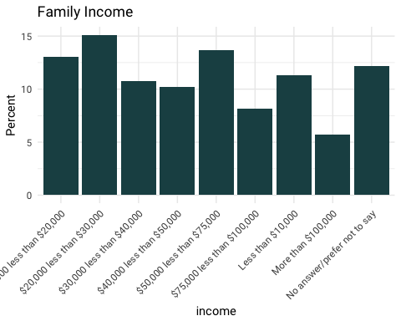

Table 8. Mean Household Members for First 5 Ventura Preschoolers

|  |
| --- |
| meanHouseholdMembers |
| 4.563438 |

Table 9. Mean Household Members by School Year

|  |  |
| --- | --- |
| school_year | meanHouseholdMembers |
| 2014 | 5.041667 |
| 2015 | 4.472067 |
| 2016 | 4.504717 |
| 2017 | 4.273256 |
| 2018 | 3.750000 |

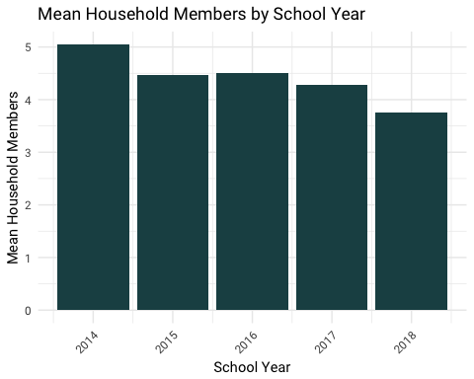

Let’s see how the Federal Poverty Level data for the First 5 Ventura Zip Codes compare to the ACS data.

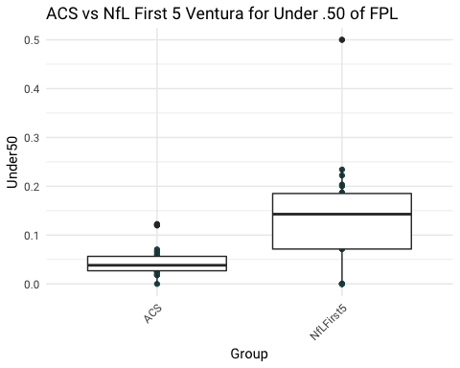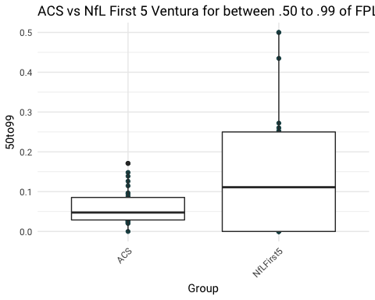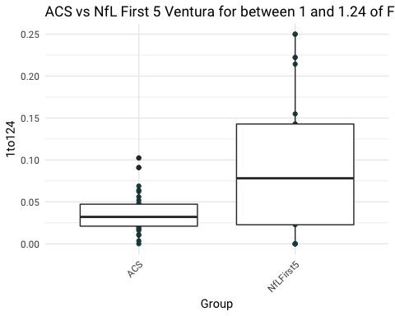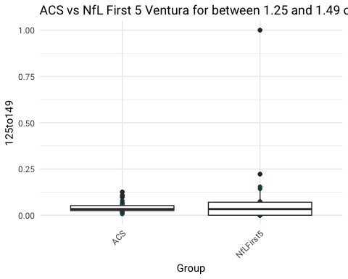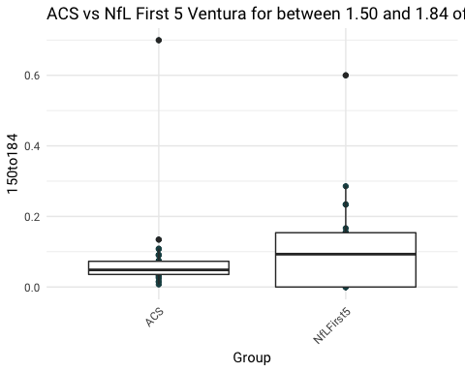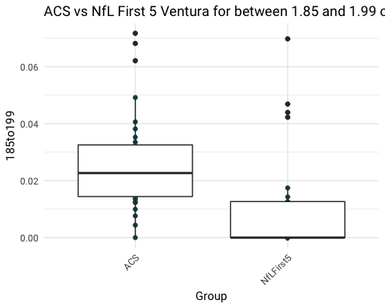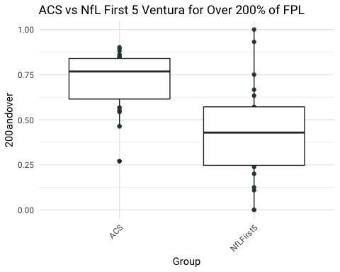

|  |  |  |  |  |  |  |  |  |
| --- | --- | --- | --- | --- | --- | --- | --- | --- |
| Zip | Group | Under50 | 50to99 | 1to124 | 125to149 | 150to184 | 185to199 | 200andover |
| 90265 | ACS | 0.0669004 | 0.0221277 | 0.0171849 | 0.0121271 | 0.0151733 | 0.0043681 | 0.8621185 |
| 91304 | ACS | 0.0707212 | 0.0945434 | 0.0518125 | 0.0433810 | 0.0755200 | 0.0335156 | 0.6305063 |
| 91307 | ACS | 0.0254340 | 0.0330566 | 0.0215849 | 0.0290943 | 0.0356226 | 0.0140377 | 0.8411698 |
| 91311 | ACS | 0.0368661 | 0.0499987 | 0.0159542 | 0.0404261 | 0.0441180 | 0.0236017 | 0.7890351 |
| 91320 | ACS | 0.0177376 | 0.0329129 | 0.0338186 | 0.0158600 | 0.0275894 | 0.0125025 | 0.8595790 |
| 91320 | NfLFirst5 | 0.5000000 | 0.5000000 | 0.0000000 | 0.0000000 | 0.0000000 | 0.0000000 | 0.0000000 |
| 91360 | ACS | 0.0401856 | 0.0531981 | 0.0265751 | 0.0259771 | 0.0352103 | 0.0217194 | 0.7971344 |
| 91360 | NfLFirst5 | 0.0000000 | 0.5000000 | 0.2500000 | 0.0000000 | 0.1250000 | 0.0000000 | 0.1250000 |
| 91361 | ACS | 0.0269513 | 0.0269030 | 0.0211553 | 0.0161321 | 0.0071484 | 0.0076314 | 0.8940784 |
| 91361 | NfLFirst5 | 0.0000000 | 0.0000000 | 0.2500000 | 0.0000000 | 0.0000000 | 0.0000000 | 0.7500000 |
| 91362 | ACS | 0.0186953 | 0.0293862 | 0.0227254 | 0.0219137 | 0.0455067 | 0.0134057 | 0.8483670 |
| 91362 | NfLFirst5 | 0.0833333 | 0.0833333 | 0.0000000 | 0.0000000 | 0.1666667 | 0.0000000 | 0.6666667 |
| 91377 | ACS | 0.0246922 | 0.0207899 | 0.0206553 | 0.0071318 | 0.0150037 | 0.0099576 | 0.9017695 |
| 91377 | NfLFirst5 | 0.0000000 | 0.0227273 | 0.0227273 | 0.0000000 | 0.0227273 | 0.0000000 | 0.9318182 |
| 93001 | ACS | 0.0561293 | 0.0890152 | 0.0481236 | 0.0471415 | 0.0906818 | 0.0262790 | 0.6426297 |
| 93001 | NfLFirst5 | 0.2222222 | 0.0000000 | 0.2222222 | 0.0000000 | 0.0000000 | 0.0000000 | 0.5555556 |
| 93003 | ACS | 0.0508832 | 0.0384438 | 0.0314503 | 0.0321135 | 0.0481703 | 0.0204377 | 0.7785012 |
| 93003 | NfLFirst5 | 0.1627907 | 0.1395349 | 0.0697674 | 0.0697674 | 0.0930233 | 0.0697674 | 0.3953488 |
| 93004 | ACS | 0.0482116 | 0.0689495 | 0.0227288 | 0.0312562 | 0.0301613 | 0.0322185 | 0.7664742 |
| 93004 | NfLFirst5 | 0.1093750 | 0.2031250 | 0.0781250 | 0.0468750 | 0.2343750 | 0.0468750 | 0.2812500 |
| 93010 | ACS | 0.0284275 | 0.0426980 | 0.0396125 | 0.0335776 | 0.0488690 | 0.0152007 | 0.7916147 |
| 93010 | NfLFirst5 | 0.1690141 | 0.1830986 | 0.1549296 | 0.0704225 | 0.0845070 | 0.0422535 | 0.2957746 |
| 93011 | NfLFirst5 | 0.0000000 | 0.0000000 | 0.0000000 | 1.0000000 | 0.0000000 | 0.0000000 | 0.0000000 |
| 93012 | ACS | 0.0294461 | 0.0204179 | 0.0101940 | 0.0174584 | 0.0247825 | 0.0161430 | 0.8815581 |
| 93012 | NfLFirst5 | 0.1111111 | 0.0000000 | 0.2222222 | 0.2222222 | 0.0000000 | 0.0000000 | 0.4444444 |
| 93013 | ACS | 0.0326545 | 0.0452464 | 0.0469334 | 0.0530787 | 0.0719364 | 0.0241595 | 0.7259911 |
| 93015 | ACS | 0.0493792 | 0.1481375 | 0.0559899 | 0.0574270 | 0.1072086 | 0.0145436 | 0.5673143 |
| 93015 | NfLFirst5 | 0.1739130 | 0.4347826 | 0.0652174 | 0.0652174 | 0.1521739 | 0.0000000 | 0.1086957 |
| 93021 | ACS | 0.0190140 | 0.0389449 | 0.0212255 | 0.0197422 | 0.0437456 | 0.0180430 | 0.8392848 |
| 93021 | NfLFirst5 | 0.0714286 | 0.0714286 | 0.2142857 | 0.0000000 | 0.0714286 | 0.0000000 | 0.5714286 |
| 93022 | ACS | 0.0268644 | 0.0619840 | 0.0372184 | 0.0330208 | 0.0369386 | 0.0352595 | 0.7687141 |
| 93022 | NfLFirst5 | 0.2000000 | 0.0000000 | 0.0000000 | 0.0000000 | 0.6000000 | 0.0000000 | 0.2000000 |
| 93023 | ACS | 0.0473848 | 0.0804638 | 0.0342335 | 0.0441723 | 0.0424154 | 0.0122980 | 0.7390322 |
| 93023 | NfLFirst5 | 0.1285714 | 0.1428571 | 0.1428571 | 0.0285714 | 0.1000000 | 0.0142857 | 0.4428571 |
| 93030 | ACS | 0.0589601 | 0.1261904 | 0.0623517 | 0.0793598 | 0.0914392 | 0.0298894 | 0.5518094 |
| 93030 | NfLFirst5 | 0.2341772 | 0.2721519 | 0.0443038 | 0.0506329 | 0.1392405 | 0.0126582 | 0.2468354 |
| 93033 | ACS | 0.0615533 | 0.1388023 | 0.0908991 | 0.0980347 | 0.1089085 | 0.0381496 | 0.4636525 |
| 93033 | NfLFirst5 | 0.2034884 | 0.2529070 | 0.1308140 | 0.0494186 | 0.1075581 | 0.0174419 | 0.2383721 |
| 93034 | NfLFirst5 | 0.0000000 | 0.0000000 | 0.0000000 | 0.0000000 | 0.0000000 | 0.0000000 | 1.0000000 |
| 93035 | ACS | 0.0274036 | 0.0273325 | 0.0410165 | 0.0234939 | 0.0588591 | 0.0620935 | 0.7598010 |
| 93035 | NfLFirst5 | 0.1851852 | 0.1111111 | 0.1111111 | 0.0740741 | 0.0740741 | 0.0000000 | 0.4444444 |
| 93036 | ACS | 0.0395223 | 0.0968512 | 0.0639305 | 0.0521824 | 0.0714007 | 0.0406298 | 0.6354832 |
| 93036 | NfLFirst5 | 0.1875000 | 0.2604167 | 0.0625000 | 0.0729167 | 0.1562500 | 0.0104167 | 0.2500000 |
| 93040 | ACS | 0.0318182 | 0.0838384 | 0.0035354 | 0.1080808 | 0.1343434 | 0.0717172 | 0.5666667 |
| 93040 | NfLFirst5 | 0.1428571 | 0.0000000 | 0.0000000 | 0.1428571 | 0.2857143 | 0.0000000 | 0.4285714 |
| 93041 | ACS | 0.0573853 | 0.0842724 | 0.0310202 | 0.0616924 | 0.0616489 | 0.0281923 | 0.6757886 |
| 93041 | NfLFirst5 | 0.1428571 | 0.0989011 | 0.0989011 | 0.1538462 | 0.1538462 | 0.0439560 | 0.3076923 |
| 93042 | ACS | NaN | NaN | NaN | NaN | NaN | NaN | NaN |
| 93043 | ACS | 0.0000000 | 0.0000000 | 0.0000000 | 0.0306748 | 0.6993865 | 0.0000000 | 0.2699387 |
| 93060 | ACS | 0.0654175 | 0.1146535 | 0.0688462 | 0.0697486 | 0.0896295 | 0.0491759 | 0.5425289 |
| 93060 | NfLFirst5 | 0.1428571 | 0.1428571 | 0.1428571 | 0.0000000 | 0.0000000 | 0.0000000 | 0.5714286 |
| 93063 | ACS | 0.0303525 | 0.0450850 | 0.0326778 | 0.0314708 | 0.0461323 | 0.0205900 | 0.7936916 |
| 93063 | NfLFirst5 | 0.0714286 | 0.2500000 | 0.1071429 | 0.0000000 | 0.0714286 | 0.0000000 | 0.5000000 |
| 93064 | ACS | NaN | NaN | NaN | NaN | NaN | NaN | NaN |
| 93065 | ACS | 0.0221503 | 0.0255944 | 0.0185535 | 0.0258166 | 0.0335241 | 0.0242751 | 0.8500861 |
| 93065 | NfLFirst5 | 0.0000000 | 0.0666667 | 0.0333333 | 0.0333333 | 0.2333333 | 0.0000000 | 0.6333333 |
| 93066 | ACS | 0.0403252 | 0.0240650 | 0.0357724 | 0.0364228 | 0.0565854 | 0.0146341 | 0.7921951 |
| 93225 | ACS | 0.1223905 | 0.0593533 | 0.0110520 | 0.1260745 | 0.0622186 | 0.0681539 | 0.5507573 |
| 93252 | ACS | 0.1198653 | 0.1710438 | 0.1023569 | 0.0444444 | 0.0693603 | 0.0296296 | 0.4632997 |