Bilkent University

Department of Computer Engineering

CS 353

Database Systems

*Final Report*

Group 4

Mehmet Ege Acıcan – 21602186-Section03

Koray Gürses – 21401254-Section01

Gülnihal Muslu – 21502606-Section01

Can Ozan Kaş – 21501228-Section02

Teaching Asistant

Mustafa Can Çavdar

Due Date: 21.05.2019

Contents

1 Introduction 1

1 Brief Description of the Application System 3

2 Final Conceptual Design 4

3 Final Logical Design 5

4 Implementation Details 5

5 Advanced Database Features_________________________________________ 5

6 User Manual______________________________________________________ 6

1. Introduction

The following is a report of a Company Interview Website Data System. The proposal will include: brief description of the Application, the final versions of the Conceptual and Logical Design, Implementation details, Advanced Database Features and User manual. Conceptual Design will include E/R Diagram of the Database and Notes about the diagram while the Logical Design will include the tables of the Database based from the E/R Diagram. In implementation details, the environment, framework, languages we used explicitly and the problems that we have encountered are described. User manual describes the basic usage of our system.

The final report outline starts with the Project description, which will try to explain what the database system is about and why it is required in this project. After the description, These discussions will be followed by the conceptual design which will show the E/R diagram and discuss specific topics about it. Then, the report will have Logical Design part that will show the tables of the Database System. Later, The report focuses on the Implementation details in which the environment, framework, used languages and the problems that we have encountered are described. Then, the report focuses on the Advanced SQL techniques that we have used and finally offers a user manual.

1. Brief Description of the Application System

Company Interview and Review Platform is a system similar to the Glassdoor job finding website or LinkedIn resume website. With the help of our platform, users are able to search and apply for a specific job and the companies would be able to hire or refuse specific users for themselves. Users are also able to share their informations about themselves and they are able to share their resume in the platform as well. The users are able to review a company as well. However, if a company wants to specific review to be deleted, that review can be removed by the admins if the admin accepts the request made by the company. So, basically this platform is an online Company and Employee review platform that allows the users to choose a specific job and companies to a specific person. Along with this, it is also a resume sharing platform.

1. Final Conceptual Design

The following section contains the Conceptual Design, which consists of the final version of the E/R Diagram.

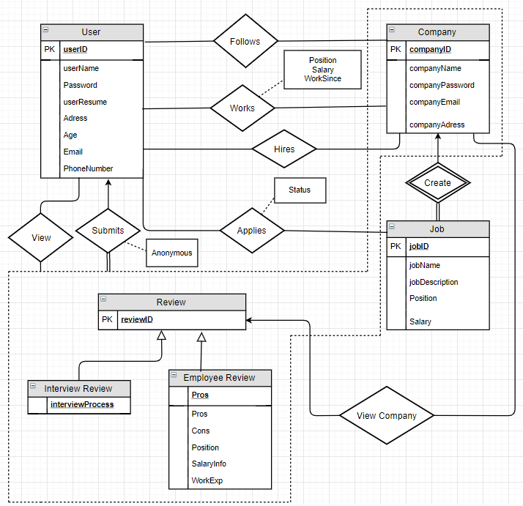

Figure 1: Final E/R Diagram

1. Final List of Tables

The following contains the final list of tables of our Logical Design. No dependencies or queries are included.

User(​UserID​, username, password, Email, userResume, address, age, PhoneNumber)

Job(​JobID, JobName​, Salary, JobDescription, Position)

Applies(​JobID, UserID, JobName, CompanyID​, Status)

FK: JobID ref JobID in Job

FK: UserID ref UserID in User

Submits(​UserID, ReviewID​, CompanyID Anonymous)

FK:CompanyID ref CompanyID in Company

FK: JobID ref JobID in Job

FK: UserID ref UserID in User

Review(​ReviewID​)

InterviewReview(​ReviewID​, InterviewProcess)

EmployeeReview(​ReviewID​, Pros, Cons, Position, SalaryInfo, WorkExp)

Company(​CompanyID​, CompanyName, CompanyAddress, CompanyEmail)

Follows(​CompanyID, UserID​)

FK:CompanyID ref CompanyID in Company

FK: UserID ref UserID in User

Create(​JobID, CompanyID​)

FK:CompanyID ref CompanyID in Company

FK: JobID ref JobID in Job

Works(​UserID, CompanyID​, Position, Salary, WorkSince)

FK: UserID ref UserID in User

FK:CompanyID ref CompanyID in Company

Hires(​CompanyID, userID​)

FK: UserID ref UserID in User

FK:CompanyID ref CompanyID in Company

View(userID,reviewID,companyID)

FK:CompanyID ref CompanyID in Company

FK: JobID ref JobID in Job

FK: UserID ref UserID in User

ViewCompany(companyID,reviewID)

FK:CompanyID ref CompanyID in Company

FK: reviewID ref reviewID in Review

1. Implementation Details

This section focuses on the Implementation details in which the environment, framework, used languages and the problems that we have encountered are described

Environment: As an environment, we have used Maven. Our project is designed to be a Maven project and it is implemented in that way.

Framework: As a framework, we have used Spring Boots. Our project is designed to be a Spring Boot project and it is implemented in that way.

Used Languages: As for Database SQL, mySQL has been used and as for High Level Language, Java Programming Language has been used. Also, HTML and CSS has been used as well. Dijkstra has been used as well.

Several Problems that we have encountered over the implementation: During the implementation, we have received errors specifically about the connection and the update of the database by user interaction. Also it took a considerable amount of time in order to comprehend the Spring Boot therefore using the framework completely has made a problem for us.

1. Advanced Database features

This section describes the advanced database features that are used in our system.

As Advanced Database features, indexing has been used. The index is being used in our Job table due to the immense amount of numbers that the available jobs can be. The indexing has been done on JobName. Triggers have not been used as an advanced Database feature.

1. User Manual

This section is a User manual. It basically describes the basic usage of our system.

The user firstly interacts our initial page where he/she chooses between login or signup options. In these login and signup options, the user is able to choose between Company and User login/signup. So, firstly the user encounters between four options.

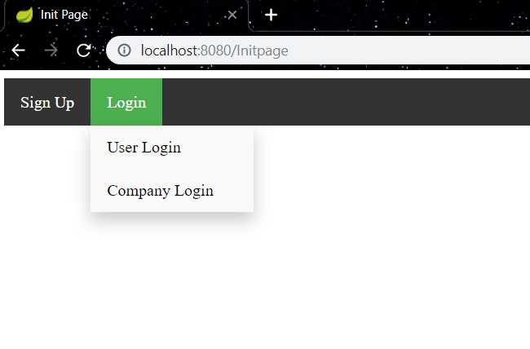

Figure 2: Initial Page: Login

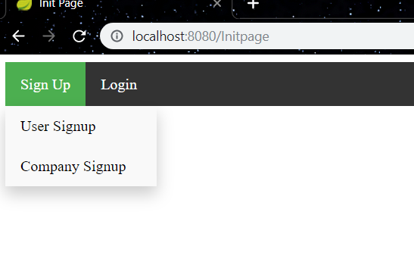

Figure 3: Initial Page: Sign Up

After the user chooses one of the four options. He/She either goes to the User signup, Company Signup, User Login or Company Login Page. If the user has entered to sign up, he/she will encounter another scene where he/she has to enter specific information about himself such as username, password, resume, phone number and address. If a company wants to signup, then the company has to enter specific information about the company.

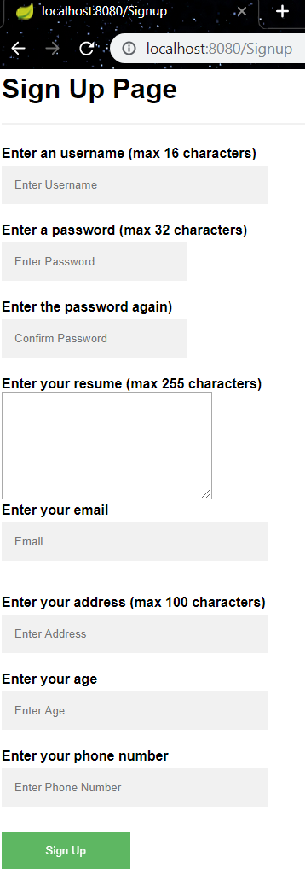

Figure 4: User signup

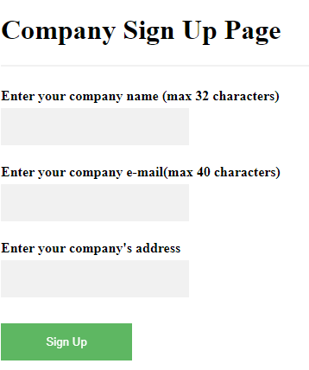

Figure 5:Company signup

If the user or the company already has an account, they have to log in by entering username and password, or if it is a company, the company has to enter the companyID.

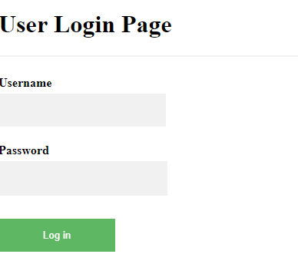

Figure 6:User Login

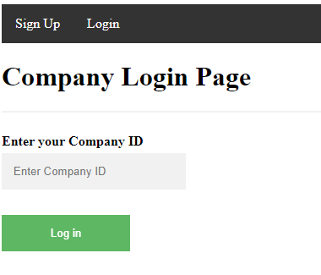

Figure 7:Company Login Page

Once the user has loggged in or signed up, the user is welcomed with a message, then above the message, the user is able to choose multiple options: Search Job, Search Company, Submit Review, Following( goes to the page which shows which companies that the user follows), Applied Job list, Settings and Logout.

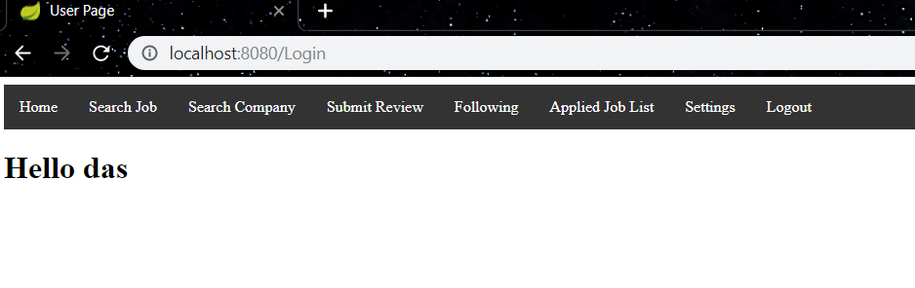

Figure 8: User Page

Once the company has logged in, the company encounters with multiple options as well. These are: Create a Job, View Applicants, Employees, Settings and Logout.

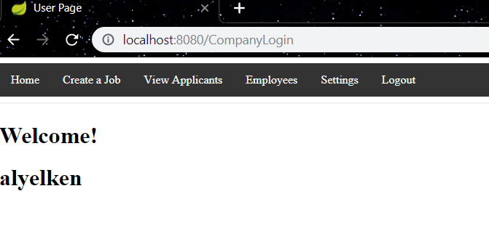

Figure 9: Company Page, Company Name is alyelken

Company options:

Create a job: The Companies can create a job by entering the respective data that their new job will contain: Enter job name, description, position and salary.

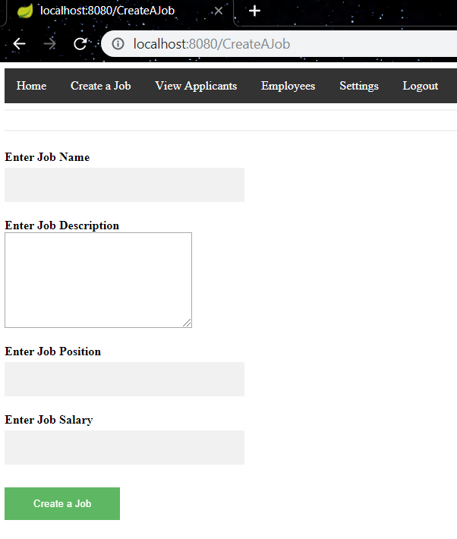

Figure 10: Create a job Page

View Applicants: The companies are able to see the applicants for their jobs. The company can hire or reject the user.

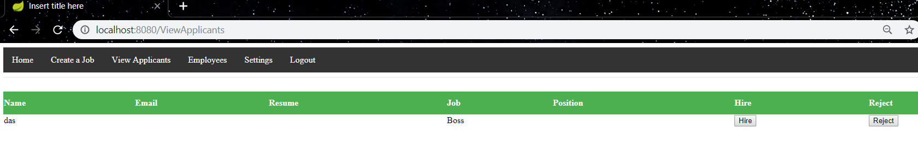

Figure 11: View Applicants page

Employees: The companies are able to see the employees that works for them. They are able to see the employees positions as well.

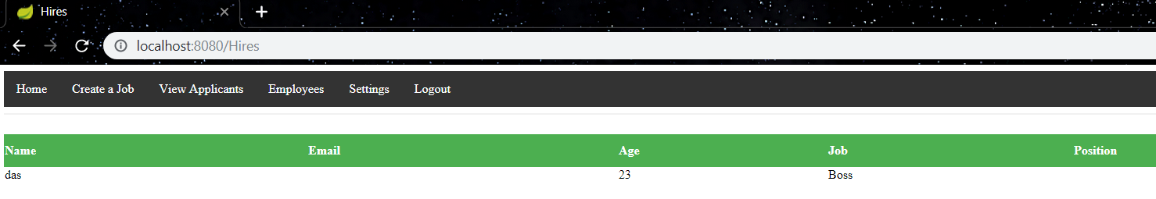

Settings: The companies are able to adjust the settings by changing their company names, company e-mails and company addresses.

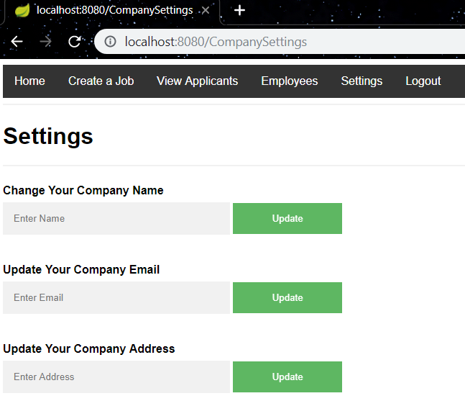

Figure 12: Settings

User options:

Search Job: The users are able to search a job by entering a specific job name or a specific company name. Once entered, the user can see the possible jobs that can be applied to.

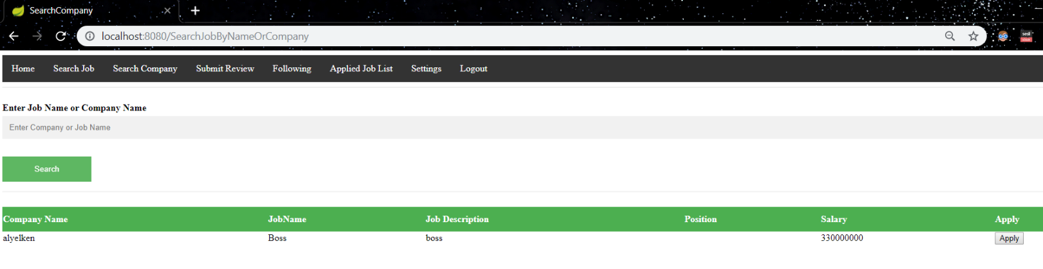

Search Company: Just like searching for a job, the users are able to search companies by their names in order to follow them.

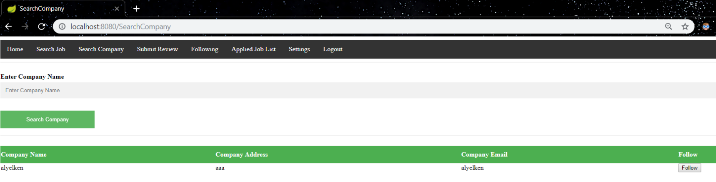

Submit Review: Firstly, the user comes across with the companies that he/she can submit review to, after clicking to submit review button on one company. He/she comes across with the page that asks what type of review that the user will enter. Then, the user enters specific info about him/herself and then enters pros, cons and work experience for the company.

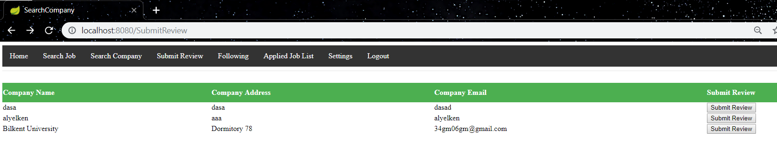

Figure 13:Submit Review company selection screen

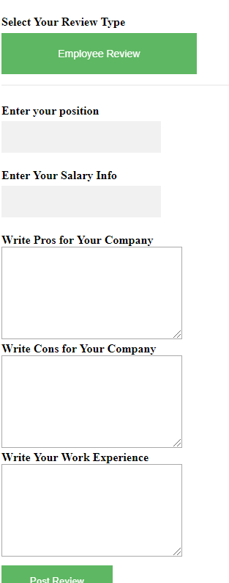

Figure 14:Submit review Post Review Screen

Following: The user can see which companies he/she follows from this page.

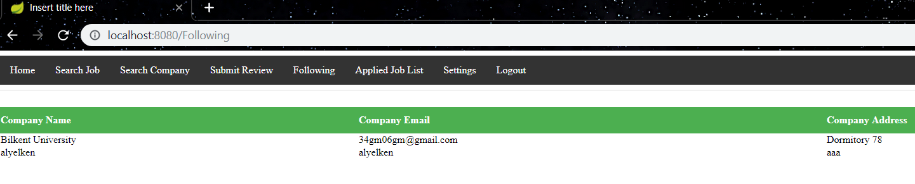

Figure 15: Following Screen

Applied Job List: The user is able to see the jobs that they have applied to.

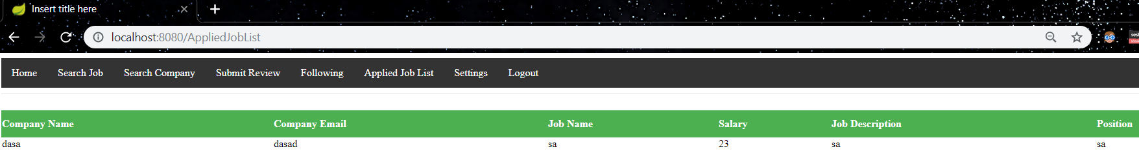

Figure 16: Applied Job list

View Review: Both the users and the companies are able to view what has been written about certain companies by this option. They are able to see who has written the review and they are able to see the viewers Username, Position, Salary, that reviewers personal pros and personal cons about the company.

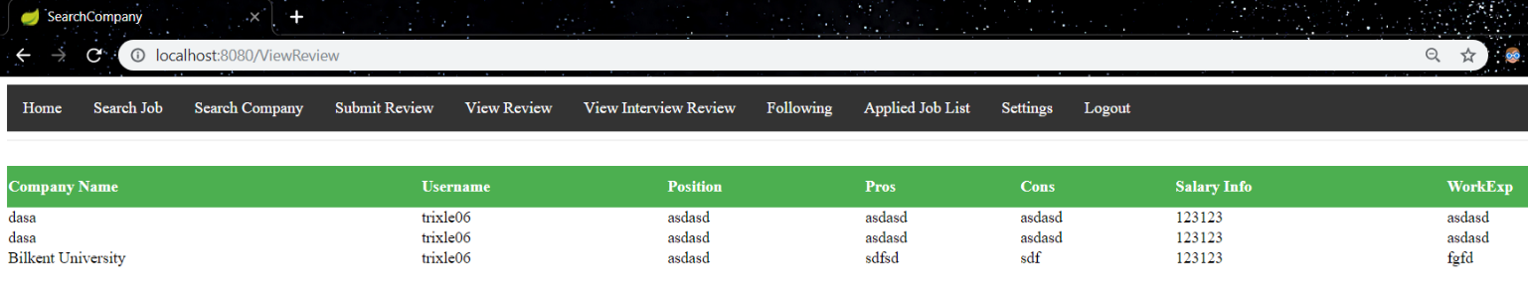

Figure 17: View Review Page

View Interview Review: Both the users and the companies are able to see the Interview view by choosing this option. The users are able to view the Company name, UserName and Interview Process of the Interview Reviews.

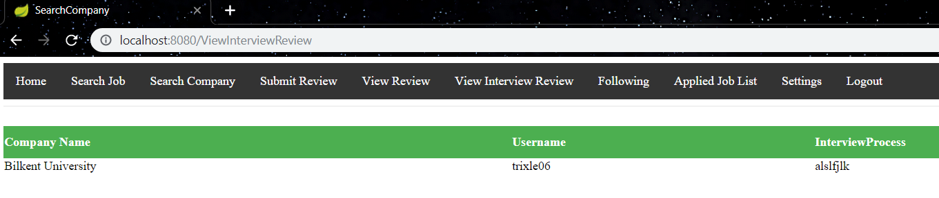

Settings: The user is able to update the password, resume, e-mail, address and phone number by the settings

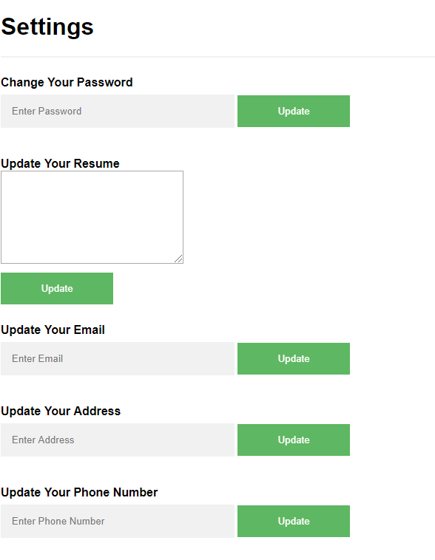

Figure 18: Settings Screen