1.2

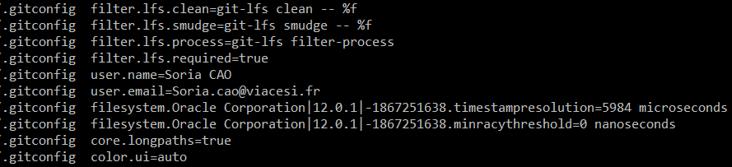

1.3

git init monprojet

git add README.md

git commit -m "Initial commit"

git remote add monprojet https://github.com/Soria54/monprojet.git

git push -u monprojet master

https://github.com/Soria54/monprojet.git

1.4

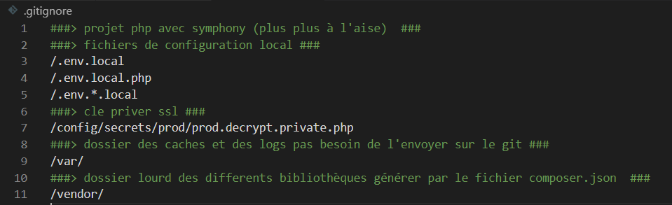

1.5

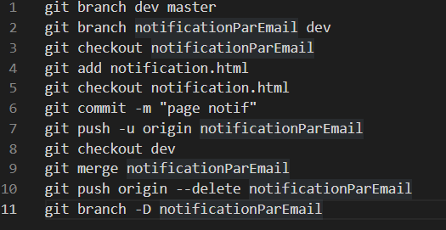

1.6

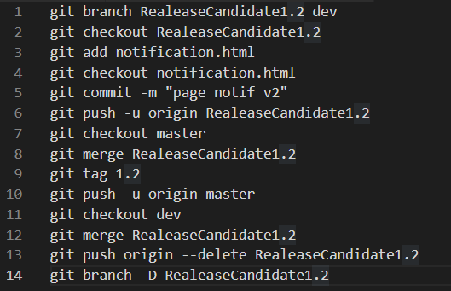

1.7

1.7.1

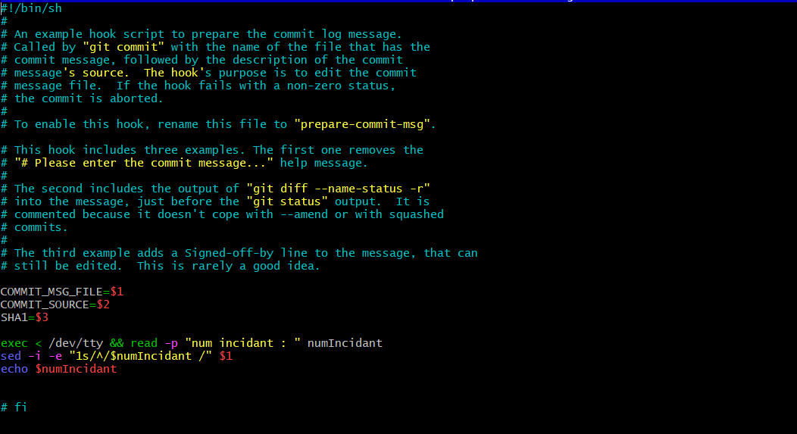

1.7.

