JACON - component power ratings and signal-chain budget
Mini-Circuits parts on hand, with the maximum power each one can take, taken directly from the manufacturer datasheets.
Every number in this document is traceable. Each part has a screenshot cropped from its own datasheet PDF with the page number, plus links to the Mini-Circuits product page and to the PDF saved in datasheets/ next to this file. Nothing here is written from memory: if a value looks wrong, open the linked PDF at the cited page and check it.
Conversion used throughout: P(mW) = 10^(P(dBm)/10). 0 dBm = 1 mW, +17 dBm = 50 mW, +30 dBm = 1 W, -15 dBm = 0.0316 mW.

1. Maximum power each part can take
Two different limits matter. The damage limit is what destroys the part. The P1dB / compression limit is where it stops behaving linearly, which happens long before damage. Both are reproduced as printed on the datasheet, then converted to dBm and mW.
Part | Damage limit, as printed on the datasheet | = dBm | = mW | P1dB / compression | = mW | Page
ZX60-5123LN+ | RF Input Power (CW) +15 dBm | +15.00 | 31.62 | +17.0 dBm | 50.1 mW | p.3
ZX05-14LH-S+ | RF Power 50 mW | +16.99 | 50 | +5.0 dBm | 3.2 mW | p.1
ZX60-14012L-S+ | Input Power (no Damage) 10 dBm | +10.00 | 10 | +11.0 dBm | 12.6 mW | p.1
ZX10-2-1252-S+ | Power Input (as a splitter) 1.85 W | +32.67 | 1850 | passive - n/a | - | p.2
ZX60-P162LN+ | Input RF Power (No Damage) VD=+4 V: +25 dBm | +25.00 | 316.2 | +19.9 dBm | 97.7 mW | p.2
ZX60-P103LN+ | Input RF Power (no damage): 21 dBm (50-2000 MHz), 26 dBm (2000-3000 MHz) | +21.00 | 125.9 | +22.4 dBm | 173.8 mW | p.3
ZX60-2534MA-S+ | Input Power (no damage) -15 dBm | -15.00 | 0.03162 | +19.0 dBm | 79.4 mW | p.1
ZFRSC-42-S+ | Power Input (as a splitter) 0.75 W | +28.75 | 750 | passive - n/a | - | p.1
ZX05-30W-S+ | RF Power 50 mW | +16.99 | 50 | +1.0 dBm | 1.3 mW | p.1
WARNING - the ZX60-2534MA-S+ stands out: its -15 dBm (0.032 mW) damage limit is about 36 dB lower than any other amplifier here. Placed directly after the RX mixer it would be destroyed by anything except a distant echo.

2. Where each part sits, and what it sees
Part | Role | Datasheet band | Frequency it sees in JACON | Gain / loss at that frequency
ZX60-5123LN+ | RX LNA | 5.5 - 12.5 GHz | 9.3 - 9.5 GHz | +22.0 dB typ (19.0 min), 5.5-12.5 GHz
ZX05-14LH-S+ | RX down-mixer / TX up-mixer | RF+LO 3.7 - 10 GHz, IF DC - 4 GHz | RF 9.3-9.5 GHz, LO 8.3 GHz, IF 1.0-1.2 GHz | conv. loss 7.72 dB typ at RF 9400 MHz (6.7 dB band typ), LO +10 dBm
ZX60-14012L-S+ | LO buffer amplifier | 0.3 MHz - 14 GHz | 8.3 GHz | 12.55 dB at 8.0 GHz, 11.85 dB at 9.0 GHz -> approx 12.3 dB at 8.3 GHz
ZX10-2-1252-S+ | LO 2-way splitter (DC pass) | 1800 - 12500 MHz | 8.3 GHz | -3.0 dB split + 0.7 dB typ insertion loss
ZX60-P162LN+ | IF amplifier (preferred for 1.0-1.2 GHz) | 0.7 - 1.6 GHz | 1.0 - 1.2 GHz | 21.81 dB at 1.1 GHz (22.49 at 1.0, 21.12 at 1.2 GHz)
ZX60-P103LN+ | IF amplifier (wideband alternate) | 50 - 3000 MHz | 1.0 - 1.2 GHz | +15.6 dB typ at 1000 MHz (13.5 min)
ZX60-2534MA-S+ | IF amplifier (high gain alternate) | 0.5 - 2.5 GHz | 1.0 - 1.2 GHz | +43.5 dB typ at 1.0 GHz (at VD = 5 V)
ZFRSC-42-S+ | Resistive 2-way splitter (IF split and delay-line split) | DC - 4200 MHz | 1.0 - 1.2 GHz | -6.0 dB total loss (5.99 / 6.02 dB at 1000 MHz)
ZX05-30W-S+ | Phase detector (delay-line mixer) | RF+LO 300 - 4000 MHz, IF DC - 950 MHz | RF+LO 1.0-1.2 GHz, IF = DC | conv. loss 6.22 dB typ at RF 944 MHz (6.8 dB band typ), LO +7 dBm

3. Block diagram with power limits
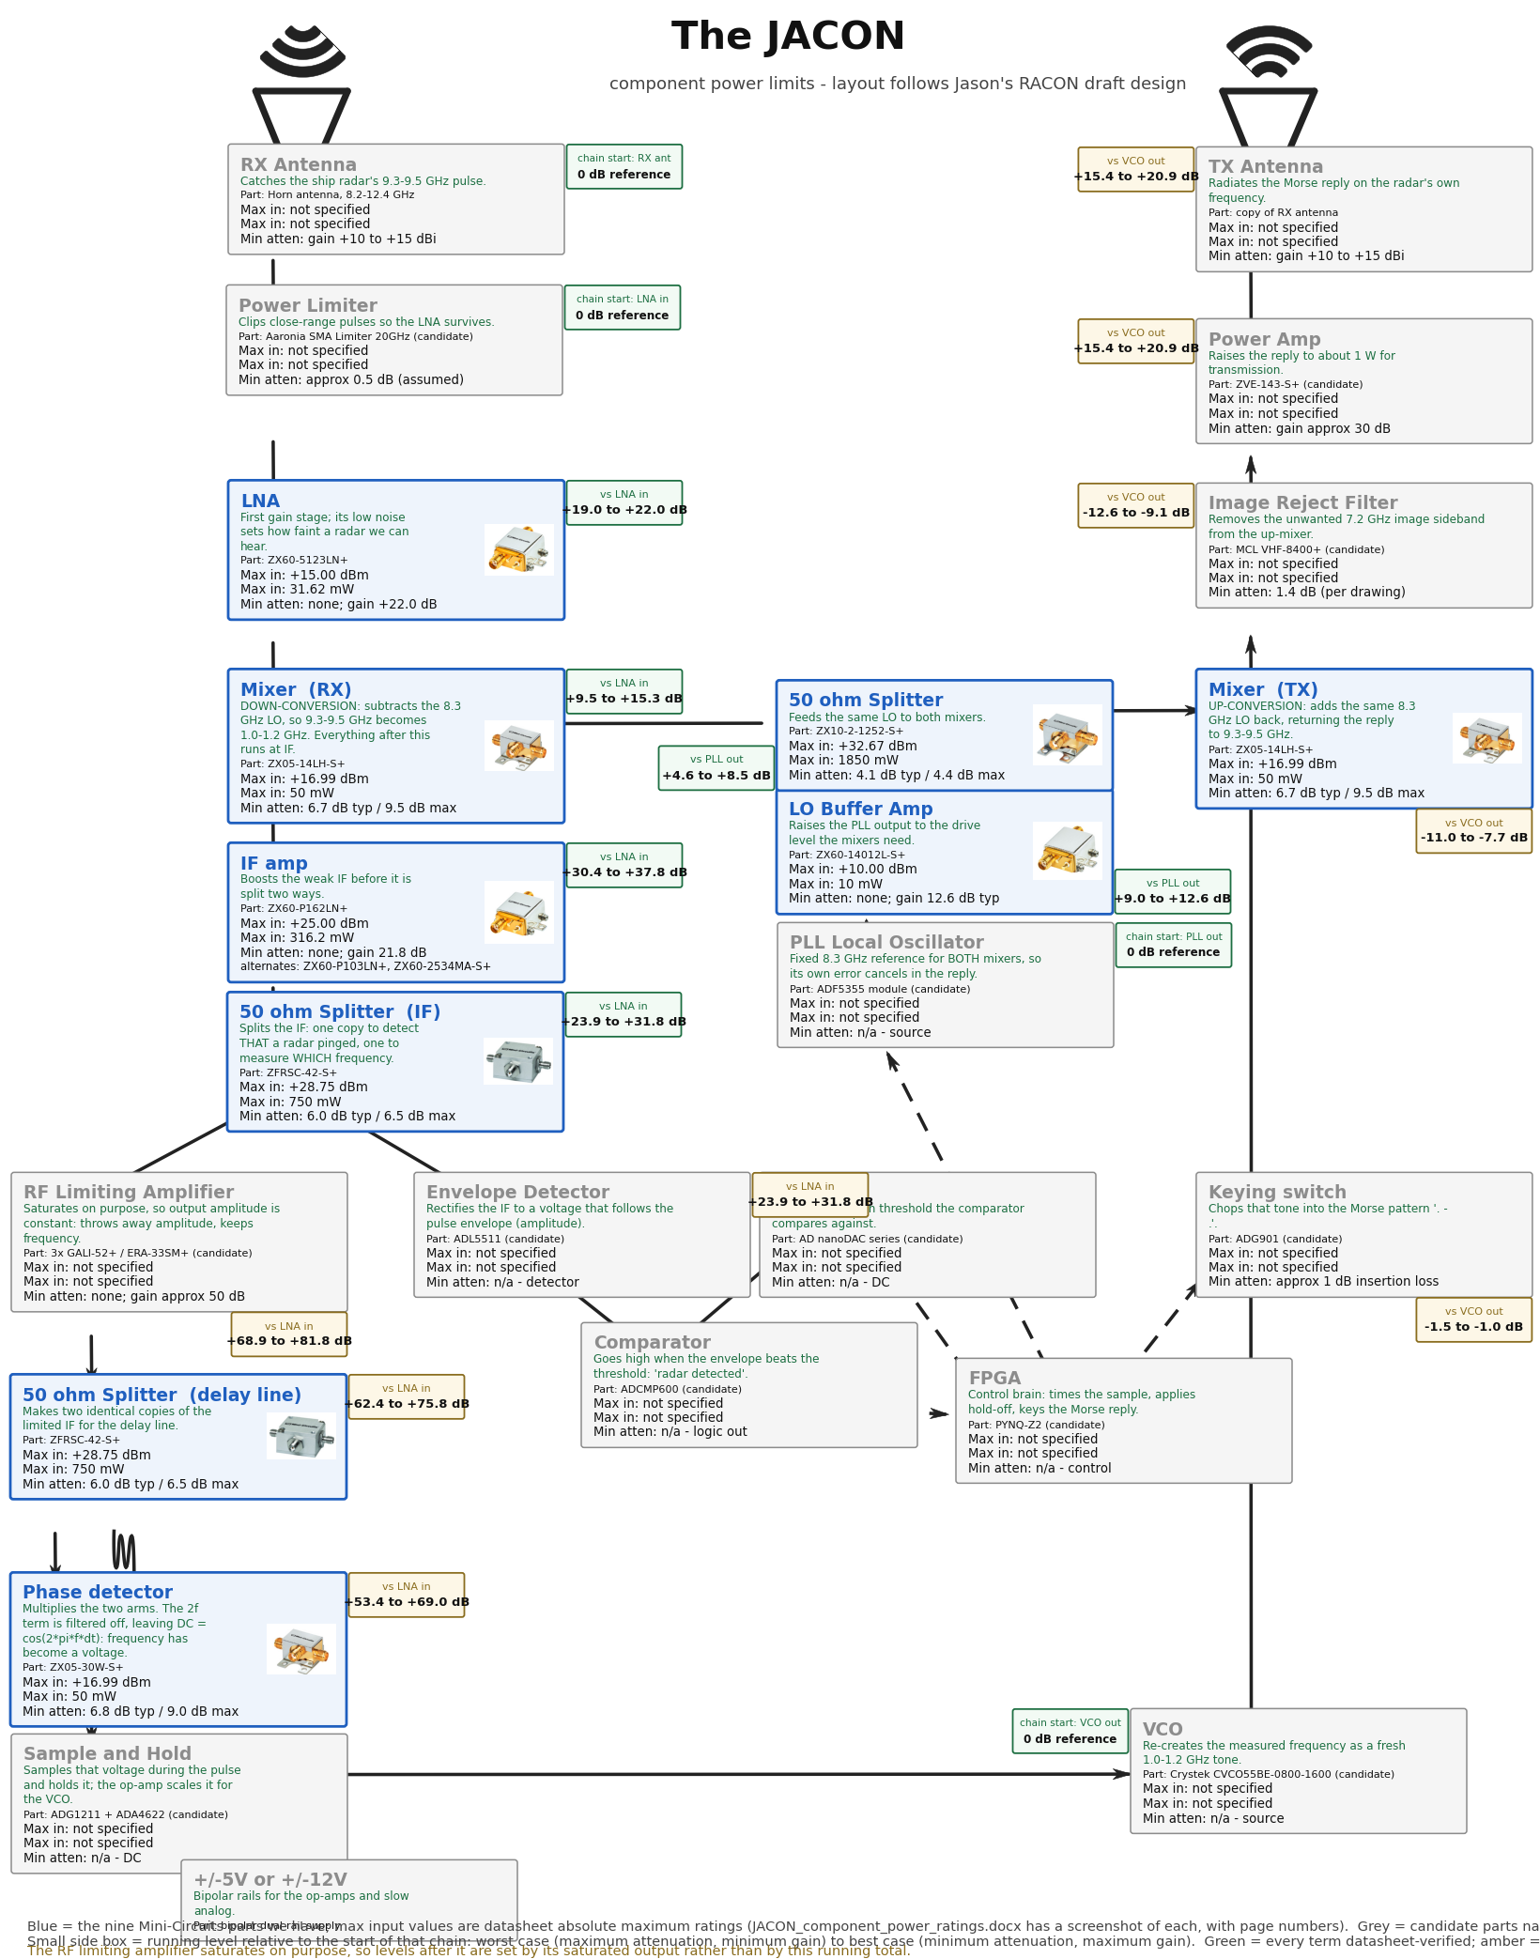
Same layout as racon_draft_design01b_drawing.pdf. Green text in each block says what that stage does. Each block also carries: title, part number, maximum input in dBm and mW, and minimum attenuation. Blue blocks are the nine parts we have, with datasheet maximum ratings and the photo from the datasheet; grey blocks are candidate parts named on the drawing and are not datasheet-verified. The small box beside each block is the running level relative to the start of that chain: worst case (maximum attenuation, minimum gain) to best case (minimum attenuation, maximum gain). Green means every term is datasheet-verified, amber means the total includes an assumed value.

3b. Bench test: Pluto TX to the phase detector
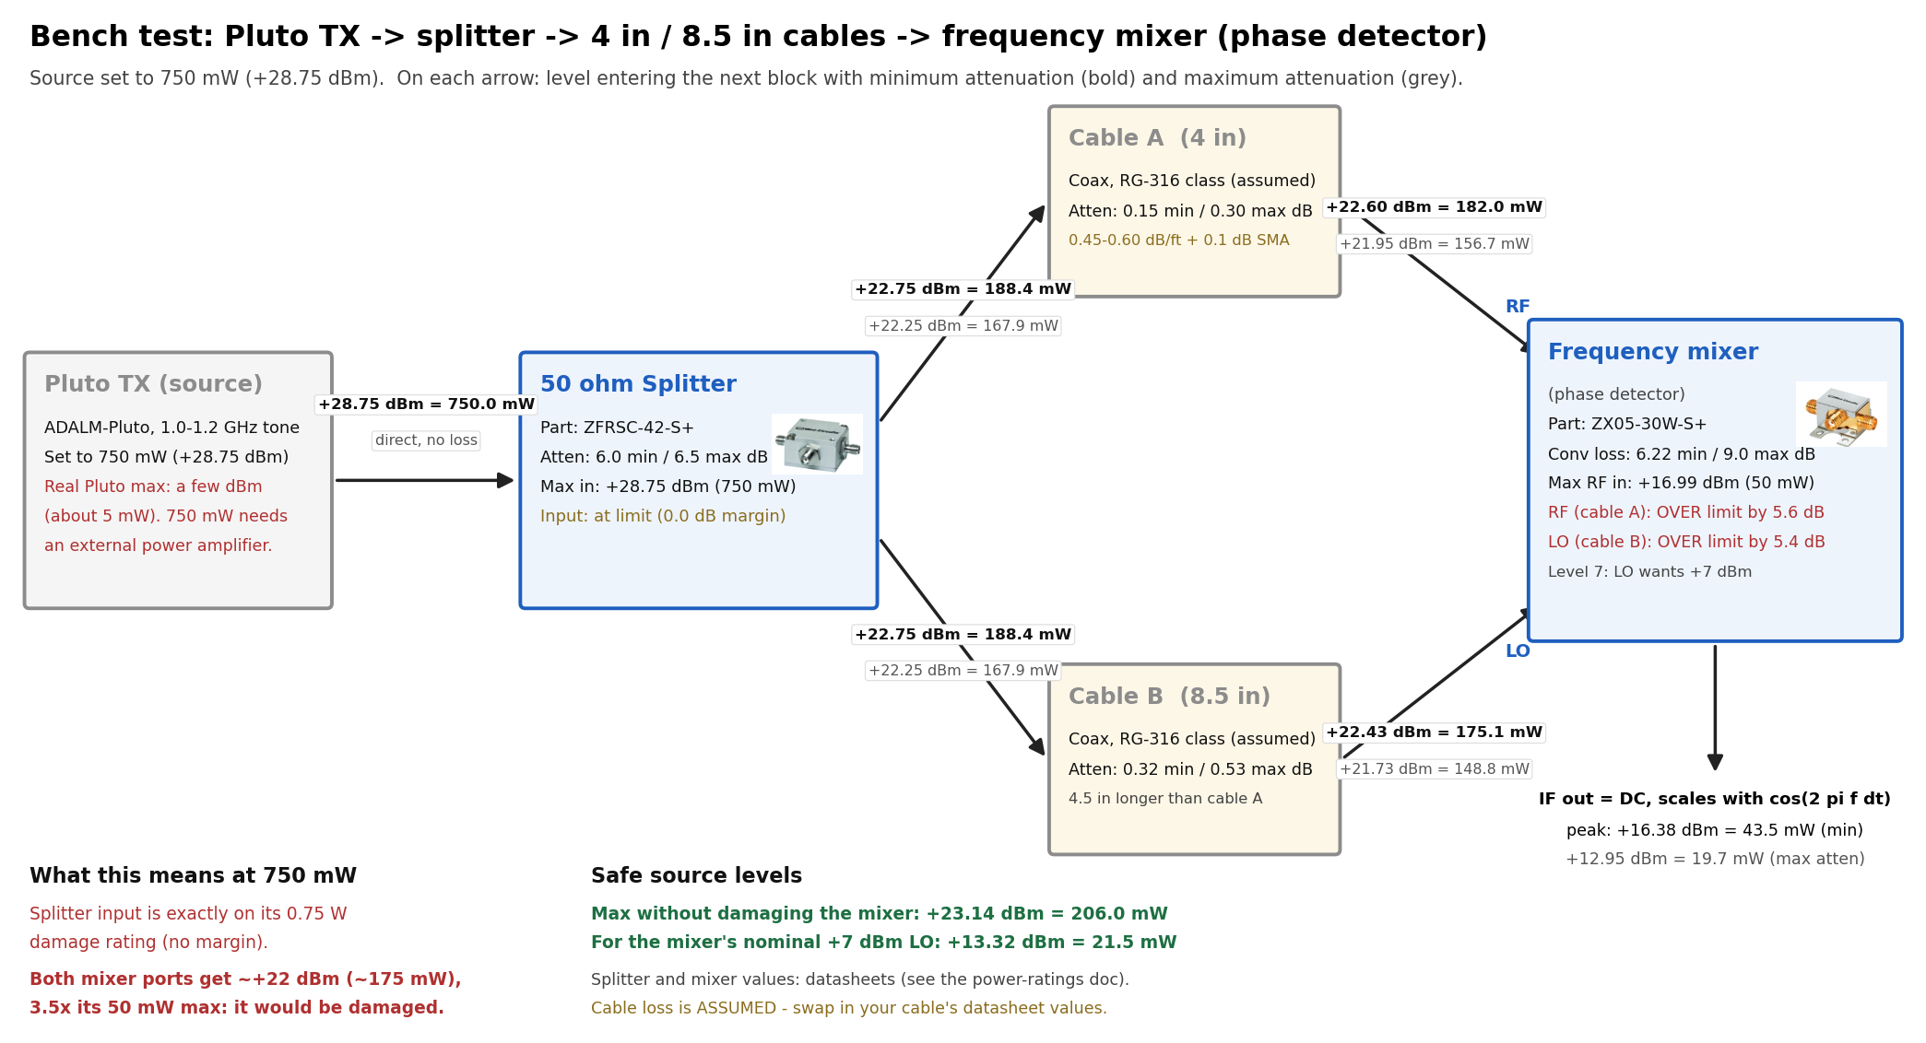
Pluto TX -> ZFRSC-42-S+ splitter -> 4 in and 8.5 in cables -> ZX05-30W-S+ mixer used as a phase detector, for a 750 mW (+28.75 dBm) source. Splitter and mixer attenuation and limits are datasheet values; cable loss is assumed for RG-316-class coax. A real ADALM-Pluto cannot deliver 750 mW, and at that level both mixer ports would be about 5.5 dB over the 50 mW rating.

4. Headroom against the damage limits
Expected levels come from the LTspice model in simulations/claude/01_jacon_system. Worst case is the -10 dBm close-range echo.
Part | Expected worst-case input | Damage limit | Margin | Action
ZX60-5123LN+ (LNA) | limiter output, +16.3 dBm while the limiter clamps | +15 dBm | OVER by 1.3 dB | Keep the in-line attenuator the drawing calls for.
ZX05-14LH-S+ (RX mixer) | LNA saturated output, about +17 to +18 dBm | +17 dBm (50 mW) | 0 to -1 dB | Marginal at close range; the same pad fixes this.
ZX60-P162LN+ (IF amp) | mixer IF output, about +11 dBm worst case | +25 dBm | 14 dB | Fine.
ZX60-P103LN+ (IF amp) | mixer IF output, about +11 dBm worst case | +21 dBm | 10 dB | Fine.
ZX60-2534MA-S+ (IF amp) | mixer IF output, about +11 dBm worst case | -15 dBm | OVER by 26 dB | Do not put this straight after the mixer.
ZFRSC-42-S+ (both units) | IF amp output, about +20 dBm saturated | +28.8 dBm (0.75 W) | 9 dB | Fine.
ZX05-30W-S+ (phase det.) | limiting-amp chain, about +8 dBm per port | +17 dBm (50 mW) | 9 dB | Above the +1 dBm compression point, which is intended here.
ZX60-14012L-S+ (LO buffer) | PLL output, about +3 dBm | +10 dBm | 7 dB | Check your ADF5355 output level; +3 dBm is an assumption.
ZX10-2-1252-S+ (LO split) | buffer output, about +14 dBm | +32.7 dBm (1.85 W) | 19 dB | Fine.

5. Datasheet evidence, part by part
Each screenshot below is cropped straight out of the linked PDF, at the page stated in its caption. Open the PDF, go to that page, and the same table is there.

ZX60-5123LN+ - RX LNA
Datasheet: ZX60-5123LN+.pdf (Mini-Circuits) | local copy: datasheets/ZX60-5123LN+.pdf | product page: minicircuits.com
Parameter | Value
Band (datasheet) | 5.5 - 12.5 GHz
Frequency in JACON | 9.3 - 9.5 GHz
Gain / loss | +22.0 dB typ (19.0 min), 5.5-12.5 GHz
Damage limit | RF Input Power (CW) +15 dBm = +15.00 dBm = 31.62 mW (page 3)
Linear limit | +17.0 dBm typ output P1dB
Notes | Total power dissipation 1.2 W; DC +12 V

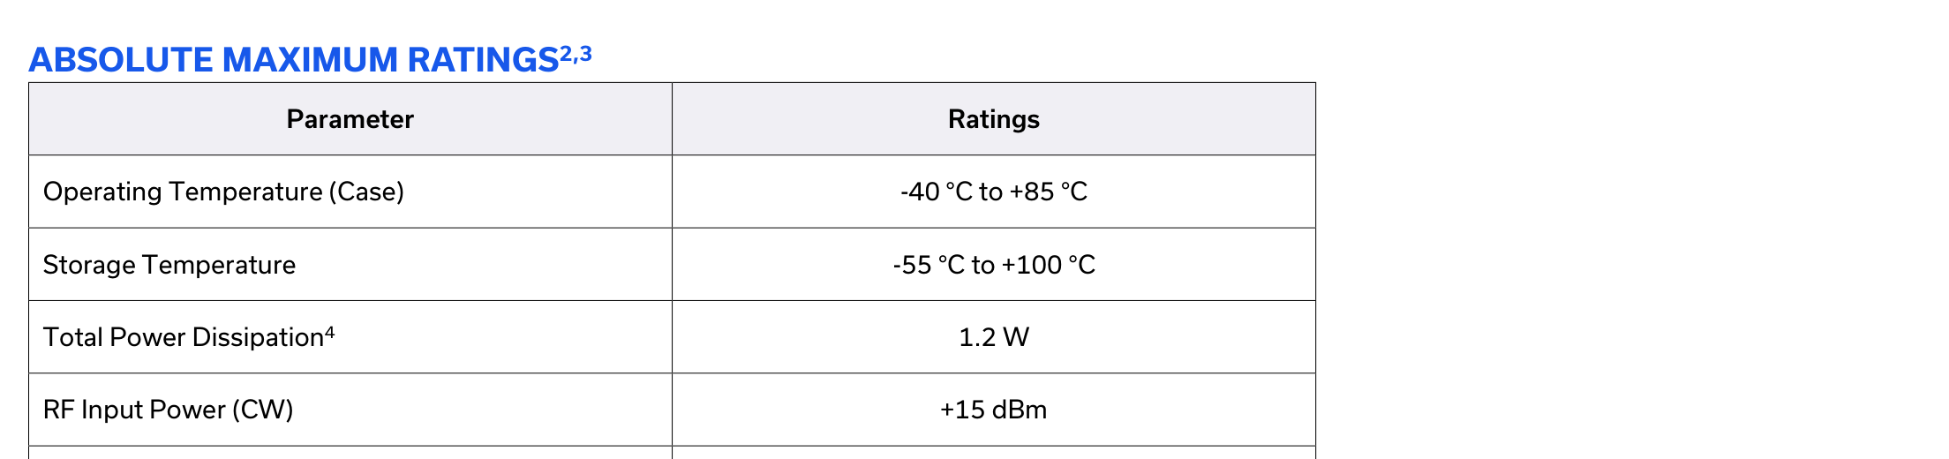
ZX60-5123LN+ datasheet, page 3 - ABSOLUTE MAXIMUM RATINGS: RF Input Power (CW) = +15 dBm
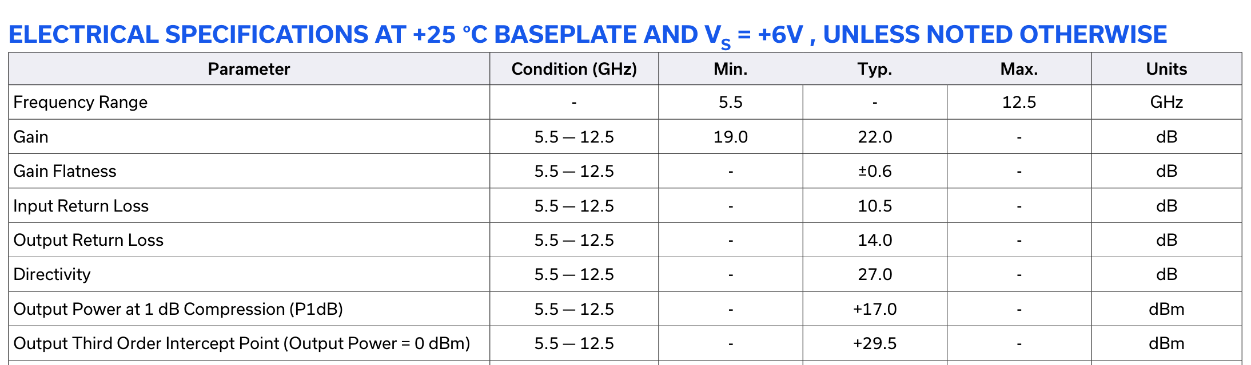
ZX60-5123LN+ datasheet, page 1 - ELECTRICAL SPECIFICATIONS: gain 22.0 dB typ, P1dB +17.0 dBm typ

ZX05-14LH-S+ - RX down-mixer / TX up-mixer
Datasheet: ZX05-14LH-S+.pdf (Mini-Circuits) | local copy: datasheets/ZX05-14LH-S+.pdf | product page: minicircuits.com
Parameter | Value
Band (datasheet) | RF+LO 3.7 - 10 GHz, IF DC - 4 GHz
Frequency in JACON | RF 9.3-9.5 GHz, LO 8.3 GHz, IF 1.0-1.2 GHz
Gain / loss | conv. loss 7.72 dB typ at RF 9400 MHz (6.7 dB band typ), LO +10 dBm
Damage limit | RF Power 50 mW = +16.99 dBm = 50 mW (page 1)
Linear limit | +5 dBm typ RF input at 1 dB compression
Notes | Level 10 mixer: LO drive +10 dBm

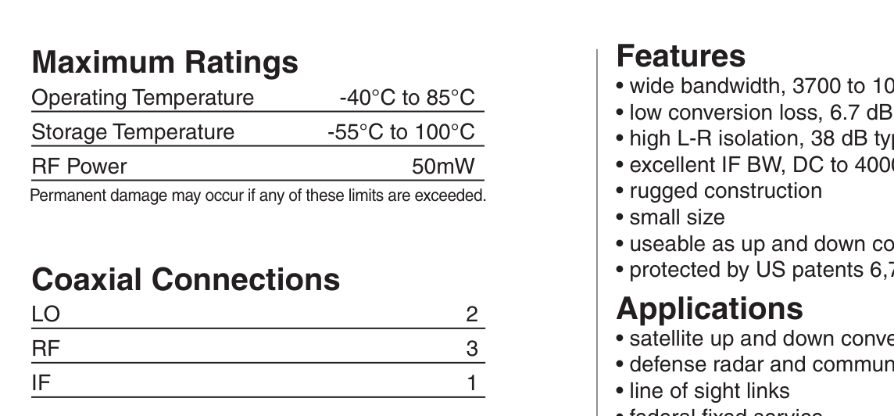
ZX05-14LH-S+ datasheet, page 1 - Maximum Ratings: RF Power = 50 mW
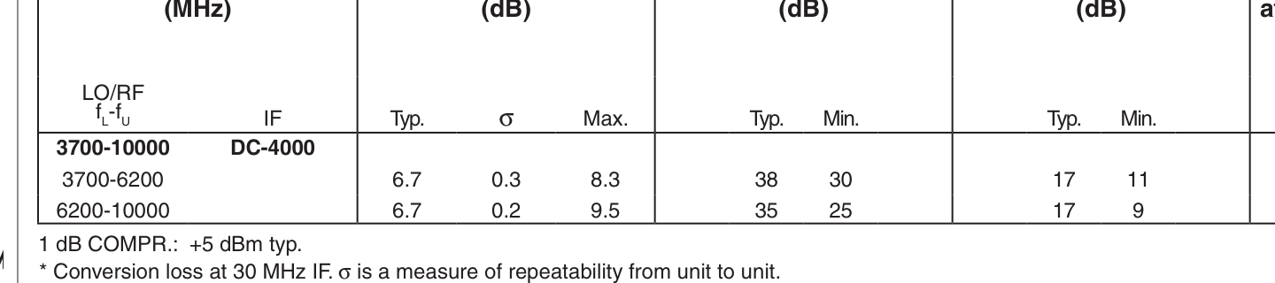
ZX05-14LH-S+ datasheet, page 1 - 1 dB COMPR.: +5 dBm typ (LO +10 dBm)
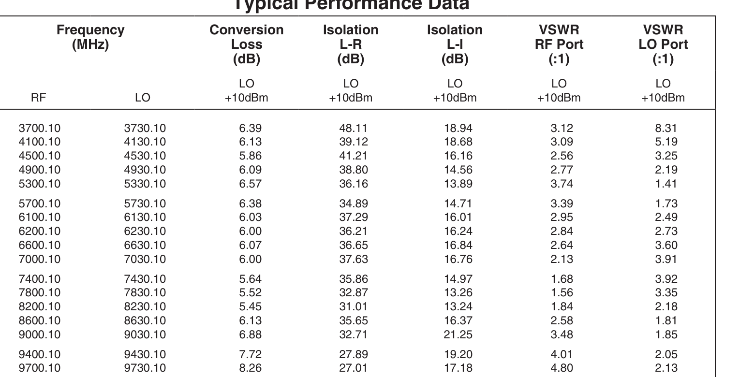
ZX05-14LH-S+ datasheet, page 1 - Typical Performance Data: conversion loss 7.72 dB at RF 9400 MHz (band typ is 6.7 dB)

ZX60-14012L-S+ - LO buffer amplifier
Datasheet: ZX60-14012L-S+.pdf (Mini-Circuits) | local copy: datasheets/ZX60-14012L-S+.pdf | product page: minicircuits.com
Parameter | Value
Band (datasheet) | 0.3 MHz - 14 GHz
Frequency in JACON | 8.3 GHz
Gain / loss | 12.55 dB at 8.0 GHz, 11.85 dB at 9.0 GHz -> approx 12.3 dB at 8.3 GHz
Damage limit | Input Power (no Damage) 10 dBm = +10.00 dBm = 10 mW (page 1)
Linear limit | +11 dBm typ output P1dB (+4 dBm min at 10-14 GHz)
Notes | Band-wide spec is +12 dB typ / 9 dB min; the page 2 table gives 12.55 dB at 8 GHz. NF 5.35 dB at 8 GHz

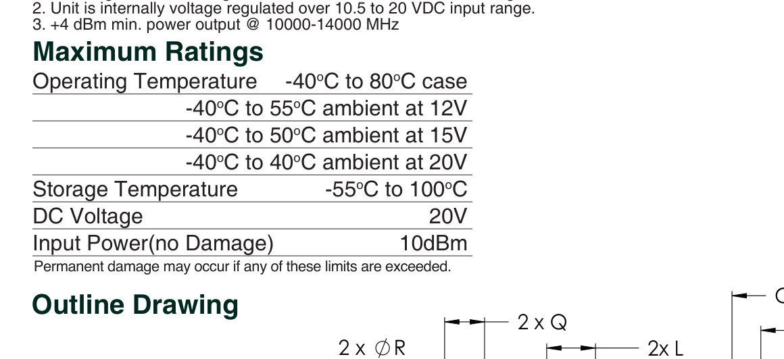
ZX60-14012L-S+ datasheet, page 1 - Maximum Ratings: Input Power (no Damage) = 10 dBm
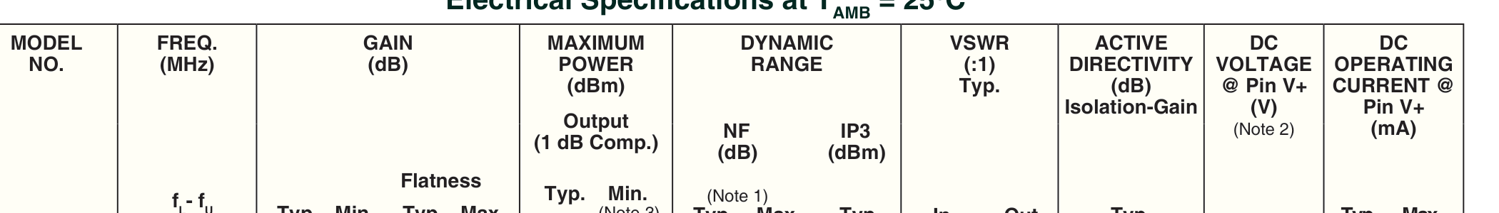
ZX60-14012L-S+ datasheet, page 1 - Electrical Specifications: gain 12 dB typ, output P1dB +11 dBm typ
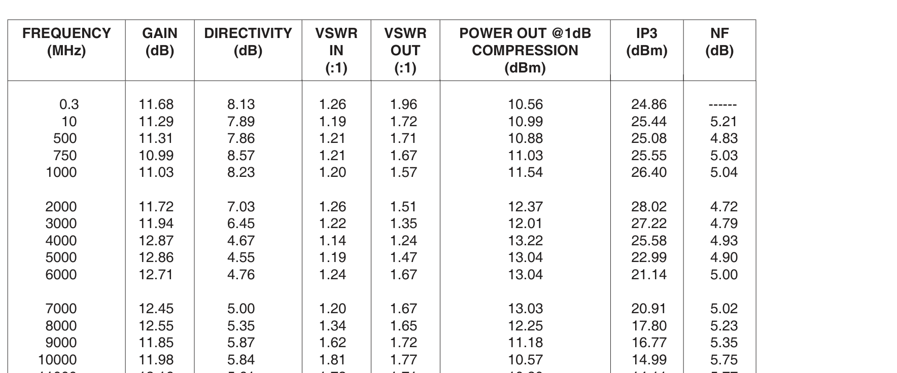
ZX60-14012L-S+ datasheet, page 2 - Typical Performance Data: 12.55 dB gain at 8000 MHz, 11.85 dB at 9000 MHz (8.3 GHz falls between)

ZX10-2-1252-S+ - LO 2-way splitter (DC pass)
Datasheet: ZX10-2-1252-S+.pdf (Mini-Circuits) | local copy: datasheets/ZX10-2-1252-S+.pdf | product page: minicircuits.com
Parameter | Value
Band (datasheet) | 1800 - 12500 MHz
Frequency in JACON | 8.3 GHz
Gain / loss | -3.0 dB split + 0.7 dB typ insertion loss
Damage limit | Power Input (as a splitter) 1.85 W = +32.67 dBm = 1850 mW (page 2)
Linear limit | passive - no compression spec
Notes | Internal dissipation 0.85 W max; DC current 0.4 A max

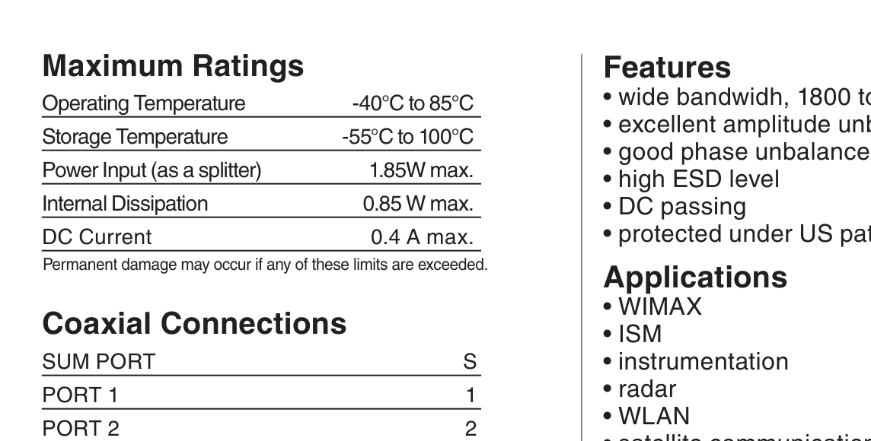
ZX10-2-1252-S+ datasheet, page 2 - Maximum Ratings: Power Input (as a splitter) = 1.85 W

ZX60-P162LN+ - IF amplifier (preferred for 1.0-1.2 GHz)
Datasheet: ZX60-P162LN+.pdf (Mini-Circuits) | local copy: datasheets/ZX60-P162LN+.pdf | product page: minicircuits.com
Parameter | Value
Band (datasheet) | 0.7 - 1.6 GHz
Frequency in JACON | 1.0 - 1.2 GHz
Gain / loss | 21.81 dB at 1.1 GHz (22.49 at 1.0, 21.12 at 1.2 GHz)
Damage limit | Input RF Power (No Damage) VD=+4 V: +25 dBm = +25.00 dBm = 316.2 mW (page 2)
Linear limit | +19.9 dBm typ output P1dB at 1.0 GHz (+17.5 min)
Notes | Noise figure 0.52 dB typ at 1.0 GHz; power consumption 0.55 W

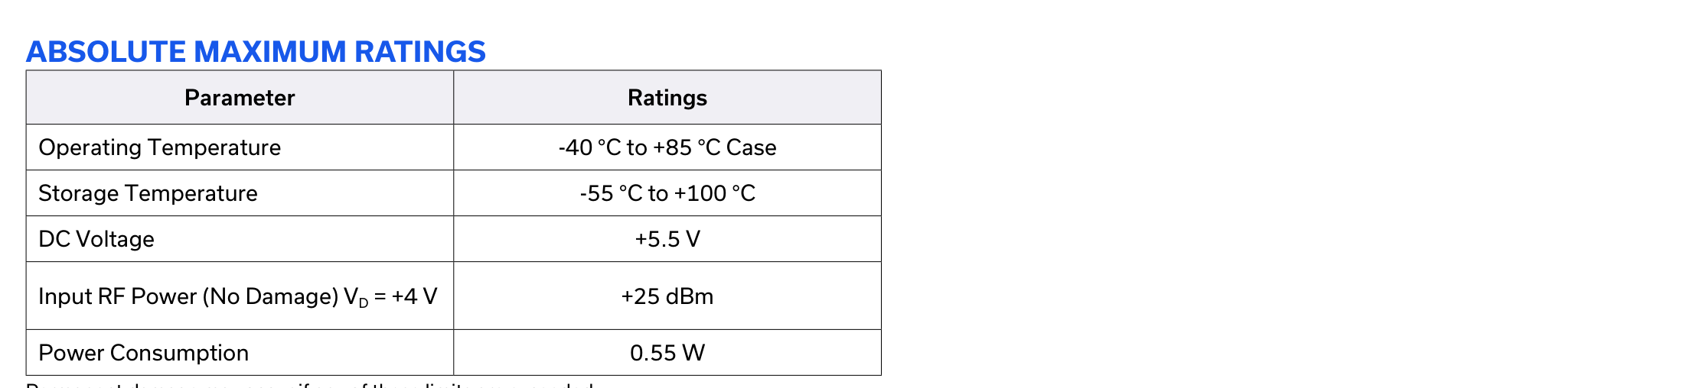
ZX60-P162LN+ datasheet, page 2 - ABSOLUTE MAXIMUM RATINGS: Input RF Power (No Damage) = +25 dBm
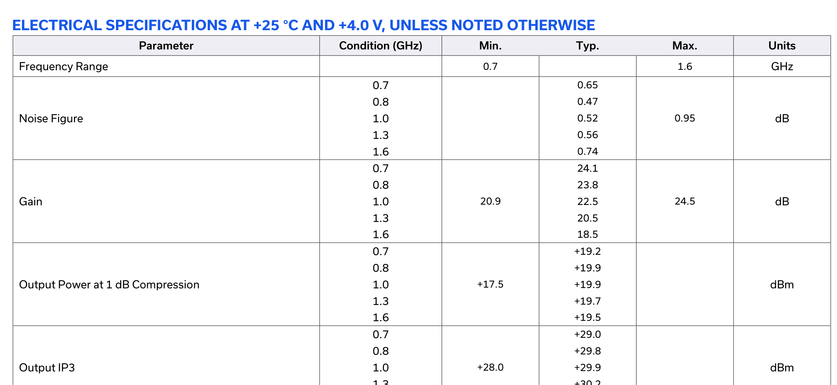
ZX60-P162LN+ datasheet, page 2 - ELECTRICAL SPECIFICATIONS: gain and output P1dB vs frequency
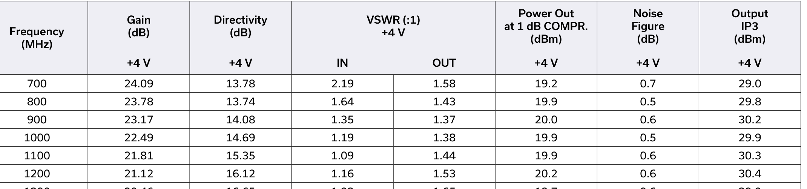
ZX60-P162LN+ datasheet, page 4 - Typical Performance Data: 21.81 dB gain and +19.9 dBm P1dB at 1100 MHz

ZX60-P103LN+ - IF amplifier (wideband alternate)
Datasheet: ZX60-P103LN+.pdf (Mini-Circuits) | local copy: datasheets/ZX60-P103LN+.pdf | product page: minicircuits.com
Parameter | Value
Band (datasheet) | 50 - 3000 MHz
Frequency in JACON | 1.0 - 1.2 GHz
Gain / loss | +15.6 dB typ at 1000 MHz (13.5 min)
Damage limit | Input RF Power (no damage): 21 dBm (50-2000 MHz), 26 dBm (2000-3000 MHz) = +21.00 dBm = 125.9 mW (page 3)
Linear limit | +22.4 dBm typ output P1dB at 1000 MHz
Notes | Noise figure 0.5 dB typ at 1000 MHz; power consumption 0.66 W

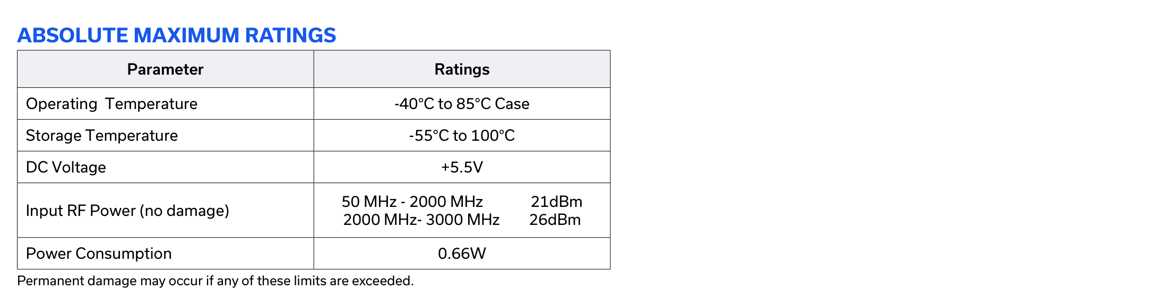
ZX60-P103LN+ datasheet, page 3 - ABSOLUTE MAXIMUM RATINGS: Input RF Power (no damage) = 21 dBm at 50-2000 MHz
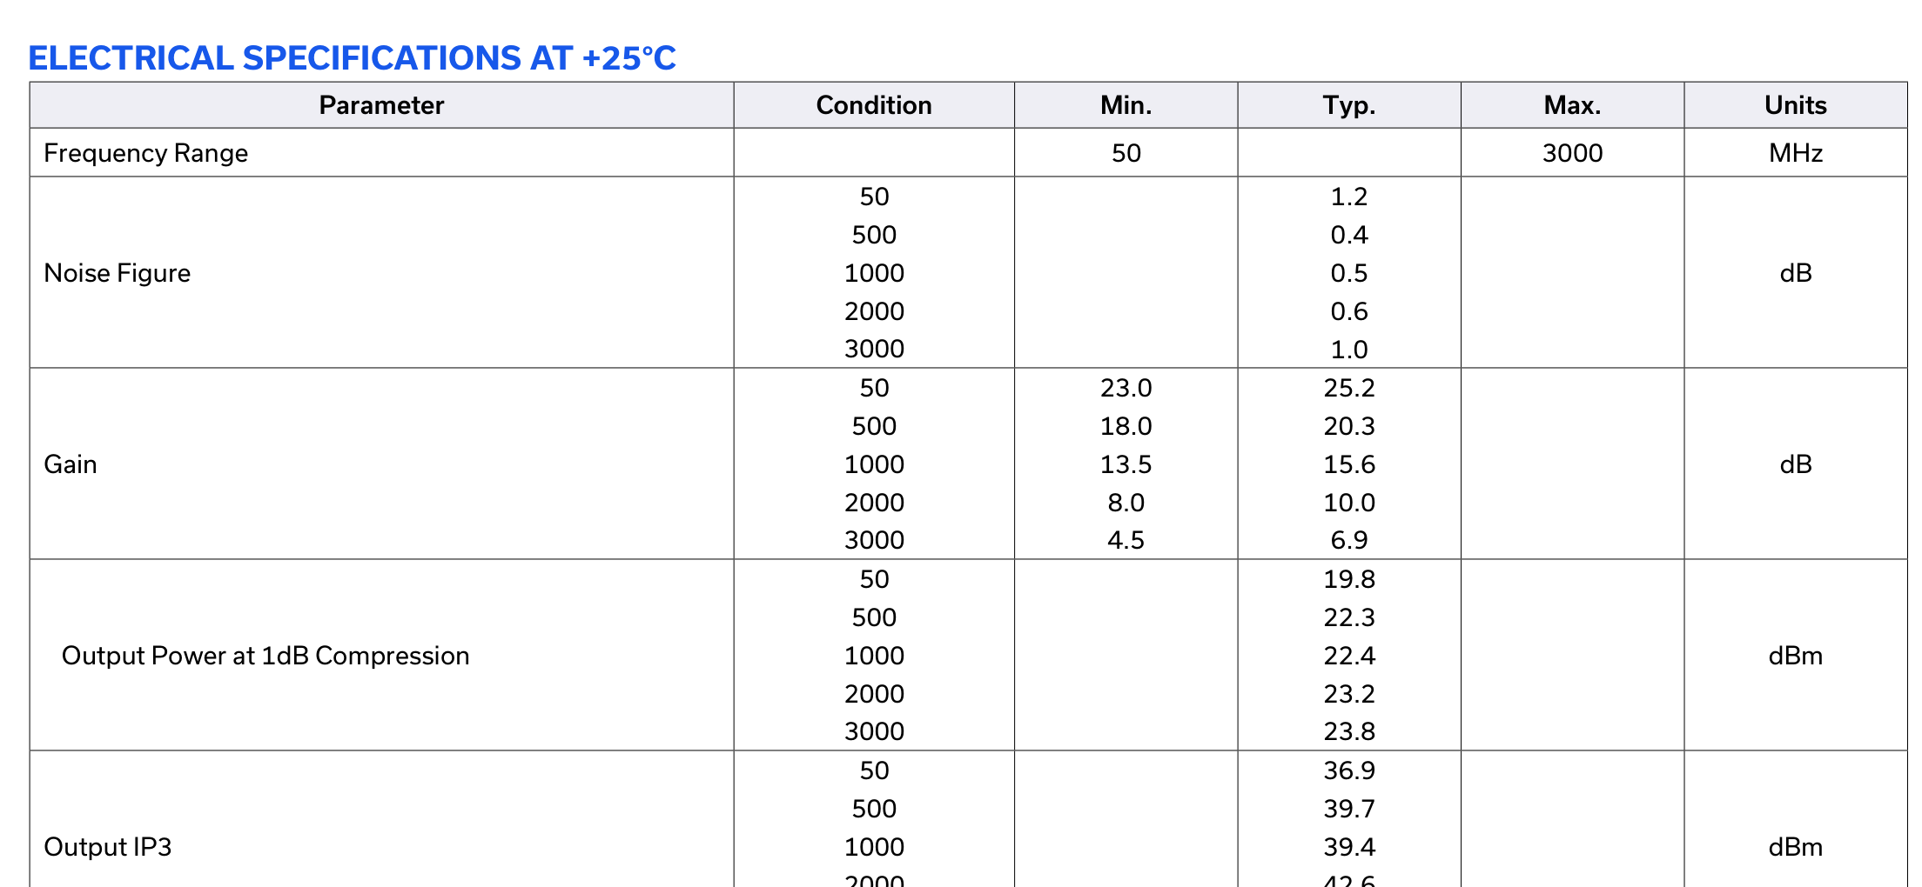
ZX60-P103LN+ datasheet, page 2 - ELECTRICAL SPECIFICATIONS: gain 15.6 dB typ and P1dB +22.4 dBm typ at 1000 MHz

ZX60-2534MA-S+ - IF amplifier (high gain alternate)
Datasheet: ZX60-2534MA-S+.pdf (Mini-Circuits) | local copy: datasheets/ZX60-2534MA-S+.pdf | product page: minicircuits.com
Parameter | Value
Band (datasheet) | 0.5 - 2.5 GHz
Frequency in JACON | 1.0 - 1.2 GHz
Gain / loss | +43.5 dB typ at 1.0 GHz (at VD = 5 V)
Damage limit | Input Power (no damage) -15 dBm = -15.00 dBm = 0.03162 mW (page 1)
Linear limit | +19.0 dBm typ output P1dB at fL
Notes | LOWEST damage limit of any part here. Power dissipation 0.5 W; DC 5 V

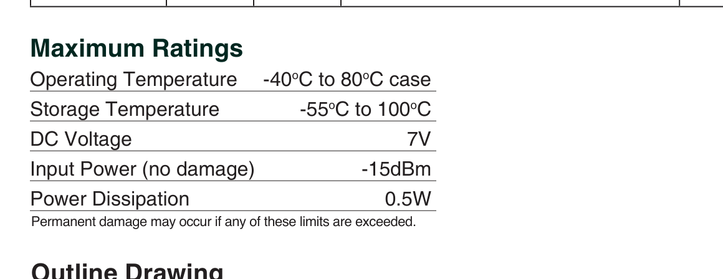
ZX60-2534MA-S+ datasheet, page 1 - Maximum Ratings: Input Power (no damage) = -15 dBm
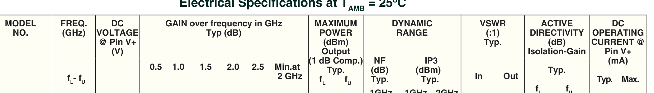
ZX60-2534MA-S+ datasheet, page 1 - Electrical Specifications: gain over frequency, output P1dB

ZFRSC-42-S+ - Resistive 2-way splitter (IF split and delay-line split)
Datasheet: ZFRSC-42-S+.pdf (Mini-Circuits) | local copy: datasheets/ZFRSC-42-S+.pdf | product page: minicircuits.com
Parameter | Value
Band (datasheet) | DC - 4200 MHz
Frequency in JACON | 1.0 - 1.2 GHz
Gain / loss | -6.0 dB total loss (5.99 / 6.02 dB at 1000 MHz)
Damage limit | Power Input (as a splitter) 0.75 W = +28.75 dBm = 750 mW (page 1)
Linear limit | passive - no compression spec
Notes | Internal dissipation 0.375 W max. Resistive: isolation equals insertion loss (~6 dB)

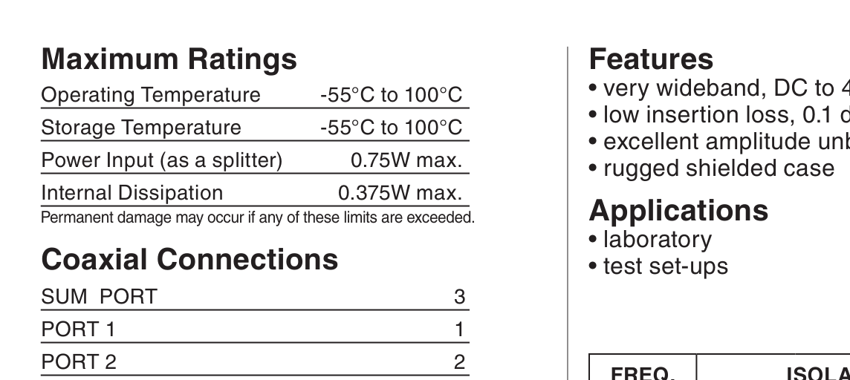
ZFRSC-42-S+ datasheet, page 1 - Maximum Ratings: Power Input (as a splitter) = 0.75 W, internal dissipation 0.375 W

ZX05-30W-S+ - Phase detector (delay-line mixer)
Datasheet: ZX05-30W-S+.pdf (Mini-Circuits) | local copy: datasheets/ZX05-30W-S+.pdf | product page: minicircuits.com
Parameter | Value
Band (datasheet) | RF+LO 300 - 4000 MHz, IF DC - 950 MHz
Frequency in JACON | RF+LO 1.0-1.2 GHz, IF = DC
Gain / loss | conv. loss 6.22 dB typ at RF 944 MHz (6.8 dB band typ), LO +7 dBm
Damage limit | RF Power 50 mW = +16.99 dBm = 50 mW (page 1)
Linear limit | +1 dBm typ RF input at 1 dB compression
Notes | Level 7 mixer: LO drive +7 dBm. IF current 40 mA max

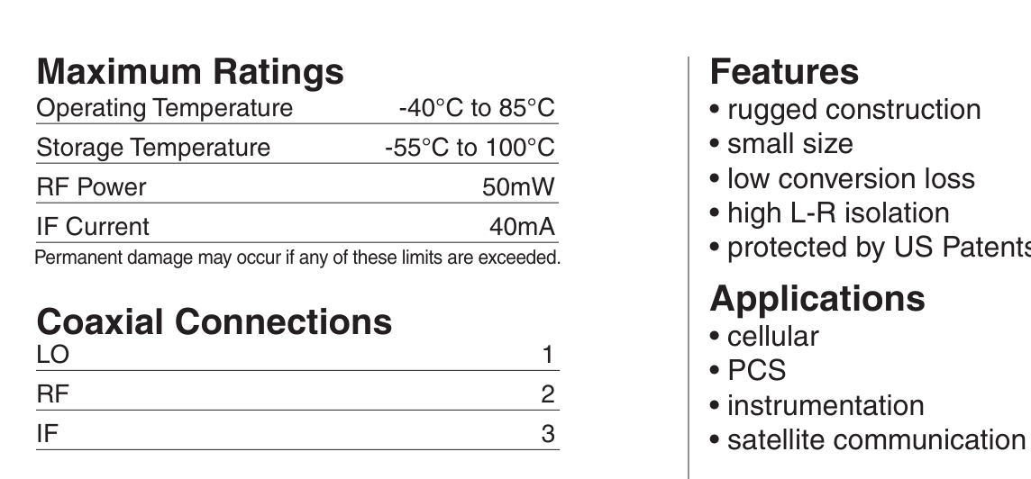
ZX05-30W-S+ datasheet, page 1 - Maximum Ratings: RF Power = 50 mW, IF Current = 40 mA
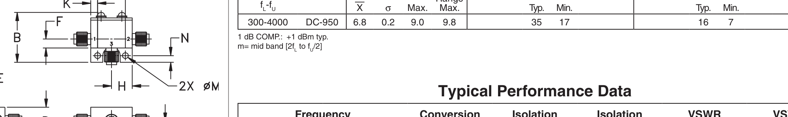
ZX05-30W-S+ datasheet, page 1 - 1 dB COMP.: +1 dBm typ; conversion loss 6.8 dB typ at LO +7 dBm
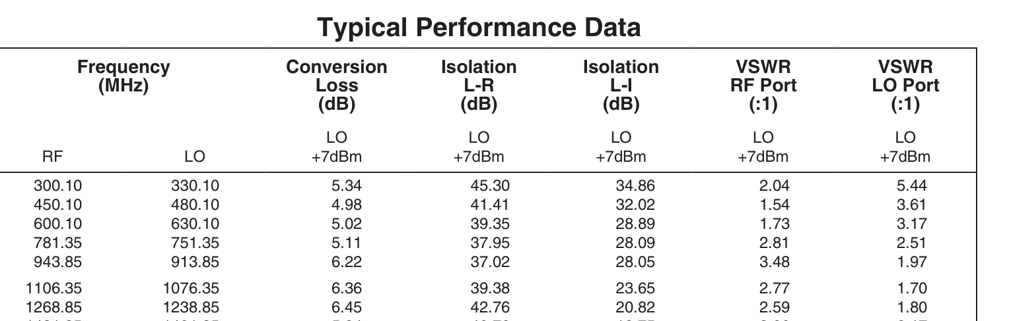
ZX05-30W-S+ datasheet, page 1 - Typical Performance Data: conversion loss 6.22 dB at RF 944 MHz, closest tabulated point to our 1.0-1.2 GHz

6. What is assumed, and what to check yourself
- Levels in the flow chart come from the LTspice model, not from measurements. They assume a -30 dBm echo, a +3 dBm ADF5355 LO output, and the limiter / limiting-amp behaviour described in the drawing.
- The ZX60-14012L-S+ gain (+12 dB typ) and P1dB (+11 dBm typ) are the band-wide specs for 0.3 MHz to 14 GHz. For 8.3 GHz specifically, read the typical performance curves on page 2 of its datasheet.
- Mini-Circuits quotes mixer damage as RF Power 50 mW. That is the RF port limit; the LO drive level is a separate specification (+10 dBm for the ZX05-14LH-S+, +7 dBm for the ZX05-30W-S+).
- The ZX60-2534MA-S+ datasheet is published as ZX60-2534MA+.pdf and covers both the connectorised -S+ version and the bare model; the model table on page 1 lists ZX60-2534MA-S+.
- The power limiter, limiting amplifier, envelope detector, VCO, keying switch, image filter and power amp are not among the nine parts, so they are not datasheet-verified in this document.
- Gain and loss figures are typical values at room temperature. Minimum / maximum columns on the datasheets are what you should design against.
- The simulated levels were computed with the band-typical 6.7 dB mixer conversion loss. The ZX05-14LH-S+ typical performance table gives 7.72 dB at RF 9400 MHz, so expect the real IF to be about 1 dB lower than the red numbers in the flow chart.
- Gain and conversion-loss values are now quoted at the frequency each part actually sees, taken from the typical performance tables, not the band-wide headline figures. Both are shown where they differ.

