**Table of Content**

1 Adopt a tree 3

1.1 Analyze the donation request 5

1.2 Complete the required information 6

1.2.1 Add first and last name 7

1.2.2 Add the name of the tree 8

1.2.3 Add the quantity 9

1.2.4 Add the sume of donation 10

1.3 Enter on "Adopt a tree" page 11

1.4 Inform the customer about the donation (accepted) 12

1.5 Read the eligibility instruction 13

1.6 Receive the donation request 14

1.7 Request Approval 15

1.8 Send "Thank you" message 16

1.9 Send e-mail to Administrator to confirm the donation 17

1.10 Send email to customer with information about the decision 18

1.11 Submit the request 19

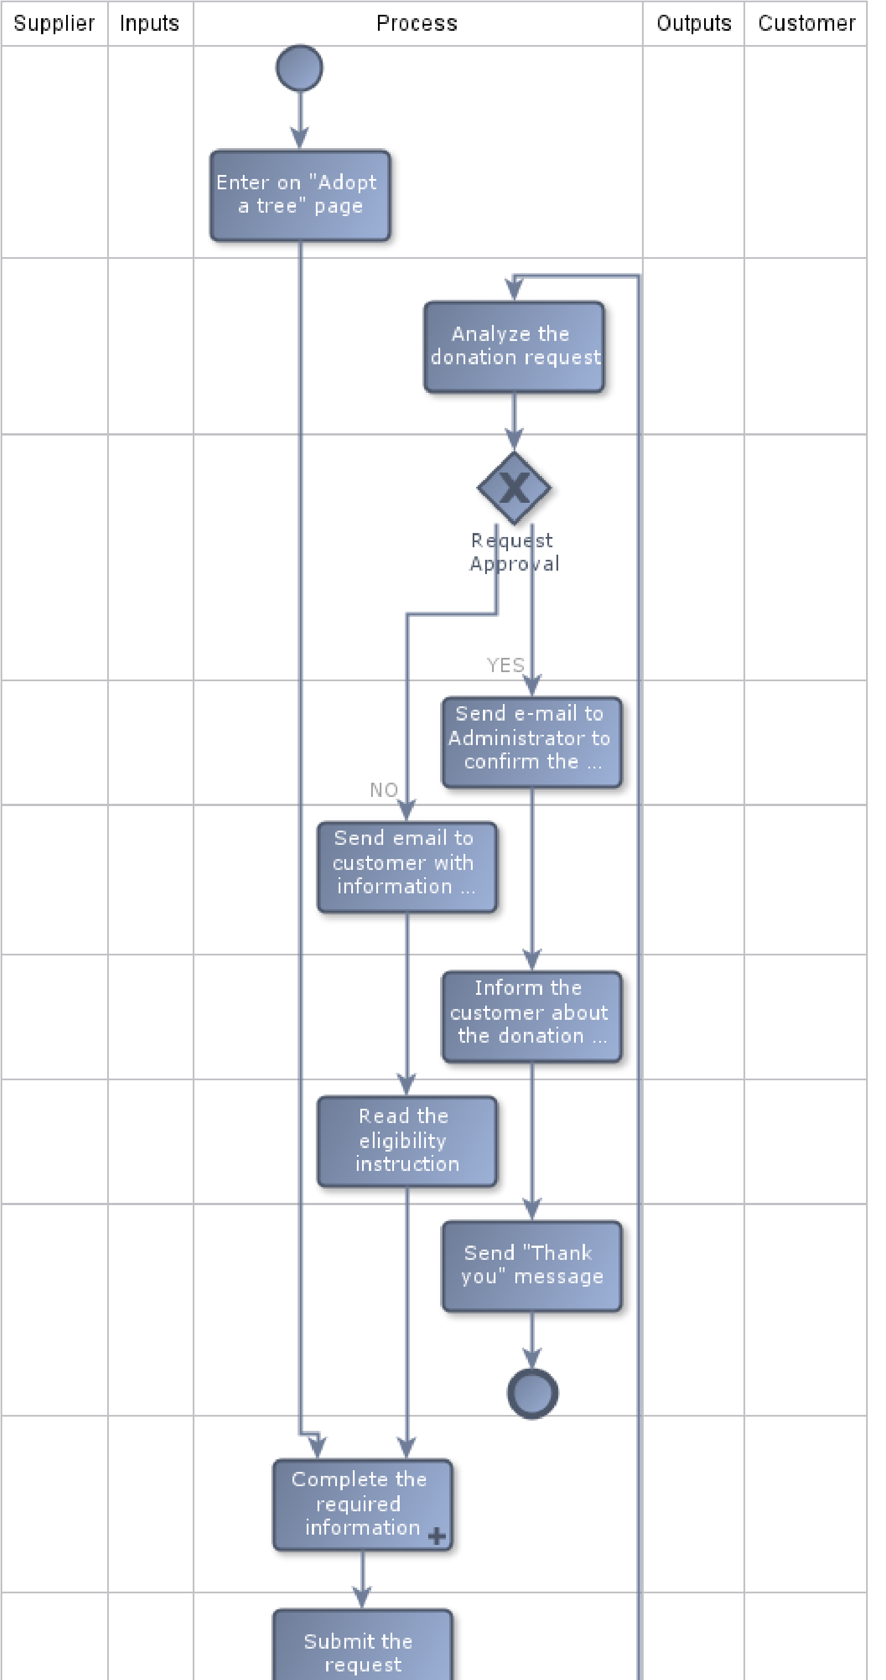



This is an option created for those who wants to help out botanic garden. In order to help us to protect our plants, every customer can adopt one or more trees.

For every adopted tree, the customer pay a sum of money (only one time).

The customer can donate as many time as he wants.

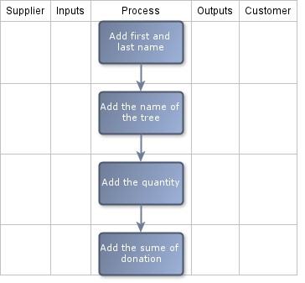

Here the customer needs to add the following information n order to adopt a tree.