* Readme file that describes the installation process of the application and how to use it:
  + how to install your application on a clean computer
  + how to access your application and with what users
  + images with all use cases and their scenarios implemented

It needs JAVA installed on the system, both on client and server side. Also, server side requests MySQL installed and running with the imported database from the project.sql file found in the main folder.

To run it: On server side:

* open the projectServer project in Eclipse
* 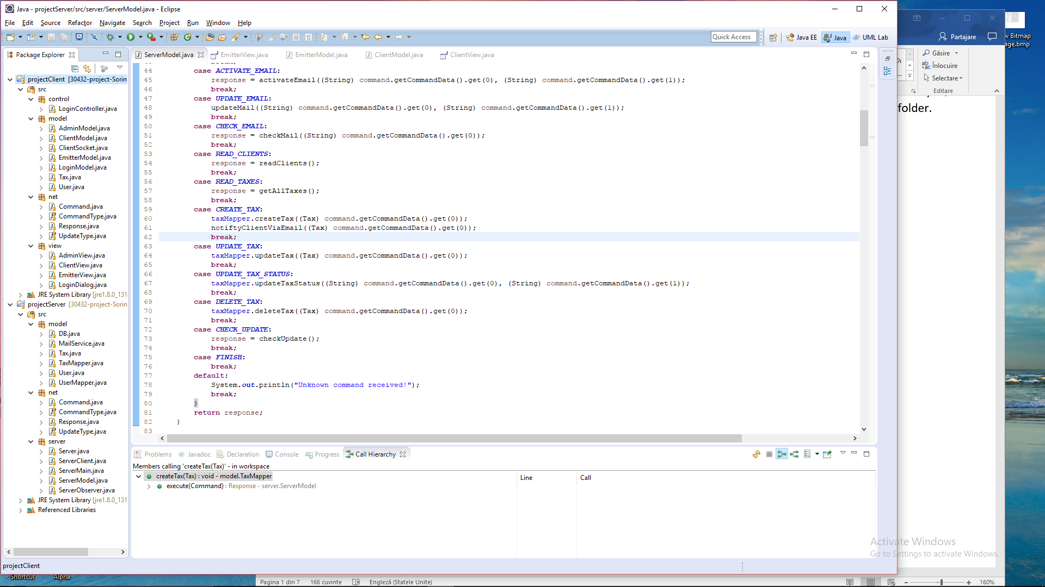
* Run projectServer project
* 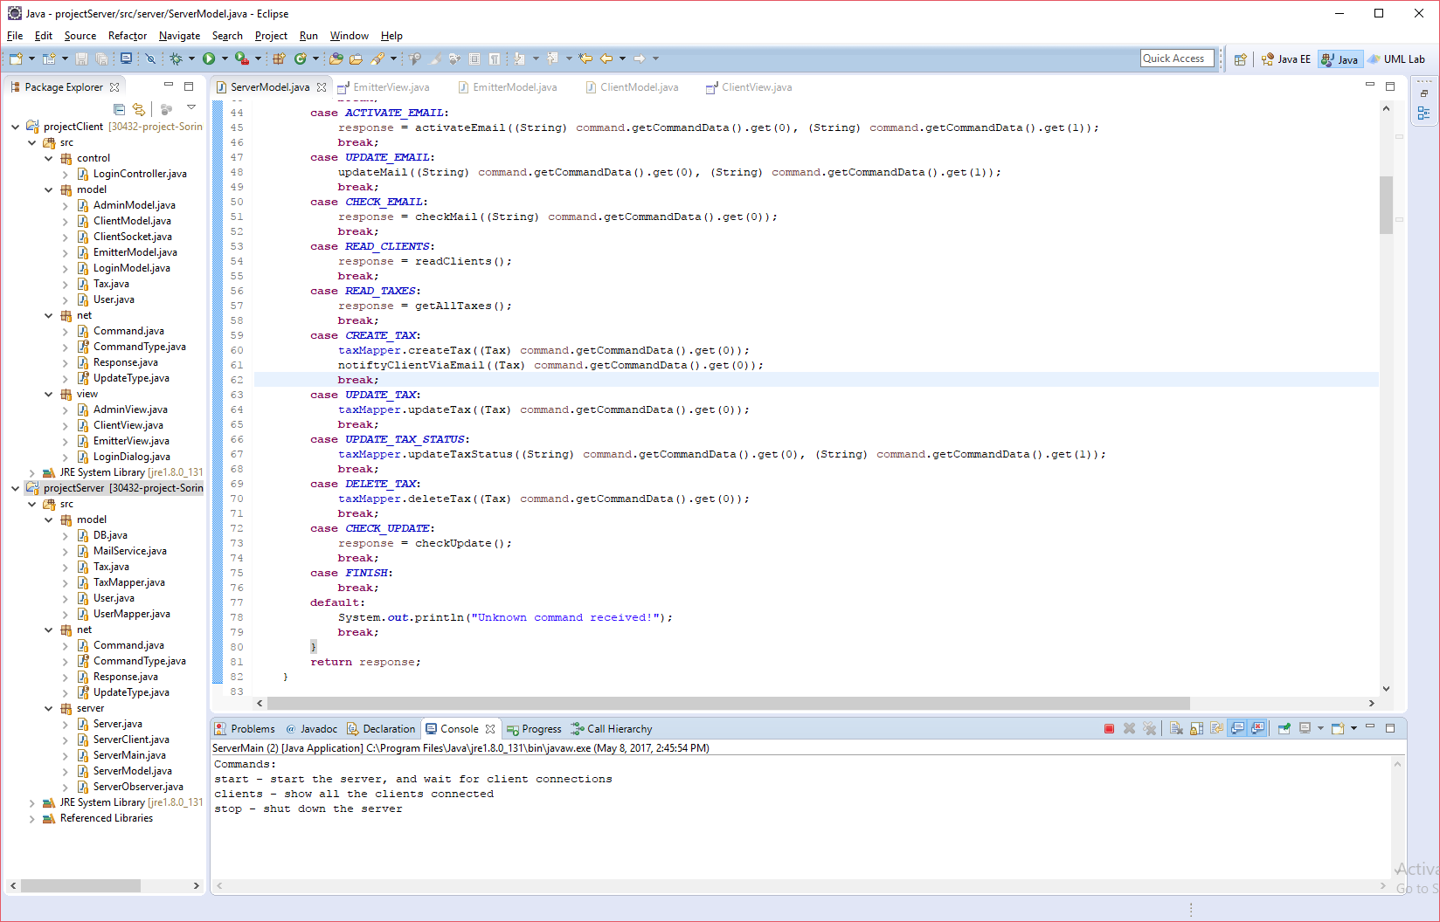
* Write “start” in console to start the server
* 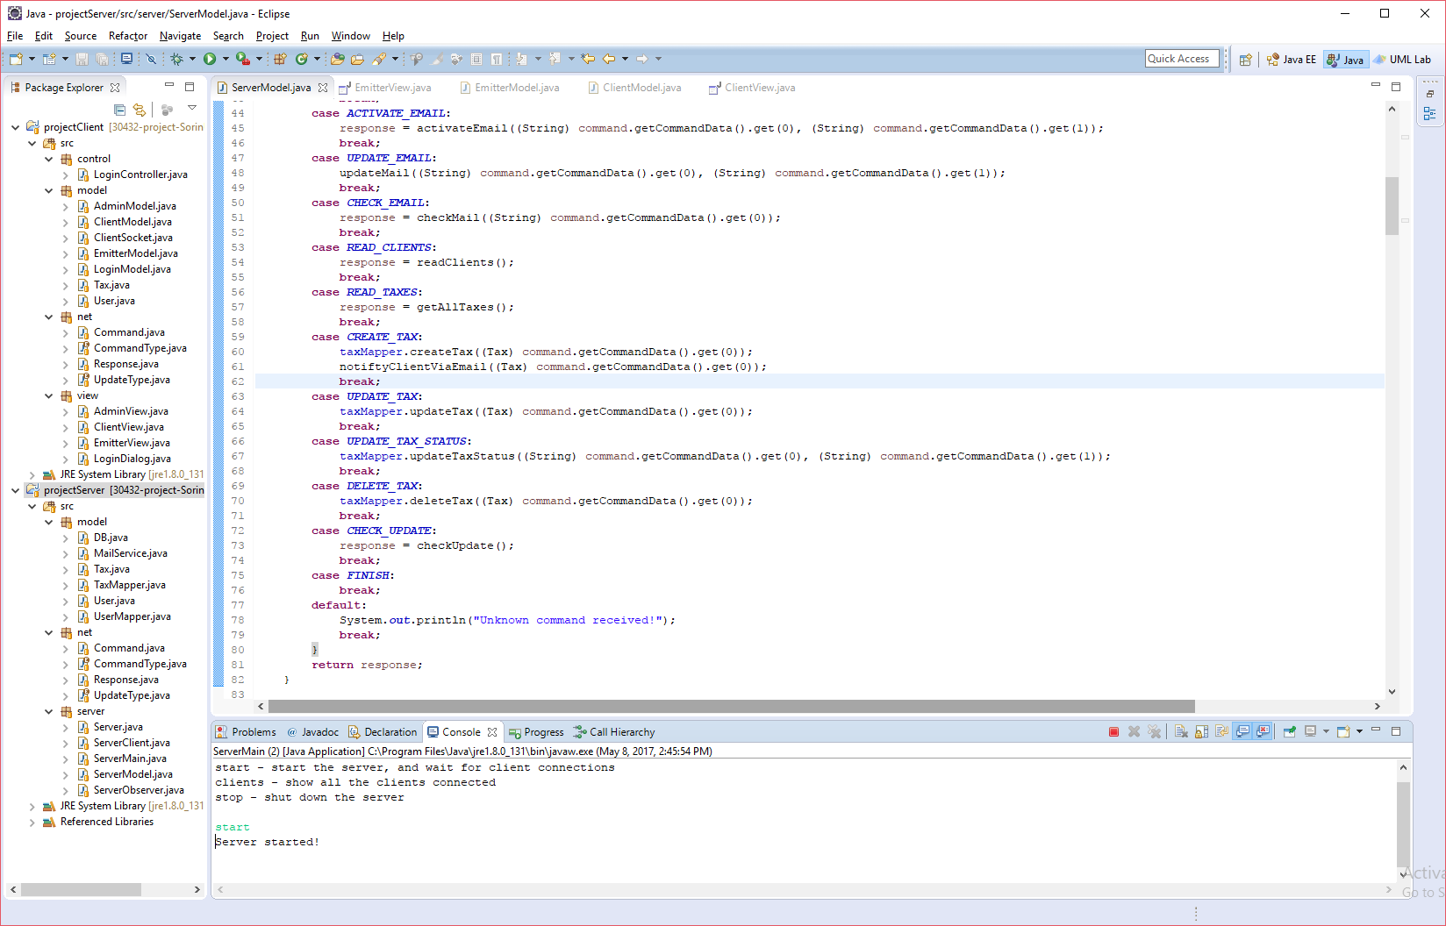

On client side:

* Open the ass3Client project in Eclipse
* 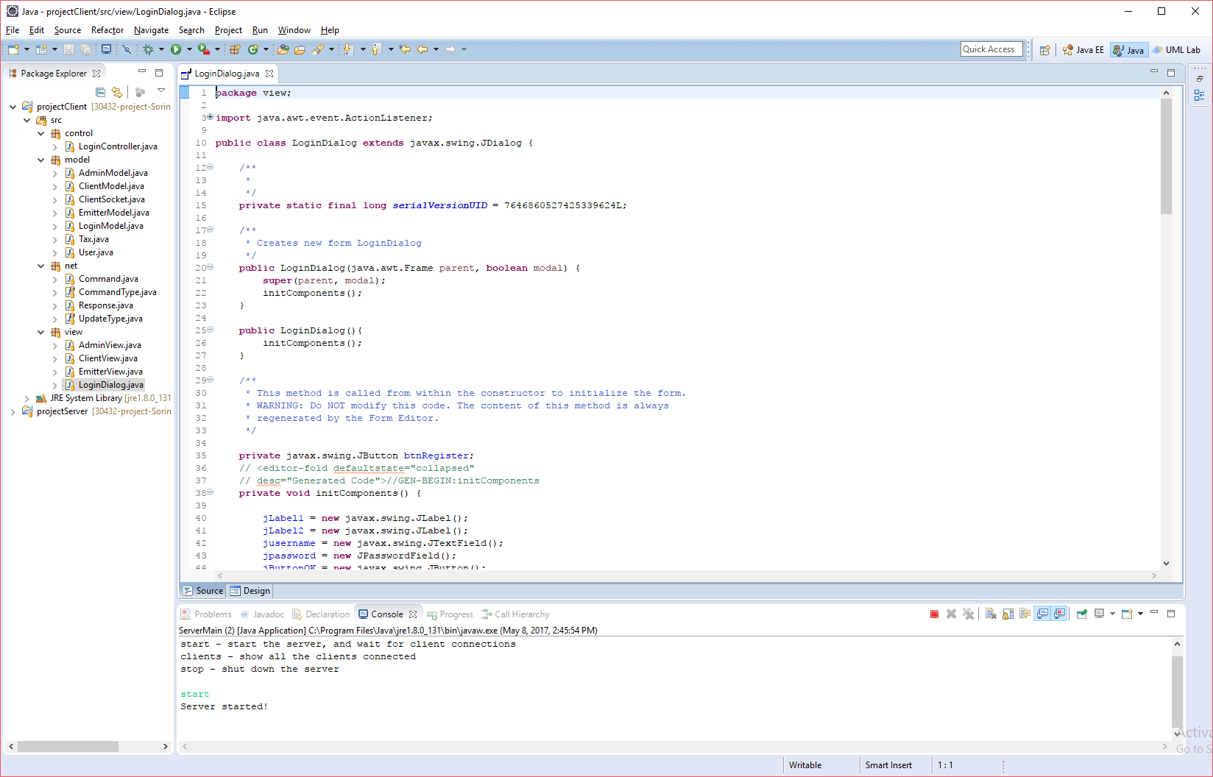
* Click RUN project
* Login with username and password

=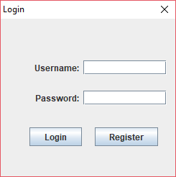

The application is accessed with Admin rights using “admin” username and password “admin”:

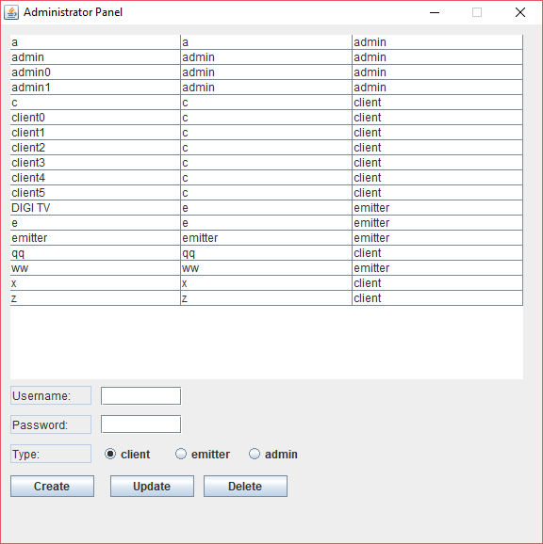

To access client, you can Register a new account or ou look for an account with client rights in the table above and login:

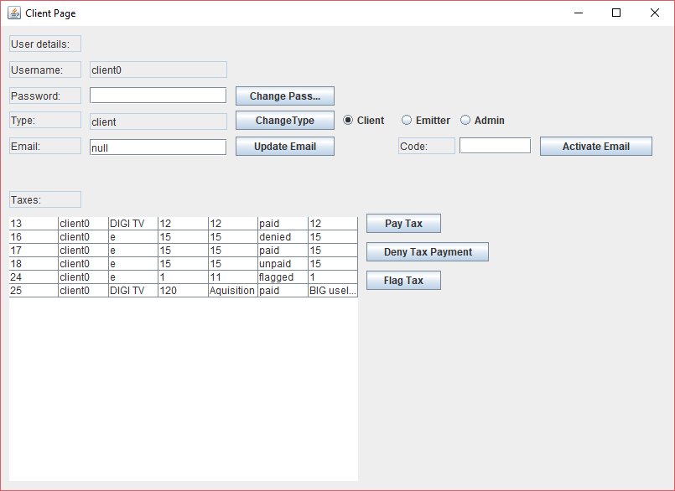

Same for a Emitter account:

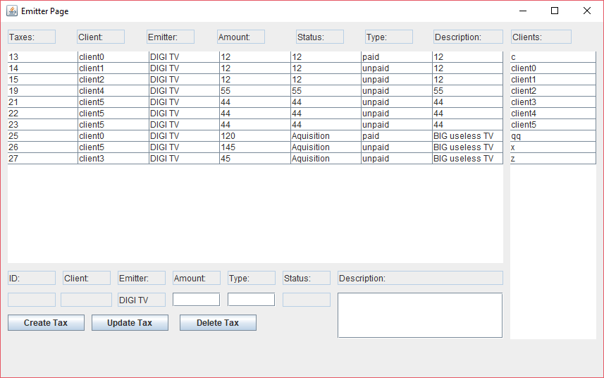

For the client to start, the server must be working and MySQL up.