

|  |
| --- |
|  |
|  |
| SEPTEMBER 17  COMPANY NAME: Arc Pulse Ltd  Authored by :  Rungiah Tirouvalen - 2410805 Parvish Kumar Peethamree - 2412277 Pullwan Devashish - 2411298 |

**

ABSTRACT

This study discusses the networking issues that Arc Pulse Ltd., a business that makes creative phone cases, is facing. Daily operations have been hampered by the antiquated network infrastructure, which has resulted in poor internet speeds, connectivity problems, and an inability to manage the increasing number of connected devices. This paper offers a full solution that includes high-performance wireless access points (WAPs) deployment, VLAN segmentation, and router, switch, and firewall upgrades. Security standards, bandwidth control, and scalability for future growth are important factors to take into account. The report tests and evaluates the suggested network and provides a comprehensive implementation plan with staged upgrades, training, and disaster recovery. The finished layout guarantees a safe, effective, and long-lasting network architecture that will maximize business productivity and support expansion.

INTRODUCTION

In this current modern era, a well-planned computer network is key to an efficient operation for any business. Due to the Outdated Network Infrastructure, Arc Pulse Ltd, a company that specializes in innovative and different phone cases, is currently having difficulties with their day to day operations. In order to address these issues, this report offers a thorough network architecture that satisfies the requirements of this particular business. A general overview of the specific problems caused by the lack of proper network infrastructure and its general impact on the company’s day to day operations.

PROBLEM

Arc Pulse Ltd utilizes a network infrastructure that is out of date, with switches, routers and access points that are inadequate to handle the bandwidth demands of today. The company’s operations are constantly being negatively impacted by the obsolete network infrastructure which frequently causes connectivity issues, slow internet speeds and is incapable to handle the growing amount of devices connected and heavy data traffic.

These problems are hindering the company’s workforce to work efficiently thus wasting valuable resources and time.

AIMS AND OBJECTIVES

 Aims:

* Create an expandable and secure network for the company.
* Test the network performance and reliability under various conditions.
* Ensure that the network is specific to the company’s needs and maximizes efficiency.

Objectives

* Identify most suitable networking requirements.
* Mount an up-to-date network system.
* Divide the whole network into parts to improve performance and security.
* Run simulations to show how the network performs in possible conditions.
* Update or change the network structure to optimize the system.
* Ensure that the network is within industrial standards.
* Document the whole setup process of the network.
* Describe how the network can be regularly updated.

Analysis

Number of employees: 200

Networking equipment needed

* Routers: to communicate between networks
* Switches: to interconnect several devices within a network
* Firewalls: to filter incoming and outgoing data
* Access points: for enabling wireless connections
* Servers: DHCP server, DNS server and HTTP server
* Load balancers: to assign portions of network traffic to different servers to avoid overloading a server
* UPS: to provide time to backup data in case of power failure and avoid data loss

How will users connect to the internet?

* Wired connections: Via Ethernet cables connected to switches, routers and firewalls to monitor internet access.
* Wireless connections: Via WIFI provided by access points placed in specific places throughout the company site
* Redundant Internet Connections: Make use of multiple Internet Service Providers with thorough plans in case of failure to allow continuous internet access

Bandwidth requirements? For local/Internet access?

* Local access: 1 Gbps

Usage policies

* Acceptable use Policy: Define what is permitted while using the network and impose restrictions if needed
* Security Policy: Guidelines to ensure security throughout the network
* Bandwidth Management: Prioritizing business related use of the network over other uses such as social media
* Access control: Assign who can have access to which parts of the network within the business to maintain data confidentiality

How will wireless connectivity be offered if needed?

* Planning and development: carry out site surveys to strategically place Access Points to maximize network area covered
* Security: Make use of WPA3 encryption for wireless connectivity, allocate limited network access to any guests and use appropriate authentication to allow authorized users only
* Management

DESIGN

The primary intention of Arc Pulse Ltd.'s new network plan is to address the challenges posed by the current old fashion network by implementing a sophisticated network system that meets the business requirements. The design enhances network security, enhances most of the performance efficiency, and widens capacity range. The main components of the suggested design are listed below:

1. Network Topology:

The access layer incorporates a hierarchical star topology which schools elements tightly and offers expansion effortlessly through orderly design with separated paths for channel of data transmission.

The primary components will be access switches, distribution switches and core switches. The core layer will manage the high-speed data transmission, the distribution layer will manage whale watching, routing and filtering subnets, and the access layer will make connections to the end-user device.

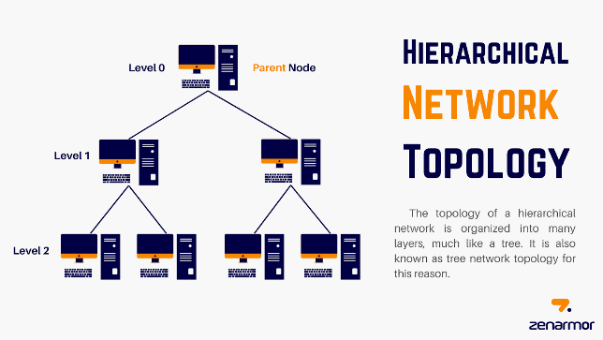

1. Network Architecture:

LAN Segmentation: Such internal divisions will also create several VLANs based on departments, such as sales marketing, HR, R&D, etc. Therefore, this segmentation enhances security by keeping sensitive information inside respective VLANs while also improving efficiency by minimizing the scope of broadcast domains.

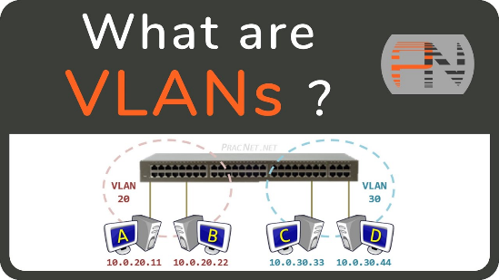

Wireless Access Points (WAPs): New high gadgets will be installed and configured to provide fast WAPs in order to optimize coverage and connection to all devices wirelessly at any part of the facility.

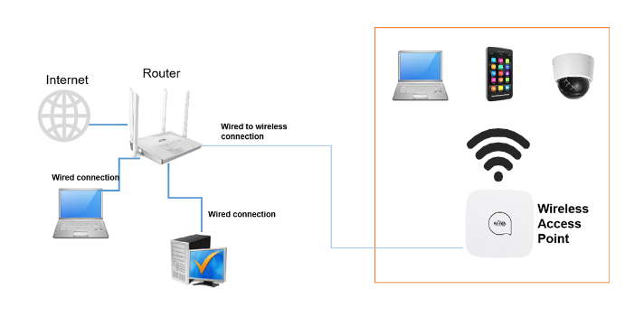



1. Network Equipment:

Replace the existing switches and routers with high efficiency and managed gigabit switches and routers which are OSPF and VLAN capable and operate on QoS and other advanced routing capabilities.

Deploy high power firewalls with means for detection and prevention of intrusions so as to protect the network from external threats.

1. Bandwidth Management:

The network construction will take into consideration the aspects of redundancy to ensure that performance is sustained at all times, over and above, provide anchored links in high traffic areas raising the bandwidth available now and in the future. With the implementation of QoS regulations on bandwidth management, the emphasis will be placed on making sure that key, business-centric applications are given priority on bandwidth over other less important applications.

1. Security Measures:

There is a need for Network Access Control (NAC) so as to ensure that devices are verified prior to being made use of the network resources.

Encryption: For all communications within and outside of the organization, it is required that encryption is performed using WPA3 protocols for wireless interaction and the usage of SSL/TLS rules for web surfaced interactions.

Frequent Security Audits: Routine security audits should be made an integral part of the regular operations so as to enable the organization to deal with the issues in a timely manner once they are identified.

1. User Accounts and Authentication:

The use of either Active Directory or a similar service should be used to set up a system of user account authentication that will be operational network wide and bring under control the access permissions of all users. This will ensure that users only access the required resources to them. This will ensure that users only access the required resources to them.



RECOMMENDATION

The study and design described and proposed contain the aforementioned further suggestions concerning the measures that will ensure successful execution of the project and its management hereafter:

1. Implementation Plan:

Instead of closing them down completely while making changes in the business efficiency by improving the accounts, improve the network slowly. First of all, upgrades to the basic infrastructure should be of distribution and access layers and lastly the rollout of any new user devices as well as WAPs.

1. Training and Support:

Training sessions should be arranged for the IT departments on the use of the new hardware and software. Ensure that there is either an internal or managed services support mechanism for continuous network management and problem solving.

1. Regular Updates and Maintenance:

Develop a maintenance schedule that consists of routine use of hardware inspections, applying security patches, as well as updating firmware. Monitor the security logs and the performance of the network with respect to the traffic being transmitted on it so as to be able to prevent any probable issues and deal with them accordingly.

1. Disaster Recovery and Back-up Plan:

Prepare a disaster management plan that envisions a possibility of providing backup for both data and network configurations. Incorporate the use of spare pathways as well as failover techniques to provide network availability in the event of a hardware failure.

1. Future Proofing:

Retain in mind possible future expansion of the network during its planning so that in the future complication of creating additional branches, bringing in more devices or users will be easy.

1. User Awareness and Policies:

Develop and enforce network use policies that detail acceptable use, censorship facilities and consequences for violation. Security awareness training should be done on a continuous basis so that staff personnel are made aware of new risks and best practices.

Arc Pulse Ltd. will in accordance with the design guidelines and recommendations have a robust network that is scalable and secure to support its operating requirements and allow for growth in the future. The recommended network will not only solve current issues but will also provide a solid foundation for the business’s digital transformation initiatives.

IMPLEMENTATION

For this section, a tool named Educational Network Simulator was used. This platform enabled the simulation of part of the network. The implementation process involved configuring the following:

* Gateways
* IP Info(LAN and WAN)
* Server Info

TESTING

The network has been extensively tested to guarantee it meets the specific criteria required. Testing included the following series of steps:

* Connectivity test establishes that all the components of the network can communicate with each other properly. This test involved the following:

1. Ping Test- Enables to verify whether an IP address exists and can accept requests in the network.
2. Request DHCP Info- Allows automatic configuration of IP addresses of the devices connected to the network.
3. DNS Lookup- Checks the domain name for validity.
4. Web Browser- Ability to access the desired website.

EVALUATION

The report achieved its goals and objectives mentioned in the study. The report’s goal was successfully implemented by offering the company a network model which was both scalable and effective. Furthermore recommendations were also made for the future which will greatly aid the Arc Pulse in the maintaining and advancement of the network architecture. The day to day operation of the business will be vastly improved by the endorsement of the proposed network model.

CONCLUSION

Arc Pulse Ltd.'s proposed network solution successfully tackles the problems of aging infrastructure, sluggish connectivity, and constrained bandwidth. The company's operational performance, data security, and worker productivity will all significantly increase with the implementation of a scalable, secure, and effective network design. Upgrades are implemented gradually to minimize interruption during the transition, and long-term business growth is supported by future-proofing techniques. Arc Pulse Ltd. will be able to handle its existing networking problems and lay a strong basis for future growth and digital transformation by using the suggested network model.



REFERENCES

* 1. (hierarchical-network-topology, n.d.)
  2. (Vlans, n.d.)

