**CONTENTS PAGE NO**

1. **INTRODUCTION** 
   1. Overview
   2. Purpose
2. **PROBLEM DEFINITION & DESIGN THINKING**
   1. Empathy Map
   2. Ideation & Brainstorming Map
3. **RESULT**
4. **ADVANTAGES & DISADVANTAGES**
5. **APPLICATIONS**
6. **CONCLUSION**
7. **FUTURE SCOPE**
8. **APPENDIX**
   1. Source Code

**INTRODUCTION**

The main objective of EXPENSE TRACKER APP

An expense tracker app allows you to monitor and categorize your expenses across different things. Some of these apps also offer budgeting tools, credit monitoring, mileage tracking, receipt keeping, and advice to grow your net worth.

* 1. **Overview:**
* Purpose of tracking expense: The Expense tracker app should makes a record of all the expenses done on a particular time.
* Helping to monitor expense: This app helps to make limit for expenses and makes saving for the future use.
* Advantages of Expense tracking app : Expense management automation offers multiple business benefits.
* Strategies : This app should provide users with the ability to recording all your expenditures so you have a clear and detailed understanding of your budget.
  1. **Purpose:**
* Personal finance management is an important part of people’s lives.
* However, everyone does not have the knowledge or time to manage their finances in a proper manner. And, even if a person has time and knowledge, they do not bother with tracking their expenses as they find it tedious and time-consuming.
* Now, you don’t have to worry about managing your expenses, as you can get access to an expense tracker that will help in the active management of your finances.

**PROBLEM DEFINITION & DESIGN THINKING**

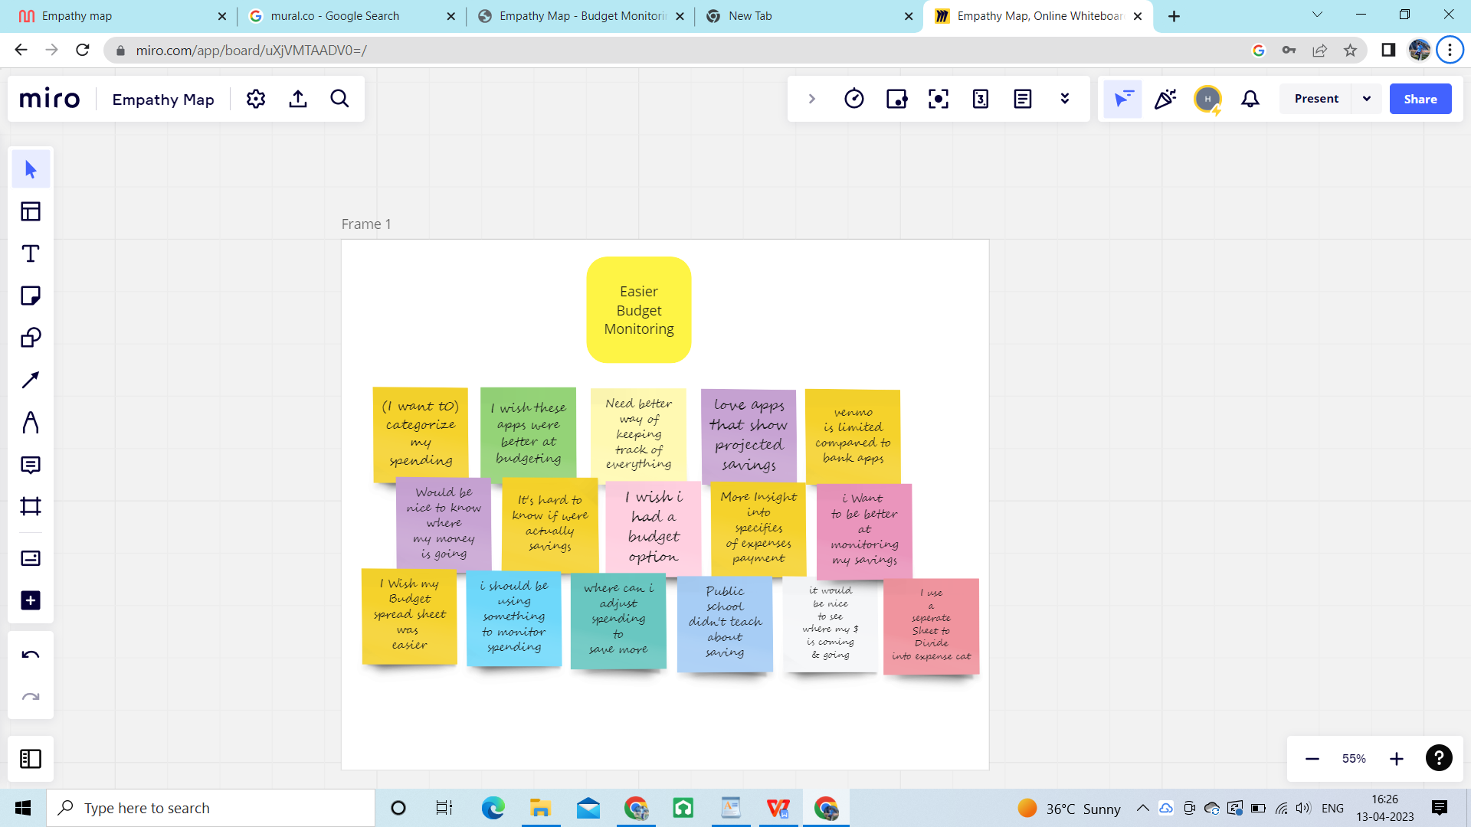

**2.1 Empathy Map:**

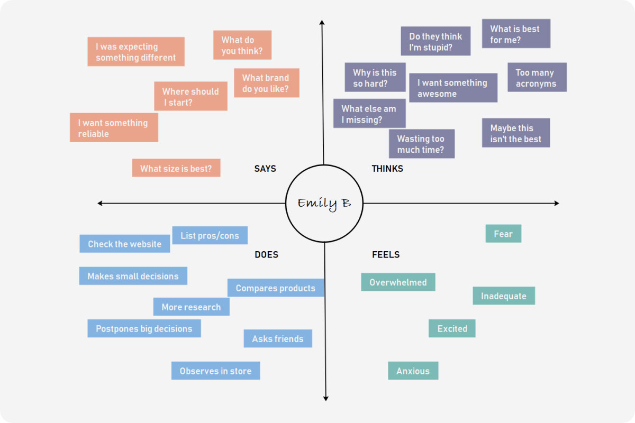

**2.2 Ideation & Brainstorming Map:**

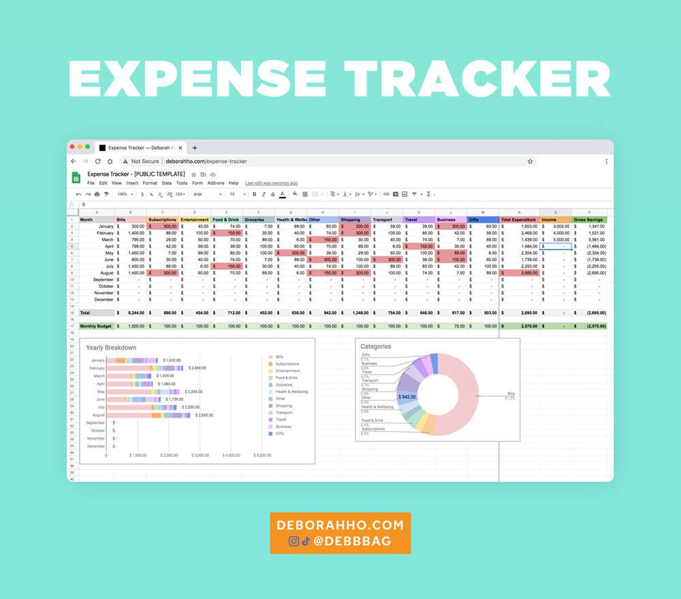

**RESULT**

**Sign in Page:**

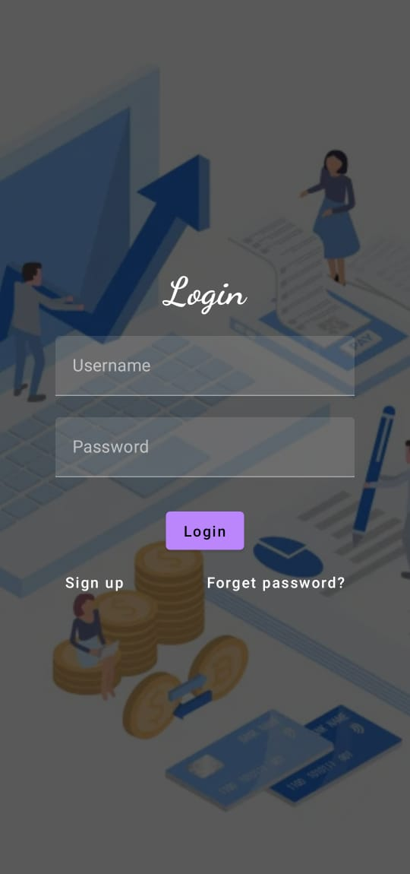

**Sign up page:**

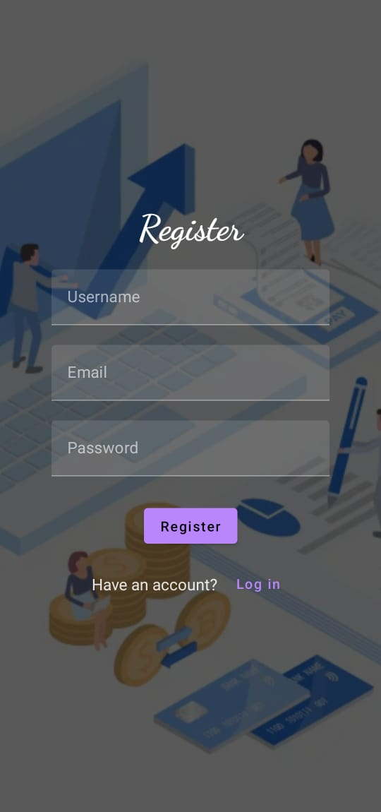

**Home Page:**

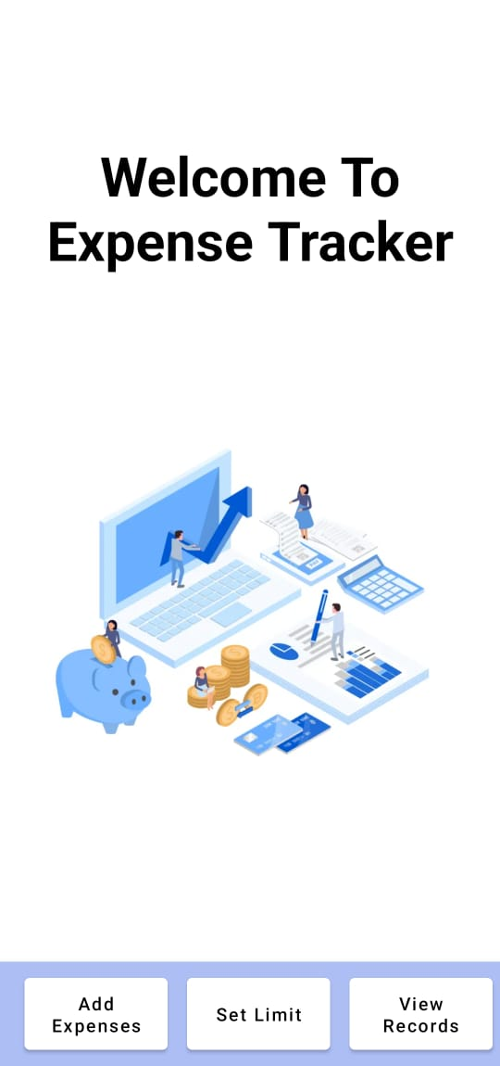

**Input page:**

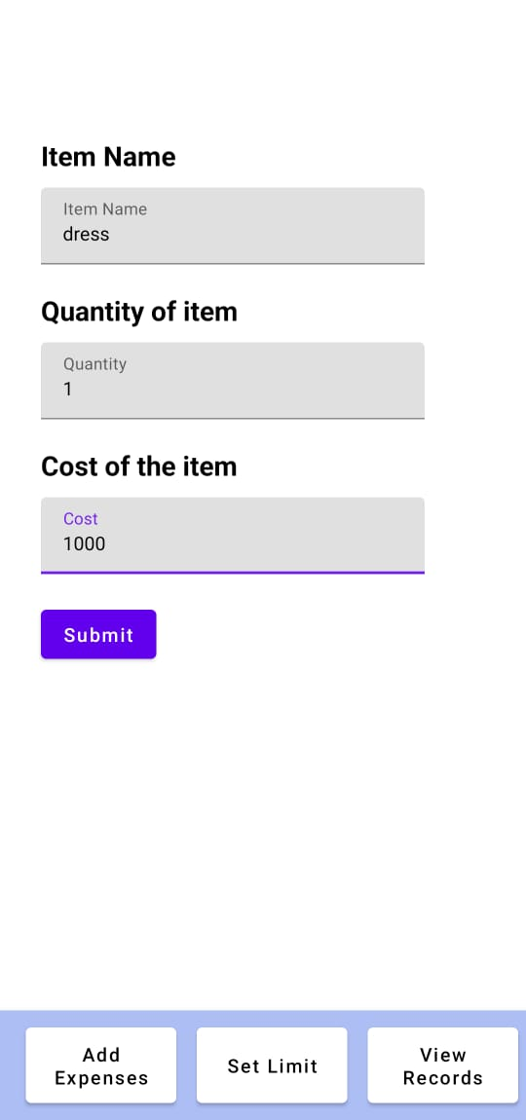

**Limit page:**

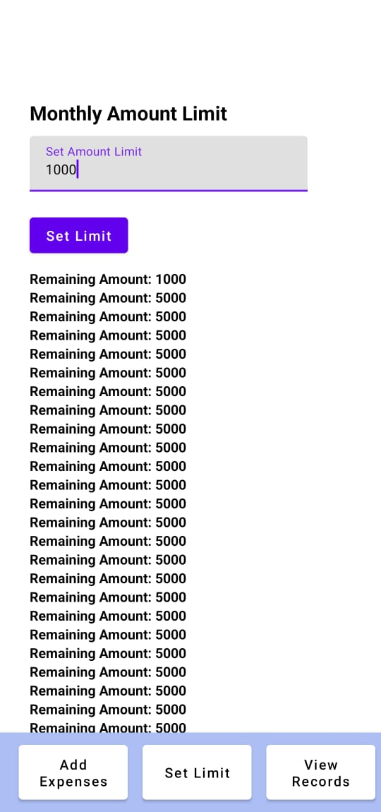

Output page:

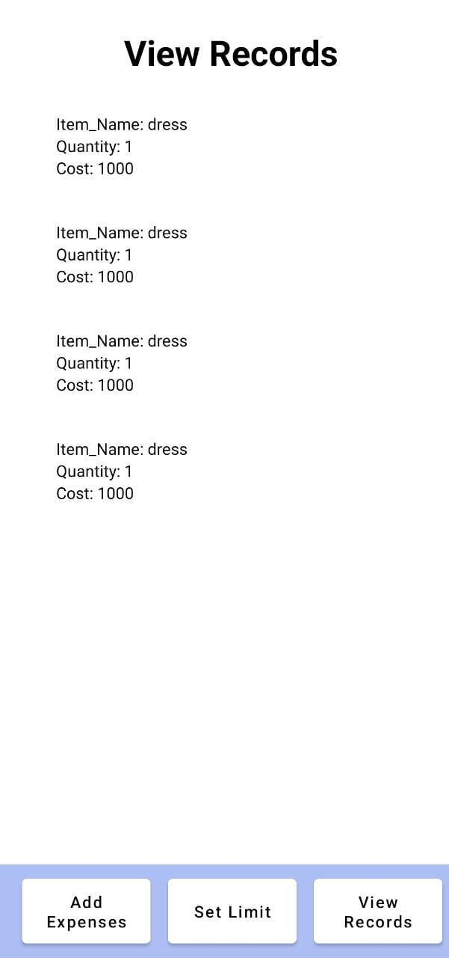

**ADVANTAGES & DISADVANTAGES**

**Advantages:**

Using the Expense Manager, you can easily make month on month comparisons of earning, expenses and spending in a more organized manner.

****1.Take Intelligent Financial Decisions****

Better planning means increased savings. So, refrain from unnecessary spending by closely watching your finances and taking careful decisions for your financial life ahead.

****2.360 degree Expense Summary****

An expense manager is quite capable of syncing your expenses and presenting intuitive graphs of your  spending. This further helps to sharpen your finances.

****3.Build Monthly Budgets****

Once you’re aware of how much you’re spending, an Expense manager lets you build upon a clear monthly budget. This will work in a direction to make your expenditures pre-planned before being spent.

****4.Stay on top of your bills****

You are open to keep a tab on your monthly bills. This is the only way to make timely payments without a miss. A personal finance manager allows you to keep updated all the time. Think how useful a basic personal loan app feature can be!

**Disadvantages:**

**1.Susceptible to costly human errors**

**2. Lack of collaboration** **and access**

**3. Time-consuming manual processes**

**4. Inaccuracy leads to slower decision making**

**5.Lack of version control**

**APPLICATIONS**

1. **Spending tracker**
2. **TraceWallet**
3. **Expense tracker and Management**
4. **Moneylover**
5. **Monefy**

**Conclusion**

The new system has overcome most of the limitations of the existing system and works according to the design specification given. The project what we have developed is work more efficient than the other income and expense tracker. The project successfully avoids the manual calculation for avoiding calculating the income and expense per month. The modules are developed with efficient and also in an attractive manner. The developed systems dispense the problem and meet the needs of by providing reliable and comprehensive information. All the requirements projected by the user have been met by the system. The newly developed system consumes less processing time and all the details are updated and processed immediately. Since the screen provides online help messages and is very userfriendly, any user will get familiarized with its usage. Module s are designed to be highly flexible so that any failure requirements can be easily added to the modules without facing many problems. The best organizations have a way of tracking and handling these reimbursements.

**Future Scopes**

****Next-gen expense management****

A recent T & E study unveiled that visibility and intelligence are the two key aspects that companies look forward to understanding spending associated with business travel. Analytics is also on the priority list of the best-in-class organisations. The motto is not just to enhance the existing process but also to leverage analytical capabilities and visibility that can help companies drive efficiency, forecast and plan better for corporate finances.

Apparently, as per research, integration, analytics and mobile apps are the three key factors that can help companies succeed at a faster pace. When incorporated, these factors add edge and value to the businesses.

**APPENDIX**

**Source Code:**