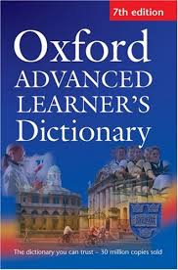
Nominator：Mr. Tsang Wai Ching

Title: Oxford Advanced Learner’s Dictionary
Author: Albert Sydney Hornby [et al.]
Publisher：Oxford University Press

If you’re already very desperate but English is still too difficult a subject for you, don’t worry – you’re one of the many ordinary, hard-working students who feel frustrated when it comes to learning English. When students seek help from me, I always ask them one question: Which dictionary do you use?

Which dictionary do you use? If you don’t use a dictionary at all, of if you use something like Yahoo! Dictionary, it’s no wonder why you can’t improve your English evidently despite the determined effort you’ve made. Using a right dictionary is of utmost importance, so let me introduce this one to you – the Oxford Advanced Learners’ Dictionary (OALD).

‘It’s very thick and heavy, and it takes forever to find the words.’ Yes, this was true a decade ago. With the online version nowadays, consulting this highly reputed dictionary only requires a few clicks. Why is it preferable? Let me use this example to show you. I’m sure you know ‘provide’ means ‘give’, but do you know they’re used differently? We say ‘PROVIDE something FOR somebody’ and ‘GIVE something TO somebody’. This’s what the dictionary can inform you. It not only indicates the meanings of words but also how to use them. It helps you write accurate English, which a good passage cannot be without.

Explore this extremely useful dictionary yourself. You’re bound to be surprised by the many elements that help improve your English. Now, bookmark this website: ‘http://www.oxfordlearnersdictionaries.com’.

