

__________________________________________________________________________

**FACULTY OF SCIENCE AND TECHNOLOGY**

**COURSEWORK FOR THE DIPLOMA INFORMATION TECHNOLOGY; YEAR 1**

**ACADEMIC SESSION 2019**

**WEB202D WEB ENGINEERING**

**DEADLINE: Project Submission 28th June 2019 @3.00 pm**

**Project Presentation 1st-5th July 2019**

**STUDENT NAME:**

**INSTRUCTIONS TO CANDIDATES**

# 

# This coursework will contribute 25% to your final grade.

* This is a group assignment (3-4 persons).

**IMPORTANT**

# The University requires students to adhere to submission deadlines for any form of assessment. Penalties are applied in relation to unauthorized late submission of work.

# Coursework submitted after the deadline but within 1 week will be accepted for a maximum mark of 40%.

# Work handed in following the extension of 1 week after the original deadline will be regarded as a non-submission and marked zero.

**Lecturer’s Remark** (Use additional sheet if required)

I…........................... (Name) …................std. ID received the assignment and read the

comments….................................... (Signature/date)

**Academic Honesty Acknowledgement**

“I …......................................(student name). Verify that this paper contains entirely my own work. I have not consulted with any outside person or materials other than what was specified (an interviewee, for example) in the assignment or the syllabus requirements. Further, I have not copied or inadvertently copied ideas, sentences, or paragraphs from another student. I realize the penalties *(refer to page 16, 5.5, Appendix 2, page 44 of the student handbook diploma and undergraduate programme)* for any kind of copying or collaboration on any assignment.”

……............................... (Student’s signature / Date)

[This paper contains ONE question printed on ONE page]



__________________________________________________________________________

**FACULTY OF SCIENCE AND TECHNOLOGY**

**COURSEWORK FOR THE DIPLOMA INFORMATION TECHNOLOGY; YEAR 1**

**ACADEMIC SESSION 2019**

**WEB202D WEB ENGINEERING**

**DEADLINE: Project Submission 28th June 2019 @3.00 pm**

**Project Presentation 1st-5th July 2019**

**STUDENT NAME:**

**INSTRUCTIONS TO CANDIDATES**

# 

# This coursework will contribute 25% to your final grade.

* This is a group assignment (3-4 persons).

**IMPORTANT**

# The University requires students to adhere to submission deadlines for any form of assessment. Penalties are applied in relation to unauthorized late submission of work.

# Coursework submitted after the deadline but within 1 week will be accepted for a maximum mark of 40%.

# Work handed in following the extension of 1 week after the original deadline will be regarded as a non-submission and marked zero.

**Lecturer’s Remark** (Use additional sheet if required)

I…........................... (Name) …................std. ID received the assignment and read the

comments….................................... (Signature/date)

**Academic Honesty Acknowledgement**

“I …......................................(student name). Verify that this paper contains entirely my own work. I have not consulted with any outside person or materials other than what was specified (an interviewee, for example) in the assignment or the syllabus requirements. Further, I have not copied or inadvertently copied ideas, sentences, or paragraphs from another student. I realize the penalties *(refer to page 16, 5.5, Appendix 2, page 44 of the student handbook diploma and undergraduate programme)* for any kind of copying or collaboration on any assignment.”

……............................... (Student’s signature / Date)

[This paper contains ONE question printed on ONE page]



__________________________________________________________________________

**FACULTY OF SCIENCE AND TECHNOLOGY**

**COURSEWORK FOR THE DIPLOMA INFORMATION TECHNOLOGY; YEAR 1**

**ACADEMIC SESSION 2019**

**WEB202D WEB ENGINEERING**

**DEADLINE: Project Submission 28th June 2019 @3.00 pm**

**Project Presentation 1st-5th July 2019**

**STUDENT NAME:**

**INSTRUCTIONS TO CANDIDATES**

# 

# This coursework will contribute 25% to your final grade.

* This is a group assignment (3-4 persons).

**IMPORTANT**

# The University requires students to adhere to submission deadlines for any form of assessment. Penalties are applied in relation to unauthorized late submission of work.

# Coursework submitted after the deadline but within 1 week will be accepted for a maximum mark of 40%.

# Work handed in following the extension of 1 week after the original deadline will be regarded as a non-submission and marked zero.

**Lecturer’s Remark** (Use additional sheet if required)

I…........................... (Name) …................std. ID received the assignment and read the

comments….................................... (Signature/date)

**Academic Honesty Acknowledgement**

“I …......................................(student name). Verify that this paper contains entirely my own work. I have not consulted with any outside person or materials other than what was specified (an interviewee, for example) in the assignment or the syllabus requirements. Further, I have not copied or inadvertently copied ideas, sentences, or paragraphs from another student. I realize the penalties *(refer to page 16, 5.5, Appendix 2, page 44 of the student handbook diploma and undergraduate programme)* for any kind of copying or collaboration on any assignment.”

……............................... (Student’s signature / Date)

[This paper contains ONE question printed on ONE page]



__________________________________________________________________________

**FACULTY OF SCIENCE AND TECHNOLOGY**

**COURSEWORK FOR THE DIPLOMA INFORMATION TECHNOLOGY; YEAR 1**

**ACADEMIC SESSION 2019**

**WEB202D WEB ENGINEERING**

**DEADLINE: Project Submission 28th June 2019 @3.00 pm**

**Project Presentation 1st-5th July 2019**

**STUDENT NAME:**

**INSTRUCTIONS TO CANDIDATES**

# 

# This coursework will contribute 25% to your final grade.

* This is a group assignment (3-4 persons).

**IMPORTANT**

# The University requires students to adhere to submission deadlines for any form of assessment. Penalties are applied in relation to unauthorized late submission of work.

# Coursework submitted after the deadline but within 1 week will be accepted for a maximum mark of 40%.

# Work handed in following the extension of 1 week after the original deadline will be regarded as a non-submission and marked zero.

**Lecturer’s Remark** (Use additional sheet if required)

I…........................... (Name) …................std. ID received the assignment and read the

comments….................................... (Signature/date)

**Academic Honesty Acknowledgement**

“I …......................................(student name). Verify that this paper contains entirely my own work. I have not consulted with any outside person or materials other than what was specified (an interviewee, for example) in the assignment or the syllabus requirements. Further, I have not copied or inadvertently copied ideas, sentences, or paragraphs from another student. I realize the penalties *(refer to page 16, 5.5, Appendix 2, page 44 of the student handbook diploma and undergraduate programme)* for any kind of copying or collaboration on any assignment.”

……............................... (Student’s signature / Date)

[This paper contains ONE question printed on ONE page]

Documentation

1. Specify all the instruction how to port your project in other pc, i.e. the server-side directory path of your application (and database if you use separate folder/path).

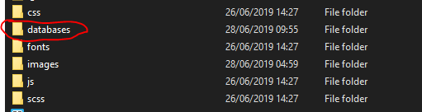

-Open databases folder



-Import database into PHPMyAdmin/MySQL work bench

-please ensure database details as below:

* Servername = localhost
* Username = root
* Password = ‘ ‘ //empty
* Database name = assignment_database

*Important notes: admin access username is ‘admin’ and password is ‘admin’

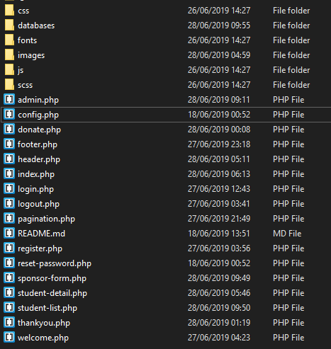

2. The URL of the assignment is WebAssignment/index.php. The HTML and PHP pages in this assignment are as follows:

-admin.php

-config.php

-donate.php

-footer.php

-header.php

-index.php

-login.php

-logout.php

-pagination.php

-register.php

-reset-password.php

-student-detail.php

-student-list.php

-thankyou.php

-welcome.php

3. Show the links or relationship of all the web page and forms, this could be tree chart and page/form screenshots or story boards.

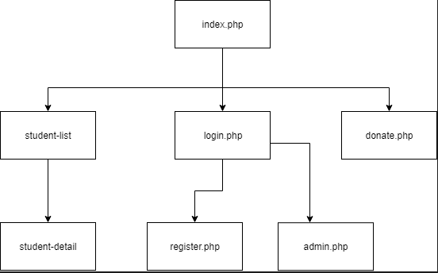

-About Me (section)

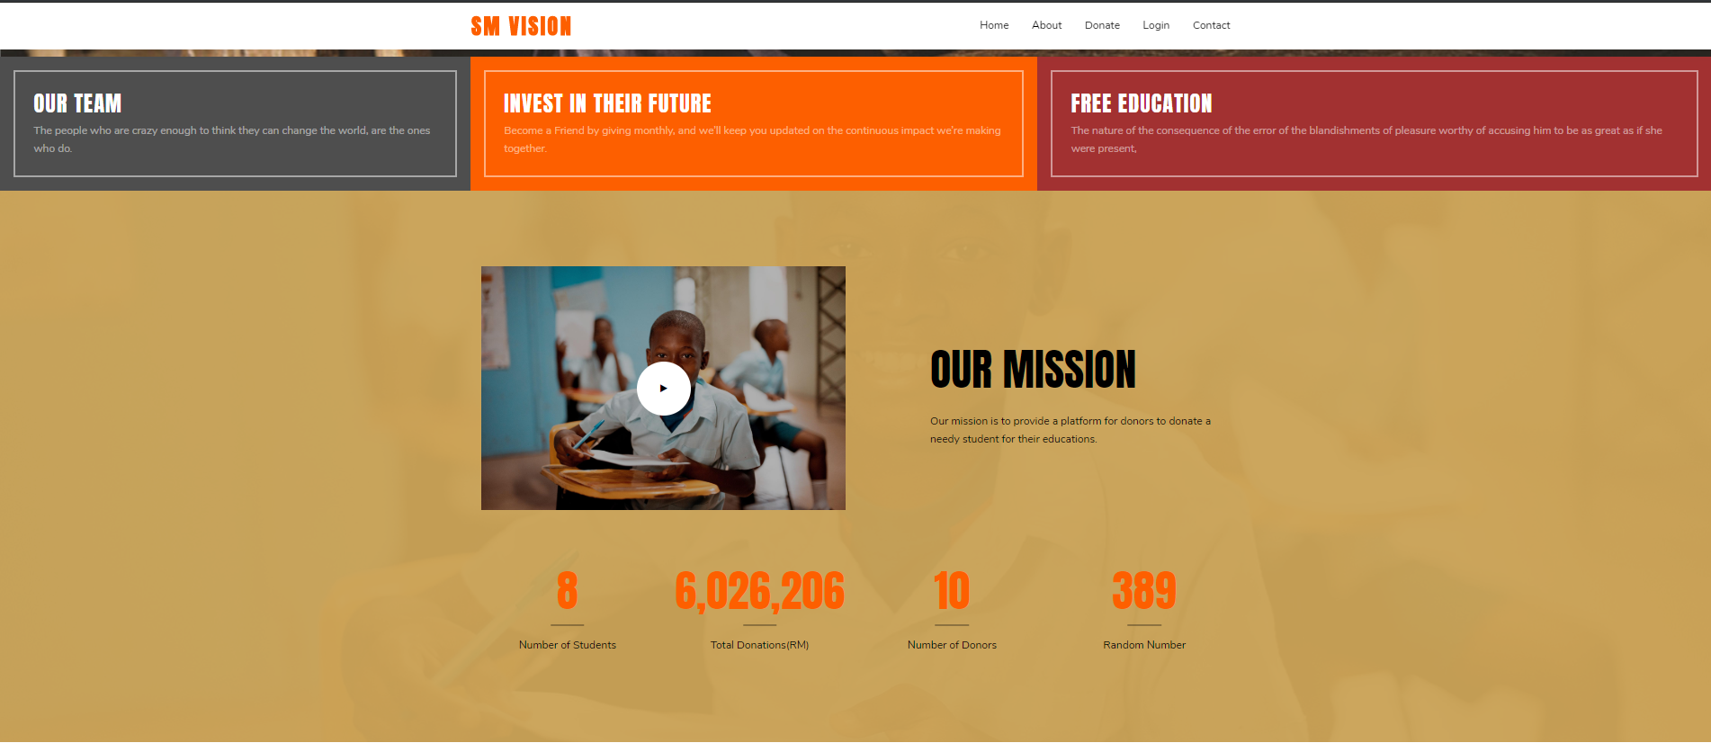

-Donate Button (section)



-Randomize Top List (Section)

* It also has “View More Students” button that leads to student-list page

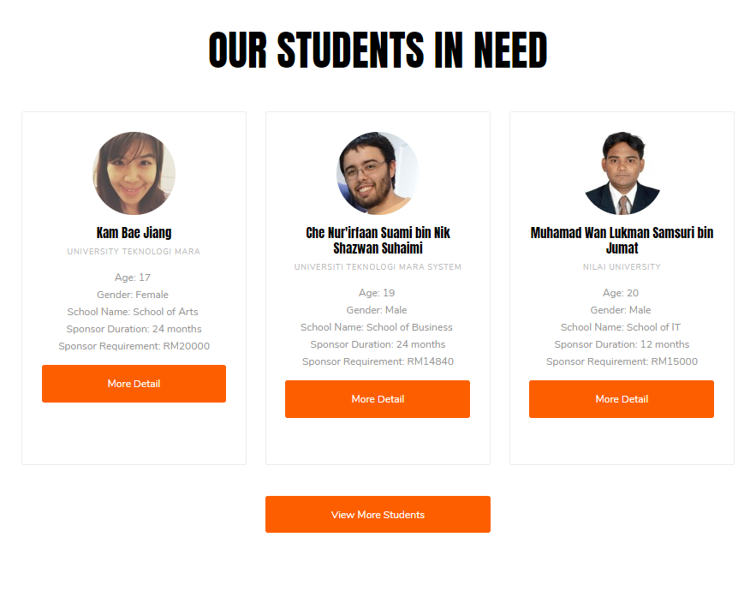

-Contact Us (Section)

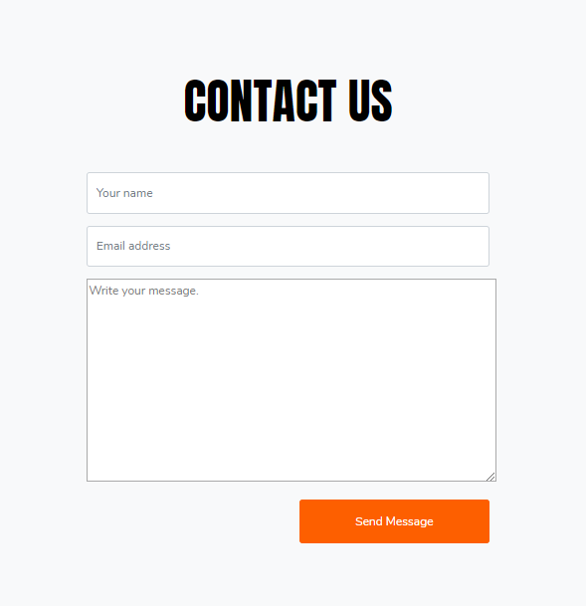

-Our index page consists of:

* About (section)
* Donation Button (section)
* Login Button (header)
* Randomize top 3 student list (section)
* Contact Us (section)

-Login Page

* Within this page there is a link that allows user to register

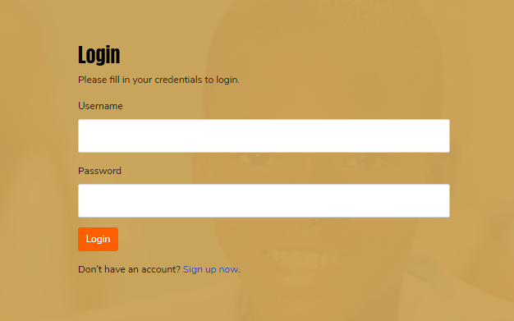

-Sign Up page

* Within this page there is a link that links back to Login Page

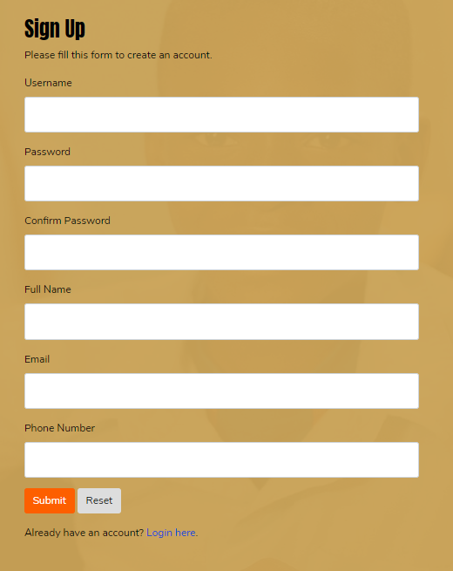

-Student list page

* Consist of all student list
* Able to view student details before applying as sponsor

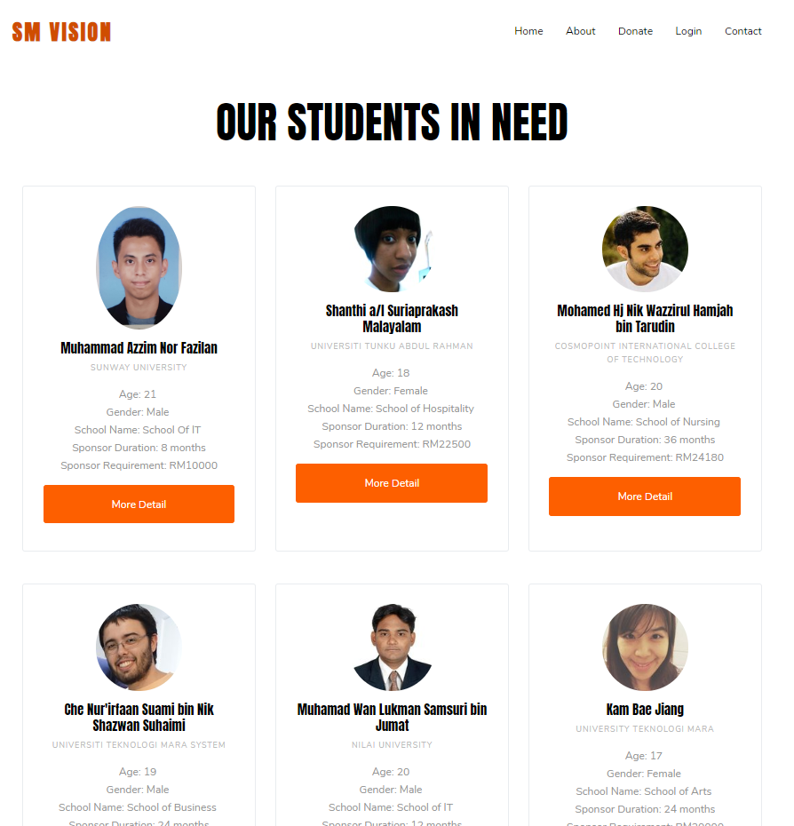

-Student Profile page

* A view before sponsorship application

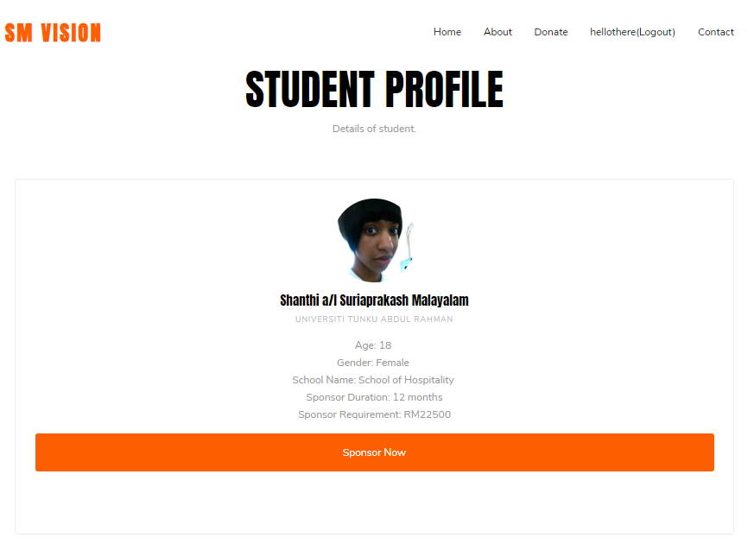

-Donation page

* Allows you to enter the amount to donate before transaction
* Before it leads to thank you

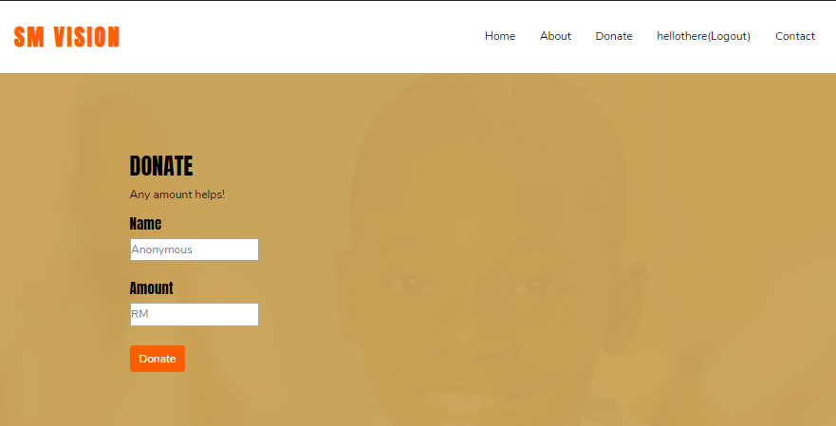

-Admin Panel

* Can only be access is user has admin access
* Can be accessed from header menu
* Consists of total of student list view, and add student into database.

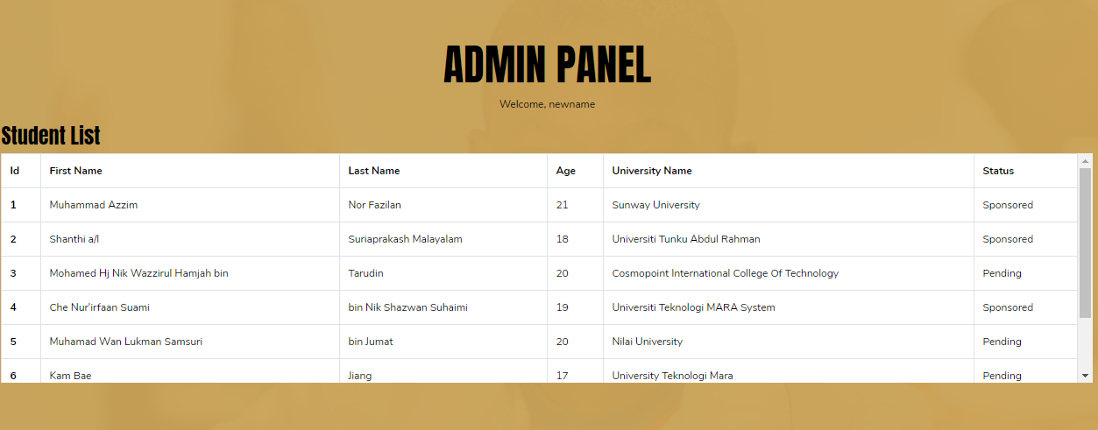

-Add student function

* Allows the admin to insert new student into database

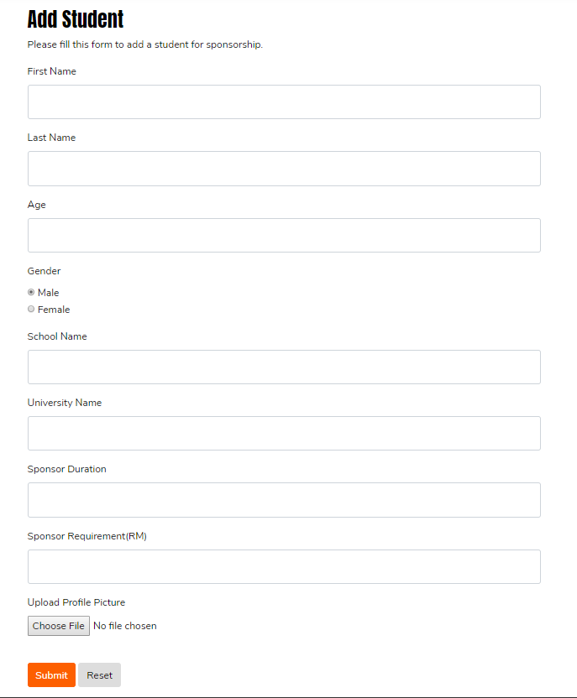

4. Register form:

The register form has a form-based interface design which consists of the fields username, password, confirm password, full name, email and phone number. Each of these fields are mandatory because any blank fields will cause an error in the record of any registering user.



Contact us form:

The contact us form has a form-based interface design which has fields your name, email address and a write your message field. Users are required to fill in each of the fields as the fields are mandatory as the information on each fields will be referred to when sent to the email designated.

