<http://localhost:4200/>

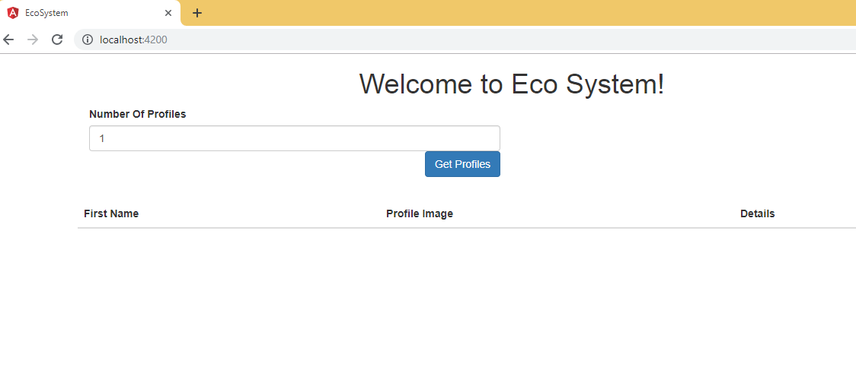

Enter input, Click on Get Profiles button, it will display the details in below grid

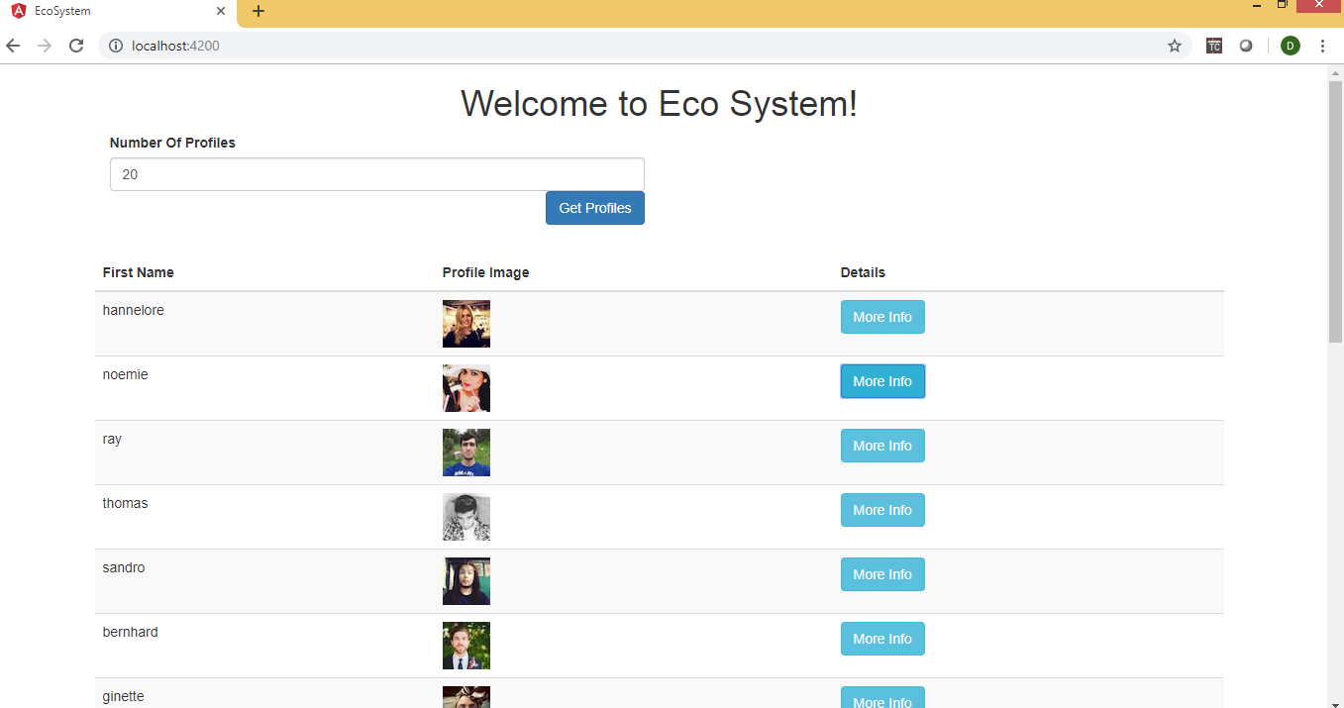

Click on More Info button, it will display the more details of the user.

