**Why the test failed**

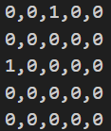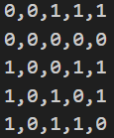

Ground truth and naive_graph_isomorphism result

First is graph_00 and graph_03:

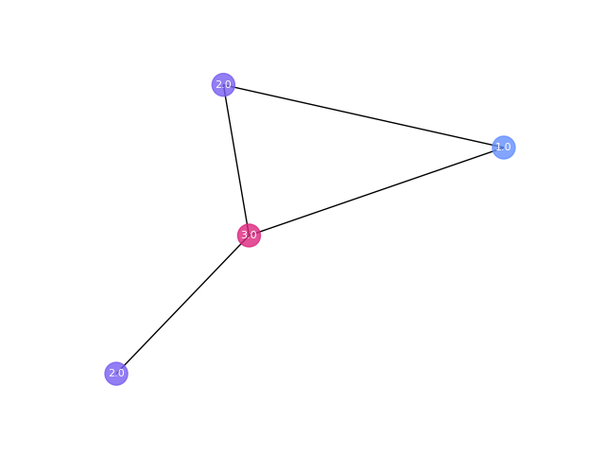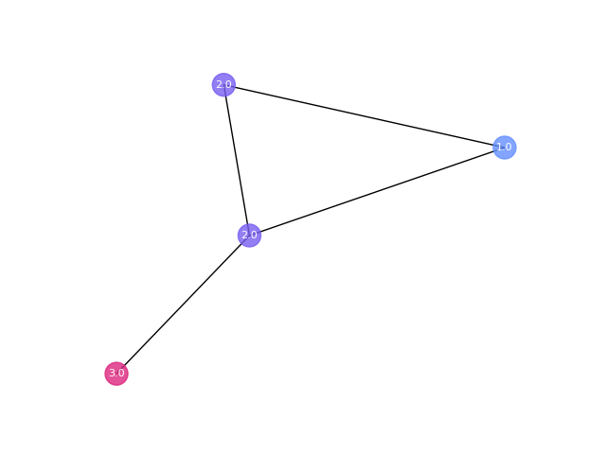

Although these two graph satisfy the three conditions we gave, they are not isomorphic. We can see in first graph, two 2.0 labeled nodes are not neighbors, but in second graph they are. Since knowing numbers of nodes and edges can not let us know the relationship between each node and edge.

Second is graph_00 and graph_04:

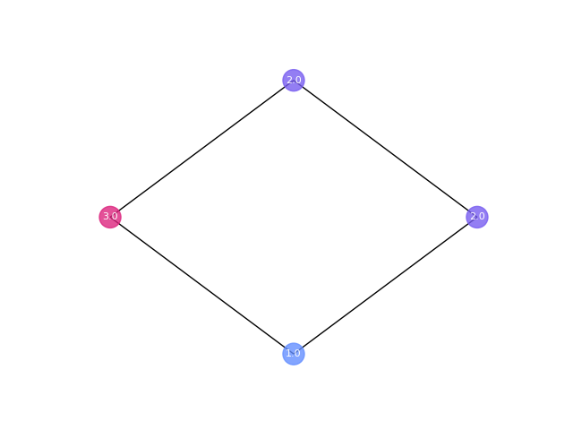

1.0 and 3.0 are not neighbors in graph_00 but in graph_04.

Third is graph_02 and graph_03:

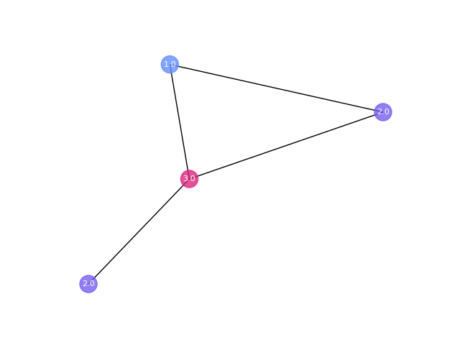

1.0 and 3.0 are neighbors in graph_02 but graph_03 not.

Fourth is graph_02 and graph_04:



2.0 and 2.0 are not neighbors in graph_02 but neighbored in graph_04.

Last one is graph_03 and graph_04:



1.0 and 3.0 are not neighbors in graph_03 but neighbored in graph_04.