A diagnostic framework for assessing trophic change from predator stomach contents
  - Appendices

Appendix A. Prey taxonomic resolution
The primary analysis was repeated at 100 prey aggregation thresholds, from 10 to 1,000 stomachs in steps of 10 (Section 2.2; Figure 2). The tables below report the quantities cited in the Results.
Table A1. Compositional effect sizes by contrast and dietary currency, Gulf-wide scale: median Bray–Curtis dissimilarity between period-mean relative prey profiles and median PERMANOVA R², across classifiable cells and prey resolutions.
Contrast | Currency | Median Bray–Curtis | Median PERMANOVA R² | Cell × resolution
2004 vs 2006 | Biomass | 0.320 | 0.035 | 5,400
2004–2005 vs 2006 | Biomass | 0.298 | 0.027 | 5,500
2018 vs 2019 | Biomass | 0.413 | 0.046 | 5,100
2006 vs 2018 | Biomass | 0.649 | 0.101 | 5,200
2004–2006 vs 2018–2019 | Biomass | 0.576 | 0.077 | 5,900
2004 vs 2006 | Occurrence | 0.283 | 0.035 | 5,400
2004–2005 vs 2006 | Occurrence | 0.277 | 0.031 | 5,500
2018 vs 2019 | Occurrence | 0.379 | 0.050 | 5,100
2006 vs 2018 | Occurrence | 0.616 | 0.162 | 5,200
2004–2006 vs 2018–2019 | Occurrence | 0.564 | 0.122 | 5,900
Table A2. Family frequencies at the ecoregion and stratum scales after excluding spatial units represented by fewer than five classifiable predator × size-class cells.
Scale | Contrast | Currency | Units retained | Stability | Substitution | Functional change | Reorganization
Ecoregion | 2004 vs 2006 | Biomass | 4 | 65.9 → 65.9 | 9.3 → 9.3 | 20.2 → 20.2 | 4.6 → 4.6
Ecoregion | 2004–2005 vs 2006 | Biomass | 4 | 69.5 → 69.5 | 8.0 → 8.0 | 18.7 → 18.7 | 3.9 → 3.9
Ecoregion | 2018 vs 2019 | Biomass | 3 | 69.5 → 59.4 | 9.6 → 12.8 | 17.7 → 23.5 | 3.2 → 4.3
Ecoregion | 2006 vs 2018 | Biomass | 4 | 34.5 → 34.5 | 30.4 → 30.4 | 18.3 → 18.3 | 16.8 → 16.8
Ecoregion | 2004–2006 vs 2018–2019 | Biomass | 4 | 24.6 → 24.6 | 41.7 → 41.7 | 9.6 → 9.6 | 24.1 → 24.1
Ecoregion | 2004 vs 2006 | Occurrence | 4 | 70.7 → 70.7 | 11.9 → 11.9 | 8.8 → 8.8 | 8.6 → 8.6
Ecoregion | 2004–2005 vs 2006 | Occurrence | 4 | 69.8 → 69.8 | 13.3 → 13.3 | 10.0 → 10.0 | 6.9 → 6.9
Ecoregion | 2018 vs 2019 | Occurrence | 3 | 78.0 → 71.1 | 9.4 → 12.0 | 7.3 → 9.7 | 5.4 → 7.2
Ecoregion | 2006 vs 2018 | Occurrence | 4 | 28.3 → 28.3 | 48.7 → 48.7 | 3.3 → 3.3 | 19.8 → 19.8
Ecoregion | 2004–2006 vs 2018–2019 | Occurrence | 4 | 16.9 → 16.9 | 53.9 → 53.9 | 5.0 → 5.0 | 24.1 → 24.1
Stratum | 2004 vs 2006 | Biomass | 12 | 78.7 → 70.7 | 4.5 → 6.4 | 14.3 → 18.2 | 2.4 → 4.7
Stratum | 2004–2005 vs 2006 | Biomass | 14 | 80.3 → 73.9 | 5.2 → 6.8 | 11.8 → 14.6 | 2.7 → 4.7
Stratum | 2018 vs 2019 | Biomass | 3 | 68.8 → 68.1 | 1.6 → 4.5 | 28.4 → 20.3 | 1.2 → 7.1
Stratum | 2006 vs 2018 | Biomass | 7 | 56.0 → 31.5 | 20.1 → 36.8 | 11.6 → 10.1 | 12.3 → 21.5
Stratum | 2004–2006 vs 2018–2019 | Biomass | 20 | 37.4 → 35.8 | 41.1 → 42.8 | 7.2 → 8.7 | 14.3 → 12.7
Stratum | 2004 vs 2006 | Occurrence | 12 | 77.8 → 70.1 | 7.5 → 11.2 | 11.7 → 13.8 | 2.9 → 4.9
Stratum | 2004–2005 vs 2006 | Occurrence | 14 | 77.7 → 71.7 | 7.7 → 9.8 | 11.6 → 13.2 | 3.1 → 5.3
Stratum | 2018 vs 2019 | Occurrence | 3 | 82.1 → 82.3 | 6.1 → 9.5 | 8.7 → 6.0 | 3.0 → 2.2
Stratum | 2006 vs 2018 | Occurrence | 7 | 48.6 → 22.1 | 39.9 → 62.7 | 3.1 → 0.0 | 8.5 → 15.2
Stratum | 2004–2006 vs 2018–2019 | Occurrence | 20 | 24.8 → 24.0 | 59.2 → 55.4 | 4.8 → 6.2 | 11.2 → 14.5
Table A3. Range of Gulf-wide family frequencies across the 100 prey resolutions, by contrast and currency. The between-period range of Stability lies entirely below the lowest within-period value at any resolution.
Contrast | Currency | Stability | Substitution | Functional change | Reorganization
2004 vs 2006 | Biomass | 54.1 [50.0–59.3] | 21.7 [16.7–25.9] | 15.6 [13.0–16.7] | 8.5 [7.4–11.1]
2004–2005 vs 2006 | Biomass | 48.3 [43.6–52.7] | 24.2 [20.0–29.1] | 20.3 [18.2–21.8] | 7.3 [5.5–9.1]
2018 vs 2019 | Biomass | 64.2 [54.9–70.6] | 14.7 [9.8–19.6] | 17.5 [11.8–21.6] | 3.6 [0.0–11.8]
2006 vs 2018 | Biomass | 15.2 [9.6–19.2] | 47.4 [38.5–53.8] | 4.9 [1.9–7.7] | 32.5 [26.9–44.2]
2004–2006 vs 2018–2019 | Biomass | 10.7 [5.1–13.6] | 55.1 [45.8–62.7] | 4.1 [1.7–5.1] | 30.2 [22.0–44.1]
2004 vs 2006 | Occurrence | 51.5 [44.4–57.4] | 28.5 [20.4–37.0] | 2.3 [0.0–7.4] | 17.8 [14.8–20.4]
2004–2005 vs 2006 | Occurrence | 52.9 [45.5–61.8] | 26.7 [20.0–30.9] | 5.2 [1.8–7.3] | 15.1 [12.7–18.2]
2018 vs 2019 | Occurrence | 63.4 [58.8–70.6] | 10.9 [5.9–17.6] | 15.6 [11.8–19.6] | 10.2 [3.9–13.7]
2006 vs 2018 | Occurrence | 10.1 [5.8–11.5] | 58.1 [46.2–63.5] | 2.3 [0.0–3.8] | 29.5 [23.1–42.3]
2004–2006 vs 2018–2019 | Occurrence | 7.4 [3.4–10.2] | 50.6 [42.4–57.6] | 2.6 [1.7–5.1] | 39.4 [30.5–49.2]

Appendix B. Alternative prey-grouping rules
Two alternatives to the primary pooled rule were evaluated (Section 2.6): a cross-predator rule retaining only prey categories found in at least two predator species, and a per-predator rule building prey categories within each predator’s diet. Comparisons use the 25 thresholds shared by the three rules.
Table B1. Gulf-wide family frequencies under the three grouping rules, by contrast and currency, on the 25 shared thresholds.
Rule | Contrast | Currency | Stability | Substitution | Functional change | Reorganization
Pooled (primary) | 2004 vs 2006 | Biomass | 52.4 | 22.4 | 15.0 | 10.1
Pooled (primary) | 2004–2005 vs 2006 | Biomass | 47.2 | 25.5 | 21.1 | 6.2
Pooled (primary) | 2018 vs 2019 | Biomass | 58.5 | 15.1 | 18.4 | 8.0
Pooled (primary) | 2006 vs 2018 | Biomass | 13.8 | 42.1 | 3.5 | 40.6
Pooled (primary) | 2004–2006 vs 2018–2019 | Biomass | 8.3 | 48.5 | 4.8 | 38.4
Pooled cross-predator | 2004 vs 2006 | Biomass | 53.7 | 21.4 | 14.7 | 10.1
Pooled cross-predator | 2004–2005 vs 2006 | Biomass | 47.7 | 23.9 | 22.3 | 6.2
Pooled cross-predator | 2018 vs 2019 | Biomass | 58.0 | 15.5 | 18.5 | 8.0
Pooled cross-predator | 2006 vs 2018 | Biomass | 11.9 | 42.1 | 5.5 | 40.5
Pooled cross-predator | 2004–2006 vs 2018–2019 | Biomass | 8.4 | 46.8 | 3.7 | 41.2
Per-predator | 2004 vs 2006 | Biomass | 61.8 | 17.9 | 12.3 | 8.0
Per-predator | 2004–2005 vs 2006 | Biomass | 59.5 | 16.1 | 16.1 | 8.3
Per-predator | 2018 vs 2019 | Biomass | 75.7 | 7.2 | 12.0 | 5.2
Per-predator | 2006 vs 2018 | Biomass | 31.0 | 35.9 | 5.6 | 27.5
Per-predator | 2004–2006 vs 2018–2019 | Biomass | 31.7 | 39.0 | 2.7 | 26.6
Pooled (primary) | 2004 vs 2006 | Occurrence | 46.1 | 35.6 | 1.8 | 16.5
Pooled (primary) | 2004–2005 vs 2006 | Occurrence | 49.0 | 29.3 | 5.8 | 15.9
Pooled (primary) | 2018 vs 2019 | Occurrence | 63.7 | 14.5 | 14.3 | 7.5
Pooled (primary) | 2006 vs 2018 | Occurrence | 10.2 | 49.4 | 2.5 | 37.9
Pooled (primary) | 2004–2006 vs 2018–2019 | Occurrence | 4.5 | 44.3 | 4.6 | 46.6
Pooled cross-predator | 2004 vs 2006 | Occurrence | 49.4 | 32.9 | 1.1 | 16.6
Pooled cross-predator | 2004–2005 vs 2006 | Occurrence | 50.3 | 28.6 | 5.7 | 15.3
Pooled cross-predator | 2018 vs 2019 | Occurrence | 63.2 | 14.0 | 14.7 | 8.1
Pooled cross-predator | 2006 vs 2018 | Occurrence | 10.8 | 49.5 | 2.0 | 37.7
Pooled cross-predator | 2004–2006 vs 2018–2019 | Occurrence | 4.5 | 39.5 | 4.6 | 51.4
Per-predator | 2004 vs 2006 | Occurrence | 53.4 | 18.7 | 12.5 | 15.4
Per-predator | 2004–2005 vs 2006 | Occurrence | 53.7 | 21.2 | 13.4 | 11.7
Per-predator | 2018 vs 2019 | Occurrence | 72.0 | 3.9 | 12.8 | 11.2
Per-predator | 2006 vs 2018 | Occurrence | 26.0 | 47.4 | 3.8 | 22.8
Per-predator | 2004–2006 vs 2018–2019 | Occurrence | 21.7 | 37.9 | 7.5 | 33.0
Table B2. As Table B1, ecoregion scale.
Rule | Contrast | Currency | Stability | Substitution | Functional change | Reorganization
Pooled (primary) | 2004 vs 2006 | Biomass | 63.2 | 9.4 | 21.5 | 6.0
Pooled (primary) | 2004–2005 vs 2006 | Biomass | 66.6 | 8.9 | 20.4 | 4.1
Pooled (primary) | 2018 vs 2019 | Biomass | 64.4 | 12.9 | 18.1 | 4.5
Pooled (primary) | 2006 vs 2018 | Biomass | 32.4 | 30.9 | 17.9 | 18.8
Pooled (primary) | 2004–2006 vs 2018–2019 | Biomass | 21.4 | 43.6 | 4.8 | 30.2
Pooled cross-predator | 2004 vs 2006 | Biomass | 65.0 | 9.2 | 21.3 | 4.5
Pooled cross-predator | 2004–2005 vs 2006 | Biomass | 68.4 | 8.6 | 19.9 | 3.2
Pooled cross-predator | 2018 vs 2019 | Biomass | 64.7 | 12.7 | 18.1 | 4.5
Pooled cross-predator | 2006 vs 2018 | Biomass | 32.5 | 30.7 | 20.2 | 16.5
Pooled cross-predator | 2004–2006 vs 2018–2019 | Biomass | 22.0 | 42.1 | 5.6 | 30.2
Per-predator | 2004 vs 2006 | Biomass | 66.6 | 7.8 | 19.0 | 6.5
Per-predator | 2004–2005 vs 2006 | Biomass | 69.9 | 6.9 | 17.6 | 5.6
Per-predator | 2018 vs 2019 | Biomass | 70.4 | 6.6 | 16.4 | 6.6
Per-predator | 2006 vs 2018 | Biomass | 50.2 | 20.4 | 13.0 | 16.4
Per-predator | 2004–2006 vs 2018–2019 | Biomass | 44.1 | 30.3 | 7.7 | 17.9
Pooled (primary) | 2004 vs 2006 | Occurrence | 69.2 | 15.0 | 7.5 | 8.2
Pooled (primary) | 2004–2005 vs 2006 | Occurrence | 67.8 | 15.7 | 9.5 | 7.1
Pooled (primary) | 2018 vs 2019 | Occurrence | 78.8 | 9.4 | 10.2 | 1.6
Pooled (primary) | 2006 vs 2018 | Occurrence | 25.4 | 51.2 | 2.6 | 20.8
Pooled (primary) | 2004–2006 vs 2018–2019 | Occurrence | 12.8 | 57.8 | 2.9 | 26.5
Pooled cross-predator | 2004 vs 2006 | Occurrence | 71.4 | 13.3 | 7.0 | 8.2
Pooled cross-predator | 2004–2005 vs 2006 | Occurrence | 69.4 | 14.0 | 9.5 | 7.2
Pooled cross-predator | 2018 vs 2019 | Occurrence | 83.0 | 7.9 | 7.3 | 1.8
Pooled cross-predator | 2006 vs 2018 | Occurrence | 25.4 | 51.1 | 2.6 | 21.0
Pooled cross-predator | 2004–2006 vs 2018–2019 | Occurrence | 12.8 | 56.1 | 2.6 | 28.4
Per-predator | 2004 vs 2006 | Occurrence | 76.7 | 8.5 | 8.0 | 6.8
Per-predator | 2004–2005 vs 2006 | Occurrence | 76.7 | 10.0 | 7.1 | 6.3
Per-predator | 2018 vs 2019 | Occurrence | 80.8 | 5.7 | 8.9 | 4.6
Per-predator | 2006 vs 2018 | Occurrence | 46.9 | 35.6 | 3.3 | 14.2
Per-predator | 2004–2006 vs 2018–2019 | Occurrence | 34.5 | 42.3 | 3.7 | 19.5
Table B3. As Table B1, stratum scale.
Rule | Contrast | Currency | Stability | Substitution | Functional change | Reorganization
Pooled (primary) | 2004 vs 2006 | Biomass | 80.5 | 4.6 | 11.9 | 3.0
Pooled (primary) | 2004–2005 vs 2006 | Biomass | 80.7 | 5.7 | 10.7 | 2.9
Pooled (primary) | 2018 vs 2019 | Biomass | 68.1 | 1.4 | 29.4 | 1.1
Pooled (primary) | 2006 vs 2018 | Biomass | 51.0 | 22.7 | 16.7 | 9.6
Pooled (primary) | 2004–2006 vs 2018–2019 | Biomass | 38.0 | 44.2 | 5.3 | 12.5
Pooled cross-predator | 2004 vs 2006 | Biomass | 79.4 | 4.6 | 13.0 | 3.0
Pooled cross-predator | 2004–2005 vs 2006 | Biomass | 79.6 | 5.7 | 11.8 | 2.9
Pooled cross-predator | 2018 vs 2019 | Biomass | 67.4 | 2.1 | 29.5 | 1.1
Pooled cross-predator | 2006 vs 2018 | Biomass | 50.7 | 24.1 | 16.4 | 8.7
Pooled cross-predator | 2004–2006 vs 2018–2019 | Biomass | 38.1 | 44.1 | 5.2 | 12.6
Per-predator | 2004 vs 2006 | Biomass | 81.3 | 5.2 | 10.6 | 2.9
Per-predator | 2004–2005 vs 2006 | Biomass | 84.3 | 4.8 | 8.1 | 2.8
Per-predator | 2018 vs 2019 | Biomass | 66.2 | 2.8 | 28.6 | 2.4
Per-predator | 2006 vs 2018 | Biomass | 59.4 | 18.2 | 12.1 | 10.2
Per-predator | 2004–2006 vs 2018–2019 | Biomass | 48.1 | 31.4 | 8.0 | 12.5
Pooled (primary) | 2004 vs 2006 | Occurrence | 76.1 | 7.1 | 11.8 | 5.1
Pooled (primary) | 2004–2005 vs 2006 | Occurrence | 75.2 | 8.0 | 12.7 | 4.1
Pooled (primary) | 2018 vs 2019 | Occurrence | 80.4 | 5.5 | 11.3 | 2.8
Pooled (primary) | 2006 vs 2018 | Occurrence | 38.9 | 45.7 | 7.2 | 8.1
Pooled (primary) | 2004–2006 vs 2018–2019 | Occurrence | 21.0 | 58.0 | 5.0 | 15.9
Pooled cross-predator | 2004 vs 2006 | Occurrence | 76.3 | 7.1 | 11.4 | 5.1
Pooled cross-predator | 2004–2005 vs 2006 | Occurrence | 75.9 | 8.0 | 12.0 | 4.0
Pooled cross-predator | 2018 vs 2019 | Occurrence | 80.4 | 5.4 | 11.3 | 2.9
Pooled cross-predator | 2006 vs 2018 | Occurrence | 40.2 | 43.9 | 7.2 | 8.8
Pooled cross-predator | 2004–2006 vs 2018–2019 | Occurrence | 22.1 | 58.3 | 4.1 | 15.5
Per-predator | 2004 vs 2006 | Occurrence | 77.3 | 8.4 | 11.5 | 2.8
Per-predator | 2004–2005 vs 2006 | Occurrence | 79.6 | 7.4 | 10.8 | 2.2
Per-predator | 2018 vs 2019 | Occurrence | 78.5 | 7.5 | 10.9 | 3.1
Per-predator | 2006 vs 2018 | Occurrence | 53.7 | 30.4 | 7.1 | 8.8
Per-predator | 2004–2006 vs 2018–2019 | Occurrence | 43.0 | 42.8 | 4.3 | 9.8
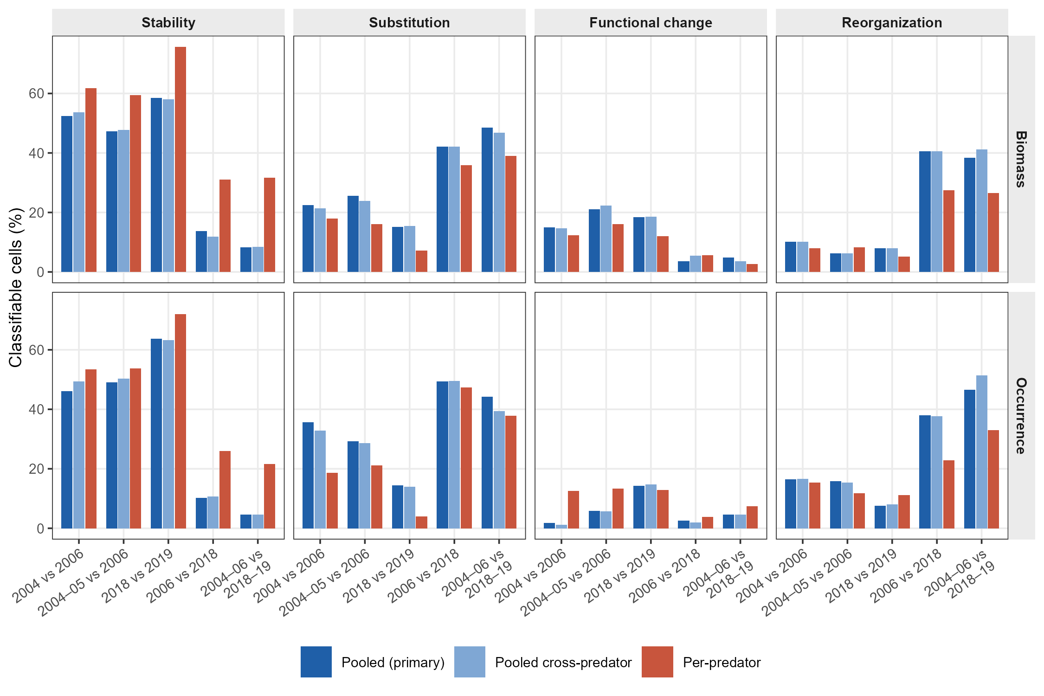
Figure B1. Gulf-wide family frequencies under the three grouping rules, by contrast and currency, on the 25 shared thresholds.
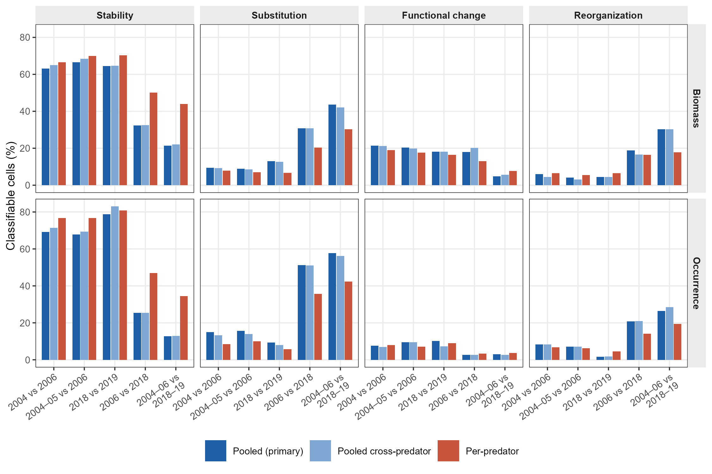
Figure B2. As Figure B1, ecoregion scale.
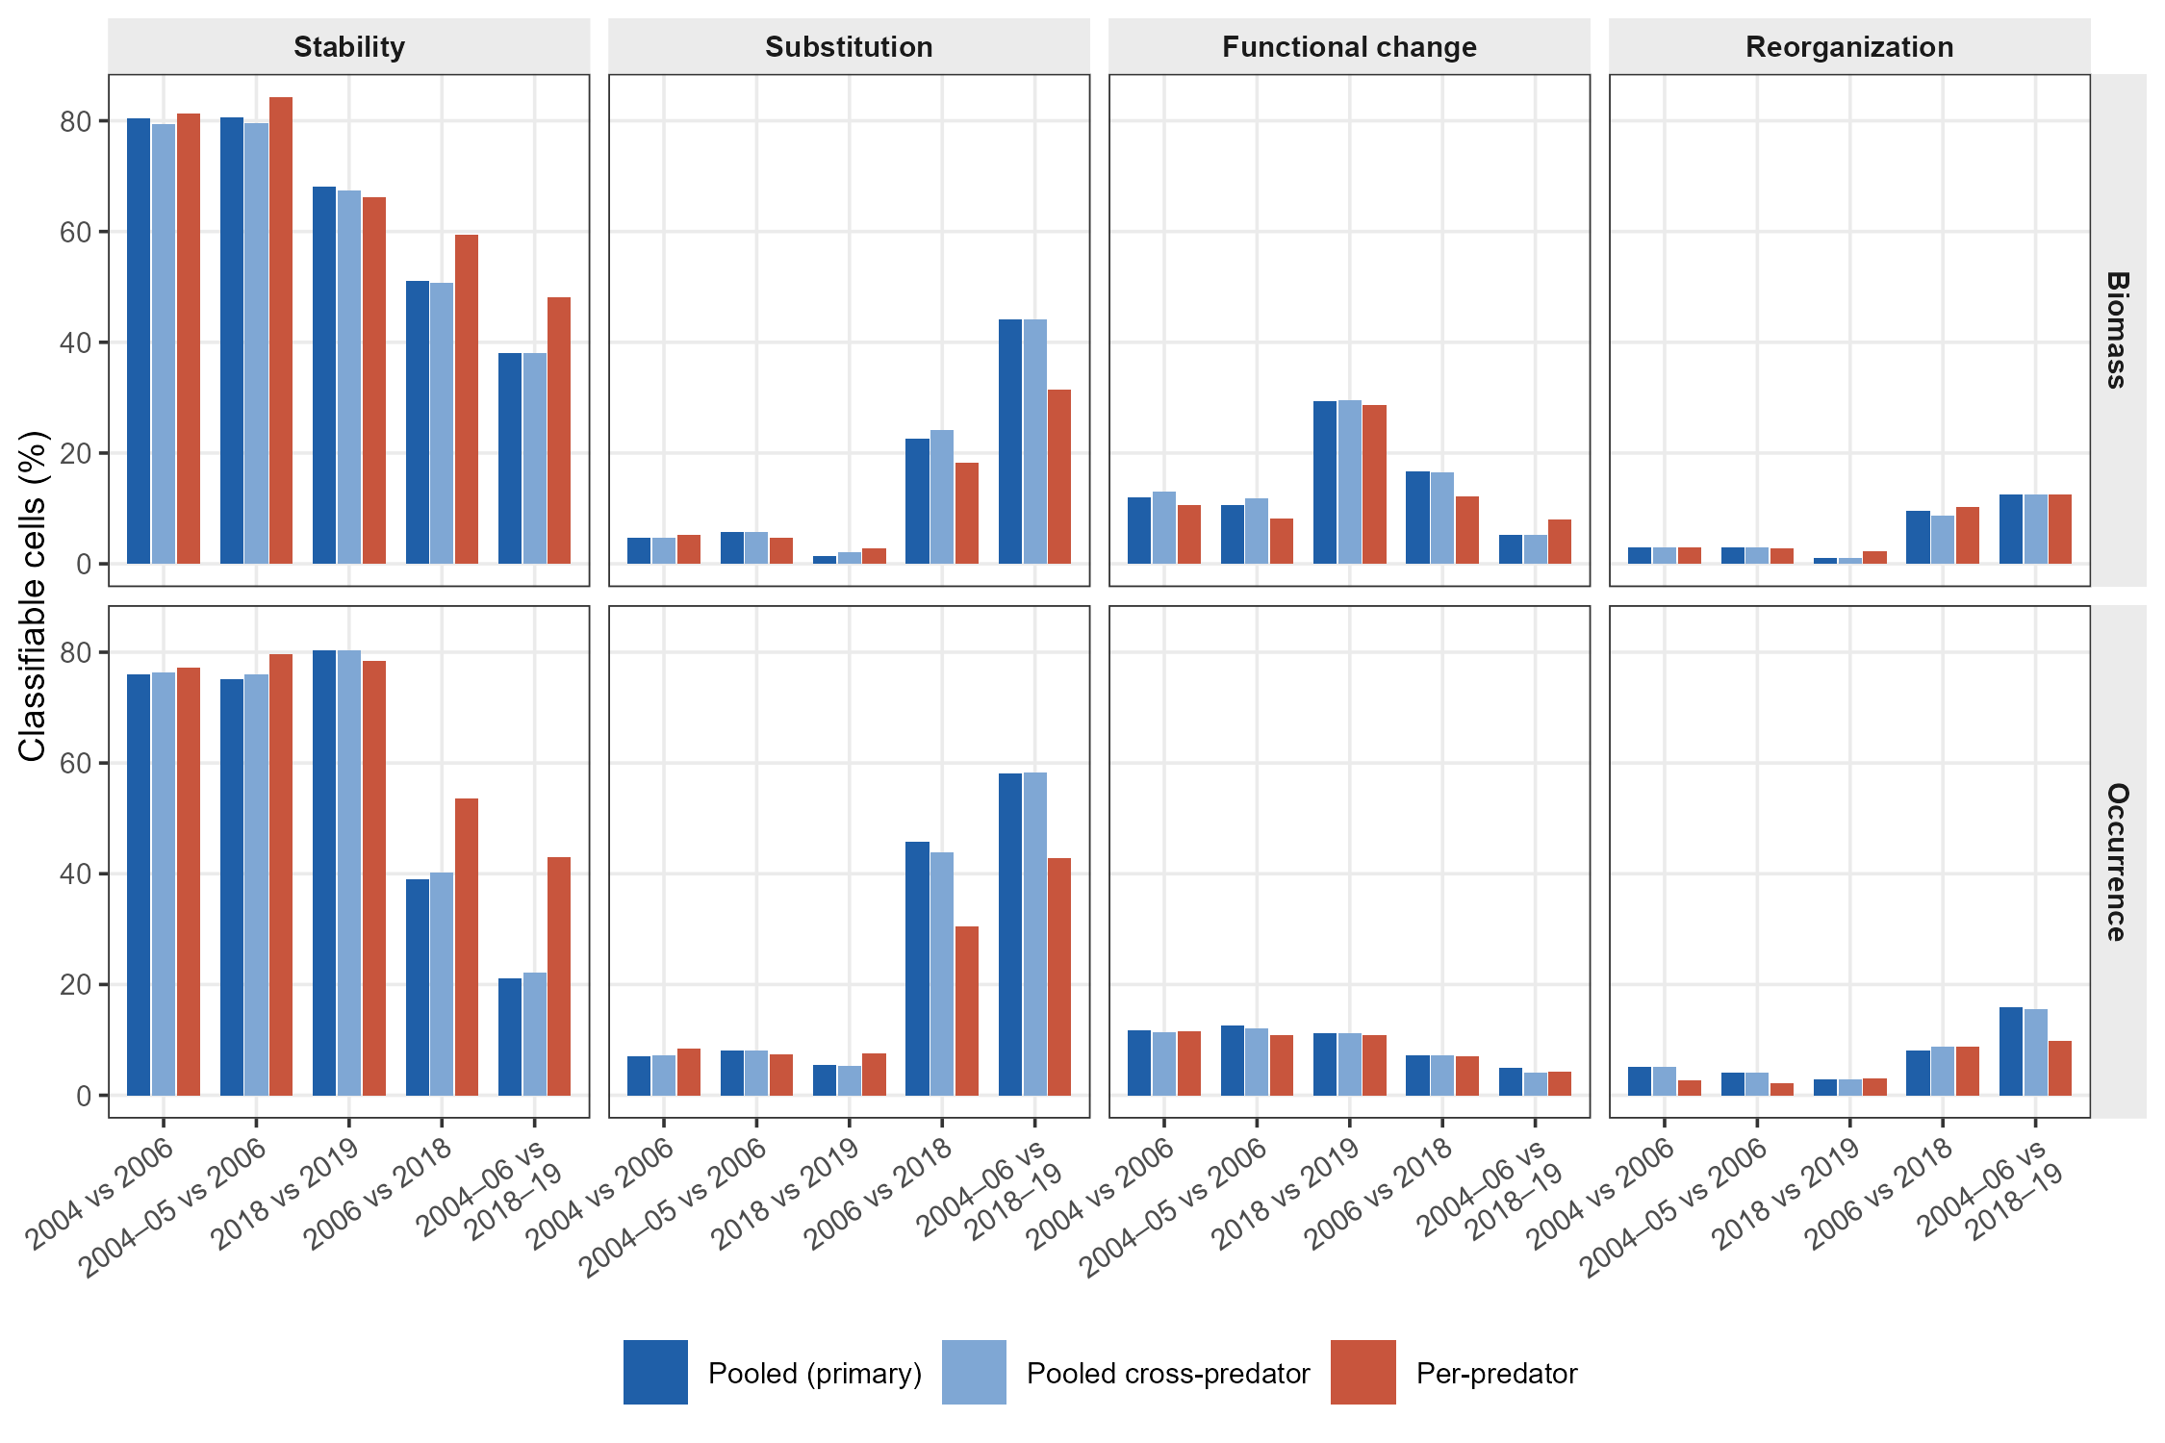
Figure B3. As Figure B1, stratum scale.

Appendix C. Robustness of the diagnostic assignment
This appendix reports the checks described in Section 2.6 and summarized in Section 3.4, all at the Gulf-wide scale under the primary grouping rule unless stated. Sampling uncertainty was estimated by resampling cells, multiple testing by Benjamini–Hochberg adjustment, test calibration by permuting period labels within cells, and sampling effort by equalizing and by restricting the number of trawl sets per period.
Table C1. Family frequencies (%) with 95% bootstrap intervals, obtained by resampling predator × size-class cells with replacement (2,000 replicates), by contrast and currency. Each entry gives the mean and the interval.
Contrast | Currency | Stability | Substitution | Functional change | Reorganization
2004 vs 2006 | Biomass | 53.9 [41.5–66.1] | 22.0 [12.1–32.5] | 15.5 [7.2–25.3] | 8.6 [2.4–16.1]
2004–2005 vs 2006 | Biomass | 48.2 [36.2–60.6] | 24.2 [14.3–35.2] | 20.2 [10.7–31.7] | 7.4 [1.8–14.2]
2018 vs 2019 | Biomass | 64.1 [53.2–74.6] | 14.7 [6.9–23.7] | 17.6 [9.7–25.7] | 3.6 [1.2–6.8]
2006 vs 2018 | Biomass | 15.3 [6.9–25.4] | 47.3 [36.2–58.5] | 4.9 [0.6–10.6] | 32.5 [22.0–43.2]
2004–2006 vs 2018–2019 | Biomass | 10.7 [4.1–18.1] | 55.1 [43.9–65.3] | 4.1 [0.0–9.7] | 30.1 [19.9–40.1]
2004 vs 2006 | Occurrence | 51.1 [38.3–63.5] | 28.7 [18.2–40.1] | 2.2 [0.4–4.8] | 17.9 [8.9–28.3]
2004–2005 vs 2006 | Occurrence | 52.6 [40.1–64.9] | 26.9 [16.1–38.5] | 5.2 [1.1–10.9] | 15.3 [7.3–24.9]
2018 vs 2019 | Occurrence | 63.1 [52.7–73.3] | 11.0 [5.0–17.9] | 15.6 [7.8–23.7] | 10.4 [4.2–17.9]
2006 vs 2018 | Occurrence | 10.2 [2.9–18.5] | 58.1 [46.3–69.5] | 2.2 [0.1–5.2] | 29.5 [19.8–40.0]
2004–2006 vs 2018–2019 | Occurrence | 7.3 [1.9–13.7] | 50.6 [40.2–61.2] | 2.6 [0.0–6.6] | 39.4 [29.2–50.4]
Table C2. Family frequencies (%) before and after Benjamini–Hochberg adjustment of the p-values of each test, applied within each combination of contrast, currency and resolution. Each entry gives the unadjusted and the adjusted value.
Contrast | Currency | Stability | Substitution | Functional change | Reorganization
2004 vs 2006 | Biomass | 54.1 → 79.0 | 21.7 → 16.1 | 15.6 → 3.0 | 8.5 → 1.9
2004–2005 vs 2006 | Biomass | 48.3 → 81.0 | 24.2 → 15.8 | 20.3 → 3.2 | 7.3 → 0.0
2018 vs 2019 | Biomass | 64.2 → 96.8 | 14.7 → 0.6 | 17.5 → 2.6 | 3.6 → 0.0
2006 vs 2018 | Biomass | 15.2 → 20.0 | 47.4 → 53.8 | 4.9 → 2.4 | 32.5 → 23.8
2004–2006 vs 2018–2019 | Biomass | 10.7 → 13.5 | 55.1 → 67.1 | 4.1 → 3.2 | 30.2 → 16.3
2004 vs 2006 | Occurrence | 51.5 → 64.2 | 28.5 → 29.6 | 2.3 → 1.8 | 17.8 → 4.5
2004–2005 vs 2006 | Occurrence | 52.9 → 63.1 | 26.7 → 31.3 | 5.2 → 1.3 | 15.1 → 4.3
2018 vs 2019 | Occurrence | 63.4 → 93.0 | 10.9 → 2.0 | 15.6 → 4.6 | 10.2 → 0.4
2006 vs 2018 | Occurrence | 10.1 → 11.6 | 58.1 → 70.1 | 2.3 → 1.2 | 29.5 → 17.1
2004–2006 vs 2018–2019 | Occurrence | 7.4 → 8.3 | 50.6 → 58.9 | 2.6 → 2.1 | 39.4 → 30.8
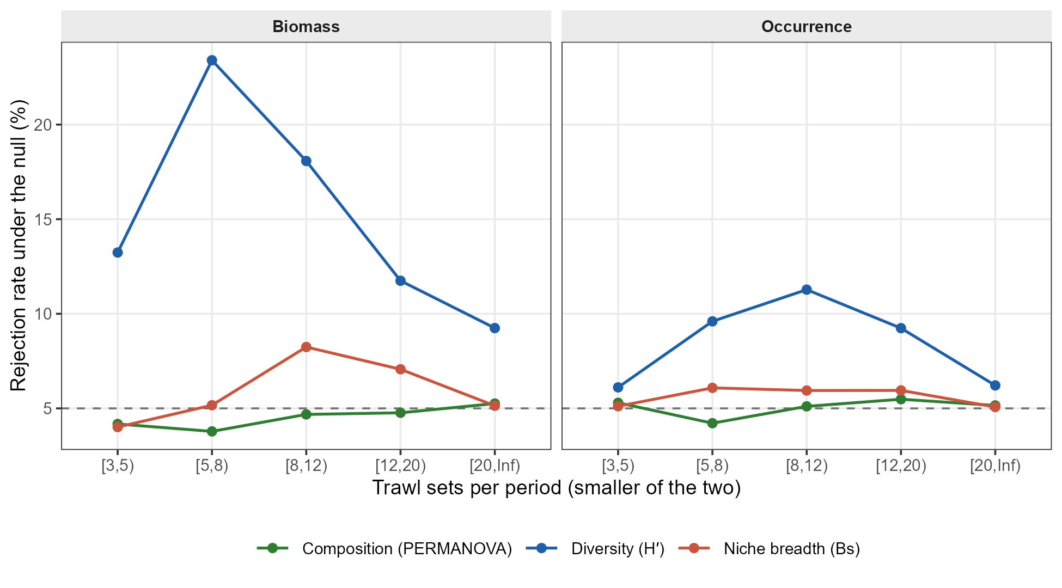
Figure C1. Calibration of the three tests under a permutation null. Period labels were permuted among trawl sets within each cell of the full between-period contrast, preserving the number of sets per period, so that no between-period difference exists by construction; the rejection rate at α = 0.05 is the empirical false-positive rate of each test. Rates are shown by class of sample size (the smaller of the two per-period set counts), from 200 permutations over ten prey resolutions. Dashed line: nominal 5%.
Table C3. False-positive rates of the three tests and null frequencies of the diagnostic families under within-cell permutation of period labels (200 permutations, full between-period contrast).
Currency | Null tests | Composition (%) | Diversity H′ (%) | Niche breadth Bs (%) | Dispersion (%)
Biomass | 118,910 | 4.98 | 11.69 | 5.80 | 5.81
Occurrence | 118,910 | 5.16 | 7.52 | 5.37 | 5.31
Currency | Family | Null mean (%) | 2.5th percentile | 97.5th percentile
Biomass | Stability | 80.1 | 71.0 | 88.5
Biomass | Substitution | 3.8 | 1.7 | 8.5
Biomass | Functional change | 14.9 | 8.3 | 23.1
Biomass | Reorganization | 2.3 | 1.7 | 5.2
Occurrence | Stability | 84.3 | 75.9 | 92.0
Occurrence | Substitution | 3.8 | 1.7 | 7.6
Occurrence | Functional change | 10.5 | 4.7 | 17.0
Occurrence | Reorganization | 2.4 | 1.7 | 4.7
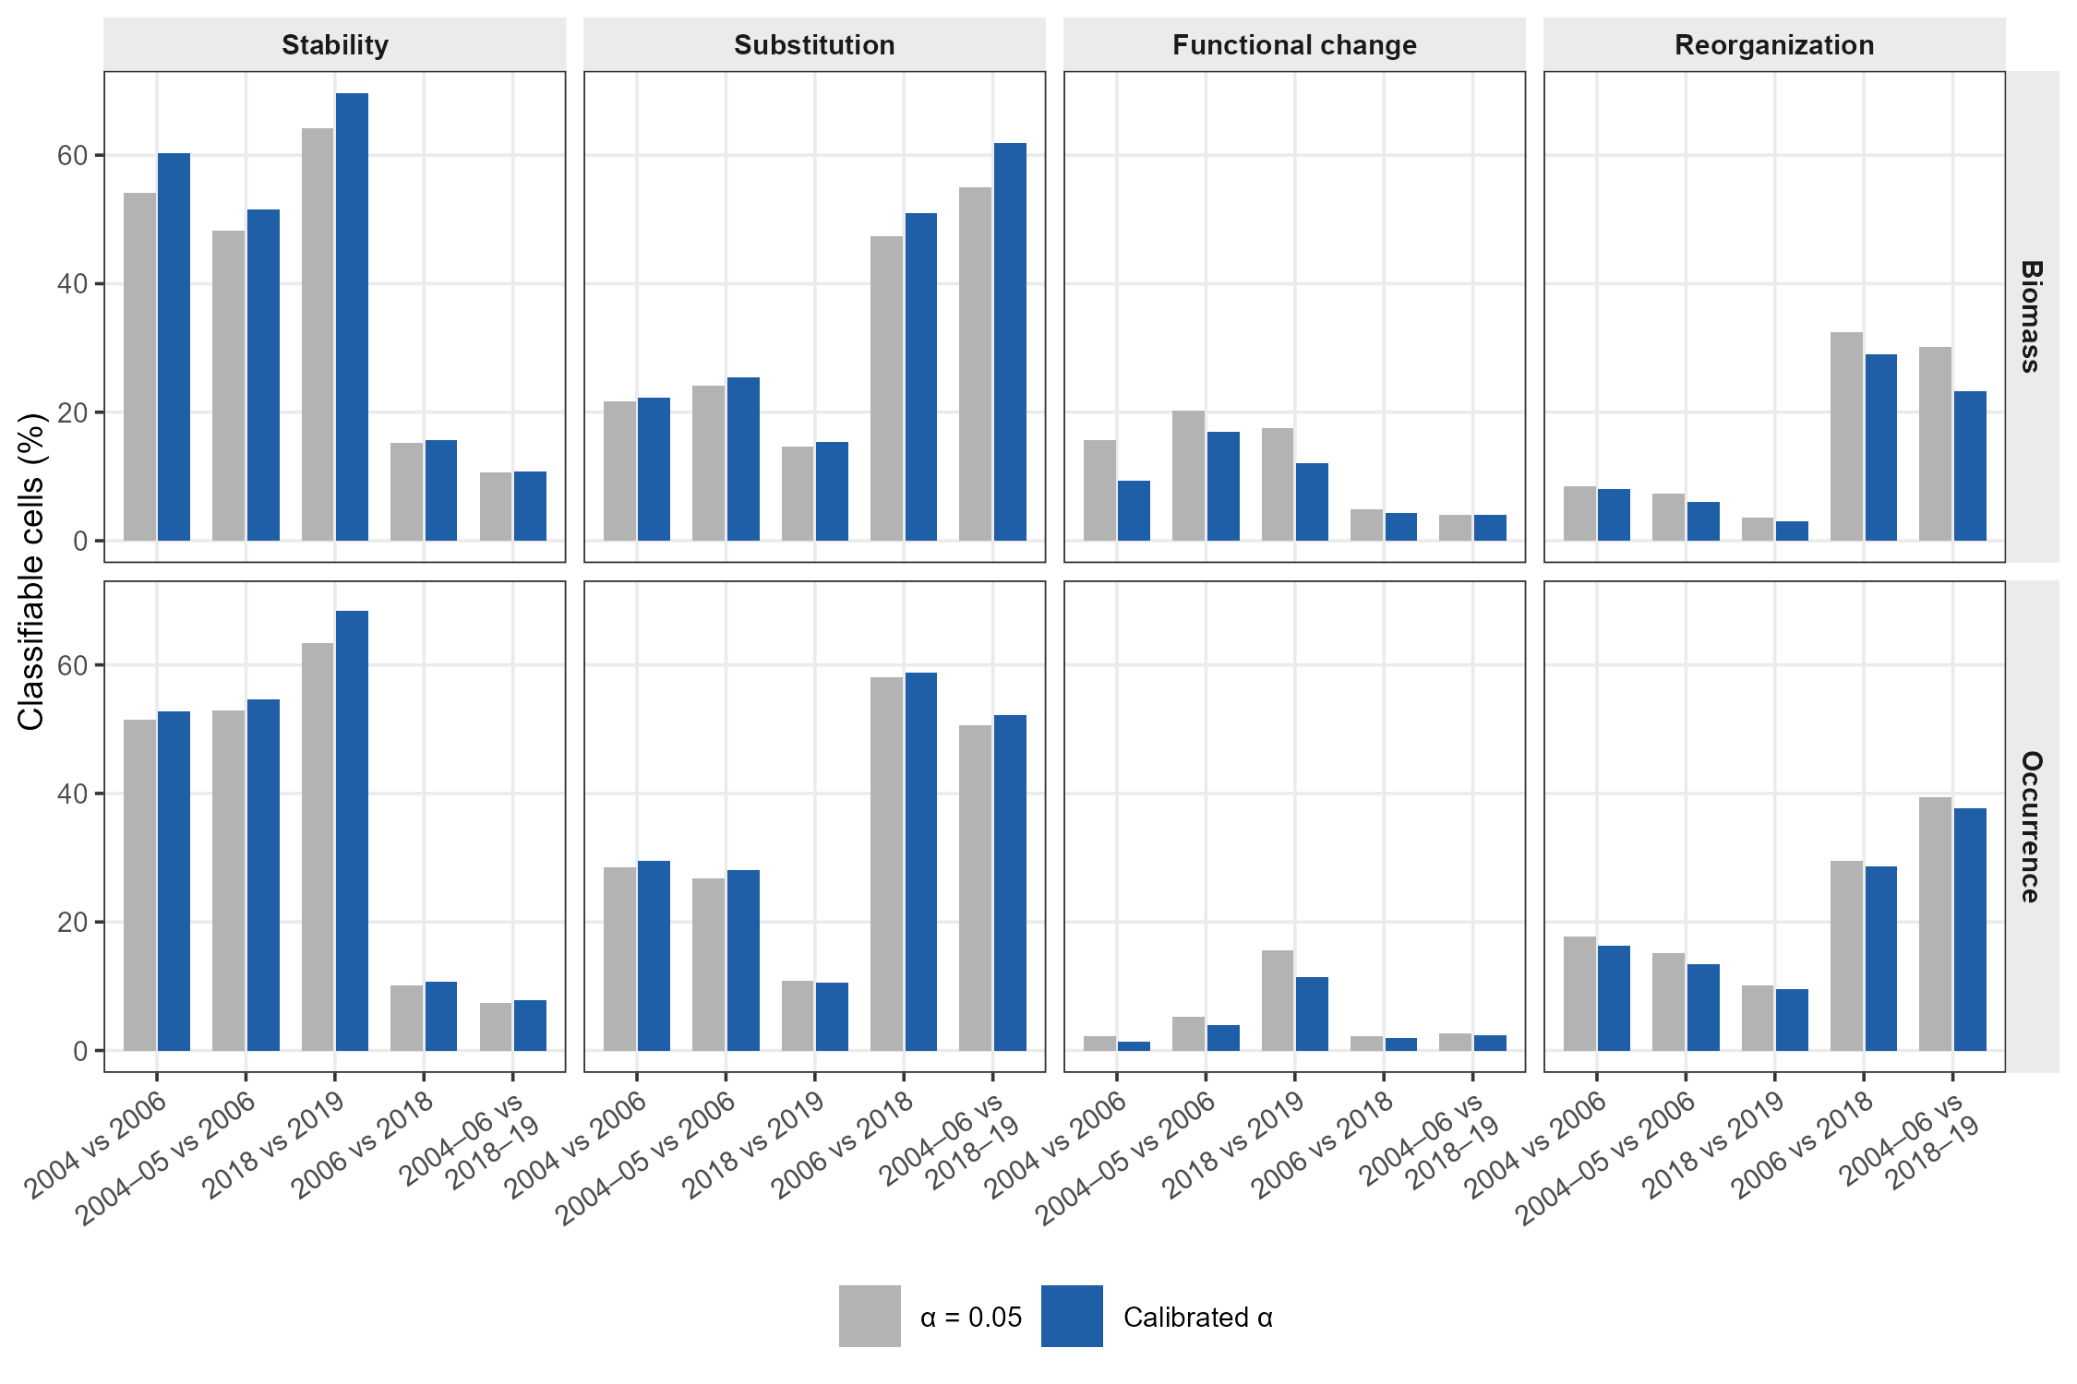
Figure C2. Frequency of the four diagnostic families under the nominal significance threshold (α = 0.05 for all three tests, grey) and under thresholds calibrated on the permutation null of Figure C1 (blue). Means across the 100 prey resolutions.
Table C4. Significance thresholds calibrated on the permutation null: the fifth percentile of the null p-value distribution of each test, overall and by class of sample size (the smaller of the two per-period set counts).
Currency | Sets per period | Null tests | α composition | α diversity (H′) | α niche breadth (Bs)
Biomass | All | 118,910 | 0.050 | 0.014 | 0.042
Occurrence | All | 118,910 | 0.048 | 0.030 | 0.046
Biomass | [3,5) | 4,910 | 0.057 | 0.014 | 0.056
Biomass | [5,8) | 6,000 | 0.062 | 0.005 | 0.047
Biomass | [8,12) | 16,000 | 0.052 | 0.006 | 0.028
Biomass | [12,20) | 18,000 | 0.052 | 0.015 | 0.034
Biomass | [20,Inf) | 74,000 | 0.047 | 0.021 | 0.048
Occurrence | [3,5) | 4,910 | 0.046 | 0.045 | 0.049
Occurrence | [5,8) | 6,000 | 0.055 | 0.020 | 0.035
Occurrence | [8,12) | 16,000 | 0.049 | 0.012 | 0.042
Occurrence | [12,20) | 18,000 | 0.046 | 0.022 | 0.042
Occurrence | [20,Inf) | 74,000 | 0.048 | 0.039 | 0.049
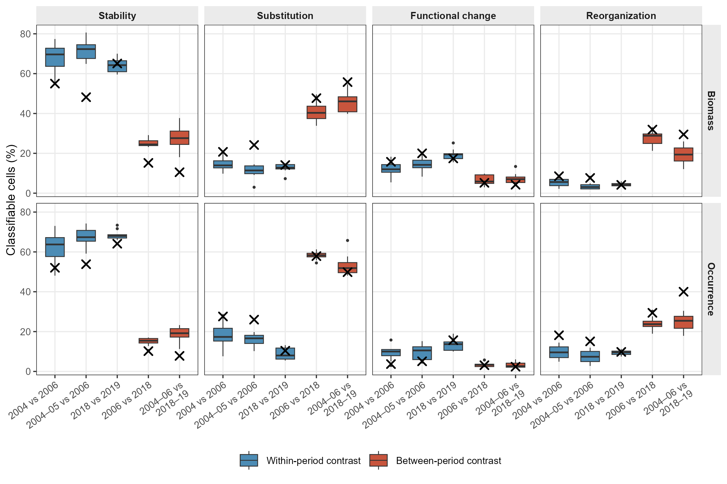
Figure C3. Family frequencies under equalized sampling effort, Gulf-wide scale. Each cell of each contrast was capped at the smallest per-period number of trawl sets observed among the within-period contrasts of that cell, sets were drawn without replacement, and the analysis was repeated over ten replicates. Boxes: distribution across replicates; crosses: values from the full data. Cells absent from any contrast or with a target below three sets were excluded (14 of the 65 cells in the set inventory).
Table C5. Separation of the within- and between-period frequencies under equalized sampling effort: proportion of replicates in which the between-period value lies entirely outside the within-period range, and the gap between them in percentage points.
Scale | Currency | Family | Replicates | Replicates separated (%) | Median gap | 2.5th percentile gap
Gulf-wide | Biomass | Stability | 10 | 100 | 34.5 | 23.3
Gulf-wide | Biomass | Substitution | 10 | 100 | 24.2 | 16.5
Gulf-wide | Occurrence | Stability | 10 | 100 | 41.2 | 28.8
Gulf-wide | Occurrence | Substitution | 10 | 100 | 32.3 | 22.6
Ecoregion | Biomass | Stability | 10 | 100 | 14.4 | 5.1
Ecoregion | Biomass | Substitution | 10 | 100 | 11.7 | 3.4
Ecoregion | Occurrence | Stability | 10 | 100 | 21.6 | 16.9
Ecoregion | Occurrence | Substitution | 10 | 100 | 14.5 | 7.2
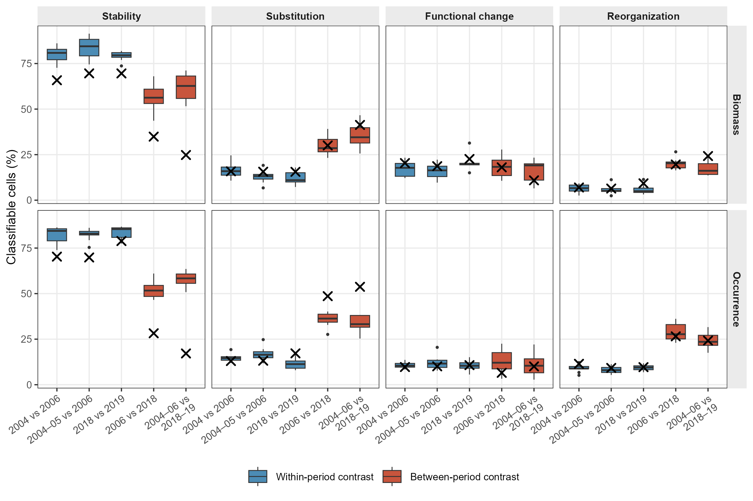
Figure C4. As Figure C3, ecoregion scale. At this scale 132 of the 200 cells in the set inventory were excluded, most because they were absent from at least one contrast, and the median target was six sets per period; the balanced comparison therefore covers a limited subset of the assemblage.
Table C6. Sampling effort per contrast and separation of the within- and between-period frequencies under a restriction to the effort range common to all five contrasts. Effort is the median number of trawl sets per period across cells; the gap is in percentage points.
Scale | Contrast | Cells | Period 1 | Period 2 | Smaller group (IQR)
Gulf-wide | 2004 vs 2006 | 54 | 26.5 | 23.5 | 21.5 (13.2–34.8)
Gulf-wide | 2004–2005 vs 2006 | 55 | 39.0 | 22.0 | 22.0 (15.0–35.0)
Gulf-wide | 2018 vs 2019 | 51 | 14.0 | 14.0 | 13.0 (7.0–18.0)
Gulf-wide | 2006 vs 2018 | 52 | 25.0 | 14.0 | 13.0 (9.8–20.2)
Gulf-wide | 2004–2006 vs 2018–2019 | 59 | 60.0 | 27.0 | 25.0 (14.0–35.5)
Ecoregion | 2004 vs 2006 | 91 | 11.0 | 9.0 | 9.0 (5.0–20.5)
Ecoregion | 2004–2005 vs 2006 | 95 | 15.0 | 9.0 | 9.0 (5.0–20.5)
Ecoregion | 2018 vs 2019 | 62 | 10.0 | 8.0 | 7.5 (4.0–12.0)
Ecoregion | 2006 vs 2018 | 76 | 10.0 | 9.0 | 7.0 (4.0–11.2)
Ecoregion | 2004–2006 vs 2018–2019 | 100 | 21.0 | 11.0 | 10.0 (6.0–20.0)
Stratum | 2004 vs 2006 | 149 | 5.0 | 5.0 | 4.0 (3.0–5.0)
Stratum | 2004–2005 vs 2006 | 168 | 6.0 | 4.0 | 4.0 (3.0–5.0)
Stratum | 2018 vs 2019 | 48 | 3.0 | 3.0 | 3.0 (3.0–3.0)
Stratum | 2006 vs 2018 | 78 | 4.5 | 3.0 | 3.0 (3.0–4.0)
Stratum | 2004–2006 vs 2018–2019 | 198 | 9.0 | 5.0 | 4.0 (4.0–6.0)
Scale | Currency | Family | Gap, all cells | Gap, common effort range
Gulf-wide | Biomass | Stability | 33.1 | 42.8
Gulf-wide | Biomass | Substitution | 23.2 | 30.0
Gulf-wide | Occurrence | Stability | 41.4 | 56.4
Gulf-wide | Occurrence | Substitution | 22.1 | 39.3
Ecoregion | Biomass | Stability | 31.4 | 25.0
Ecoregion | Biomass | Substitution | 20.7 | 18.5
Ecoregion | Occurrence | Stability | 41.5 | 27.0
Ecoregion | Occurrence | Substitution | 35.3 | 24.3
Stratum | Biomass | Stability | 12.8 | 12.1
Stratum | Biomass | Substitution | 14.9 | 14.8
Stratum | Occurrence | Stability | 29.0 | 29.2
Stratum | Occurrence | Substitution | 32.1 | 29.8
Table C7. Summary of the robustness checks: the question each addresses and its result. Values are read directly from the analysis outputs.
Check | Question addressed | Result
Bootstrap over cells | Is the separation larger than sampling error? | Stability intervals separated by 10.7 (biomass) and 19.8 (occurrence) points
Benjamini–Hochberg adjustment | Does repeated testing drive the families? | Between-period Substitution 55.1% → 67.1% (biomass)
Threshold sweep | Does the result depend on α = 0.05? | No crossing for α = 0.01–0.075; smallest Stability gap 28.8 points
Permutation null | Are the three tests equally calibrated? | False-positive rates: C 4.98 / 5.16%, H′ 11.69 / 7.52%, Bs 5.80 / 5.37% (biomass / occurrence)
Calibrated thresholds | Does a liberal test drive the classification? | Substitution 55.1% → 61.9%; Stability gap 33.1 → 35.9 points (biomass)
Equalized sampling effort | Does the decadal contrast gain from more sets? | Separated in 100% of replicates; median gap 24.2–41.2 points
Common effort range | Does unequal effort drive the result at all scales? | Gaps of 12.1–56.4 points at 3 scale(s)

