A diagnostic framework for assessing trophic change from predator stomach contents
  - Figures
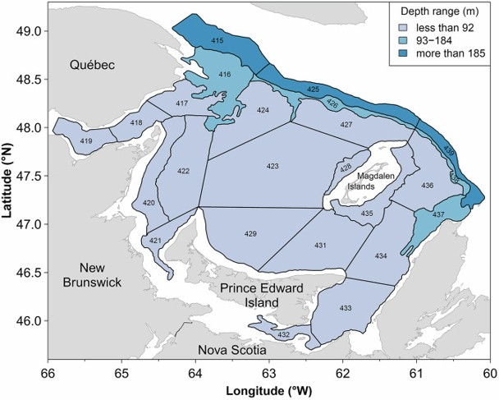
Figure 1. Study area. Bottom-trawl survey strata of the southern Gulf of St Lawrence (sGSL); numbers identify individual strata and the shading gives the depth range of each.
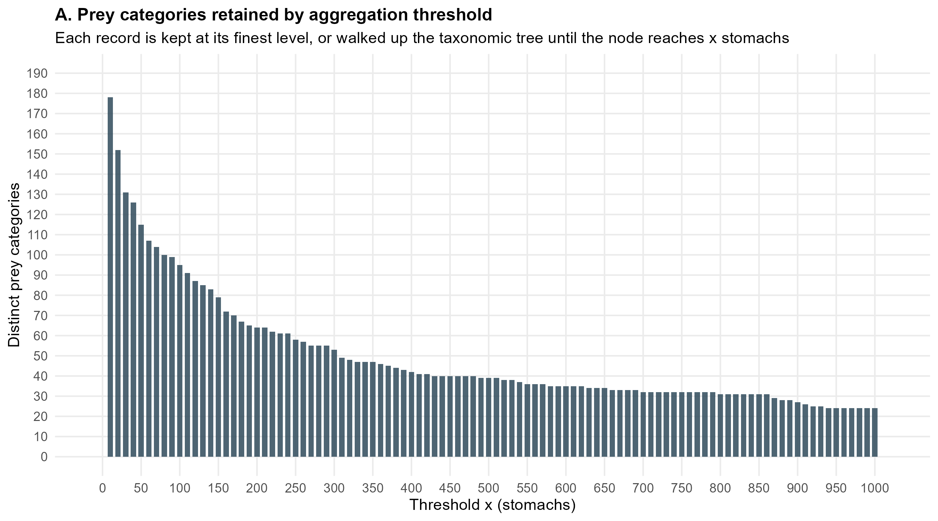
Figure 2. Prey taxonomic resolution. (A) Number of prey categories retained as the aggregation threshold x (minimum number of stomachs) is swept from 10 to 1,000.
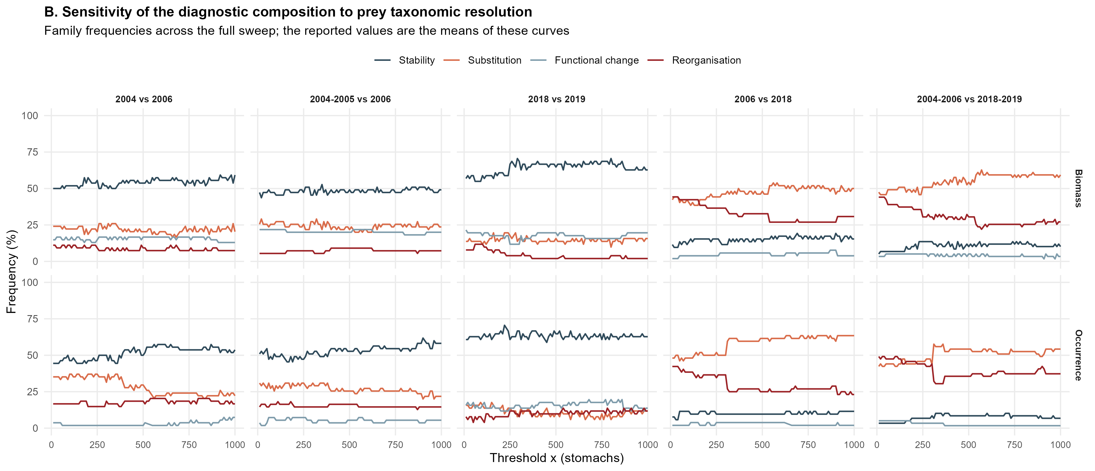
Figure 2 (continued). (B) Frequency of the four diagnostic families across the full sweep, by contrast and currency. The values reported in the text are the means of these curves.
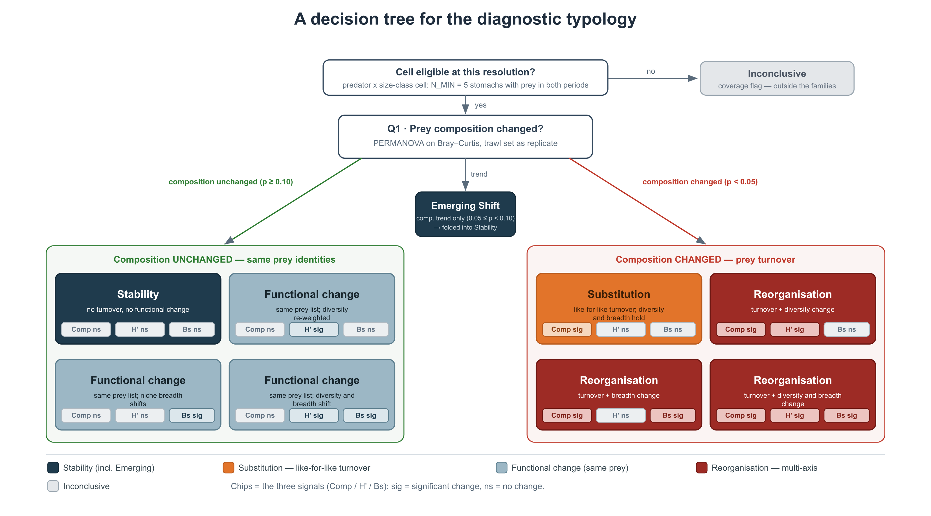
Figure 3. Decision tree of the diagnostic typology. Each eligible predator × size-class cell is routed by the outcomes of the composition, diversity and niche-breadth tests to one of nine states and to its family.
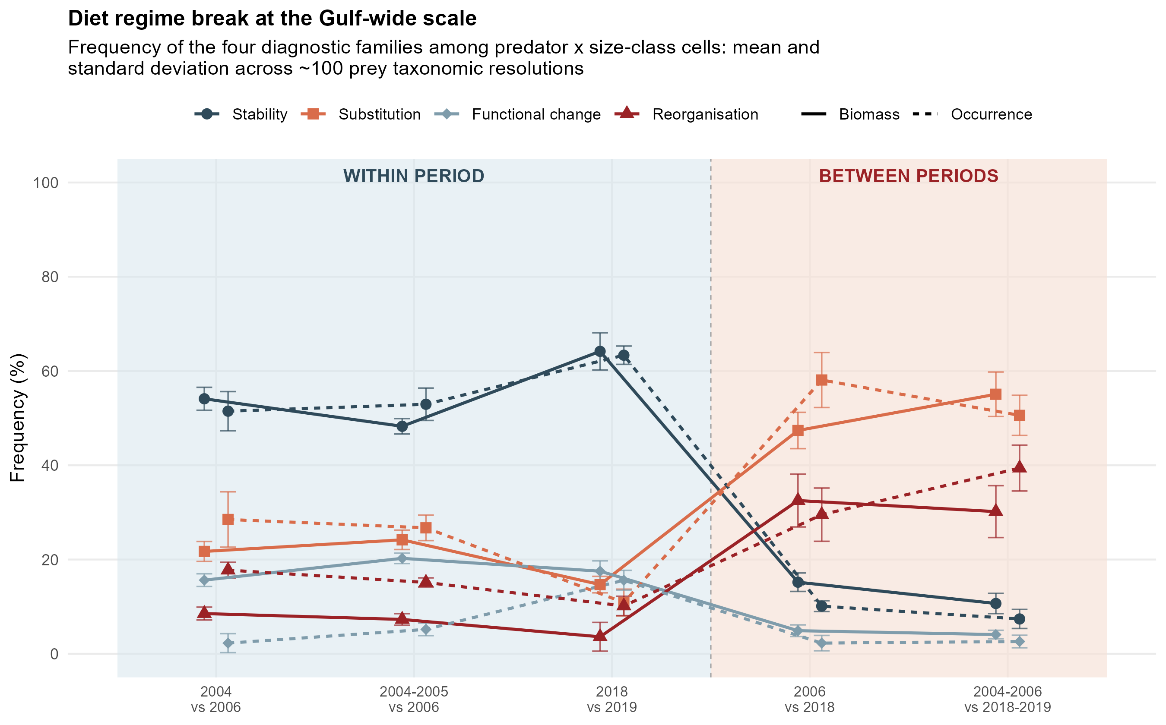
Figure 4. Gulf-wide diagnostic families. Frequency (%) of the four families among classifiable predator × size-class cells, by contrast and currency; mean and standard deviation across the 100 prey taxonomic resolutions.
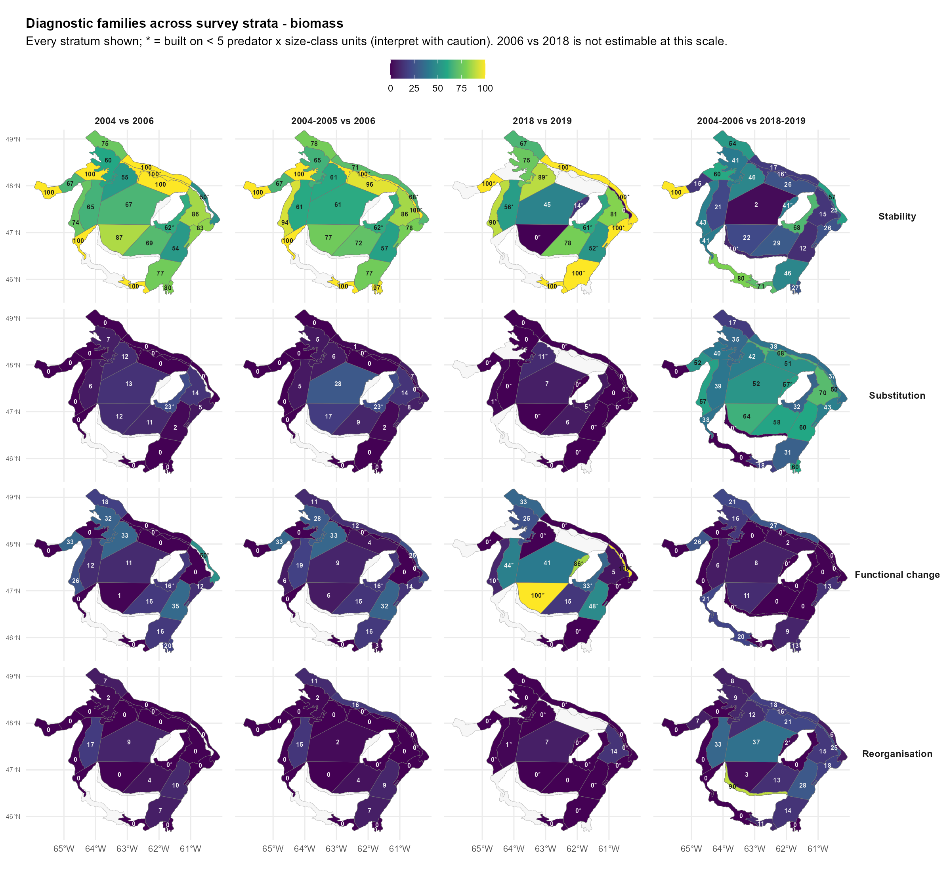
Figure 5. Spatial distribution of the four diagnostic families across survey strata, biomass currency. Each panel maps the within-stratum family composition for one contrast.
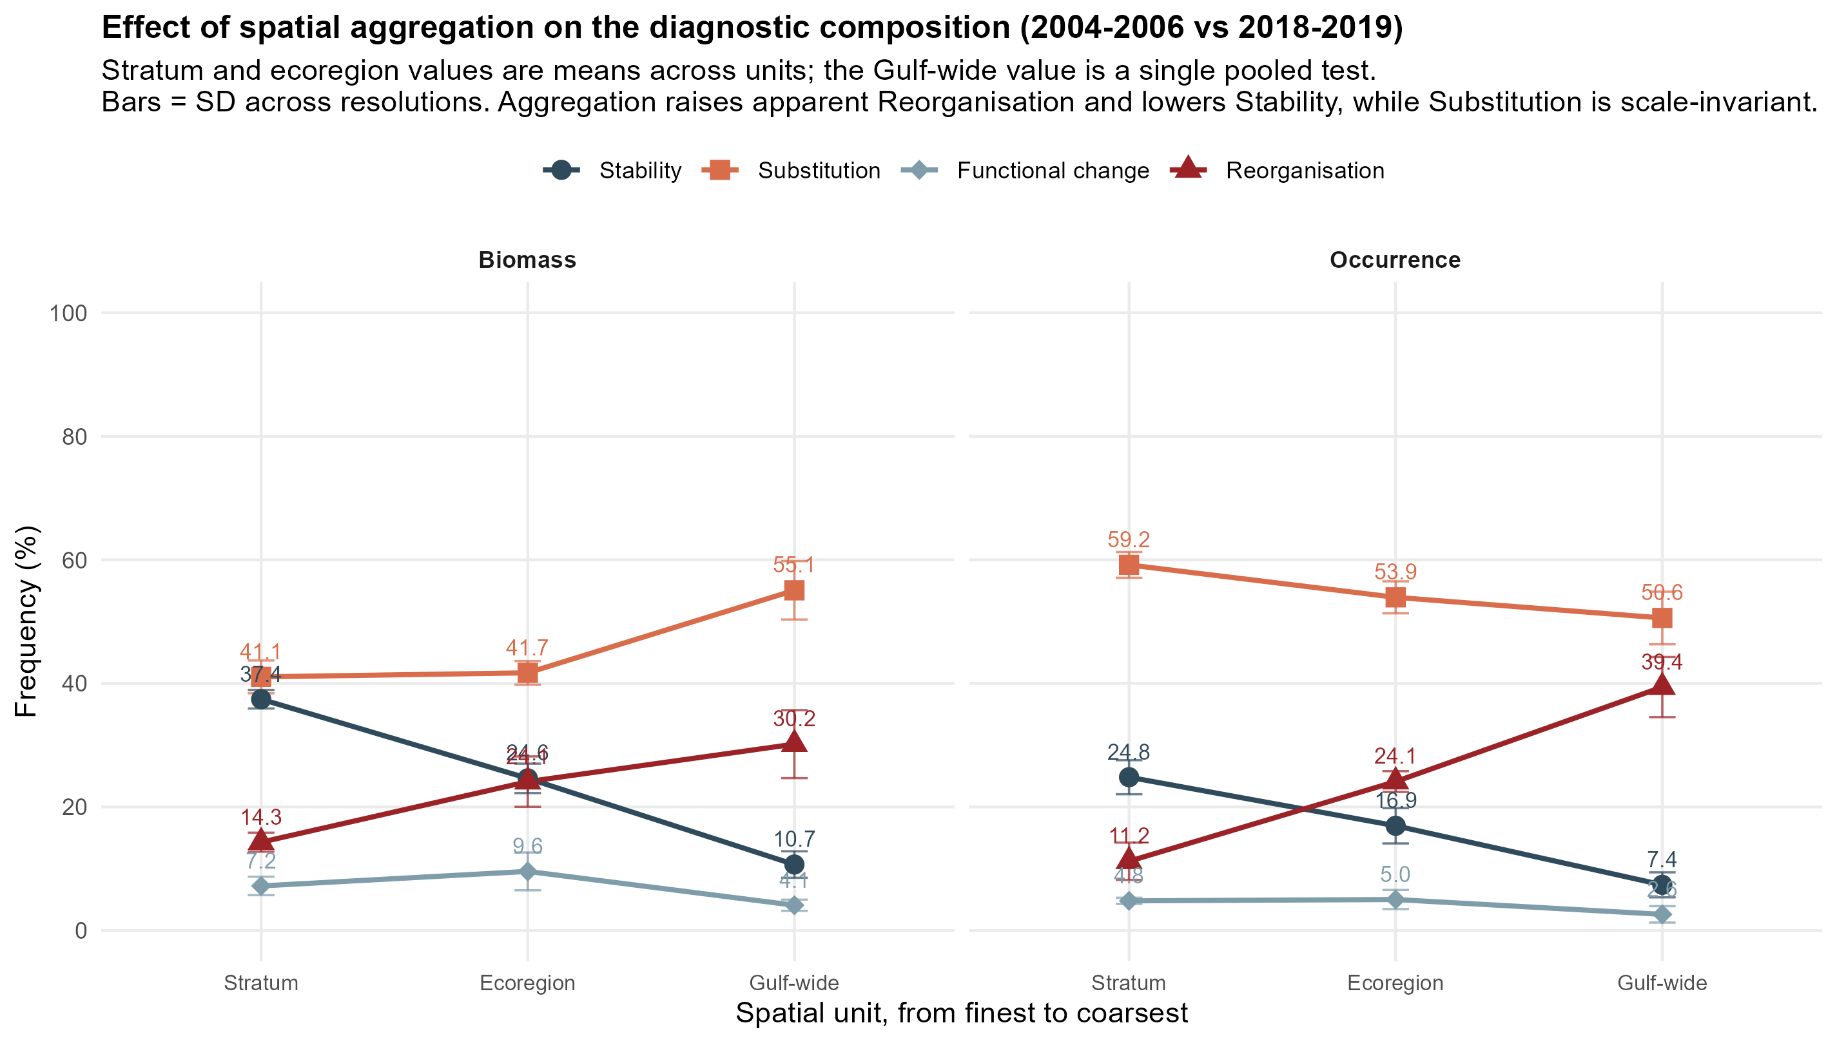
Figure 6. Effect of spatial aggregation on the diagnostic composition for the full between-period contrast (2004–2006 vs 2018–2019). Stratum and ecoregion values are means across units; the Gulf-wide value is a single pooled test. Bars are the standard deviation across resolutions.

Supplementary figures
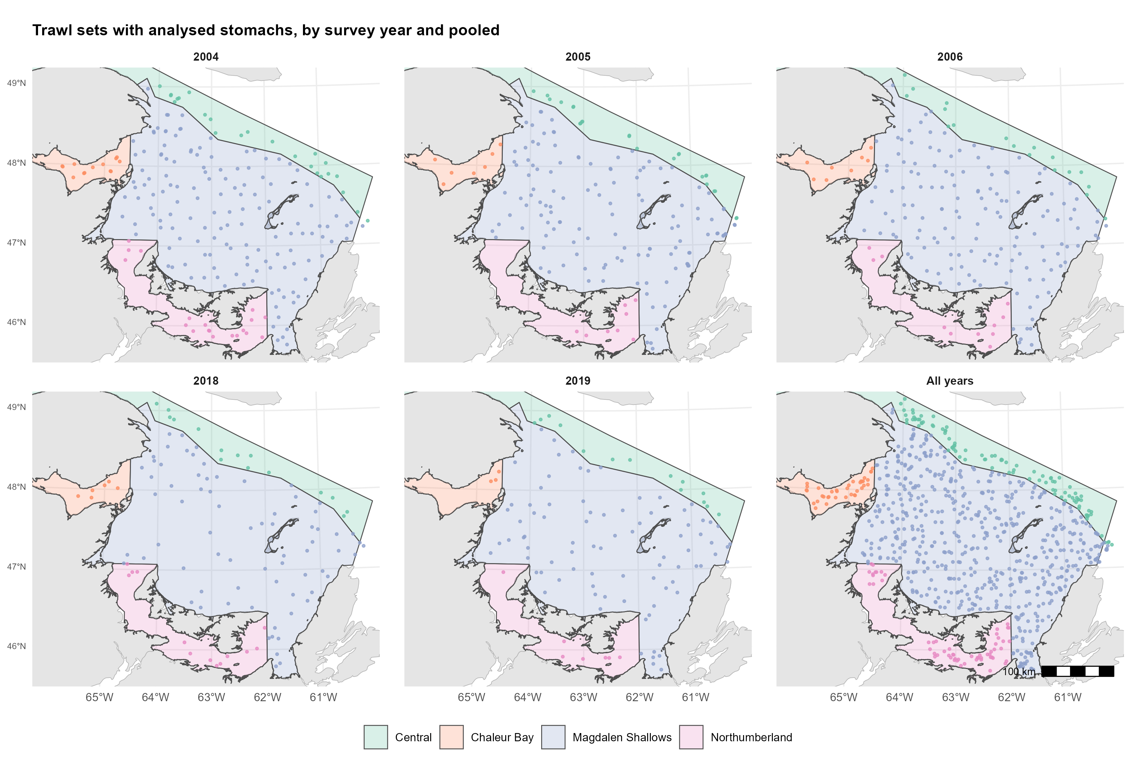
Figure S1. Position of the trawl sets from which predator stomachs were analysed, by survey year and pooled over years, in the four ecoregions.
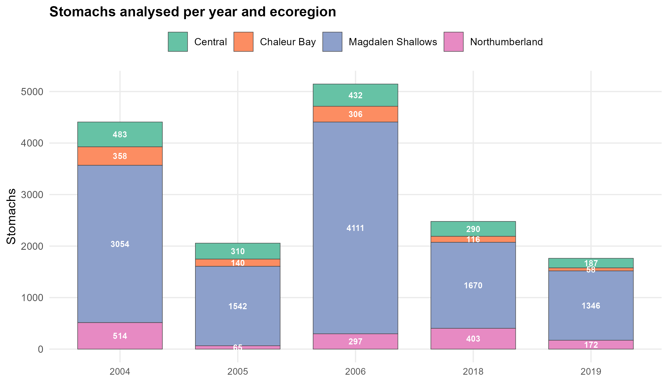
Figure S2. Number of stomachs analysed per survey year and ecoregion, for the predators retained in the analysis.
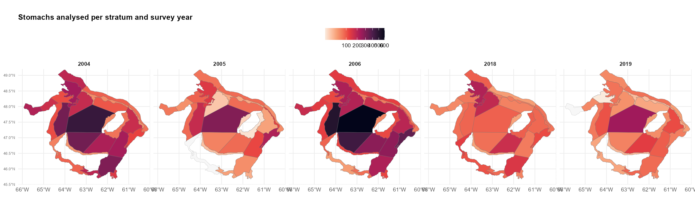
Figure S3. Number of stomachs analysed per survey stratum and year (colour scale on a square-root transform).
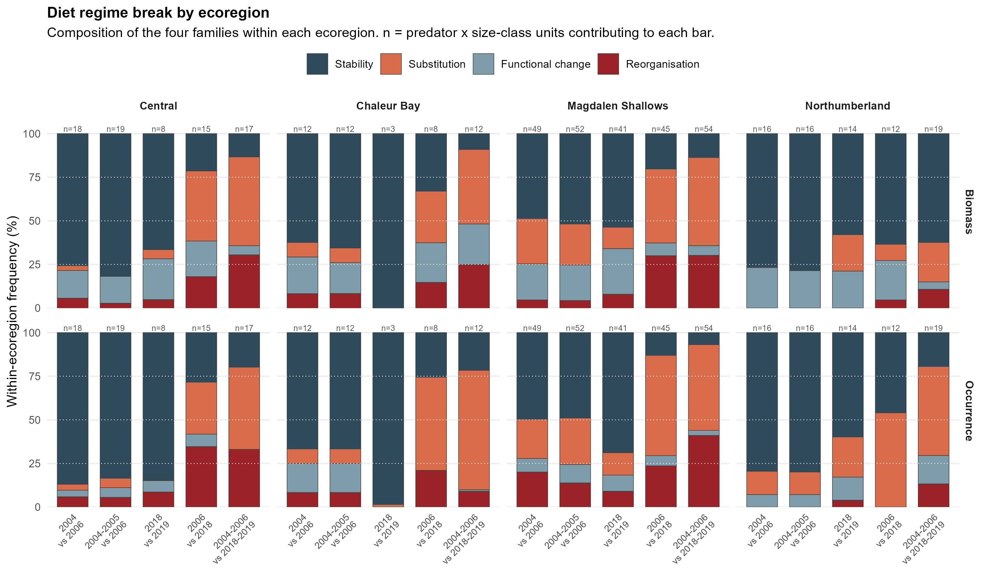
Figure S4. Diagnostic families by ecoregion. Composition of the four families within each ecoregion (columns) for each contrast, in both currencies.
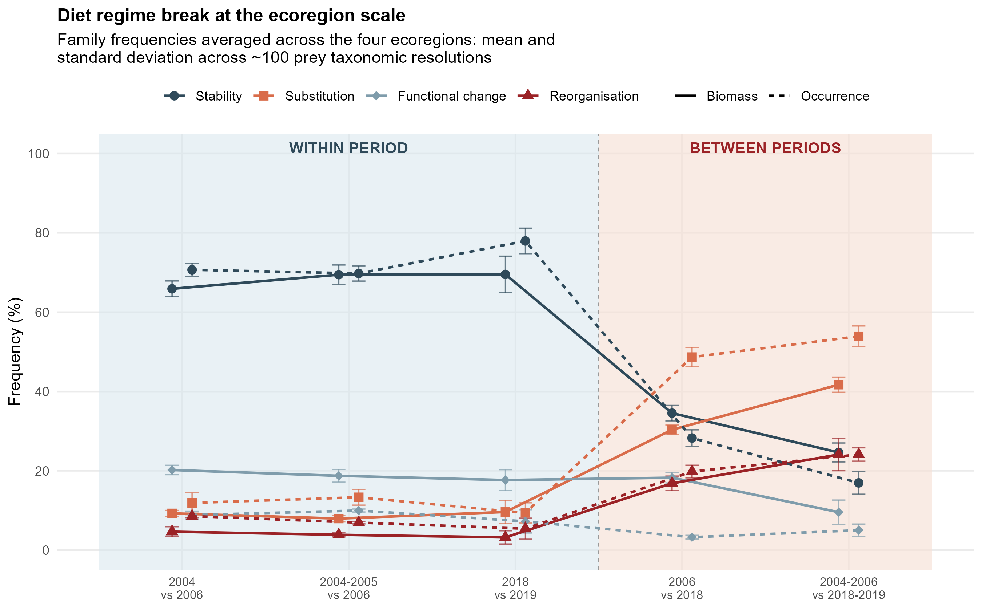
Figure S5. Ecoregion-scale diagnostic families. Frequency (%) of the four families for each contrast, in biomass (solid) and occurrence (dashed); means across the four ecoregions.
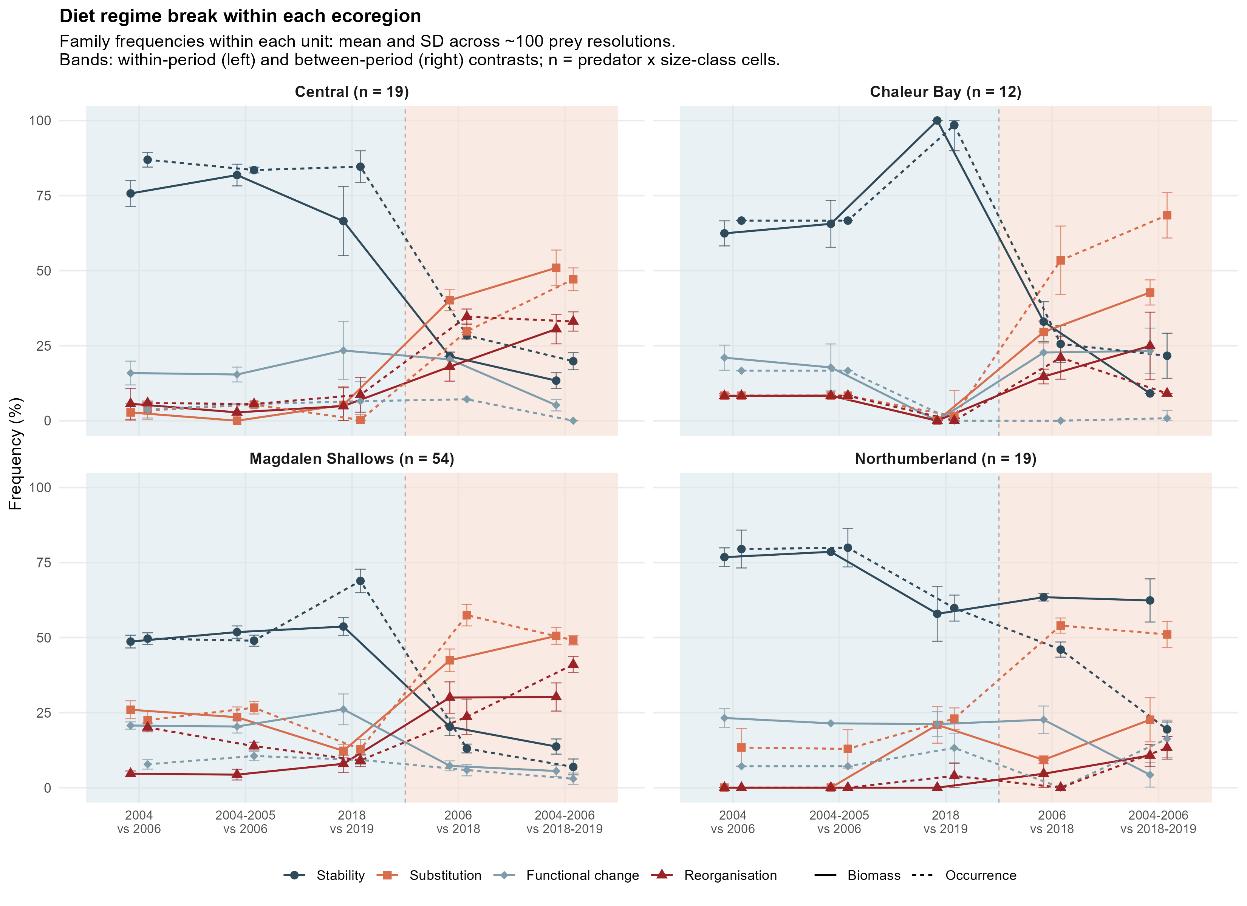
Figure S6. Diagnostic families within each ecoregion. Frequency (%) of the four families for each contrast, in biomass and occurrence, shown separately for each ecoregion.
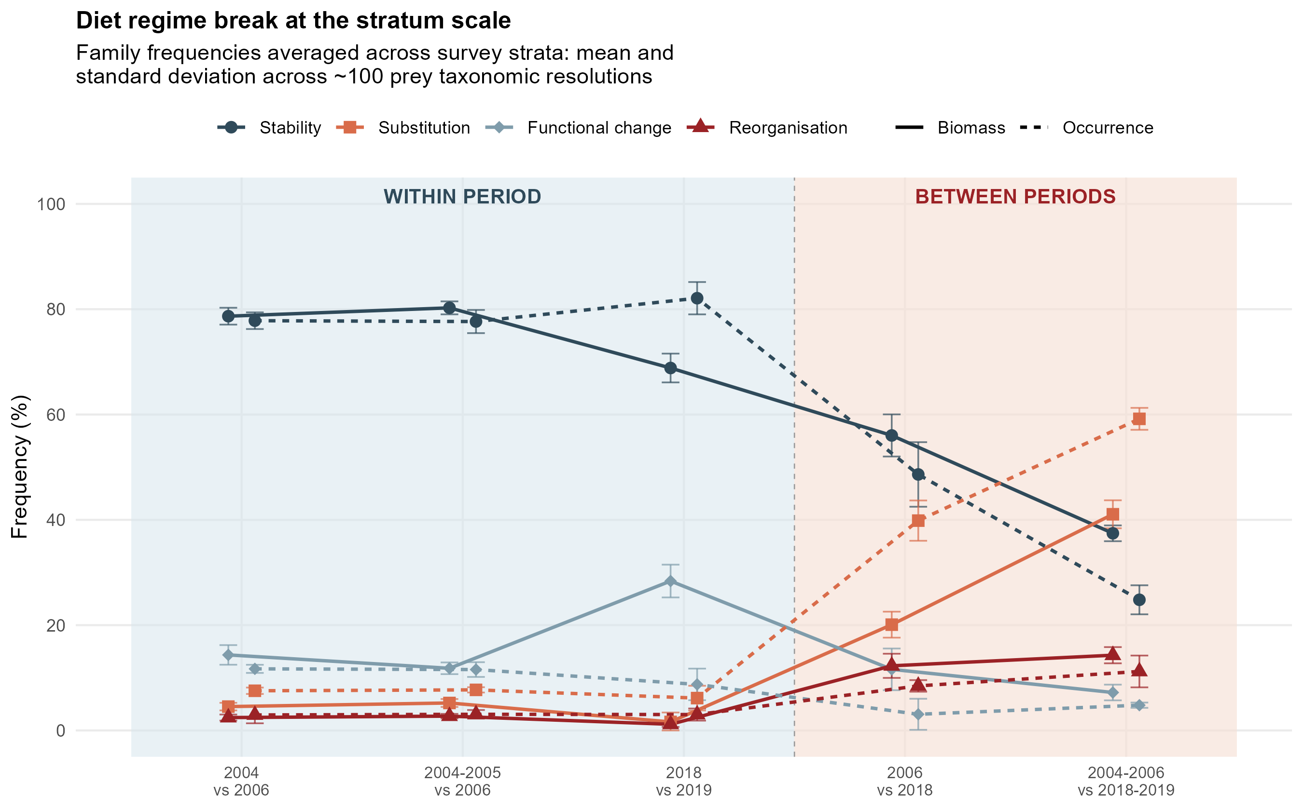
Figure S7. Stratum-scale diagnostic families. As Figure S5, with frequencies computed per survey stratum and averaged across strata.
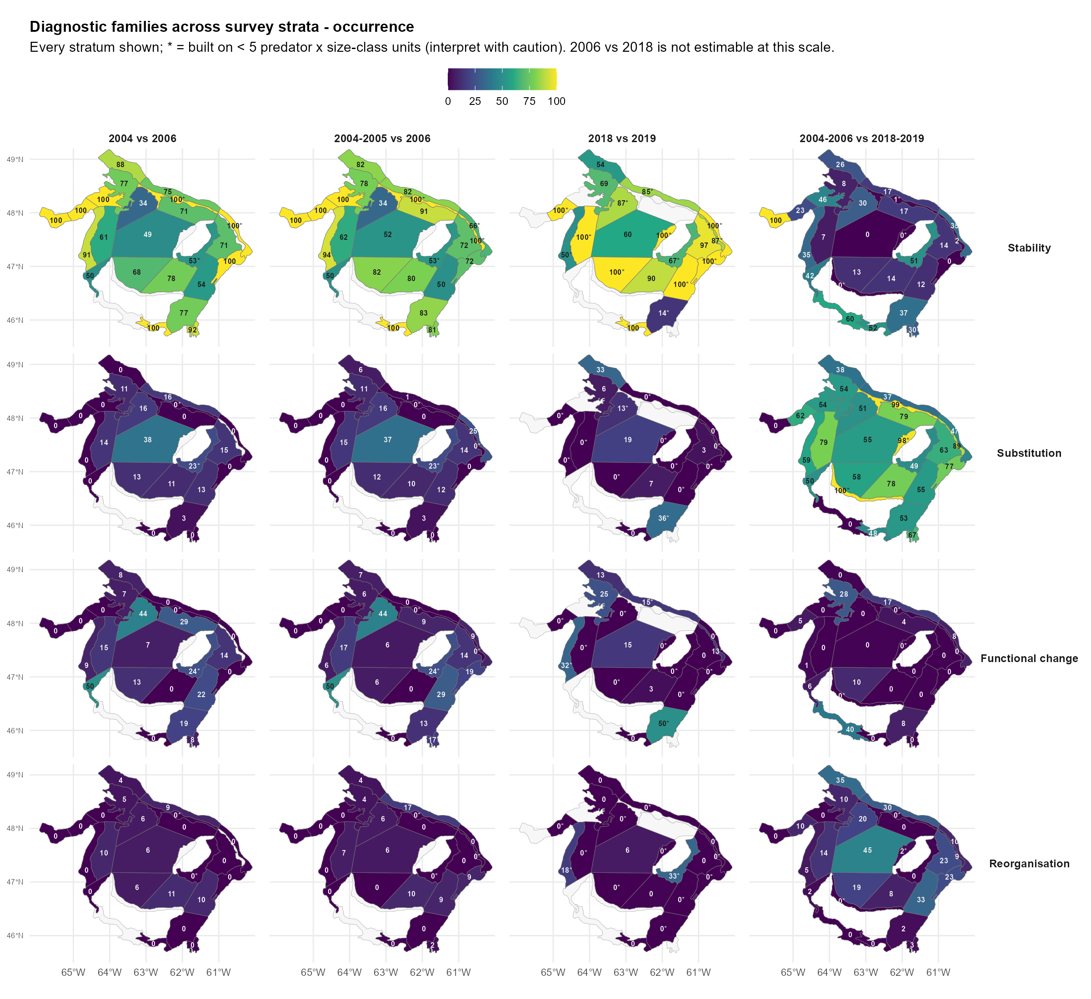
Figure S8. Spatial distribution of the four diagnostic families across survey strata, occurrence currency (same layout as Figure 5).
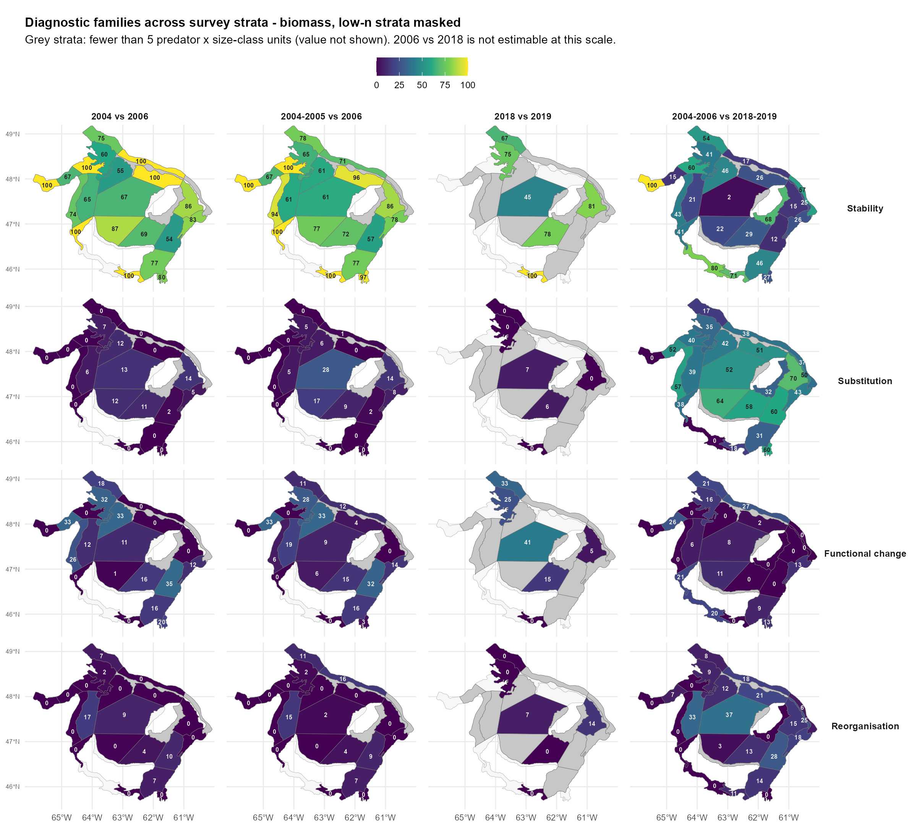
Figure S9. As Figure 5, with strata represented by fewer than five classifiable predator × size-class cells masked.
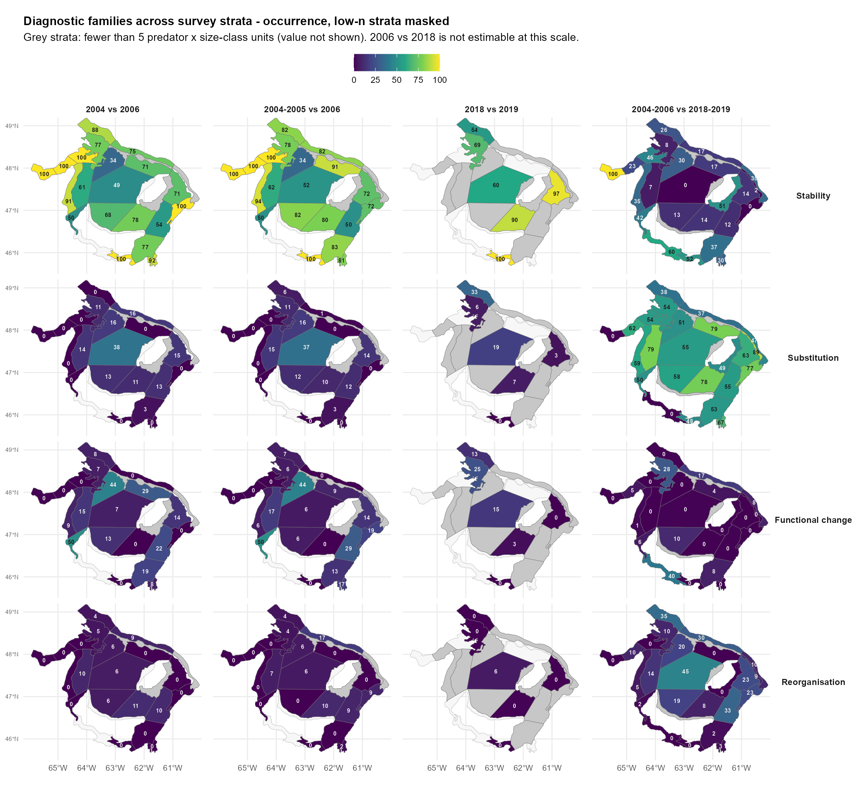
Figure S10. As Figure S9, occurrence currency.
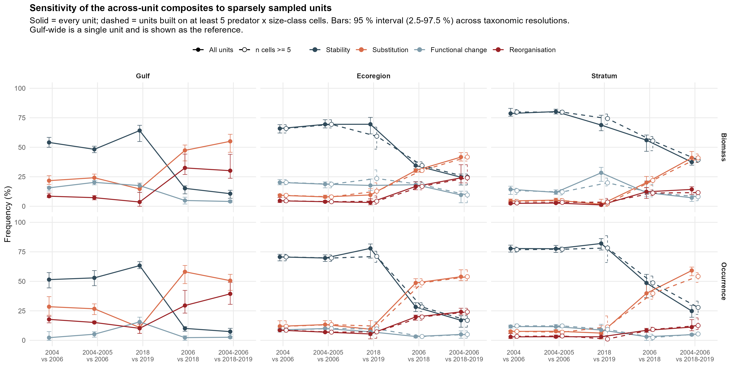
Figure S11. Sensitivity of the across-unit summaries to sparsely represented spatial units, at the ecoregion and stratum scales.

