Programme: BSc Applied Computing
Module: Data Warehousing and Data Mining
Module code: ACCA6026
Assignment Title: Assessment 2
Data Mining
Student Name: Francis Monney
Student ID: 2223886

Lecturer: Nouh Elmitwally


University of Wales
Trinity Saint David

Table of Contents
Table of Contents 1
“Analysing Why Students Drop Out Using Statistics and Data Visualization.” 2
Introduction 3
1. Purpose and Practice of Data Mining in Business 3
2. Dataset Description and Exploratory Analysis 4
3. Data Pre-processing and Post-processing 6
4. Sample Analysis and Results Using Tableau 8
5. Business Recommendations 14
6. Reflective Commentary 14
Conclusion 15
References 16

“Analysing Why Students Drop Out Using Statistics and Data Visualisation.”

Introduction
Student dropout poses significant challenges for higher education institutions [1], impacting academic success rates, financial sustainability, and institutional reputation [2]. This report examines dropout patterns within a Portuguese higher education institution, utilising a dataset comprising demographic, academic, and financial variables collected at enrolment.
Tableau is used as the main analysis tool, allowing the transformation of raw data into clear, descriptive visualisations. The analysis examines variables such as course enrolment, age, gender, tuition payment status, marital status, scholarship support, etc, to identify high-risk groups. By emphasising accessible visual analysis over complex predictive models, the study uncovers actionable trends and relationships within the data.
The findings aim to inform targeted, evidence-based interventions, addressing both academic and external factors influencing student retention. Ultimately, this approach supports the development of policies and support systems designed to reduce dropout rates and enhance overall student success.

1. Purpose and Practice of Data Mining in Business

Data mining is the process of finding useful information, patterns, and trends in large amounts of data [3]. The main goal is to get useful information that can help with decision-making, find new business opportunities, and solve difficult business problems. Data mining turns raw data into useful knowledge by using statistics, machine learning, and computer science [4].
There are a few important steps that make up data mining in practice. These steps include gathering data, pre-processing it (cleaning and changing it), using mining methods (like classification, clustering, association rule mining, and anomaly detection), and figuring out what the results mean [5]. People often use tools like Tableau, Python, R, and SQL to look at and analyse data.
In the business world, data mining has a lot of benefits. It helps businesses learn more about their customers, divide up their markets, improve their operations, and predict trends [6]. For instance, in retail, data mining helps businesses figure out what people are buying so they can suggest products (market basket analysis) or keep track of their stock. In finance, it helps find fraud by spotting strange patterns in transactions. HR departments can use it to figure out how many employees will leave, and marketing teams can use it to improve campaigns by focusing on certain groups of customers based on their behaviour and demographics.
Furthermore, data mining is crucial for predictive analytics, which forecasts future results based on past data. This ability helps businesses act proactively instead of reactively. For example, telecom companies can anticipate customer churn and take measures to retain at-risk customers before they depart.
Overall, data mining enhances strategic decision-making by turning data into a business asset. As organizations increasingly rely on data-driven strategies, the ability to mine data efficiently has become a critical competitive advantage. It allows businesses not only to understand what is happening in the present but also to anticipate future trends and act accordingly.

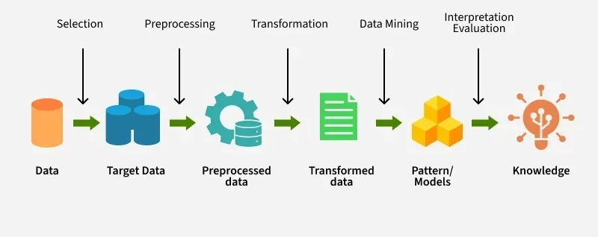
Figure 1: Workflow of Data Mining

2. Dataset Description and Exploratory Analysis

What is a dataset?
A dataset is a structured set of data, typically arranged in rows and columns, where each row corresponds to an individual record or instance, and each column represents an attribute or variable. It serves as the fundamental input for data analysis, machine learning, or statistical modelling [7].

Data Sources
For our report, the dataset analysed in this study originates from a Portuguese higher education institution and contains detailed records of 4423 students, each described by 14 attributes. The dataset’s primary objective is to enable the prediction of student outcomes, specifically whether a student Graduated, dropped out, or remains enrolled.

Data Familiarisation, Exploration & Visualisation
After obtaining the dataset, an initial familiarisation phase was conducted to understand its structure, variable types, and overall content. The data set includes a mix of categorical and numerical variables:
• Demographic: Age at enrolment, Gender, Marital status, Nationality, Educational special needs, Displaced.
• Financial: Scholarship holder, Debtor, Tuition fees up to date.
• Academic: Course, Previous qualification, Target (Dropout/Enrolled/Graduate).
• Socio-Economic: GDP, Unemployment rate, Inflation rate.

In the exploration phase, attention was given to possible trends and relationships that may be influencing the outcome of students, whether a student dropped out or completed. Visualisation tools, mainly Tableau, were used to bring out any underlying patterns that were not so obvious by looking at the raw data.
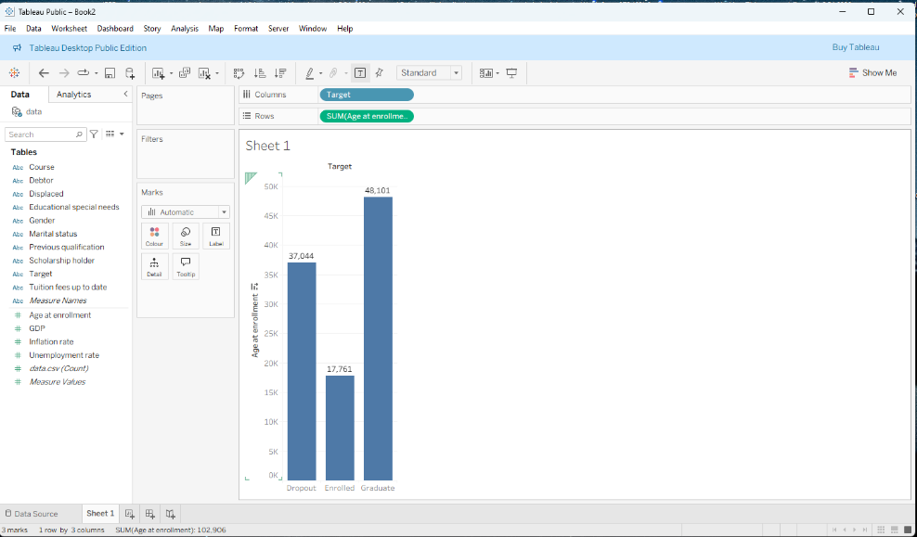
Figure 2: Sum of students' outcomes
This bar chart, created with Tableau, displays the total number of students enrolled by age for three educational outcomes: Dropout, Enrolled, and Graduate. Graduates have the highest total age at enrolment (48.101), followed by Dropouts (37.044), and Enrolled individuals (17.761). The chart provides a broad overview but lacks demographic details, such as gender or marital status. Since it uses the sum of ages rather than the average or count, it’s unclear whether the differences are due to more individuals or older ages. For deeper insights, including the average age and participant counts, along with demographic segmentation, would help better understand enrolment patterns.

3. Data Pre-processing and Post-processing

Data pre-processing is crucial for preparing the dataset for mining and achieving accurate results. This process involves cleaning, transforming, selecting, and encoding data [8]. Post-processing then interprets the model outputs for business understanding [9].

Primary Pre-processing
Primary pre-processing refers to the initial and essential steps taken to clean, prepare, and structure raw data before it can be effectively analysed or used in data mining tasks. This stage is crucial to ensure data quality, consistency, and usability, as real-world datasets often contain errors, inconsistencies, or incomplete information that can distort results or degrade model performance.
One of the key characteristics of primary pre-processing is handling missing or invalid values. This may involve identifying and imputing missing entries using statistical methods such as mean, median, or mode, or removing problematic rows or columns altogether. For example, values like zero in “Previous Qualification Grade” might be replaced with the median of valid values to maintain accuracy without removing data.
Data cleaning is another core element, which involves detecting and correcting inaccuracies, removing duplicates, and ensuring that data types and formats are consistent across all fields. Attributes with constant values or those that are highly correlated with others may also be removed to eliminate redundancy and reduce noise.
Categorical data encoding is often performed to convert non-numeric attributes (e.g., gender, nationality) into numeric formats suitable for analysis or modelling. Common methods include label encoding and one-hot encoding.
Lastly, normalisation or standardisation of numerical variables may be applied to bring all attributes to a similar scale, especially important for distance-based algorithms.
Overall, primary pre-processing transforms raw, inconsistent data into a clean and structured format, laying the groundwork for accurate and reliable analysis. Without this critical step, data mining processes risk producing biased, misleading, or invalid results.

Secondary pre-processing
Secondary data processing refers to the stage of data preparation that follows primary pre-processing. While primary pre-processing focuses on cleaning and formatting raw data, secondary processing involves transforming and optimising the cleaned data for specific analytical tasks, such as modelling, visualisation, or reporting. It refines the dataset to enhance efficiency, interpretability, and model performance.
One key characteristic of secondary processing is featuring selection, where the most relevant attributes are identified and retained while less significant or redundant features are excluded. Techniques like correlation analysis or information gain ranking help highlight which variables contribute most to the predictive power of a model.
Another aspect is featuring transformation, which includes grouping, binning, or encoding variables to enhance data structure. For example, a continuous age variable might be binned into age groups, or nominal target variables may be converted into class labels for classification tasks.
Target variable restructuring also falls under secondary processing, particularly in classification problems. In this case, student outcomes (e.g., Graduate, Dropout, Enrolled) are grouped into a simplified categorical class for model training.
Additionally, data partitioning for training and testing purposes, such as using cross-validation, is typically considered part of secondary processing, ensuring models are evaluated fairly.
This stage is crucial for turning cleaned data into actionable insights.

post-processing
After completing the classification process, we conducted several post-processing steps to ensure the results were meaningful and accessible for stakeholders. First, we interpreted confusion matrices and accuracy scores to compare the performance of different classification approaches. Important features influencing student outcomes were visualized using Tableau, providing clear, data-driven insights. Complex outputs such as decision tree logic and probabilistic model predictions were translated into plain language to facilitate understanding among non-technical audiences. Prediction probabilities and classification labels were also exported for use in business reports. Post-processing enabled us to distil technical findings into actionable insights, simplifying outputs for decision-makers and highlighting high-confidence predictions that could inform targeted interventions (e.g., academic support for likely dropouts). Additionally, results were aggregated by student groups: graduates, dropouts, and currently enrolled students, allowing for group-level analysis and tailored strategic planning. Overall, these steps ensured the analysis was both accurate and practically useful for institutional decision-making.

4. Sample Analysis and Results Using Tableau
This section presents targeted Tableau analyses performed on the Portuguese higher education dataset to identify patterns that influence student dropout. Each sample run focuses on a distinct factor or intersection of factors, providing a comprehensive view of risks.


Figure 3:
The analysis compares dropout patterns in Management and Nursing by gender. In Management, female dropout rates are significantly higher than male rates, suggesting added challenges such as balancing work, study, and family responsibilities. Nursing shows a smaller gender gap, though female students still drop out more frequently, likely reflecting higher overall female enrolment. The sharp disparity in Management highlights a specific retention issue for women, while Nursing reflects more balanced attrition. Targeted interventions such as mentorship, academic advising, and stress-management support are especially needed for female Management students to address barriers and reduce dropout risk in this vulnerable group.

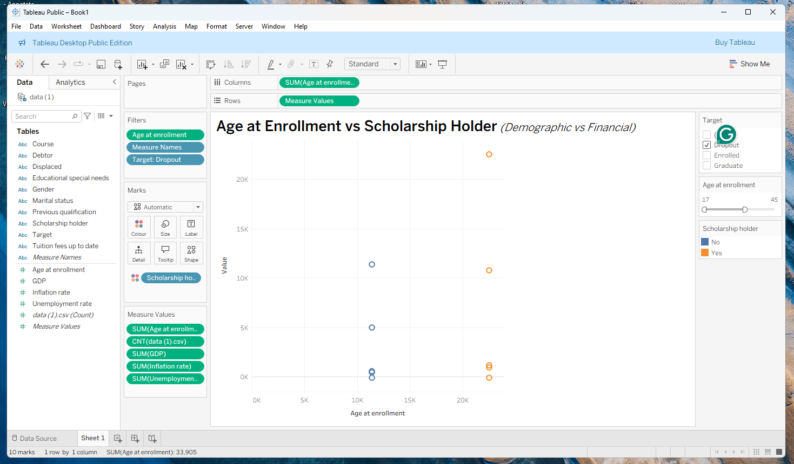
Figure 4
The scatter plot explores dropout patterns by age at enrolment and scholarship status. Scholarship holders (orange) cluster mainly at younger ages (late teens to mid-20s), with higher dropout counts at the extremes, suggesting that early-career students face adaptation challenges despite financial aid. Non-scholarship dropouts (blue) are more evenly spread, especially among mid-life students, indicating that factors beyond finance, such as work study conflicts and family duties, drive attrition. Overall, the findings show that scholarships help but are insufficient alone; younger students need academic and personal support, while older non-scholarship students require flexible learning and targeted retention measures.

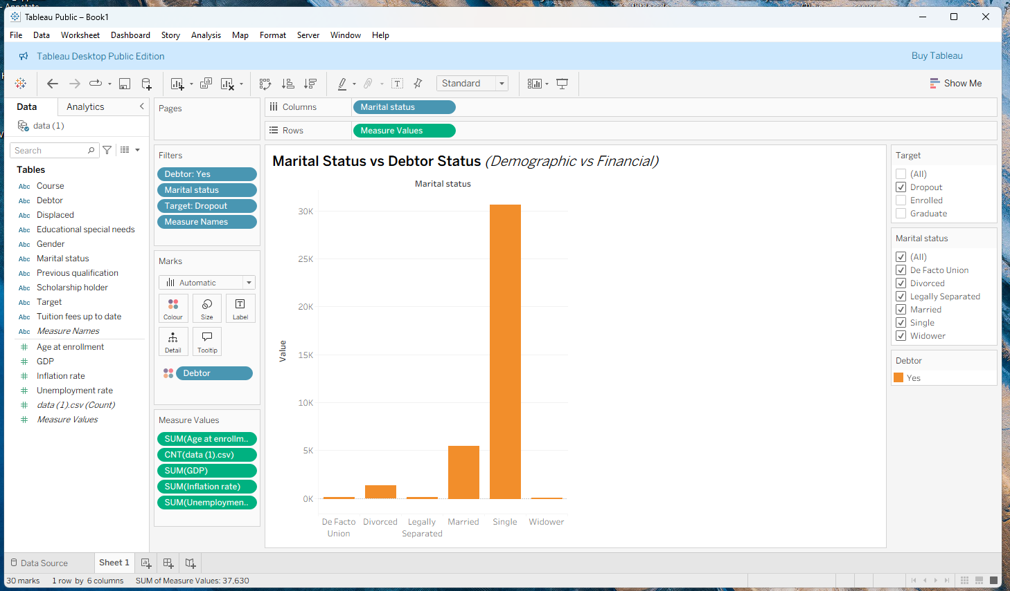
Figure 5
The bar chart compares marital status with debtor status among student dropouts, revealing financial vulnerability as a major risk factor. Single students with outstanding debts represent the largest dropout group, suggesting that financial instability strongly affects those without partner support. Married students also show notable dropout levels, likely due to family expenses and balancing responsibilities. Smaller categories divorced, legally separated, and de facto union indicate transitional life phases that disrupt financial stability, while widowers show minimal dropout, likely due to smaller numbers. Overall, indebted singles are most at risk, highlighting the need for targeted financial aid and debt management support.


Figure 6
The diagram compares tuition fees across courses, highlighting academic (blue) and financial (orange) components alongside dropout, enrolment, and unemployment metrics. Courses with higher financial costs often show elevated dropout rates, particularly among economically vulnerable students. A mismatch between academic value and financial burden may drive attrition, while poor career prospects further increase dropout risk. By analysing dropout-to-enrolment ratios, institutions can identify programs with critical retention issues. Courses showing both high dropout and unemployment require urgent attention. Overall, the dashboard provides a multidimensional view of how financial and academic factors shape student dropout, guiding targeted support and interventions.


Figure 7
The diagram highlights gender disparities in scholarship distribution within Management courses and their link to dropout risk. Male students are more likely to receive scholarships, while females dominate the non-scholarship category, suggesting uneven financial support. This imbalance may contribute to higher dropout rates among women, especially non-scholarship holders. Filters for course, dropout, and enrolment provide deeper insights into how financial aid intersects with gender and academic outcomes. If female non-scholarship students show higher attrition, financial constraints emerge as a key driver. The dashboard helps identify vulnerable groups, supporting targeted interventions to improve equity and retention in higher education.



Figure 8
The diagram shows a clear relationship between educational special needs and student debt levels, broken down by gender. Students with special needs tend to have higher debt counts than those without, indicating a greater financial burden. Among male students, those with special needs have debt levels exceeding 21,000, compared to around 12,000 for those without. Female students also show a similar pattern, though the gap is smaller. This suggests that students with special needs, regardless of gender, are more likely to accumulate debt. The data implies that financial challenges are more prevalent among students requiring additional academic support, which may be linked to higher dropout rates. The diagram effectively highlights how educational needs and financial stress intersect across different student groups

5. Business Recommendations

An analysis of student retention data underscores both financial and academic drivers of dropout in higher education. Financially, female students in Management courses face disproportionately high attrition due to unequal scholarship access, while mature students aged 30–45 without financial support struggle to balance academic, work, and family responsibilities. Single students with outstanding debts are particularly vulnerable, reflecting that financial instability is a key factor in withdrawal [10]. Compounding this, students with special educational needs often incur greater debt and disengage due to insufficient support. On the academic side, high failure rates, lack of institutional engagement, and barriers like rigid curricula and inadequate advising contribute significantly to dropout risk. Recent literature highlights how poor academic integration and outdated institutional practices amplify attrition [11].
Based on these analytical findings, institutions should implement a comprehensive retention strategy addressing both financial and academic challenges. Financially, scholarship allocation should be revised to ensure gender equity, especially for Management students, alongside debt relief, emergency funding, and personalized financial counselling [12]. Academically, the expansion of flexible learning modalities (e.g., part-time, evening, online courses) can better support mature learners [13]. For students with special educational needs, integrated support systems combining tailored academic accommodations, financial aid, and inclusive pedagogies are essential. Furthermore, aligning tuition and program design with labour market demands supported by enhanced career services and industry partnerships will improve perceptions of value and reduce dropout driven by economic uncertainty [14].

6. Reflective Commentary
Using Tableau for this project proved to be highly effective and insightful. It delivered strong accuracy and efficiency, enabling me to explore patterns in the student dropout data without programming skills. The platform’s visual interactivity facilitated easy segmentation by age, gender, course, and scholarship status, uncovering key trends like higher dropout rates among mature, female, and scholarship students in Management courses. A major benefit was the swift recognition of visual patterns. Nonetheless, a drawback was the challenge in obtaining precise statistical measures such as averages or counts, which sometimes limited deeper analysis. Additionally, Tableau does not include the advanced statistical tests necessary for validation. If I revisited this analysis, I would combine Tableau with a statistical tool like Python or R to improve the depth and accuracy of insights, blending visual storytelling with solid data validation.

Conclusion

This report analysed student dropout trends using Tableau with data from a Portuguese higher education institution. The visualisations revealed that financial and academic challenges are the primary drivers of attrition. Key financial factors include debtor status, unpaid tuition fees, and limited access to scholarships, all of which create economic pressure that forces many students to leave their studies. Academic issues, such as high curricular failure rates and difficulties coping with course demands, also strongly contribute to dropout. Demographic elements, including age and marital status, further shape outcomes, with mature students often struggling to balance work, family, and education. Program-specific patterns, particularly in Management, highlight the need for course-level interventions.
While Tableau does not support predictive modelling, it effectively uncovered these patterns, demonstrating how visual analytics can guide institutions in addressing both financial and academic barriers. By acting on these insights, universities can design tailored support, strengthen retention, and enhance overall student success.

References

[1] G. Bertola, “University dropout problems and solutions,” Journal of Economics (Vienna, Austria), vol. 138, no. 3, pp. 221–248, 2023, Doi: 10.1007/s00712-022-00814-7.
[2] S. Kim, E. Yoo, and S. Kim, “Why Do Students Drop Out? University Dropout Prediction and Associated Factor Analysis Using Machine Learning Techniques,” 2023, doi: 10.48550/arxiv.2310.10987.
[3] A. Twin, “What Is Data Mining? How It Works, Benefits, Techniques, and Examples,” Investopedia, Feb. 23, 2024. https://www.investopedia.com/terms/d/datamining.asp
[4] L. Zhang, K. Liu, I. Ilham, and J. Fan, “Application of Data Mining Technology Based on Data Center,” Journal of physics. Conference series, vol. 2146, no. 1, p. 12017, 2022, doi: 10.1088/1742-6596/2146/1/012017
[5] W. van der Aalst and J. Carmona, Process Mining Handbook, 1st ed. 2022. Cham: Springer International Publishing, 2022. doi: 10.1007/978-3-031-08848-3.
[6] S. Dutta, “Benefits of Data Mining: Unlocking Insights from Data,” Sprinkledata.com, Jun. 25, 2024. https://www.sprinkledata.com/blogs/benefits-of-data-mining-unlocking-insights-from-data
[7] Databricks, “What is a Dataset?” Databricks, Nov. 29, 2023. https://www.databricks.com/glossary/what-is-dataset
[8] G. Lawton, “Data Preprocessing: Definition, Key Steps and Concepts,” SearchDataManagement, Jan. 2022. https://www.techtarget.com/searchdatamanagement/definition/data-preprocessing
[9] “Post-processing data,” SBG Systems, Jul. 10, 2025. https://www.sbg-systems.com/glossary/ppk-post-processing-data/ (accessed Aug. 18, 2025).
[10] Pertegal-Felices et al., “University Dropout: A Systematic Review of the Main Determinant Factors (2020–2024),” F1000Research, 2024.
[11] Santos-Villalba et al., “Academic Advising and Curricular Flexibility as Dropout Risk Factors,” F1000Research, 2024.
[12] Nguyen et al., “Effect of Grant Aid on Enrolment and Persistence: A Systematic Review,” Review of Educational Research, 2019 (updated 2023).
[13] RCL, “How Mature Students Benefit from Flexible Learning,” Royal College of Learning, UK, Dec 2024.
[14] Cheng et al., “Dual-Modal Abrupt Behavioral Changes Approach for Dropout Risk Prediction,” ArXiv, 2025.

‌

‌

‌

‌

‌

