
Fortinet Config Lab – SOHO and initial configuration
The following is the Firewall I will be working with in this lab
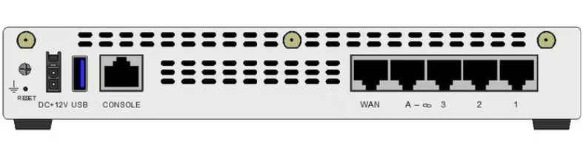
Purpose:
The purpose of this lab was to perform a factory reset on a FortiGate 61E firewall and complete a initial SOHO network configuration. In this lab, I configured the FortiGate so that the internal LAN network could receive IP addresses through DHCP and access the internet through the WAN interface. This lab helped me understand firewall interfaces, DHCP, WAN LAN separation, Firewall policies and the basics of FortiGate management

Background information and Lab concepts
- A FortiGate firewall is used to protect networks and control what traffic flows in and out
- In this lab, the FortiGate was used for a small office/home office network
- The internal interface was the LAN side of the network. This is where the local computers or devices would connect
- The WAN interface was the outside connection connected to the internet through the ISP
- DHCP is what automatically gives the IP addresses, in this lab the FortiGate gave out the IP addresses through 192.168.10.100 to 192.168.10.20

Lab Summary:
In this lab, I first performed a factory reset on the FortiGate firewall by using the physical reset button on the firewall. After the firewall reset, I connected to the web GUI to confiture the internal LAN interface with the IP address 192.168.10.1/24 and turned on DHCP so devices could automatically get their own IP addresses. I also set up the WAN interface to use DHCP, and after that I created a firewall policy that allowed all traffic from internal to WAN.

Lab Commands:
- Before starting the configuration, I factory reset the firewall through the physical reset button. I powered on the firewall and waited for it to boot, then I pressed and held the reset button with a paperclip until the firewall began the reset process .

- Go to Network -> Interfaces -> Internal.

- Set the LAN IP to 192.168.10.1/24
- Enable the DHCP with the range 192.168.10.100 – 192.168.10.200.
- Allow management access like HTTPS , HTTP, PING, and SSH
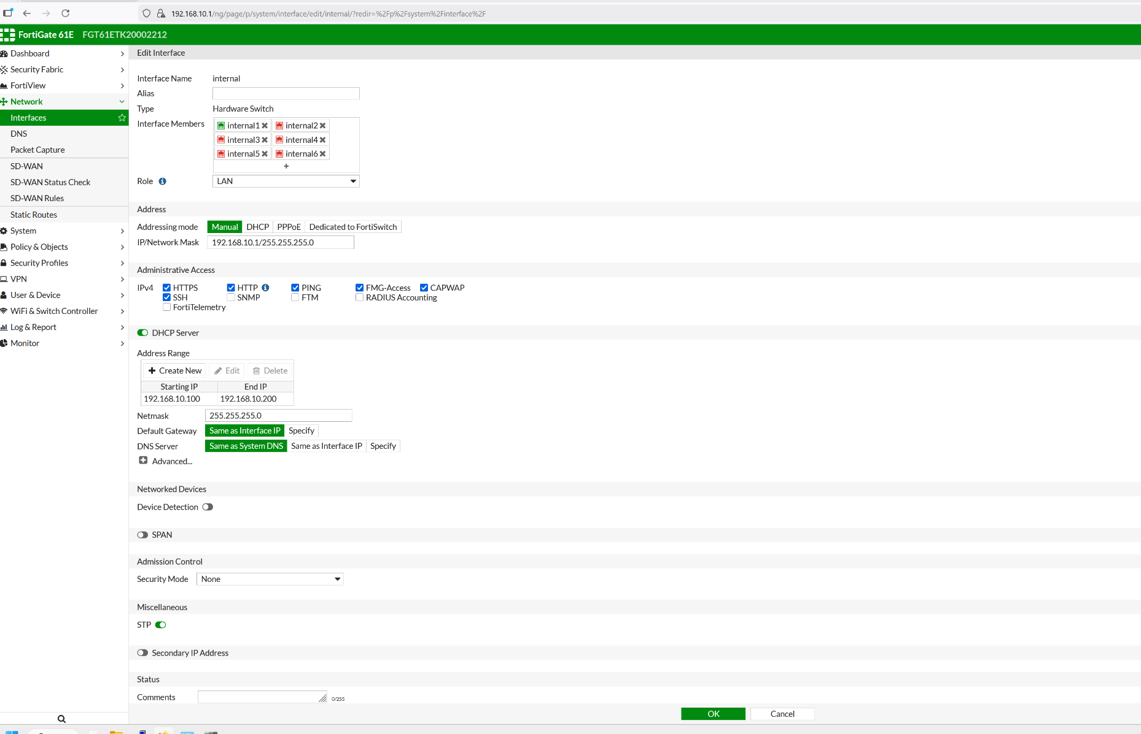

- Go to Network -> interfaces -> wan1

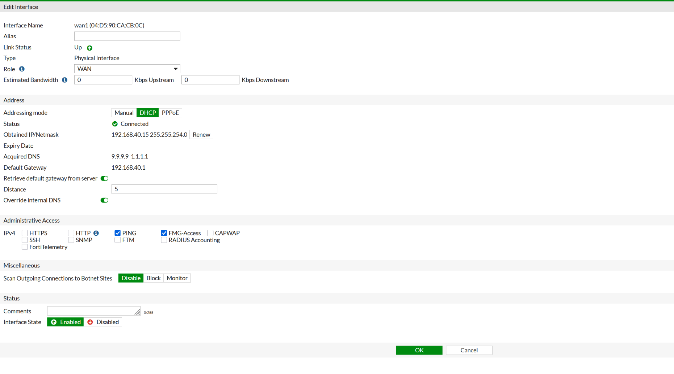
- Configure wan1 as the outside interface
- Set it to DHCP, for my case it received 192.168.30.15/23
- Verified gateway as 192.168.40.1

- Go to Policy & Objects -> IPv4 Policy

- Create an internal to wan1 firewall rule.
- Allowed all sources, destinations, and ALL services.
- Turned NAT on using outgoing interface address
- Enable logging for security events
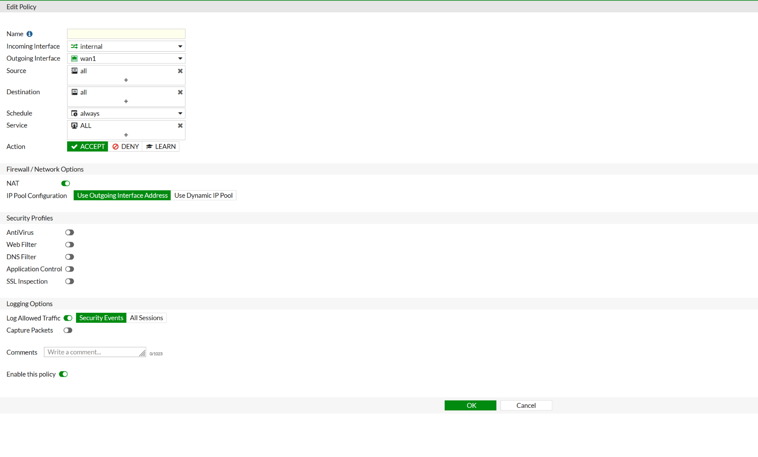
In FortiGate 61E, we have the implicit deny rule stayed below as the default block rule
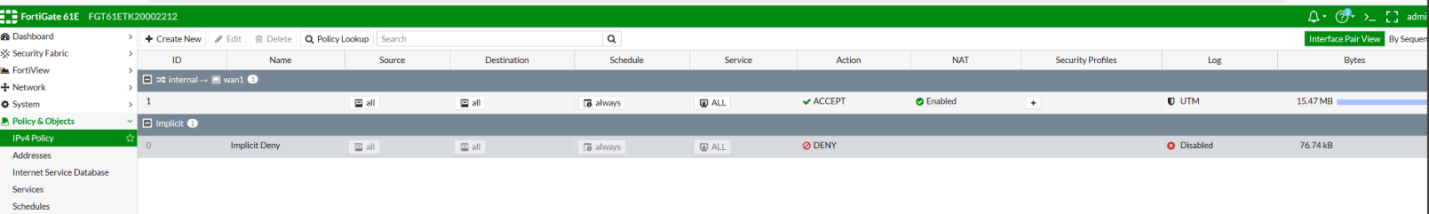

Problems:
One of the problems I encountered during this lab is that after factory reset, I could not access the FortiGate web GUI. This could happen if the client-side computer does not receive an IP address. To solve this, I enabled DHCP and tried accessing the web GUI from the right management IP.

Another problem we encountered is that the client computer receiving the IP address was still not able to reach the internet. This usually indicates that the firewall policy is configured wrong or some routings are missing. In this lab, we had to enable NAT on the internal to wan1 policy we created.

Conclusion:
In this lab, I successfully configured a small office/home office network on the FortiGate 61E firewall. Overall, this lab helped me understand how a FortiGate firewall is configured in a small network. I was able to learn how LAN and WAN interfaces work, how DHCP gives IP addresses to clients and how NAT policies allow private addresses to go out into the internet.

