

Fortinet Config Lab – VPN Configuration Lab
The following is the firewall I will be working with in this lab
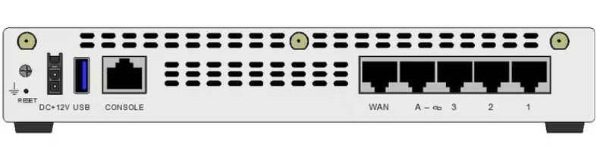
Purpose:
The purpose of this lab was to set up a remote access SSL VPN on a FortiGate 40F firewall. The goal was to let a remote user, who is outside the network, securely connect back into the office LAN over the internet using the FortiClient app. Once connected, the remote user is able to reach internal devices as if they were sitting in the office. This lab helped me understand VPN users and groups, SSL VPN settings, VPN firewall policies, and how to connect and test the VPN with FortiClient.
Background information and Lab concepts
- A VPN (Virtual Private Network) creates a secure, encrypted tunnel over the internet so a remote user can safely reach a private network.
- SSL VPN is a type of VPN that works through the browser or the FortiClient app, so the user does not need any special hardware to connect.
- The WAN interface is the outside internet facing connection. The remote user connects to the firewall's WAN address to start the VPN.
- The LAN interface is the inside network where the office devices live. In this lab the LAN was 192.168.1.0/24.
- When a remote user connects, the firewall hands them a temporary IP address from a set range so their traffic can flow through the tunnel.
- A firewall policy is still needed to actually allow the VPN traffic to reach the LAN, otherwise the connection is blocked.
Lab Summary:
In this lab, I started with a fresh FortiGate 40F and logged into the web GUI. I set up the WAN and LAN interfaces, then created a VPN user and a user group for remote access. I made an address range for the VPN clients, turned on and configured the SSL VPN settings, and created a firewall policy to let the VPN reach the LAN. Finally, I installed and configured FortiClient on a remote computer, connected to the VPN, and tested it by using Remote Desktop to reach a machine on the office LAN.
Lab Commands:
- Factory reset the firewall and let it boot. I reset the FortiGate 40F so it started from a clean configuration.
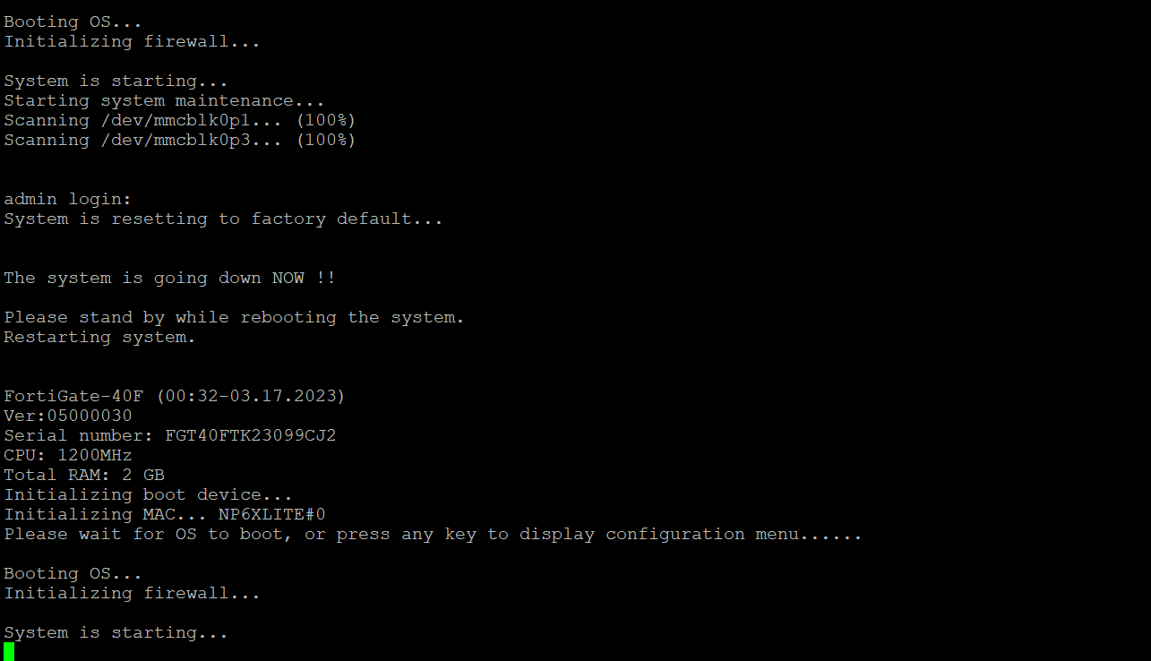
- Log into the FortiGate web GUI using the admin account.
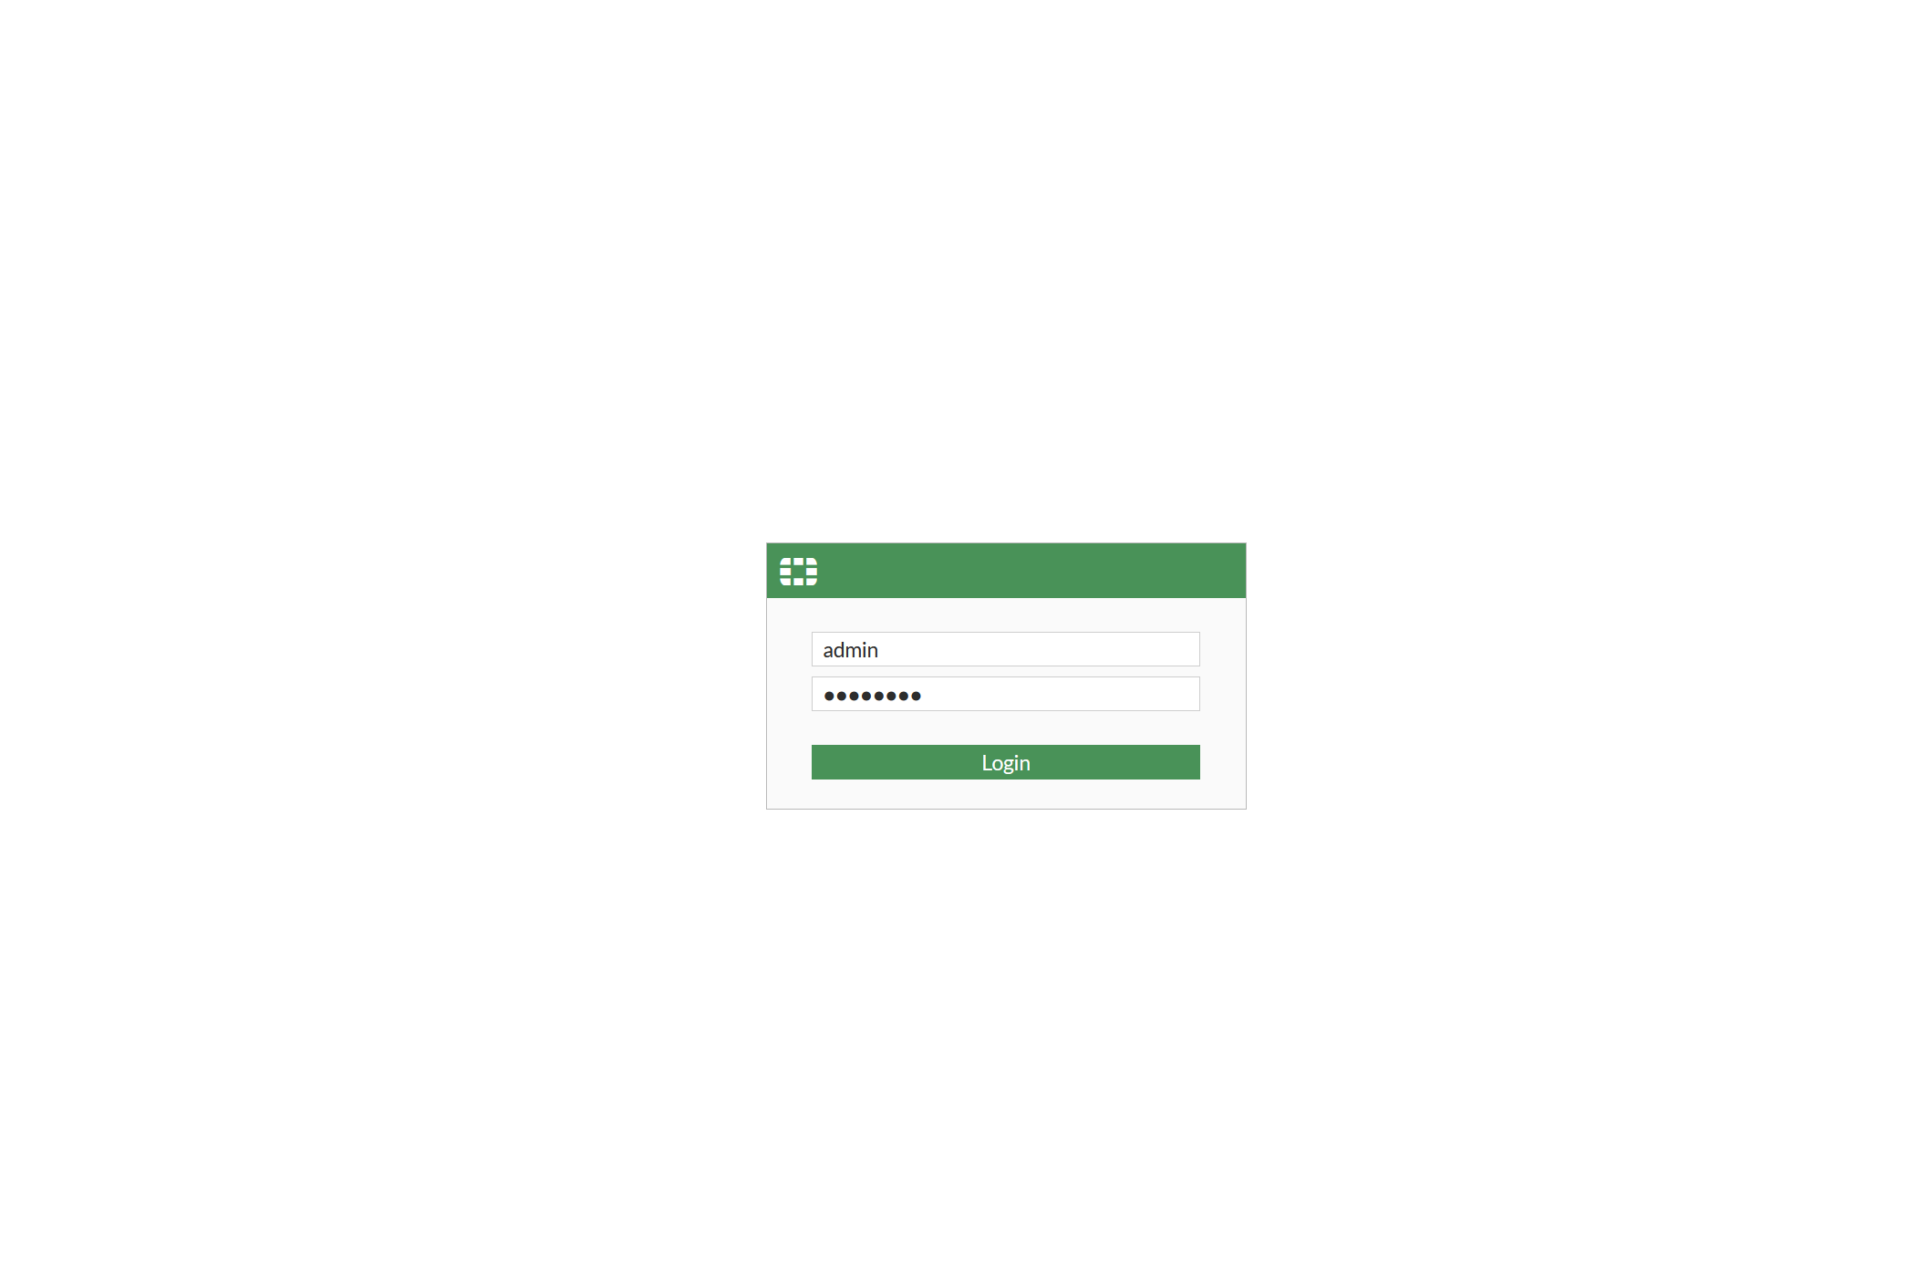
- Set up the WAN interface. Go to Network → Interfaces, open the wan port, and set it to DHCP. It received the address 192.168.40.51.
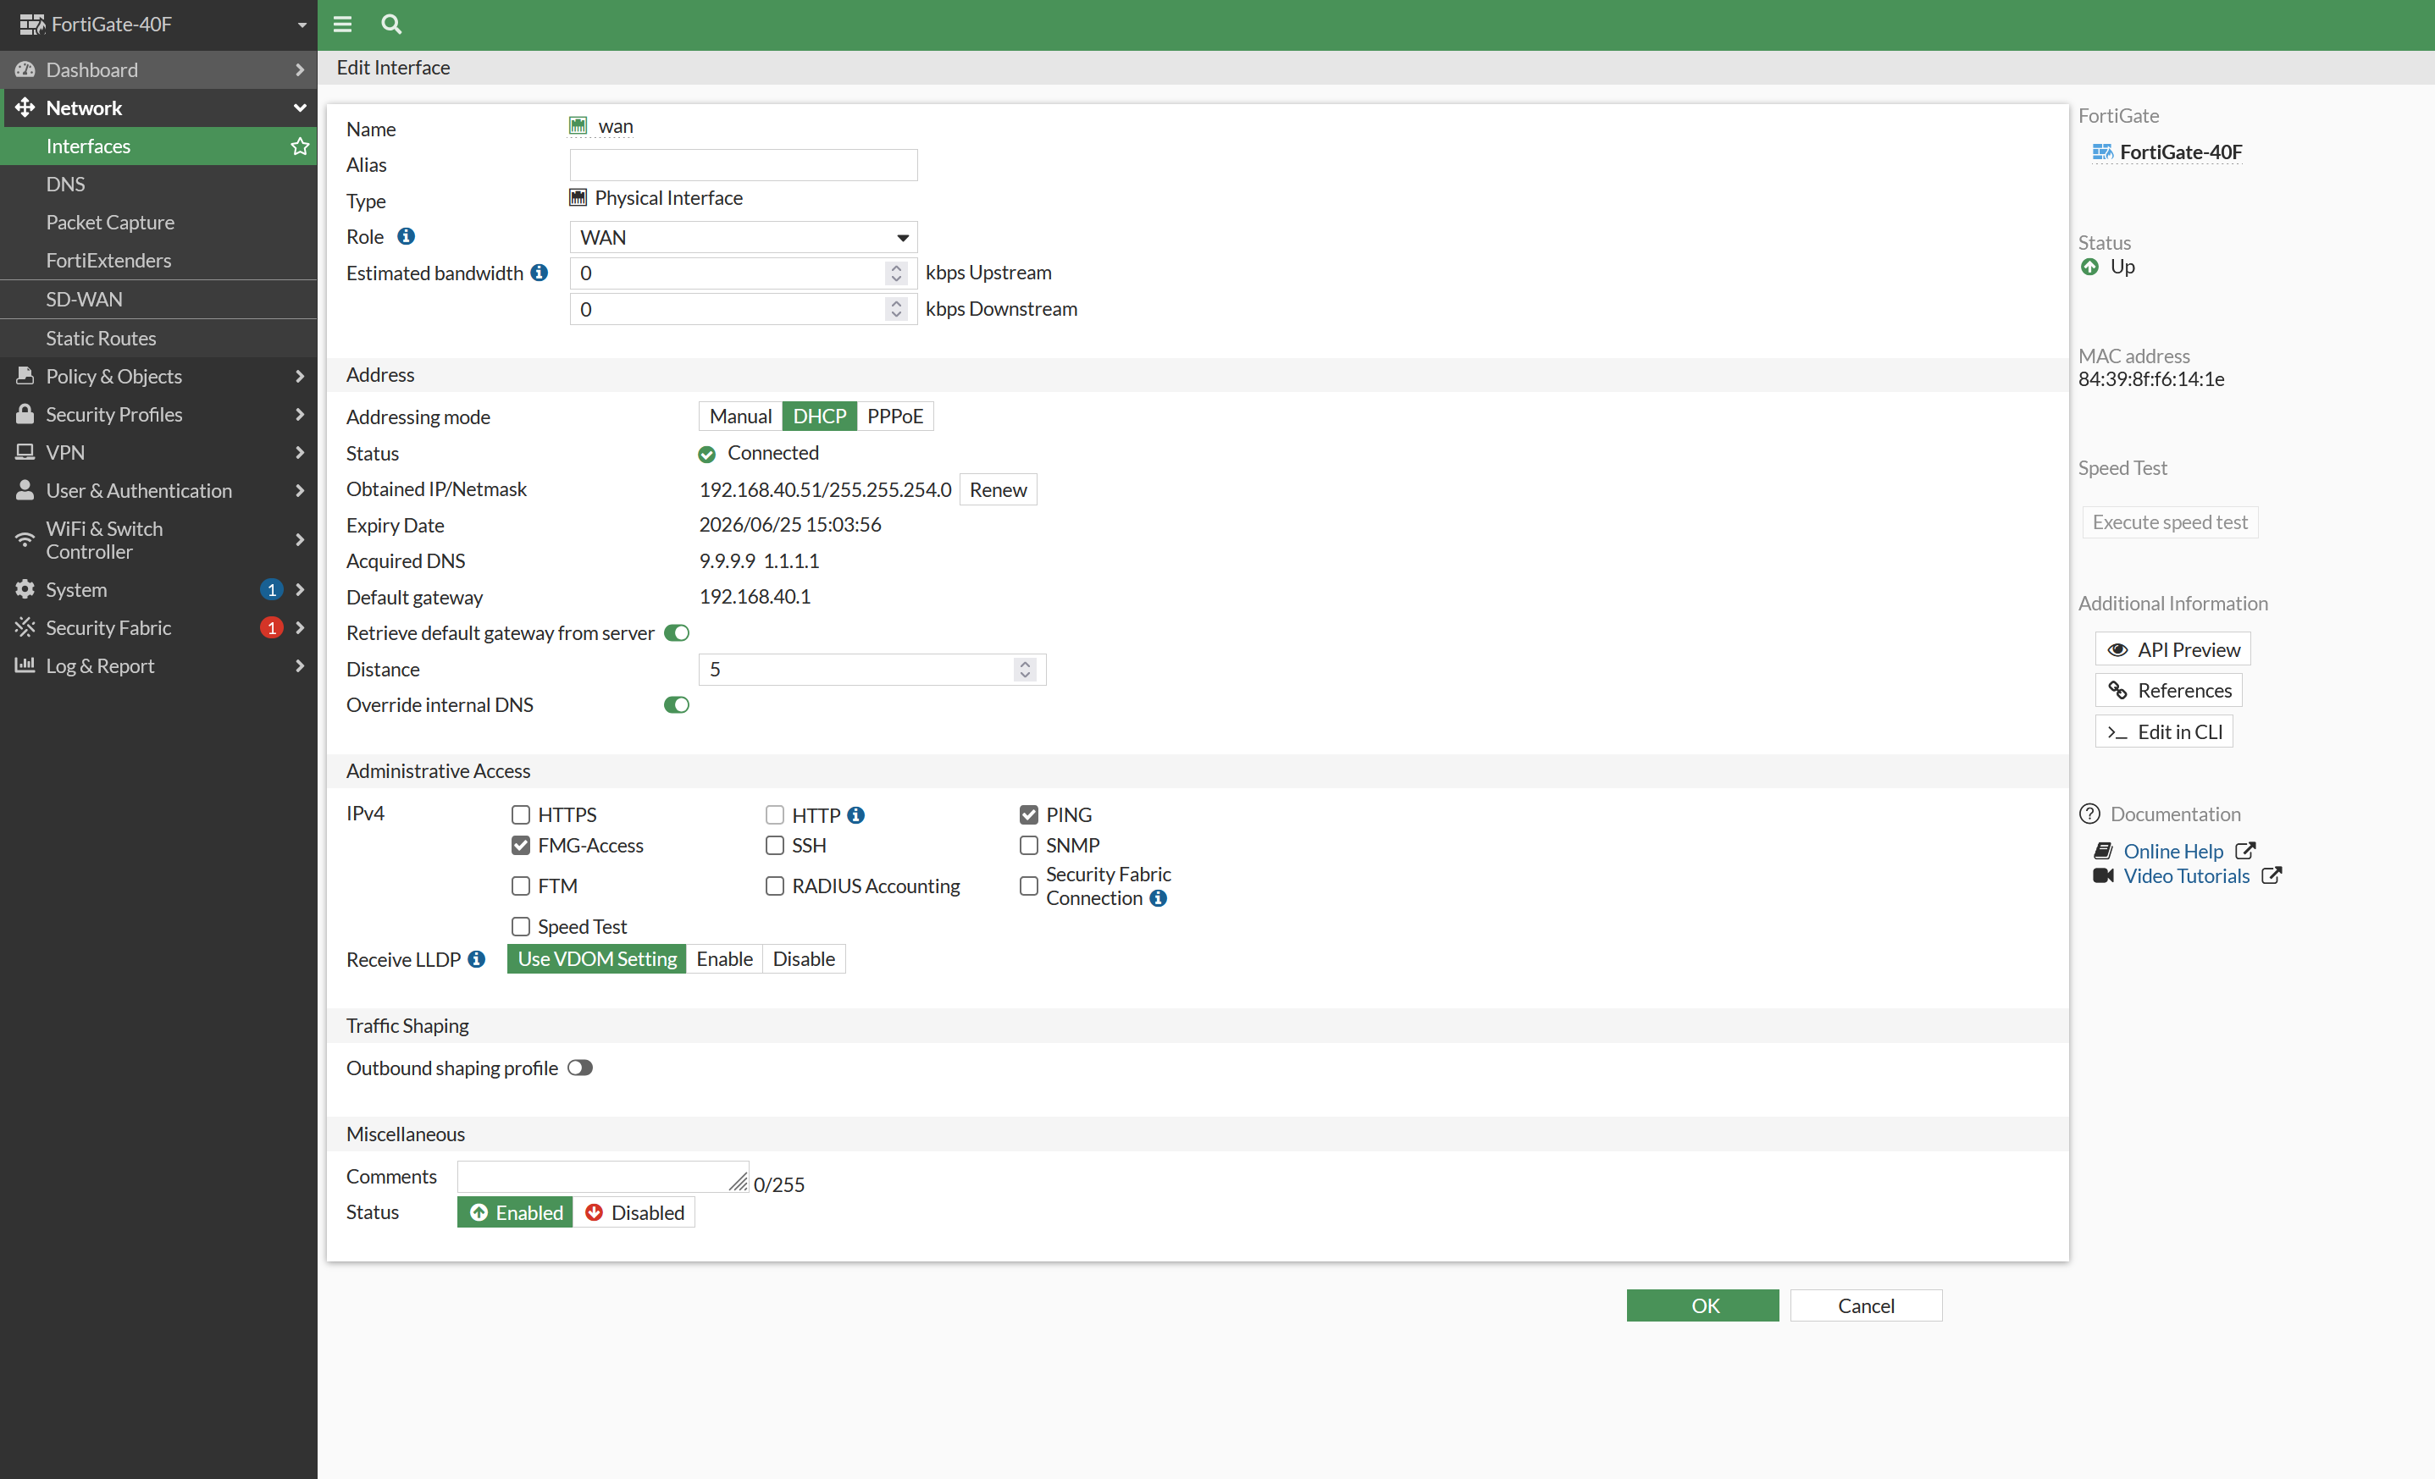
- Set up the LAN interface. Open the lan interface, give it the IP 192.168.1.99/24, and turn on the DHCP server so office devices get an address automatically.
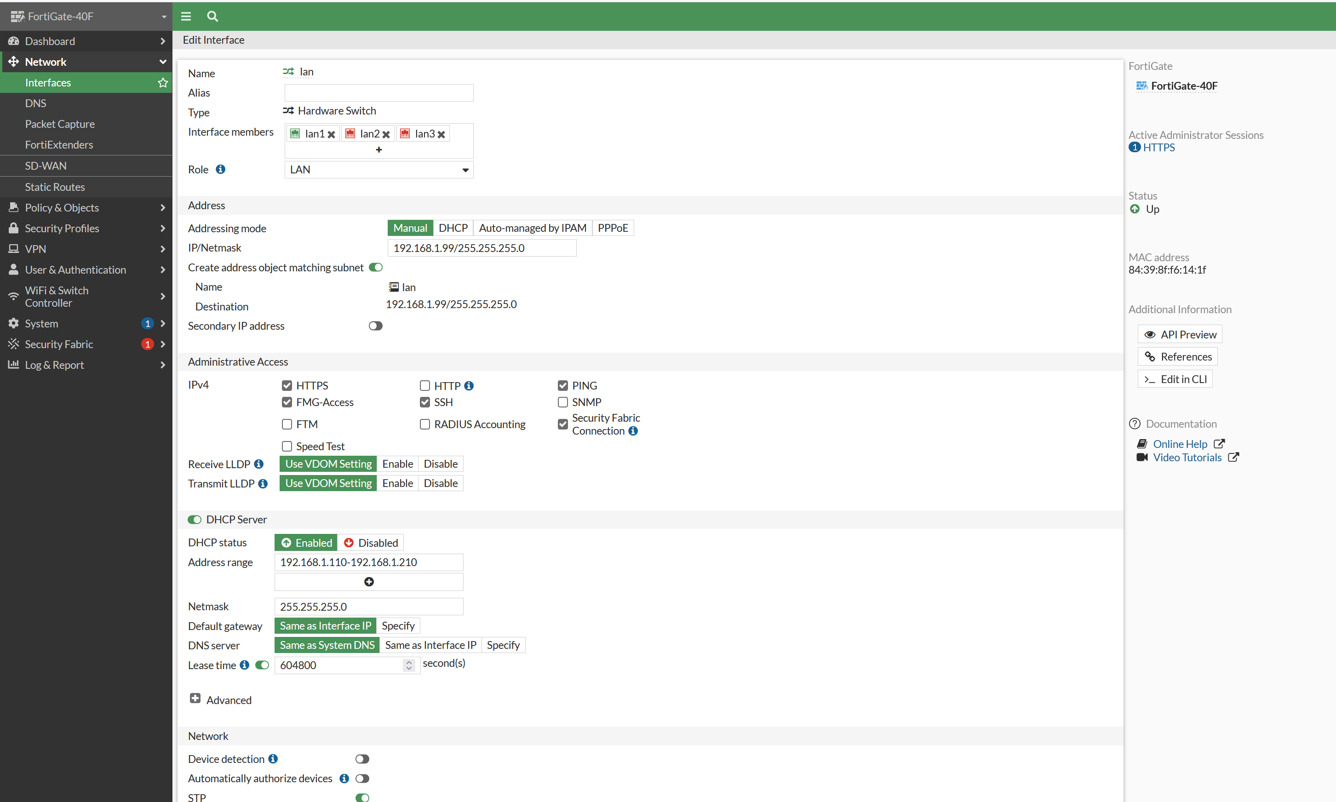
- Create the VPN user. Go to User and Authentication → User Definition, click Create New, and make a local user named remote with a password.
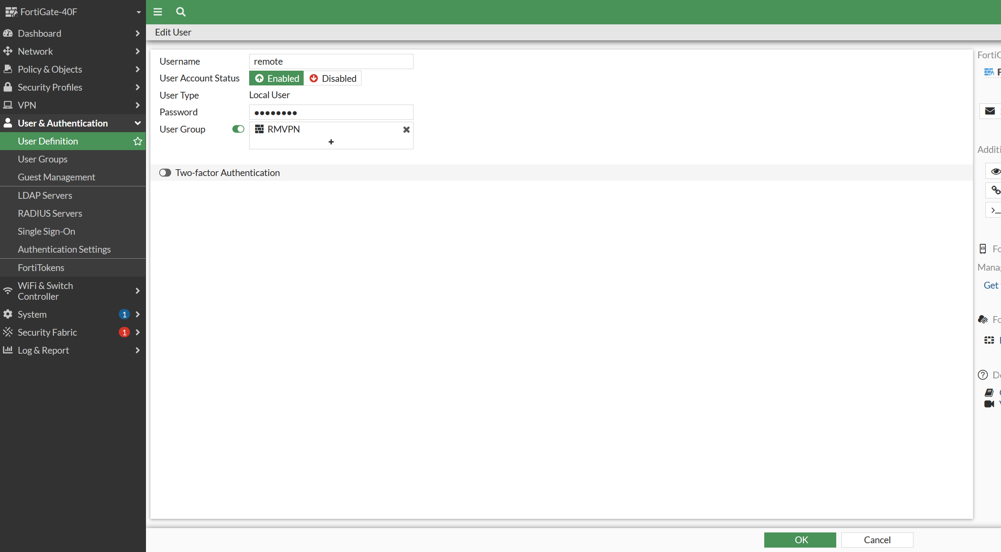
- Create a user group for the VPN. Go to User Groups, click Create New, name it RMVPN, and add the remote user as a member. Groups make it easier to control who can use the VPN.
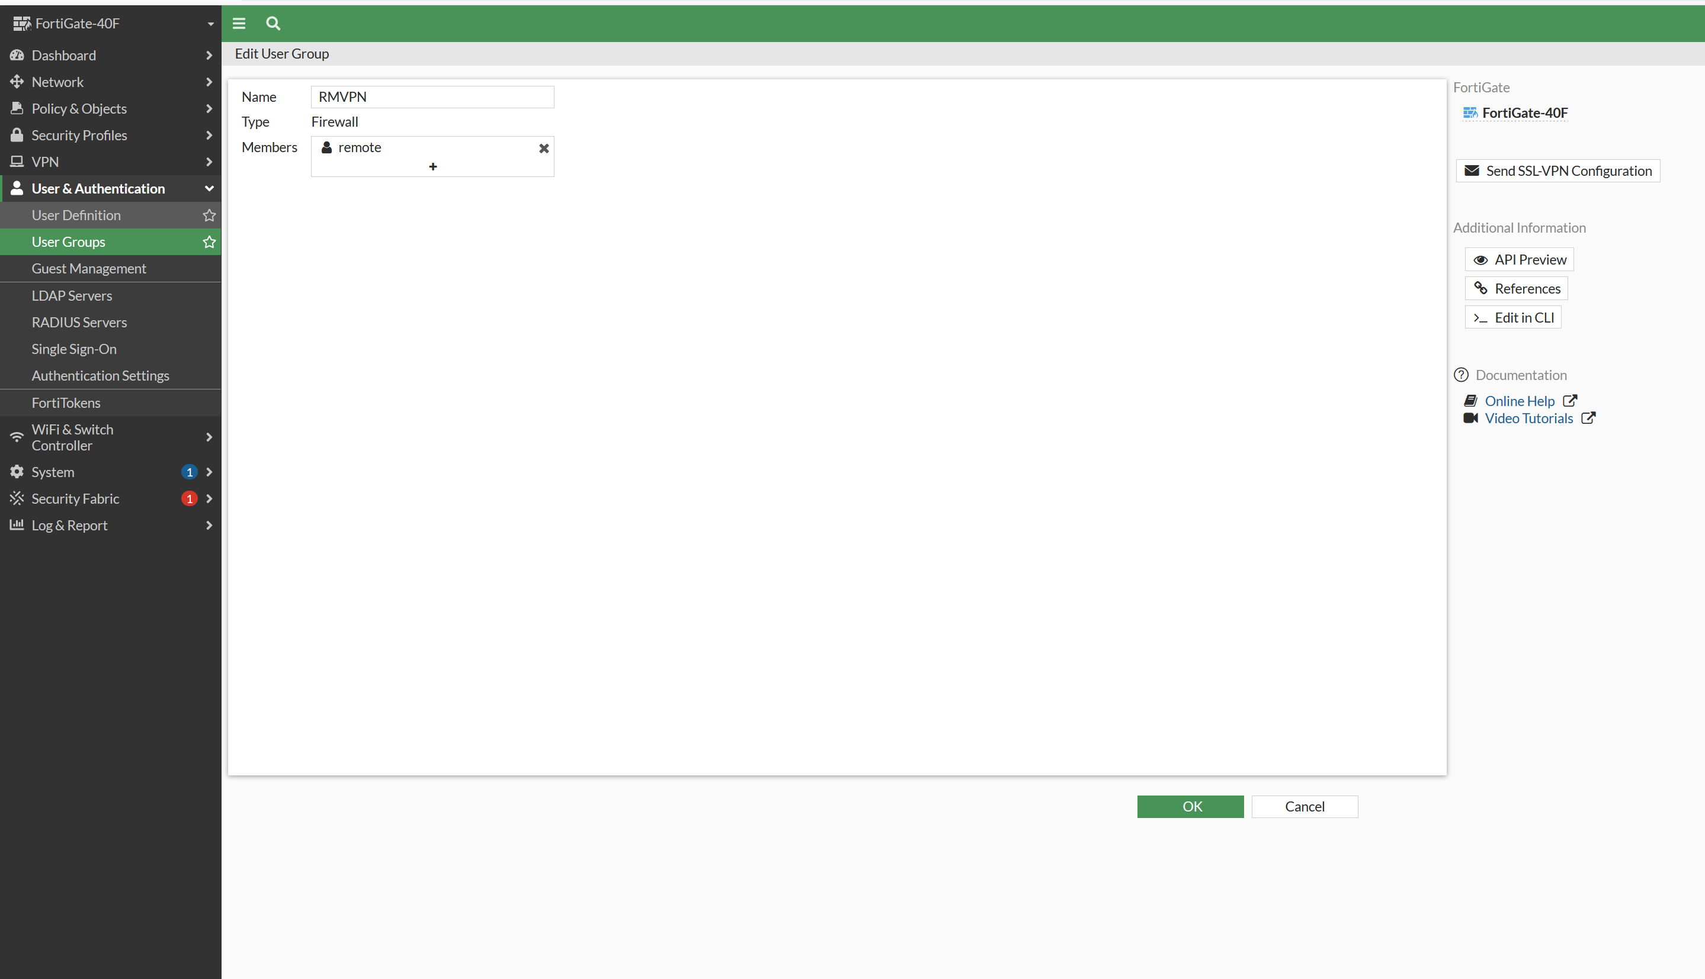
- Check the user list to confirm the remote user and group were created.
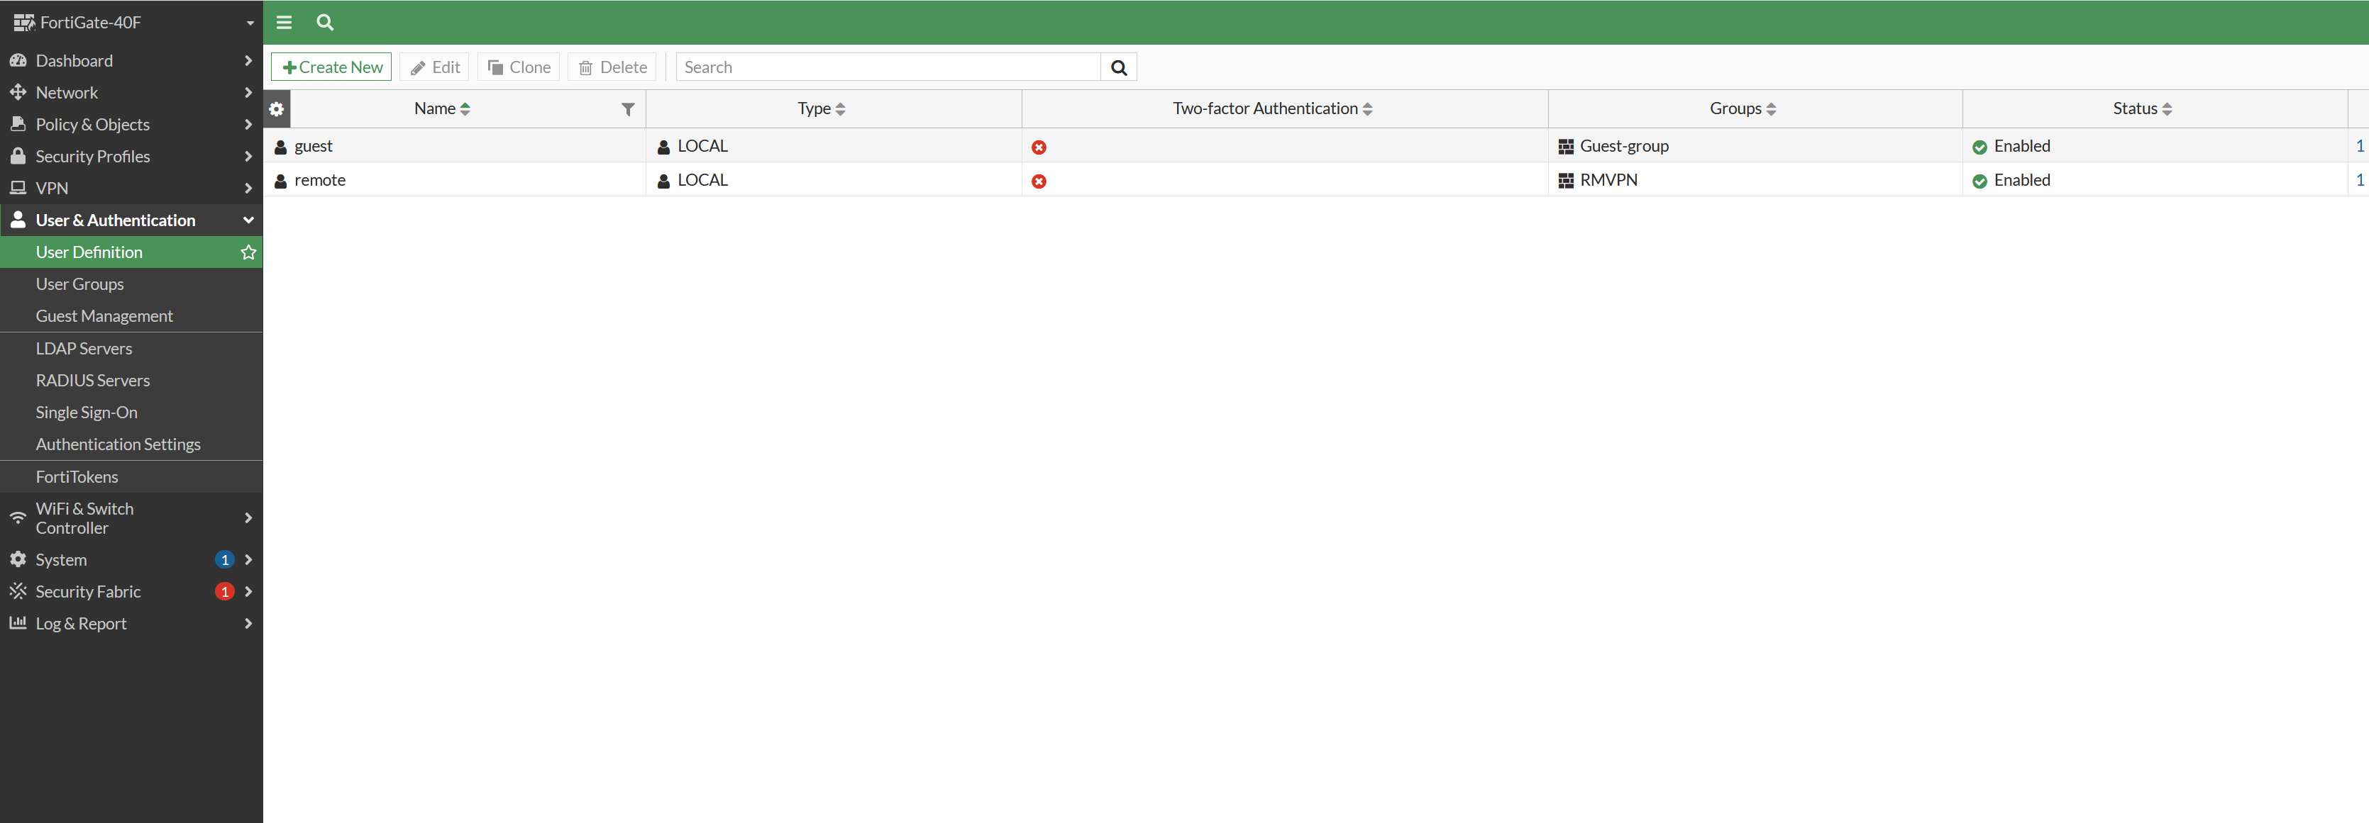
- Create an address range for the VPN clients. Go to Policy & Objects → Addresses, click Create New, name it RM_VPN_range, and set the IP range to 10.10.10.1 – 10.10.10.254. These are the addresses given to people once they connect.
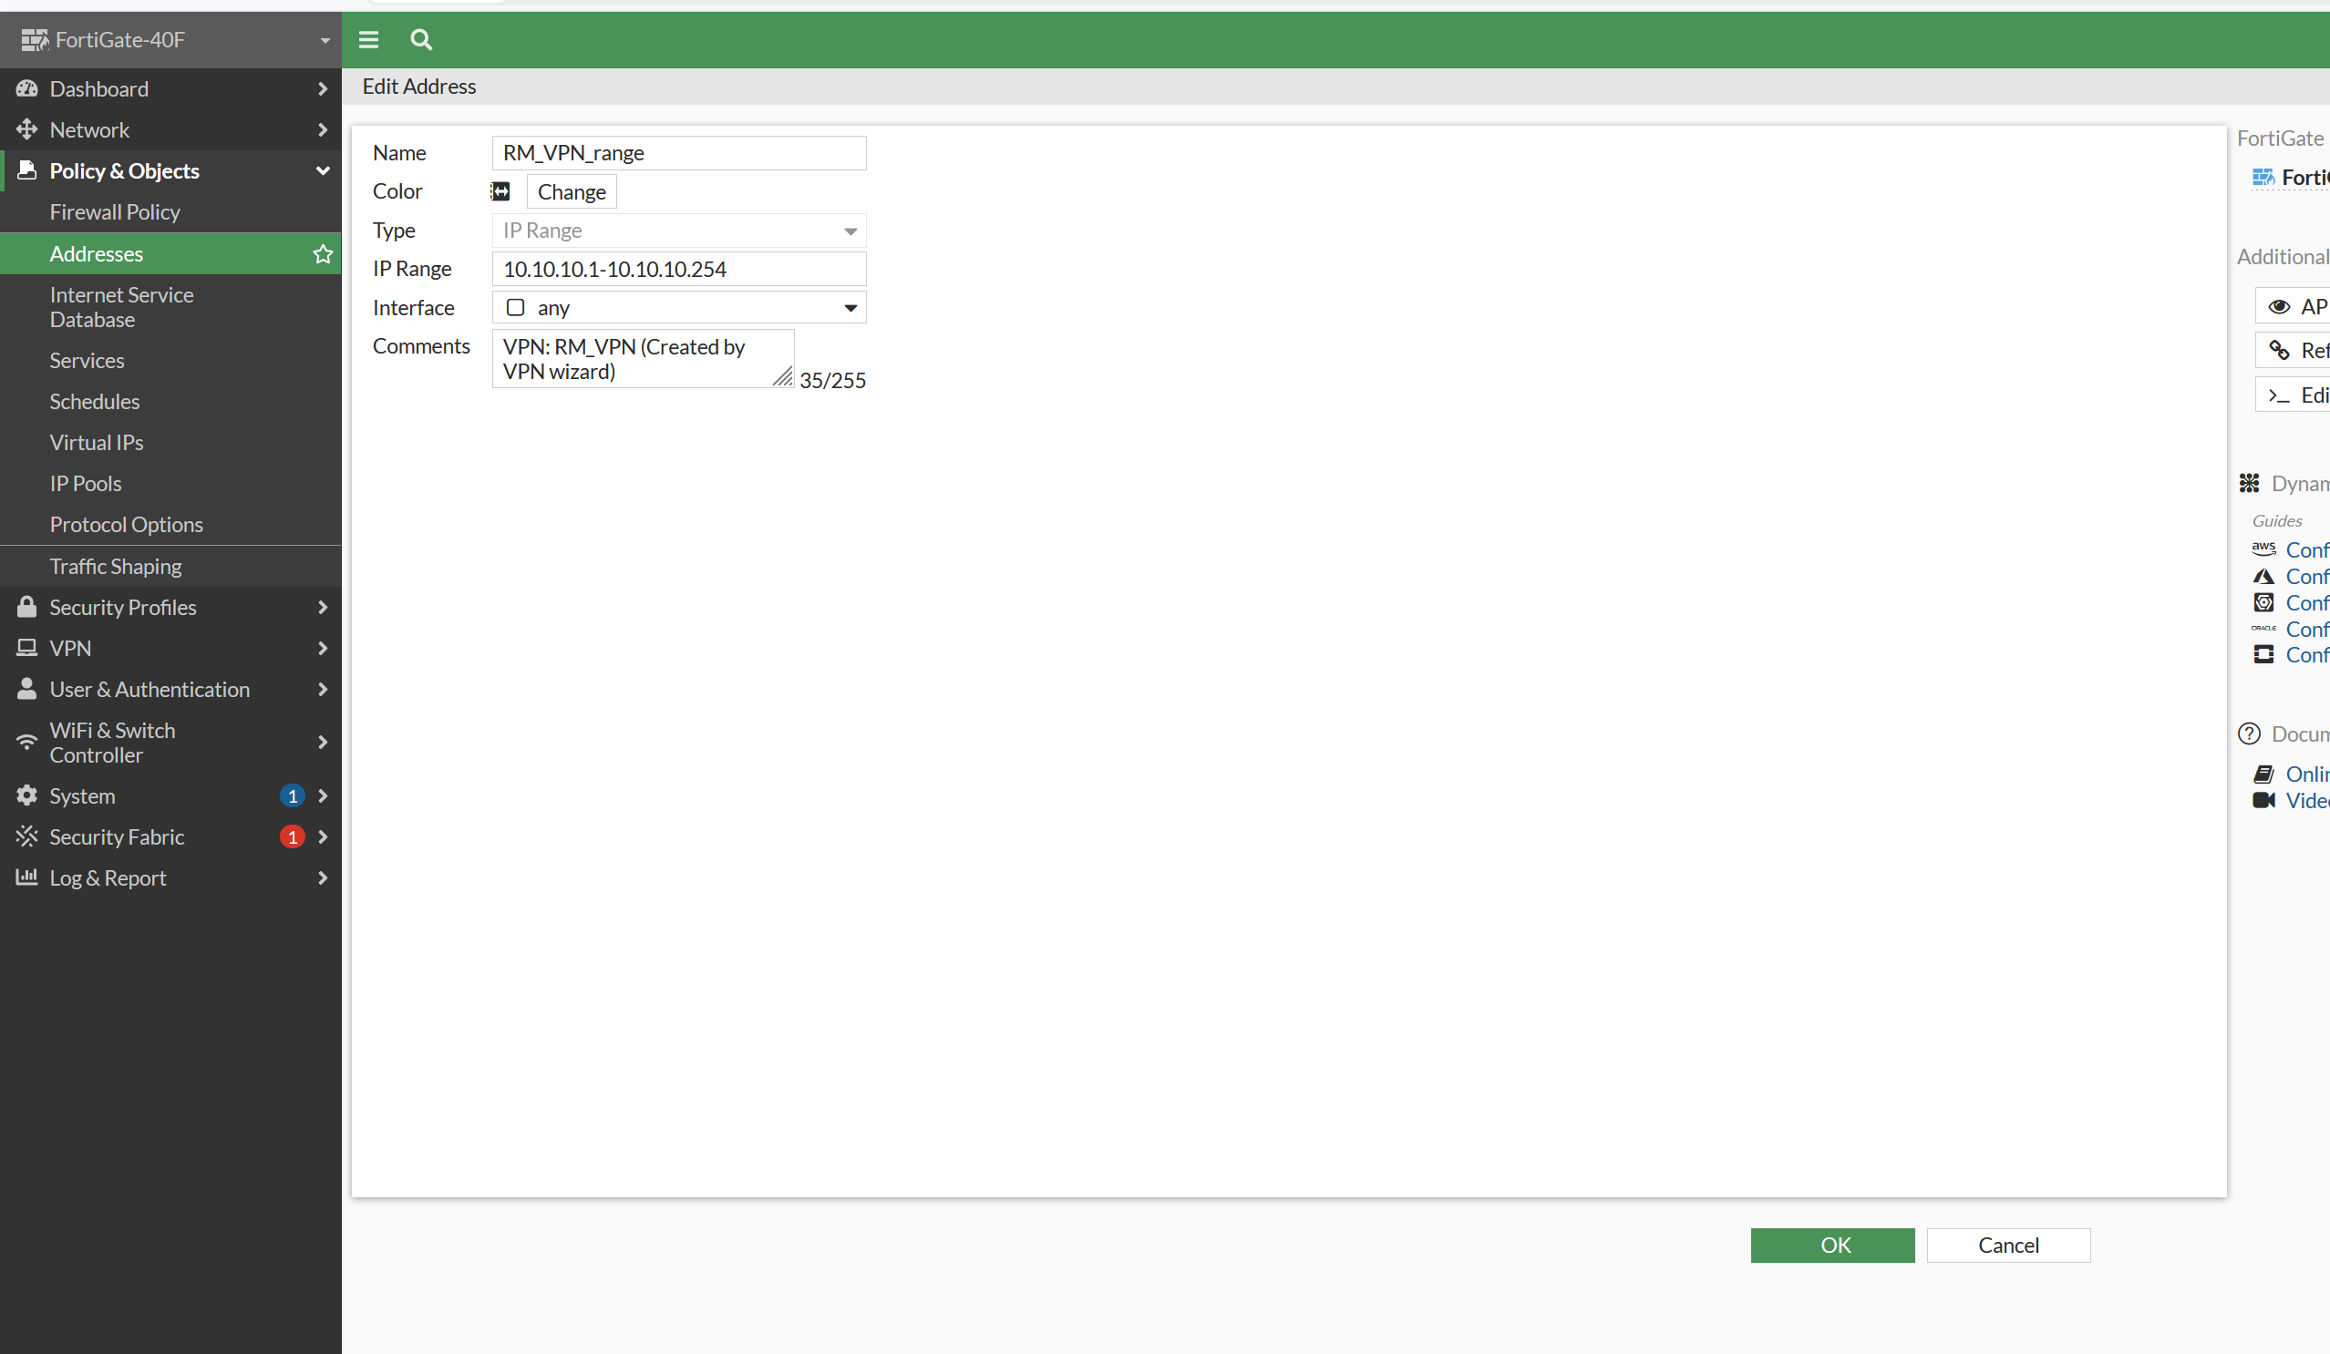
- View the address list to confirm the new range is there.
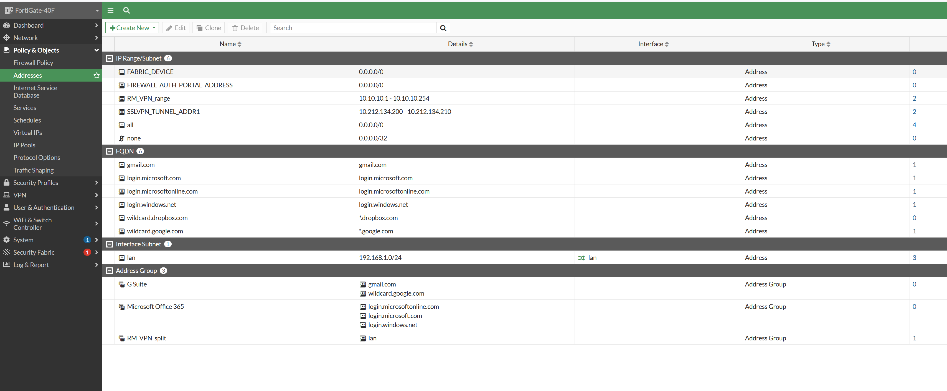
- Turn on and configure the SSL VPN. Go to VPN → SSL-VPN Settings, enable SSL-VPN, set it to listen on the wan interface using port 4433, choose the RM_VPN_range for client addresses, and map the RMVPN group to the full-access portal.
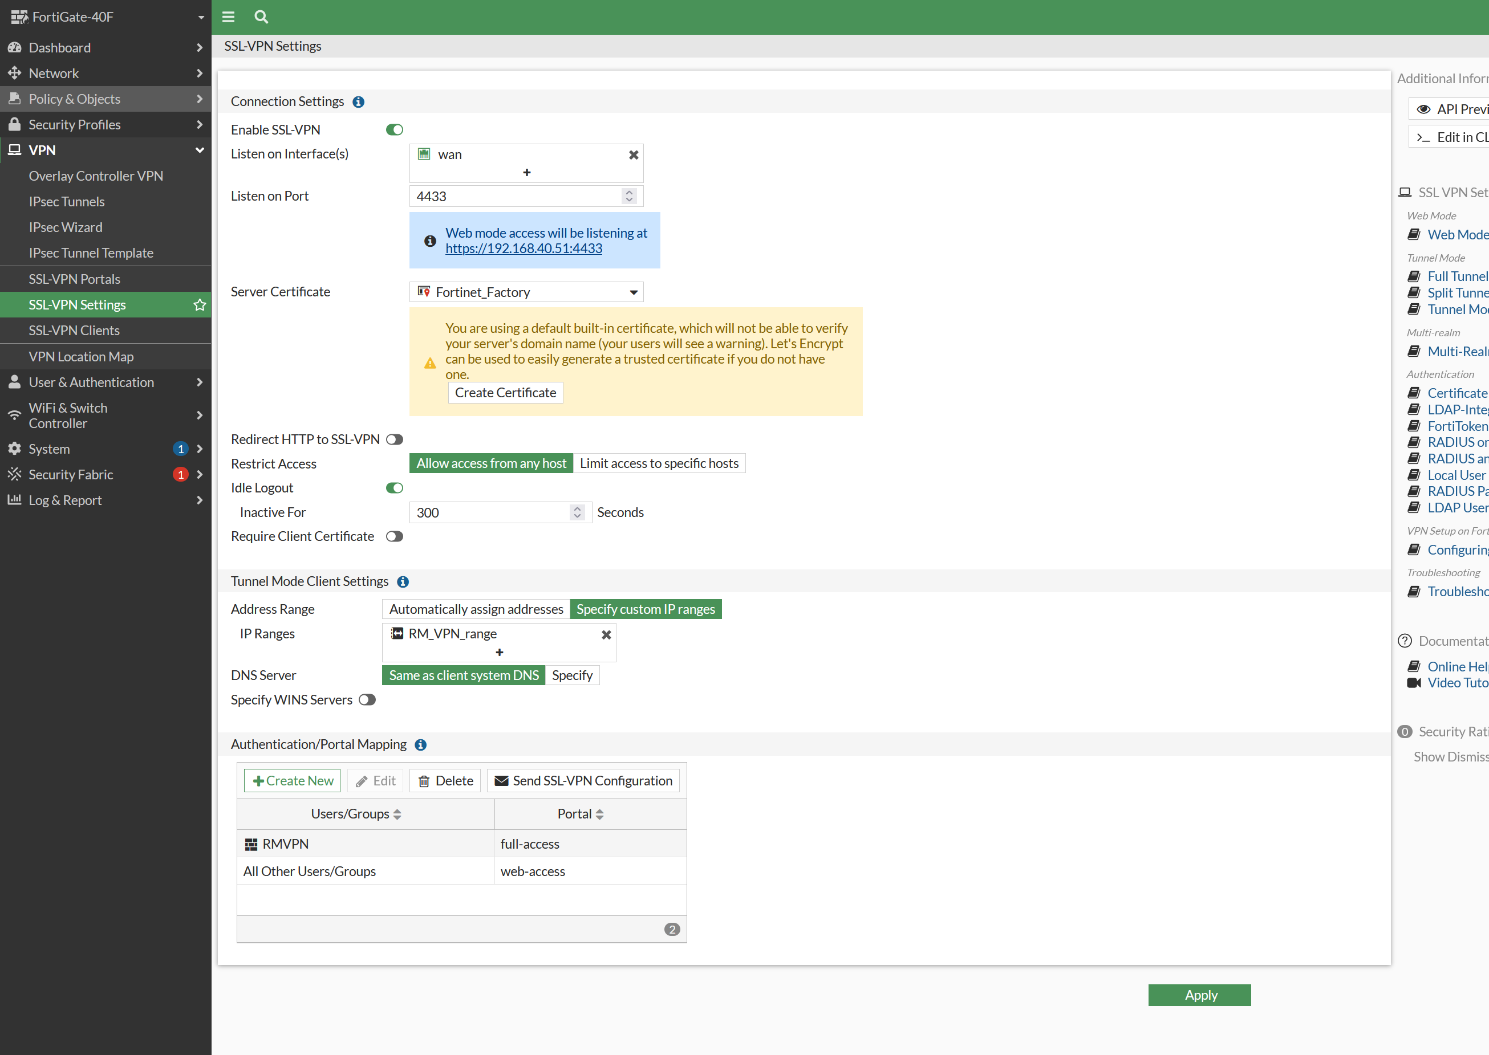
- Create a firewall policy to allow the VPN traffic. Go to Policy and Objects → Firewall Policy and make a policy from the SSL-VPN tunnel interface to the lan, allowing the RMVPN group through. Without this, the VPN connects but cannot reach anything.
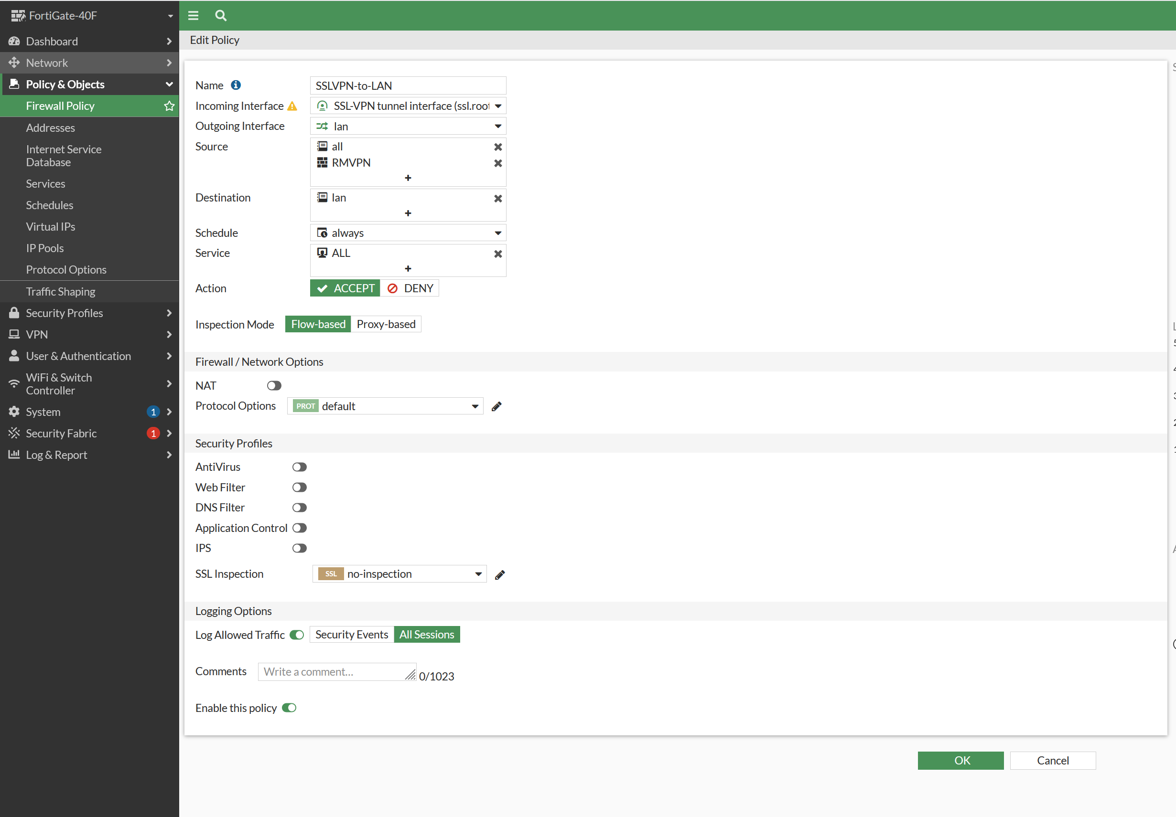
- On the remote computer, open FortiClient and set up a new SSL VPN connection. Name it RMVPN, set the Remote Gateway to the WAN address 192.168.40.51, and set the port to 4433.
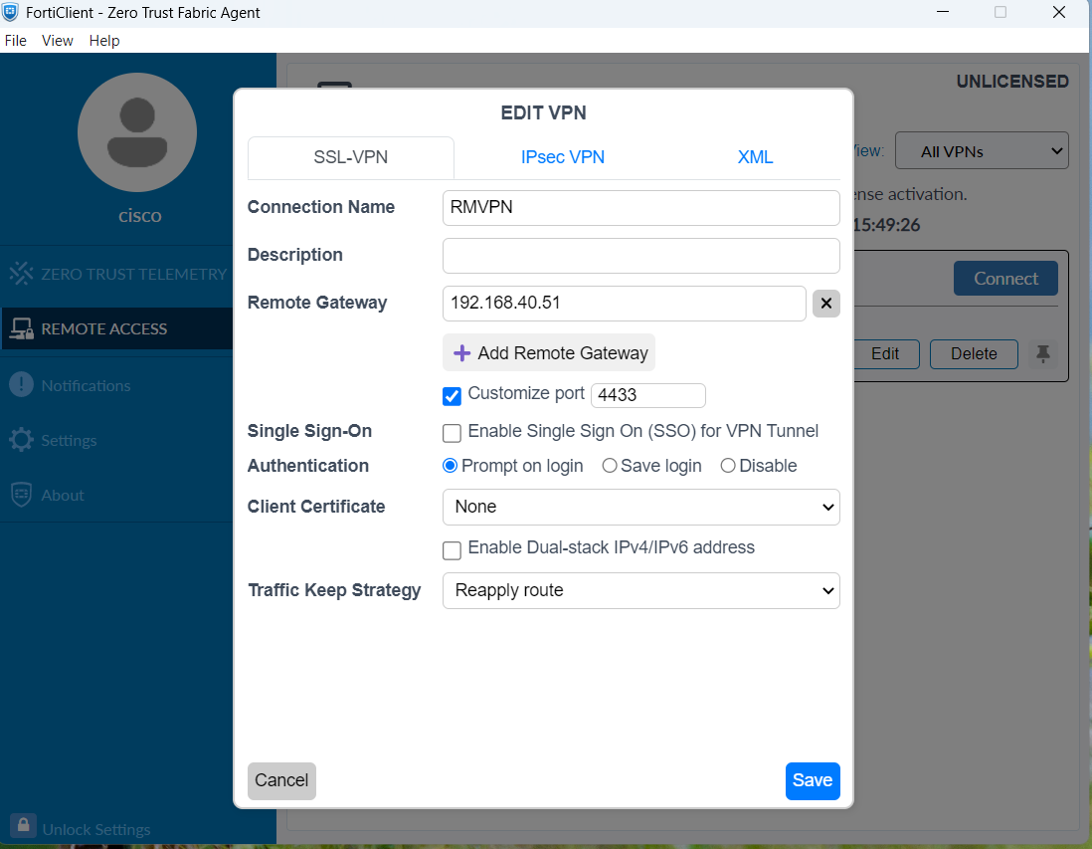
- The new RMVPN connection now shows in FortiClient, ready to connect.
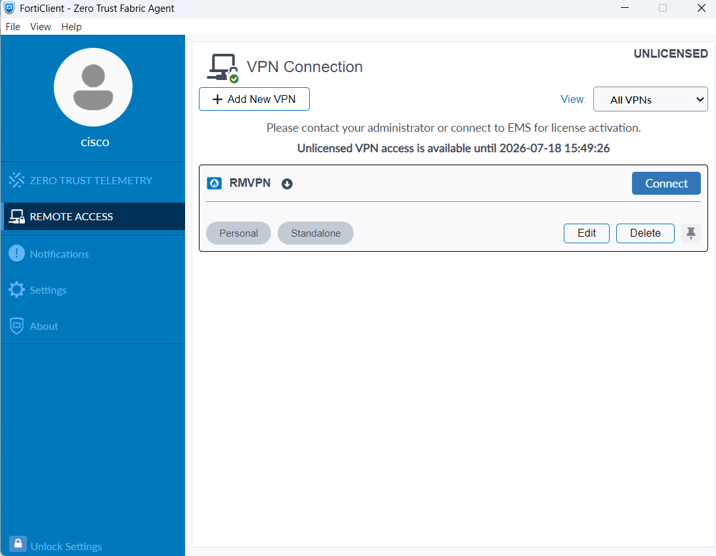
- Log in with the remote user and connect. FortiClient connects and the user is given a tunnel IP address (10.212.134.200), which means the VPN is working.
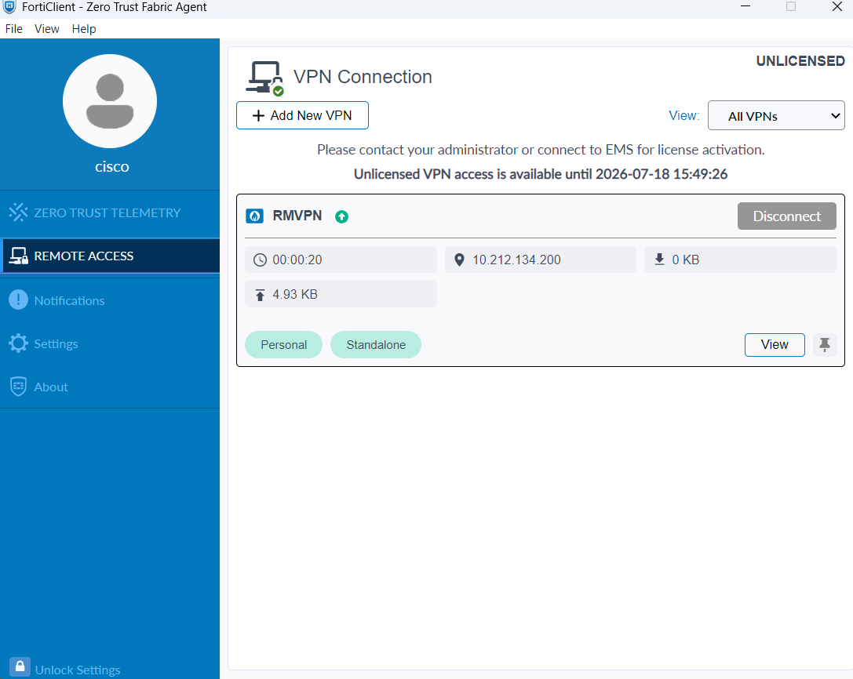
- Before testing the VPN if you go to a web page with the https URL using public ip and the port, you can check if the SSL-VPN is disfunctional or not
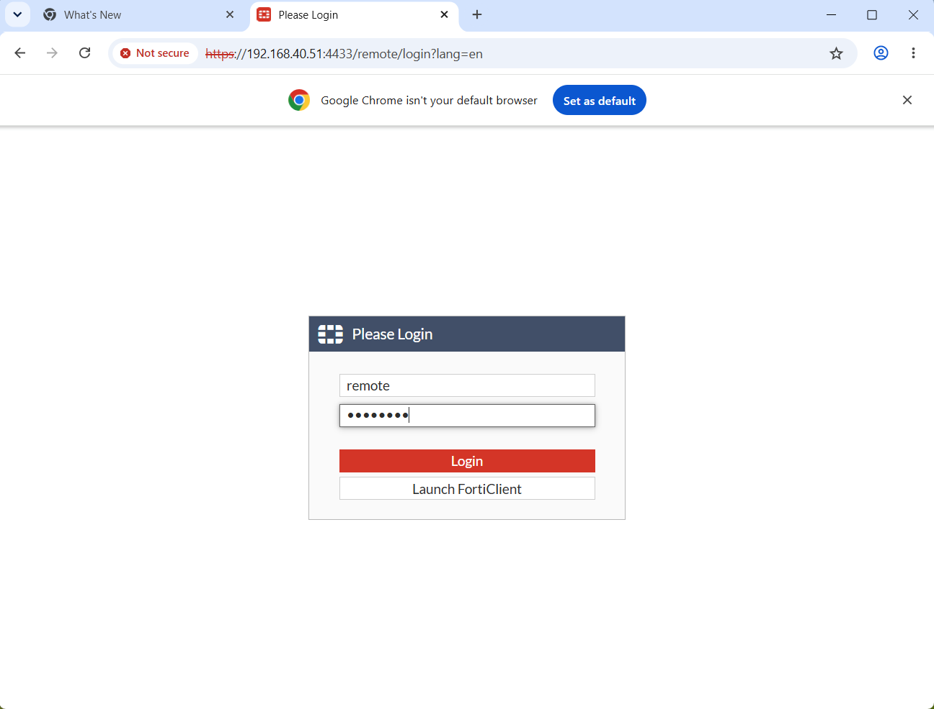

- While connected to the VPN, I opened Remote Desktop and connected to that internal machine at 192.168.1.110.
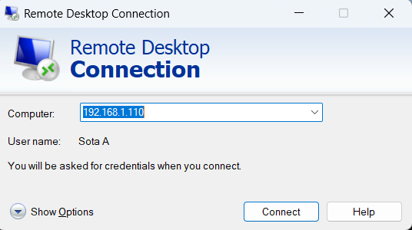
- I entered the login credentials, and the remote desktop connection succeeded, proving the VPN reached the office LAN.
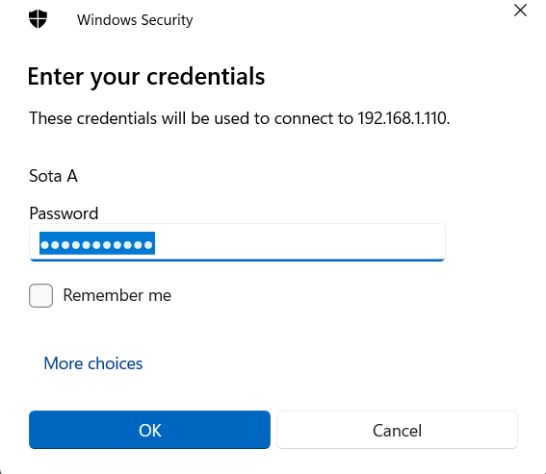
Problems:
One problem I ran into was that the VPN would connect but the remote user could not reach anything on the LAN. This happens when the firewall policy for the VPN is missing or wrong. I fixed it by creating the policy from the SSL-VPN tunnel interface to the lan and allowing the RMVPN group.
I also got logged out of the FortiGate web GUI a few times because the admin session expired while I was working. I just had to log back in with the admin account to keep going.

Conclusion:
In this lab, I successfully set up a remote access SSL VPN on the FortiGate 40F and connected to it from a remote computer using FortiClient. Overall, this lab helped me understand how a VPN lets users safely connect into a private network from the outside. I learned how to create VPN users and groups, configure SSL VPN settings, write a firewall policy to allow the traffic, and test the connection by reaching an internal machine over the tunnel.

