

Fortinet Config Lab – Wireless Access Point with RADIUS Authentication
The following is the FortiGate firewall and managed FortiAP I will be working with in this lab
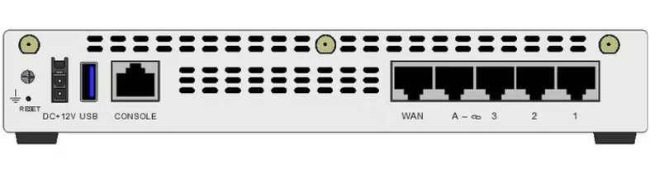
Purpose:
The purpose of this lab was to configure a wireless Access Point on a FortiGate 61E firewall and to provide secure Wi-Fi access using both WPA2-Personal and WPA2-Enterprise security. For the SSID, I configured a RADIUS server running on a Linux machine to handle the authentication, and directed the Fortigate at it as a RADIUS server. This lab helped me understand how to manage a FortiAP, RADIUS authentication, FortiAP profiles, and how wireless traffic is allowed out to the internet through firewall policies.
Background information and Lab concepts
- A FortiAP is a wireless Access Point that is managed by FortiGate through built in WiFi and switch controller. FortiGate pushes the SSID and radio settings down to the AP.
- An SSID is the wireless network name that clients see and connect to. Each SSID can have its own IP subnet, DHCP server, and security mode.
- WPA2-Personal uses a single pre-shared keyfor everyone, while WPA2-Enterprise uses a RADIUS server so each user logs in with their own username and password.
- RADIUS is the authentication protocol used by WPA2-Enterprise. In this lab the FortiGate acted as the RADIUS client and a Linux FreeRADIUS server at 192.168.10.101 acted as the RADIUS server.
- A FortiAP Profile defines how each radio behaves and which SSIDs are broadcast on Radio 1 with 2.4GHz and Radio 2 with 5GHz.
Lab Summary:
In this lab, I first set up the RADIUS server on the Linux side by adding the FortiGate as a RADIUS client. On the FortiGate, I configured the FortiAP, added the Linux RADIUS server under User and Device, and created the wireless SSIDs. I built one WPA2-Enterprise SSID that authenticates against the RADIUS server and WPA2-Personal SSIDs that uses a pre-shared key. Then i grouped the SSIDs, assigned them to the FortiAP profile, authorized the FortiAP, and then finally created firewall policies so each SSID could reach the internet through the wan1 interface.
Lab Commands:
- First on the Linux RADIUS server, edit the clients configuration file to add the FortiGate as an allowed RADIUS client. In this case i ran sudo nano /etc/freeradius/3.0/clients.conf. I also added its IP address and secret as Cisco123
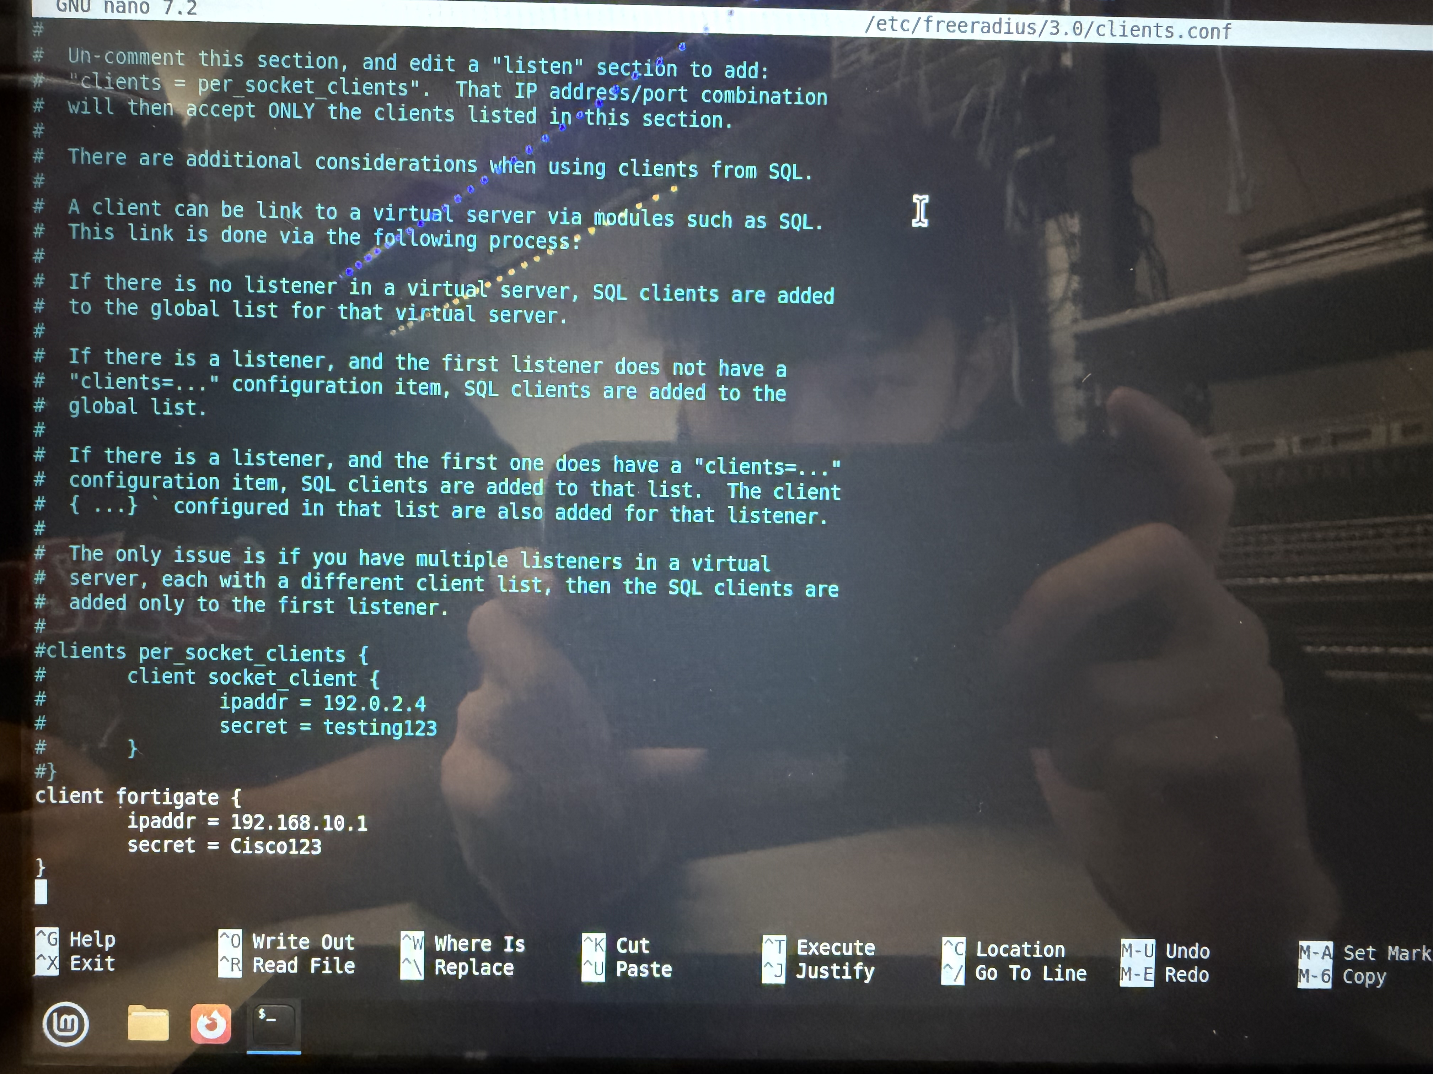
- Then you edit the FreeRADIUS users file to create a account that the SSID will authenticate. In this case i ran sudo nano /etc/freeradius/3.0/users and added the user students with a Cleartext-Password of blizzy.
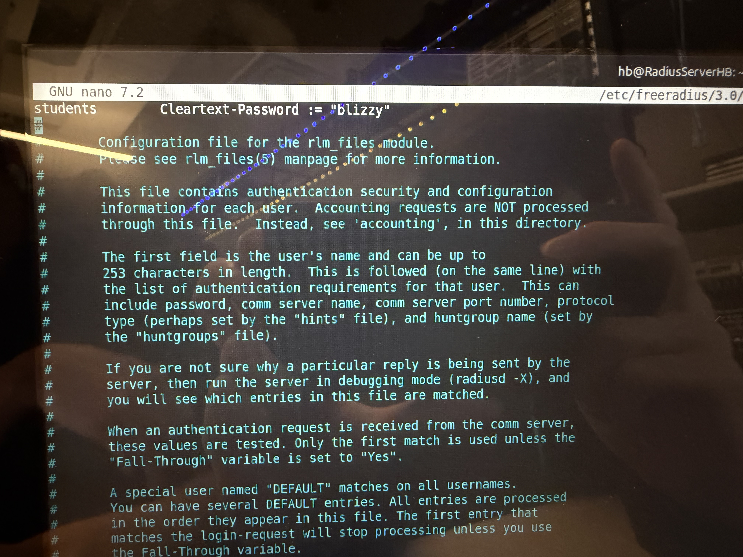
- Restart and verify the FreeRADIUS service so the new client and user take effect. I ran sudo systemctl status freeradius and confirmed the service was active and processing requests.
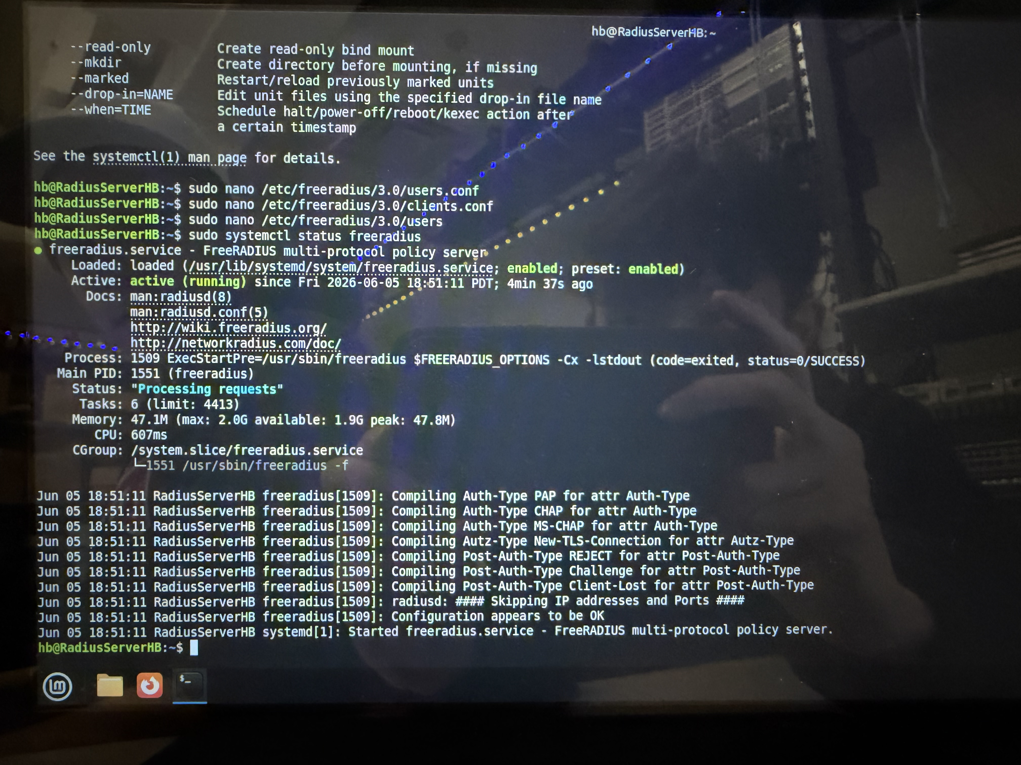
- On the FortiGate, open web GUI and configure the interface that the FortiAP plugs into. Go to Network -> Interfaces -> internal7 and give it the alias WAPconnector, set the role to LAN, give it an IP like 192.168.20.1/24, and also enable a DHCP server so the AP can obtain and IP.
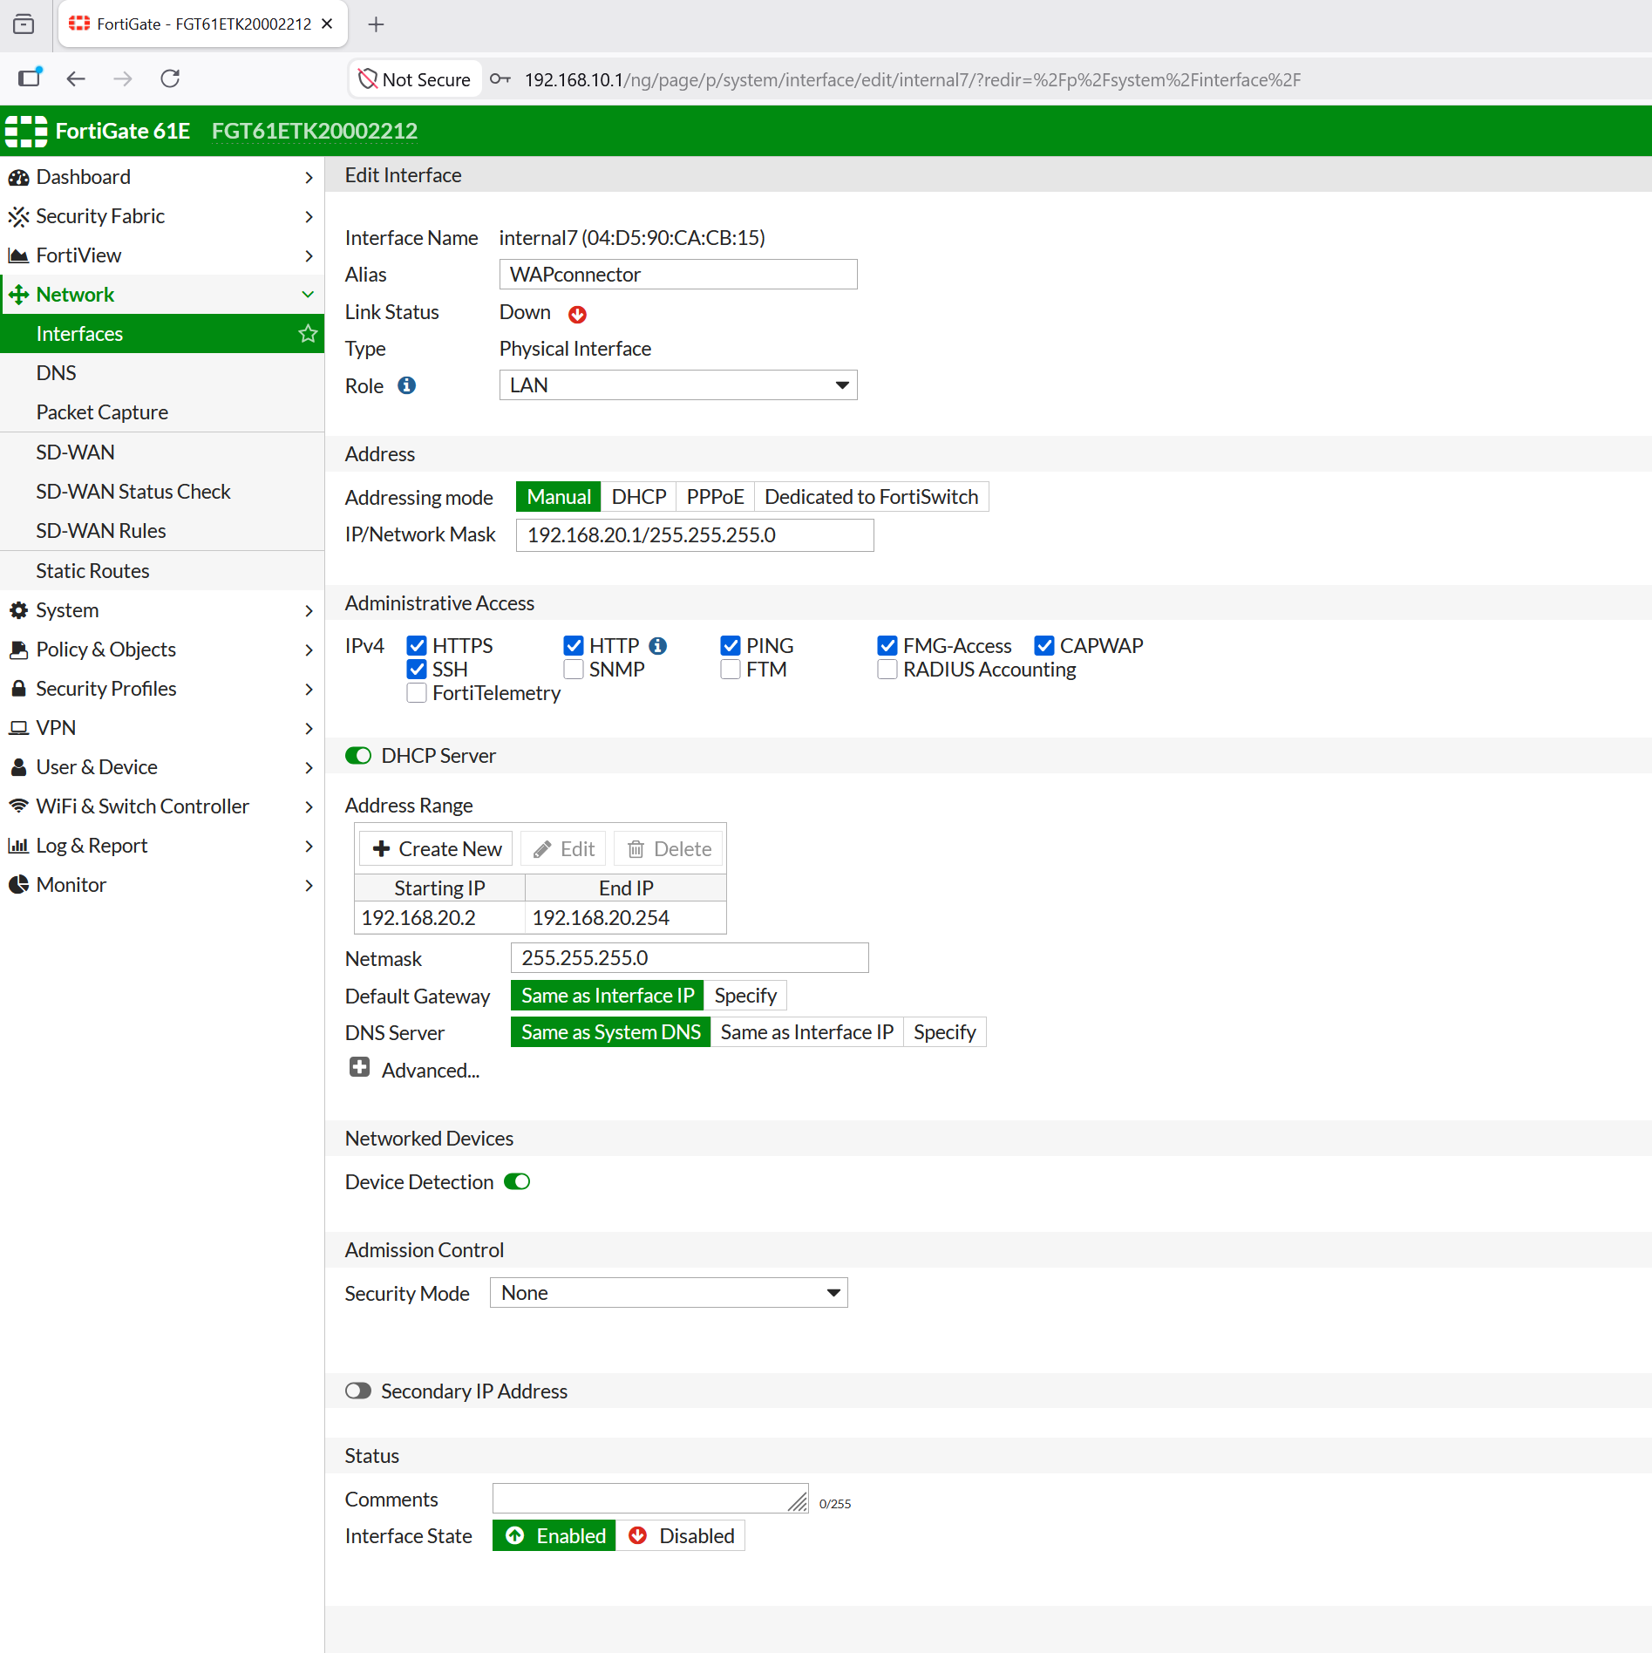
- Add the Linux RADIUS server to the FortiGate. Go to User & Device -> RADIUS Servers -> Create New, name it, set the Primary Server IP to 192.168.10.101, and enter the same shared secret that was configured in clients.conf. The secret must match on both sides or authentication will fail.
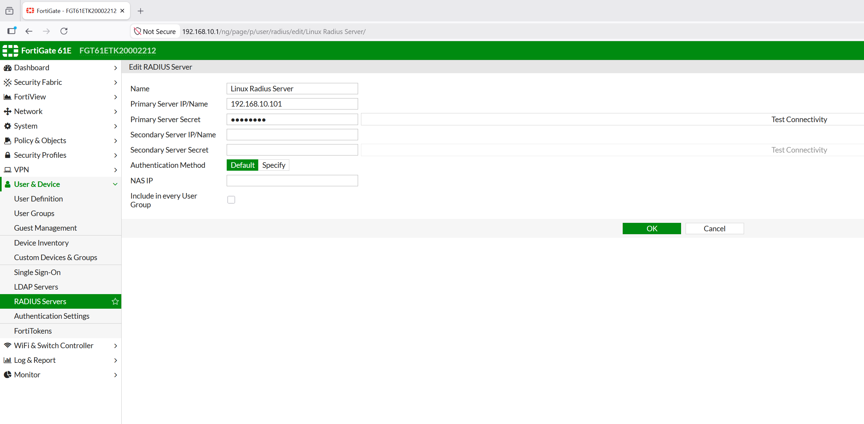
- Create the WPA2-Enterprise SSID. Go to WiFi and Switch Controller -> SSID -> Create New, set the SSID name, give it the IP 10.0.2.1/24 with a DHCP server, set Security Mode to WPA2 Enterprise, and under Authentication choose RADIUS Server and select the Linux Radius Server.
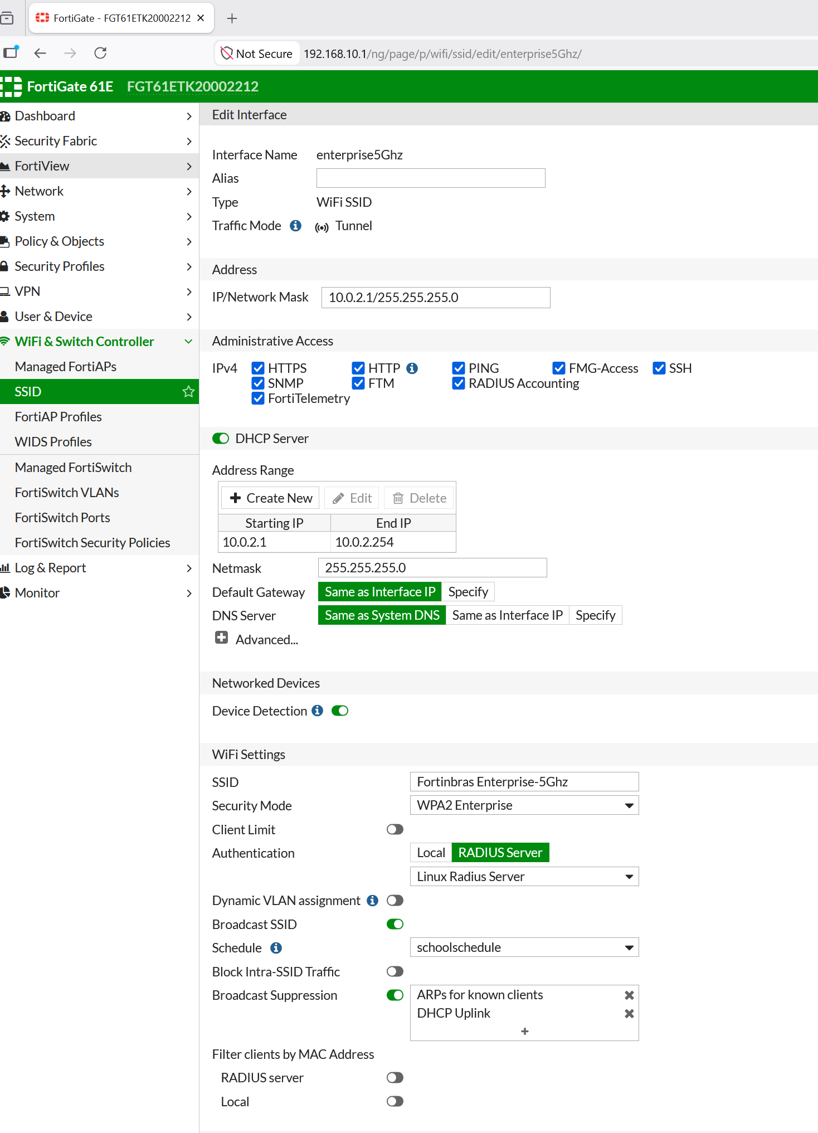
- Create the WPA2-Personal SSID. Create another SSID named Fortinbras-5.0Ghz with the IP 10.0.0.1/24, a DHCP server, Security Mode set to WPA2 Personal, and a Pre-shared Key. I also set a client limit of 3 on this SSID.
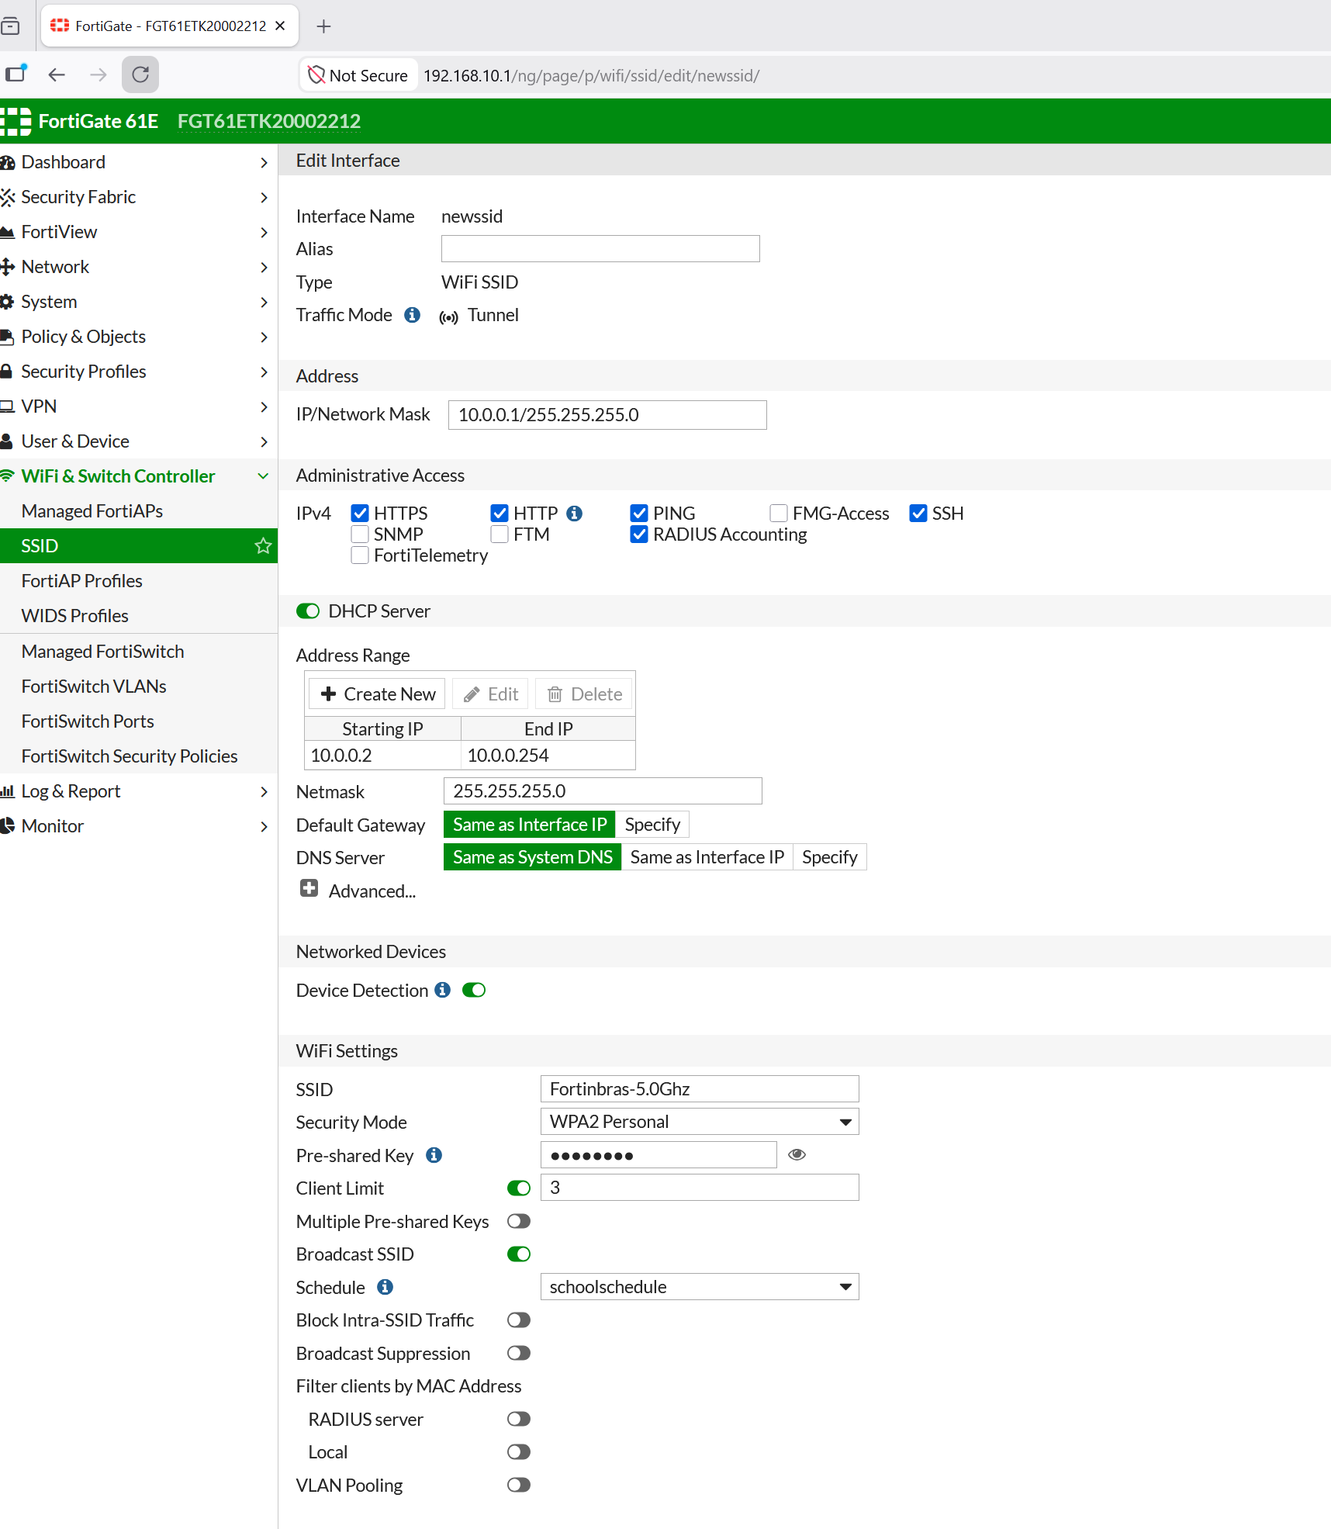
- Next we confirm the SSIDs were created. The SSID list shows the three SSIDs along with their traffic mode (Tunnel) and security mode.
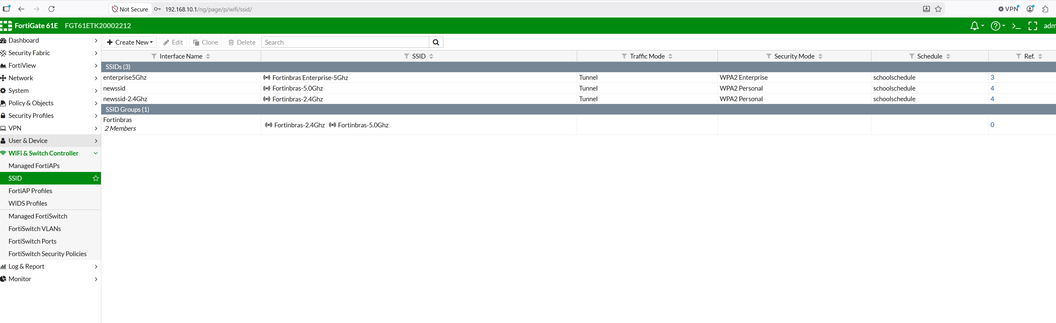
- Group the personal SSIDs together so they can be assigned and referenced as one object. Go to SSID -> Create New -> SSID Group, name it Fortinbras, and add the 2.4Ghz and 5.0Ghz members.
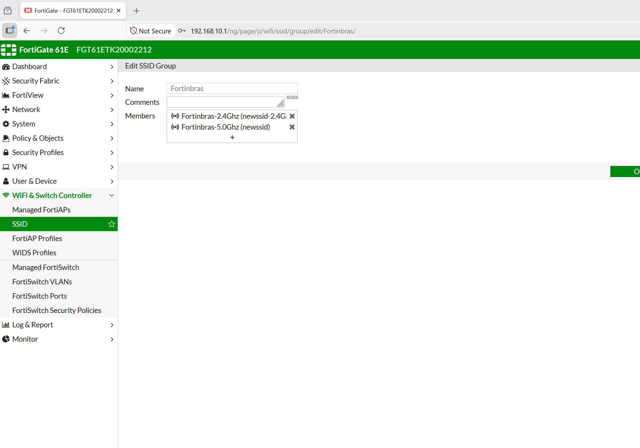
- Configure the FortiAP profile and assign the SSIDs to the radios. Go to WiFi & Switch Controller -> FortiAP Profiles. Set Radio 1 to 2.4GHz and assign the Fortinbras-2.4Ghz SSID, then set Radio 2 to 5GHz and assign the Enterprise-5Ghz and Fortinbras-5.0Ghz SSIDs.
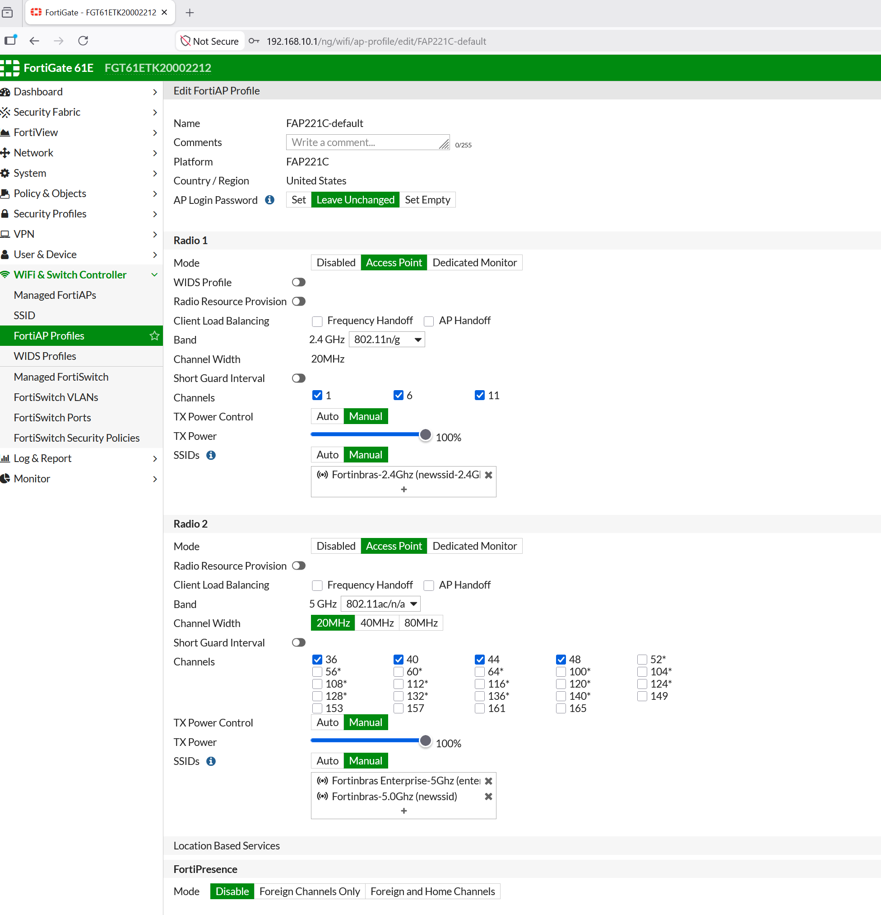

- Next we need to Create firewall policies so each SSID can reach the internet. Go to Policy and Objects -> IPv4 Policy and create a policy from each SSID interface to wan1, allowing all sources/destinations and ALL services, with NAT enabled.
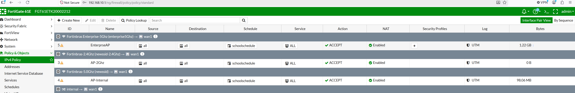
For context, this lab was built on top of the initial SOHO configuration with the internal LAN interface and the wan1 interface were already set up. Along with the base internal -> wan1 policy that provides internet access.

Problems:
One problem I encountered was that clients connecting to the SSID were rejected even though the username and password were correct. This was because the shared secret on the FortiGate RADIUS server did not match the secret in the Linux server. Once I made both secrets the same using Cisco123, the authentication worked fine.
Another problem was that wireless clients could associate to an SSID and get an IP address but they weren’t able to access the internet. To solve this I had to create a separate internal to wan1 policy for each SSID interface with NAT enabled before it worked
Conclusion:
In this lab, I successfully configured a FortiAP managed by a FortiGate 61E and configured both WPA2-Personal and WPA2-Enterprise wireless access. Overall, this lab helped me understand how a FortiGate controls a wireless Access Point, how SSIDs and security modes are configured, and how WPA2-Enterprise uses a RADIUS server so each user authenticates with their own credentials. I also learned how to tie a Linux FreeRADIUS server to the FortiGate and how firewall policies allow wireless traffic out to the internet.

