

Palo Alto Beginner Lab – Accessing the Web GUI.
The following is the Firewall I will be working with on this lab.
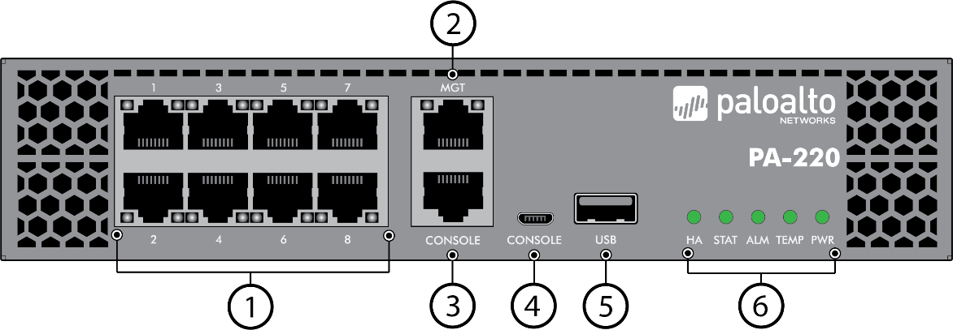
Purpose:
The purpose of this lab was to demonstrate how to return a Palo Alto PA-220 firewall to its factory default state and establish management access of it through the Web GUI. This procedure is a foundational skill required for network engineers, ensuring that the device can be securely reset, and properly managed before deployment. This lab will also reinforce skills in console access, factory reset, and initial web GUI configuration.

Background information on Lab Concepts:
- Factory Reset – Clears all previous configurations and log data, restoring the device to a clean, vendor supplied state
- Maintenance mode – Special boot mode providing recovery tools such as factory reset, system info, and disk checks
- Console access – Serial terminal connection to interact with the device during the boot and maintenance.
- Management interface – A dedicated interface used for administration
- Web Gui – Browser based interface providing visual access to the system dashboards, configuration menus, and monitoring tools

Lab Summary:
I connected to the Palo Alto PA-220 via console through putty to initiate factory reset. After boot, I entered the PAN-OS bootloader then the maintenance mode. From there I selected the Factory Reset option, confirmed and waited for the progress until success. Once the reset was completed, I rebooted the device, changed the default user and password, and accessed the web GUI at “https://192.168.1.1”. I confirmed access by successfully logging in and reviewing the web page.

Lab Commands and procedures:

- Upon booting, the firewall presents a PAN-OS Boot loader screen

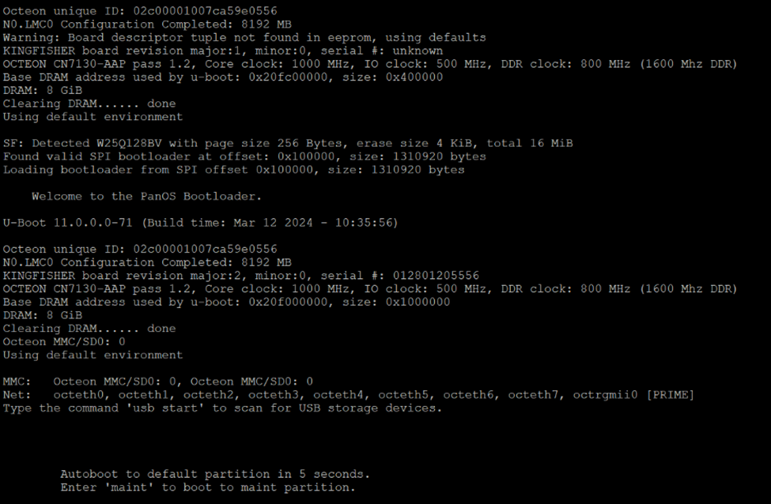
- The device entered Maintenance Recovery Tool mode, offering options such as the Factory Reset procedure used in this lab.

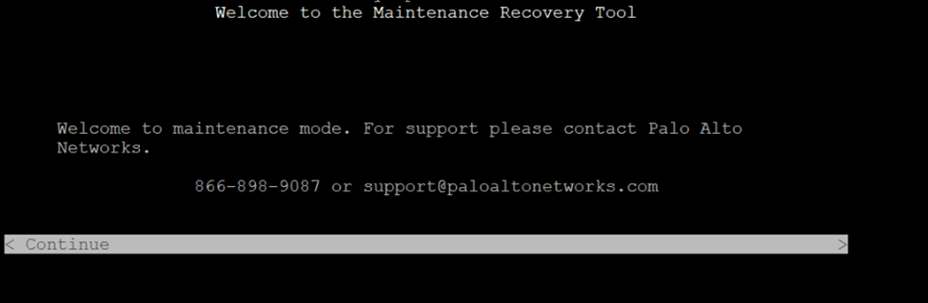

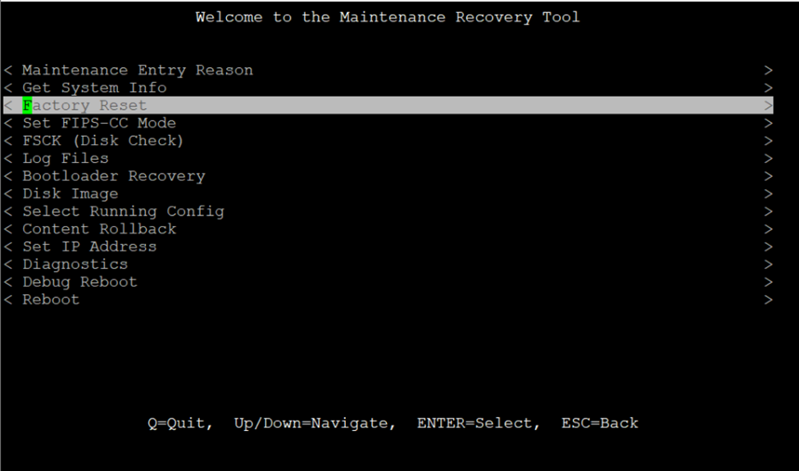

- I selected Factor Reset, and confirmed the reset

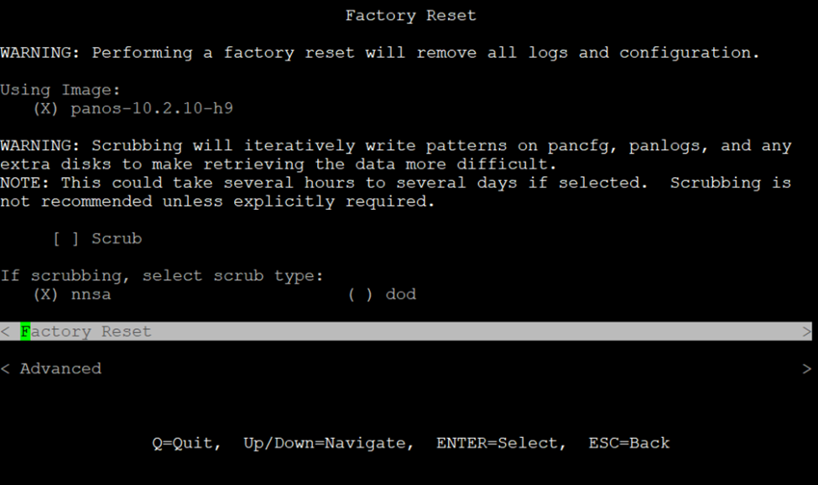

- The Reset showed a progress bar.

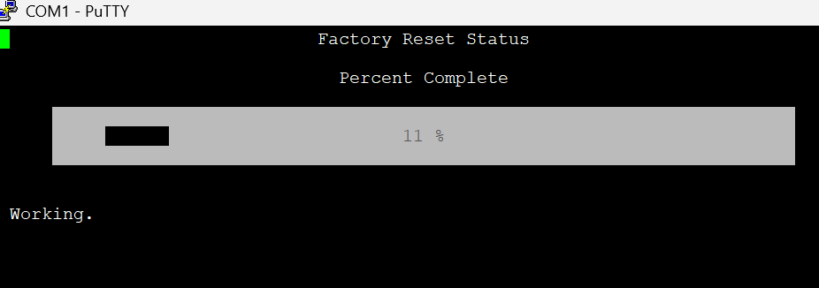

Upon Completion, Factory Reset Status: Success was displayed

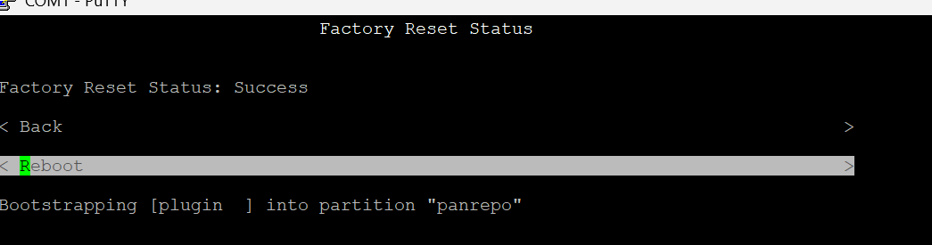

- After reboot, I logged in via console with admin/admin. The device then forced a change in password, which I then changed to admin/Cisco123

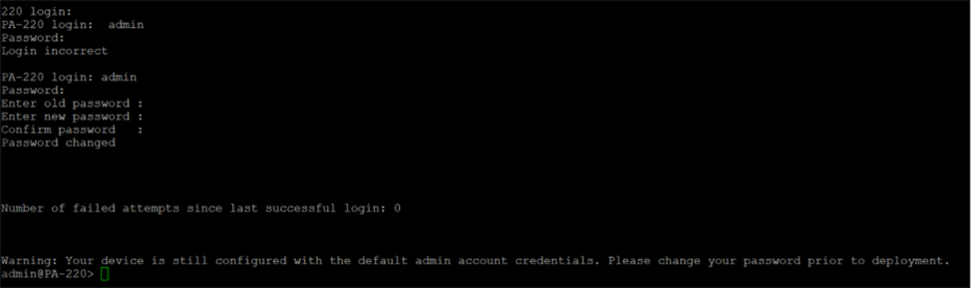

- I turned the Wi-fi of my workstation off and navigated into Microsoft Edge, entering the web link https://192.168.1.1, and reached the Palo Alto login page.

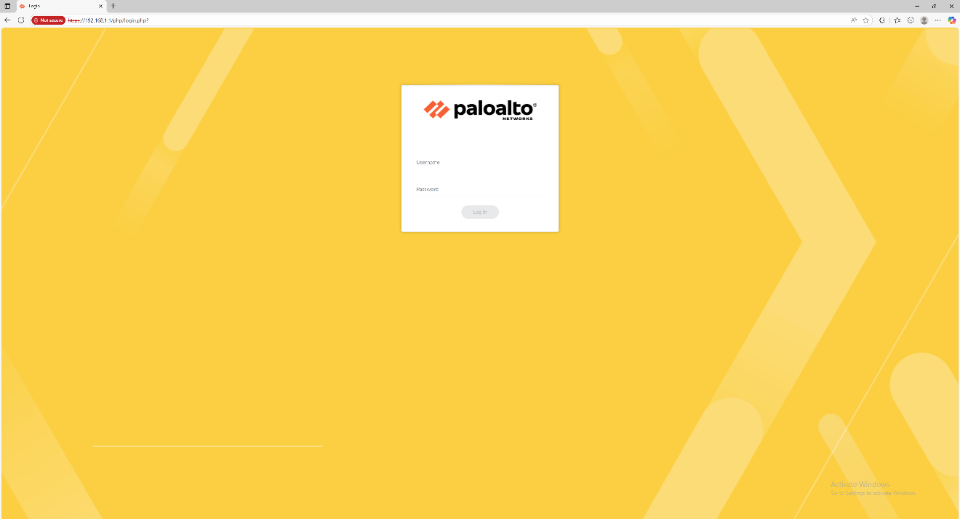

After login, I confirmed access to the main dashboard of the firewall Web GUI.

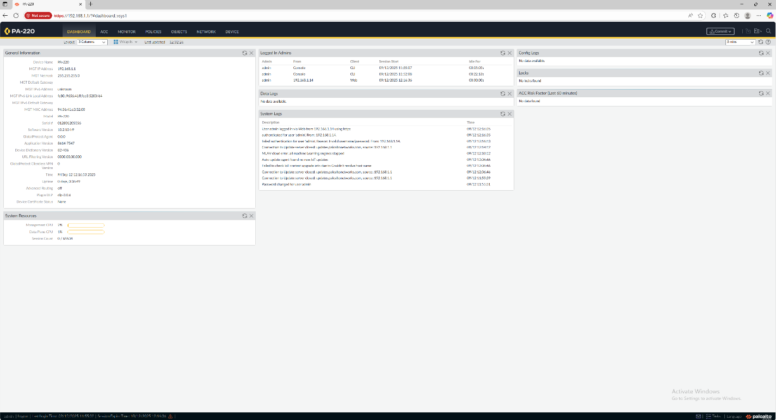
Net Diagrams with Ips:
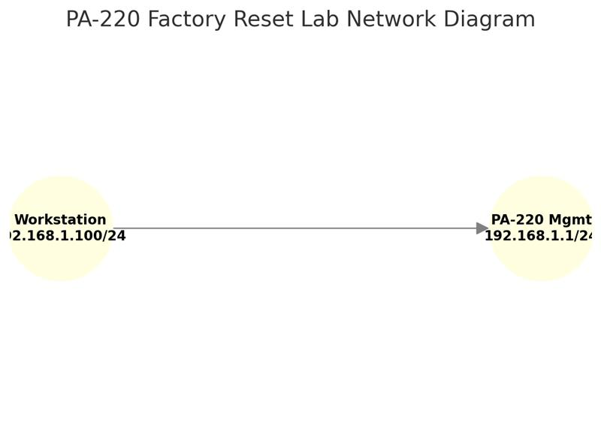
Configurations:
- PA-220 Management IP: 192.168.1.1
- Login: admin/admin -> changed during Factory Reset.
- PAN-OS version: Displayed in the system info screen from the ss provided.

Problems:
- During this lab, we ran into many firewalls that were unable to go through factory resetting due to the boot loop constantly occurring
Resolution: Get a new firewall that was not in a boot loop
- When we tried to access the Web GUI it failed to direct us to the Palo-Alto Login page
Resolution: We were entering http://192.168.1.1 instead of the required https://192.168.1.1.

Conclusion:
In this lab, I successfully reset the Palo Alto PA-220 to factory default setting and established console access. I learned how to use maintenance mode for recovery and preformed the initials login security steps. I also confirmed the web GUI access and the system info after reset.

