

Palo Alto Config Lab – Setting up a SOHO network
The following is the firewall I will be working with on this lab
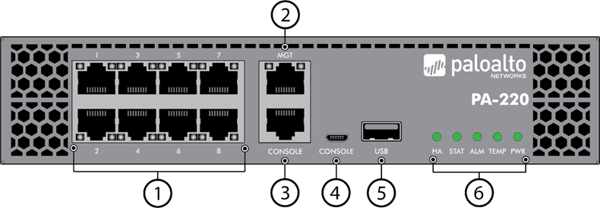
Purpose:
The goal of this lab is to configure a Palo Alto PA-220 firewall for a small-office/home-office (SOHO) network. It involves creating security zones, VLANs, and interface configurations so that the firewall can separate trust and untrust networks. And also provide DHCP services to the internal network and obtain an address from the ip provider. The completed configuration should deliver Internet connectivity to internal clients through secure zones and NAT, and enable simple management through the web interface

Background information on lab concepts:
- The Palo Alto PA-220 is an enterprise-grade firewall suitable for SOHO environments.
- It supports Layer 2 and Layer 3 interfaces, VLANs, and DHCP services, making it versatile for both routing and switching tasks.
- In this lab, the device was used to create two main security zones:
    - Trust: for the internal LAN (private, secure network).
    - Untrust: for the external WAN (Internet connection).
- VLANs (Virtual Local Area Networks) enable multiple Layer 2 networks to operate over a single physical interface, improving segmentation and efficiency.
- VLAN Interfaces act as Layer 3 gateways for VLANs, allowing routing between internal subnets.
- DHCP services dynamically assign IP addresses to internal clients, simplifying device connectivity and network management.

Lab summary:
I reset the Palo Alto PA-220 to factory defaults and logged into the web interface using the default IP 192.168.1.1 and the admin credentials. From there, I created the three zones Trust-L2, Trust-L3, and Untrust-L3, and then assigned the proper layers. I then made a VLAN object, named vlan.10 and assigned it to ethernet1/2 in the Trust-L2 zone, giving it the IP 192.168.1.254/24 as the internal gateway. Ethernet1/1 was configured as a Layer 3 interface and set to obtain an IP from the ISP via DHCP. I enabled a DHCP server on vlan.10 with a pool from 192.168.1.2–192.168.1.252 for internal clients. After committing the configuration, a connected PC received an IP automatically and successfully accessed the Internet, confirming the SOHO setup worked correctly.

Lab commands and procedures

    - create a VLAN object and named it Vlan Object
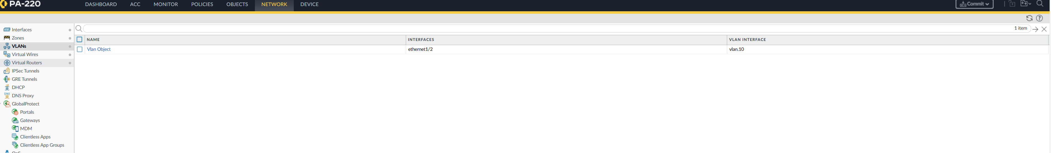

    - VLANs page with VLAN object listed
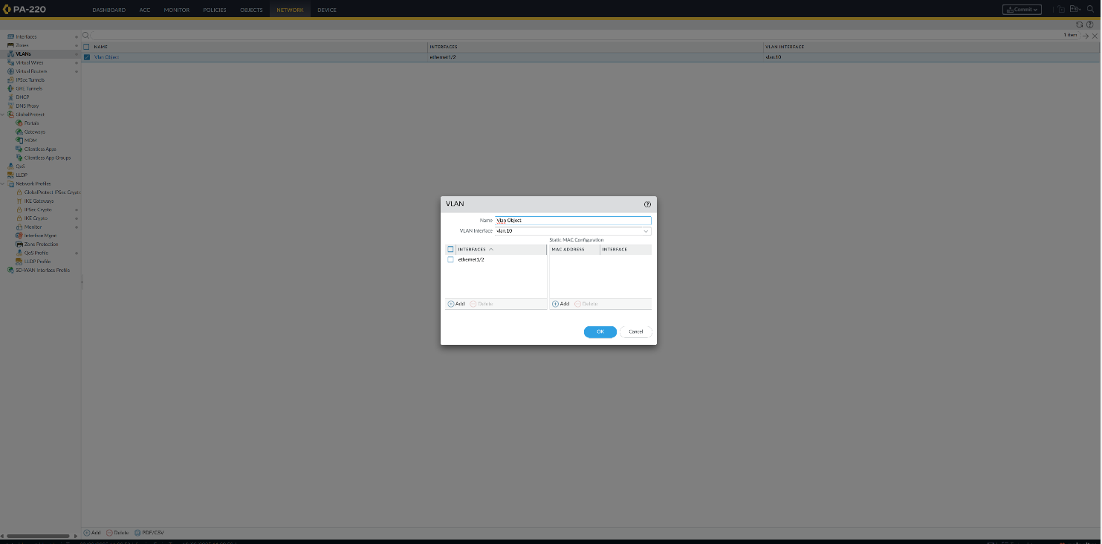

    - Config for the Untrust-L3 Zone
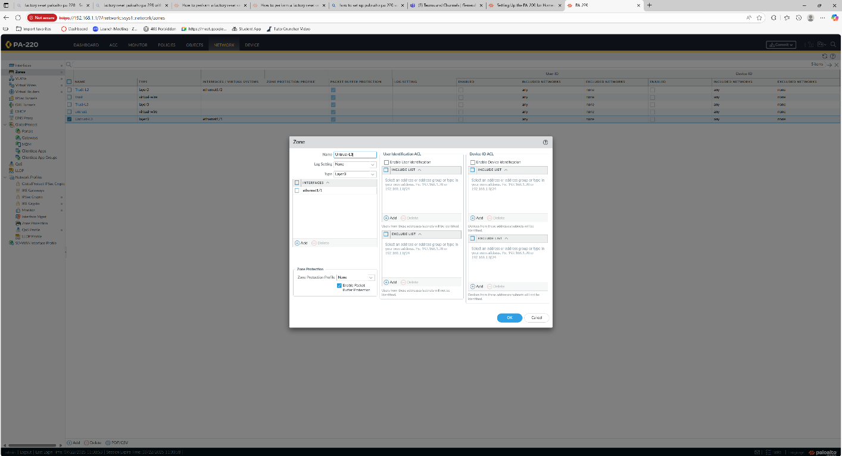

    - Config for the Trust-L3 Zone
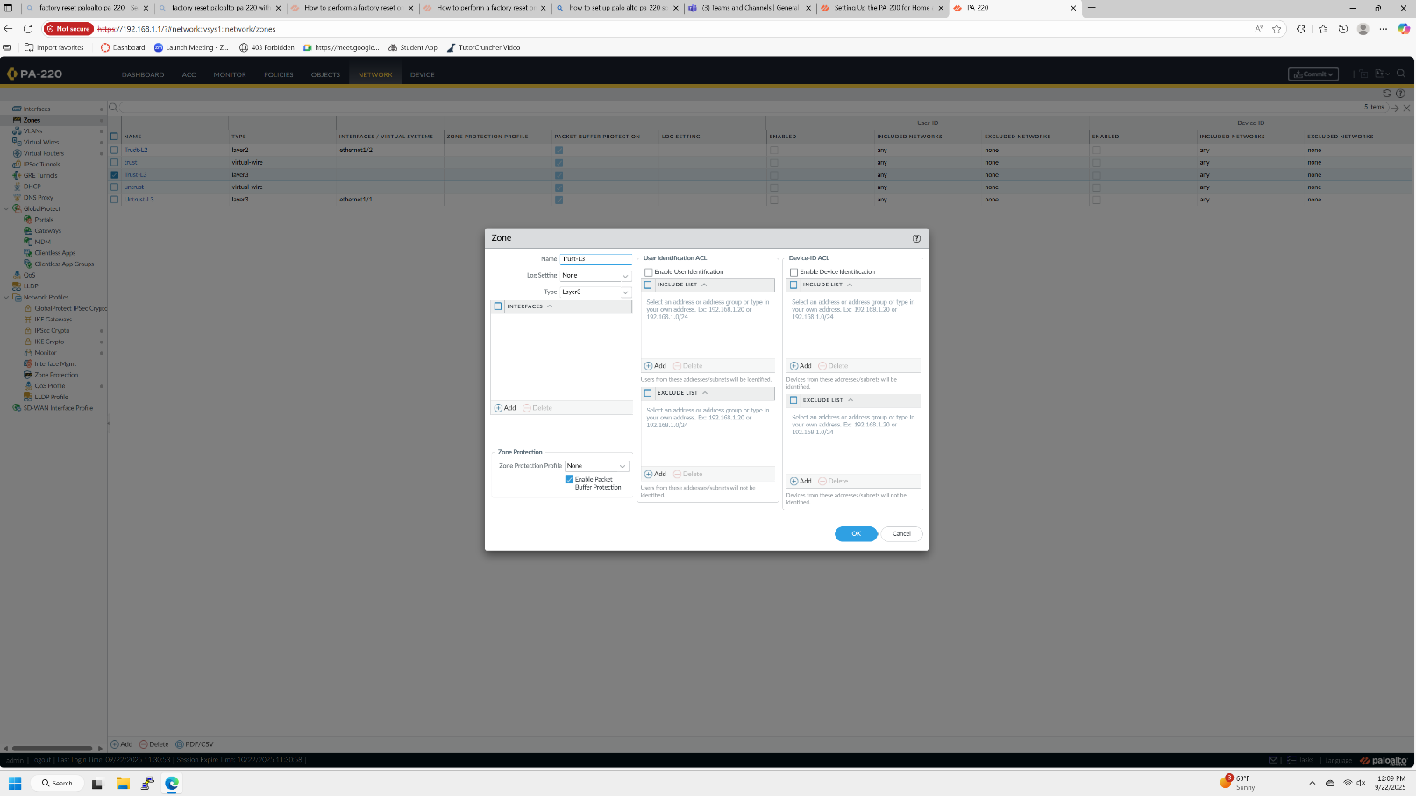
    - Config for the Trust-L2 zone
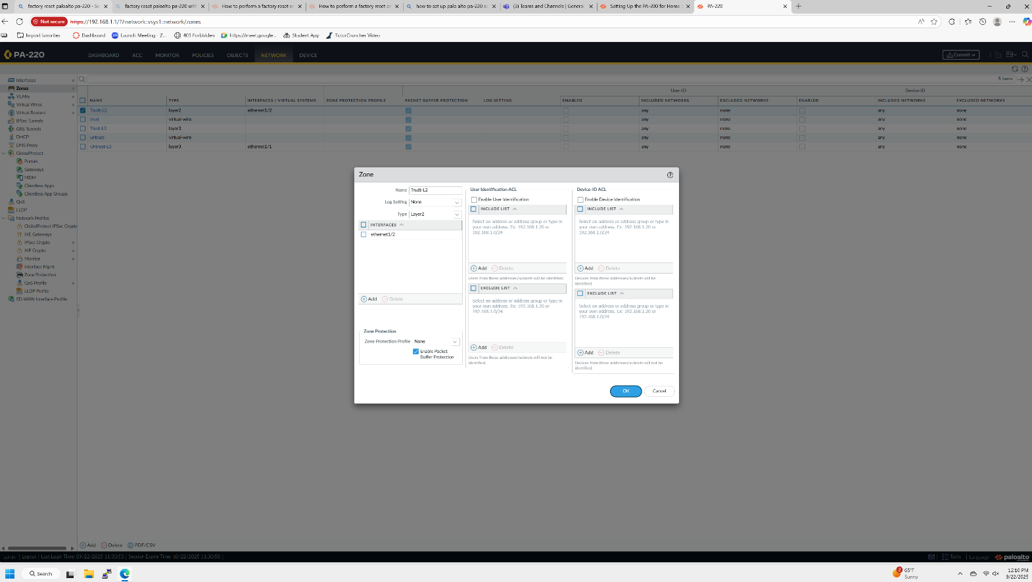
    - Configure ethernet 1/1 with the zones and default VR(virtual router)
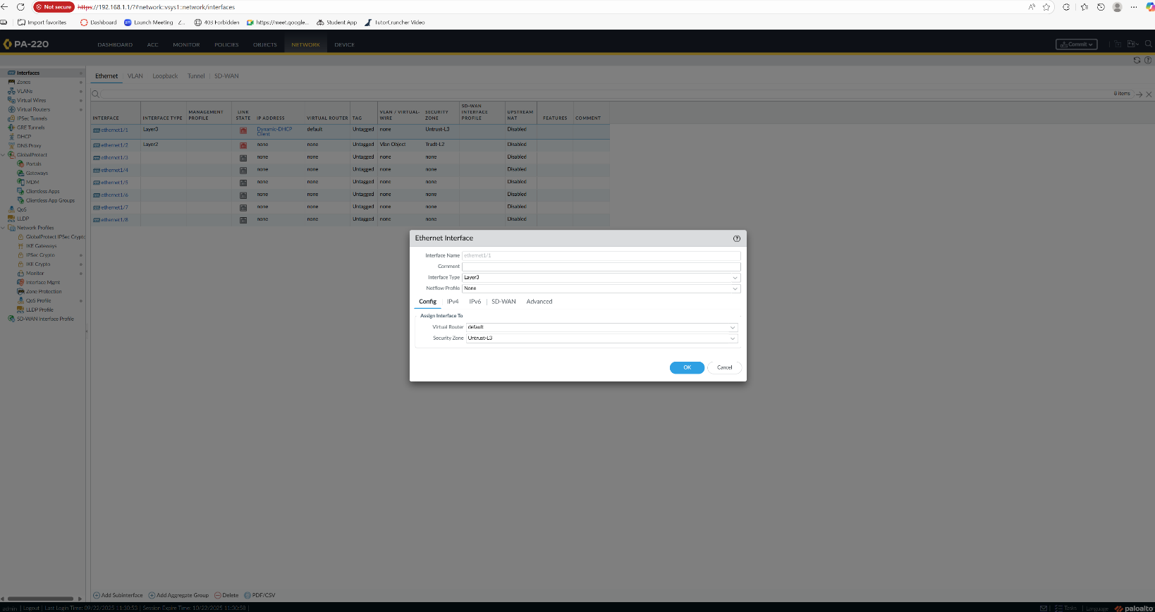
    - Make it so that the interface ethernet1/1 receives its IP from the ISP provider through DHCP
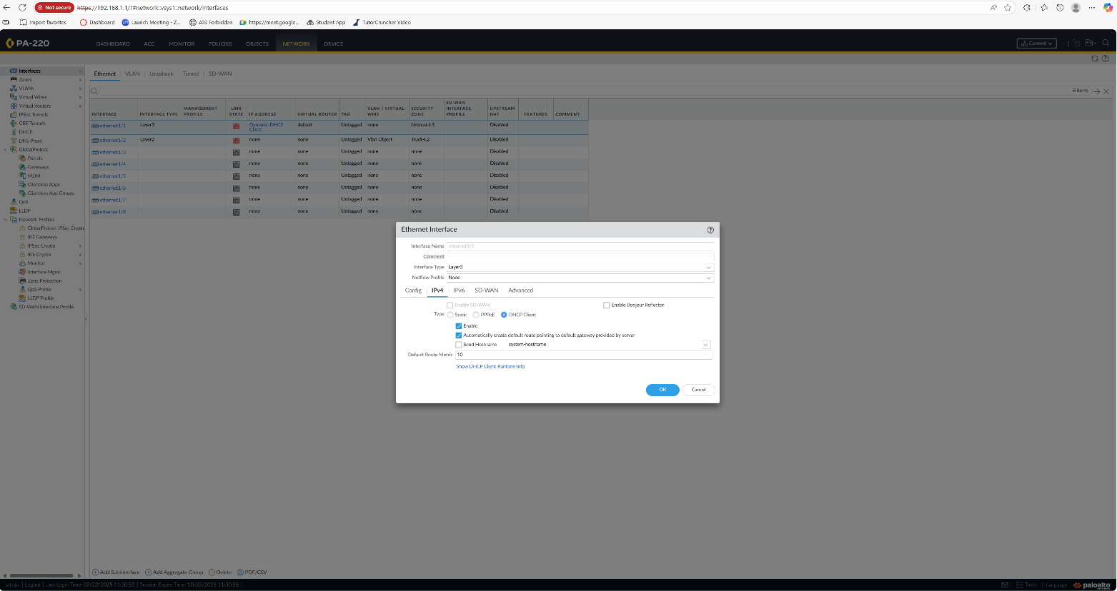

    - Ethernet1/2 configured, assigned to Trust-L2 and Vlan Object.
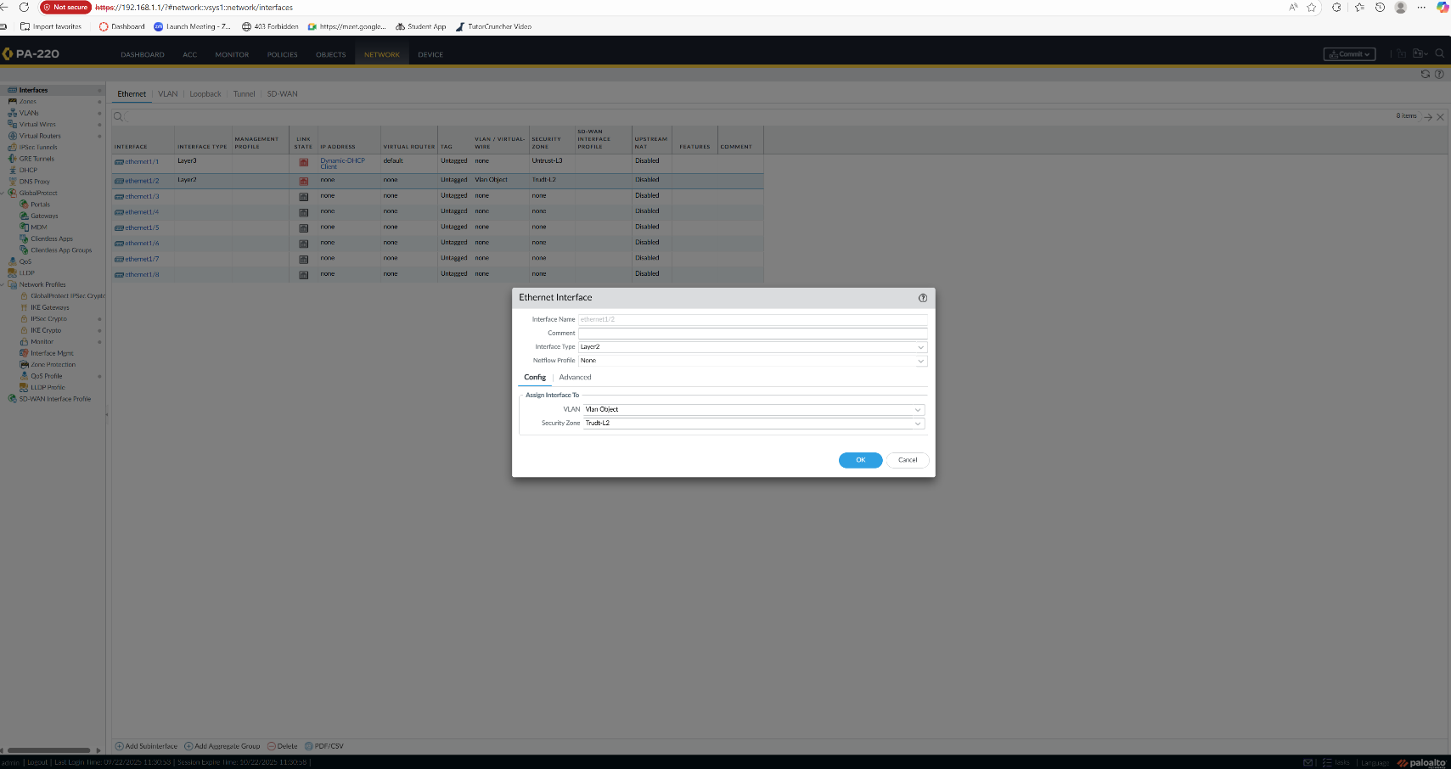
    - Assign VLAN interface vlan.10 to Clan object, default VR and zone Trust-L3
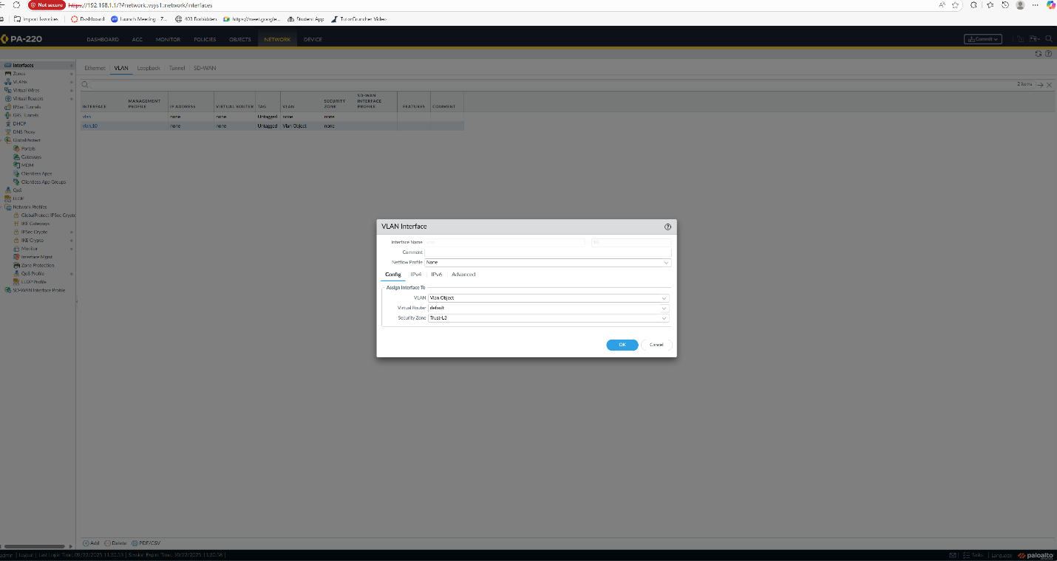

    - Set VLAN interface with static IP 192.168.1.254
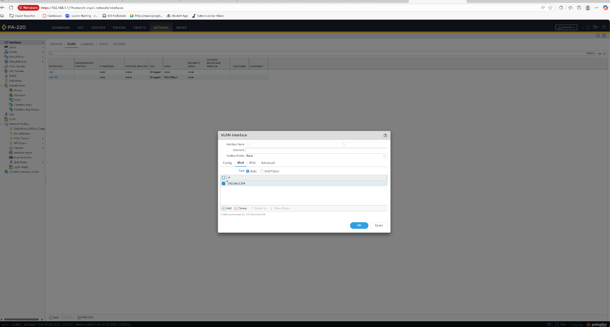
    - Set up a DHCP server setup on vlan.10
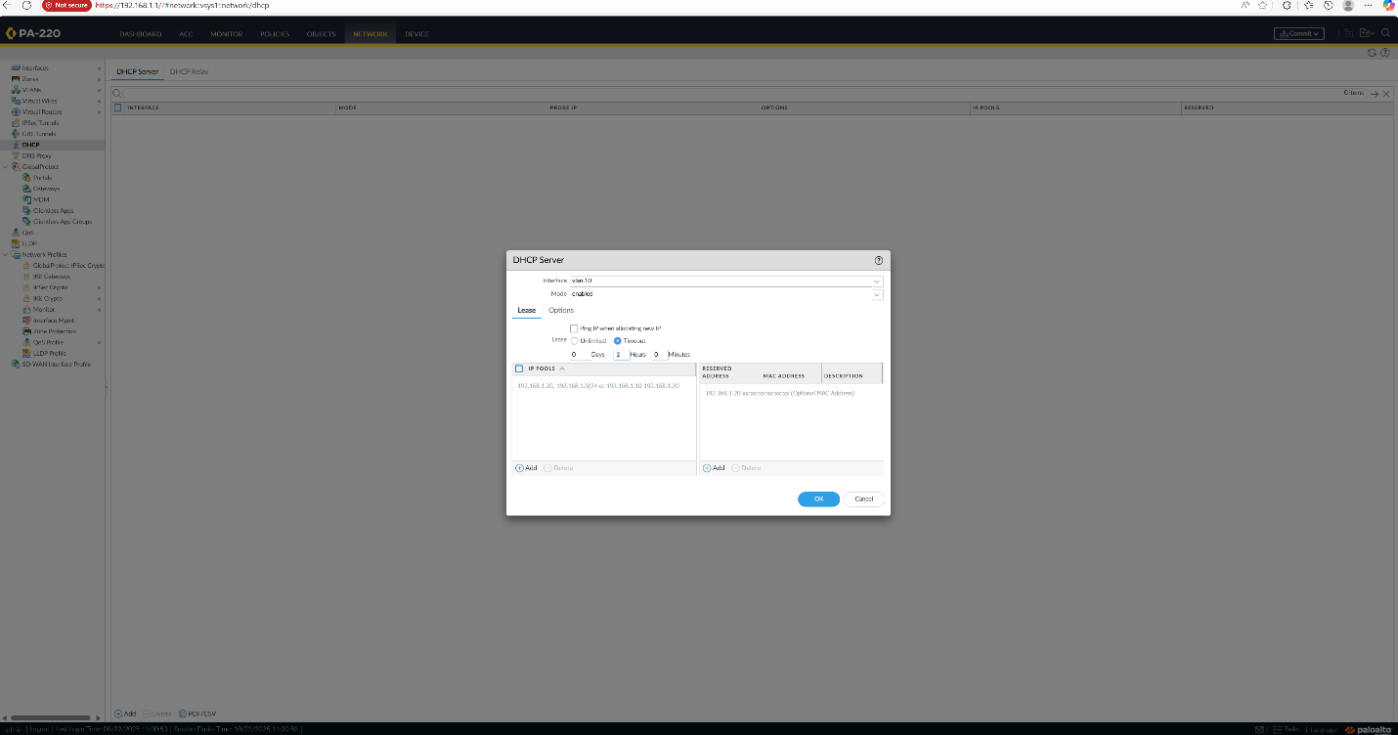
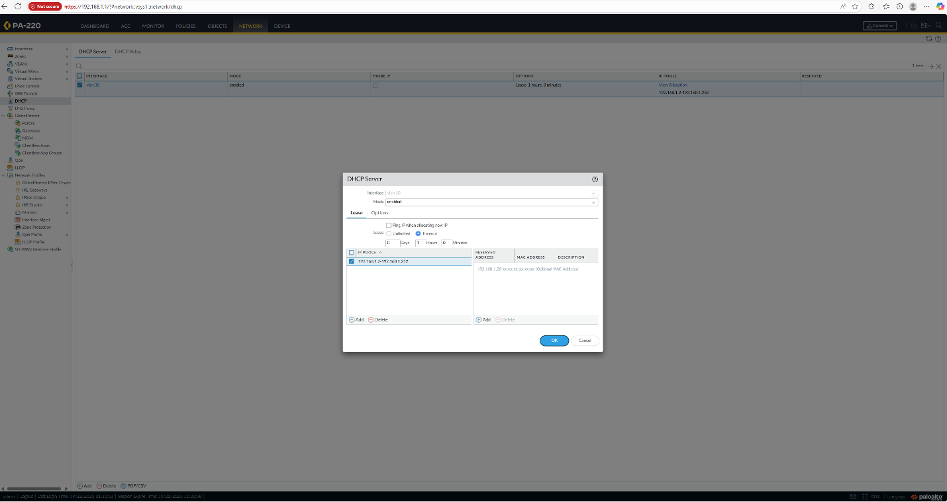
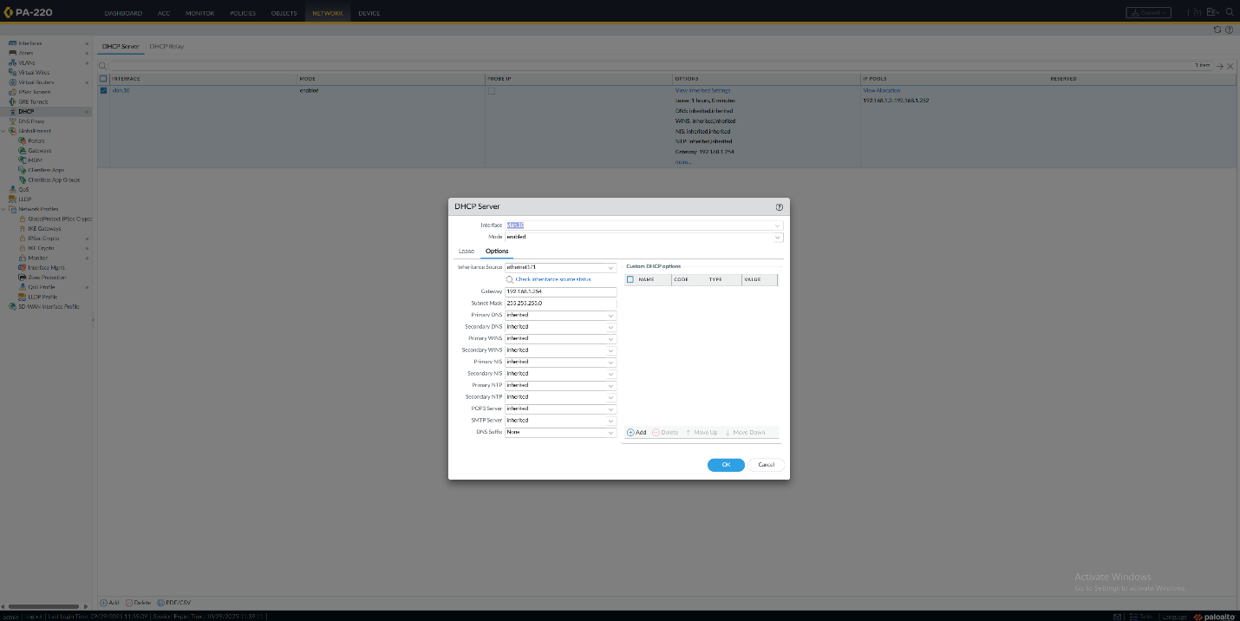

    - Go to policies -> security -> and edit the internet outgoing interface so that the source zone is Trust-L3 and the destination zone is Untrust-L3

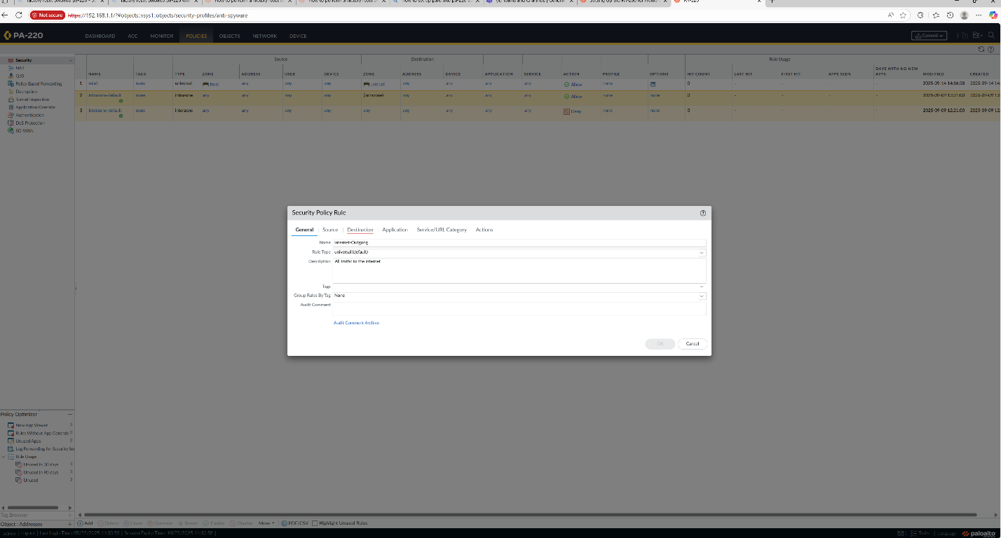
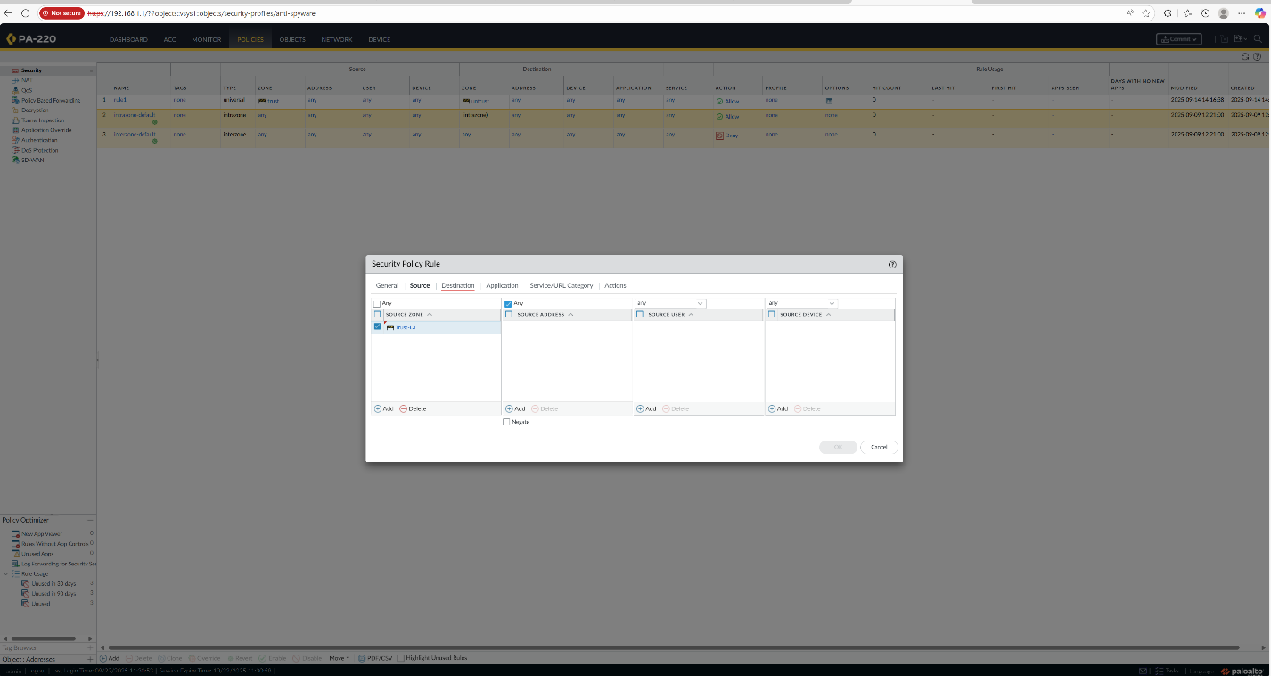
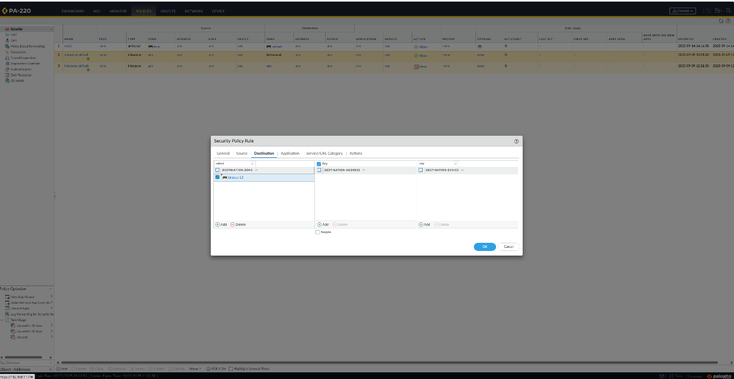

    - Create a NAT policy rule for the internet outgoing interface.
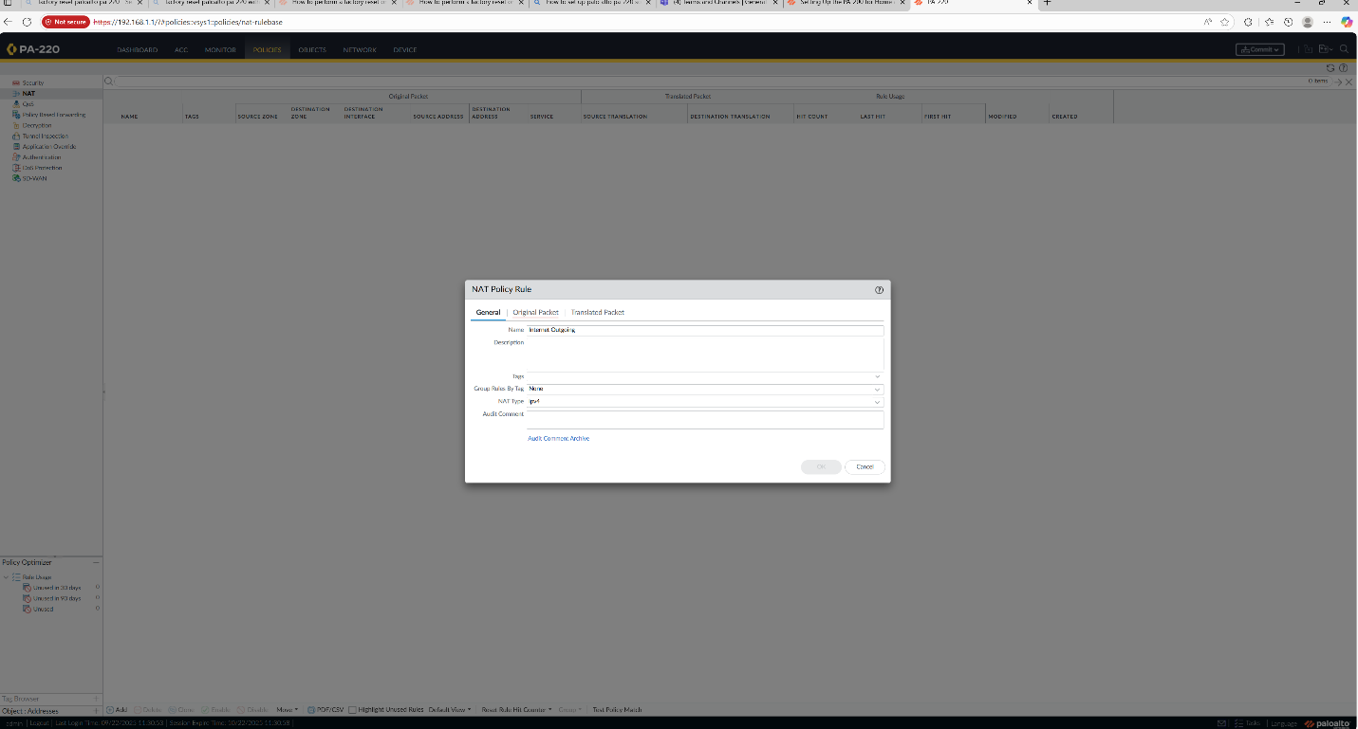
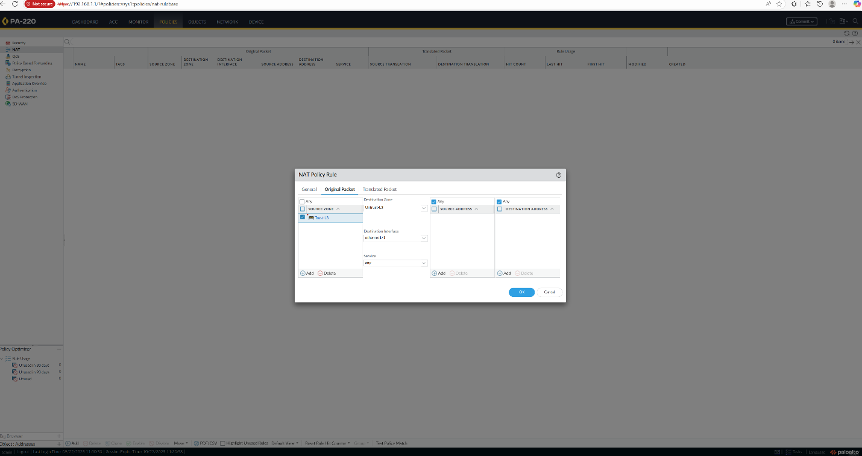
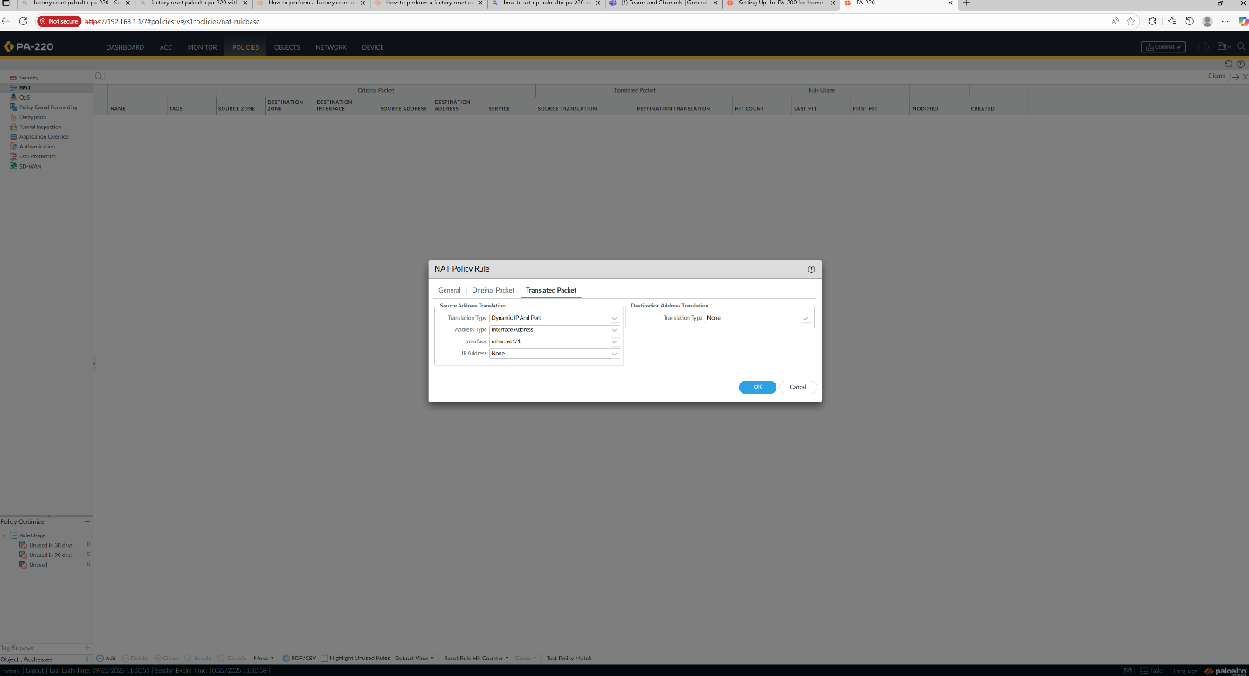

    - Go to device -> setup -> and change the management interface settings so it can reach the default gateway.
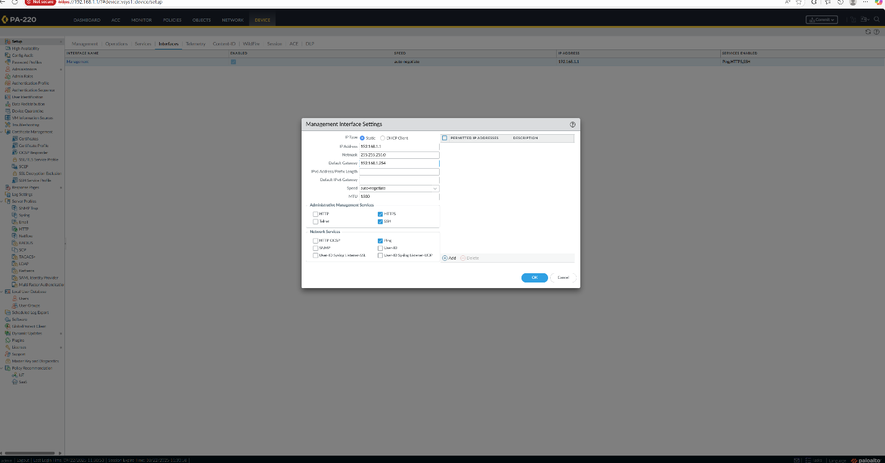

    - Go to Device -> setup -> and Set the primary DNS server as 8.8.8.8 and secondary as 8.8.4.4
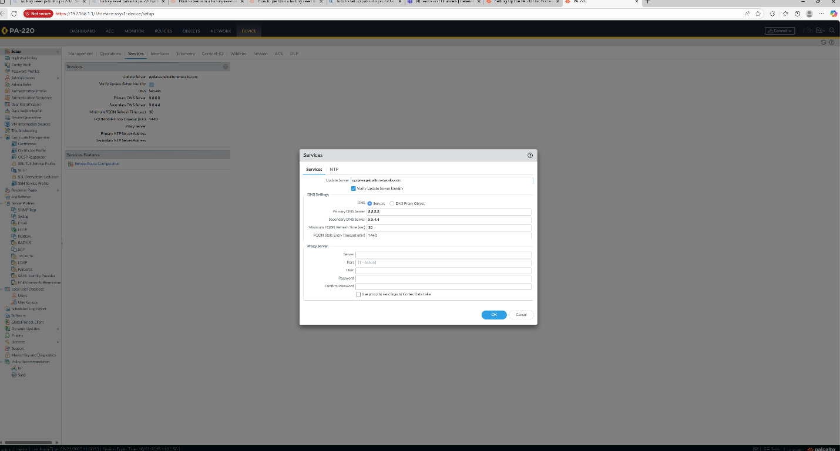

Network Diagram with Ips:
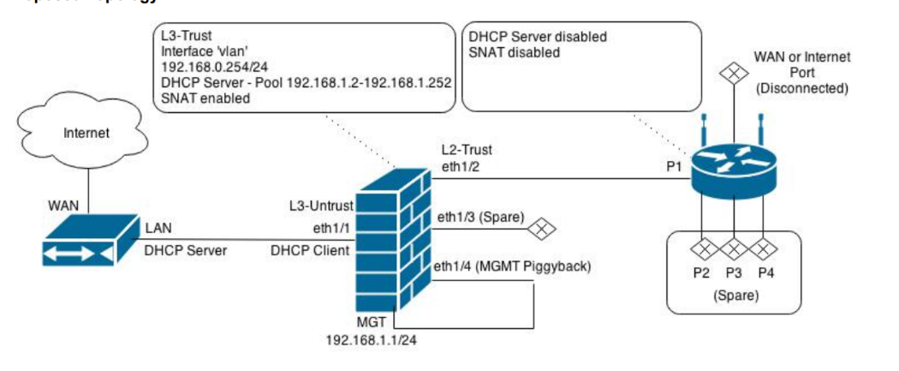

Problems:
During the lab there were a few minor issues:
- Initially the outside interface had a static IP configured from a previous lab; it needed to be changed to a DHCP client to obtain an address from the ISP.
- When assigning the Layer 2 interface to the VLAN object, the commit failed because the interface was still configured as Layer 3. Changing the type to Layer 2 resolved the error.
- The DHCP pool range originally overlapped with the gateway address. Adjusting the pool to start at 192.168.1.2 resolved this issue.
Conclusion:
The PA-220 can be configured as a versatile SOHO firewall through its web interface. This lab demonstrated how to create trust and untrust zones, establish a VLAN and VLAN interface to separate Layer 2 and Layer 3 functionality, assign interfaces to zones, and set up a DHCP server for internal clients. After committing the configuration, the internal network was able to successfully obtain addresses from the DHCP server and was also able to access the Internet through the NAT firewall.

