

Palo Alto Config Lab – Setting up a VPN network
The following is the firewall I will be working with on this lab
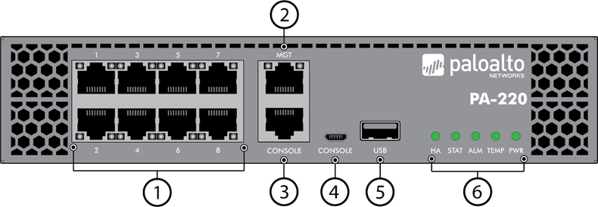
Purpose:
In this lab, I learned how to configure VPN (Virtual Private Network) on the pa-220 firewall so that a client from outside the network can remotely connect to my computer. I Used Global protect which is Palo Alto’s own VPN service. This lab focused on understanding how secure remote connections are established over the internet and how to encrypt User information between different networks.

Background information and Lab Concepts:
- The Palo Alto PA-220 is an enterprise-grade firewall suitable for SOHO environments.
- It supports Layer 2 and Layer 3 interfaces, VLANs, and DHCP services, making it versatile for both routing and switching tasks.
- In this lab, the device was used to create three main security zones:
    - Trust: for the internal LAN
    - Untrust: for the external WAN
    - VPN: for client-side connection
- VLANs (Virtual Local Area Networks) enable multiple Layer 2 networks to operate over a single physical interface, improving segmentation and efficiency.
- VLAN Interfaces act as Layer 3 gateways for VLANs, allowing routing between internal subnets.
- DHCP services dynamically assign IP addresses to internal clients, simplifying device connectivity and network management.
- VPN services allow clients on outside the network to be able to access a private network through encrypted traffic within the tunnel interface.

Lab Summary:
In this lab, I created certificates which allowed a client from outside the network to be able to use remote desktop to remotely access my computer in a different private network. I then configured the User authentication and created a password. Then I configured a Global Protect remote access VPN on the pa-220 firewall. On another computer, I connected the gateway to the CPN and used remote desktop on windows to remotely connect to the Host PC

The Lab configurations preformed in this lab are listed below:

1. Go to Device -> Certificate Management -> certificates, then click generate at the bottom. Certificate type local, Name Root-Cert, check Certificate Authority. Keep the crypto
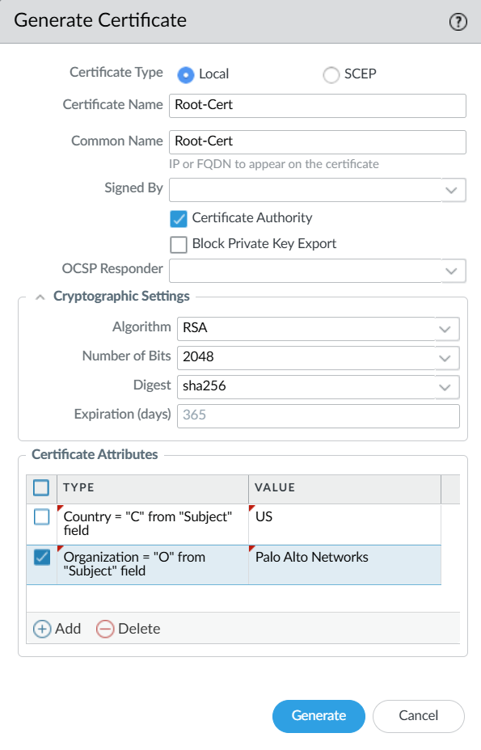

2. Click Generate Certificate again. Certificate type is still local. Common name should be the IP address of the port going out onto the internet. It should be signed by the Root-Cert we previously created Below. No CA (Certificate Authority)
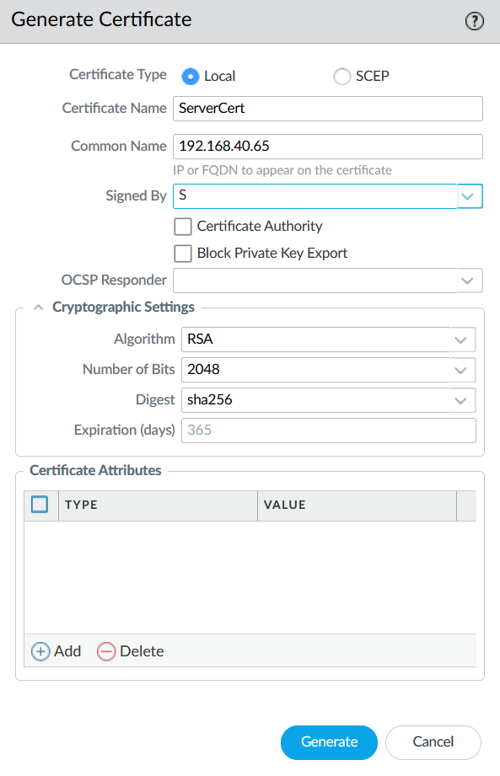
3. Go to Device -> Certificate Management -> SSL/TLS Profile. Click add at the bottom. Name anything you want, use Server-Cert as the Certificate.
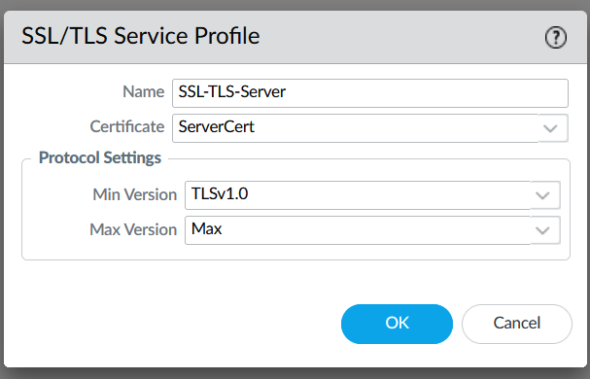
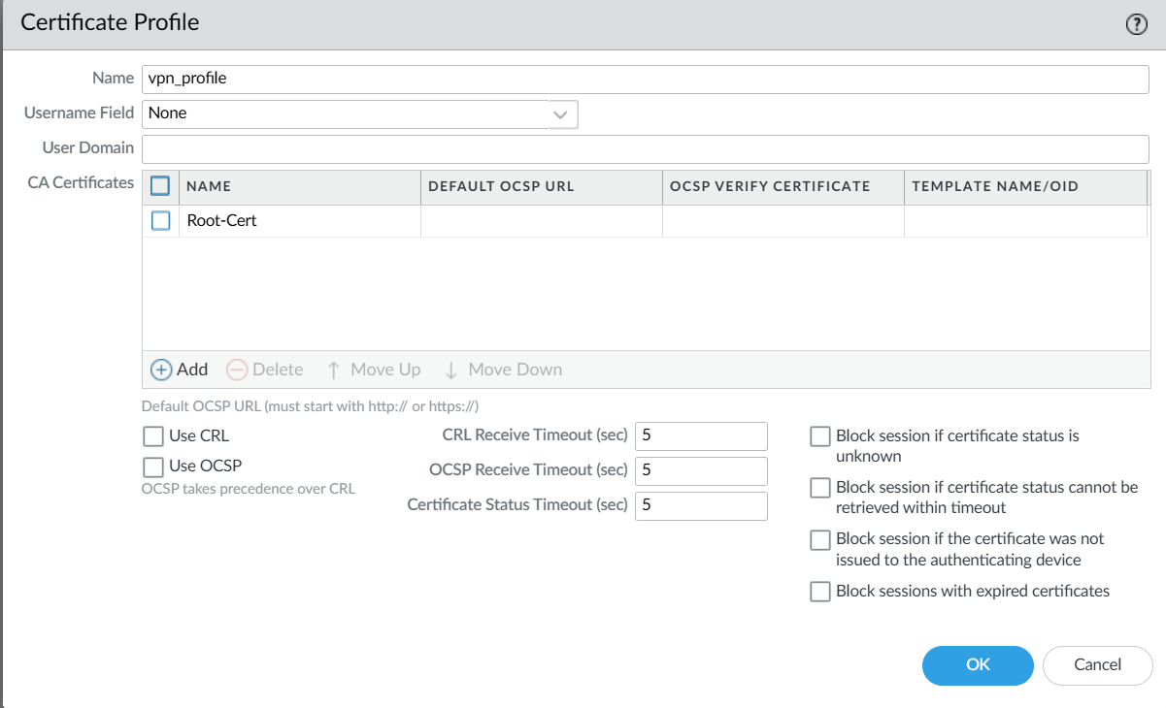
4. Next go to Certificate Management -> Certificate Profile. Name anything and add the Root-Cert In the list of CA Certificates. Click ok.

5. Click windows + r, type mmc in the Run search. Click ok. Once in the Console screen click file -> Add/Remove Snap-in
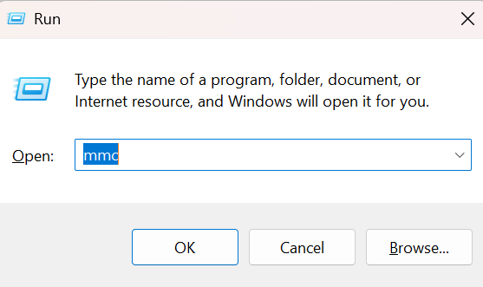

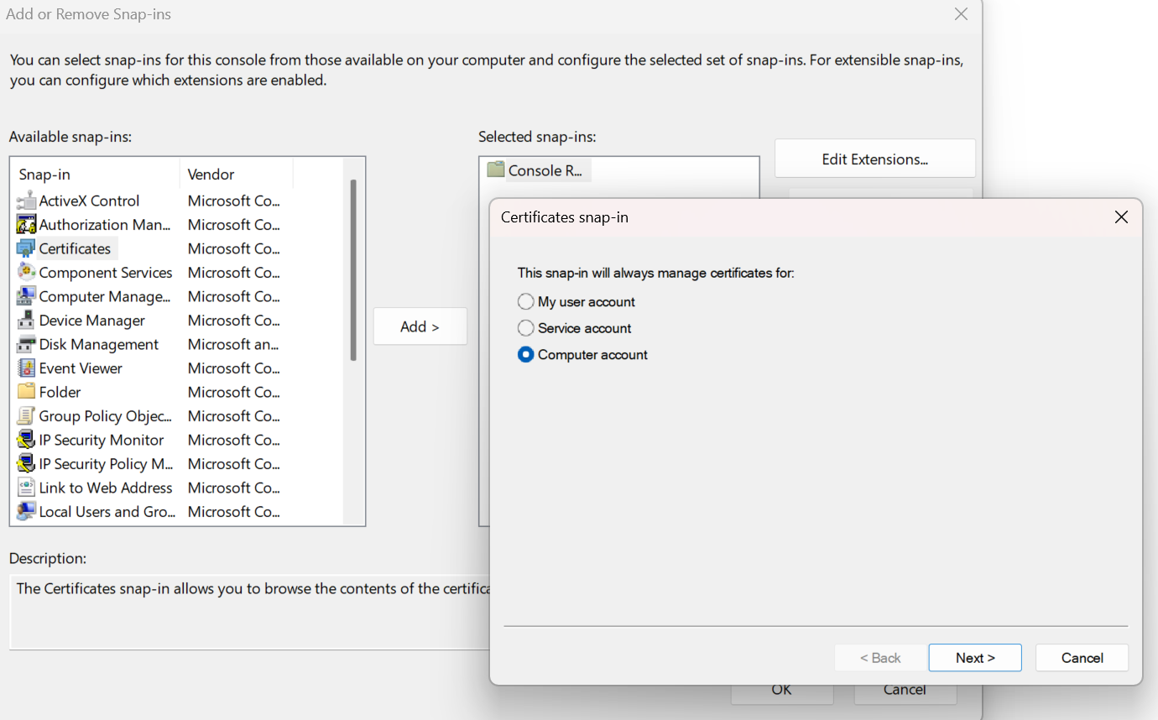
6. Select Certificates, click add in the middle, and select computer account. Click Next. When a pop up comes up click Local Computer and click Finish. Do for all Certificates.

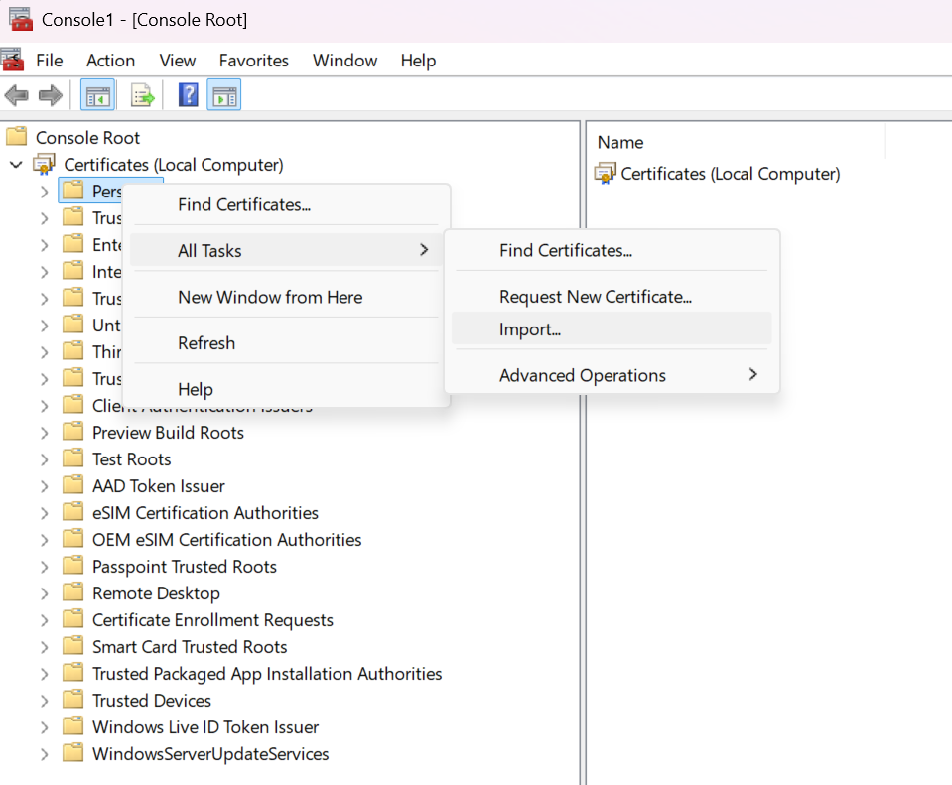
7. Right click on certificates, go to all tasks then click import. Browse through your certificates and import them. Do for all Certificates

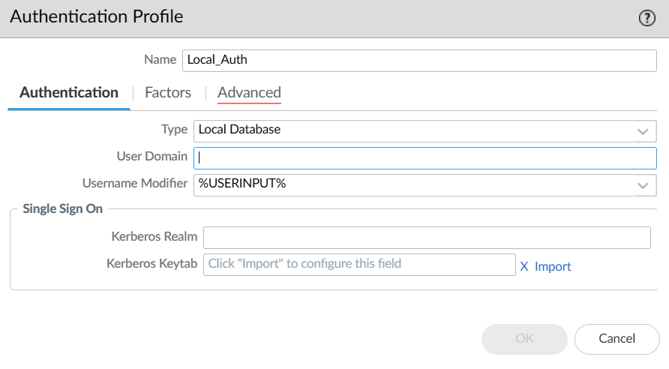
8. Go back to Web GUI. Go to Device -> Authentication Profile and click add. Name whatever you want. Click add and type all into the allow list. Click ok.
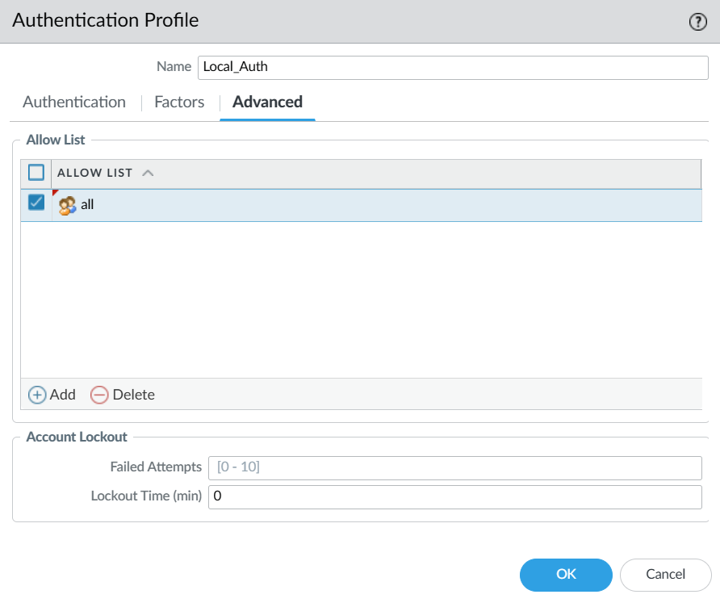

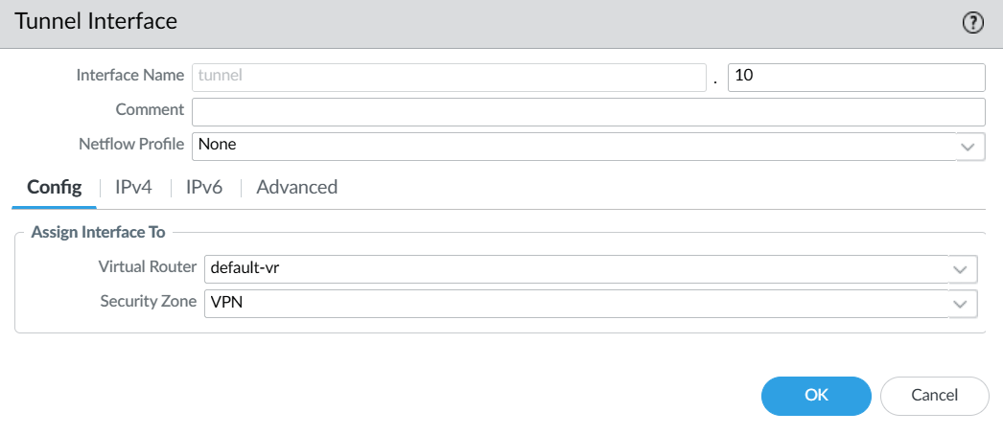
9. Go to Network -> Interfaces -> Tunnel. Click add at the bottom. Type .10 at the bottom right corner and click ok.

10. Go to Network -> Zones and click add. Name VPN and under the interfaces add the tunnel interface
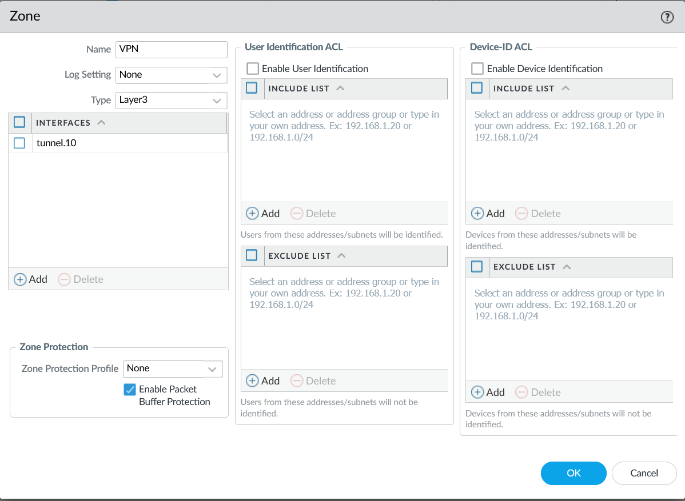
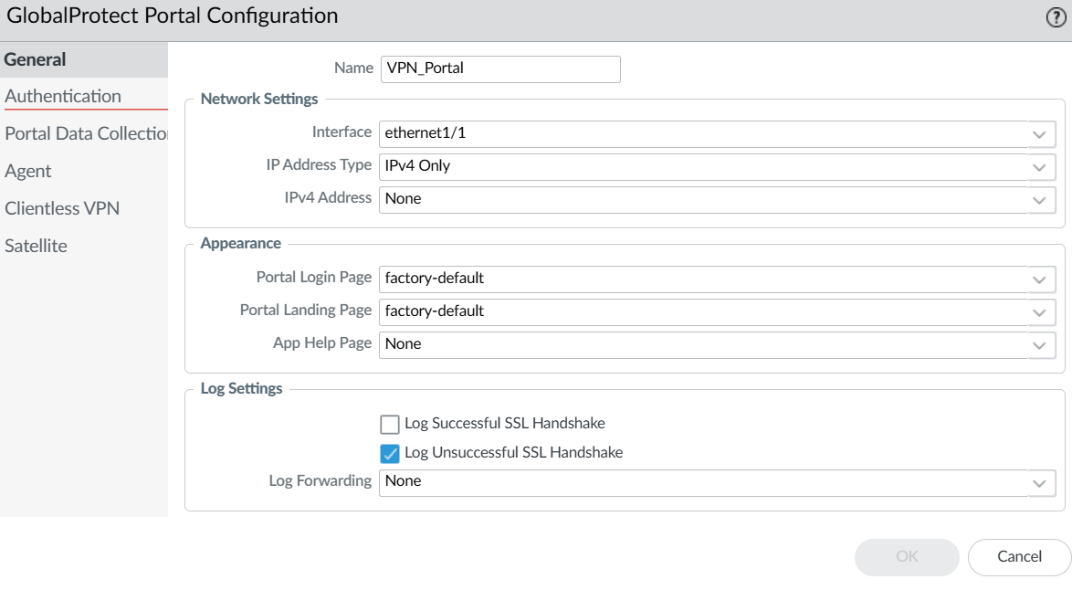
11. Go to Network -> Global Protect -> Portal and click add. Name it whatever you want and set the interface to the interface outgoing into the internet. Set type as IPv4 only.

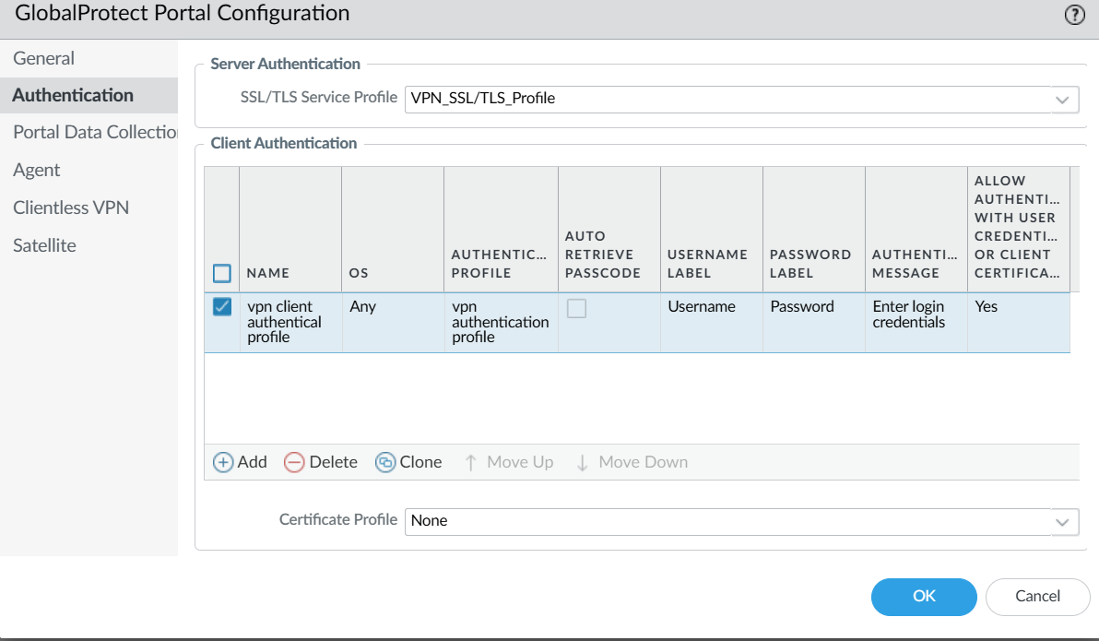
12. Go to Authentication tab, click the SSL/TLS profile we previously created for server authentication. Set Cert Profile to none.

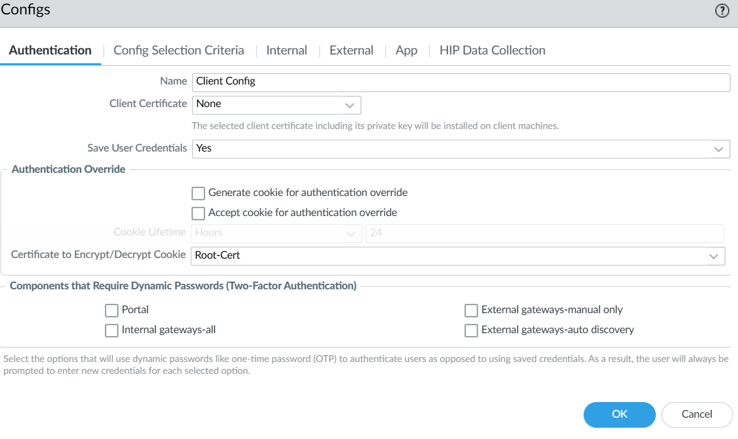
13. Go to Agent tab and click add new agent config. Name it something, leave Client Cert as none, and Save User Credentials to Yes. Set Certificate to encrypt to Root-Cert.

14. Go to External Tab, Click add. Name it something and click IP. Name it the IP address of the interface going out into Internet. Add source region as Any. Click ok.
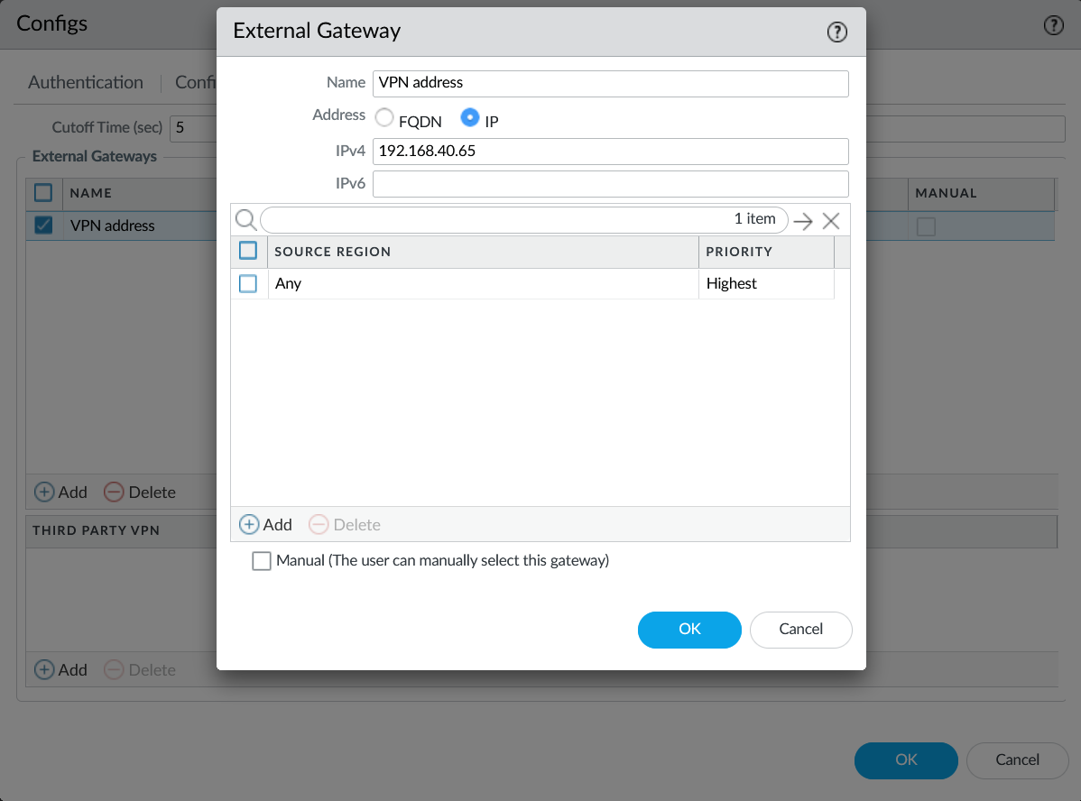
15. Important Step. Go to apps, and configure the following ->

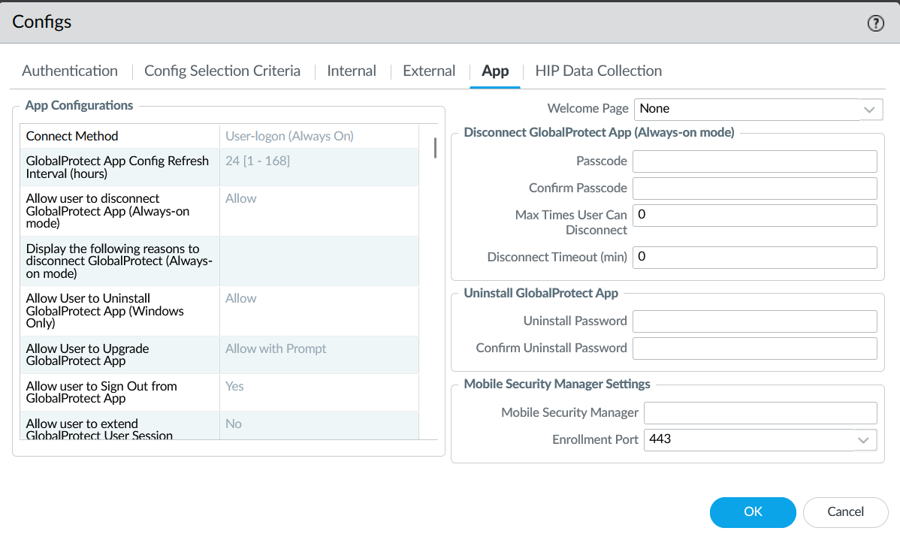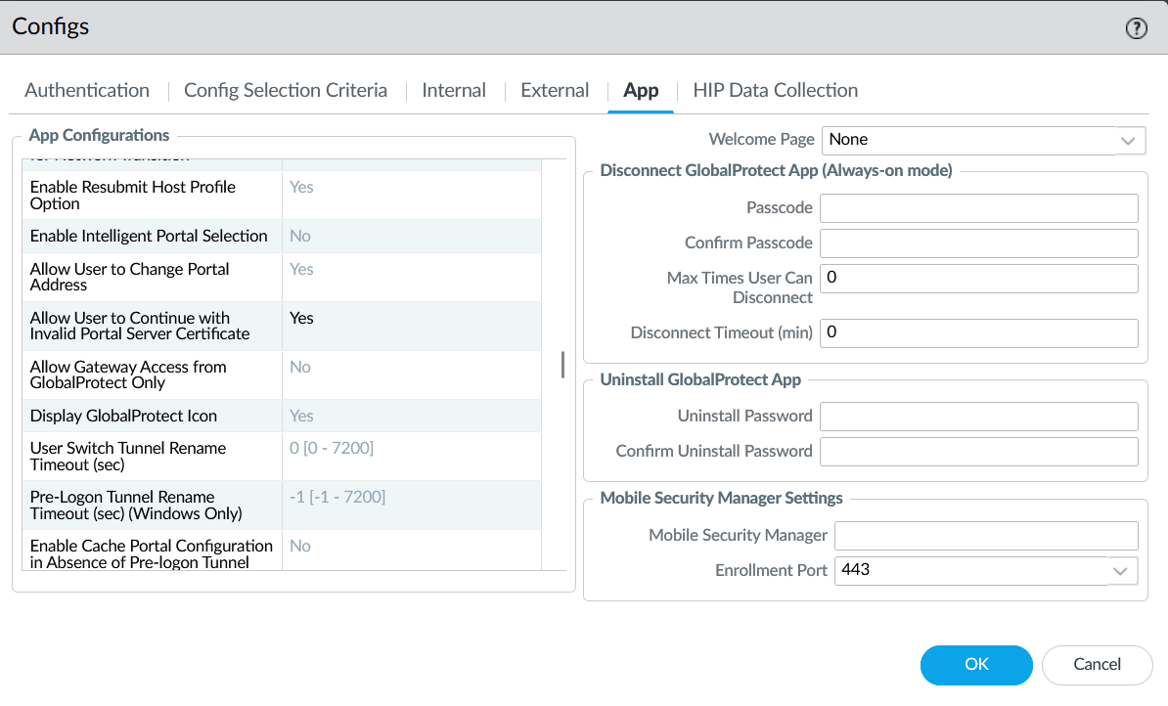
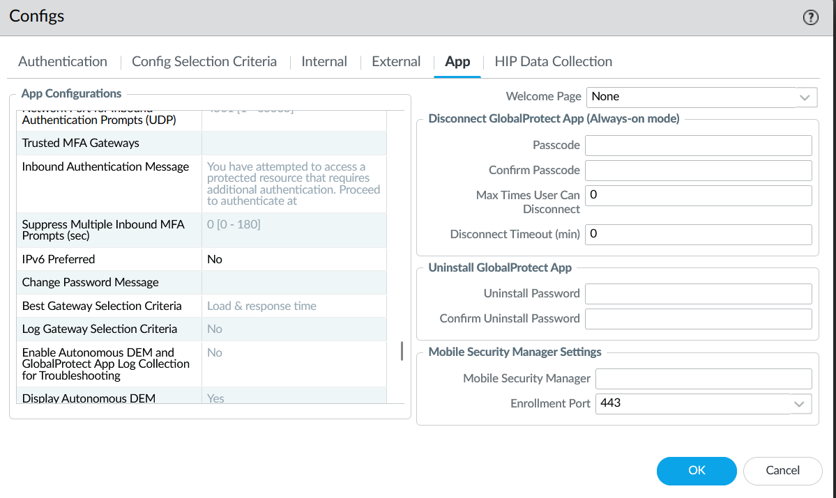

16. Go to Network -> Global Protect -> Gateway. Name what you want, select interface as the interface going out into internet and select IPv4 only.
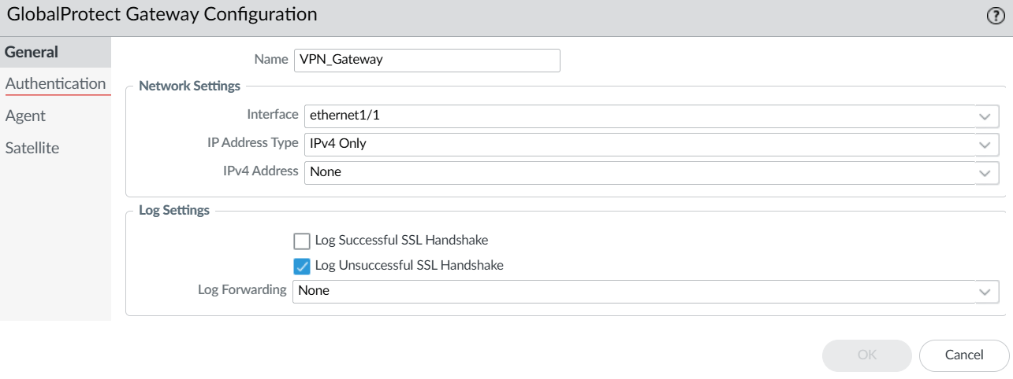

17. Go to client authentication, name it something and choose the authentication profile. On the bottom, select Yes (User Credentials OR Client Certificate Required)
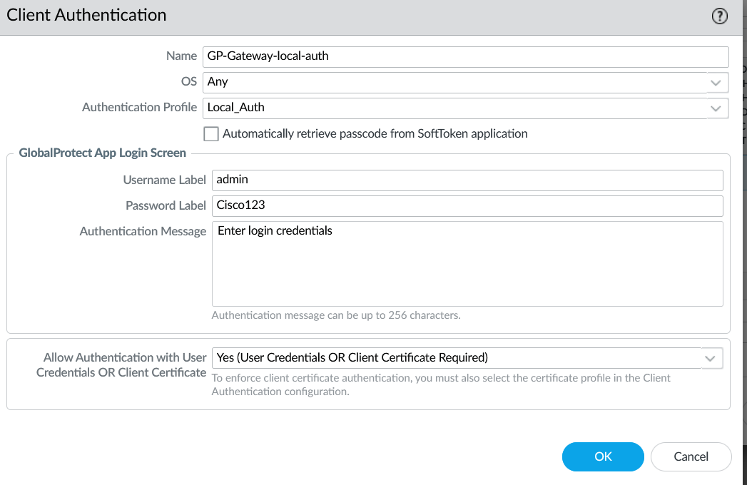
18. Go to Agent Tab. Then go to tunnel settings. Choose the previously configured tunnel interface and enable IPSec.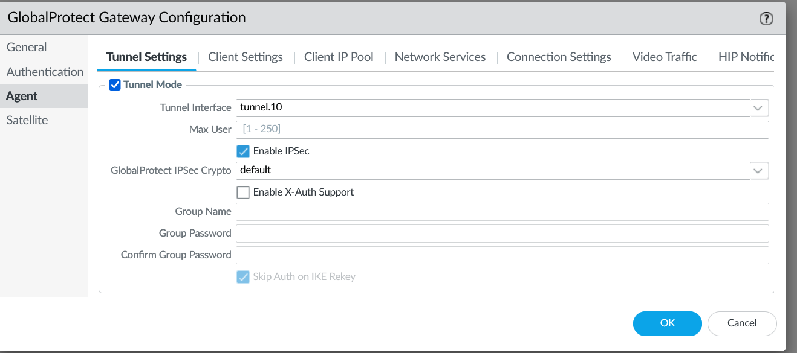
19. Go to Client tab, click add, and go to the IP Pools tab. Add a Ip pool available in your private network. Click Ok.
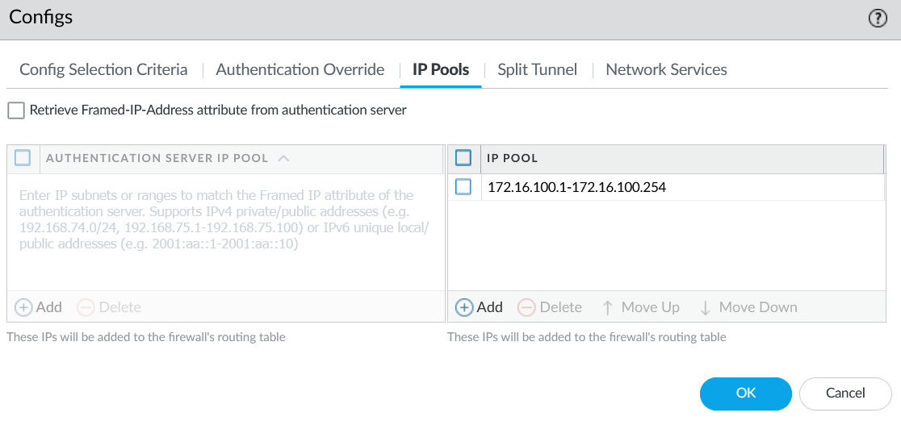
20. Go to Device -> local user -> database -> users and click add. Name what you want and choose a password. This settings will later be used on the client-side PC to download Global Protect on their PC so they can access out PC remotely. 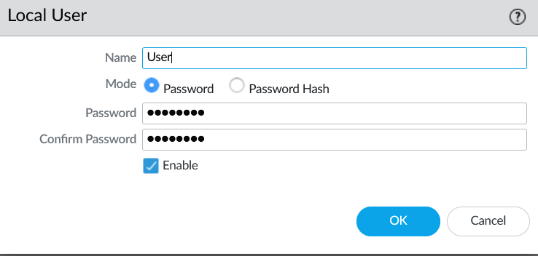

21. Go to Policies -> Security. Create two new security Policy with the following settings.
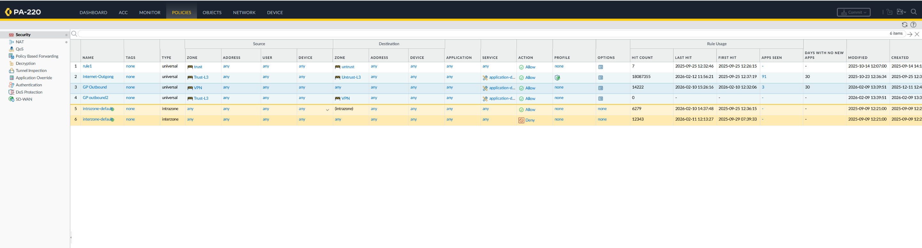

22. To test out the VPN, on the client computer, enter the IP address of that port going out to the internet, in my case it was 192.168.40.167, or if you used the FQDN, enter that into your browser. If Global Protect pops up, download whichever one fits your computer, and wait for it to download. Once downloaded, enter the IP address or FQDN of the portal and click connect. If everything is configured correctly, the VPN should connect you, and from there, you can use remote desktop manager to connect to the host PC.

Problems:
- A Problem We encountered is that when we downloaded Global Protect on the Client side PC and tried to remote desktop out way in using the server certificate, it would keep denying access.
Solution : The solution to this problem was to complete step 15 above. We needed to allow users to access the portal with invalid server certificates.

- Another problem we encountered was that even after configuring everything, the Client-side PC was not able to download the Global Protect onto their computer
Solution: the solution to this was to complete step 21. We did not have all of our security policies sorted out and the VPN was unable for access from the client PC.

Conclusion: In this lab, I successfully configured a VPN on a PA-220 firewall and learned how secure communication is established over the internet. I gained a better understanding of how IPSec and tunnel interfaces works. Although I faced some issues troubleshooting , this helped me understand the process of setting up an VPN more deeply and was beneficial to my learning.

