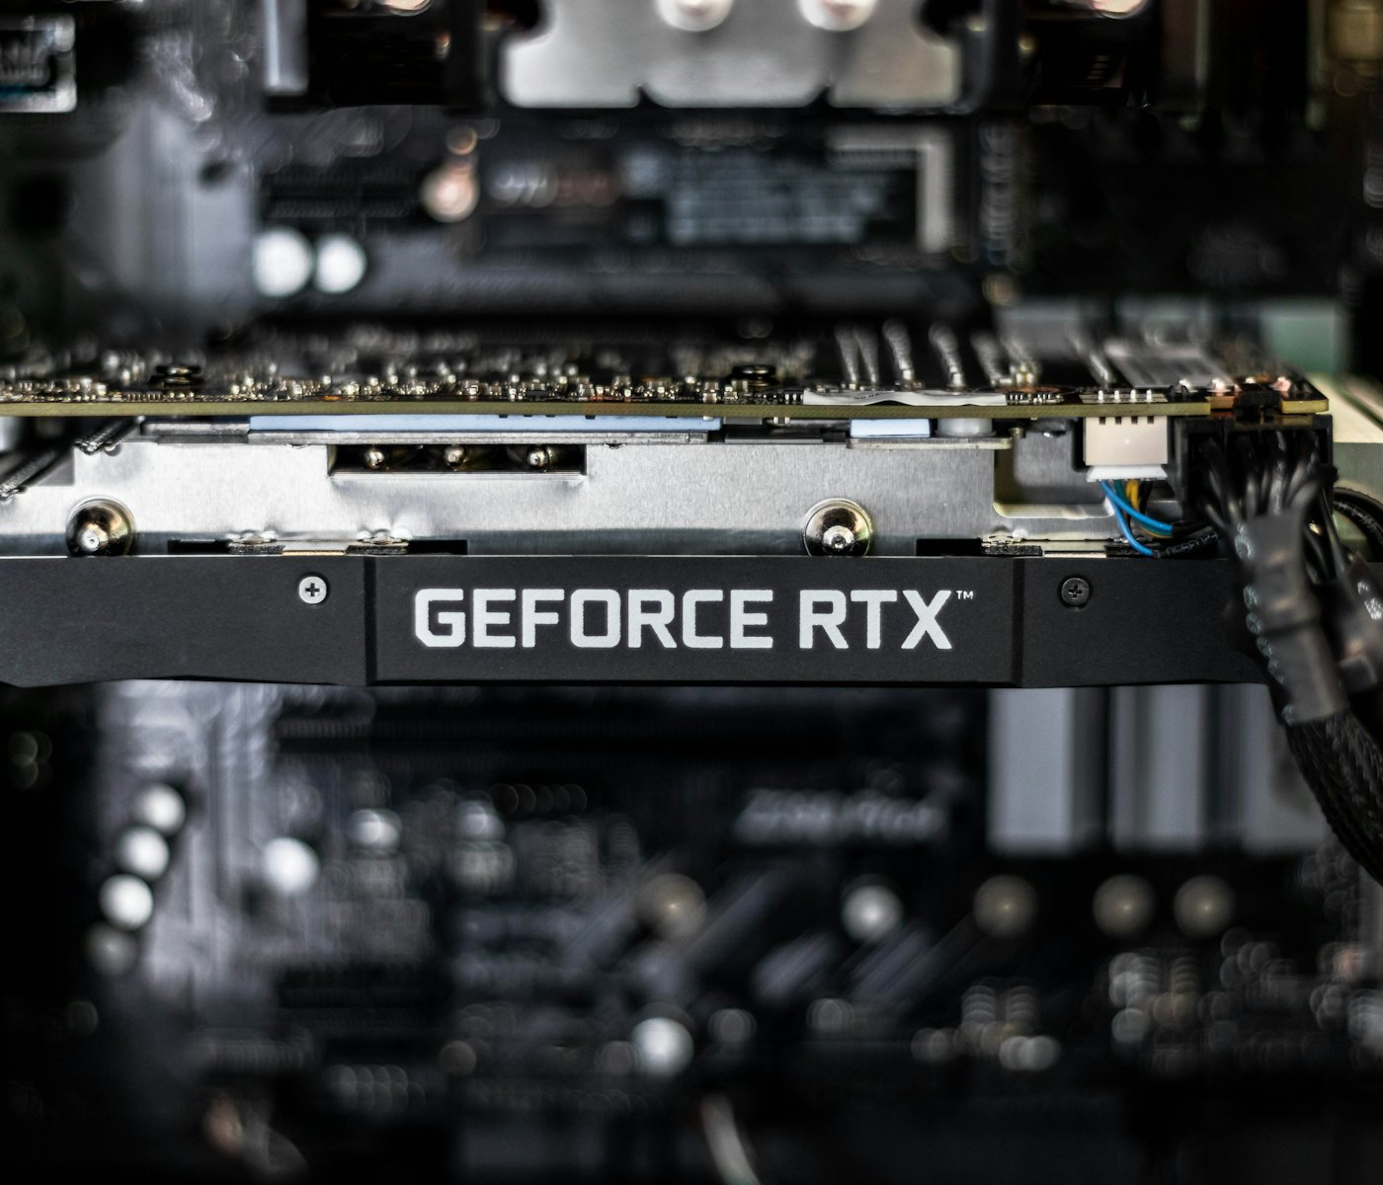
Local AI Lab: Deploying a Self-Hosted AI Platform on NVIDIA GPUs
Sota Arakawa
The following is the GPU I will be working with in this lab (three NVIDIA RTX A4000 cards, 16 GB each):
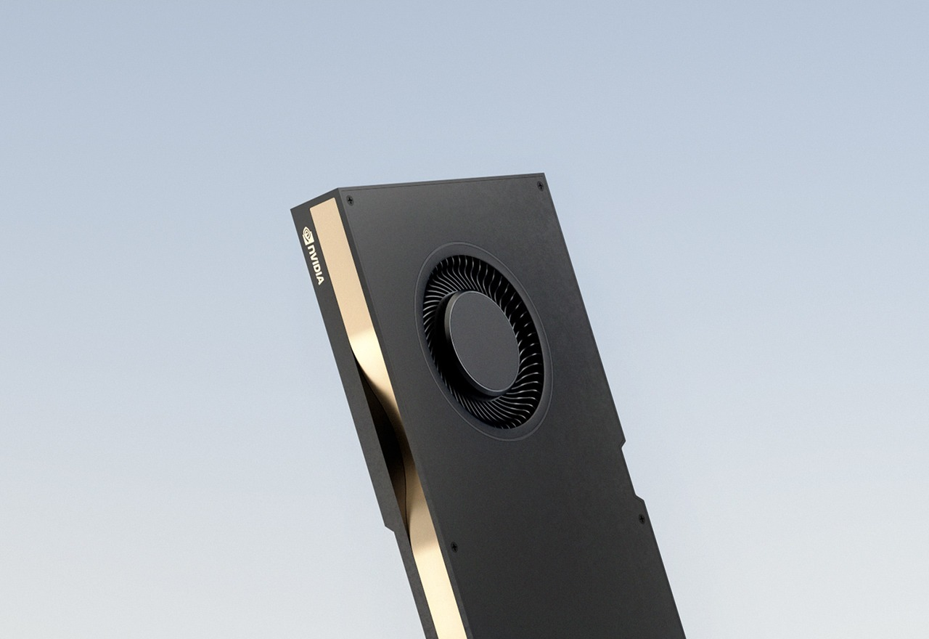
Purpose:
This lab served as an introduction to running large language models (LLMs) locally on my own hardware instead of a cloud service. It helped me build the foundational skills for deploying, securing, and monitoring a multi-container AI platform.
Background:
A large language model (LLM) is the type of AI behind chat assistants such as ChatGPT Claude and Gemini. It reads text and predicts the next words to write a reply. Running one locally makes it so that your prompts and documents never leave the computer, which matters for privacy and for organizations that don’t want to share their data with AI services
Ollama is the program that I used to run the models. It loads a model into the GPU memory, called VRAM, and uses API to answer requests. GPUs can do thousands of math operations at once, which makes the AI reply many times faster than a normal processor would. A model that’s takes up too much VRAM and does not fully fit in spills into regular system memory and slows down dramatically. so, a large part of this lab was making sure each model stayed 100% on the GPU.
Models are stored in a compressed format called quantization. A 4-bit (Q4_K_M) or 8-bit (q8_0) version of a model takes up much less space than the original model, why having small reduction is the quality. This is what makes it possible to run a 14 billion or 30 billion parameter model on 16 GB graphics cards such as the A4000.
Docker is used to package each piece of software into a container, basically a small environment with everything the program needs. On Windows, Docker Desktop runs these containers inside WSL2 (Windows Subsystem for Linux). WSL2 is also used to pass the NVIDIA GPU to the containers, which allows Ollama inside a container to access the GPU. A single docker-compose.yml file can be used to describe all eight containers with their networks and their storage. This allows the lab to be rebuilt with one command
RAG (Retrieval-Augmented Generation) Is what allows the AI to answer questions using the documents or files given. When a file is uploaded, it is split into parts and turned into numbers called embeddings by a small embedding model. These are stored in a vector database called Qdrant. When a question is asked, the most relevant parts are found and handed to the model along with the question, so the answer is model doesn’t need to answer based on a guess.
Open WebUI is the chat website used in this lab to talk to the models. It sits behind a reverse proxy called NGINX. This essentially acts as a single front door to this lab. NGINX is what handles the HTTPS encryption, security headers, and limits how many requests a client can send. In this lab, every port is bound to 127.0.0.1 so nothing is reachable from outside this computer.
The term used to describe being able to see what a system is doing while it runs is Observability. In this lab, Prometheus is used to collect measurements every few seconds. Grafana then turns them into a live dashboard I can see from a web page. Since Ollama doesn’t report metrics on its own, the lab uses Prometheus and Grafana to measure response time, tokens per second (how fast the AI writes), and whether each model is fully in VRAM. A GPU exporter adds temperature, power, and memory use for every graphics card.
Parameter is what determines how smart an AI model is why some models take more VRAM to run A larger parameter usually requires a larger total VRAM. Later in the lab, I upgraded the system from one to three RTX A4000 cards (48 GB of VRAM in total). This allowed me to run a 30B parameter model of Qwen compared to the 14B parameter model I was first running.
Lab summary:
In this lab I built a self-hosted local AI platform on a Windows 11 workstation with an Intel Xeon w5-3435X processor, 128 GB of RAM, and NVIDIA RTX A4000 graphics cards. I enabled virtualization and WSL2, installed Docker Desktop and the latest NVIDIA driver, and confirmed that containers could use the GPU. I then deployed an eight-container stack with Ollama, Open WebUI, Qdrant, NGINX, Prometheus, Grafana, and two metrics exporters, generated random secrets and an HTTPS certificate, and loaded the Qwen3 14B chat model and an embedding model. I verified the model ran 100% in VRAM, tested RAG with an uploaded document, and benchmarked performance in Grafana. Finally, I upgraded to three GPUs, deployed the larger Qwen3 30B-A3B model at 8-bit quality, and compared the speed of the two models.
Lab configuration:
Commands used in PowerShell
wsl --install
netsh int ip reset
wsl --install
nvidia-smi
wsl --update
wsl --version
wsl --shutdown
docker run --rm --gpus all nvidia/cuda:12.4.1-base-ubuntu22.04 nvidia-smi
Set-ExecutionPolicy -Scope Process Bypass
.\scripts\init.ps1
docker compose config --quiet
docker compose up -d --build
docker compose ps
docker compose exec ollama ollama pull qwen3:14b
docker compose exec ollama ollama pull nomic-embed-text
docker compose exec ollama ollama create lab-qwen3-14b -f /modelfiles/qwen3-14b-lab.Modelfile
docker compose exec ollama ollama run qwen3:14b "hello" --verbose
docker compose exec ollama ollama ps
docker compose logs ollama | Select-String "library=cuda|offloaded"
Invoke-RestMethod http://localhost:11434/api/ps | ConvertTo-Json -Depth 4
docker compose exec ollama-exporter python bench.py --model qwen3:14b --concurrency 1 2 4
docker compose up -d ollama open-webui
docker compose exec ollama ollama pull qwen3:30b-a3b-q8_0
docker compose exec ollama ollama list
docker compose exec ollama ollama create lab-qwen3-30b-a3b-q8_0 -f /modelfiles/qwen3-30b-a3b-q8_0-lab.Modelfile
docker compose exec ollama ollama run qwen3:30b-a3b-q8_0 "hello" --verbose
docker compose exec ollama ollama ps
docker compose logs ollama | Select-String "offloaded|split"
(Get-Content grafana\dashboards\ai-lab-overview.json -Raw) -replace '\{\{name\}\}', '{{uuid}}' | Set-Content grafana\dashboards\ai-lab-overview.json -Encoding utf8
docker compose restart grafana
docker compose exec ollama-exporter python bench.py --model qwen3:30b-a3b-q8_0 --concurrency 1 2

Lab commands:
Part 1: Preparing Windows
I first created a free Docker account, which Docker Desktop uses to sign in.
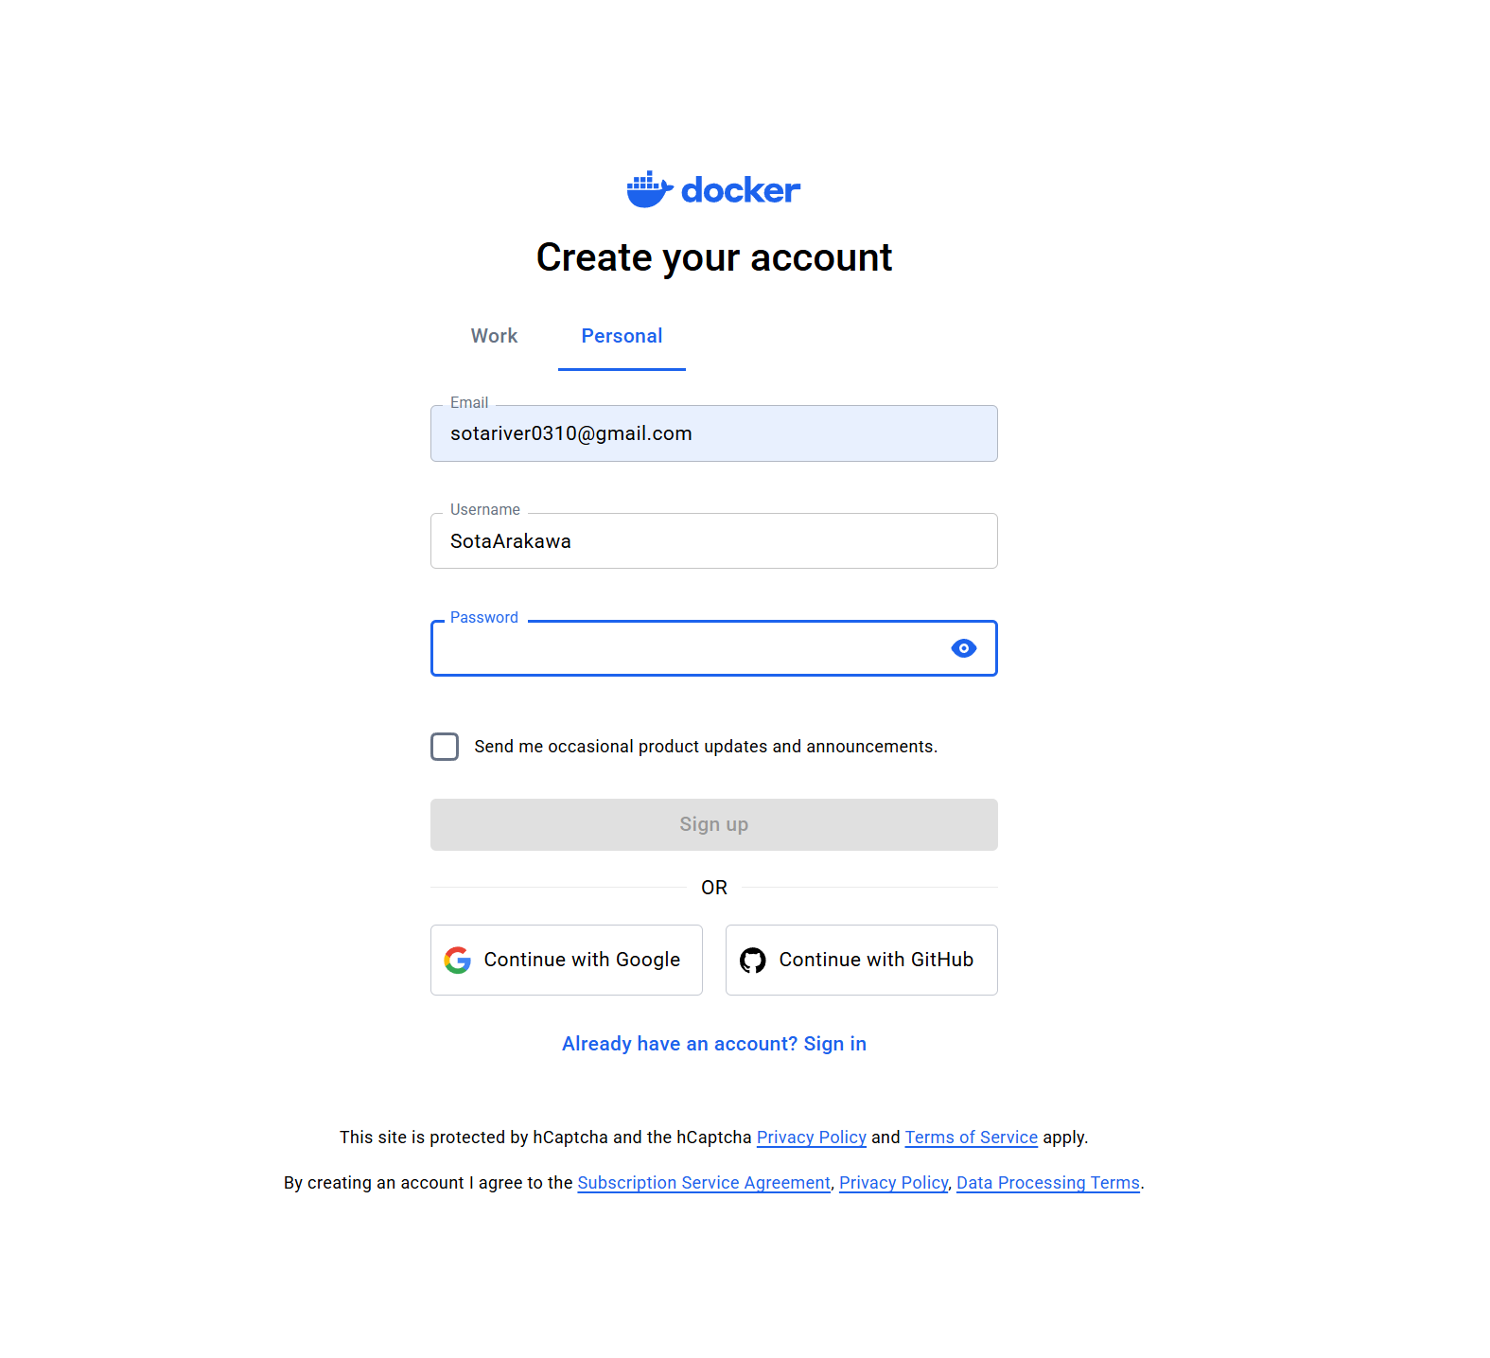
When I opened Docker Desktop, it failed to start because Windows virtualization support was not turned on. Docker needs virtualization to run its Linux environment.
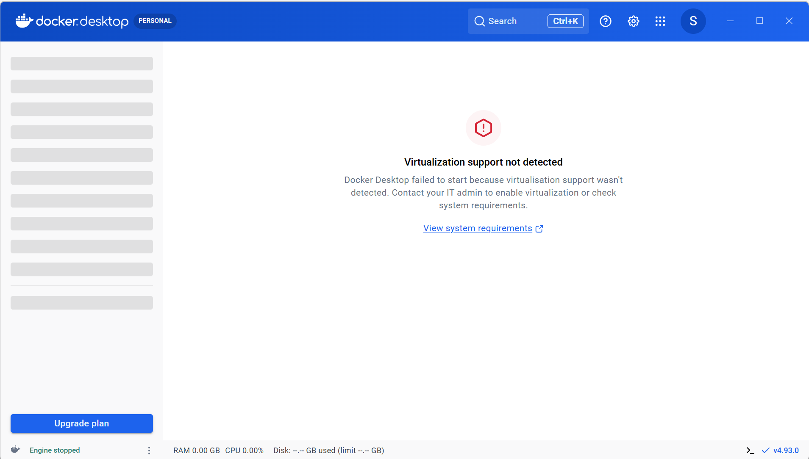
In Task Manager under Performance → CPU, I confirmed that virtualization was enabled in the BIOS. This meant the missing piece was a Windows feature, not a hardware setting.
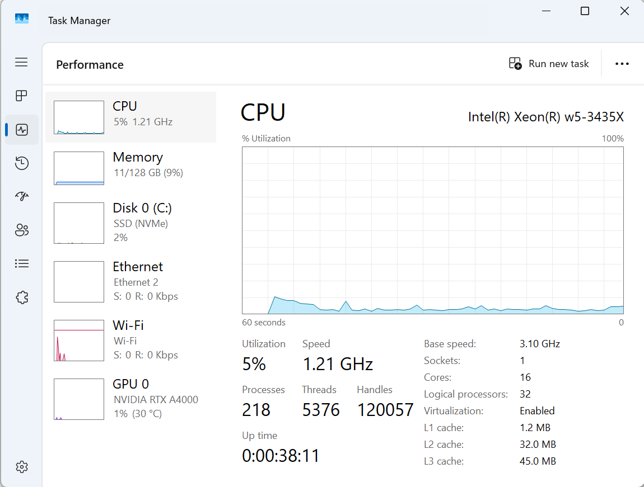
I searched for "Turn Windows features on or off" in the Start menu to open the Windows Features window.
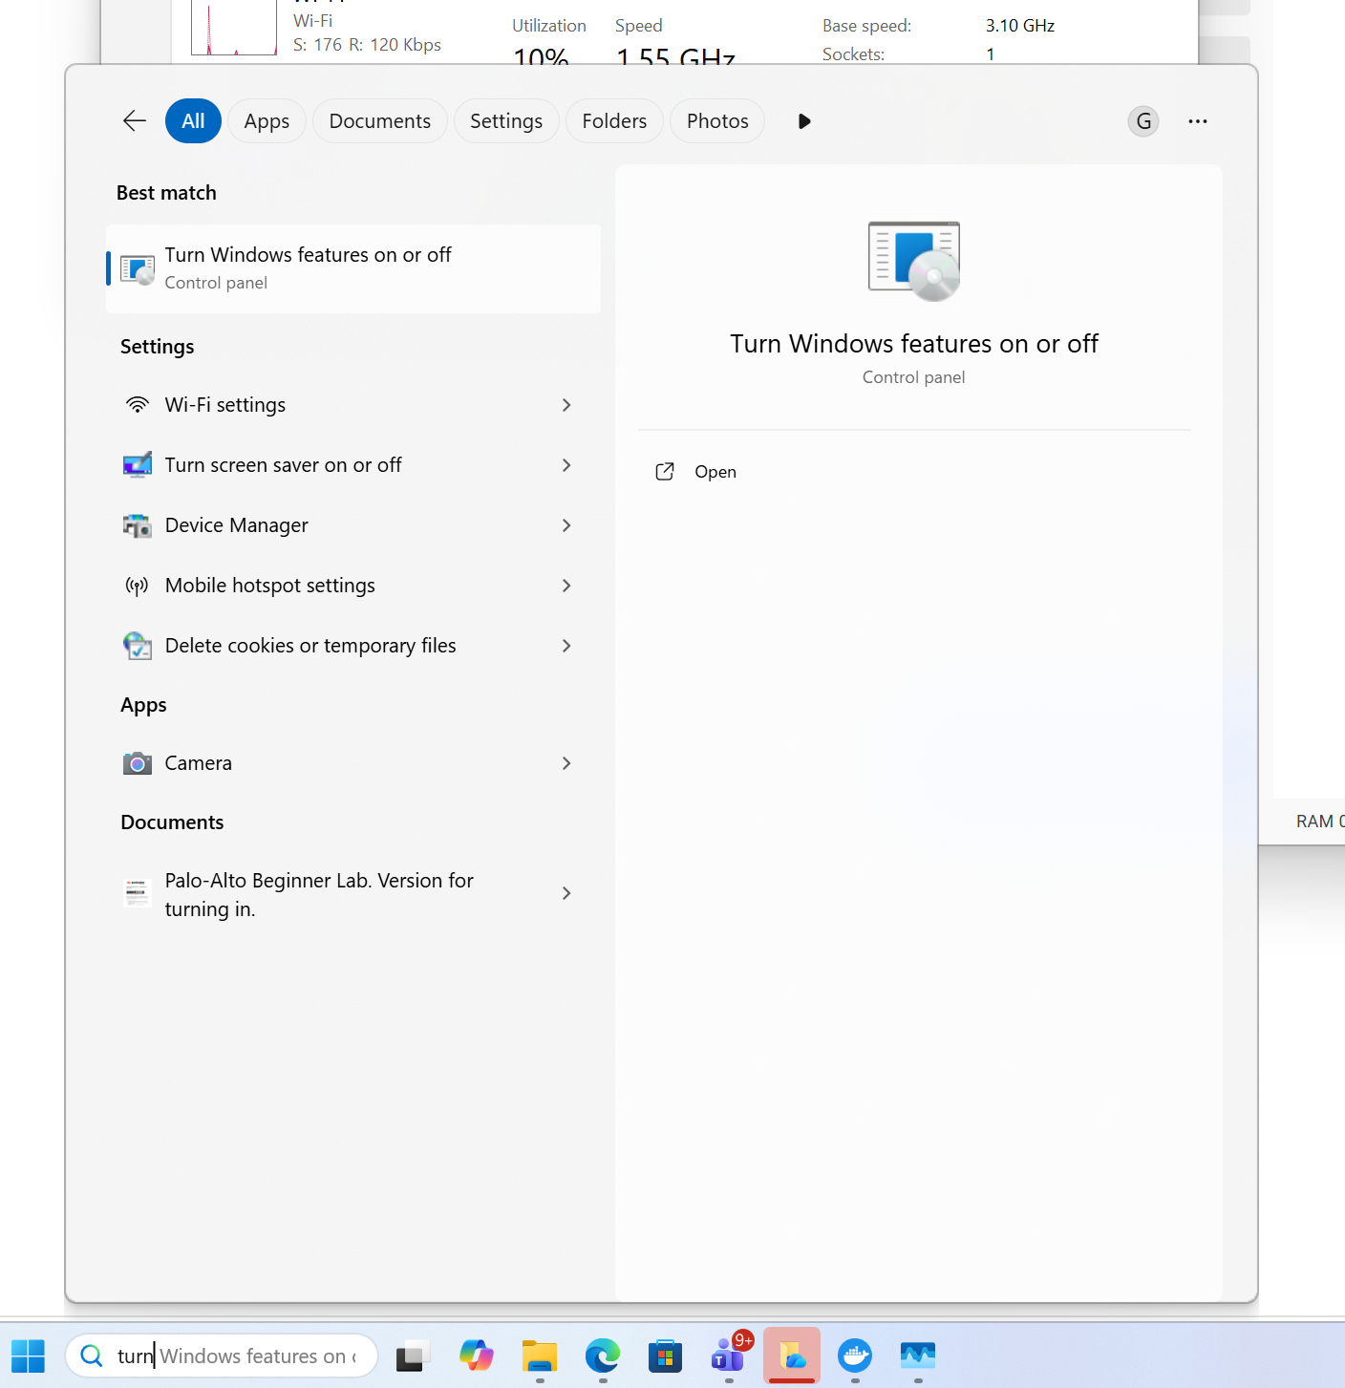
I turned on Virtual Machine Platform and Windows Subsystem for Linux. These two features are what WSL2 and Docker Desktop run on.
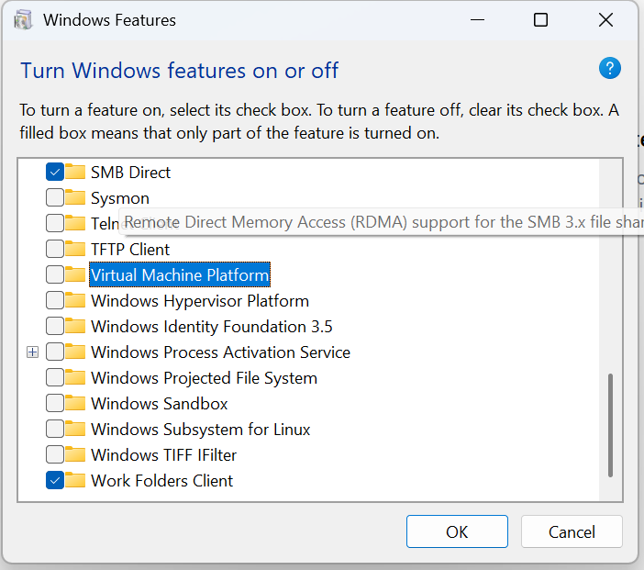
I also turned on Hyper-V, Windows' built-in virtualization platform.
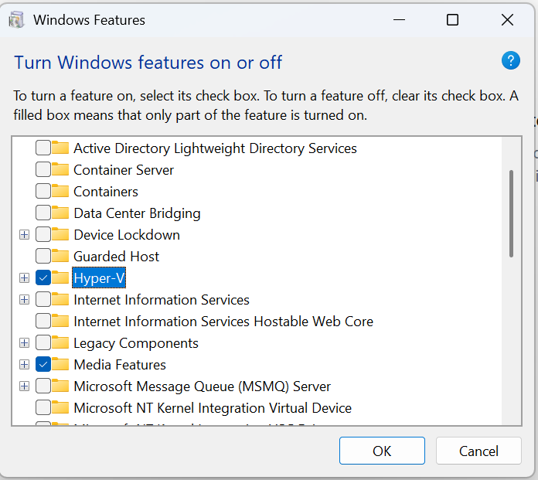
Windows applied the changes and asked for a restart, which is required before the new features load.
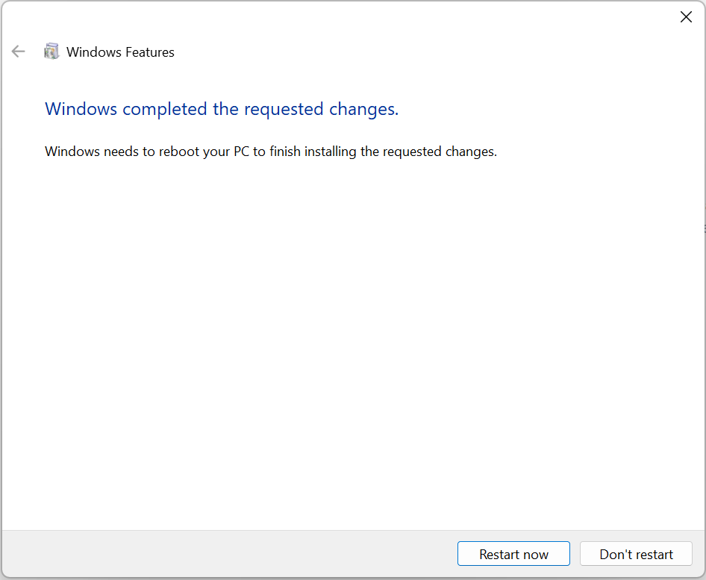
After restarting, Docker Desktop reported that WSL itself was not installed and told me to run wsl --install.
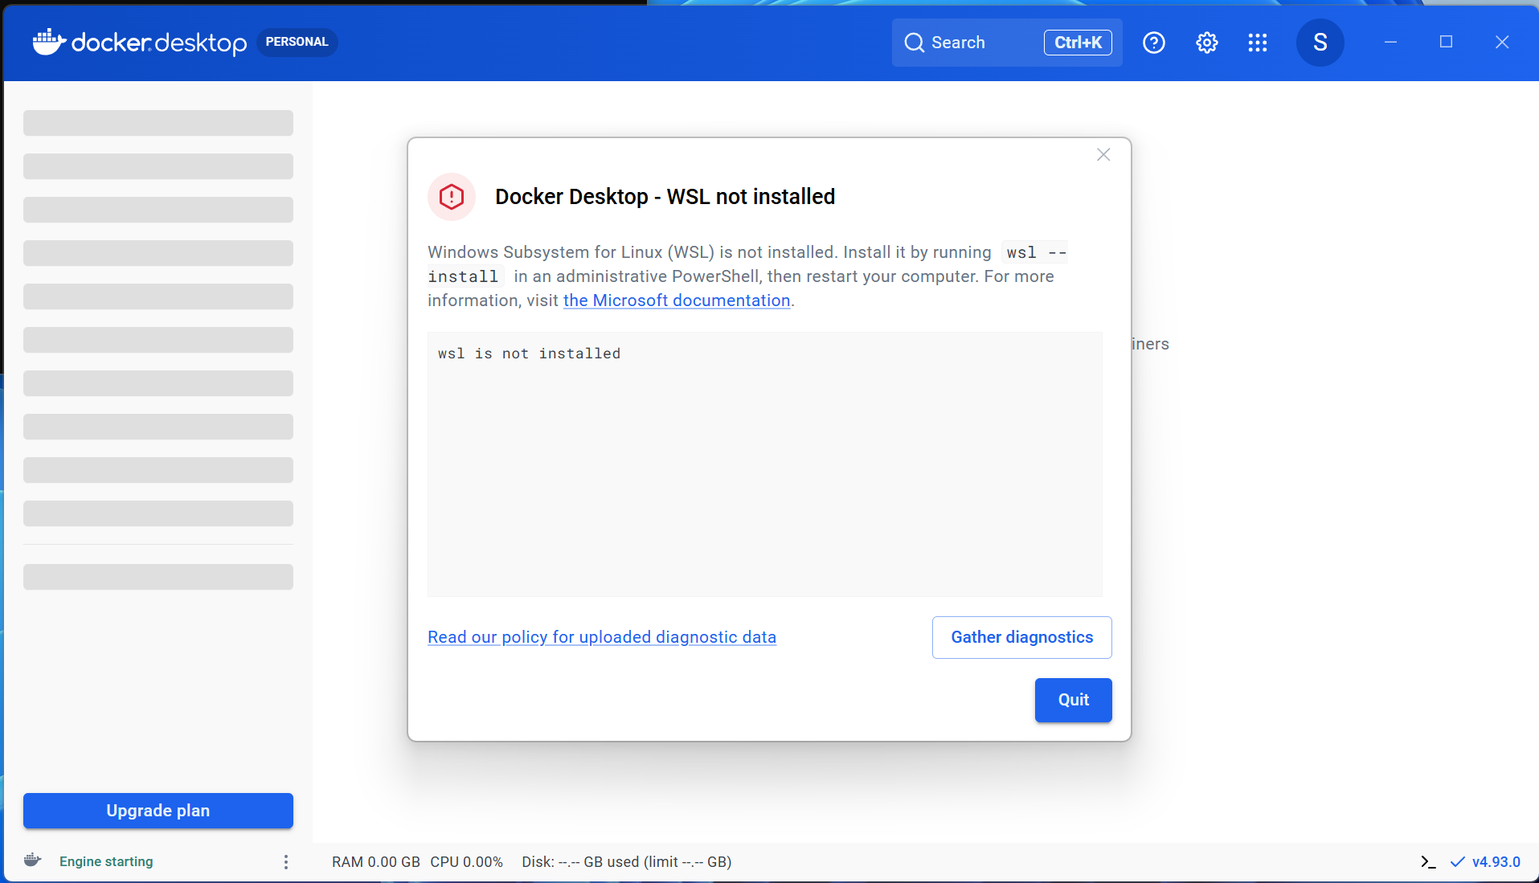
My first wsl --install in an Administrator PowerShell failed with "The server name or address could not be resolved", meaning the computer could not reach Microsoft's download server.
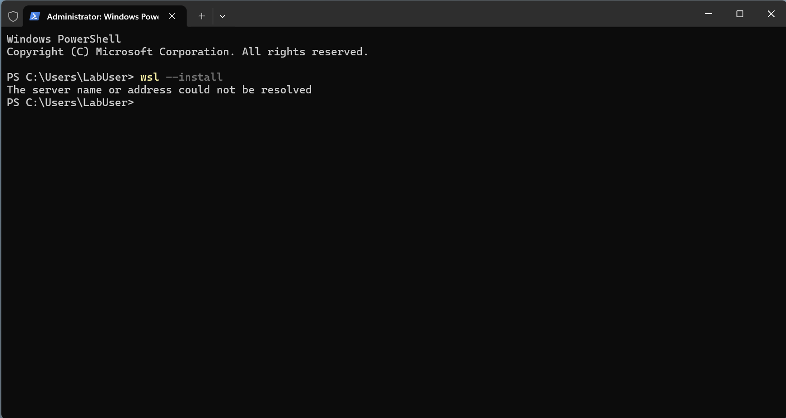
The cause was my VPN blocking the download. I turned off the VPN and reset the network settings with netsh int ip reset. After that, wsl --install downloaded successfully.
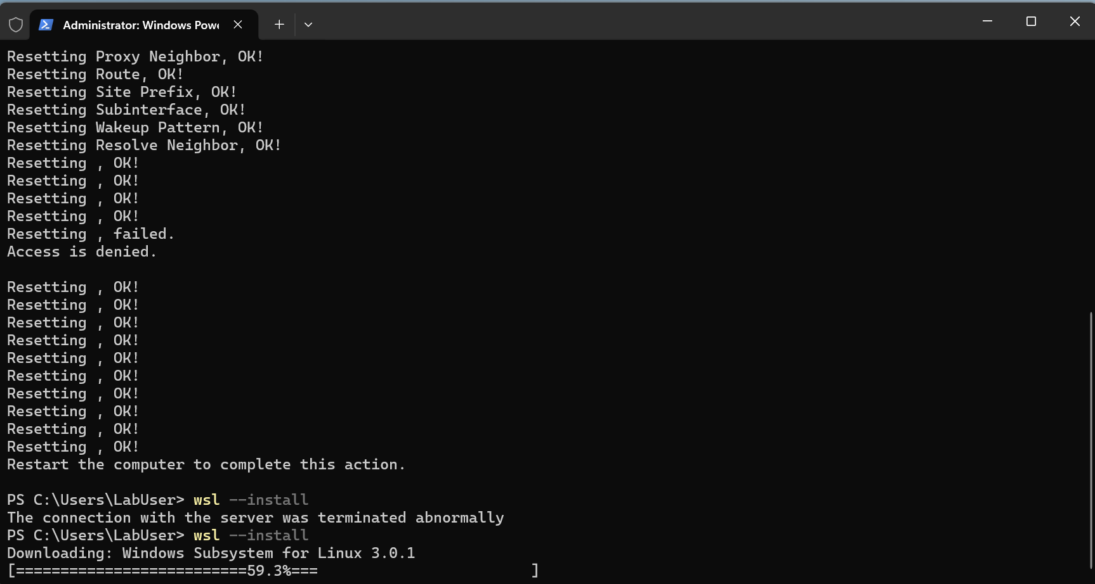
Once WSL finished installing, the Welcome to WSL window confirmed it was ready, including GPU Acceleration and Docker Desktop Integration.
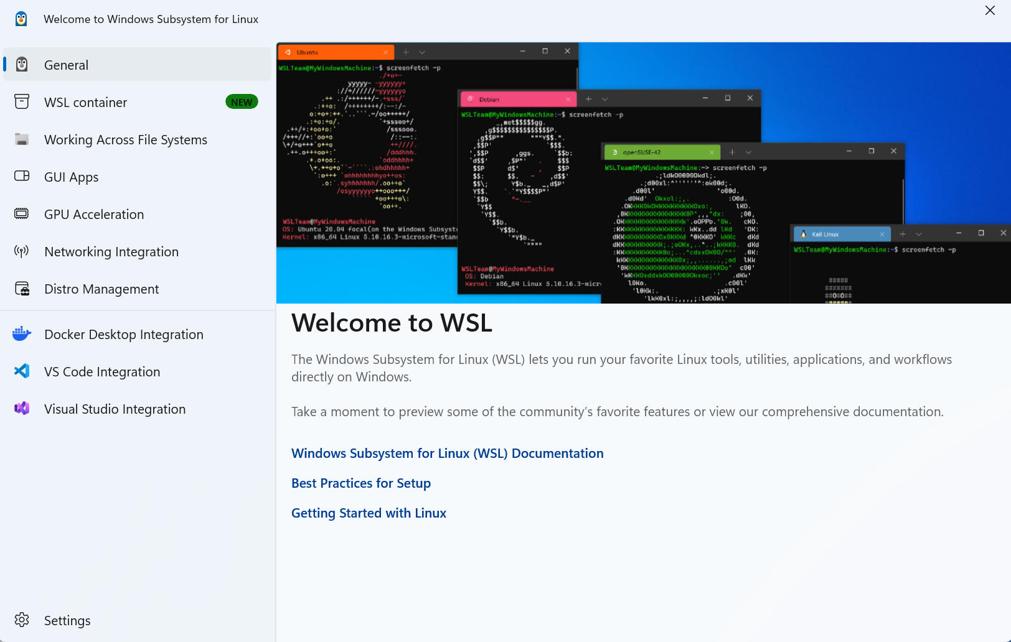
Docker Desktop now opened with "Engine running" at the bottom left, which means containers can be started.
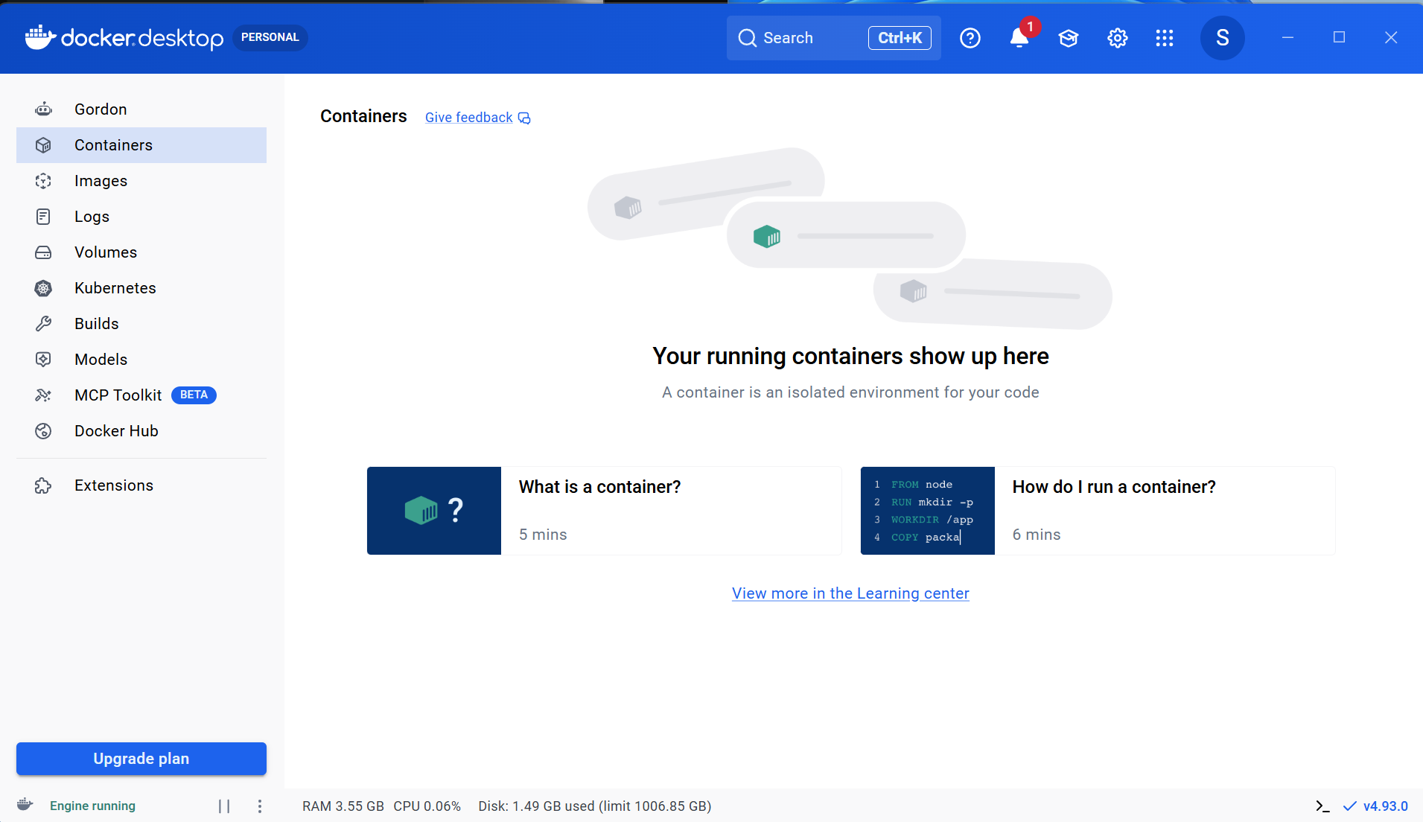
Part 2: GPU driver and WSL2 setup
In the NVIDIA app, I opened Drivers and downloaded the newest driver. WSL2 uses the Windows driver to give containers access to the GPU, so it must be up to date.
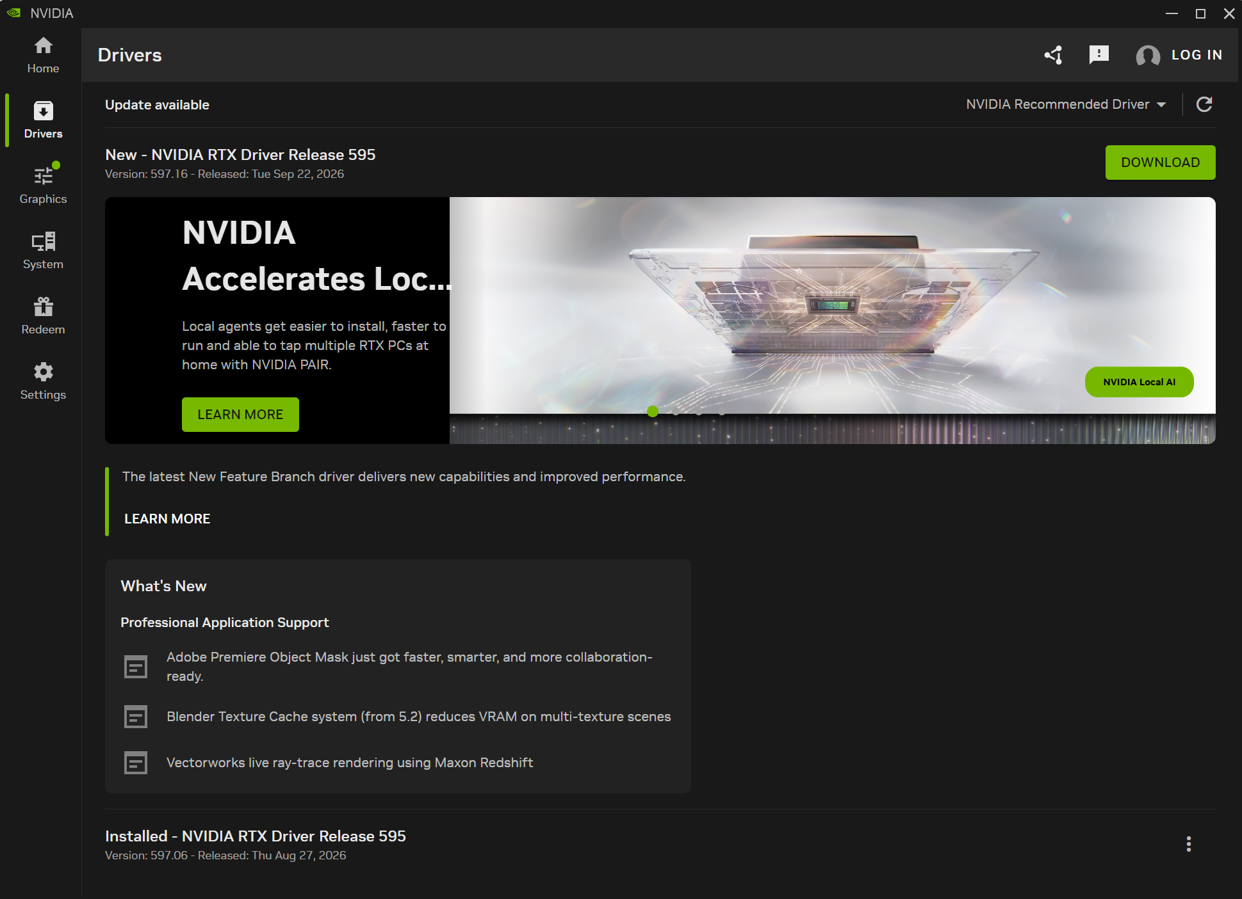
I chose Express installation, which upgrades the driver and keeps existing settings.
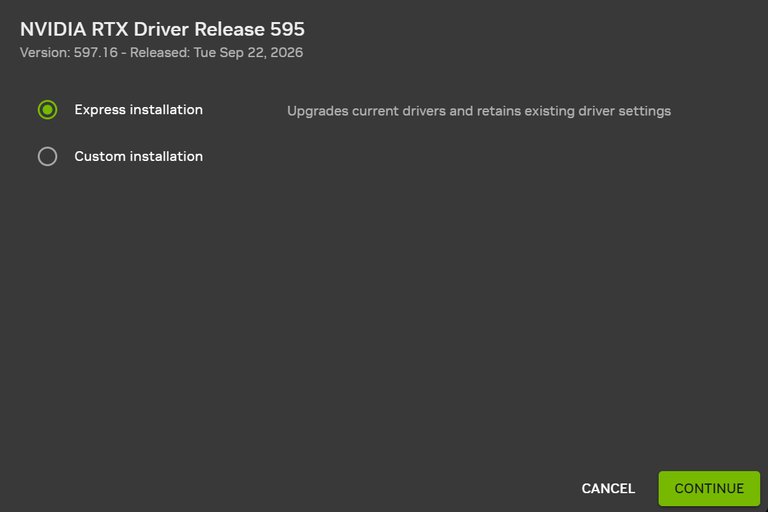
The driver installed. The screen can flash during this step, which is normal.
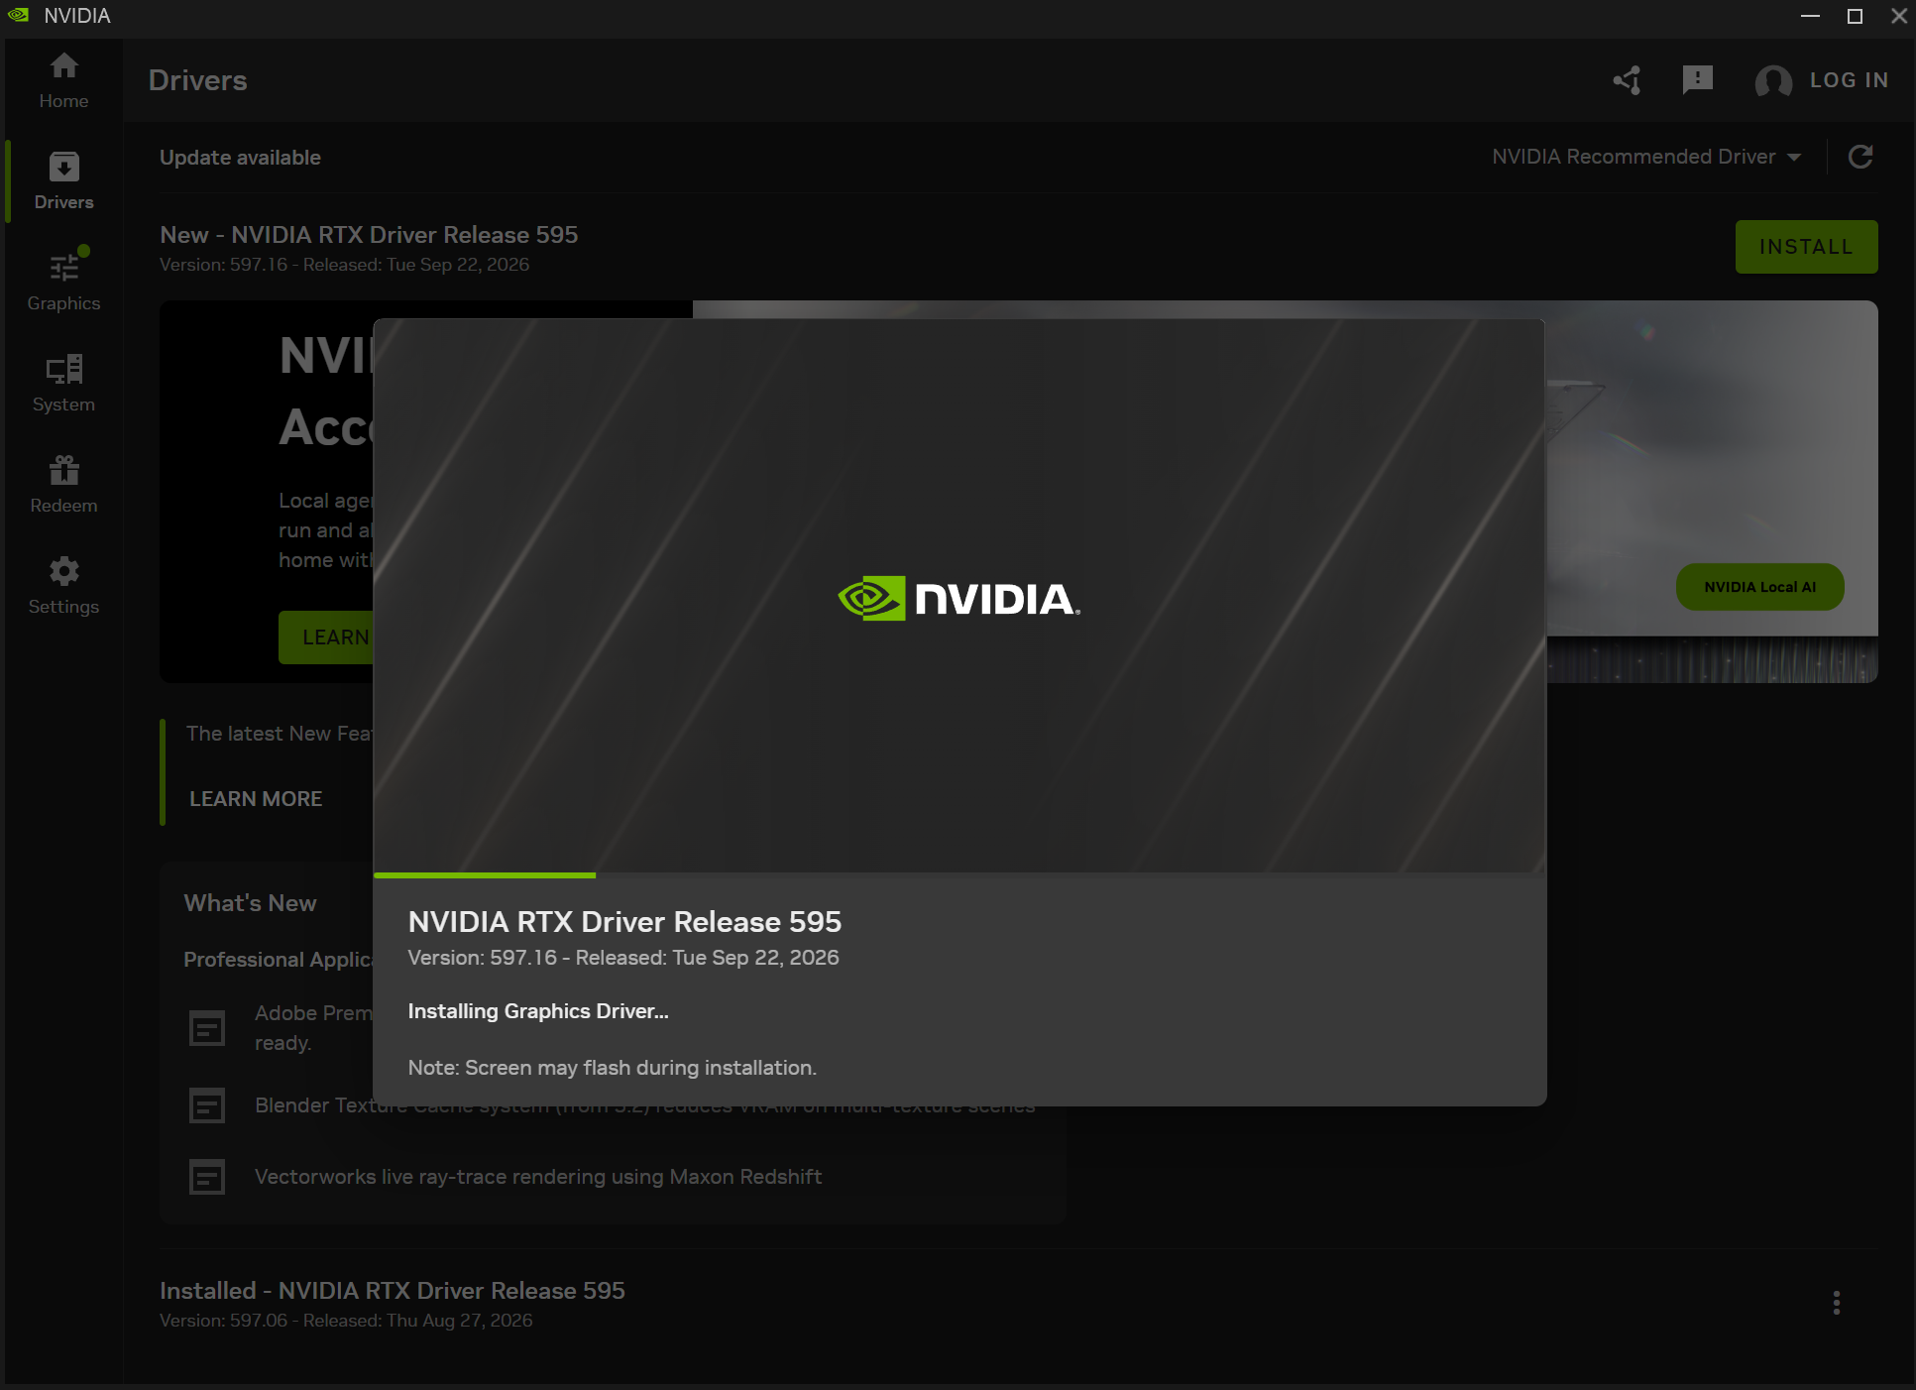
The installation finished with driver version 597.16.
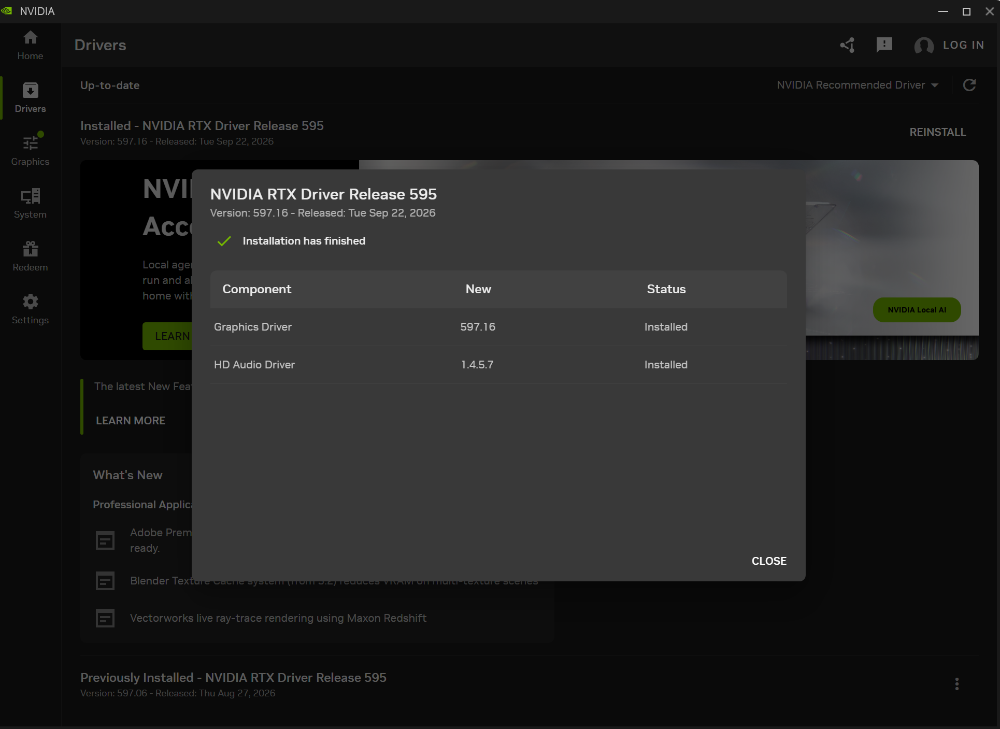
Running nvidia-smi in PowerShell confirmed Windows could see the RTX A4000 with the new driver and 16 GB of VRAM.
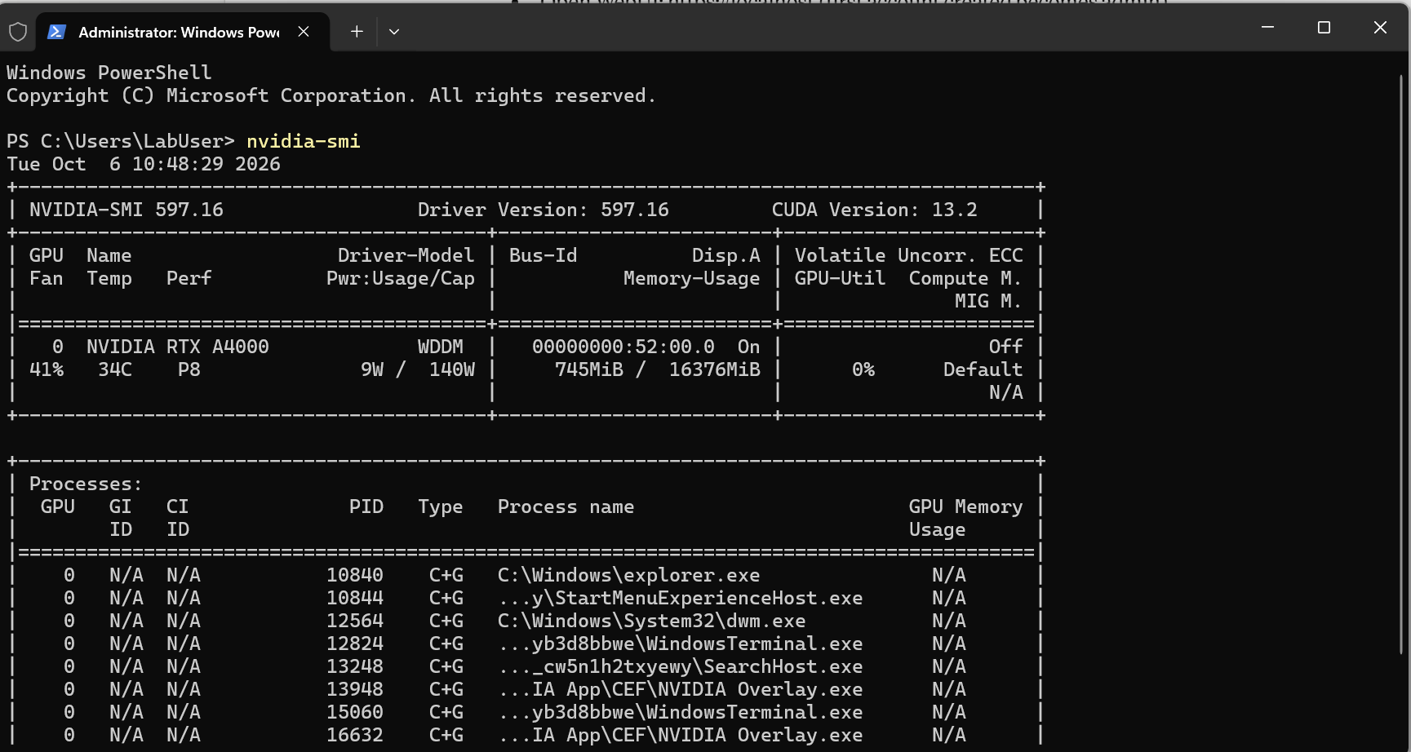
I ran wsl --update and wsl --version to make sure WSL was on the latest version, since GPU support depends on a current WSL kernel.
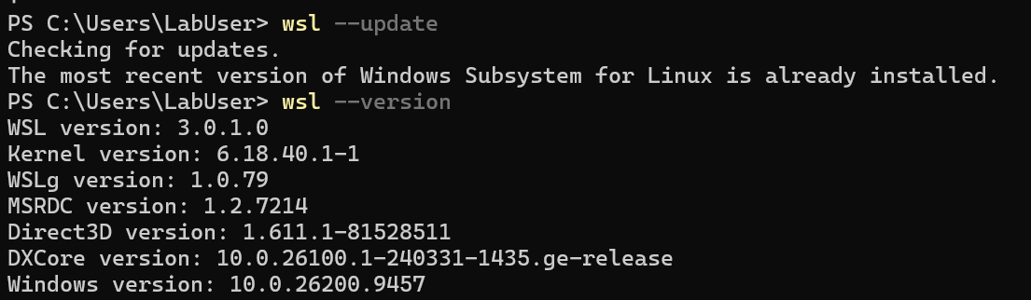
I tried to limit WSL's memory to 24 GB with 8 GB of swap. (These lines belong in a .wslconfig file, see Problems.)
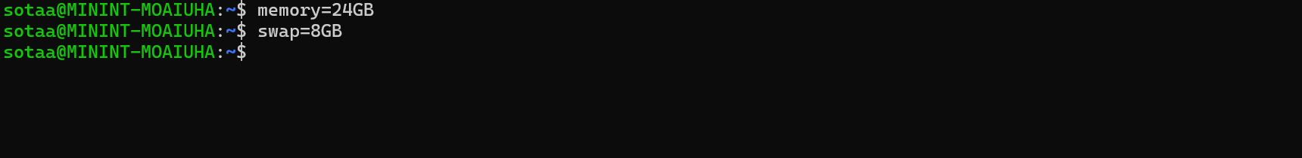
I ran wsl --shutdown so that WSL would restart and reload its settings.
In Docker Desktop Settings → General, I confirmed WSL2 was selected as the engine. This is the option that supports GPU pass-through.
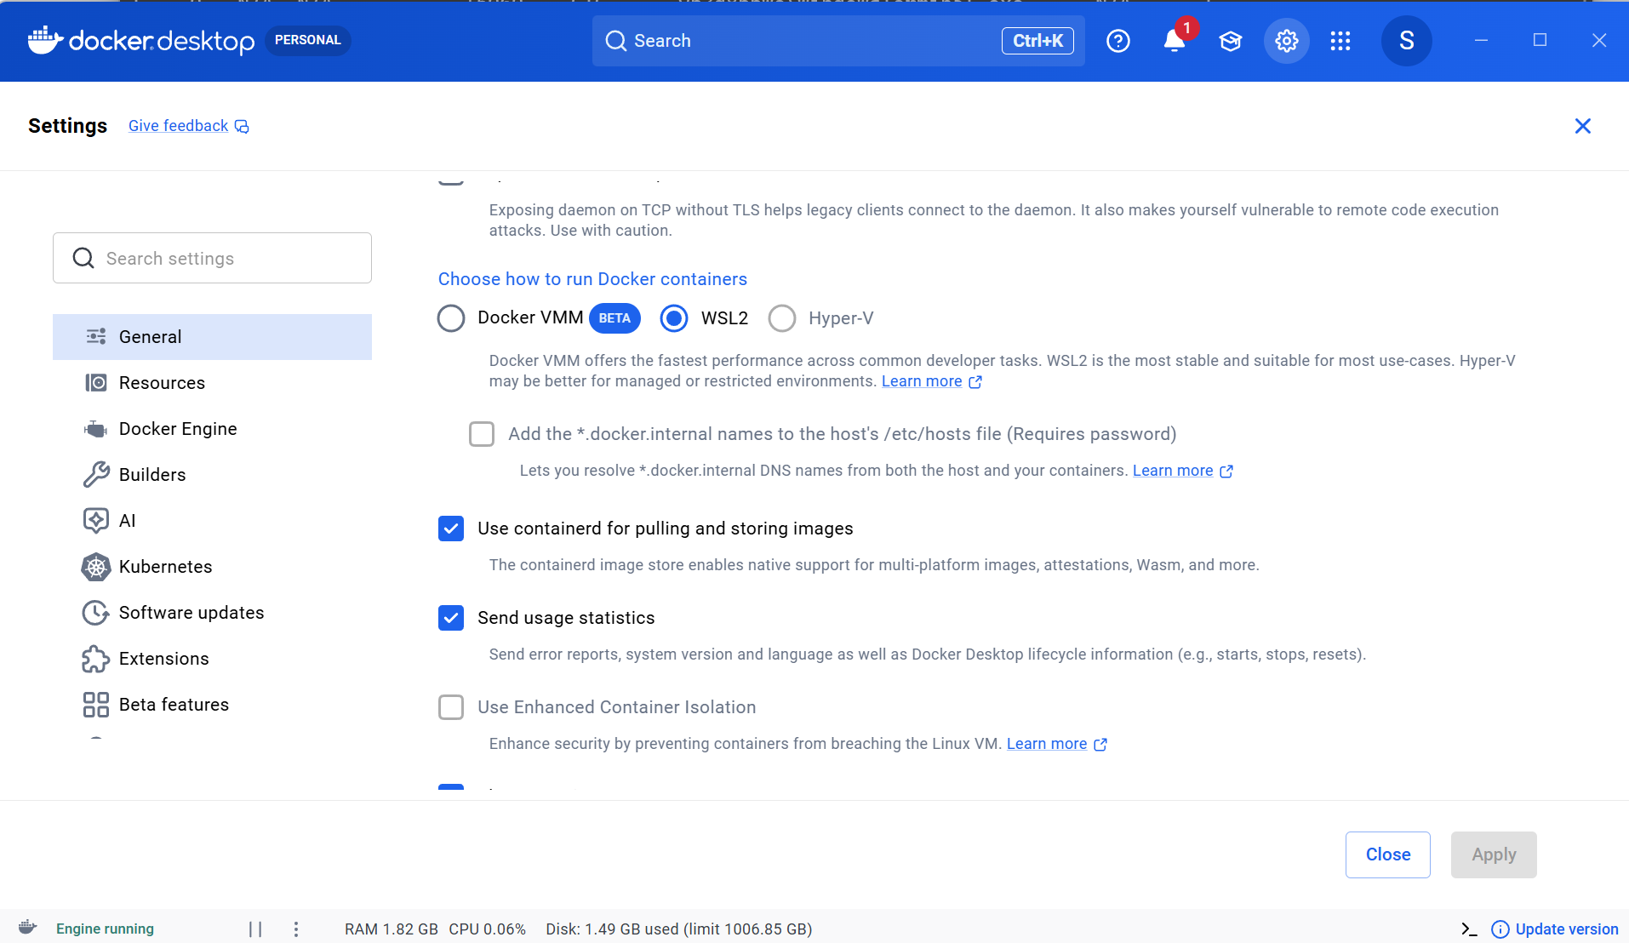
I ran a test CUDA container with nvidia-smi inside it. Seeing the RTX A4000 listed from inside a container proved Docker could use the GPU before I built anything on top of it.
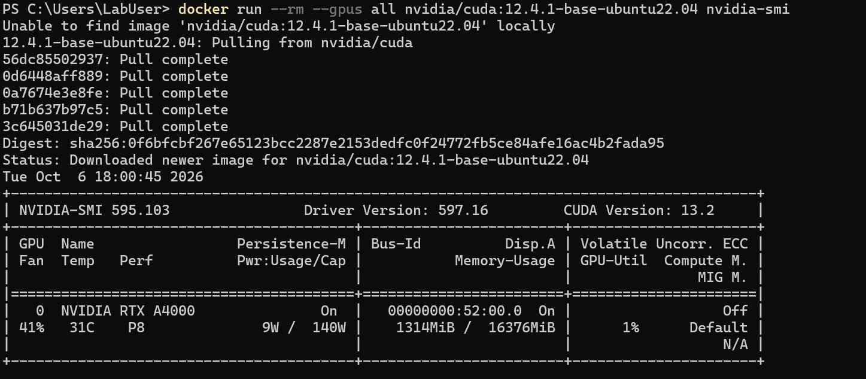
Part 3: Deploying the AI stack
From the local-ai-lab folder, I allowed scripts for this window only and ran init.ps1. It created the .env file with random secrets and generated an HTTPS certificate for NGINX.
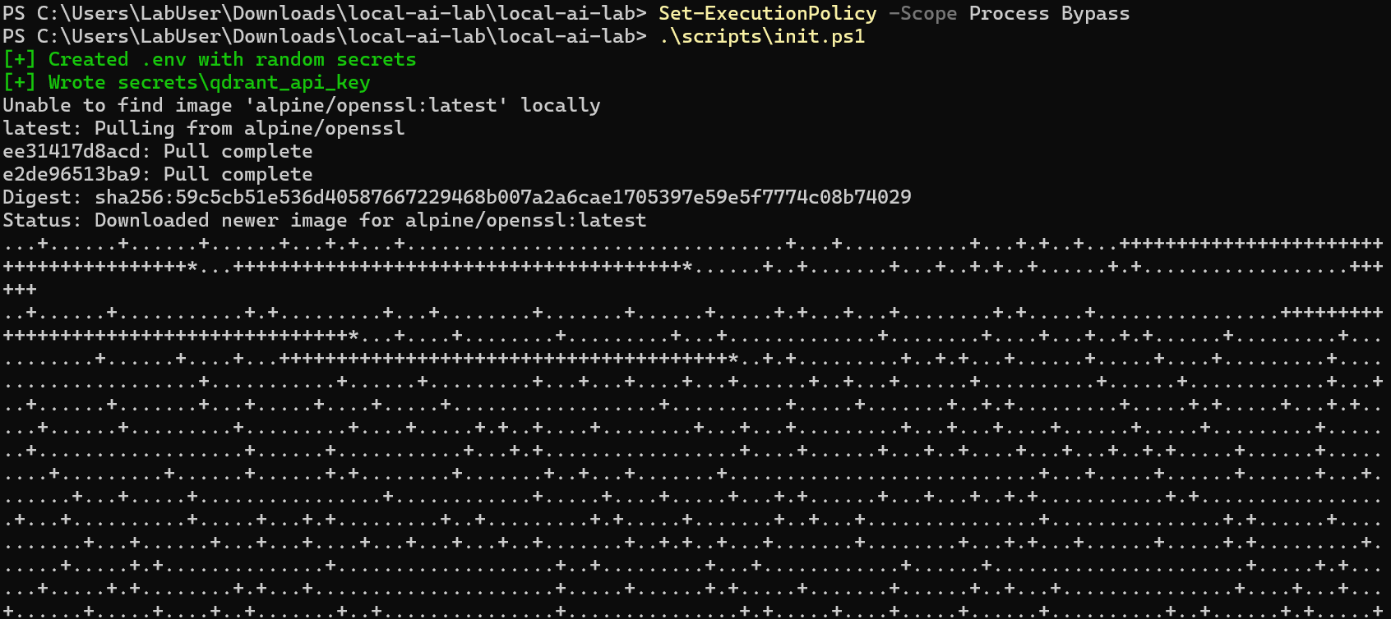
The script finished and printed the Grafana admin password and the next command to run. Generating random secrets keeps passwords out of the configuration files and out of Git.
Note: The blacked-out parts of this screenshot are my secrets (secret keys and the Grafana admin password). I hid them so they are not exposed in this report.
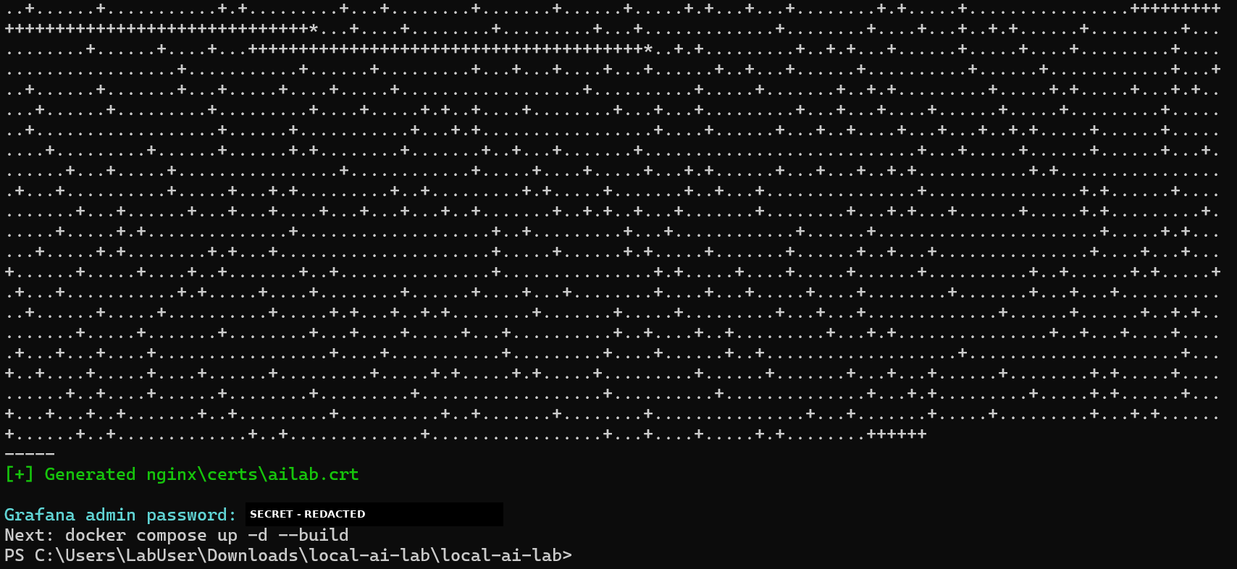
I checked the compose file for errors with docker compose config --quiet (no output means no errors), then started the stack with docker compose up -d --build.
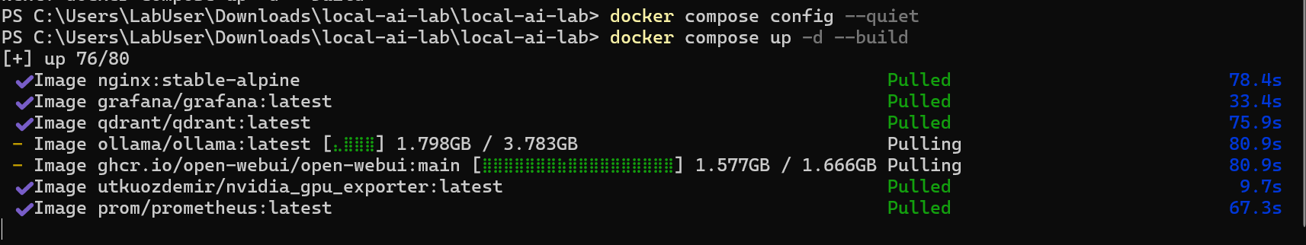
Docker pulled all the images and built the custom Ollama metrics exporter.
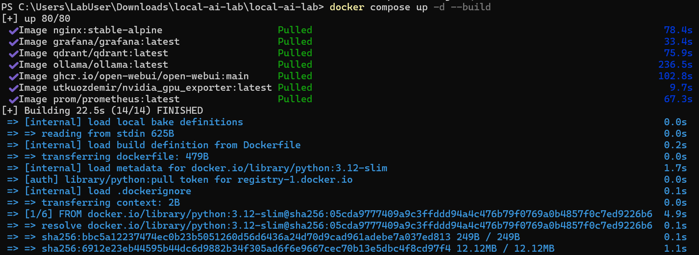
All networks, volumes, and eight containers were created. Containers start in order based on health checks, so Open WebUI waits until Ollama is ready.
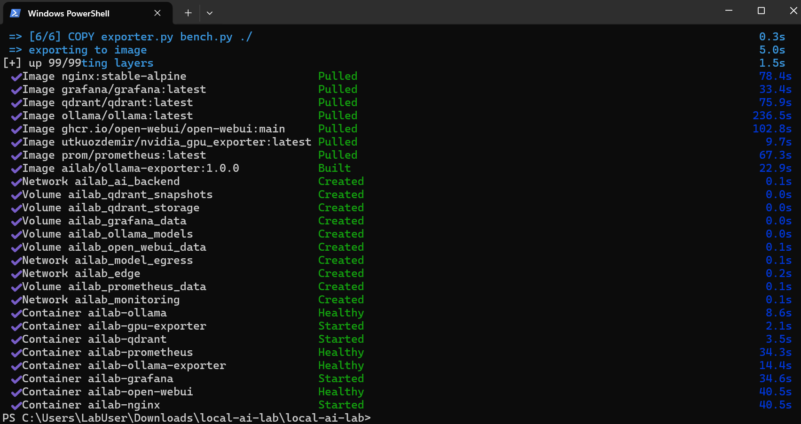
docker compose ps showed every container up and healthy. I then downloaded the Qwen3 14B chat model (9.3 GB).
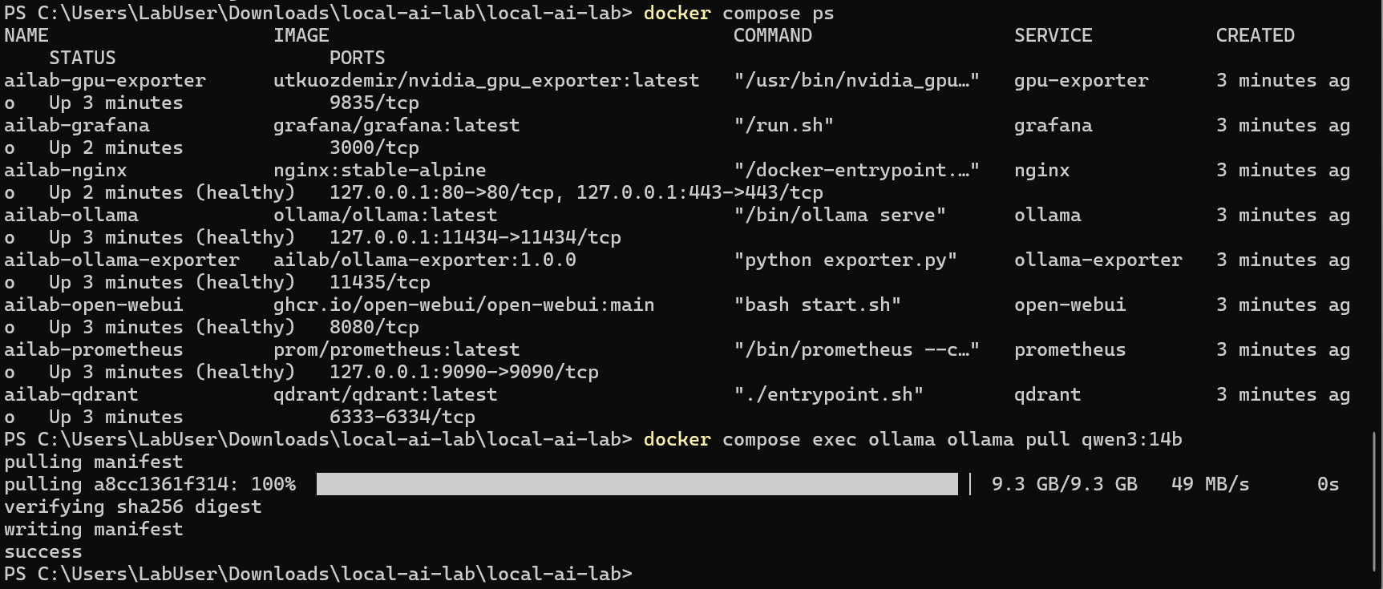
I downloaded nomic-embed-text, the small model that turns documents into embeddings for RAG.
I built lab-qwen3-14b from the Modelfile. This version forces every layer onto the GPU so it fails loudly instead of silently slowing down.
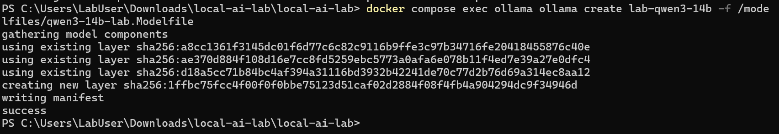
Part 4: Verifying the model runs in VRAM
The first test prompt took 1 minute 8 seconds, mostly from loading the 9 GB model from disk into the GPU (see Problems).
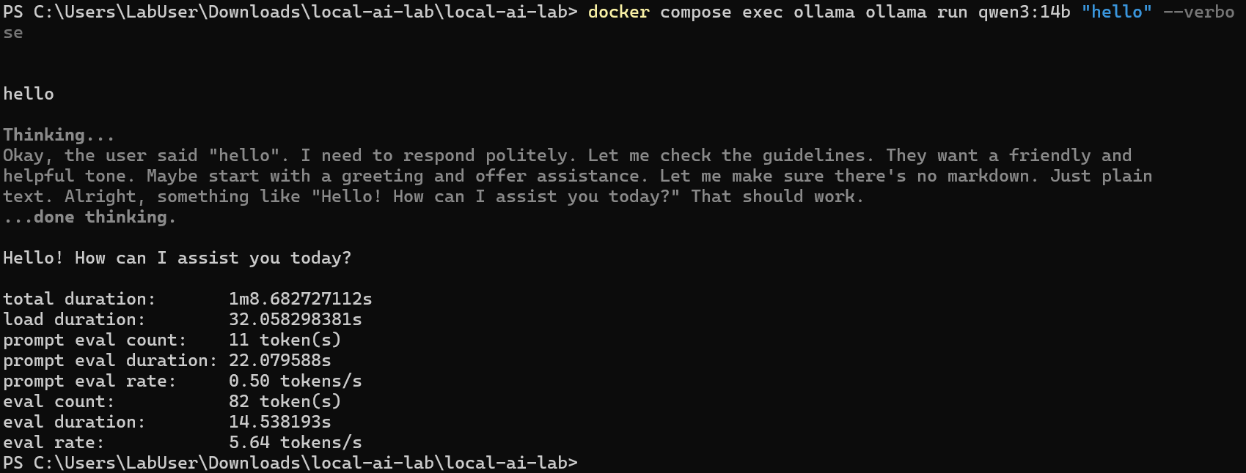
Running the same prompt again took only 2.6 seconds at 36 tokens per second, because the model was already loaded in VRAM.
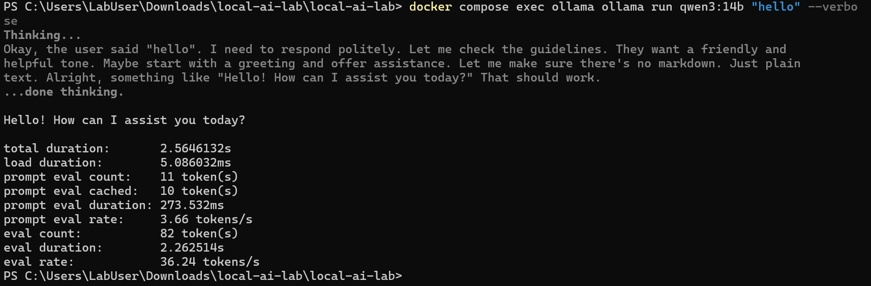
ollama ps showed the PROCESSOR column as 100% GPU, which confirms nothing spilled into system RAM.
The Ollama logs showed library=CUDA and "offloaded 41/41 layers to GPU", meaning every layer of the model is on the graphics card.
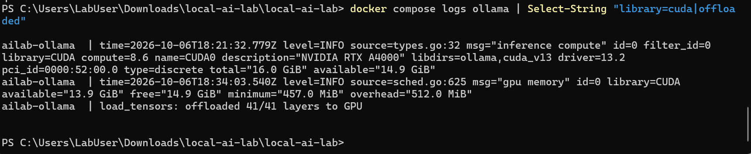
The Ollama API reported size and size_vram as the same number, a third confirmation that the model is fully in VRAM.
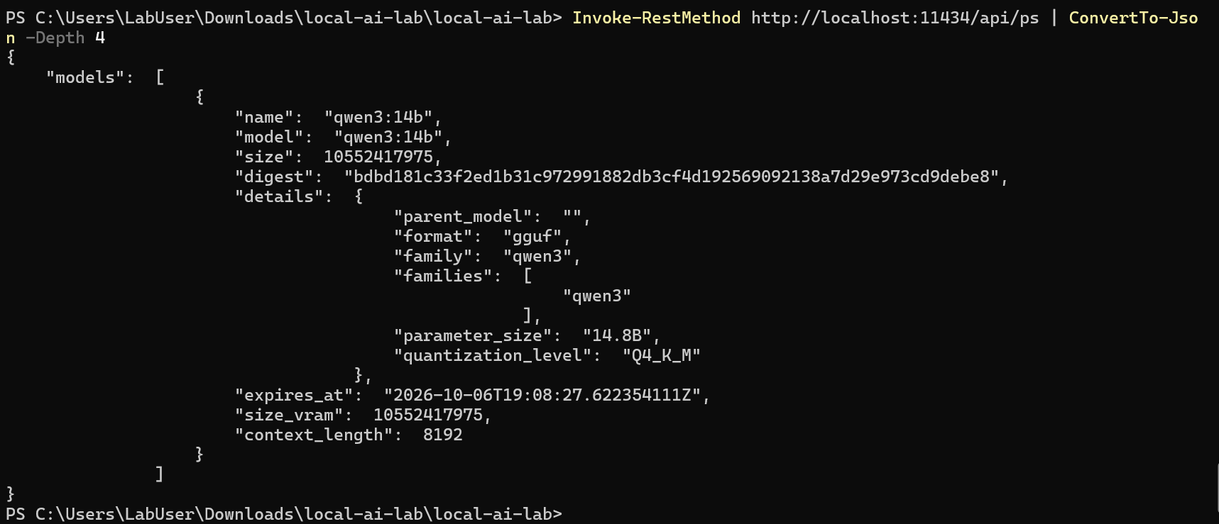
I opened Grafana at https://localhost/grafana and signed in as admin with the password from the .env file.
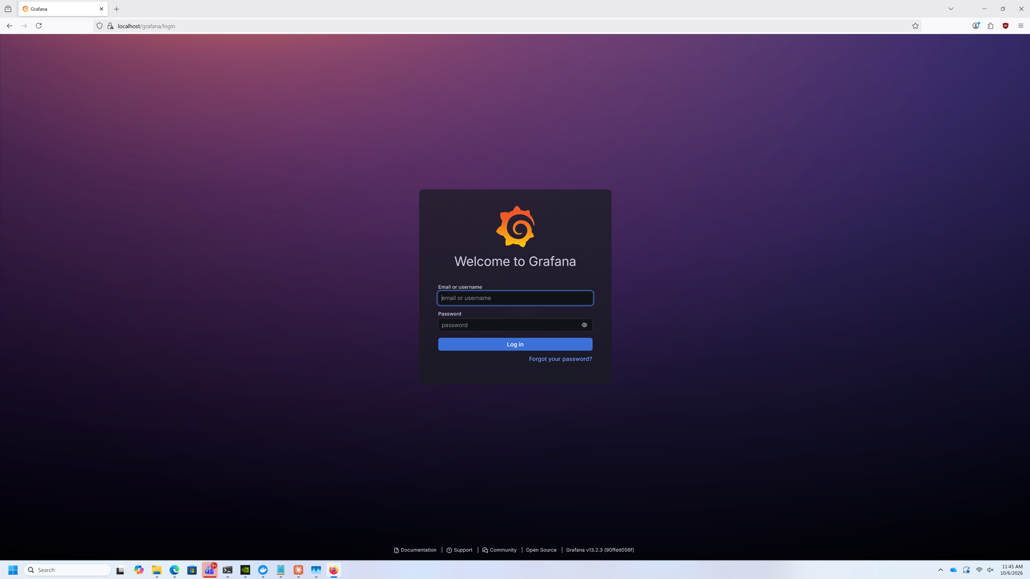
The AI Lab dashboard showed Model VRAM residency at 100% and 0 B spilled to RAM. The speed panels read Idle because no prompts were running yet.
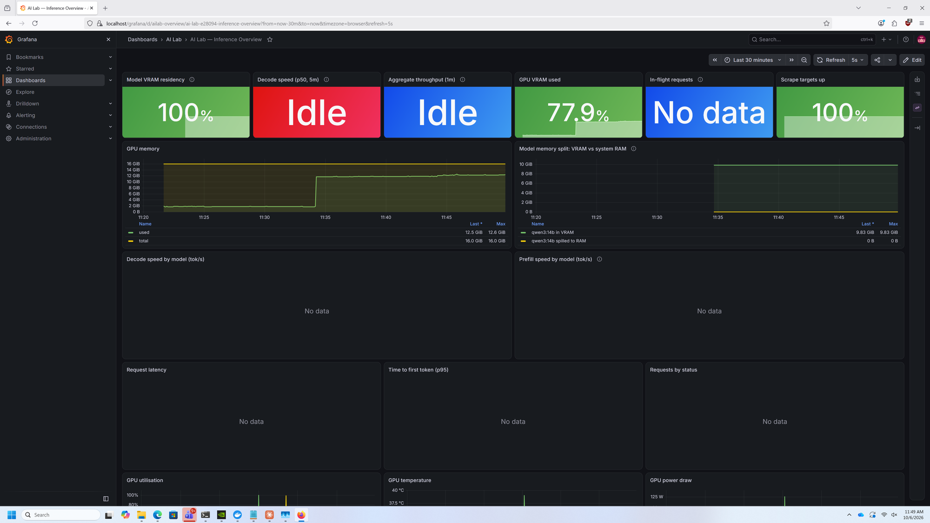
Part 5: Testing the chat interface and RAG
I opened Open WebUI at https://localhost. The first account created becomes the administrator.
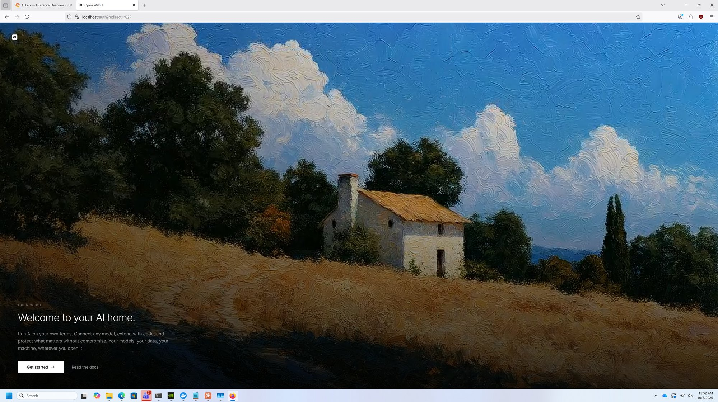
After signing in, Open WebUI showed its release notes, confirming the interface was running.
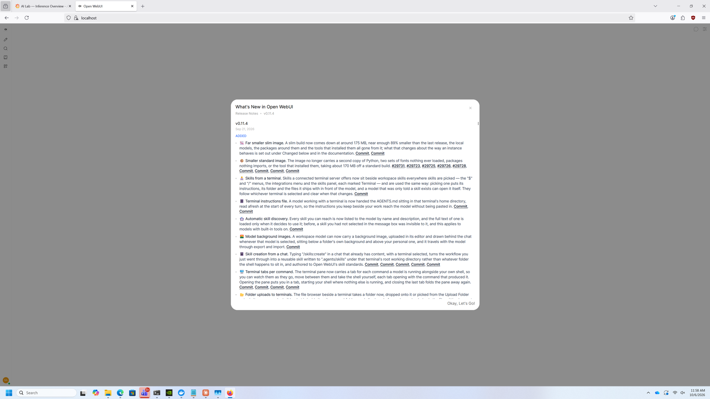
To test RAG, I uploaded a test document and asked the model about it. The model searched the document and reported "Retrieved 1 source".
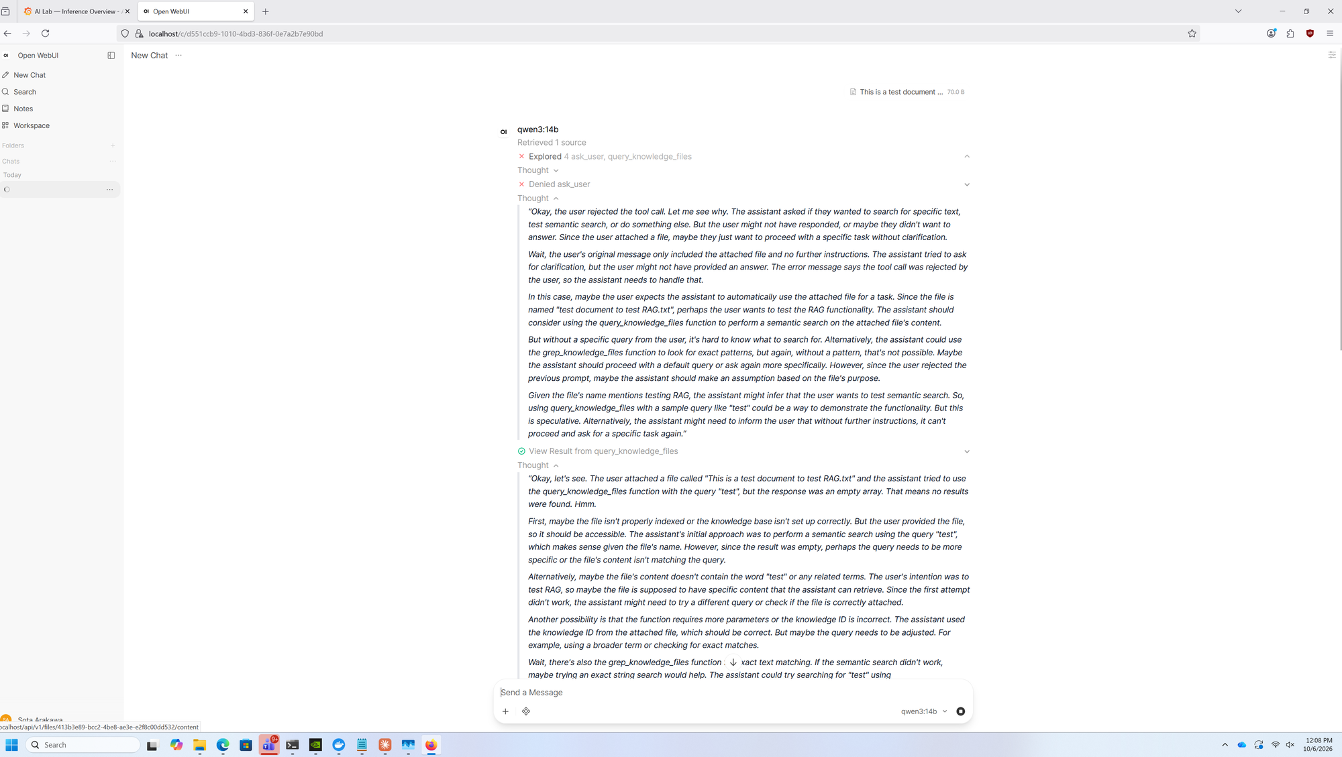
The answer cited the uploaded file as its source, which shows the document was stored in Qdrant and found again when needed.
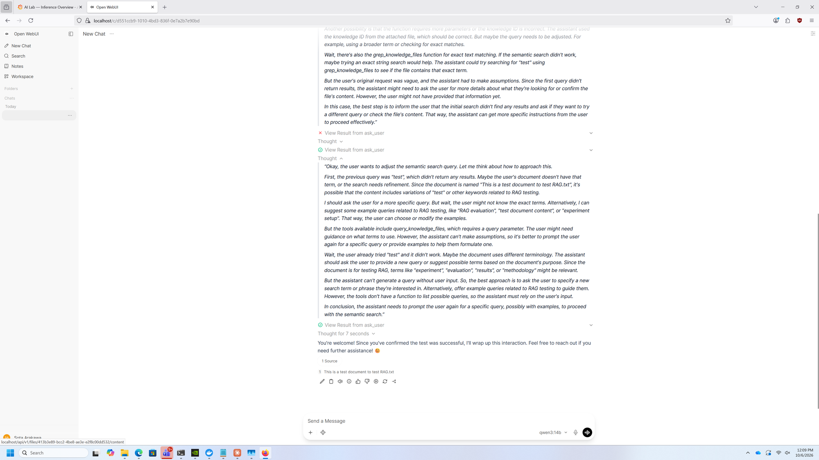
Back in Grafana, the dashboard now showed live data: about 34 tokens per second, both models fully in VRAM, and response-time charts.
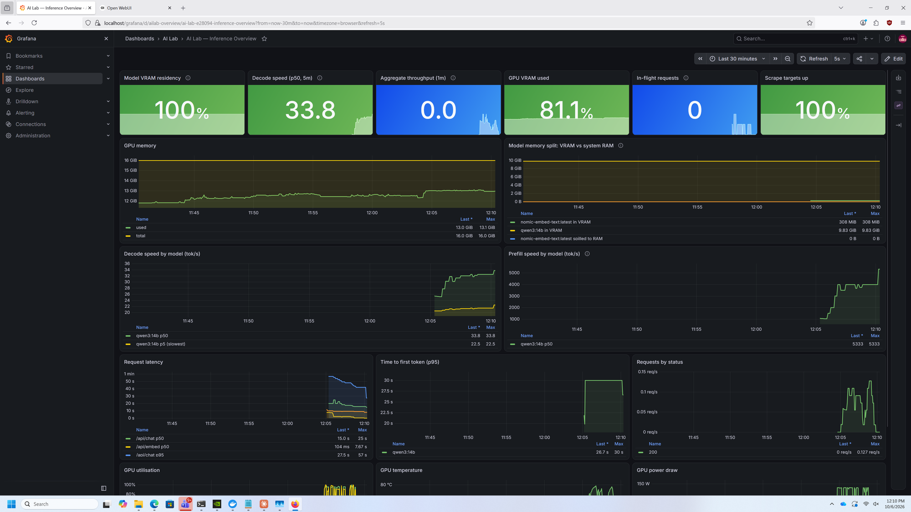
I ran the benchmark script at 1, 2, and 4 users at once. Each request stayed around 35-38 tokens per second, and total throughput doubled to about 70 with 2 users before levelling off, which matches OLLAMA_NUM_PARALLEL=2.
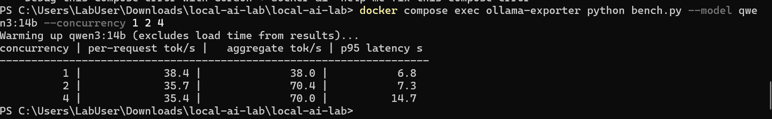
The model menu in Open WebUI listed all available models, including the custom lab-qwen3-14b profile.
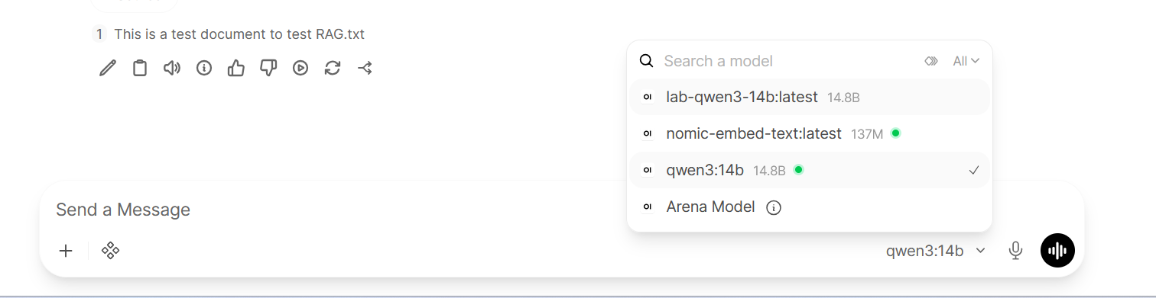
Part 6: Upgrading to three GPUs and a 30B model
With three RTX A4000 cards installed (48 GB of VRAM in total), I opened the local-ai-lab folder.
Inside the project folder, I located the .env file, which holds the lab's settings.
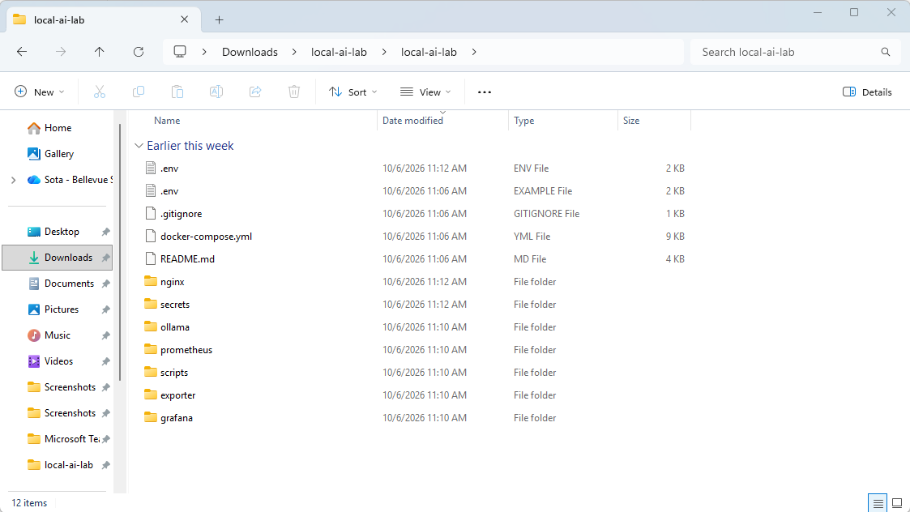
I opened .env in Notepad and changed CHAT_MODEL to qwen3:30b-a3b-q8_0 and OLLAMA_CONTEXT_LENGTH to 16384. The extra VRAM allows a larger context, so more of a document fits into each answer.
Note: The blacked-out parts of this screenshot are my secrets (secret keys and the Grafana admin password). I hid them so they are not exposed in this report.
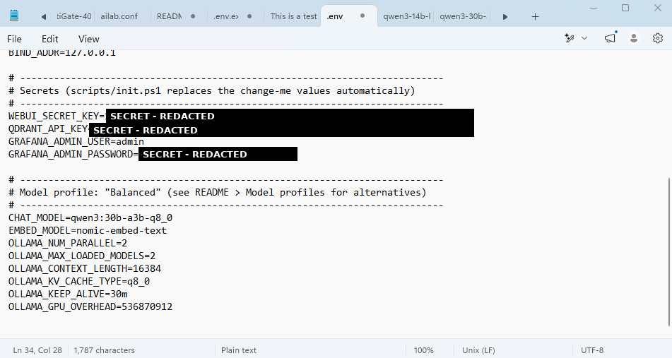
I ran docker compose up -d ollama open-webui so the containers would pick up the new settings.
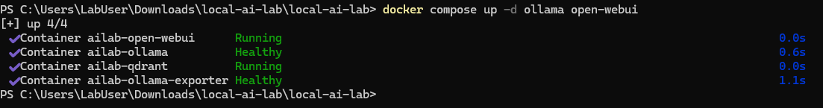
I downloaded the Qwen3 30B-A3B model in 8-bit quality (32 GB).
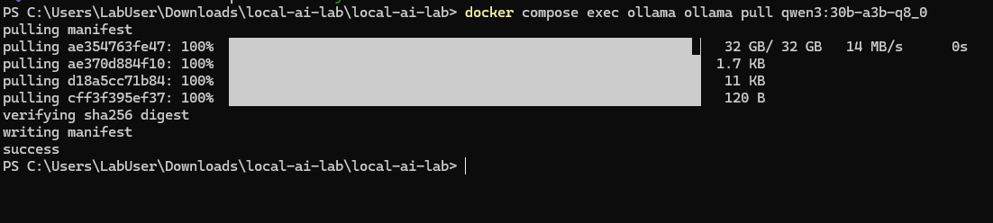
ollama list showed the new model next to the original models, so nothing was deleted and I can switch between them.
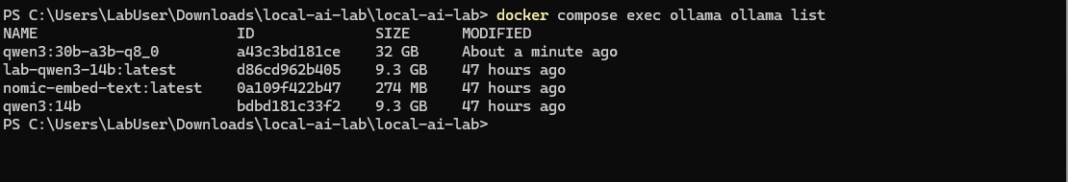
I opened the ollama folder in the project.
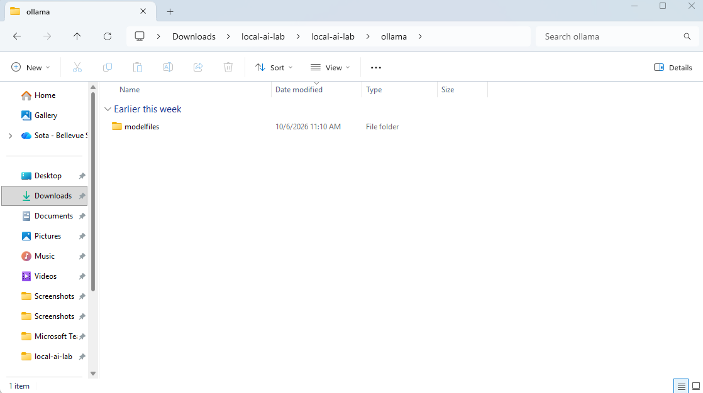
Inside it, the modelfiles folder held the existing 14B profile.
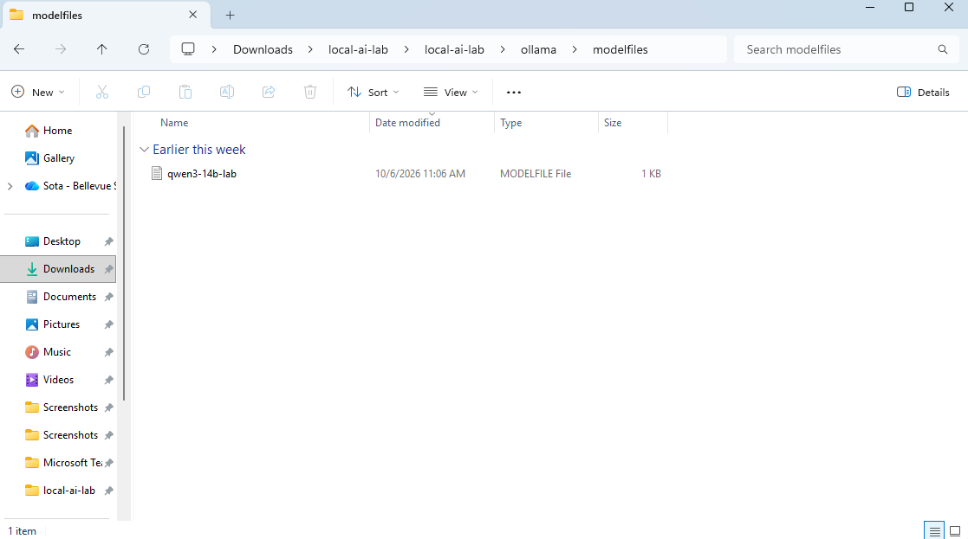
I created a new Modelfile for the 30B model next to the 14B one.
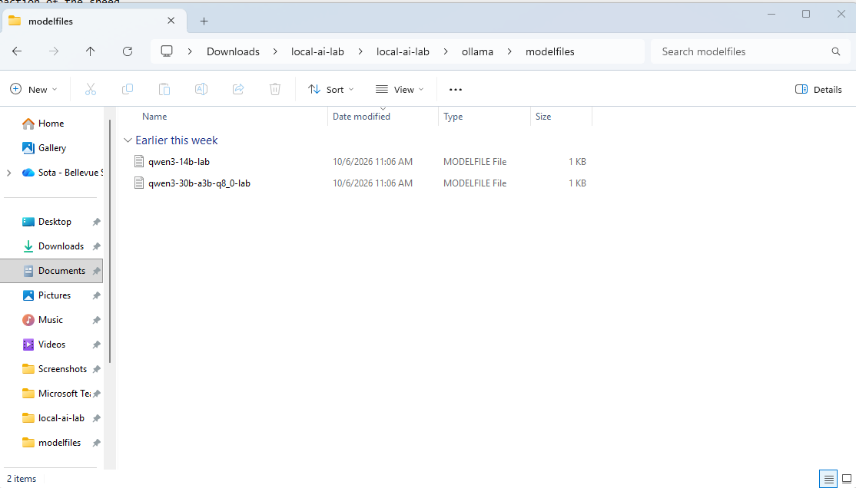
The new Modelfile points to qwen3:30b-a3b-q8_0, sets a 16K context, and forces every layer onto the GPU.
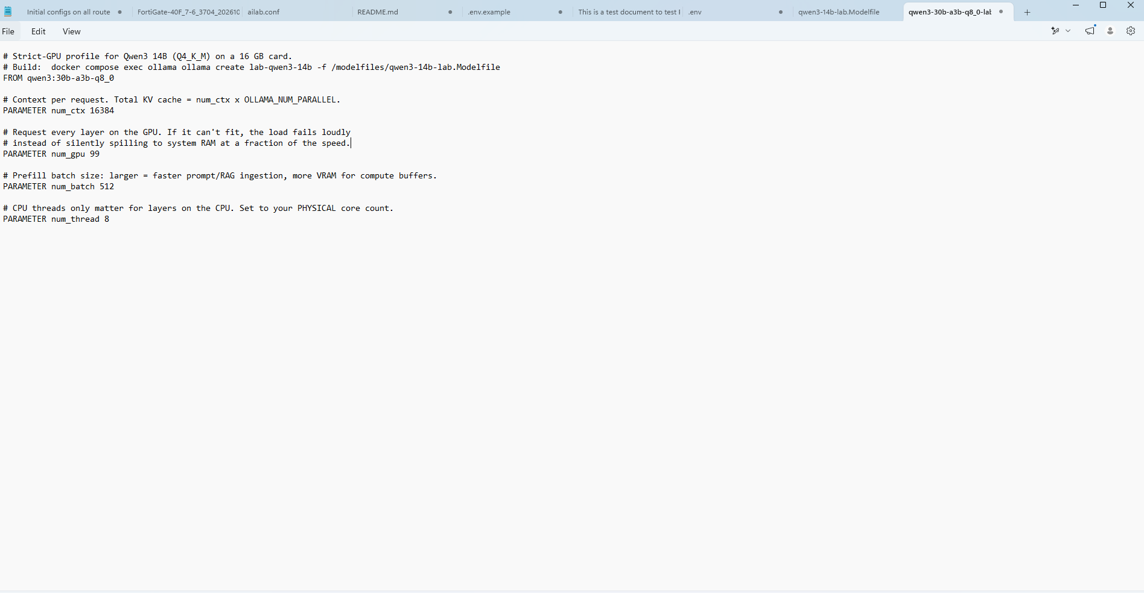
I built the lab-qwen3-30b-a3b-q8_0 profile from the new Modelfile.
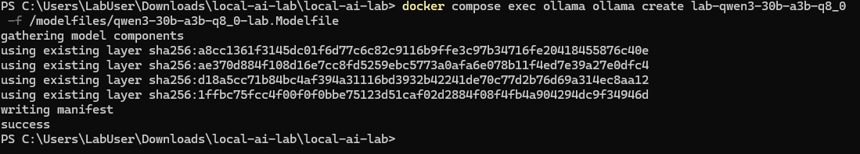
A test prompt on the 30B model generated 65.7 tokens per second, faster than the 14B, because this mixture-of-experts model only uses about 3 billion parameters per word.
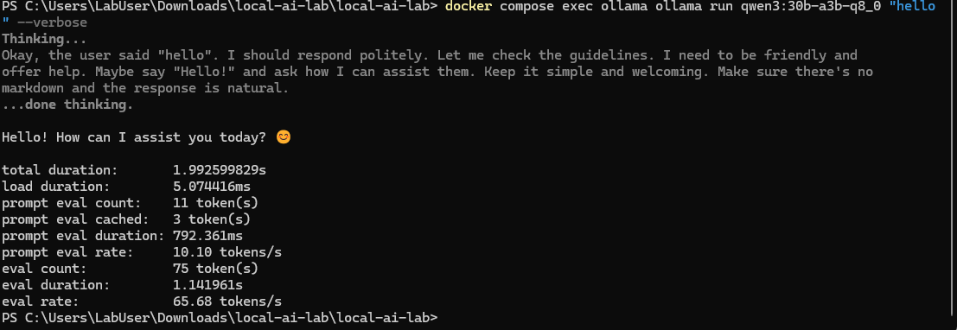
ollama ps showed the 33 GB model at 100% GPU. It is too big for one 16 GB card, so this proves it was split across the GPUs.
The logs showed "offloaded 49/49 layers to GPU", so every layer of the 30B model is on the graphics cards.
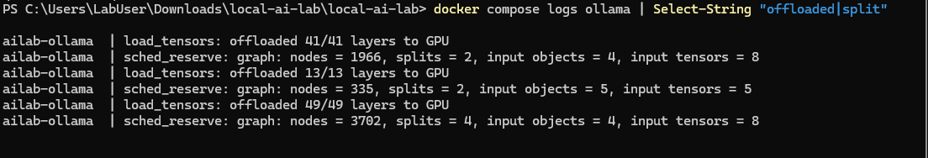
Because all three cards have the same name, I changed the Grafana dashboard to label each GPU by its unique ID instead.
I restarted Grafana so it would load the updated dashboard.
I benchmarked the 30B model at 1 and 2 users at once.
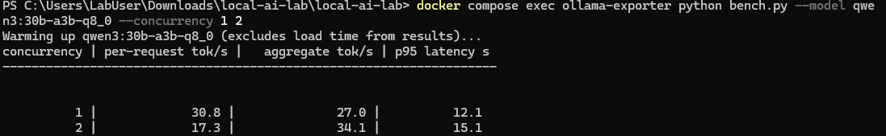
I chatted with the 30B model in Open WebUI to confirm it worked through the full stack, from the browser through NGINX to Ollama.
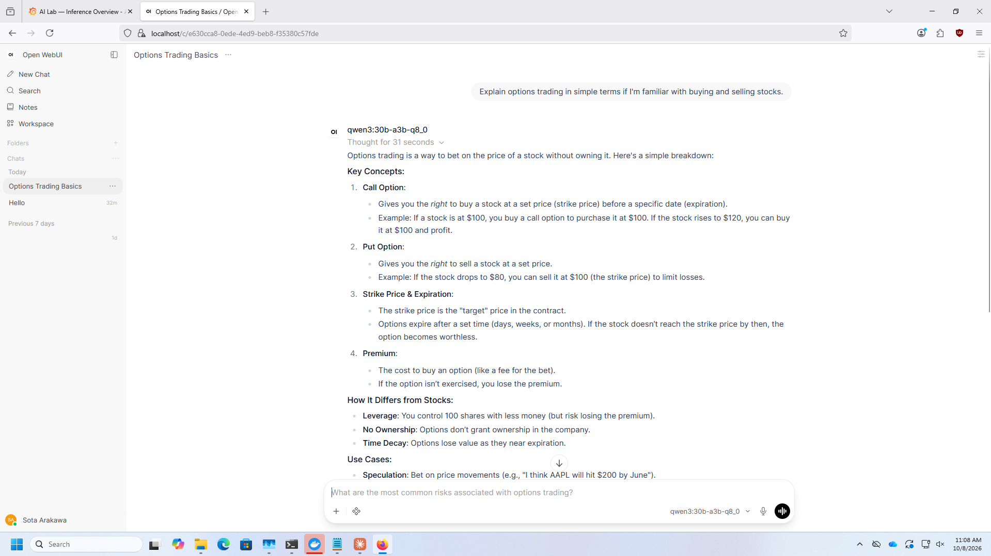
Grafana showed the 30B model at 100% VRAM residency with 31.5 GB on the GPUs and 0 B spilled to RAM. The GPU memory chart now has three lines, one per card.
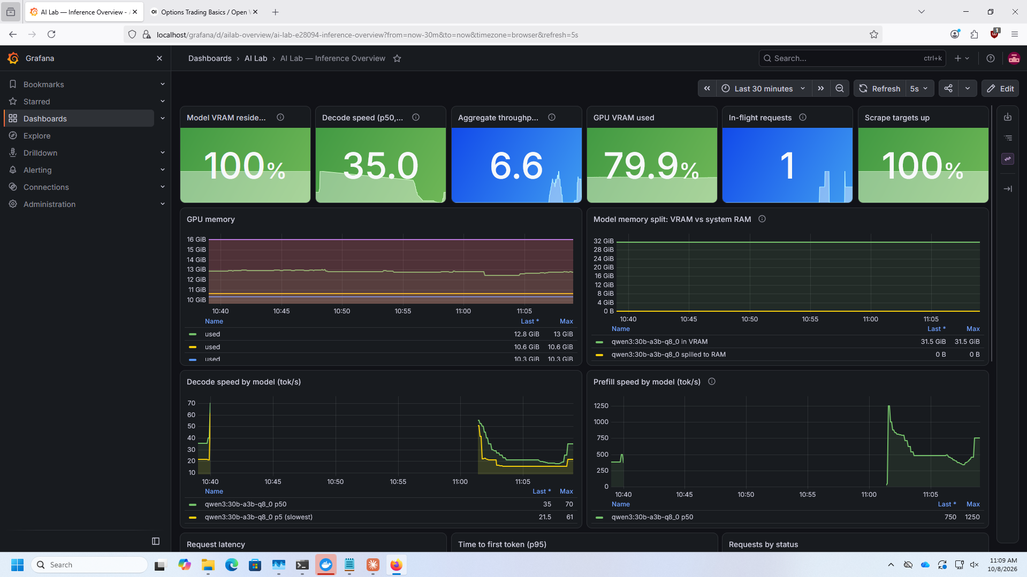
The Decode speed panel compares both models on the same chart, so their speeds can be compared side by side.
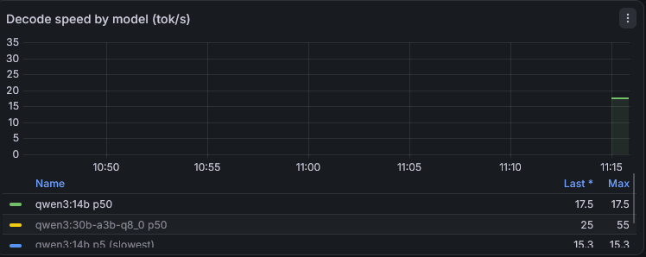
Docker Desktop shows the whole lab running as one ailab project.
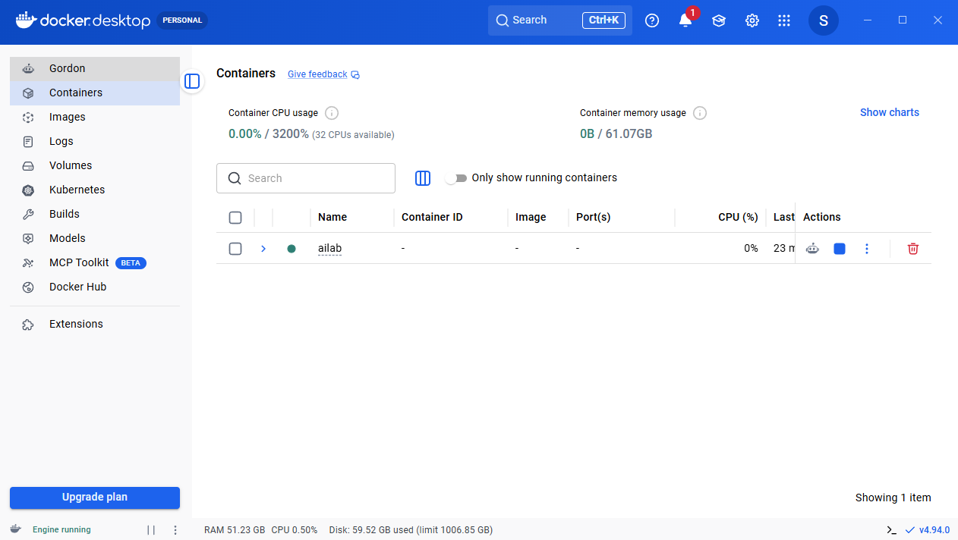
The Images tab lists every image the lab uses, including my custom ollama-exporter.
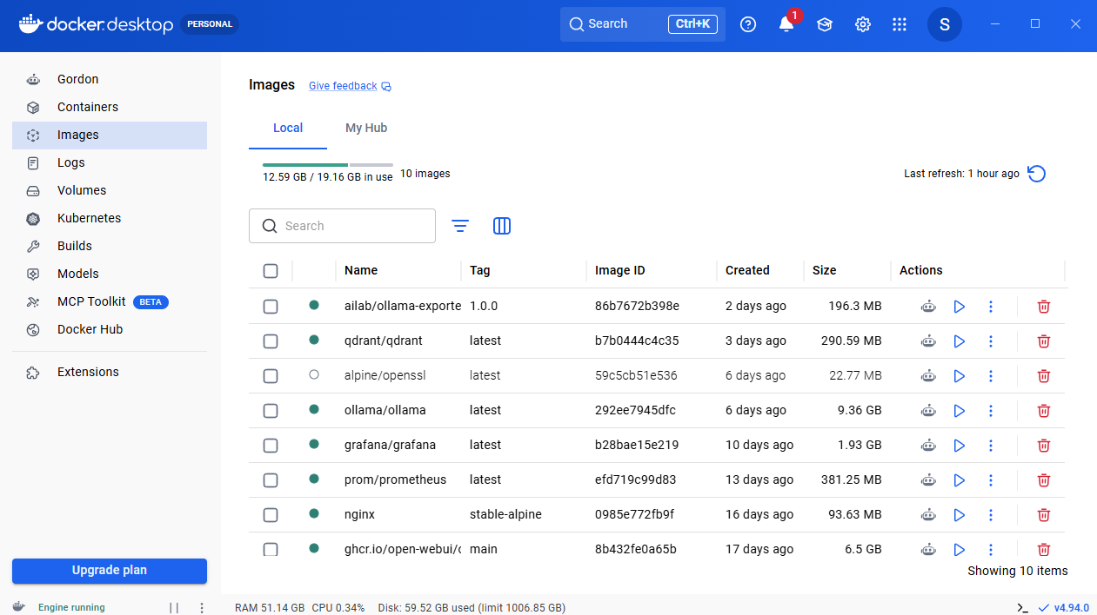
The Volumes tab shows where data is saved permanently. ailab_ollama_models holds 39.2 GB of downloaded models, which survive even if the containers are deleted.
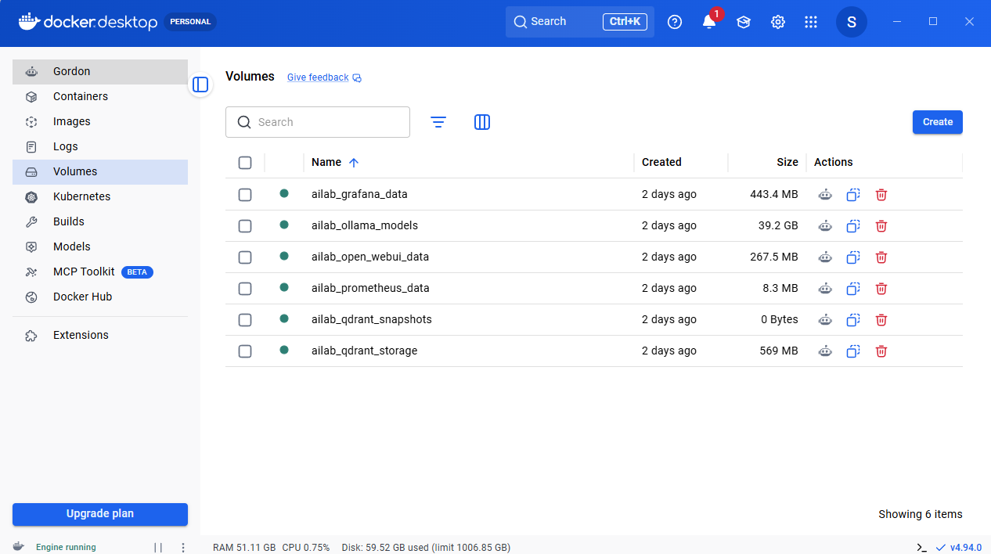
Problems:
Virtualization support is not detected on Docker Desktop: Docker would not start even though task manager showed virtualization was enabled in the bios. The problem was that the required Windows features were turned off. Turning on Hyper-V, Virtual Machine Platform, and Windows Subsystem for Linux, then restarting, fixed it.
wsl --install could not download: The install failed with "The server name or address could not be resolved" and later "The connection with the server was terminated abnormally". My VPN was interfering with the download. Turning off the VPN and resetting the network stack with netsh int ip reset allowed WSL to install.
The first AI response took over a minute: The first prompt took 1 minute 8 seconds, with 32 seconds spent loading the model and only 5.6 tokens per second. This was a one-time cold start while the 9 GB model was read from disk into the GPU. The second prompt finished in 2.6 seconds at 36 tokens per second.
Grafana asked for a login: Grafana showed a sign-in page I did not expect. The username is admin, and the password is the random value init.ps1 saved in the .env file under GRAFANA_ADMIN_PASSWORD.
No certificate warning appeared at https://localhost: The lab uses a self-signed certificate, so a warning was expected. Firefox did not show one because it had already saved an exception for localhost. Firefox keeps its own certificate list separate from Windows, so importing the certificate into Windows was not needed. The connection is still encrypted.
The first RAG test needed a second try: When I uploaded the test document without a clear question, the model first tried to ask me what to search for, and its first search for "test" returned nothing. After I confirmed, it found and cited the document. RAG works best with a specific question about the document's contents.
The new context length did not take effect after the upgrade: My screenshots show docker compose up -d ollama open-webui reporting the containers as "Running" instead of "Recreated", because I ran it before saving the .env changes. As a result, ollama ps still lists the 30B model with a context of 8192 instead of 16384. Running the same command again after saving .env applies the new setting.
Conclusion:
This lab showed me how to build, secure, and monitor a private AI platform from start to finish. The hardest part was preparing since windows virtualization, WSL2, and a VPN conflict all had to be solved before Docker could run. Once that foundation was in place pulling and running the AI models were easy

