Project Proposal
YEDI + TIDAL
Two-Sided Staffing & Compliance Platform
From a Built Platform to Commercial Launch
Flutter Mobile (iOS & Android) + Laravel / Filament Web Admin
Version: v1.0
Authored by: Otis Hoang
Approved by: Bryan Du
United Kingdom, July 2026
Presenter
Presenter | Position | Division
Bryan Du | CDO | Global Delivery
Edit History
Date | Version | Description | Editor
July 8, 2026 | 1.0 | Create | Otis Hoang
Approval
Approved date | Version | Approved by | Position
 | 1.0 | Bryan Du | CDO

Table of Contents

1. Project Overview
Yedi and Tidal are a two-sided staffing platform — Yedi connects schools and safeguarding-regulated settings with teachers and support staff; Tidal connects brands and employers with candidates across beauty, retail and events — built on one shared Laravel + Filament core with native Flutter mobile apps for both sides of the marketplace. Sotatek proposes a “keep & extend” programme (no rebuild): we take the client’s existing product from its current state to a production, transacting release that both brands launch on together, delivered on a single shared multi-tenant foundation.
Unlike a typical estimate, the figures in this proposal are not indicative — they are grounded in a completed source-code review (July 2026) of the live Laravel back end and Flutter apps. We have already confirmed what is built, what is reusable, and what remains. There is no separate pre-project audit phase and no additional approval gate: the assessment is done, and the scope and price below reflect the real codebase.

Current State — Verified from Source Code
We reviewed the actual repositories — not just the admin panel — for both the API and the mobile apps. The backbone is real, shipped, and reusable: roughly three-quarters of the Phase 1 release already exists or is substantially in place.
- Shipped mobile apps (both sides): release-signed Flutter apps for applicants and advertisers are already live — onboarding, browse/apply, bookings, ratings, profile and document viewing all exist as native iOS/Android apps.
- Working application lifecycle: apply / accept / decline / rate / cancel with server-side policies and automatic sibling-application handling — the core loop functions today.
- A real billing engine: invoice, payslip and contract generation already runs when an assignment completes, with VAT handled and immutable invoice snapshots — this is present, not absent.
- Compliance onboarding with an enforcement gate: references, right-to-work, declarations, evidence uploads and video verification feed a booking gate on compliance status.
- One shared white-label foundation: Yedi and Tidal run from the same codebase, re-labelled and configured per brand — the multi-tenant core the client wants already exists.
- Assessment: against the platform’s baseline requirements, roughly three-quarters of the Phase 1 scope is built or partially built; what remains is correctness, security, structured compliance and the last self-service gaps — not a ground-up build.

Why It Is Not Yet Launch-Ready
What stands between the current build and a commercial launch is a focused set of gaps — the reason for this engagement:
- Money must be trustworthy: billing correctness, idempotency and a completed payslip are required before real payments and placements flow through the platform.
- Compliance is a hard gate, not a feature: for Yedi, an applicant must not be bookable into a safeguarding-regulated role with an expired or missing DBS credential — this enforceable, structured gate does not yet exist.
- Billing must follow real work: charge and pay are currently driven by scheduled shift times, not approved timesheet hours — a dispute and revenue-leakage risk.
- UK regulatory baseline: GDPR (account deletion, data export, erasure, consent) and correct UK payroll (umbrella/PAYE) are legal must-haves for launch.

Solution Value Proposition
Because both brands run on one codebase, every gap is closed once, on the shared foundation, and serves Yedi and Tidal together:
- Trustworthy money flow: idempotent billing, validated charge/pay bounds, and correct payslip/invoice generation driven by approved hours.
- Enforceable compliance: structured DBS/credential records with expiry logic that automatically block non-compliant bookings for Yedi.
- Timesheet-to-billing rewire: workers submit timesheets, advertisers approve them, and billing is triggered off approved hours.
- Integrated umbrella payroll: assignment hours, rates and dates feed an umbrella payroll provider, with payslip display and AWR tracking.
- A launch-safe platform: security hardening, a GDPR baseline, observability, an automated test/CI baseline and the cross-cutting UX a live app needs.
- One build, both brands: a shared multi-tenant foundation — materially cheaper than building or maintaining two separate products.

Project Objectives
- Deliver a production-ready Phase 1 release that Yedi and Tidal launch on together, on the existing Flutter + Laravel stack.
- Close all identified security, GDPR, payments-integrity and reliability gaps ahead of commercial launch.
- Implement multi-headcount booking, availability and ranked matching so advertisers fill and cover assignments efficiently.
- Stand up the DBS/safeguarding compliance gate as a first-class, enforceable part of the Yedi booking flow.
- Integrate umbrella payroll and rewire billing to approved timesheet hours.
- Establish a brand-policy layer so both brands share one platform while differing on compliance, payroll and matching.

2. Project Scope
Delivery is organised into two phases. Phase 1 hardens and completes the existing build into a launchable release for both brands, on the shared multi-tenant foundation. Phase 2 — scoped and costed here as a separate tranche — adds scale, revenue depth, automation and advanced compliance once the platform is live.

2.1 In-Scope — Phase 1
Because this is a keep-and-extend build, Phase 1 is grouped into nine capability workstreams (A–I) — reusing what is sound and closing the gaps that stand between the current product and launch.
Workstream | Scope
A. Platform Hardening & Security | Auth hardening (rate limiting, token revoke/rotation, secure token storage, 401 handling); fine-grained role-based access control; GDPR — account deletion, data export (SAR), right to erasure, PII scrubbing, consent.
B. Payments Integrity & Reliability | Billing correctness and charge/rate-bounds validation; idempotency (unique constraints, single-server scheduling, job retry); reliability/observability (crash reporting, backups, monitoring); database integrity (money as minor-unit + currency, index/foreign-key fixes); test-harness and CI/CD baseline.
C. Booking & Allocation | Multi-headcount booking: per-person booking model, partial-fill advert status, accept-to-booking allocation, advert editing, and applicant/advertiser booking views.
D. Timesheet & Billing Rewire | Timesheet capture and approval (submit/approve/dispute/query) with applicant and advertiser UI; billing rewired to approved hours with real gross/net payslip generation.
E. Availability & Matching | Availability model, picker UI, double-booking guard; ranked candidate suggestions scored on compliance, availability and proximity, with an advertiser suggestions UI.
F. Compliance — Yedi DBS / Safeguarding | Structured compliance-credential records (DBS number/level/dates, QTS), expiry columns and admin entry; automatic compliance-status computation, scheduled expiry, booking gate by expiry, and applicant warnings.
G. Payroll (Umbrella) | Umbrella provider connector, assignment-data feed (hours/rate/dates), payslip proxy and display, worker onboarding handoff, and AWR 12-week tracking.
H. Reporting & Brand-Policy | CSV export, client dashboard (fill-rate/spend/cover) and admin report widgets; brand-policy layer and configuration resolver for Yedi vs Tidal differences.
I. Cross-Cutting UX & Platform | Search and filtering, empty/error/loading states, onboarding/first-run, notification preferences, pagination, offline handling; internationalisation/timezone, force-update/version gate, accessibility and analytics.

2.2 In-Scope — Phase 2 (Enhancement, costed separately)
Phase 2 is fully scoped and costed in this proposal (Sections 6.2–6.3) and commissioned after the Phase 1 launch. It deepens the platform once it is live and transacting.
Workstream | Scope
P2-A. Scale & Operations | Horizontal scaling (stateless app, shared cache, load balancer, distributed scheduler); admin impersonation/support tooling, maintenance mode, demo/seed environments; anti-virus scanning of uploads.
P2-B. Revenue & Payments | Refunds/adjustments/credit notes and dispute handling; in-house PAYE payroll (tax/NI, HMRC RTI, pension auto-enrolment, holiday pay); additional payroll providers; multi-currency.
P2-C. Growth & Intelligence | Automated matching engine and learning from placement outcomes; predictive staffing demand; advanced analytics/BI dashboards; ratings depth, referral programme, in-app training, worker rewards, calendar integration.
P2-D. Advanced Compliance & Talent | Full DBS engine (DBS Update Service API, barred-list, automated reminders); talent pools by city/brand; client self-serve booking; additional brand onboarding.

2.3 Out-of-Scope Items
- All Phase 2 items above are outside the Phase 1 fixed price and quoted separately.
- Native (non-Flutter) rewrites and new third-party integrations beyond the umbrella payroll provider.
- Cloud infrastructure costs and third-party service fees (umbrella provider, FCM, maps, crash reporting) — paid directly by the client.
- Data migration beyond existing records; hosting and post-launch support.

2.4 Dependencies and Assumptions
# | Category | Description
1 | Baseline codebase | Reuse of the client’s existing Laravel and Flutter code. Scope is the keep-and-extend build confirmed by the source review; materially undisclosed defects may change scope.
2 | Umbrella payroll API | Access, credentials and the API contract for the umbrella provider are supplied by the client — the single largest external dependency; Sprint 1 includes a discovery step.
3 | Employment model | Applicants are engaged via an umbrella provider for Phase 1 (gross-only, self-employed today). In-house PAYE (tax/NI/RTI) is Phase 2.
4 | Currency | Figures are in USD; the platform transacts in GBP. A GBP figure at the prevailing rate is confirmed before contracting.
5 | Man-month basis | One man-month = 20 working days.
6 | Joint launch | Yedi and Tidal launch together; the DBS/safeguarding gate is in Phase 1.
7 | Deployment | A single application server is assumed for Phase 1; the platform is built scale-ready so horizontal scaling in Phase 2 is additive, not a rework.
8 | Third-party fees | Payment, SMS, maps, crash-reporting and cloud infrastructure fees are client-borne.
9 | Q&A | Questions and clarifications are answered within two working days.

3. Solution Approach

3.1 Delivery Methodology
We employ an Agile Scrum methodology with two-week sprints, following a keep-and-extend approach (no rebuild). As a brownfield engagement, Sprint 1 establishes a safety net before feature work — a test-harness bootstrap and CI/CD pipelines so every subsequent change to the existing code is validated automatically. Work then respects the platform’s critical dependencies: idempotency and timesheet capture land before the billing rewire; the compliance model lands before the booking gate that depends on it.
Key ceremonies:
- Sprint Planning — define the sprint backlog from prioritised user stories.
- Daily Stand-ups — 15-minute sync on progress, blockers and next steps.
- Sprint Demo — a working, demoable build at the end of each sprint.
- Sprint Retrospective — team reflection to improve the process; source-code ownership transferred to the client on completion.

3.2 Communication & Collaboration
Activity | Cadence | Participants
Sprint planning | Every 2 weeks | PM, tech lead, client product owner
Progress stand-up / update | Weekly | Delivery team + client PO
Sprint demo & review | End of each sprint | Full team + client stakeholders
Milestone sign-off | At each milestone | PM + client approver
Ad-hoc risk escalation | As needed | PM + client PO

3.3 Quality Assurance Strategy
QA is weighted heavily, reflecting the correctness-critical nature of a payments-and-compliance platform. Testing focuses where defects are most costly:
Area | Focus
Payments integrity | Idempotency under retries; charge/rate-bounds; invoice/payslip correctness; money-column migration reconciliation.
Compliance gate | Expired/missing DBS correctly blocks Yedi bookings; status auto-computation and scheduled expiry verified.
Timesheet-to-billing | Approved hours drive billing; dispute/query paths; no double-billing.
Umbrella payroll | Correct assignment feed, payslip proxy and AWR tracking; failure/retry against the external API.
Regression & CI | Automated suite gates every merge; brownfield changes validated against existing behaviour.

4. Technical Requirements

4.1 Core Architectural Principles
- Reuse over rewrite: build on the existing Laravel + Flutter codebase; refactor only where correctness, security or compliance require it.
- Correctness-critical by design: money as integer minor units + currency; billing idempotent; compliance enforced at the policy layer, not the UI.
- Brand-policy driven: a single platform resolves compliance, payroll and matching rules per brand from a configuration layer.
- Scale-ready from Phase 1: stateless app, shared cache/session and data-layer idempotency, so Phase 2 horizontal scaling is additive — not a re-architecture.
- Observable and recoverable: crash reporting, monitoring/alerts, backups and queue retry/backoff as first-class concerns.

4.2 System Architecture
The platform is a layered, service-oriented extension of the existing system — an admin (Filament) and two native mobile apps over a REST API, backed by service modules for identity, adverts, booking/matching, compliance, timesheets, billing, payroll and notifications, on MySQL + Redis + S3-compatible storage.
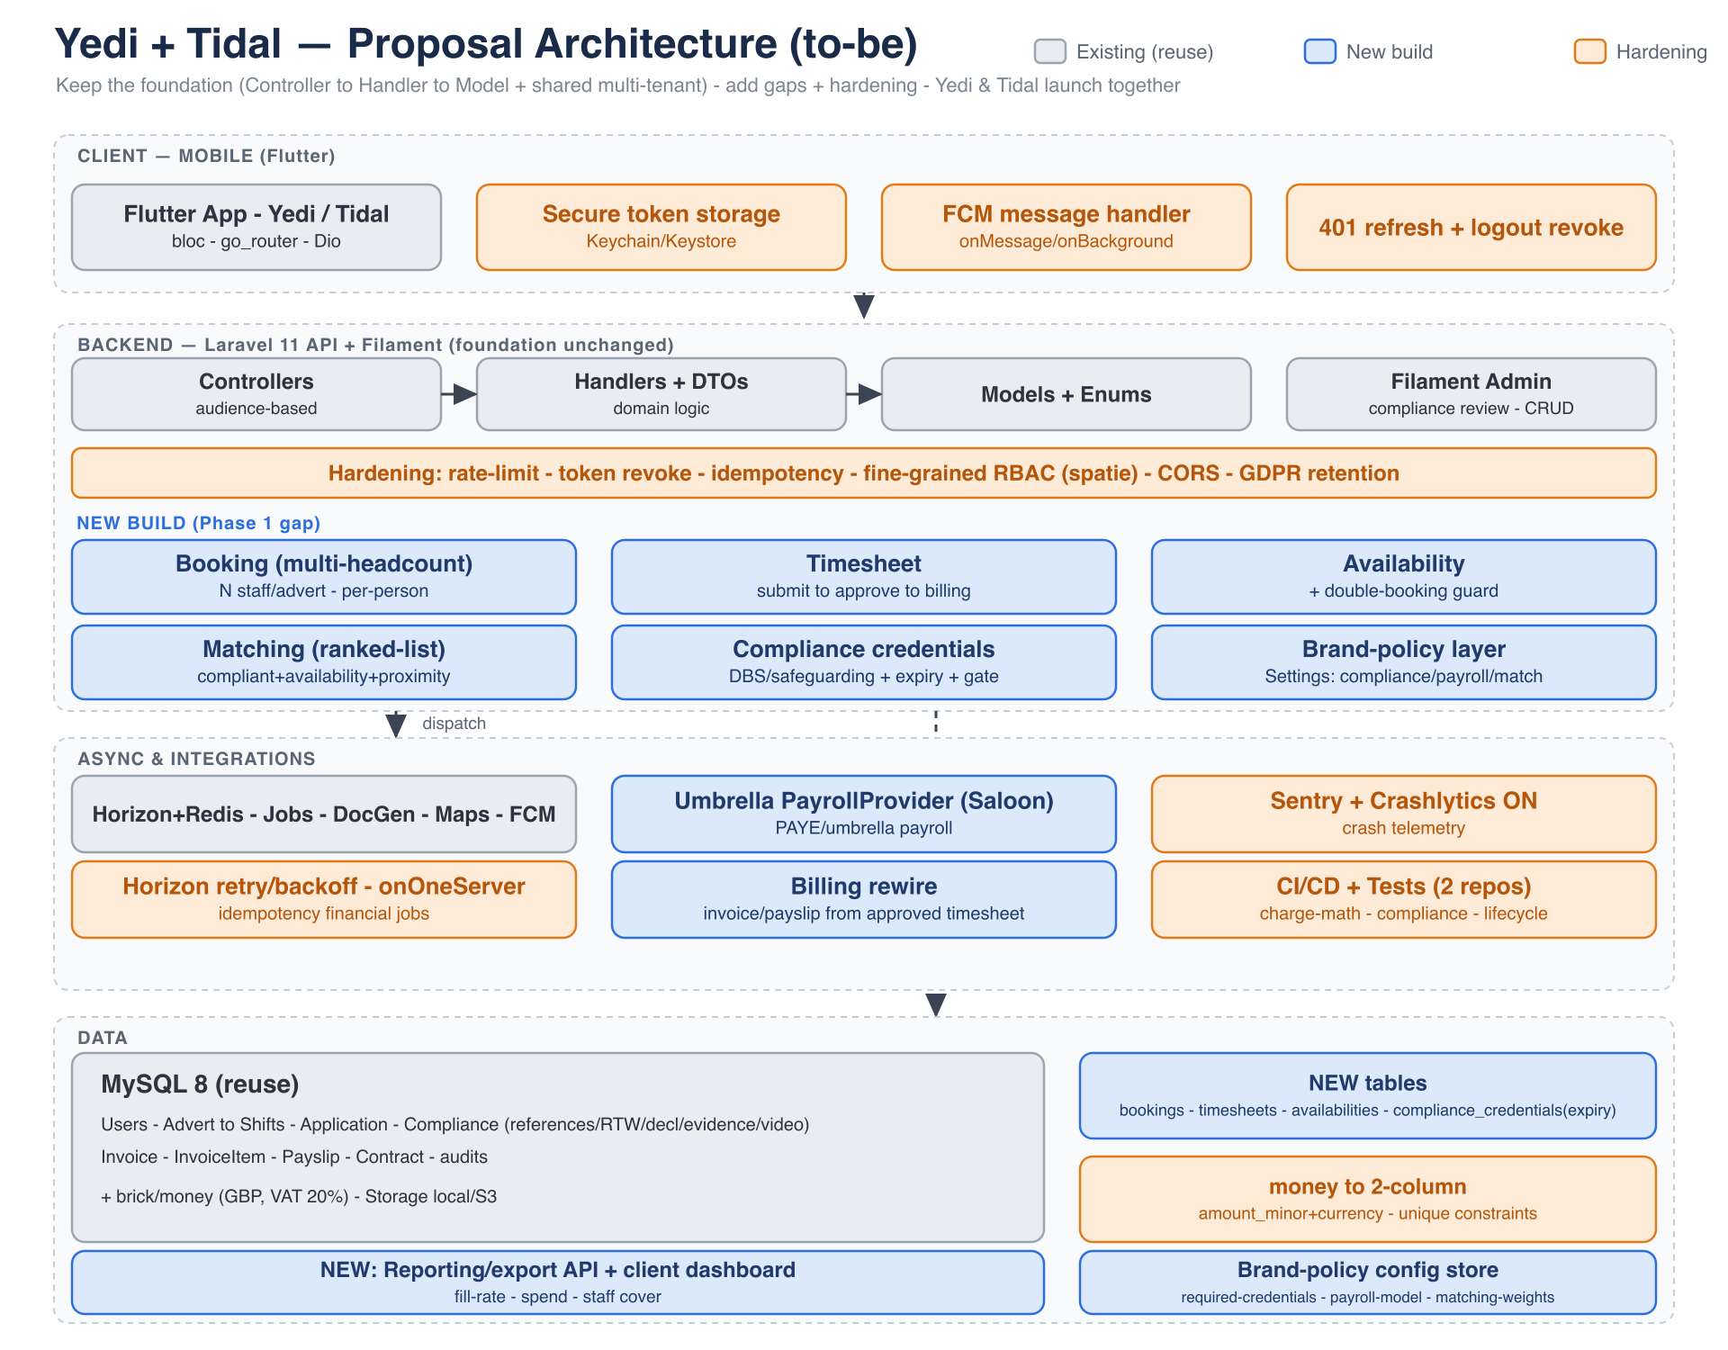
Yedi + Tidal — target architecture (grey = reuse, blue = new build, orange = hardening)
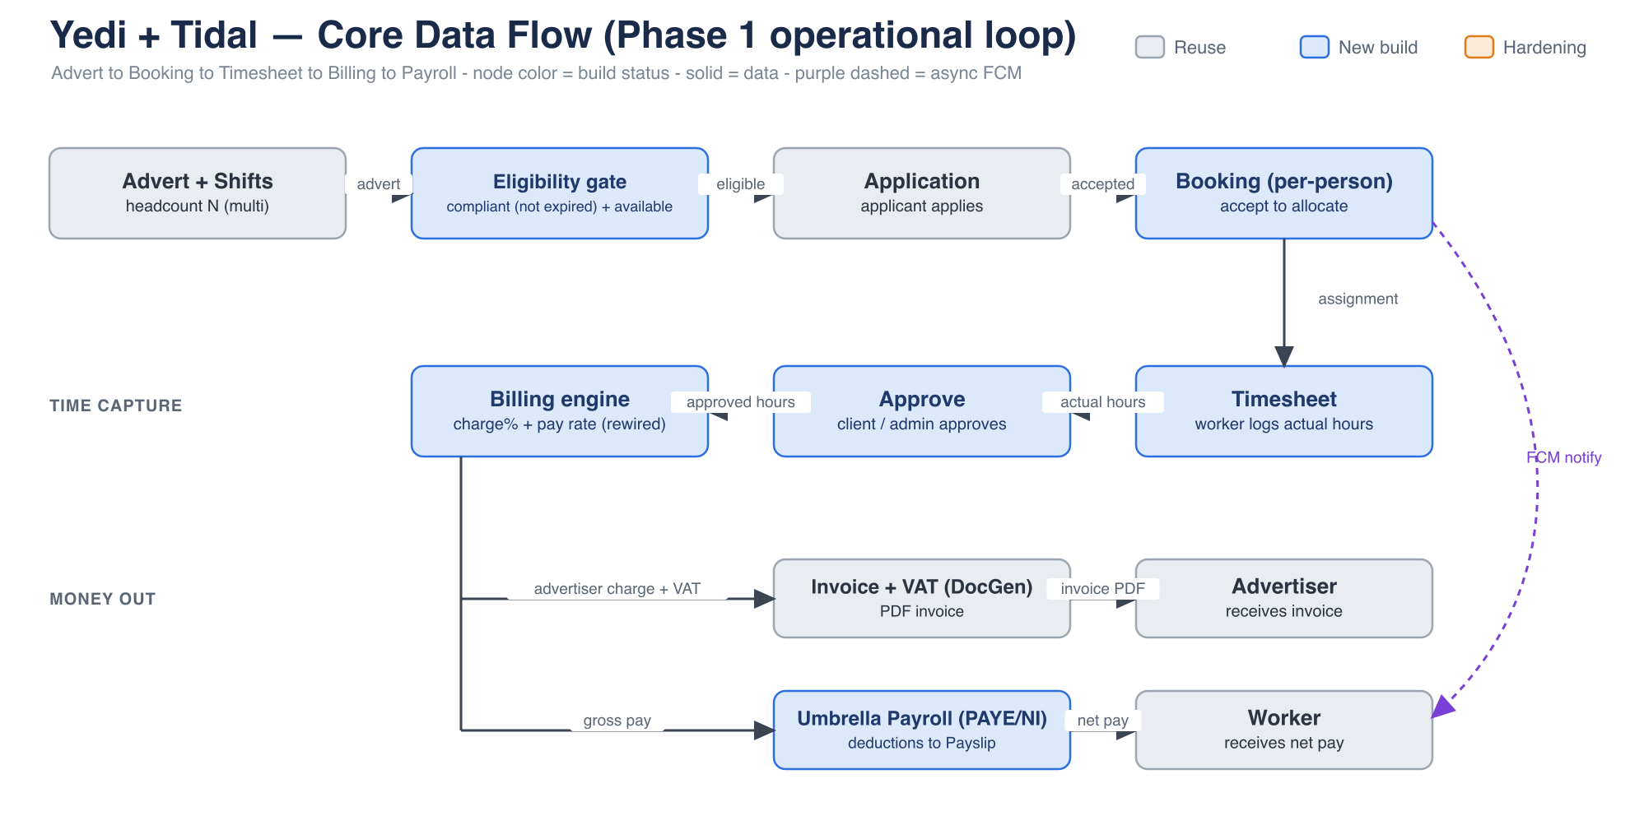
Core data flow: Advert → Booking → Timesheet → Billing → Payroll

4.3 Architecture Options — Shared vs Separate
The source review confirmed Yedi and Tidal already run from one codebase. Because every remaining engine is identical for both brands, we recommend keeping and extending the single shared foundation — the lowest-cost, lowest-risk path:
Scenario | Cost | Assessment
A. Shared multi-tenant core; brand-specific branding, policy & compliance | Lowest | RECOMMENDED — matches the existing codebase and the client’s instinct.
B. Shared core library + two separate deployments | Medium | Versioning overhead and drift risk.
C. Two fully separate products | Highest (+70–90%) | Not recommended — 2× build and maintenance.

4.4 Technical Configuration
Category | Technology | Note
Mobile | Flutter (Dart) | Existing apps; iOS & Android — reuse & extend.
Back end | Laravel 11 (PHP) | Existing API; Filament 3 admin — keep & extend.
Frontend (portals) | Filament / Livewire | Advertiser & admin web surfaces.
Database | MySQL 8 | Confirmed on the baseline (49 migrations); multi-tenant schema.
Cache / Queue | Redis + Laravel Horizon | Async billing, PDF, notifications; retries.
Auth / RBAC | Laravel Sanctum + role/permission layer | Multi-party auth; fine-grained policies (added).
File Storage | S3-compatible | Documents, evidence, contracts, PDFs.
Payroll integration | Typed HTTP connector | Umbrella provider (external API).
Notifications | Firebase FCM | Push + preferences/opt-out.
Observability | Sentry + Crashlytics + monitoring | Alerts, backups, queue metrics.
CI/CD | GitHub Actions | Automated tests, build, deploy (added).

5. Master Schedule

5.1 Master Schedule Overview
- Phase 1 (Launch release): ~2 months (up to four 2-week sprints) — hardening and completion of the existing build to a joint Yedi + Tidal go-live, delivered by a parallel team.
- Phase 2 (Enhancement): ~1.5 months (three 2-week sprints) — scale, revenue depth, automation and advanced compliance, commissioned after launch.
- Sequencing: quality baseline first; idempotency and timesheet before the billing rewire; the compliance model before the booking gate.

5.2 Phase 1 Sprint Breakdown
Sprint | Timeline | Key Activities
Sprint 1 | Weeks 1–2 | Test-harness + CI/CD; security hardening (rate-limit, token rotation, secure storage, RBAC); GDPR (deletion, export, erasure, consent); idempotency + database integrity + money-column refactor.
Sprint 2 | Weeks 3–4 | Payments integrity (payslip/invoice, retries); multi-headcount booking (model, partial-fill, allocation, views); timesheet capture.
Sprint 3 | Weeks 5–6 | Billing rewire to approved hours + real payslips; availability (model, picker, guard); compliance (DBS model, enforcement, booking gate); ranked matching.
Sprint 4 | Weeks 7–8 | Umbrella payroll integration; reporting & brand-policy; cross-cutting UX/platform; UAT and launch hardening.

5.3 Phase 2 Sprint Breakdown
Sprint | Timeline | Key Activities
Sprint 1 | Weeks 1–2 | Scale & operations (stateless app, load balancer, distributed scheduler, ops tooling, AV scanning); refunds/adjustments/credit notes.
Sprint 2 | Weeks 3–4 | In-house PAYE payroll (tax/NI, RTI, pension, holiday pay); automated matching engine; advanced analytics/BI.
Sprint 3 | Weeks 5–6 | Full DBS engine (Update Service, barred-list, reminders); talent pools, client self-serve booking, engagement features; UAT and launch.

6. Quotation & Work Breakdown Structure

6.1 Quotation Summary
A fixed-price model per phase, covering complete development, QA/testing and source-code ownership transfer on completion. Figures are in USD and exclude cloud infrastructure and third-party service fees. Phase 1 pricing is grounded in the completed source review — not indicative.
Scope | Effort (person-months) | Fixed Price (USD)
Phase 1 — Launch release | 10.0 | $33,600
Phase 2 — Enhancement | 8.5 | $28,672
Combined | 18.5 | $62,272
Cloud infrastructure and third-party service fees (umbrella provider, FCM, maps, crash reporting) are not included and are paid directly by the client.

6.2 Work Breakdown Structure
6.2.1 Phase 1
EPIC | Feature | Sub-Feature | Function
A. Platform Hardening & Security | Authentication & Access | Auth hardening | Rate limiting (login/forgot-pw/signed form)
 |  |  | Token revoke + rotation endpoint
 |  |  | Secure token storage (Keychain/Keystore)
 |  |  | Session 401 handling + refresh
 |  | Authorization | Fine-grained RBAC (spatie roles/permissions)
 |  |  | Policy coverage audit + gaps
 | GDPR & Privacy | Account lifecycle | Account deletion (self-serve, cascade/anonymize)
 |  |  | Account deactivation / reactivation
 |  | Data rights | SAR data export (per-user)
 |  |  | Right to erasure + retention policy jobs
 |  |  | PII scrubbing in logs/audits
 |  |  | Consent + Terms/Privacy acceptance
B. Payments Integrity & Reliability | Billing correctness | Payslip & invoice | Fix payslip stub (fields + template)
 |  |  | Charge %/rate bounds validation
 |  | Idempotency | Unique constraints (invoices/payslips per booking)
 |  |  | Scheduler onOneServer + withoutOverlapping
 |  |  | Job retry/backoff/failed handling
 | Reliability & Infra | Observability | Crash reporting (Sentry + Crashlytics on)
 |  |  | Backup + monitoring/alerts setup
 |  |  | Horizon retry / queue tuning
 |  | DB integrity | money -> 2-column refactor (amount_minor+currency)
 |  |  | Indexes + FK + soft-delete cascade fixes
 | Quality baseline | Test & CI | Test harness bootstrap (factories/fixtures)
 |  |  | CI/CD pipelines (2 repos)
C. Booking & Allocation | Multi-headcount booking | Booking entity | Booking model + migration (per-person)
 |  |  | AdvertStatus refactor (partial-fill)
 |  |  | Accept -> create Booking + allocation
 |  | Advert management | Advert edit/update (API + admin)
 |  |  | Headcount N on advert (create/list UI)
 |  | Booking views | Applicant booking views (per-person)
 |  |  | Advertiser booking / coverage views
D. Timesheet & Billing Rewire | Timesheet | Capture | Timesheet model + enum + migration
 |  |  | SubmitTimesheet handler + API
 |  |  | Applicant submit timesheet UI
 |  | Approval | Approve/Dispute/Query handlers
 |  |  | Advertiser approve timesheet UI
 | Billing rewire | Billing from actual hours | Rewire charge/pay to approved hours
 |  |  | Trigger change (approved gate, not ends_at)
 |  |  | Payslip real (gross/net) generation
E. Availability & Matching | Availability | Availability model | Availability model + API
 |  |  | Availability picker UI
 |  |  | Double-booking guard
 | Matching | Ranked suggestions | Ranked scoring (compliant+avail+proximity)
 |  |  | Suggested-candidates UI (advertiser)
F. Compliance (Yedi DBS/Safeguarding) | Structured credentials | Credential model | compliance_credentials model+enum+migration
 |  |  | Typed fields (DBS number/level/dates, QTS)
 |  |  | Expiry columns + admin entry (Filament)
 |  | Enforcement | Auto-compute compliance status
 |  |  | ExpireCredentials scheduled command
 |  |  | Booking gate by expiry (AdvertPolicy)
 |  |  | Compliance warnings UI (applicant)
G. Payroll (Umbrella) | Umbrella integration | Connector | PayrollProvider connector (typed HTTP)
 |  |  | Feed assignment data (hours/rate/dates)
 |  |  | Payslip proxy + display
 |  | Compliance | Worker umbrella onboarding handoff
 |  |  | AWR 12-week tracking
H. Reporting & Brand-Policy | Reporting | Reports | Export API (CSV)
 |  |  | Client dashboard (fill-rate/spend/cover)
 |  |  | Admin report widgets
 | Brand-policy & multi-tenant | Policy layer | Brand-policy DB layer (Settings ext)
 |  |  | Config resolver (compliance/payroll/matching)
I. Cross-Cutting UX & Platform | UX completeness | States & search | Search & filter (adverts/candidates)
 |  |  | Empty / error / loading states (all screens)
 |  |  | Onboarding / first-run / tutorials
 |  |  | Notification preferences / opt-out
 |  |  | Pagination / infinite scroll
 |  |  | Offline handling + connectivity
 |  | Platform | i18n / timezone handling
 |  |  | App force-update / version gate
 |  |  | Accessibility (a11y) pass
 |  |  | Analytics / event tracking

6.2.2 Phase 2
EPIC | Feature | Sub-Feature | Function
P2-A. Scale & Operations | Horizontal scaling | Multi-instance | Stateless app + shared session/cache
 |  |  | Load balancer + health/readiness probes
 |  |  | Distributed scheduler / leader-election
 |  |  | Multi-instance queue tuning
 | Ops tooling | Support | Admin impersonation / support login
 |  |  | Maintenance mode
 |  |  | Demo / seed-data environments
 |  |  | AV scanning of uploads (ClamAV integration)
P2-B. Revenue & Payments | Adjustments | Corrections | Refunds / adjustments / credit notes
 |  |  | Dispute / chargeback handling
 | Payroll expansion | In-house PAYE | PAYE engine (income tax + NI calc)
 |  |  | RTI submission (HMRC FPS/EPS)
 |  |  | Pension auto-enrolment
 |  |  | Holiday pay accrual
 |  | Providers | Additional umbrella/payroll providers
 | Multi-currency | Currency | Multi-currency support
P2-C. Growth & Intelligence | Smart matching | Automation | Automated matching engine (scoring + auto-offer)
 |  |  | Learning from placement outcomes
 |  |  | Predictive staffing demand
 | Analytics & BI | Dashboards | Advanced analytics / BI dashboards
 |  |  | Regional performance dashboards
 |  |  | Candidate performance scoring
 | Engagement | Worker features | Ratings depth / 2-way feedback
 |  |  | Referral programme
 |  |  | In-app training / onboarding modules
 |  |  | Worker rewards
 |  |  | Calendar integration
P2-D. Advanced Compliance & Talent | Full DBS engine | Automation | DBS Update Service API integration
 |  |  | Barred-list check
 |  |  | Automated compliance reminders
 | Talent | Pools & self-serve | Talent pools by city/brand
 |  |  | Client self-serve booking
 |  |  | Additional brand onboarding (multi-tenant)

6.3 Team Structure & Cost Breakdown
Effort in person-months (one man-month = 20 working days), spread across the delivery months. Unit prices are confirmed at contracting. Figures exclude hosting, third-party licences and post-launch support.
6.3.1 Phase 1 — Launch release (~2 months)
Position | M1 | M2 | Total (M/M) | Unit Price (USD) | Total Cost (USD)
Project Manager | 0.5 | 0.5 | 1.0 | $3,600 | $3,600
BA & UI/UX Designer | 0.5 | 0.5 | 1.0 | $3,000 | $3,000
Senior Backend Engineer | 1.5 | 1.5 | 3.0 | $3,000 | $9,000
Mobile Engineer (Flutter) | 1.0 | 0.5 | 1.5 | $3,000 | $4,500
Frontend / Web Engineer | 0.0 | 0.5 | 0.5 | $3,000 | $1,500
QC Engineer | 1.0 | 2.0 | 3.0 | $2,800 | $8,400
TOTAL | 4.5 | 5.5 | 10.0 |  | $30,000
Development $30,000 + Delivery contingency 12% $3,600 = Phase 1 Fixed Price $33,600
6.3.2 Phase 2 — Enhancement (~1.5 months)
Position | M1 | M2 | Total (M/M) | Unit Price (USD) | Total Cost (USD)
Project Manager | 0.5 | 0.5 | 1.0 | $3,600 | $3,600
BA & UI/UX Designer | 0.5 | 0.5 | 1.0 | $3,000 | $3,000
Senior Backend Engineer | 2.0 | 1.0 | 3.0 | $3,000 | $9,000
Mobile Engineer (Flutter) | 0.5 | 0.0 | 0.5 | $3,000 | $1,500
Frontend / Web Engineer | 0.5 | 0.0 | 0.5 | $3,000 | $1,500
QC Engineer | 1.5 | 1.0 | 2.5 | $2,800 | $7,000
TOTAL | 5.5 | 3.0 | 8.5 |  | $25,600
Development $25,600 + Delivery contingency 12% $3,072 = Phase 2 Fixed Price $28,672

6.4 Payment Milestones
6.4.1 Phase 1 (fixed price $33,600)
Milestone | Deliverables | % | Amount
M1: Contract signing | Signed SOW; Sprint 1 initiated — test harness, CI/CD, security baseline; umbrella-payroll API discovery. | 40% | $13,440
M2: Core demo (Wk 4) | Payments integrity, multi-headcount booking and timesheet capture on a hardened build. | 30% | $10,080
M3: UAT & beta (Wk 6) | Billing rewire, availability/matching, compliance gate and umbrella payroll; internal QA passed; beta deployed. | 20% | $6,720
M4: Production launch (Wk 8) | Reporting & brand-policy and cross-cutting UX complete; UAT resolved; documentation and source-code transfer. | 10% | $3,360
6.4.2 Phase 2 (fixed price $28,672)
Milestone | Deliverables | % | Amount
M1: Kickoff | Scope confirmation and sprint planning; scale & operations started. | 40% | $11,469
M2: Feature demo (Wk 4) | PAYE payroll, automated matching and analytics/BI complete. | 40% | $11,469
M3: Launch (Wk 6) | Full DBS engine, talent & self-serve, engagement features; UAT resolved and source transfer. | 20% | $5,734
Grand Total (Phase 1 + Phase 2): 18.5 person-months ~ $62,272

7. Future Enhancements Roadmap
Beyond Phase 2, and subject to Phase 1–2 feedback and client priorities, candidate enhancements (not costed here) include:
- Matching that learns from placement outcomes and predicts staffing demand.
- Deeper workforce analytics and BI across regions, brands and cohorts.
- Client self-serve booking and dynamic rate management.
- An integrations marketplace (accounting, HR, background-check providers).
- Onboarding of additional brands onto the shared multi-tenant platform.

