Project Proposal
YEDI + TIDAL
Staffing & Compliance Platform — MVP & Phase 2
Flutter Mobile (iOS & Android) + Laravel / Filament Web Admin
Version: v1.0
Authored by: Sotatek — Client Delivery
Approved by: ______________________
United Kingdom, July 2026
Presenter | Position | Division
[Presenter Name] | Project Lead | Sotatek — Client Delivery
Edit History
Date | Version | Description | Editor
July 8, 2026 | 1.0 | Create | Sotatek
Approval
Approved date | Version | Approved by | Position
 | 1.0

Table of Contents

1. Project Overview
Yedi and Tidal are two staffing brands operated on one shared platform connecting advertisers (schools, care settings, brands, and employers) with applicants (workers) for short-notice and planned assignments. Yedi serves the education and safeguarding-regulated segment, where placement is gated on Disclosure and Barring Service (DBS) checks and other compliance credentials; Tidal serves the broader beauty, retail, and events staffing market. This proposal covers the work to take the client's existing codebase from its current state to a production-ready Minimum Viable Product that both brands can launch on together, plus a costed Phase 2 enhancement roadmap.
This is a brownfield engagement. A source-code audit (July 2026) confirmed the existing Laravel back end and Flutter mobile apps are substantially built — the applicant and advertiser apps are shipped, and the application lifecycle, compliance onboarding, and document-generation billing already work. The scope is therefore a gap-and-hardening build — reusing what is sound and closing correctness, security, compliance, and reliability gaps — rather than a rebuild.

Core Business Challenge
- Not yet launch-ready: gaps in payments integrity, billing correctness, and reliability must be closed before real money and real placements flow through the platform.
- Compliance is a hard requirement, not a feature: for Yedi, an applicant must not be bookable into a safeguarding-regulated role with an expired or missing DBS/credential — this enforceable gate does not yet exist in structured form.
- Billing is disconnected from actual work: charge and pay are driven by scheduled shift times, not approved timesheet hours, creating dispute and revenue-leakage risk.
- Dual-brand launch: Yedi and Tidal must run on one platform with brand-specific policy (compliance, payroll, matching) resolved per brand.
- Regulatory exposure: GDPR obligations (account deletion, data export, right to erasure, consent) and correct UK payroll (umbrella/PAYE) are legal must-haves for a UK launch.

Solution Value Proposition
- Trustworthy money flow: idempotent billing, validated charge/pay bounds, and correct payslip/invoice generation driven by approved hours.
- Enforceable compliance: structured DBS/credential records with expiry logic that automatically block non-compliant bookings for Yedi.
- Timesheet-to-billing rewire: workers submit timesheets, advertisers approve them, and billing is triggered off approved hours.
- Integrated umbrella payroll: assignment hours, rates, and dates are fed to an umbrella payroll provider, with payslip display and AWR tracking.
- A launch-safe platform: security hardening, GDPR compliance, observability, a test/CI baseline, and the cross-cutting UX a live app needs.

Project Objectives
- Deliver a production-ready MVP that Yedi and Tidal can launch on together, on the existing Flutter + Laravel stack.
- Close all identified security, GDPR, payments-integrity, and reliability gaps ahead of commercial launch.
- Implement multi-headcount booking, availability, and ranked matching so advertisers can fill and cover assignments efficiently.
- Stand up the DBS/safeguarding compliance gate as a first-class, enforceable part of the Yedi booking flow.
- Integrate umbrella payroll and rewire billing to approved timesheet hours.
- Establish a brand-policy layer so both brands share one platform while differing on compliance, payroll, and matching rules.

2. Project Scope

2.1 In-Scope — MVP (Phase 1)
The MVP is organised into nine capability workstreams (A–I). Because this is a hardening-and-gap build, workstreams are grouped by capability rather than by end-user surface.
Workstream | Scope
A. Platform Hardening & Security | Auth hardening (rate limiting, token revoke/rotation, secure token storage, 401 handling); fine-grained RBAC; secrets rotation/CORS; GDPR — account deletion, data export (SAR), right to erasure, PII scrubbing, consent.
B. Payments Integrity & Reliability | Billing correctness and charge/rate-bounds validation; idempotency (unique constraints, single-server scheduling, job retry); reliability/observability (crash reporting, backups, monitoring); DB integrity (money as minor-unit + currency, index/FK fixes); test-harness and CI/CD baseline.
C. Booking & Allocation | Multi-headcount booking: per-person booking model, partial-fill advert status, accept-to-booking allocation, advert editing, and applicant/advertiser booking views.
D. Timesheet & Billing Rewire | Timesheet capture and approval (submit/approve/dispute/query) with applicant and advertiser UI; billing rewired to approved hours with real gross/net payslip generation.
E. Availability & Matching | Availability model, picker UI, double-booking guard; ranked candidate suggestions scored on compliance, availability, and proximity, with an advertiser suggestions UI.
F. Compliance — Yedi DBS / Safeguarding | Structured compliance-credential records (DBS number/level/dates, QTS), expiry columns and admin entry; automatic compliance-status computation, scheduled expiry, booking gate by expiry, and applicant warnings.
G. Payroll (Umbrella) | Umbrella provider connector, assignment-data feed (hours/rate/dates), payslip proxy and display, worker onboarding handoff, and AWR 12-week tracking.
H. Reporting & Brand-Policy | CSV export, client dashboard (fill-rate/spend/cover) and admin report widgets; brand-policy layer and configuration resolver for Yedi vs Tidal differences.
I. Cross-Cutting UX & Platform | Search and filtering, empty/error/loading states, onboarding/first-run, notification preferences, pagination, offline handling; internationalisation/timezone, force-update/version gate, accessibility, and analytics.

2.1.10 Phase 2 — Enhancement Roadmap (costed)
Phase 2 is scoped and costed in this proposal (Sections 6.1–6.3) as a separate tranche, to be commissioned after MVP launch.
Workstream | Scope
P2-A. Scale & Operations | Horizontal scaling (stateless app, shared cache, load balancer, distributed scheduler); admin impersonation/support tooling, maintenance mode, demo/seed environments; anti-virus scanning of uploads.
P2-B. Revenue & Payments | Refunds/adjustments/credit notes and dispute handling; in-house PAYE payroll (tax/NI, HMRC RTI, pension auto-enrolment, holiday pay); additional payroll providers; multi-currency.
P2-C. Growth & Intelligence | Automated matching engine and learning from placement outcomes; predictive staffing demand; advanced analytics/BI dashboards; ratings depth, referral programme, in-app training, worker rewards, calendar integration.
P2-D. Advanced Compliance & Talent | Full DBS engine (DBS Update Service API, barred-list, automated reminders); talent pools by city/brand; client self-serve booking; additional brand onboarding.

2.2 Out-of-Scope Items (MVP)
- All Phase 2 items above are out of the MVP fixed price and quoted separately.
- Native (non-Flutter) rewrites and new third-party integrations beyond the umbrella payroll provider.
- Cloud infrastructure costs and third-party service fees (umbrella provider, FCM, maps, crash reporting) — paid directly by the client.
- Architecture discovery and DevOps/environment setup are treated as pre-project activities and are not itemised in the quotation.

2.3 Dependencies and Assumptions
# | Category | Description
1 | Baseline codebase | Reuse of the client's existing Laravel and Flutter code. Scope is the gap-and-hardening build, not a rewrite. Material undisclosed defects may change scope.
2 | Umbrella payroll API | Access, credentials, and API contract for the umbrella provider must be supplied by the client. External dependency and key schedule risk.
3 | Currency | Figures are in USD per the internal rate card. GBP conversion at the prevailing rate to be confirmed before contracting.
4 | Man-month basis | One man-month = 20 working days (locked with client, 2026-07-08).
5 | Joint launch | Yedi and Tidal launch together; the DBS/safeguarding gate is in the MVP.
6 | Deployment | A single application server is assumed for the MVP; multi-server scaling is Phase 2.
7 | Delivery efficiency | Man-days reflect AI-assisted development plus a client-directed 30% acceleration to hit a 1.5–2 month MVP; correctness-critical work carries lower reduction.

3. Solution Approach

3.1 Delivery Methodology
Delivery follows two-week agile sprints with fixed scope per sprint. As a brownfield engagement, Sprint 1 establishes a safety net before feature work: a test-harness bootstrap and CI/CD pipelines so every subsequent change to the existing code is validated automatically. Work then respects the platform's critical dependencies — idempotency and timesheet capture land before the billing rewire; the compliance model lands before the booking gate that depends on it.
- Sprint 1: test harness, CI/CD, and the security-hardening baseline.
- Incremental hardening: each workstream delivered behind tests; correctness-critical paths given extra review.
- Demonstrable increments: a working, demoable build at each milestone rather than a big-bang delivery.
- Source-code ownership transferred to the client on completion.

3.2 Communication & Collaboration
Activity | Cadence | Participants
Sprint planning | Every 2 weeks | PM, tech lead, client product owner
Progress stand-up / update | Weekly | Delivery team + client PO
Sprint demo & review | End of each sprint | Full team + client stakeholders
Milestone sign-off | At each milestone | PM + client approver
Ad-hoc risk escalation | As needed | PM + client PO

3.3 Quality Assurance Strategy
Testing is budgeted at 30% of total effort, reflecting the correctness-critical nature of a payments-and-compliance platform. QA focuses where defects are most costly:
Area | Focus
Payments integrity | Idempotency under retries; charge/rate-bounds; invoice/payslip correctness; money-column migration reconciliation.
Compliance gate | Expired/missing DBS correctly blocks Yedi bookings; status auto-computation and scheduled expiry verified.
Timesheet-to-billing | Approved hours drive billing; dispute/query paths; no double-billing.
Umbrella payroll | Correct assignment feed, payslip proxy, AWR tracking; failure/retry against the external API.
Regression & CI | Automated suite gates every merge; brownfield changes validated against existing behaviour.

4. Technical Requirements

4.1 Core Architectural Principles
- Reuse over rewrite: build on the existing Laravel + Flutter codebase; refactor only where correctness, security, or compliance require it.
- Correctness-critical by design: money as integer minor units + currency; billing idempotent; compliance enforced at the policy layer, not the UI.
- Brand-policy driven: a single platform resolves compliance, payroll, and matching rules per brand from a configuration layer.
- Observable and recoverable: crash reporting, monitoring/alerts, backups, and queue retry/backoff as first-class concerns.

4.2 System Architecture (MVP target)
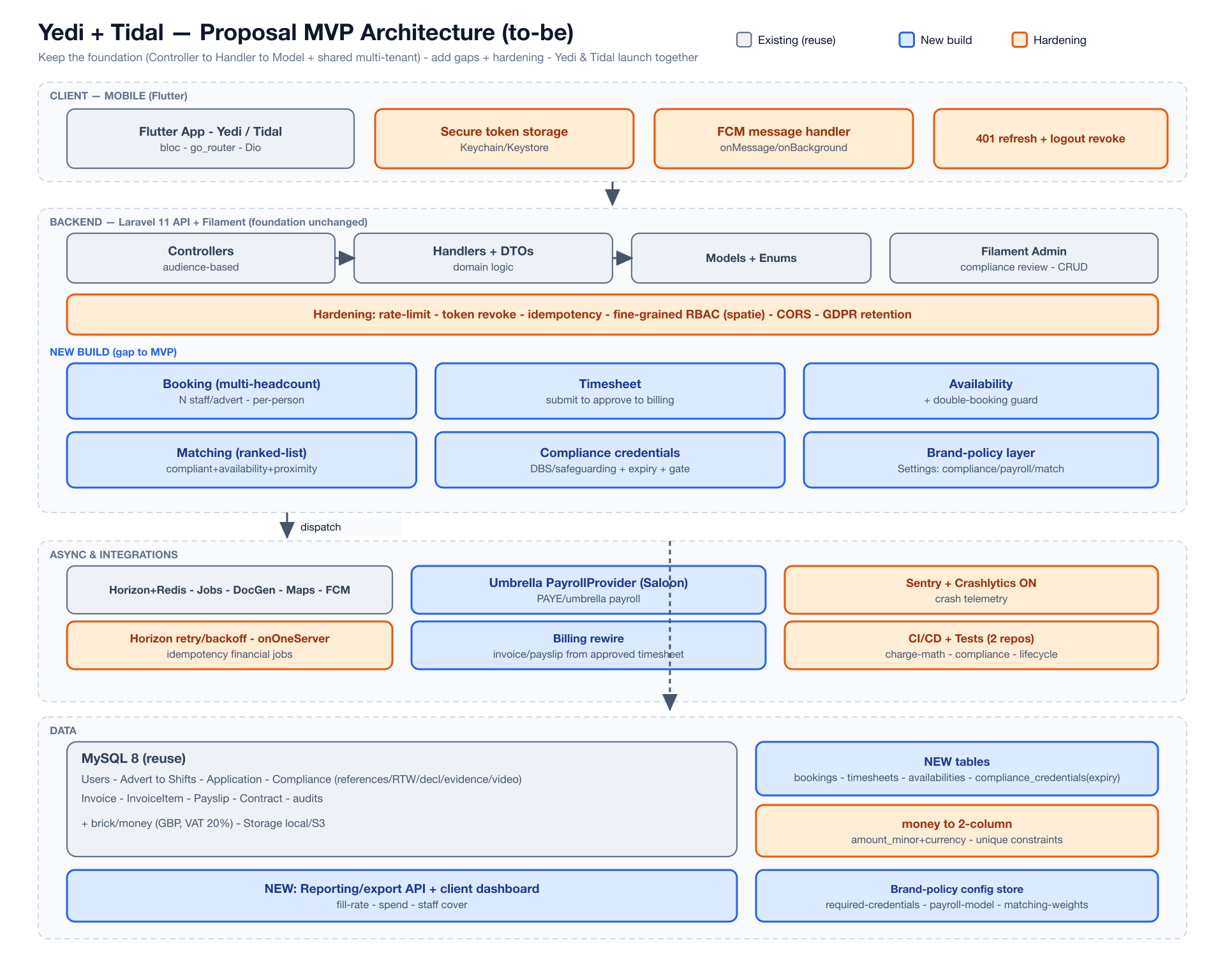
Yedi + Tidal — Proposal MVP architecture (grey = reuse, blue = new build, orange = hardening)
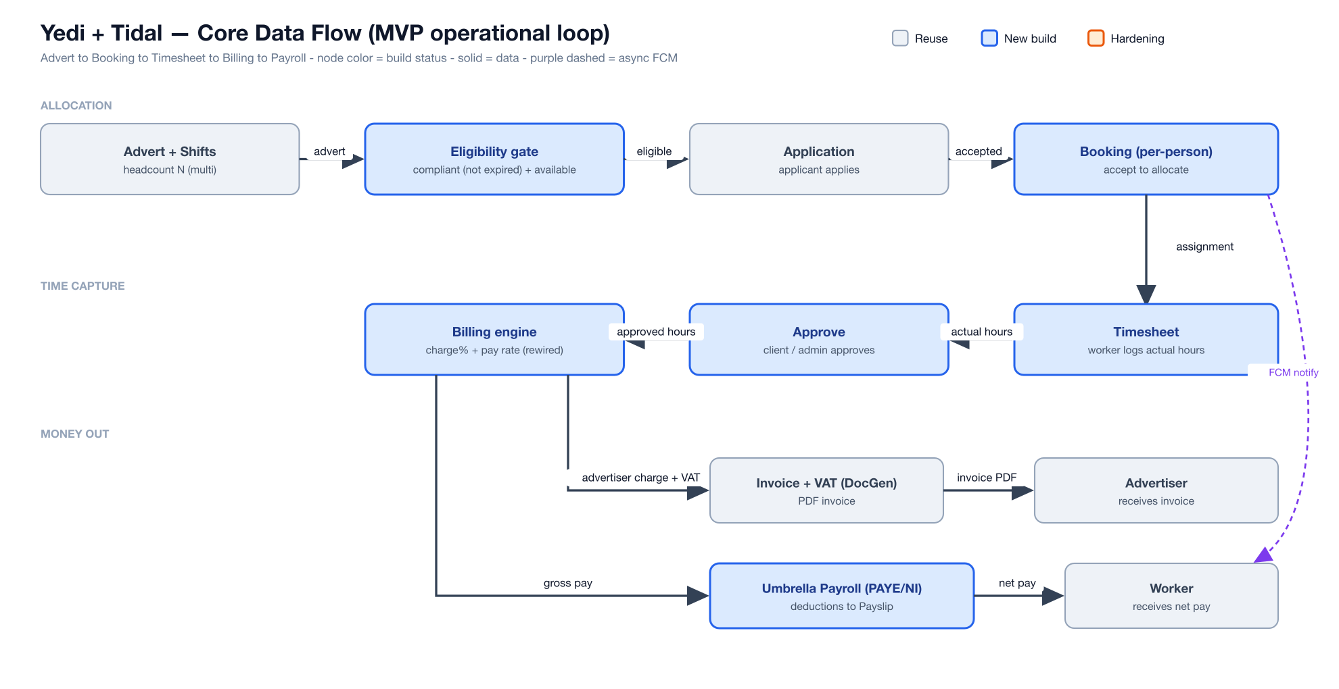
Core data flow: Advert to Booking to Timesheet to Billing to Payroll

4.3 Technical Configuration
Category | Technology | Note
Mobile | Flutter (Dart) | Existing apps; iOS & Android.
Back end | Laravel 11 (PHP) | Existing API; Filament 3 admin.
Queues / jobs | Laravel Horizon + Redis | Scheduling, retries, background jobs.
Auth / RBAC | Laravel Sanctum + role/permission layer | Fine-grained policies (added).
Payroll integration | Typed HTTP connector (Saloon) | Umbrella provider (external API).
Notifications | Firebase FCM | Push + preferences/opt-out.
Observability | Sentry + Crashlytics + monitoring | Alerts, backups, queue metrics.
Database | MySQL 8 | Confirmed on the baseline (49 migrations).

5. Master Schedule

5.1 Overview
- MVP effort: ~197 man-days (AI-assisted, 30% acceleration applied), $29,526 before contingency.
- MVP duration: ~1.5–2 months, delivered by a parallel team across 4 two-week sprints (upper bound shown).
- Phase 2 effort: ~163 man-days, $24,496 before contingency — scoped as a separate tranche.
- Sequencing: quality baseline first; idempotency and timesheet before billing rewire; compliance model before the booking gate.

5.2 MVP Sprint Breakdown
Sprint | Timeline | Key Activities
Sprint 1 | Weeks 1–2 | Test-harness + CI/CD; security hardening (rate-limit, token rotation, secure storage, RBAC, secrets/CORS); GDPR (deletion, export, erasure, consent); idempotency + DB integrity + money-column refactor.
Sprint 2 | Weeks 3–4 | Payments integrity (payslip/invoice, retries); multi-headcount booking (model, partial-fill, allocation, views); timesheet capture.
Sprint 3 | Weeks 5–6 | Billing rewire to approved hours + real payslips; availability (model, picker, guard); compliance (DBS model, enforcement, booking gate); ranked matching.
Sprint 4 | Weeks 7–8 | Umbrella payroll integration; reporting & brand-policy; cross-cutting UX/platform; UAT and launch hardening.
A 1.5-month (3-sprint) plan is achievable with higher parallelism; the 4-sprint plan above is the upper bound. The critical path (timesheet to billing rewire; compliance model to gate) is the main constraint on further compression.

6. Work Breakdown Structure & Quotation

6.1 Quotation Summary
Fixed Price for the defined MVP scope: complete development, QA/testing, and source-code ownership transfer on completion. A 12% contingency reflects brownfield risk and the external umbrella-payroll dependency. Figures in USD (see Assumptions).
Scope | Effort (md) | Development | Fixed Price (incl. 12%)
MVP (Phase 1) | 197 | $29,526 | $33,069
Phase 2 (enhancement) | 163 | $24,496 | $27,436
Combined | 360 | $54,022 | $60,505
Note: Cloud infrastructure and third-party service fees (umbrella provider, FCM, maps, crash reporting) are not included and are paid directly by the client.

6.2 Work Breakdown Structure
6.2.1 Phase 1 (MVP)
EPIC | Feature | Sub-Feature | Function | Notes
A. Platform Hardening & Security | Authentication & Access | Auth hardening | Rate limiting (login/forgot-pw/signed form)
 |  |  | Token revoke + rotation endpoint
 |  |  | Secure token storage (Keychain/Keystore)
 |  |  | Session 401 handling + refresh
 |  | Authorization | Fine-grained RBAC (spatie roles/permissions)
 |  |  | Policy coverage audit + gaps
 | Secrets & Config | Config hardening | Rotate + externalize Maps/Firebase keys
 |  |  | CORS configuration
 |  |  | .env.example + secrets management
 | GDPR & Privacy | Account lifecycle | Account deletion (self-serve, cascade/anonymize)
 |  |  | Account deactivation / reactivation
 |  | Data rights | SAR data export (per-user)
 |  |  | Right to erasure + retention policy jobs
 |  |  | PII scrubbing in logs/audits
 |  |  | Consent + Terms/Privacy acceptance
B. Payments Integrity & Reliability | Billing correctness | Payslip & invoice | Fix payslip stub (fields + template)
 |  |  | Charge %/rate bounds validation
 |  | Idempotency | Unique constraints (invoices/payslips per booking)
 |  |  | Scheduler onOneServer + withoutOverlapping
 |  |  | Job retry/backoff/failed handling
 | Reliability & Infra | Observability | Crash reporting (Sentry + Crashlytics on)
 |  |  | Backup + monitoring/alerts setup
 |  |  | Horizon retry / queue tuning
 |  | DB integrity | money -> 2-column refactor (amount_minor+currency) | Live-data migration: backfill
 |  |  | Indexes + FK + soft-delete cascade fixes
 | Quality baseline | Test & CI | Test harness bootstrap (factories/fixtures)
 |  |  | CI/CD pipelines (2 repos)
C. Booking & Allocation | Multi-headcount booking | Booking entity | Booking model + migration (per-person)
 |  |  | AdvertStatus refactor (partial-fill)
 |  |  | Accept -> create Booking + allocation
 |  | Advert management | Advert edit/update (API + admin)
 |  |  | Headcount N on advert (create/list UI)
 |  | Booking views | Applicant booking views (per-person)
 |  |  | Advertiser booking / coverage views
D. Timesheet & Billing Rewire | Timesheet | Capture | Timesheet model + enum + migration
 |  |  | SubmitTimesheet handler + API
 |  |  | Applicant submit timesheet UI
 |  | Approval | Approve/Dispute/Query handlers
 |  |  | Advertiser approve timesheet UI
 | Billing rewire | Billing from actual hours | Rewire charge/pay to approved hours | Critical path (after Timesheet)
 |  |  | Trigger change (approved gate, not ends_at)
 |  |  | Payslip real (gross/net) generation
E. Availability & Matching | Availability | Availability model | Availability model + API
 |  |  | Availability picker UI
 |  |  | Double-booking guard
 | Matching | Ranked suggestions | Ranked scoring (compliant+avail+proximity) | Correctness-critical
 |  |  | Suggested-candidates UI (advertiser)
F. Compliance (Yedi DBS/Safeguarding) | Structured credentials | Credential model | compliance_credentials model+enum+migration
 |  |  | Typed fields (DBS number/level/dates, QTS)
 |  |  | Expiry columns + admin entry (Filament)
 |  | Enforcement | Auto-compute compliance status | Safeguarding — critical
 |  |  | ExpireCredentials scheduled command
 |  |  | Booking gate by expiry (AdvertPolicy) | Blocks non-compliant Yedi bookings
 |  |  | Compliance warnings UI (applicant)
G. Payroll (Umbrella) | Umbrella integration | Connector | PayrollProvider connector (typed HTTP) | External umbrella API
 |  |  | Feed assignment data (hours/rate/dates)
 |  |  | Payslip proxy + display
 |  | Compliance | Worker umbrella onboarding handoff
 |  |  | AWR 12-week tracking
H. Reporting & Brand-Policy | Reporting | Reports | Export API (CSV)
 |  |  | Client dashboard (fill-rate/spend/cover)
 |  |  | Admin report widgets
 | Brand-policy & multi-tenant | Policy layer | Brand-policy DB layer (Settings ext)
 |  |  | Config resolver (compliance/payroll/matching)
I. Cross-Cutting UX & Platform | UX completeness | States & search | Search & filter (adverts/candidates)
 |  |  | Empty / error / loading states (all screens)
 |  |  | Onboarding / first-run / tutorials
 |  |  | Notification preferences / opt-out
 |  |  | Pagination / infinite scroll
 |  |  | Offline handling + connectivity
 |  | Platform | i18n / timezone handling
 |  |  | App force-update / version gate
 |  |  | Accessibility (a11y) pass
 |  |  | Analytics / event tracking

6.2.2 Phase 2
EPIC | Feature | Sub-Feature | Function | Notes
P2-A. Scale & Operations | Horizontal scaling | Multi-instance | Stateless app + shared session/cache
 |  |  | Load balancer + health/readiness probes
 |  |  | Distributed scheduler / leader-election
 |  |  | Multi-instance queue tuning
 | Ops tooling | Support | Admin impersonation / support login
 |  |  | Maintenance mode
 |  |  | Demo / seed-data environments
 |  |  | AV scanning of uploads (ClamAV integration)
P2-B. Revenue & Payments | Adjustments | Corrections | Refunds / adjustments / credit notes
 |  |  | Dispute / chargeback handling
 | Payroll expansion | In-house PAYE | PAYE engine (income tax + NI calc) | In-house payroll
 |  |  | RTI submission (HMRC FPS/EPS) | HMRC integration
 |  |  | Pension auto-enrolment
 |  |  | Holiday pay accrual
 |  | Providers | Additional umbrella/payroll providers
 | Multi-currency | Currency | Multi-currency support
P2-C. Growth & Intelligence | Smart matching | Automation | Automated matching engine (scoring + auto-offer)
 |  |  | Learning from placement outcomes
 |  |  | Predictive staffing demand
 | Analytics & BI | Dashboards | Advanced analytics / BI dashboards
 |  |  | Regional performance dashboards
 |  |  | Candidate performance scoring
 | Engagement | Worker features | Ratings depth / 2-way feedback
 |  |  | Referral programme
 |  |  | In-app training / onboarding modules
 |  |  | Worker rewards
 |  |  | Calendar integration
P2-D. Advanced Compliance & Talent | Full DBS engine | Automation | DBS Update Service API integration
 |  |  | Barred-list check
 |  |  | Automated compliance reminders
 | Talent | Pools & self-serve | Talent pools by city/brand
 |  |  | Client self-serve booking
 |  |  | Additional brand onboarding (multi-tenant)

6.3 Team Structure & Cost Breakdown
Effort in person-months (one man-month = 20 working days). Unit prices (USD) are the internal rate card; confirm before contracting.
MVP (Phase 1)
Position | Person-months | Unit Price (USD/mo) | Total Cost (USD)
Project Manager | 0.98 | $3,600 | $3,528
BA & UI/UX Designer | 0.98 | $3,000 | $2,940
Backend Engineer | 2.93 | $3,000 | $8,790
Mobile Engineer (Flutter) | 1.49 | $3,000 | $4,470
Frontend Engineer (Web) | 0.50 | $3,000 | $1,500
QC Engineer | 2.95 | $2,800 | $8,260
TOTAL | 9.83 |  | $29,526
Development $29,526 + Brownfield contingency 12% $3,543 = MVP Fixed Price $33,069
Phase 2 (enhancement tranche)
Position | Person-months | Unit Price (USD/mo) | Total Cost (USD)
Project Manager | 0.82 | $3,600 | $2,952
BA & UI/UX Designer | 0.82 | $3,000 | $2,460
Backend Engineer | 2.94 | $3,000 | $8,820
Mobile Engineer (Flutter) | 0.68 | $3,000 | $2,040
Frontend Engineer (Web) | 0.47 | $3,000 | $1,410
QC Engineer | 2.45 | $2,800 | $6,860
TOTAL | 8.18 |  | $24,496
Development $24,496 + contingency 12% $2,940 = Phase 2 Fixed Price $27,436

6.4 Payment Milestones (MVP)
Milestone amounts are a fixed percentage of the MVP fixed price ($33,069).
Milestone | Deliverables | % | Amount
M1: Contract Signing | Signed SOW; Sprint 1 initiated — test harness, CI/CD, security baseline; umbrella-payroll API discovery. | 40% | $13,228
M2: Core Demo (Wk 4) | Payments integrity, multi-headcount booking, and timesheet capture on a hardened build. | 30% | $9,921
M3: UAT & Beta (Wk 6) | Billing rewire, availability/matching, compliance gate and umbrella payroll; internal QA passed; beta deployed. | 20% | $6,614
M4: Production Launch (Wk 8) | Reporting & brand-policy and cross-cutting UX complete; UAT resolved; documentation and source-code transfer. | 10% | $3,307
Phase 2 milestones are agreed when the tranche is commissioned; indicative split 40% / 40% / 20% of the Phase 2 fixed price ($27,436).

7. Future Enhancements Roadmap
Beyond Phase 2, candidate enhancements (not costed here) include:
- AI-assisted matching that learns from placement outcomes and predicts staffing demand.
- Deeper workforce analytics and BI across regions, brands, and cohorts.
- Client self-serve booking and dynamic rate management.
- Onboarding of additional brands onto the shared brand-policy platform.

8. Q&A Clarifications
Q1. Which currency is the quotation in?
Figures are in USD per the internal rate card. A GBP figure at the prevailing exchange rate will be confirmed before contracting; the platform itself transacts in GBP.
Q2. What does the 12% contingency cover?
Brownfield risk (the baseline's full state is confirmed in Sprint 1) and the external umbrella-payroll dependency. It is included in the fixed price.
Q3. How was 1.5–2 months achieved for the MVP?
Bottom-up estimate per function, AI-assisted, plus a client-directed 30% delivery-efficiency acceleration and a parallel team. Correctness-critical work keeps a lower reduction; the schedule assumes a clean baseline and prompt umbrella-API access.
Q4. Are file uploads virus-scanned?
Not in the MVP. Uploads currently have no AV scanning; it is recommended and included in Phase 2 (or can be pulled into the MVP on request).
Q5. Are refunds/credit notes included?
No — they are Phase 2 (Revenue & Payments). If required for launch they can be added, affecting effort and price.
Q6. What is the umbrella-payroll dependency?
API access, credentials, and a documented contract from the umbrella provider — external and the single largest schedule risk. Sprint 1 includes a discovery step.
Q7. Why single app-server for the MVP?
Sufficient for expected launch load and keeps the scheduler/queue model simple (single-server scheduling supports idempotent billing). Horizontal scaling is Phase 2.
Q8. How was the estimate produced?
Per function as AI-assisted coding man-days across Backend, Mobile, and Web, expanded via a fixed 10/10/50/30 ratio (Spec / PM / Coding / Testing), with AI reductions by task type and a 30% delivery-efficiency factor.
End of Document

