Personal Budget Tracker is a system that able user to track their expenses through their daily usage.

This system allows user to
- Add their income
- Add their expense (sort by category)
- Limit their spending budget per month (increase or decrease) + note to specify category
- Saving by taking income – limit = saving
- Saving section alble user to add wish-list item, eg. Car or motor (example car = 25000$ by saving monthly, the function calculate its completion percentage) if saving = 100$ of 1000% means saving = 10%
- Show transaction
- View current balance
- Save users data
- GUI
Folder structure
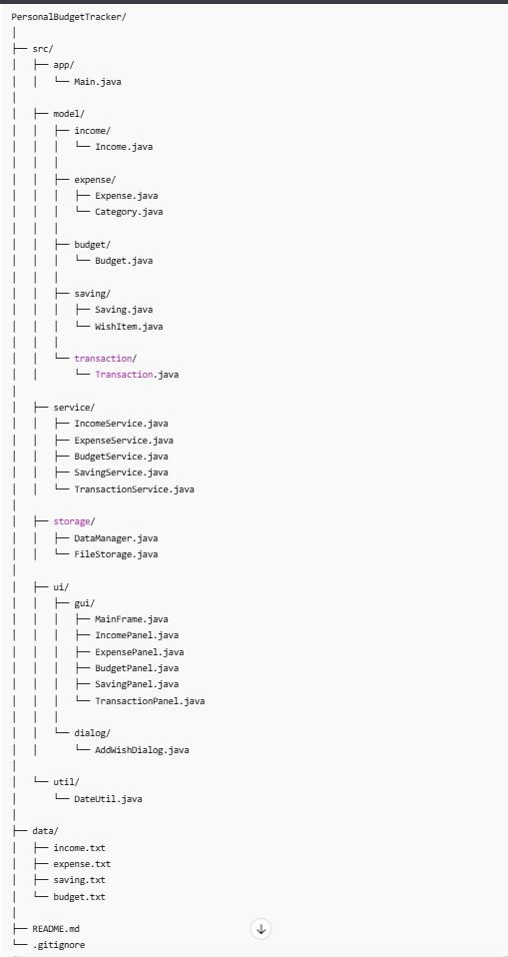

App flow
- Get user income

