Practicing: Database Version Control and Querying with Sequelize

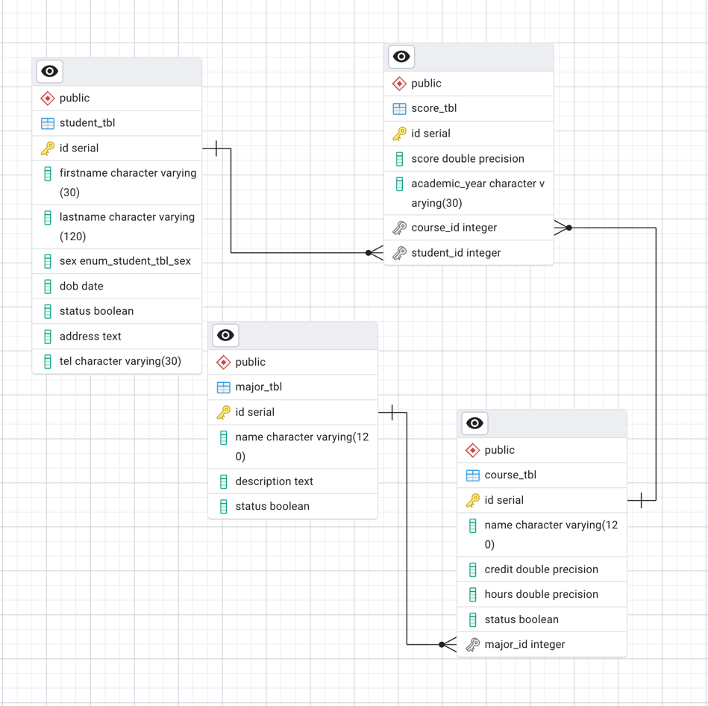
Assume we have below tables:

Exercise 1: High-performing students in a specific year
Display students who:
- studied in academic year 2025-2026
- received a score greater than or equal to 85
- belong to active courses only
Expected fields:
Student ID
Full Name
Course
Score
Academic Year

Exercise 2: Multiple score conditions

Display scores that are:
score >= 60
score <= 90
academic_year = "2025-2026"
Use: [Op.between]
Exercise 3: Search students by name and score
Accept query parameters:
GET /api/reports/scores?keyword=dara&minScore=70
Search by:
- firstname
- lastname
- minimum score
Hint:
[Op.or]
[Op.iLike]
[Op.gte]

Exercise 4: Full academic report
- Display:
Student
Score
Academic year
Course
Credit
Major
- Relationship path: Student-> Score -> Course -> Major

Exercise 5: Average score for each student

Task: you need to return
student_id
full_name
average_score
Usage:
Sequelize.fn("AVG", ...)
group

Part 11: Build an Academic Performance API

Students must create these endpoints:
GET /api/reports/student-performance
GET /api/reports/course-performance
GET /api/reports/major-performance
GET /api/reports/top-students
GET /api/reports/at-risk-students
GET /api/reports/pass-rate

