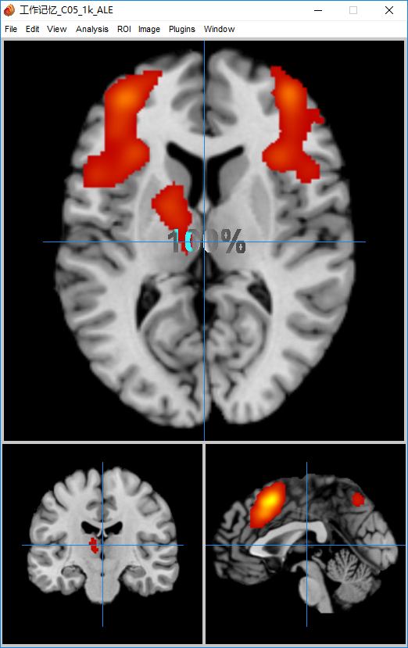

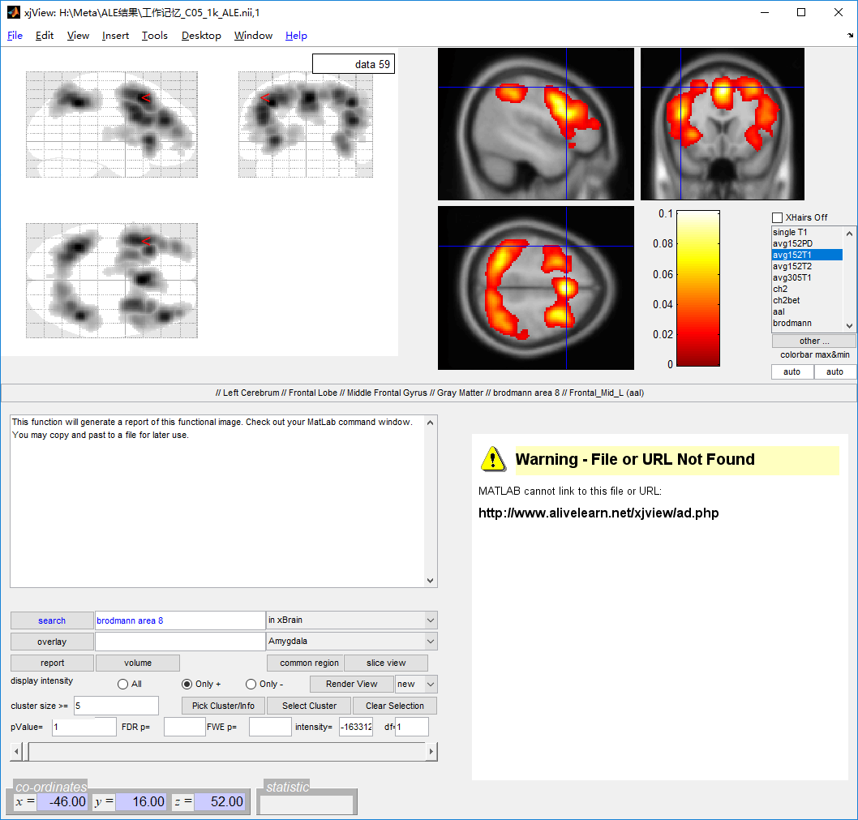

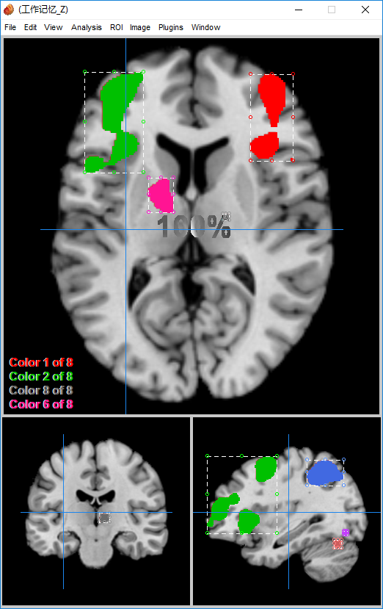

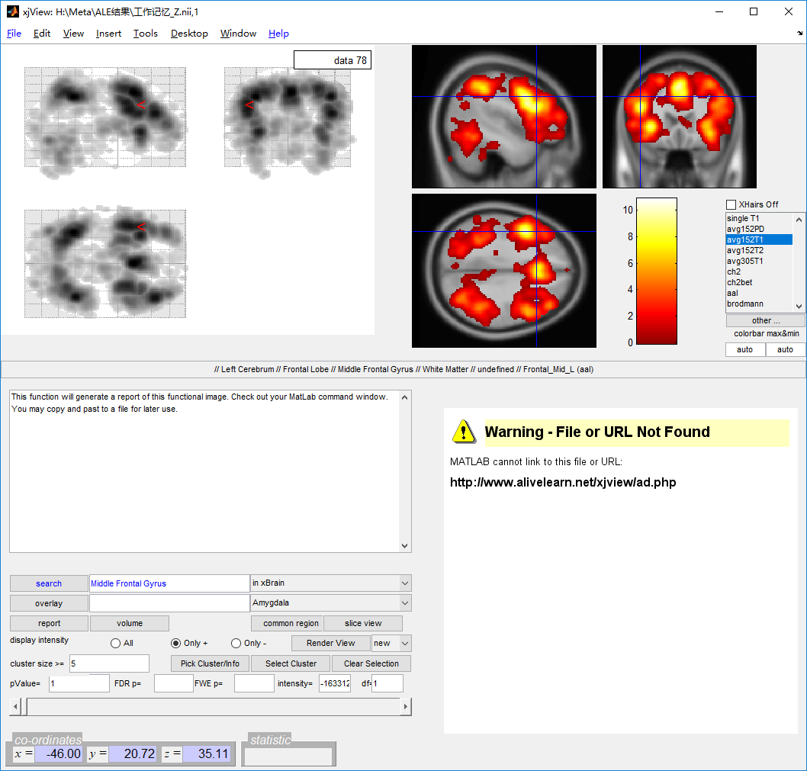

Cluster 1

Number of voxels: 76644

Peak MNI coordinate: -36 -50 44

Peak MNI coordinate region: // Left Cerebrum // Parietal Lobe // Inferior Parietal Lobule // Gray Matter // brodmann area 40 // Parietal_Inf_L (aal)

Peak intensity: 10.8753

----------------------

Cluster 2

Number of voxels: 5

Peak MNI coordinate: -38 -84 -48

Peak MNI coordinate region: // Left Cerebellum // Cerebellum Posterior Lobe // Inferior Semi-Lunar Lobule // undefined // undefined // undefined

Peak intensity: 0.28157

----------------------

Cluster 3

Number of voxels: 18

Peak MNI coordinate: 44 -4 -44

Peak MNI coordinate region: // Right Cerebrum // Frontal Lobe // Precentral Gyrus // Brodmann area 6 // undefined // Temporal_Inf_R (aal)

Peak intensity: 0.40517

----------------------

Cluster 4

Number of voxels: 19

Peak MNI coordinate: -46 -82 -38

Peak MNI coordinate region: // Left Cerebellum // Cerebellum Posterior Lobe // Tuber // undefined // undefined // undefined

Peak intensity: 0.45982

----------------------

Cluster 5

Number of voxels: 20

Peak MNI coordinate: 38 -26 -32

Peak MNI coordinate region: // Right Cerebrum // Temporal Lobe // Fusiform Gyrus // undefined // undefined // Fusiform_R (aal)

Peak intensity: 0.40517

----------------------

Cluster 6

Number of voxels: 65

Peak MNI coordinate: 10 -30 -26

Peak MNI coordinate region: // Right Brainstem // Pons // undefined // undefined // undefined // undefined

Peak intensity: 0.5492

----------------------

Cluster 7

Number of voxels: 20

Peak MNI coordinate: 30 -12 -24

Peak MNI coordinate region: // Right Cerebrum // Limbic Lobe // Parahippocampa Gyrus // White Matter // undefined // Hippocampus_R (aal)

Peak intensity: 0.38908

----------------------

Cluster 8

Number of voxels: 83

Peak MNI coordinate: 12 54 -22

Peak MNI coordinate region: // Right Cerebrum // Frontal Lobe // Sub-Gyral // White Matter // undefined // Frontal_Sup_Orb_R (aal)

Peak intensity: 1.0182

----------------------

Cluster 9

Number of voxels: 22

Peak MNI coordinate: -22 -56 -22

Peak MNI coordinate region: // Left Cerebellum // Cerebellum Anterior Lobe // Culmen // undefined // undefined // Cerebelum_6_L (aal)

Peak intensity: 0.40975

----------------------

Cluster 10

Number of voxels: 11

Peak MNI coordinate: -4 -34 -20

Peak MNI coordinate region: // Left Brainstem // Midbrain // undefined // undefined // undefined // undefined

Peak intensity: 0.28157

----------------------

Cluster 11

Number of voxels: 8

Peak MNI coordinate: 40 -88 -14

Peak MNI coordinate region: // Right Cerebrum // Occipital Lobe // Inferior Occipital Gyrus // White Matter // undefined // Occipital_Inf_R (aal)

Peak intensity: 0.16589

----------------------

Cluster 12

Number of voxels: 219

Peak MNI coordinate: 64 -34 -10

Peak MNI coordinate region: // Right Cerebrum // Temporal Lobe // Middle Temporal Gyrus // White Matter // undefined // Temporal_Mid_R (aal)

Peak intensity: 1.2129

----------------------

Cluster 13

Number of voxels: 30

Peak MNI coordinate: -2 -6 -10

Peak MNI coordinate region: // Left Cerebrum // Sub-lobar // Extra-Nuclear // White Matter // undefined // undefined

Peak intensity: 0.40287

----------------------

Cluster 14

Number of voxels: 23

Peak MNI coordinate: -8 -60 -8

Peak MNI coordinate region: // Left Cerebellum // Cerebellum Anterior Lobe // Culmen // undefined // undefined // Cerebelum_4_5_L (aal)

Peak intensity: 0.45303

----------------------

Cluster 15

Number of voxels: 68

Peak MNI coordinate: -62 -32 -8

Peak MNI coordinate region: // Left Cerebrum // Temporal Lobe // Middle Temporal Gyrus // White Matter // undefined // Temporal_Mid_L (aal)

Peak intensity: 0.52261

----------------------

Cluster 16

Number of voxels: 11

Peak MNI coordinate: -6 -46 -6

Peak MNI coordinate region: // Left Cerebellum // Cerebellum Anterior Lobe // Culmen // undefined // undefined // Cerebelum_4_5_L (aal)

Peak intensity: 0.25539

----------------------

Cluster 17

Number of voxels: 26

Peak MNI coordinate: -68 -22 -6

Peak MNI coordinate region: // Left Cerebrum // Temporal Lobe // Middle Temporal Gyrus // undefined // undefined // Temporal_Mid_L (aal)

Peak intensity: 0.57341

----------------------

Cluster 18

Number of voxels: 206

Peak MNI coordinate: -22 -58 2

Peak MNI coordinate region: // Left Cerebrum // Occipital Lobe // Lingual Gyrus // Gray Matter // brodmann area 18 // undefined

Peak intensity: 1.6305

----------------------

Cluster 19

Number of voxels: 8

Peak MNI coordinate: -66 0 -4

Peak MNI coordinate region: // undefined // undefined // undefined // undefined // undefined // undefined

Peak intensity: 0.12149

----------------------

Cluster 20

Number of voxels: 12

Peak MNI coordinate: -52 -36 2

Peak MNI coordinate region: // Left Cerebrum // Temporal Lobe // Middle Temporal Gyrus // White Matter // undefined // Temporal_Mid_L (aal)

Peak intensity: 0.23623

----------------------

Cluster 21

Number of voxels: 24

Peak MNI coordinate: 38 -2 6

Peak MNI coordinate region: // Right Cerebrum // Sub-lobar // Insula // White Matter // undefined // Insula_R (aal)

Peak intensity: 0.4326

----------------------

Cluster 22

Number of voxels: 95

Peak MNI coordinate: -40 -14 12

Peak MNI coordinate region: // Left Cerebrum // Sub-lobar // Insula // Gray Matter // brodmann area 13 // Insula_L (aal)

Peak intensity: 1.4014

----------------------

Cluster 23

Number of voxels: 299

Peak MNI coordinate: 2 -92 24

Peak MNI coordinate region: // Inter-Hemispheric // undefined // undefined // undefined // undefined // Cuneus_L (aal)

Peak intensity: 1.2091

----------------------

Cluster 24

Number of voxels: 24

Peak MNI coordinate: 40 -68 18

Peak MNI coordinate region: // Right Cerebrum // Temporal Lobe // Middle Temporal Gyrus // White Matter // undefined // undefined

Peak intensity: 0.48461

----------------------

Cluster 25

Number of voxels: 28

Peak MNI coordinate: -66 -16 18

Peak MNI coordinate region: // Left Cerebrum // Parietal Lobe // Postcentral Gyrus // Gray Matter // brodmann area 43 // Postcentral_L (aal)

Peak intensity: 0.59537

----------------------

Cluster 26

Number of voxels: 19

Peak MNI coordinate: 8 50 18

Peak MNI coordinate region: // Right Cerebrum // Frontal Lobe // Medial Frontal Gyrus // White Matter // undefined // Cingulum_Ant_R (aal)

Peak intensity: 0.37754

----------------------

Cluster 27

Number of voxels: 27

Peak MNI coordinate: 20 56 18

Peak MNI coordinate region: // Right Cerebrum // Frontal Lobe // Superior Frontal Gyrus // White Matter // undefined // Frontal_Sup_R (aal)

Peak intensity: 0.38677

----------------------

Cluster 28

Number of voxels: 24

Peak MNI coordinate: 20 68 20

Peak MNI coordinate region: // Right Cerebrum // Frontal Lobe // Sup Frontal Gyrus // undefined // Brodmann area 10 // Frontal_Sup_R (aal)

Peak intensity: 0.55581

----------------------

Cluster 29

Number of voxels: 33

Peak MNI coordinate: -32 -24 24

Peak MNI coordinate region: // Left Cerebrum // Sub-lobar // Extra-Nuclear // White Matter // undefined // undefined

Peak intensity: 0.40287

----------------------

Cluster 30

Number of voxels: 7

Peak MNI coordinate: -20 -16 22

Peak MNI coordinate region: // Left Cerebrum // Sub-lobar // Extra-Nuclear // White Matter // undefined // Caudate_L (aal)

Peak intensity: 0.20245

----------------------

Cluster 31

Number of voxels: 21

Peak MNI coordinate: 22 -22 26

Peak MNI coordinate region: // Right Cerebrum // Sub-lobar // Extra-Nuclear // White Matter // undefined // undefined

Peak intensity: 0.38908

----------------------

Cluster 32

Number of voxels: 19

Peak MNI coordinate: -66 -38 28

Peak MNI coordinate region: // Left Cerebrum // Parietal Lobe // Inferior Parietal Lobule // Gray Matter // brodmann area 40 // undefined

Peak intensity: 0.39368

----------------------

Cluster 33

Number of voxels: 8

Peak MNI coordinate: -52 -16 28

Peak MNI coordinate region: // Left Cerebrum // Frontal Lobe // Precentral Gyrus // White Matter // undefined // Postcentral_L (aal)

Peak intensity: 0.1314

----------------------

Cluster 34

Number of voxels: 84

Peak MNI coordinate: -2 58 30

Peak MNI coordinate region: // Left Cerebrum // Frontal Lobe // Superior Frontal Gyrus // Gray Matter // brodmann area 9 // Frontal_Sup_Medial_L (aal)

Peak intensity: 1.0083

----------------------

Cluster 35

Number of voxels: 5

Peak MNI coordinate: -6 -62 32

Peak MNI coordinate region: // Left Cerebrum // Parietal Lobe // Precuneus // White Matter // undefined // Precuneus_L (aal)

Peak intensity: 0.096562

----------------------

Cluster 36

Number of voxels: 19

Peak MNI coordinate: -20 -28 36

Peak MNI coordinate region: // Left Cerebrum // Frontal Lobe // Sub-Gyral // White Matter // undefined // undefined

Peak intensity: 0.45303

----------------------

Cluster 37

Number of voxels: 6

Peak MNI coordinate: -12 46 44

Peak MNI coordinate region: // Left Cerebrum // Frontal Lobe // Superior Frontal Gyrus // White Matter // undefined // Frontal_Sup_L (aal)

Peak intensity: 0.16834

----------------------

Cluster 38

Number of voxels: 26

Peak MNI coordinate: 0 -14 50

Peak MNI coordinate region: // Left Cerebrum // Frontal Lobe // Paracentral Lobule // undefined // undefined // Supp_Motor_Area_L (aal)

Peak intensity: 0.46434

----------------------

Cluster 39

Number of voxels: 26

Peak MNI coordinate: -4 -26 60

Peak MNI coordinate region: // Left Cerebrum // Frontal Lobe // Medial Frontal Gyrus // White Matter // undefined // Paracentral_Lobule_L (aal)

Peak intensity: 0.42348

----------------------

Cluster 40

Number of voxels: 18

Peak MNI coordinate: 14 -8 68

Peak MNI coordinate region: // Right Cerebrum // Frontal Lobe // Superior Frontal Gyrus // White Matter // undefined // Supp_Motor_Area_R (aal)

Peak intensity: 0.37754

----------------------

Cluster 41

Number of voxels: 8

Peak MNI coordinate: -36 -42 68

Peak MNI coordinate region: //Left Cerebrum // Parietal Lobe // Sup Parietal Lob // undefined // Brodmann area 7 // Postcentral_L (aal)

Peak intensity: 0.20245

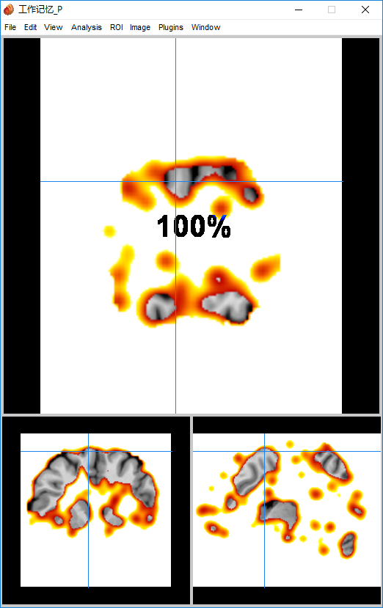

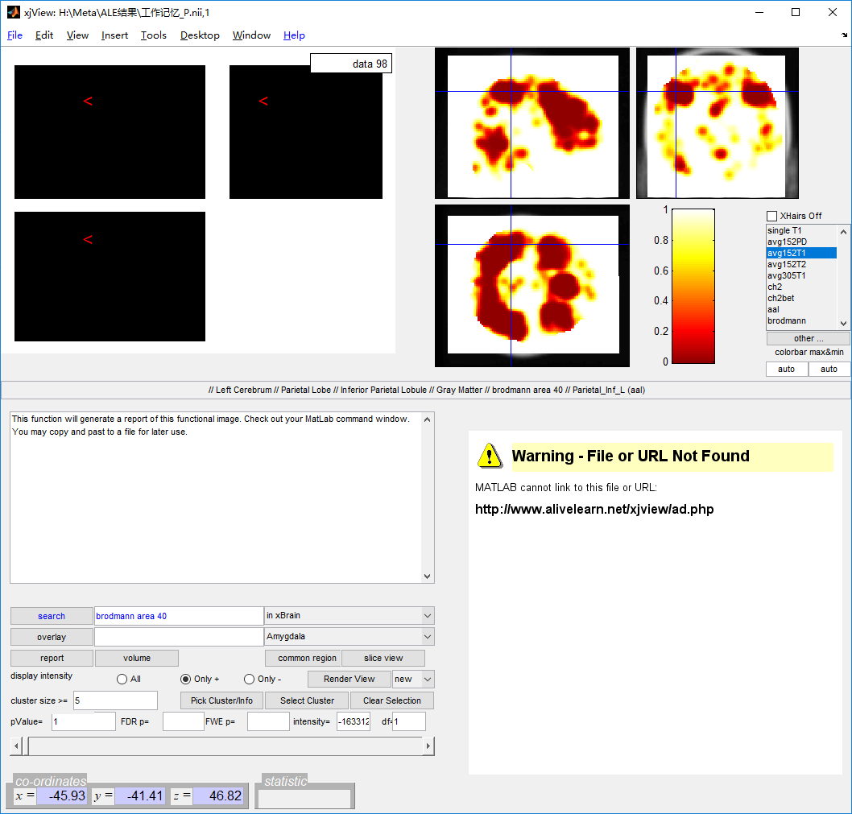

Cluster 1

Number of voxels: 583968

Peak MNI coordinate: -76 -112 -70

Peak MNI coordinate region: // undefined // undefined // undefined // undefined // undefined // undefined

Peak intensity: 1

# voxels structure

583968 --TOTAL # VOXELS--

106935 White Matter

97359 Right Cerebrum

96069 Left Cerebrum

70324 Frontal Lobe

67855 Gray Matter

33103 Temporal Lobe

26850 Parietal Lobe

24626 Sub-Gyral

23535 Sub-lobar

21322 Occipital Lobe

17400 Limbic Lobe

17391 Cerebellum Posterior Lobe

14668 Middle Frontal Gyrus

12427 Left Cerebellum

12384 Right Cerebellum

12327 Superior Frontal Gyrus

10759 Extra-Nuclear

10496 Superior Temporal Gyrus

10013 Middle Temporal Gyrus

9516 Inferior Frontal Gyrus

8465 Medial Frontal Gyrus

8367 Precentral Gyrus

7726 Precuneus

7217 Cerebellum Anterior Lobe

6971 Postcentral Gyrus

6890 Cingulate Gyrus

6452 brodmann area 6

5917 Inferior Parietal Lobule

5904 Cuneus

5264 Culmen

5104 Frontal_Mid_R (aal)

5012 Middle Occipital Gyrus

4942 Temporal_Mid_L (aal)

4863 Frontal_Mid_L (aal)

4510 Declive

4409 Temporal_Mid_R (aal)

4399 Lingual Gyrus

4287 Cerebellar Tonsil

4256 Insula

4072 Parahippocampa Gyrus

4056 Frontal_Sup_R (aal)

3892 Postcentral_L (aal)

3823 Inter-Hemispheric

3823 Postcentral_R (aal)

3775 brodmann area 19

3604 brodmann area 10

3599 Frontal_Sup_L (aal)

3559 brodmann area 7

3557 Temporal_Inf_R (aal)

3530 brodmann area 18

3528 Precuneus_L (aal)

3526 Precentral_L (aal)

3508 Fusiform Gyrus

3381 Precentral_R (aal)

3270 Occipital_Mid_L (aal)

3265 Precuneus_R (aal)

3205 brodmann area 40

3200 Temporal_Inf_L (aal)

3141 Temporal_Sup_R (aal)

3110 Anterior Cingulate

2992 Frontal_Sup_Medial_L (aal)

2861 brodmann area 9

2732 Inferior Temporal Gyrus

2685 Corpus Callosum

2648 Cerebelum_Crus1_R (aal)

2603 Cerebelum_Crus1_L (aal)

2600 Inferior Semi-Lunar Lobule

2579 Tuber

2547 Cerebro-Spinal Fluid

2529 Frontal_Inf_Tri_L (aal)

2518 Fusiform_R (aal)

2497 Left Brainstem

2447 Parietal_Inf_L (aal)

2395 Right Brainstem

2386 brodmann area 11

2371 Supp_Motor_Area_R (aal)

2349 Lateral Ventricle

2324 Lentiform Nucleus

2310 Fusiform_L (aal)

2308 Cerebelum_8_R (aal)

2300 Lingual_R (aal)

2296 Temporal_Sup_L (aal)

2289 Midbrain

2258 Calcarine_L (aal)

2222 Parietal_Sup_R (aal)

2203 Cingulum_Mid_R (aal)

2199 brodmann area 8

2177 brodmann area 21

2157 Pons

2151 Frontal_Inf_Tri_R (aal)

2147 Supp_Motor_Area_L (aal)

2134 Frontal_Sup_Medial_R (aal)

2117 Cerebelum_Crus2_R (aal)

2098 Occipital_Mid_R (aal)

2095 Lingual_L (aal)

2065 Parietal_Sup_L (aal)

2034 Thalamus

1989 Posterior Cingulate

1974 SupraMarginal_R (aal)

1941 Cingulum_Mid_L (aal)

1894 Cerebelum_Crus2_L (aal)

1892 Pyramis

1887 Cerebelum_8_L (aal)

1861 Calcarine_R (aal)

1858 Insula_L (aal)

1848 brodmann area 20

1848 brodmann area 13

1795 Cerebelum_6_R (aal)

1775 Supramarginal Gyrus

1770 Insula_R (aal)

1752 Angular_R (aal)

1727 Paracentral Lobule

1723 brodmann area 47

1720 brodmann area 22

1707 Frontal_Inf_Orb_R (aal)

1694 Cerebelum_6_L (aal)

1690 Frontal_Inf_Orb_L (aal)

1685 Putamen

1674 Superior Parietal Lobule

1631 brodmann area 38

1569 brodmann area 31

1526 Cuneus_L (aal)

1460 brodmann area 39

1440 Inferior Occipital Gyrus

1439 brodmann area 37

1424 Cuneus_R (aal)

1420 brodmann area 32

1413 Occipital_Sup_R (aal)

1400 Cingulum_Ant_L (aal)

1399 Frontal_Inf_Oper_R (aal)

1366 Occipital_Sup_L (aal)

1349 Paracentral_Lobule_L (aal)

1345 Parietal_Inf_R (aal)

1338 Temporal_Pole_Sup_R (aal)

1331 Rolandic_Oper_R (aal)

1313 Cingulum_Ant_R (aal)

1300 Uncus

1285 Temporal_Pole_Sup_L (aal)

1279 brodmann area 4

1269 Uvula

1256 SupraMarginal_L (aal)

1239 Caudate

1187 Temporal_Pole_Mid_R (aal)

1173 Angular_L (aal)

1173 brodmann area 46

1170 brodmann area 24

1132 ParaHippocampal_R (aal)

1125 Cerebelum_4_5_L (aal)

1125 brodmann area 3

1100 Thalamus_L (aal)

1064 Putamen_R (aal)

1057 Thalamus_R (aal)

1038 Frontal_Inf_Oper_L (aal)

1015 Frontal_Mid_Orb_R (aal)

1009 Putamen_L (aal)

997 Frontal_Sup_Orb_R (aal)

994 Caudate_R (aal)

990 Rolandic_Oper_L (aal)

989 Occipital_Inf_R (aal)

978 ParaHippocampal_L (aal)

963 Frontal_Sup_Orb_L (aal)

962 Caudate_L (aal)

946 Hippocampus_R (aal)

941 Occipital_Inf_L (aal)

932 Hippocampus_L (aal)

888 Frontal_Mid_Orb_L (aal)

869 Cerebelum_9_L (aal)

861 Cerebelum_4_5_R (aal)

856 Frontal_Med_Orb_R (aal)

852 Rectus_L (aal)

836 Paracentral_Lobule_R (aal)

809 Cerebelum_9_R (aal)

801 Angular Gyrus

755 Temporal_Pole_Mid_L (aal)

745 Rectus_R (aal)

732 brodmann area 17

719 Frontal_Med_Orb_L (aal)

714 brodmann area 2

713 Rectal Gyrus

711 brodmann area 5

711 Orbital Gyrus

665 Vermis_4_5 (aal)

640 Caudate Body

617 brodmann area 45

585 Cerebelum_7b_L (aal)

576 Subcallosal Gyrus

538 brodmann area 30

534 Pulvinar

534 Cerebelum_7b_R (aal)

490 Caudate Head

481 Transverse Temporal Gyrus

463 Cingulum_Post_L (aal)

452 Medulla

448 Lateral Globus Pallidus

441 brodmann area 44

439 brodmann area 36

426 Claustrum

419 Superior Occipital Gyrus

413 brodmann area 41

410 Dentate

391 brodmann area 25

371 Vermis_6 (aal)

361 brodmann area 23

335 Cingulum_Post_R (aal)

334 brodmann area 42

321 Frontal-Temporal Space

319 Amygdala

293 Pallidum_L (aal)

289 Nodule

289 brodmann area 28

289 Olfactory_R (aal)

283 brodmann area 43

280 Pallidum_R (aal)

280 Olfactory_L (aal)

273 brodmann area 34

261 Hippocampus

249 Heschl_R (aal)

248 Amygdala_R (aal)

244 Medial Dorsal Nucleus

243 Vermis_8 (aal)

228 Vermis_3 (aal)

225 Heschl_L (aal)

222 Ventral Lateral Nucleus

220 Amygdala_L (aal)

213 brodmann area 1

207 brodmann area 35

207 Cerebelum_3_R (aal)

194 Vermis_7 (aal)

174 Vermis_9 (aal)

170 Cerebellar Lingual

168 Medial Globus Pallidus

159 Cerebelum_10_R (aal)

144 Cerebelum_10_L (aal)

143 Ventral Anterior Nucleus

136 Cerebelum_3_L (aal)

126 Declive of Vermis

112 Vermis_10 (aal)

109 Caudate Tail

107 brodmann area 29

101 Fastigium

92 Third Ventricle

84 Ventral Posterior Lateral Nucleus

79 Fourth Ventricle

77 Culmen of Vermis

73 Red Nucleus

60 Lateral Posterior Nucleus

58 Uvula of Vermis

56 Substania Nigra

54 Mammillary Body

53 Vermis_1_2 (aal)

51 brodmann area 27

50 Pyramis of Vermis

48 Optic Tract

44 Subthalamic Nucleus

34 Ventral Posterior Medial Nucleus

32 brodmann area 33

25 Hypothalamus

24 Lateral Dorsal Nucleus

23 Tuber of Vermis

16 Medial Geniculum Body

13 Midline Nucleus

10 Lateral Geniculum Body

7 Anterior Commissure

H:\Meta\ALE结果\工作记忆_P.nii,1

Type: S

df: 1

Threshold

-- p value = 1

-- intensity = -16331239353195370

-- cluster size = 5

Number of clusters found: 1