Name: Dean Lour

Customers School Supplier Report

About:

Customer needs to purchase supplies for their next semester at California State University Sacros. Customer has provided a document, listing the items needed, the quantity of items needed, and a sample detailing the cost between three suppliers. Since Customer has limited financial resources, Customer wants to determine which supplier is the most cost-efficient choice.

Duties:

1. Create a new column, called *prod_type_id*. The column should extract the product id, from *product*, column and store it as “NE” or “E”.
2. Create a new column, that identifies the products as “Non-Electronic” & “Electric”, based on the type of product it is. Use “VLOOKUP” to fill this column. Name this column Product Type.
3. Create A bar chart & Hierarchy chart.
   1. Ensure Horizontal Axis Names is equal to *Product* column.
4. Determine the Total Cost per supplier based on the customers quantity requirement.
5. Create a Simple Pivot Table, to determine how much Electronics are totaled per supplier.
6. *Question:* Which product takes most of financial resources?
7. *Questions:* which supplier is most cost-efficient?

Contents

Duties 1 & 2: 3

Duties 3 & 4: 4

Duties 4 & 5: 5

Duties 6 & 7: 6

Summary 7

# Duties 1 & 2:

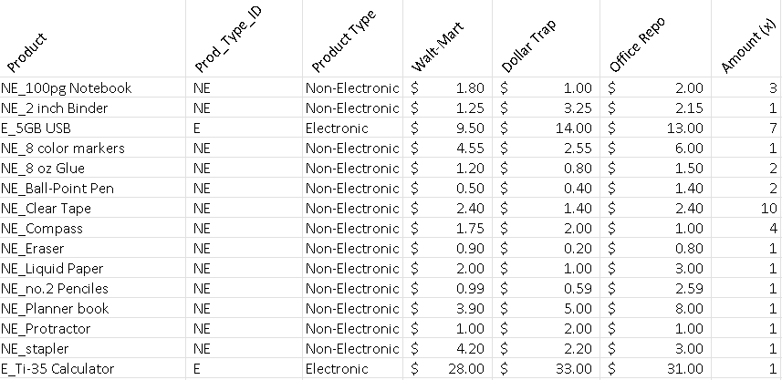

**Report:**

As customer requested, two columns were successfully created. *Prod_Type_ID* & *Product Type* Columns. Both Columns detailing important information for identification of product type, and ID classification.

**Functions Used:**

* IF ()
* LEFT ()
* VLOOKUP ()

*Duties 3 & 4 begin next page…*

# Duties 3 & 4:

Bar chart data of product type & cost of product type(s). Supplier market seems to spike on electronic purchases, across all suppliers.

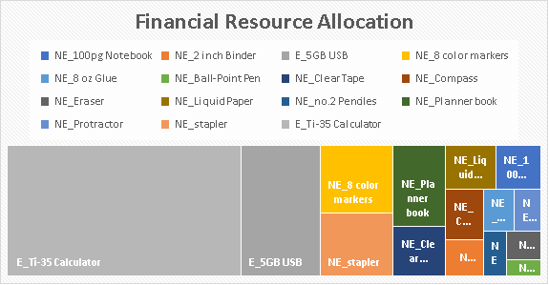

A hierarchy chart observes financial resource allocation, in overall purchase.

# Duties 4 & 5:



The total cost per item & Quantity for every supplier, indicated by customer, is shown (above) for each supplier.

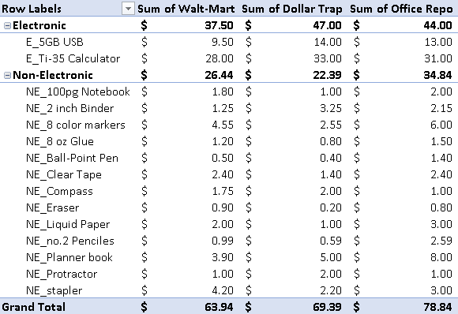

As requested by customer, a pivot table created from Sheet 1, detailing the total cost of NE and E categories. Quantity not considered in this calculation. However, Pivot tables give’s general insight into prices.

# Duties 6 & 7:

*Questions*

*Question:* Which product takes most of financial resources?

1. The product, calculator, accounts for most of the financial resources. When accounting for the electronic category, as a whole, the electronic category accounts for most financial resource allocation.

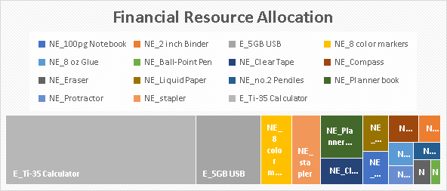

*Note: The two large grey rectangles (electronic products)*

*Questions:* which supplier is most cost-efficient?

1. Walt-Mart is the most cost-efficient supplier for school supplies. At $153.09, it is $22.10 dollars cheaper than Dollar Trap, and $36.25 dollars cheaper than Office Repo.



# Summary

From the research conducted, the concluding analysis was that Walt-Mart is the best supplier out of the three suppliers. While Walt-Mart may have more mid-expense items in the non-electronic category, their total prices remain low, due to their inexpensive *electronic* products.

Although Electronics allocate for most of the financial resources, according to the customers need, Walt-Mart is able to capture the market with its low prices in this category of suppliers. In conjunction with this, walt-Mart has some competitive prices on non-electronic products as well (though very few).



For example, the *NE_Planner book, is $2-5* dollars cheaper (refer to image above) than its competitor prices. Because students strive to remain organized, a crucial product such as a planner, with the growing use of technology, certainly leads Walt-Mart to be most appealing in attracting customers (in addition to their prices on such crucial supplies).

In conclusion, the Customer should choose Walt-Mart as their choice of suppliers, when purchasing products. Their savings on crucial items such as the Planner Book, USB Drive, and Ti-35 Calculator, is most appealing.