A new string matching method for genomic sequencing data

XXX1, Zhang Zhang1,*

1CAS Key Laboratory of Genome Sciences and Information, Beijing Institute of Genomics, Chinese Academy of Sciences, Beijing 100029, China

2School of Computer Science and Technology, XXX

\***Corresponding authors**:

Zhang Zhang (zhangzhang@big.ac.cn): CAS Key Laboratory of Genome Sciences and Information, Beijing Institute of Genomics, Chinese Academy of Sciences, No.7 Beitucheng West Road, Building G, Chaoyang District, Beijing 100029, China, Tel & Fax: +86-10-82995427

Running head: Parallel construction of multiple protein-coding DNA alignments

### Abstract

In this research, we propose a fast pattern matching algorithm for biological sequences:The SSE Hash Shift algorithm.The algorithm makes use of sse instrument to compute the shift distance.The experimental results show the algorithm is superior to other algorithms especially when the length of the pattern is short then 64 bytes.

Key words: String matching ,SSE,biological sequences

### Introduction

Alignments of homologous sequences within and among species are of utmost importance for comparative genomics, molecular evolution and phylogenetic reconstruction [1,2,3,4].

XXX.

Here we present XXX.

### Material and methods

##### Algorithm

XXX

, (1)

where  and .

##### Estimating XXX

XXX

, , ,  (2)

XXX

##### Data collection

XXXX

##### Section XXX

XXXX

### Results

##### Section 1

XXX

##### Section 2

XXX.

##### Section 3

XXX.

### Discussion

##### Section 1

XXX

##### Section 2

XXX.

##### Section 3

XXX.

### Acknowledgments

We thank XXX for YYY. This work was supported by the “100-Talent Program” of Chinese Academy of Sciences (Y1SLXb1365; ZZ).

### References

[1] W.-H. Li, Molecular Evolution, Sinauer Associates, Sunderland, Massachusetts, 1997.

[2] B. Rannala, Z. Yang, Phylogenetic inference using whole genomes, Annu Rev Genomics Hum Genet 9 (2008) 217-231.

[3] Z. Yang, Inference of selection from multiple species alignments, Curr Opin Genet Dev 12 (2002) 688-694.

[4] J.P. Townsend, F. Lopez-Giraldez, R. Friedman, The phylogenetic informativeness of nucleotide and amino acid sequences for reconstructing the vertebrate tree, J Mol Evol 67 (2008) 437-447.

### Tables

Table 1

Table 2

### Figure legends

Fig. 1 Parallelization scheme of ParaAT.

Fig. 2 Speedup (dotted lines) and running time (solid lines) for constructing protein-coding DNA alignments using 1–16 CPUs.

### Figures

(Font: Arial Narrow; Size: >=12pt; Format: EPS;)

Fig. 1

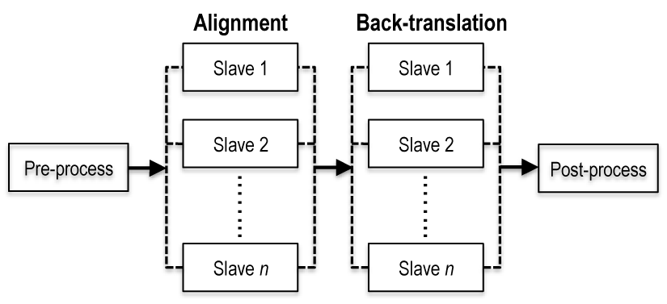

Fig. 2

