INDEX

Practical No. | Name | Date | Sign
1. | Association Rules (Apriori Algorithm) | 22/12/2025
2. | Regression Model  - Single Linear Regression  - Multiple Linear Regression  - Logistic Regression | 4/12/2025
3. | Clustering Model  - Hierarchical Clustering  - K-Means Clustering | 12/12/2025
4. | Classification Model  - Decision Tree Classification  - Naive Bayes Classification | 15/01/2026
5. | Working with Time Series Analysis & Text Analysis | 7/01/2026
6. | Install, configure and run Hadoop and HDFS & working with Spark | 21/01/2026
7. | Implement word count / frequency programs using  MapReduce | 22/01/2026
8. | Implement an application that scores big data in  Hbase / MongoDB and manipulate it using R/ Python
9. | Working with Pig & Sqoop | 27/02/2026
10. | Configure the Hive and implement the application in Hive

Practical No. 01

Aim: Association Rules (Apriori Algorithm).

Output:

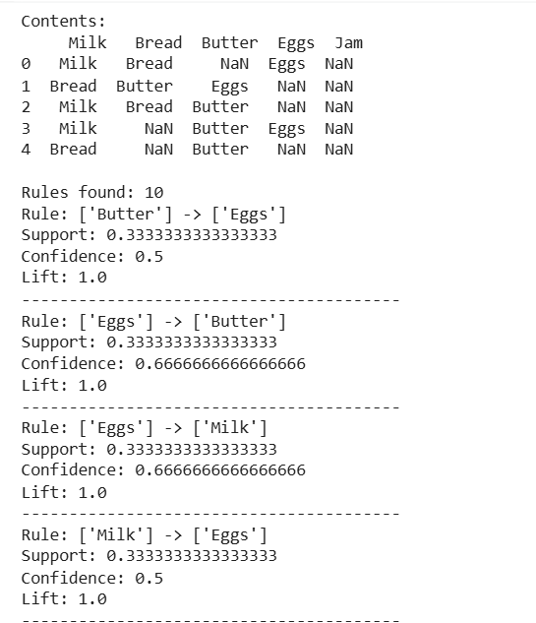

Practical No. 02

Aim: Regression Model :
a. Single Linear Regression
b. Multiple Linear Regression
c. Logistic Regression

1. Single Linear Regression.

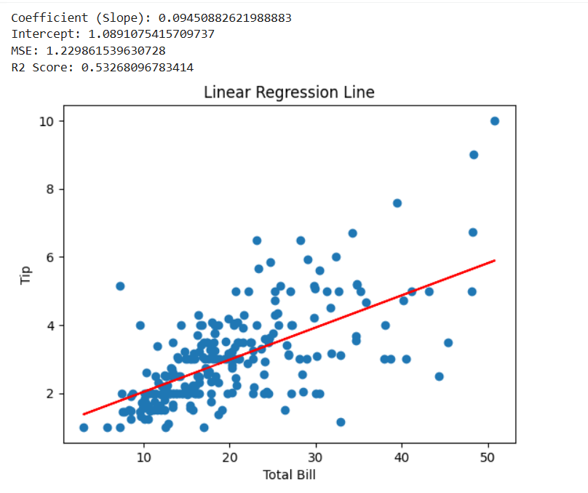

2. Multiple Linear Regression.

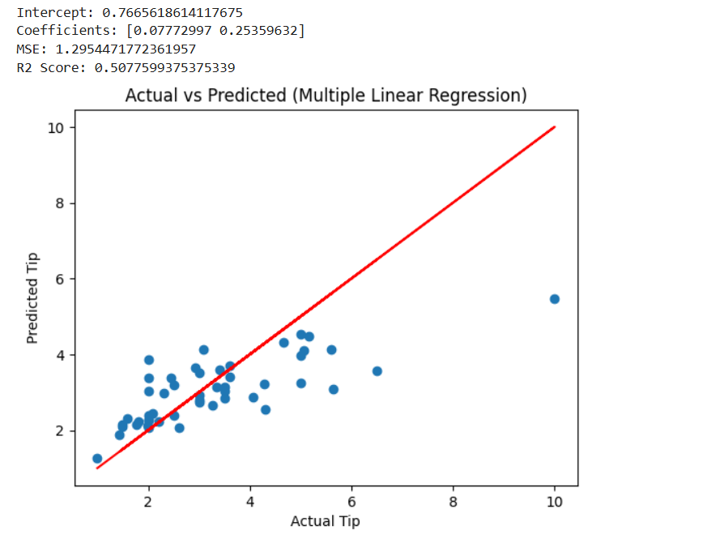
3. Logistic Regression.

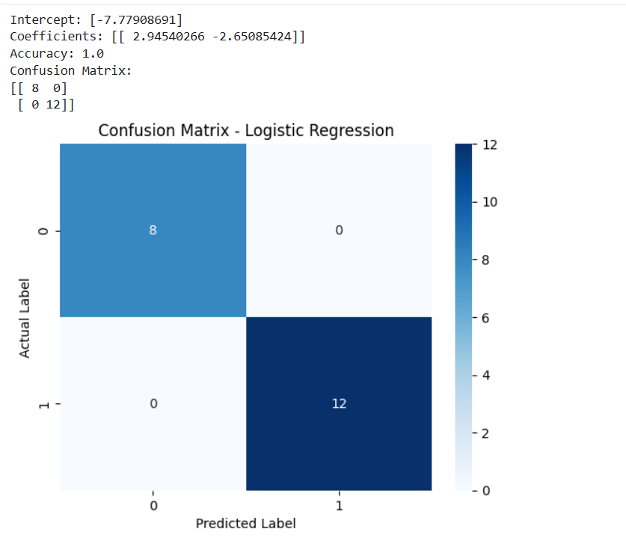

Practical No. 03

Aim: Clustering Model
a. Hierarchical Clustering
b. K-Means Clustering

a. Hierarchical Clustering

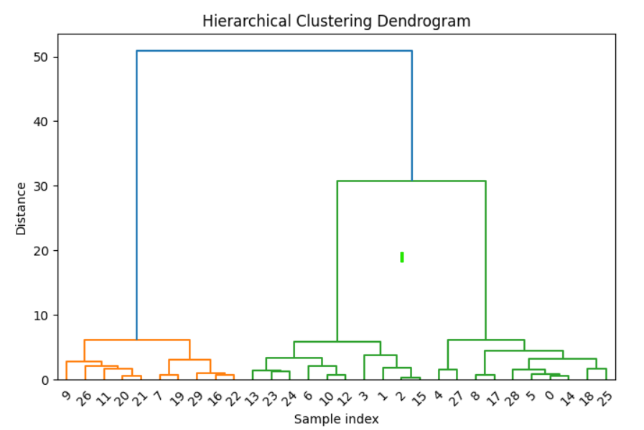

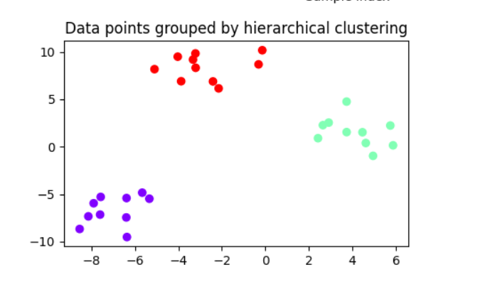

b. K-Means Clustering

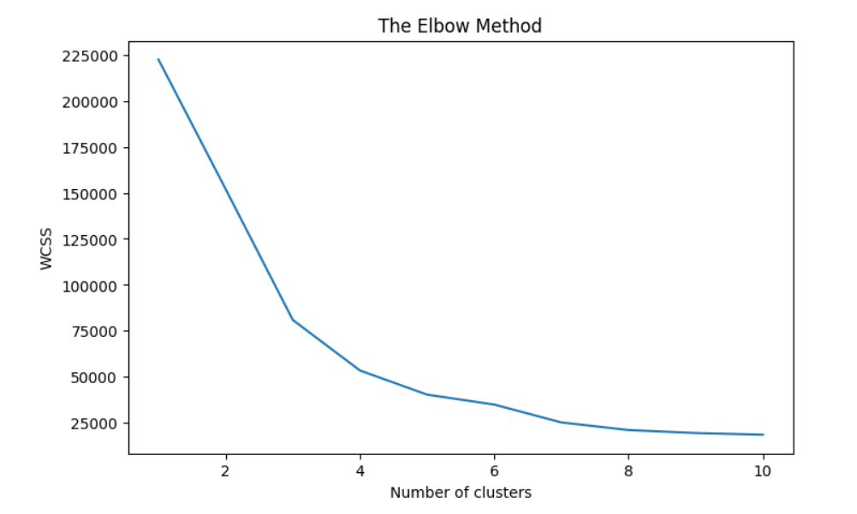

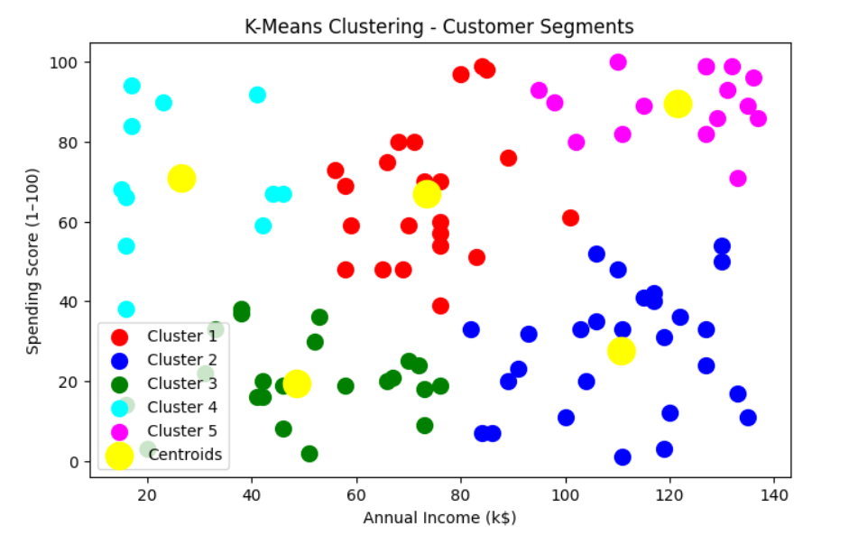

Practical No. 04

Aim: Classification Model
a. Decision Tree Classification
b. Naïve Bayes Classification

a. Decision Tree Classification

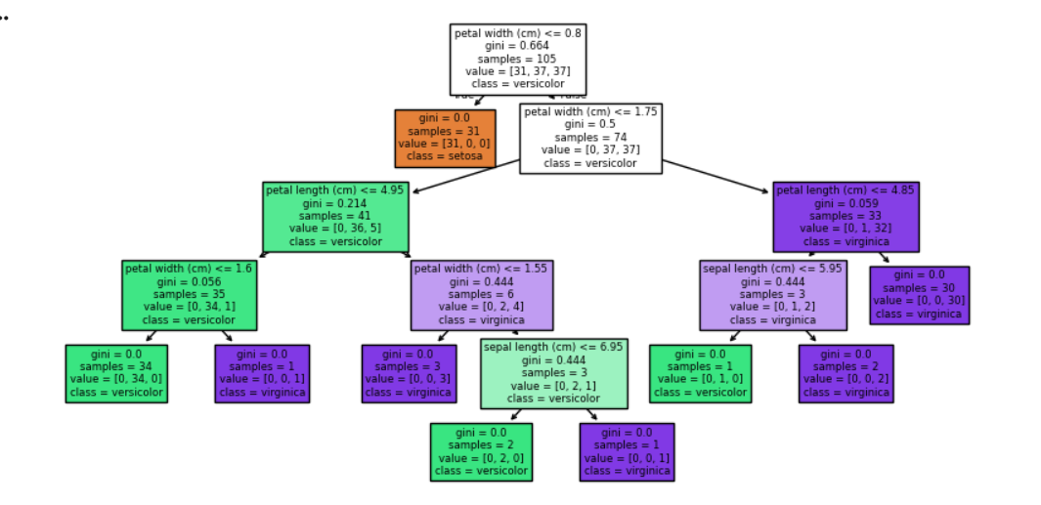

b. Naïve Bayes Classification

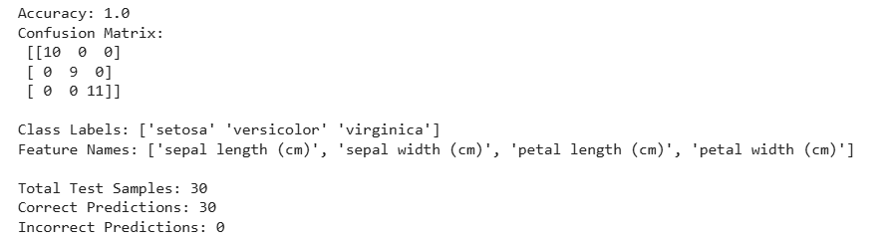

Practical No. 05

Aim: Working with Time Series Analysis & Text Analysis.

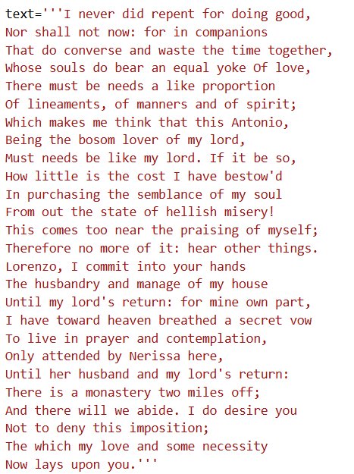

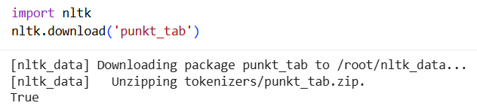

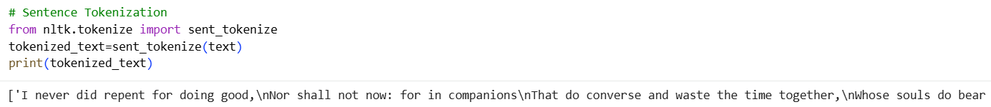

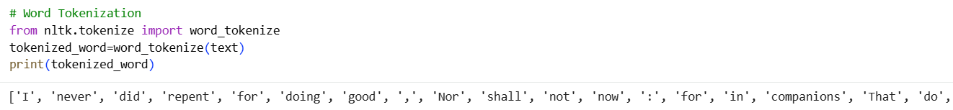

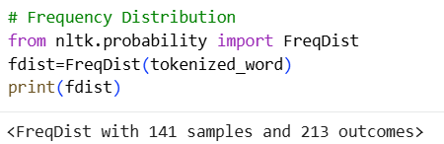

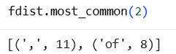

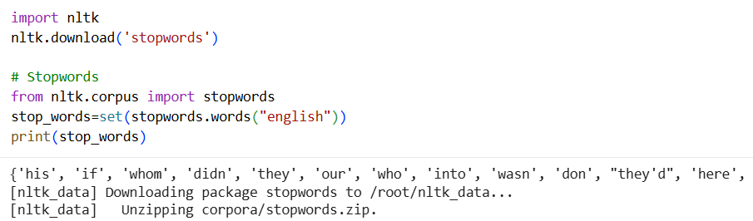
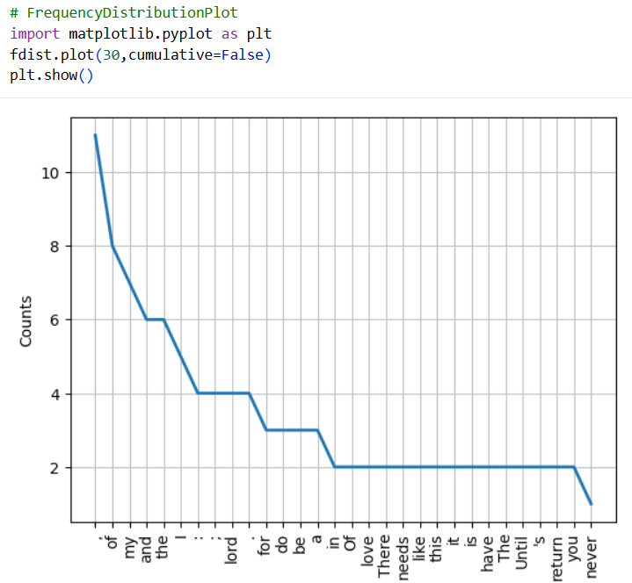

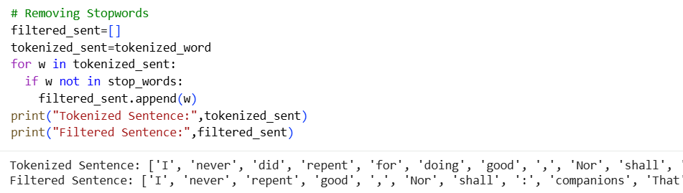

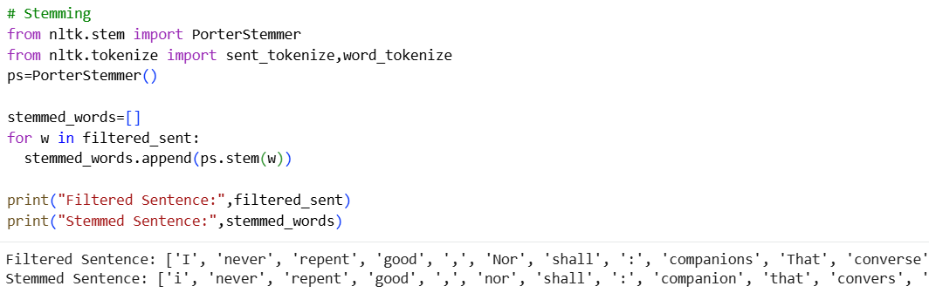

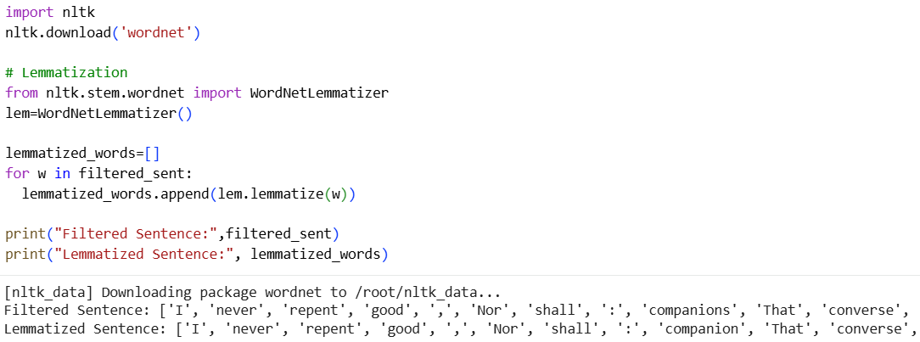

Practical No. 06

Aim: Install, configure and run Hadoop and HDFS & Working with Spark.

Step 1: Create a text file. Ex. sparkdata.txt with some contents.

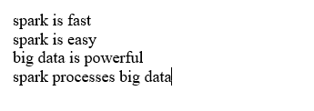

Step 2: Upload File to Hadoop (HDFS)

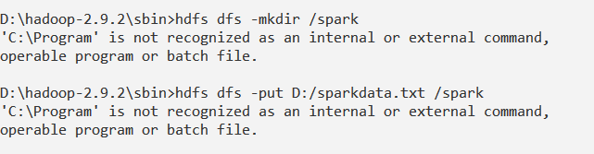

Step 3: Start Spark Shell using command spark-shell.

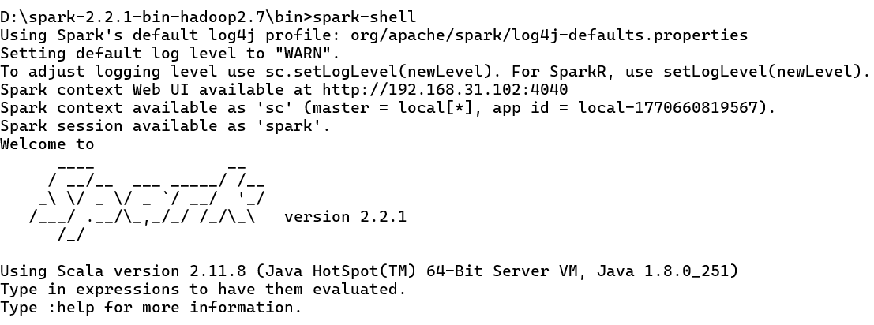

Step 4: Use following code/commands

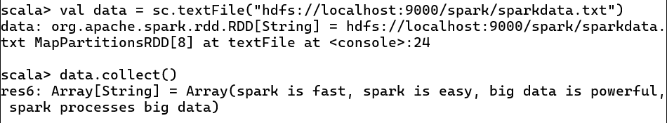

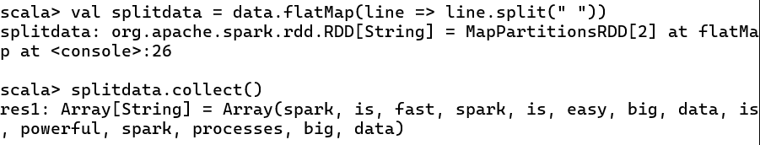

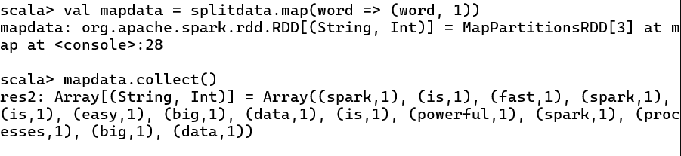

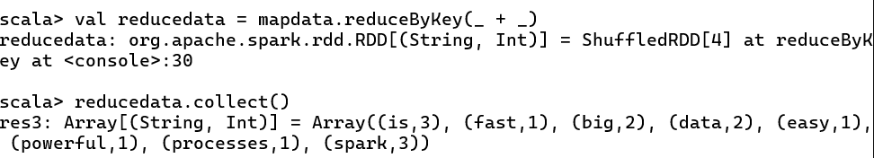

Practical No. 07

Aim: Implement word count / frequency programs using MapReduce.

Step 1: Create a word_count.txt file.

Step 2: Start the Hadoop using command: start-all.cmd

Step 3: Create a directory in the Hadoop HDFS by using the following command:
hdfs dfs -mkdir /input_wordCount

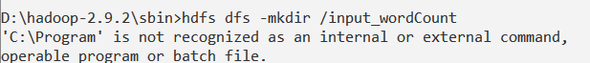

Step 4: Copy text file to HDFS using following command
hdfs dfs -put D:/word_count.txt /input_wordCount

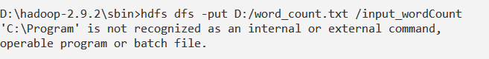

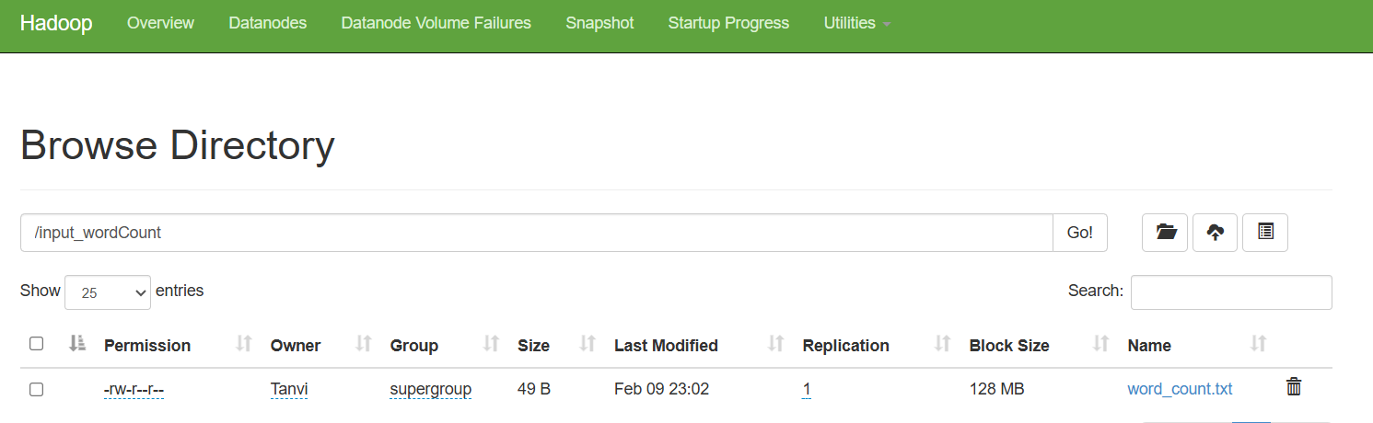

Step 5: Create Java Project using Netbeans → File → New Project → Java → Java Application → then add project name “WordCount” → Finish.

Step 6: Add following code in WordCount.java file

Step 7: Add Hadoop JAR files
Project → Properties → Libraries → Add JAR/Folder

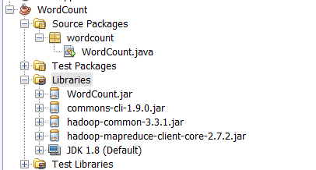

Step 8: Clean and Build Project.

Step 9: Go to the project location in File Explorer and go into the /dist folder and copy the jar
file path. Eg. D:\WordCount\dist\WordCount.jar

Step 10: Run following command:
hadoop jar D:\WordCount\dist\WordCount.jar /input_wordCount /op

View the output using localhost:50070

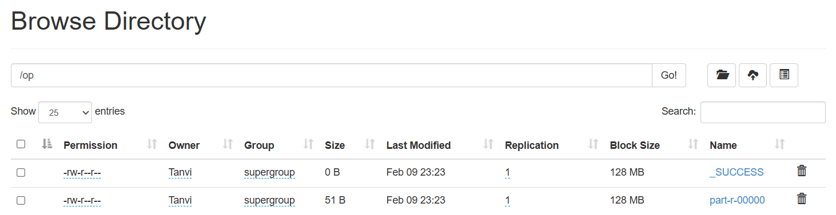

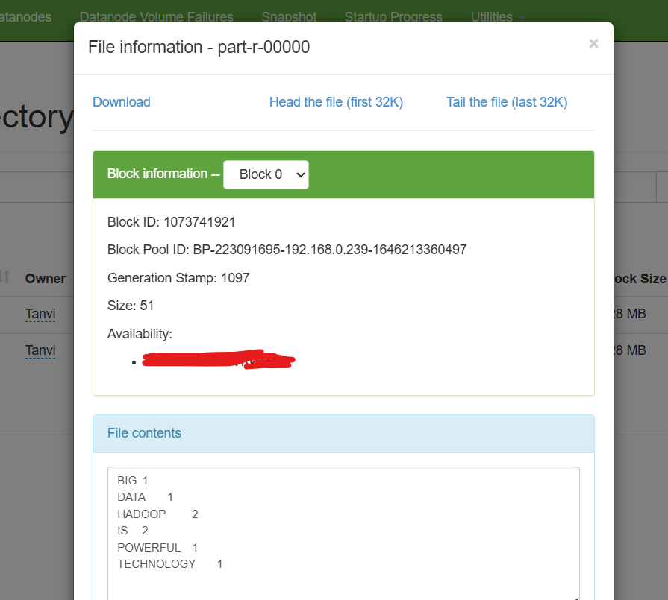

Practical No. 08

Aim: Implement an application that stores big data in Hbase / MongoDB and manipulate it using R / Python.

Step 1: Start Hadoop with start-all.cmd

Step2: Create a table in Netbeans (Open NetBeans → Services → Databases → newdb).
Create a table named STUDENT.

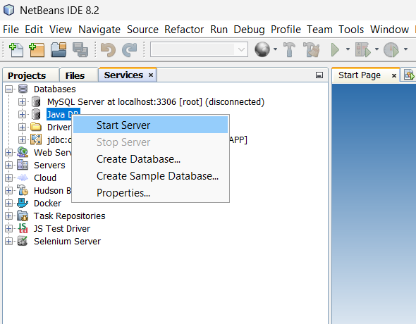

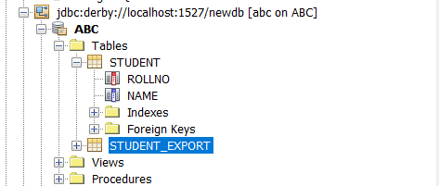

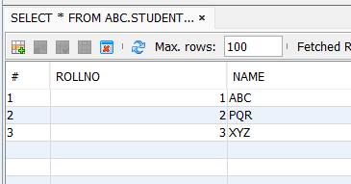

Step 3: Open Sqoop Command Prompt

Import command:
sqoop import --connect jdbc:derby://localhost:1527/newdb --username abc --password abc --table STUDENT --target-dir /studentdata --driver org.apache.derby.jdbc.ClientDriver

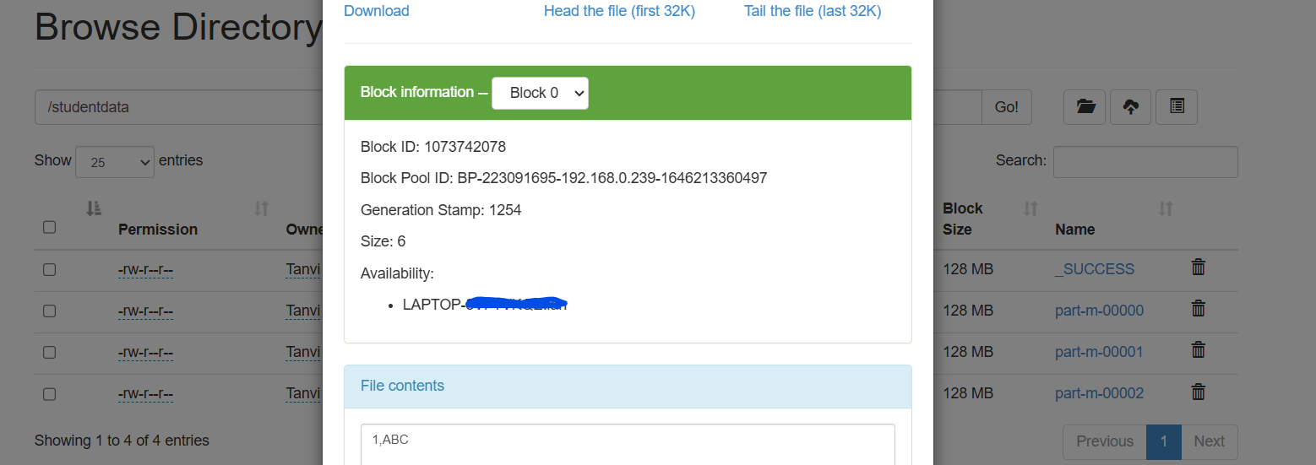

Step 5: Create another table to export data in netbeans with name student_export.

Export command:
sqoop export --connect jdbc:derby://localhost:1527/newdb --username abc --password abc --table STUDENT_EXPORT --export-dir /studentdata --driver org.apache.derby.jdbc.ClientDriver

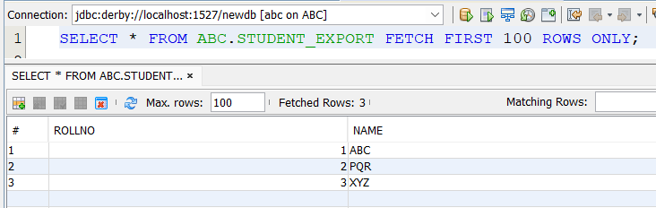

Practical No. 09

Aim: Working with Pig & Sqoop.
PIG OPERATORS
1. LOAD Operator
grunt> A = LOAD '/pigexample/data1.txt' USING PigStorage(',') AS (a1:int,a2:int,a3:int);
grunt> DUMP A;
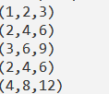

2. DISTINCT Operator
grunt> Result = DISTINCT A;
grunt> DUMP Result;
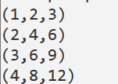

3. FILTER Operator
grunt> Result = FILTER A BY a2 == 4;
grunt> DUMP Result;
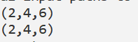

4. FOREACH Operator
grunt> B = FOREACH A GENERATE a1,a2;
grunt> DUMP B;
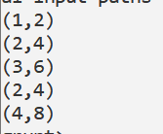

5. LIMIT Operator
grunt>Result = LIMIT A 2;
grunt>DUMP Result;
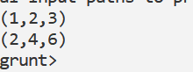

6. ORDER BY Operator
grunt>Result = ORDER A BY a1 DESC;
grunt>DUMP Result;
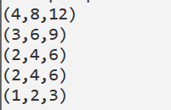

7. SPLIT Operator
grunt>SPLIT A INTO X IF a1 <= 2, Y IF a1 > 2;
grunt>DUMP X;
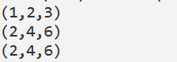

grunt>DUMP Y;
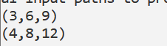

8. CROSS Operator
grunt>B = LOAD '/pigexample/data2.txt' USING PigStorage(',') AS (b1:int,b2:int);
grunt>Result = CROSS A,B;
grunt>DUMP Result;
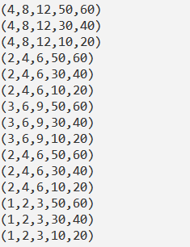

9. UNION Operator
grunt>Result = UNION A,B;
grunt>DUMP Result;
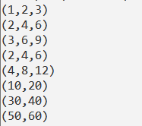

10. GROUP Operator
grunt>Result = GROUP A BY a1;
grunt>DUMP Result;
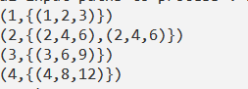

PIG MATH FUNCTIONS:

1. ABS Function
grunt> Result = FOREACH A GENERATE ABS(a1);
grunt> DUMP Result;
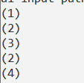

2. CBRT Function
grunt> Result = FOREACH A GENERATE CBRT(a1);
grunt> DUMP Result;
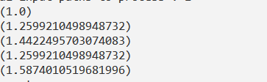

3. CEIL Function
grunt> Result = FOREACH A GENERATE CEIL((float)a1);
grunt> DUMP Result;
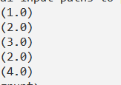

4. FLOOR Function
grunt> Result = FOREACH A GENERATE FLOOR((float)a1);
grunt> DUMP Result;


5. LOG Function
grunt> Result = FOREACH A GENERATE LOG((double)a1);
grunt> DUMP Result;
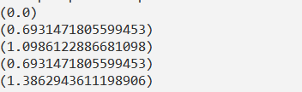

6. LOG10 Function
grunt> Result = FOREACH A GENERATE LOG10((double)a1);
grunt> DUMP Result;
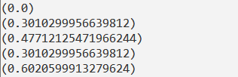

7. ROUND Function
grunt> Result = FOREACH A GENERATE ROUND((float)a2);
grunt> DUMP Result;
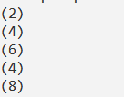

8. SQRT Function
grunt> Result = FOREACH A GENERATE SQRT((double)a1);
grunt> DUMP Result;
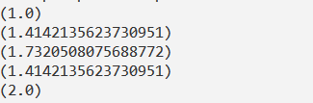

PIG EVAL FUNCTIONS

1. AVG Function
grunt> B = GROUP A ALL;
grunt> Result = FOREACH B GENERATE AVG(A.a1);
grunt> DUMP Result;
output: (2.4)

2. COUNT Function
grunt> B = GROUP A ALL;
grunt> Result = FOREACH B GENERATE COUNT(A);
grunt> DUMP Result;
output: 5

3. MAX Function
grunt> B = GROUP A ALL;
grunt> Result = FOREACH B GENERATE MAX(A.a1);
grunt> DUMP Result;
output: 4

4. MIN Function
grunt> B = GROUP A ALL;
grunt> Result = FOREACH B GENERATE MIN(A.a1);
grunt> DUMP Result;
output: 1

5. IN Function
grunt> Result = FILTER A BY a1 IN (2,4);
grunt> DUMP Result;
output: (2,4,6)
(2,4,6)
(4,8,12)

5. CONCAT Function
grunt> A = LOAD '/pigexample/chardata.txt' USING PigStorage(',') AS (fname:chararray,lname:chararray);
grunt> DUMP A;
output: (John,Doe)
(Jane,Smith)
(Ram,Patil)
(Riya,Sharma)
grunt> Result = FOREACH A GENERATE CONCAT(fname,'_',lname);
grunt> DUMP Result;
output: (John_Doe)
(Jane_Smith)
(Ram_Patil)
(Riya_Sharma)

6. SIZE Function
grunt> Result = FOREACH A GENERATE fname,SIZE(fname);
grunt> DUMP Result;
output: (John,4)
(Jane,4)
(Ram,3)
(Riya,4)

7. TOKENIZE Function
grunt> B = FOREACH A GENERATE CONCAT(fname,' ',lname) AS fullname;
grunt> Result = FOREACH B GENERATE TOKENIZE(fullname);
grunt> DUMP Result;
output: ({(John),(Doe)})
({(Jane),(Smith)})
({(Ram),(Patil)})
({(Riya),(Sharma)})

Practical No. 10

Aim: Configure the Hive and implement the application in Hive

